3GPP TSG-SA5 Meeting #164 S5- 255520
Dallas, USA, 17 - 21 November 2025

Source: Huawei
Title: Pseudo-CR on TR 28.882 add use case for registration and discovery of management information for ML model
Document for: Approval
Agenda item: 6.20.2
Spec: 3GPP TR 28.882
Version: 0.1.0
Work Item: FS_AIML_MGT_Ph3

Comments
The new SID SP-2501197 on study on MDA was approved at the SA #108 meeting. The objectives including:
WT-4: Registration and Discovery management for AI/ML
WT-4.1: Study enhancements to support registration and discovery management for AI/ML
For management for AI/ML, there are certain scenarios, such as coverage optimization analysis, where different ML models may be applicable to different regions/scenarios. Operator should have capability to be aware of the management ML model identification.
This contribution proposes to add use case to support management ML model registration management.
Proposed Changes
* * * First Change * * * *

X Use cases

X.Y Registration and Discovery of management information for ML model

X.Y.1 Description

The ML model management information Repository is used to store the management capability information for ML model (model version, applicable inference scenarios, model capabilities, etc.) provided by different ML training Function. The management information for ML model needs to be registered to ML model management information Repository. The MnS consumer could discover/retrieve the management information for ML model to perform ML model training.

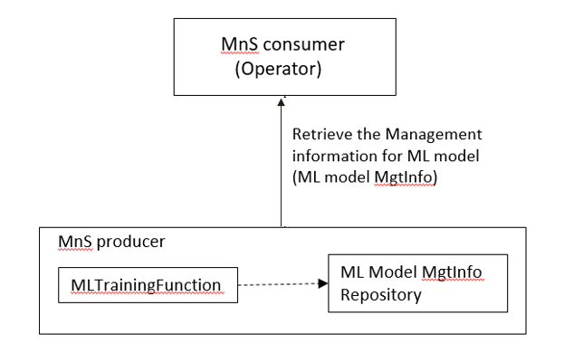
Figure X.Y.1-1 Registration and Discovery of management information for ML model.
For the ML model management information, the existing ML model ID definition is described in TS 28.105 [x], but it is not globally unique, then it will have the risk of confusion for different ML model. The management ML model(s) needs to be uniquely identified. This is crucial for network operators to ensure precise tracking of the model's information and it can also eliminate the risk of duplication to enable network performance improvement.

X.Y.2 Potential requirements
REQ-ML_REGIS-x1: The 3GPP management system shall have a capability allowing the authorized consumer to retrieve the management information for ML model(s).

X.Y.3 Potential solutions
The exsiting attribute in ML model IOC can be reused to retrieve the management information (e.g. model ID, model version, applicable inference scenarios, model capabilities, etc.) for ML model(s) .The uniqueness of ML model can be guaranteed with the usage of DN identifying the MLModel and mlModelId.

X.Y.4 Evaluation of solutions
TBD

* * * End of Changes * * * *

