3GPP TSG-SA5 Meeting #164 S5-255508
Dallas, Texas, USA, 17 – 21 November 2025 revision of S5-255116

Source: Nokia
Title: Pseudo-CR on TR 28.882 Collecting data for training UE-side Models
Document for: Approval
Agenda item: 6.20.2
Spec: 3GPP TR 28.882
Version: V0.0.0
Work Item: FS_AIML_MGT_Ph3

Comments
A use case for Management support to training for UE-side model has been agreed by SA5. This pCR proposes the solution outline for this use case.

Proposed Changes
* * * First Change * * * *

5.1 ML model training

5.1.1 Use cases

5.1.1.1 Management support to training for UE-side model

5.1.1.1.1 Management support to AI/ML-based beam management

5.1.1.1.1.1 Description
To support AI/ML-based beam management defined in TS 38.300 [2], for beam prediction management, a UE can perform measurements of beam prediction management and send the data to an entity (e.g. a server inside MNO or an OTT server) for training UE-side models (models that should then be transferred to the UE to be used by the UE for inferences). The data for training UE-side model can be sent from the UE via gNB and 3GPP management system for (see NOTE 1). 3GPP management system needs to collect data from gNB and report it to UE-side training entity to management support of training for UE-side model.

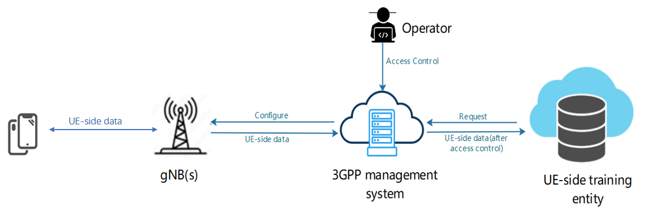
Figure 5.1.1.1.1.1-1: Management of UE-side data collection and reporting for UE-side model training
Being a MnS consumer, the UE-side training entity requests 3GPP management system to collect the data for the purpose of training UE-side beam prediction models. Then 3GPP management system configures the gNB(s) to collects data from targeted UEs or UE types, and gNB may further select corresponding UEs and shall send configuration information to the selected UE(s). The request from UE-side training entity shall include the type of data (e.g. based on UE/UE Group, use case) and other characteristics for the data (e.g., location, time) to be produced and the gNB(s) where the data shall be collected.
After the UE-side training data such as beam prediction data are produced, UE(s) shall report the data to gNB(s), and 3GPP management system shall collect data from the gNB(s). 3GPP management system report the collected data to UE-side training entity depending on access information specified by operator (see NOTE 2).
NOTE 1: The UE-side data are subject to further discussion, pending ongoing correspondence and confirmation by RAN2 and RAN1.
NOTE 2: Access control information is for further discussion.

5.1.1.1.1.2 Potential requirements
REQ-ML_UESIDE-01: The 3GPP management system should have a capability enabling an authorized UE-side training entity to request the collection of data for UE-side model training.
REQ-ML_UESIDE-02: The 3GPP management system should have a capability to request (configure gNBs to initiate data collection) and get the UE-side training data from gNB(s) for the UE-side model training.
REQ-ML_UESIDE-03: The 3GPP management system should have a capability to report the UE-side data to authorized UE-side training entity for UE-side model training.

5.1.1.1.1.3 Possible solutions
5.1.1.1.1.3.X End-to-end Solution Outline
The End-to end solution includes data request to OAM via ManagementDataCollection IOC, configuration of data collection to the gNB via Trace IOC, data reporting to OAM via either CP path or UP path and delivery of data to the data consumer via file notification. The Solution outline is highlighted in Figure 5.1.1.1.1.3-1. The related sequence of interactions and stage 2 impact in SA5 is summarized by Table 5.1.1.1.1.3-1.
Figure 5.1.1.1.1.3-1: sequence of interactions
Table 5.1.1.1.1.3-1: sequence of interactions and stage 2 impact
Solution Outline | Stage 2 impacts
1) UE model training server sends request to instantiate a data collection job – including configuration parameters such as the identification for required UE hardware (e.g., Type Allocation Code)  - E.g., for network scope from which to collect data; UE vendor information; use case for which data is needed | Extend ManagementDataCollection to support request for enhanced list of UE data  Note: ManagementDataCollection supports request for UE data, it just needs to be enhanced
2) Operator may configure Data Collection Function (entity exposing dataCollectionJob capability) with other aspects critical for data collection e.g., access rights, for UE model Training server, which data can be collected, whether to store the collected data, etc. | Extend ManagementDataCollection to add attributes that are configurable by the operator
3) Data Collection Function derives/extends gNB data collection configurations – incl. data delivery path information e.g., TCE identifier | No stage 2 impact
4) Data Collection Function configures data collection on the gNB –incl. data delivery path information e.g., TCE identifier and data collection request information e.g. dataCollectionJob identifier  - Data Collection Function also configures TCE to provide data collection request information | Extend traceJob (RAN as trace MnS producer) to add ​ ​  - data for training UE-side Models  - collection-request  - data-delivery-path information  Note: TCE identifier information is already specified for the trace job
5) gNB configures UEs to perform measurements and collect data – incl. data collection Job identifier for which UEs will provide data, information (identifier, IP address) for the TCE to which the data should bedelivered and indication that data is to be delivered via UP path | No impact in SA5
6a) UEs capture and deliver data via control path to the RAN – indicate destination TCE and data collection Job identifier to which they provide data | No impact in SA5  FFS: impact of the format (XML, ) of the data sent by the UE?
7a) RAN delivers data to TCE via trace reporting, data includes data collection request information e.g., dataCollectionJob identifier
6b) UEs capture and deliver data via UP path – indicate destination TCE and data collection Job identifier to which they provide data  Note: UE sets up a normal user plane traffic path via a GTP-U tunnel over the N3 interface to the UPF | No impact in SA5  No expected change in SA2 specification, path from UE to TCE is similar toa normal user plane data delivery  Impact of the format (e.g., XML) of the data sent by the UE is FFS.
7b) UPF forwards data to TCE, data includes data collection request information e.g., dataCollectionJob identifier  Note: TCE acts as a data network, UPF data delivery to TCE is similar to normal data forwarding to any data network | TCE can act as recipient of data from UPF
8) (If needed) TCE aggregates data according to request (e.g., if file reporting). TCE also saves data if configured to save the data | No stage 2 impact
9) If accumulation is complete. TCE notifies the UE model training server of the data. Then UE model training server can request to pull and receive the data. | Data object on TCE is notifiable - Introduce model of data (as managed object) on TCE; make data notifiable

Note: Details on the different steps are FFS.

5.1.1.1.1.4 Possible solutions evaluation
TBD

* * * End of Change * * * *

