3GPP TSG-SA5 Meeting #164 S5-255507

Dallas, USA, 17 - 21 Oct 2025
Source: Samsung
Title: Rel-20 pCR 28.882 UE Data Collection for UE-side model
Document for: Agreement
Agenda item: 6.20.2
Spec: 3GPP TR 28.882
Version: 0.1.0
Work Item: FS_AIML_MGT_Ph3

1 Decision/action requested.
The group is asked to endorse the proposal.

2 References
None

3 Rationale
This contribution provides a solution for UE Data Collection.
* * * First Change * * * *

5.1.1 Use cases

5.1.1.1 Management support to training for UE-side model

5.1.1.1.1 Management support to AI/ML-based beam management

5.1.1.1.1.1 Description
To support AI/ML-based beam management defined in TS 38.300 [2], for beam prediction management, UE can send the data of beam prediction management to UE-side training entity (e.g. a server inside MNO or an OTT server) via gNB and 3GPP management system for UE-side model training (see NOTE 1). 3GPP management system needs to collect data from gNB and report it to UE-side training entity to management support of training for UE-side model.

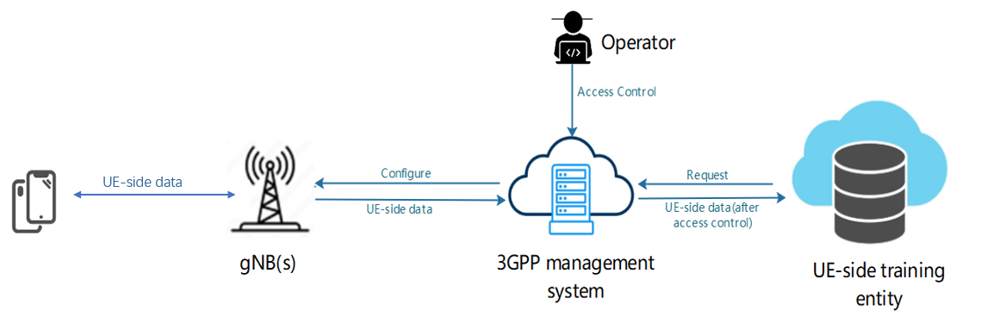
Figure 5.1.1.1.1.1-1: Management of UE-side data collection and reporting for UE-side model training
Being a MnS consumer, the UE-side training entity requests 3GPP management system to collect the UE-side data of beam prediction management, then 3GPP management system configure the gNB(s) to collects data from specified UEs, and gNB shall send configuration information to the UE(s). The request from UE-side training entity shall include the type of data (e.g. based on UE/UE Group, location, time) to be produced and the gNB(s) where the data shall be collected.
After the UE-side training data such as beam prediction data are produced, UE(s) shall report the UE-side data to gNB(s), and 3GPP management system shall collect data from the gNB(s). 3GPP management system report the collected data to UE-side training entity depending on access information specified by operator (see NOTE 2).
NOTE 1: The UE-side data are subject to further discussion, pending ongoing correspondence and confirmation by RAN2 and RAN1.
NOTE 2: Access control information is for further discussion.

5.1.1.1.1.2 Potential requirements
REQ-ML_UESIDE-01: The 3GPP management system should have a capability allowing the authorized UE-side training entity to request the UE-side training data for the UE-side model training.
REQ-ML_UESIDE-02: The 3GPP management system should have a capability to request and get the UE-side training data from gNB(s) for the UE-side model training.
REQ-ML_UESIDE-03: The 3GPP management system should have a capability to report the UE-side data to authorized UE-side training entity for UE-side model training.

5.1.1.1.1.3 Possible solutions

The solution proposes to enhance the existing MgmttDataInfo IOC (clause 4.3.75, TS 28.622) with attributes specifying additional information about the collected data.This includes:
- Single or a group of UE: This will specify the identification of UE or group of UE for each collected data. This can be defined as IMSI or N4 session identifier.
- Geographical location: This will specify the related location for each collected data i.e the location of the UE(s) when the data was collected. Categorization based on location can be used to identify the input data to train an ML model for handover optimization for a particular VIP location. This can be defined as a geographical coordinate i.e a set of latitude and longitude, a civic address, TAI list etc.
Note: Geographical location can be used together with Single or a group of UE to indicate the location per UE(s). When a UE enters within the specified Geographical location, the gNB can configure the UE with resources to initiate data collection.
- Time: This will specify the time at which the data was collected. The collected data may belong to a particular time window i.e data from all the UE in a particular time window.
Note: This can be used together with Geographical location and Single or a group of UE indicating that the collected data was reported by the UE in a particular location at a particular time.

In order to model the above metadata information in the existing NRM defined as part of 3GPP TS 28.622 the following options are provided:
- Option 1: Update the existing attribute supportedManagementData with supportedManagementDataInfo, which further includes supportedManagementData and relatedMetadata including the metadata proposed above. This will imply that the all the available management data, represented by supportedManagementData attribute, pertains to the given metadata (provided by the attribute relatedMetadata).
- Option 2: Add the attribute relatedMetadata directly into MgmtDataInfo IOC. This will imply that all the available management data, as part of MgmtDataInfo instance, pertains to the given metadata (provided by the attribute relatedMetadata). For different set of meta data, respective MgmtDataInfo instances will be created.
- Option 3: A new IOC (RelatedMetadata IOC) is created, the instance of which shall contain the metadata for the available management data. This IOC will be name contained in MgmtDataInfo IOC.

The solution further proposes to use existing ManagementDataCollection IOC that can be used by the UE Server to request required UE-side model training data from the management system. The enhancement includes the following information

- RequiredDataInfo: This will define the requirement for the requested data. This may be specified based on the following
  - Single or a group of UE: This indicates that the provided data should be from a single or a group of UE. This can be defined as IMSI or N4 session identifier.
  - Geographical location: This indicates that the provided data should be pertaining to a geographical location. This can be defined as a geographical coordinate i.e a set of latitude and longitude, a civic address, TAI list etc.
  - Time: This indicates that the provided data should be pertaining to a time window. This is defined as a time window in DDMMYYYY:HHMM:SS format.
Editor’s Note: configuration of policies enabling gNB to select appropriate UE(s) are FFS.

5.1.1.1.1.4 Possible solutions evaluation
TBD

* * * Next Change * * * *

* * * End of Change * * * *

