TSG SA5 Meeting #164 S5-255506d1
(was S5-255285)
Dallas, US, 17th – 21th, November, 2025

Source: NEC, Huawei, Nokia, Samsung, Vivo
Title: Pseudo-CR on TR 28.882 add Management support use case and requirement for two-sided model training
Document for: Approval
Agenda item: 6.20.2
Spec: 3GPP TR 28.882
Version: 0.1.0
Work Item: FS_AIML_MGT_Ph3

Comments
The new SID SP-250867 study on AIML management phase 3 has been approved at the SA #108 meeting. The objectives including:
WT-1: AI/ML Lifecycle Management Enhancements
WT-1.1: Investigate enhancements of AI/ML management capabilities throughout the AI/ML lifecycle in 5GS, including training, testing, emulation, deployment, inference, to support AI/ML-enabled features in the 5GS. This includes:
- ML model transfer/delivery as defined by RAN for Solution 4b: OAM can transfer/delivery AI/ML model(s) to UE.
- NG-RAN use cases including QoE optimization, network energy saving, and mobility use case(as defined in RP-250812).
- 5GC Analytics: Encompasses new 5GC analytics use cases currently under study under WT#2 (see SP-250413) and investigates OAM support for provisioning ML models to relevant 5GC functions to enable AI/ML-based analytics.
- LMF-based AI/ML Positioning including data collection and ML model training by the OAM for UE positioning.
- Study feasibility and potential requirements for data collection for (e.g., UE-side and Network-side) to enable model training.
Item 5 under sub work task WT-1.1 is to study feasibility and potential requirements for data collection to enable model training.
According to the incoming LS in RP-252966, the action for SA5 is to complete the study of dataset/model parameter exchange in Rel-20.
In line with this, this contribution proposes to add a use case on management support to two-sided model training to study management procedures for dataset/model parameter collection and reporting to enable two-side model training supporting the CSI compression features defined in TR 38.843.

Proposed Changes
* * * 1st change * * * *

2 References
The following documents contain provisions which, through reference in this text, constitute provisions of the present document.
- References are either specific (identified by date of publication, edition number, version number, etc.) or non-specific.
- For a specific reference, subsequent revisions do not apply.
- For a non-specific reference, the latest version applies. In the case of a reference to a 3GPP document (including a GSM document), a non-specific reference implicitly refers to the latest version of that document in the same Release as the present document.
[1] 3GPP TR 21.905: "Vocabulary for 3GPP Specifications".
…
[x1] 3GPP TR 38.843: " Study on Artificial Intelligence (AI)/Machine Learning (ML) for NR air interface ".

* * * Next change * * * *

3.3 Abbreviations
For the purposes of the present document, the abbreviations given in TR 21.905 [1] and the following apply. An abbreviation defined in the present document takes precedence over the definition of the same abbreviation, if any, in TR 21.905 [1].

OTT Over the top
* * * Next change * * * *

5 Management capabilities for AI/ML lifecycle

5.1 ML model training

5.1.1 Use cases

5.1.1.x Management support to data collection for two-sided model training

5.1.1.x.1 Management support to CSI compression

5.1.1.x.1.1 Description
To support CSI compression defined in TR 38.843 [x1], the operator can deliver relevant data for two-sided model training (see Note 1) to a UE-side model training entity (e.g. a server deployed by an MNO or by an OTT service provider). The UE-side model training entity uses the received data to perform UE-part model training for CSI compression.
For this use case, the following approach is considered: gNB -> OAM -> UE-side training entity (a server inside MNO or an OTT server), where the gNB is the data-collection entity for relevant data for two-sided model training.

The operator uses the 3GPP management system to control and supervise how relevant data for CSI compression is delivered to the UE-side training entity (see Note 2).

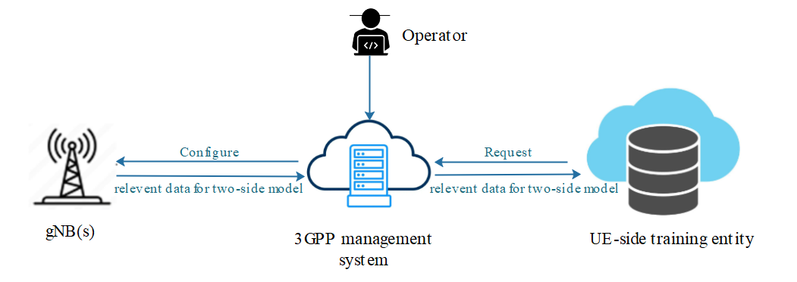
Figure 5.1.1.x.1.1-1 Illustration of data collection for two-side CSI model training

The UE-side training entity sends a subscription request (see Note 3) to the 3GPP management system, expressing its interest to receive the data for CSI compression including some conditions (e.g., geographic area, time windows, etc.). The 3GPP management system registers this request, which may also include the identifier of the UE-side training entity. If the needed data is not available at the management system, the management system then decides from which gNB(s) (see Note 4) this data needs to be collected, and configures the information that specifies what data the 3GPP management system needs from the gNB(s) and when (see Note 5). The gNB sends the requested data to the 3GPP management system after the relevant data is produced.
Upon collecting the data from the different gNBs, the management system delivers it to the UE-side training entity based on access control information specified by the operator (see Note 2).
NOTE 1: The relevant data for two-side model (see arrows in Figure 5.1.1.x.1.1-1) is subject to further discussion, pending ongoing correspondence and confirmation by RAN2.
NOTE 2: Access control information is for further discussion.
NOTE 3: The term ‘subscription request’ does not specifically imply adoption of a subscribe/notify mechanism in the solution. It is used to capture the requirement that the UE-side training entity can declare its interest in data delivery.
NOTE 4: The selected gNB(s) support the AI/ML feature for CSI compression use case.
NOTE 5: Consumer identity (i.e. the UE-side training entity) is managed by the operator within the 3GPP management system and may be included in the configuration for traceability purposes.

5.1.1.x.1.2 Potential requirements
REQ-ML_TWOSIDE-x1: The 3GPP management system should have a capability allowing an UE-side training entity to subscribe for receiving relevant data for CSI compression.
REQ-ML_TWOSIDE-x2: The 3GPP management system should have a capability to configure one or more gNBs to report relevant data for CSI compression.

REQ-ML_TWOSIDE-x3: The 3GPP management system should have a capability to deliver relevant data to a subscribed UE-side training entity.

* * * End of Changes * * * *

