3GPP TSG-SA5 Meeting #164 S5-255500
Dallas, USA, 17 – 21 November 2025

Source: NTT DOCOMO
Title: Pseudo-CR on Rel-20 TR 28.881 Enhance solution for Use case#13 Intent Lifecycle Management State Transition
Document for: Approval
Agenda item: 6.20.1
Spec: 3GPP TR 28.881
Version: 0.2.0
Work Item: FS_IDMS_MN_Ph4

Comments
This pCR provides enhancements to the solution of intent lifecycle management state transition considering the potential solution in clause 4.11.3.1 (Use Case#11) of adding a new value for intentMgmtPurpose as “FEASIBILITYCHECK_WITH_EXPLORATION”. This pCR proposes to update the Figure 4.13.2.1: intent lifecycle management state transition diagram and Table 4.13.2.1: The intent lifecycle management state transition diagram table accordingly.

Proposed Changes

* * * First Change * * * *

4.13 Use case #13: Investigation on the intent lifecycle management state transition

4.13.1 Description
3GPP TS 28.312 [1] studies the state transitions during fulfilment phase. However, the intent Lifecycle management states that describes the pre-evaluation phase (i.e. intent feasibility check and intent exploration) and negotiation in intent fulfilment phase is missing. The main difference between the pre-evaluation phase, fulfilment phase and negotiation in intent fulfilment phase is on the intentMgmtPurpose. Thus, investigation on the intent lifecycle management state transition should be made, including the intent lifecycle management state transition diagram and the state transition events based on the intentMgmtPurpose.

4.13.2 Potential requirements

4.13.3 Potential solution
It proposes to add intent lifecycle management state transition diagram and intent lifecycle management state transition table to indicate the state transitions. Figure 4.13.2.1 shows the intent lifecycle management state diagram, where the number in the Figure identify the changes to the intent lifecycle management state. The explanations for the changes are described in Table 4.13.2.1.
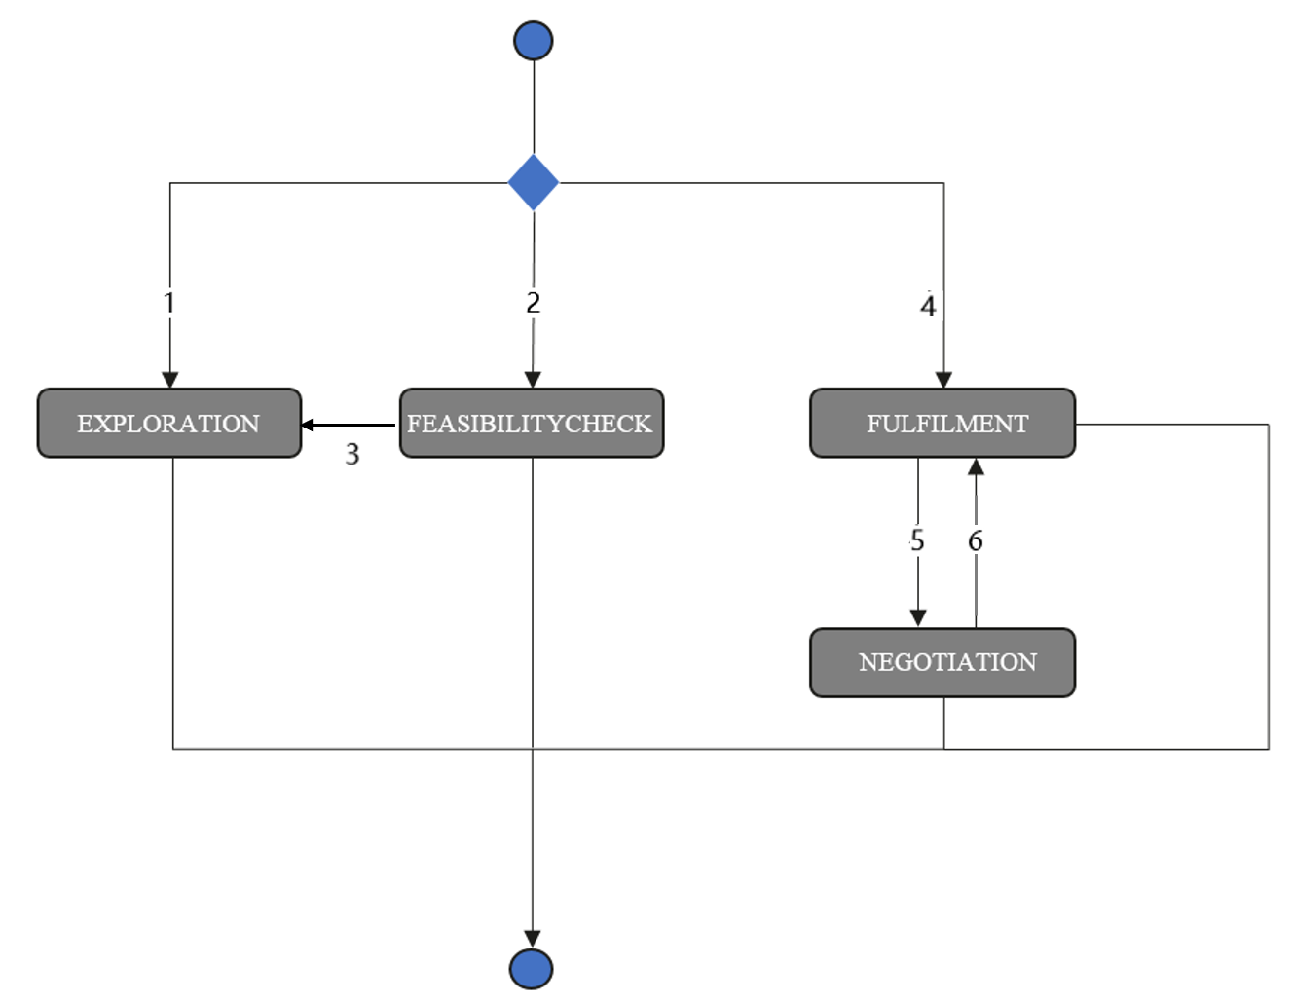
Figure 4.13.2.1: intent lifecycle management state transition diagram
The transition numbers in the first column represent the intent lifecycle management state changes in Figure 4.13.2.1. The interactions specified under the column " Intent lifecycle management state transition events" of Table 4.13.2.1 shall be present for the transition.
NOTE 1: The transition numbers do not indicate any strict order and not correspond to procedure steps.
NOTE 2: Figure 4.13.2.1 may not be complete, and other states and transitions may be added.
Table 4.13.2.1: The intent lifecycle management state transition diagram table
Transition number | Intent lifecycle management state transition events | Intent lifecycle management state
1 | The MnS producer creates the intent instances for intent exploration based on the received intent creation request, with the intentMgmtPurpose specified as "EXPLORATION" and the value of specific intent targets or contexts that need to be explored initially set to 'NULL'. | EXPLORATION
2 | The MnS producer creates the intent instances for intent feasibility check based on the received intent creation request, with the intentMgmtPurpose specified as "FEASIBILITYCHECK" or "FEASIBILITYCHECK_WITH_EXPLORATION". | FEASIBILITYCHECK
3 | The MnS producer triggers the exploration process when intentMgmtPurpose is specified as "FEASIBILITYCHECK_WITH_EXPLORATION" and the feasibilityCheckResult is infeasible. | EXPLORATION
4 | The MnS producer creates or modify the intent instances during fulfilment phase based on the received request, with the intentMgmtPurpose specified as " FULFILMENT_WITH_NEGOTIATION" or " FULFILMENT_ WITHOUT _NEGOTIATION ". | FULFILMENT
5 | The MnS producer triggers the negotiation process. The process only can be triggered when intentMgmtPurpose is specified as " FULFILMENT_WITH_NEGOTIATION". | NEGOTIATION
6 | The MnS producer finishes the negotiation process. | FULFILMENT
NOTE: The Table 4.13.2.1 also provides information regarding the impact of the potential solution provided in clause 4.11.3.1 for enhancing intent feasibility check capability. The potential solution provided in clause 4.11.3.1 does not require a new intent lifecycle management state in potential solutions studied in clause 4.13.3.
* * * End of Changes * * * *

