3GPP TSG-SA5 Meeting #164 S5-255382
Dallas, US 17 - 21 Nov 2025

Source: Rakuten Mobile
Title: pCR TR 28.884 Management Data Streaming based on Message Bus Potential Solution 2
Document for: Approval
Agenda item: 6.20.4
Spec: 3GPP TR 28.884
Version: 0.1.0
Work Item: FS_SBMA_Ph4

Comments
To address WT-1 of Study on Service Based Management Architecture enhancement phase 4, this contribution proposes to add potential solution for management data streaming based on message bus.

Proposed Changes
* * * First Change * * * *

Use case #2: Management data streaming based on Message Bus

5.2.3 Potential solutions
5.2.3.X Solution #2: Multipoint-to-Multipoint management data streaming based on message broking MnF
This potential solution proposes introduction of a message broking MnF implementing the message broker(s) that mediates data from MnS producers (data publishers) to MnS consumers (data subscribers) to enable multipoint-to-multipoint streaming data reporting between the MnS producers and MnS consumers.
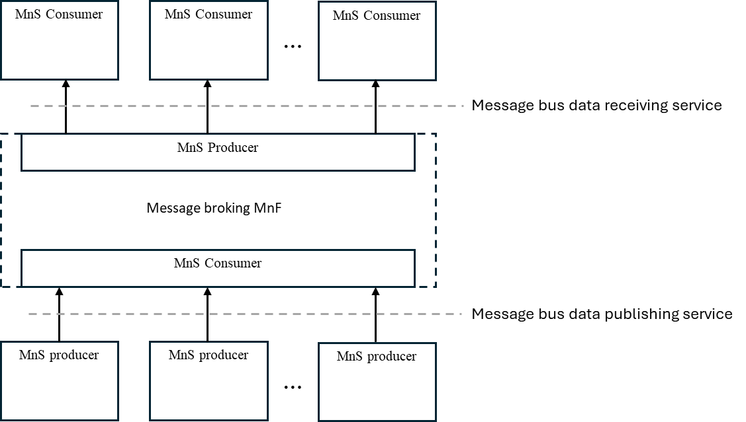
Figure 5.2.3.X-1: Potential solution for multipoint-to-multipoint management data streaming based on message bus
As shown in Figure 5.2.3.X-1, in this solution, MnS producers stream management data to Message broking MnF using a new data publishing service. MnS consumers receive the management data based on subscription using a new data receiving service. This approach allows the same copy of management data produced by the MnS producer to be shared across multiple MnS consumers thus enabling multipoint-to-multipoint communication and a publishing-and-subscribing based communication pattern. This solution complies with the existing SA5 SBMA. This solution requires only the new MnSs related to message bus data publishing, receiving and potentially data subscribing to be defined in 3GPP TS28.532.

* * * End of Changes * * * *

