3GPP TSG-SA5 Meeting #164 S5-255381
Dallas, US 17 - 21 Nov 2025

Source: Rakuten Mobile
Title: pCR TR 28.884 Management Data Streaming based on Message Bus Potential Solution 1
Document for: Approval
Agenda item: 6.20.4
Spec: 3GPP TR 28.884
Version: 0.1.0
Work Item: FS_SBMA_Ph4

Comments
To address WT-1 of Study on Service Based Management Architecture enhancement phase 4, this contribution proposes to add potential solution for management data streaming based on message bus.

Proposed Changes
* * * First Change * * * *

Use case #2: Management data streaming based on Message Bus

5.2.3 Potential solutions
5.2.3.X Solution #1: Point-to-Point management data streaming based on message bus communication protocol
This potential solution proposes the addition of a new reporting method for management data for network functions running in the cloud. The solution proposes the use of message bus for the reporting of management data from the MnS producer to the MnS consumer as shown in figure 5.2.3.X-1.
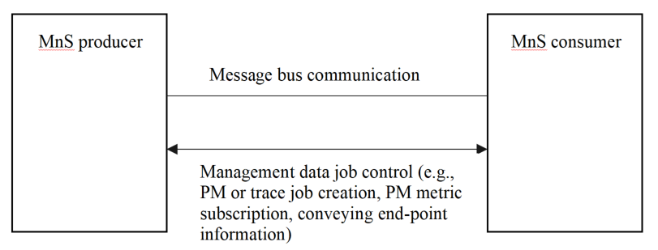
Figure 5.2.3.X-1: Potential solution for management data streaming based on message bus
The proposed solution enables MnS producer(s) to stream management data to the MnS consumer(s) using message bus communication protocol, e.g. Kafka publishing. The interactions between MnS producer and MnS consumer for management data streaming is illustrated in in Figure 5.2.3.X-2.
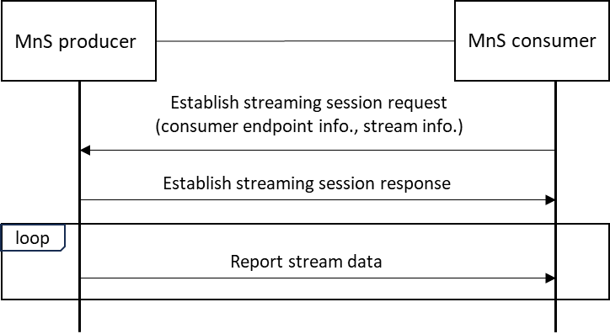
Figure 5.2.3.X-2: Interactions between MnS producer and MnS consumer for management data streaming
The MnS consumer send request to the MnS producer to establish a logical streaming session containing the consumer’s message broker endpoint(s) information and stream information (the same streamInfoList in 3GPP TS 28.532, clause 12.5). The MnS producer after establishing the streaming session sends response to the MnS consumer. The MnS producer starts reporting the stream data to endpoint(s) provided by the MnS consumer using message bus-based communication protocol. A new establish logical streaming session operation is introduced in addition to the previous establishStreamingConnection operation defined in clause 12.5.1 of 3GPP TS 28.532 for WebSocket based streaming data reporting. New streaming data reporting service APIs maybe introduced in 3GPP TS 28.532, or the existing streaming data reporting service APIs, clause 12.5.1 of 3GPP TS 28.532, maybe modified.
The solution enables multiple data subscribers within the MnF implementing the MnS consumer. However, between MnS producer and consumer, it is still point-to-point communication.
* * * End of Changes * * * *

