3GPP TSG-SA5 Meeting #164 S5-255080
Dallas, USA, 17 - 21 November 2025

Source: Ericsson Hungary
Title: pCR TR 28.884 Merge operation
Document for: Approval
Agenda item: 6.20.4
Spec: 3GPP TR 28.884
Version: V0.1.0
Work Item: FS_SBMA_Ph4

Comments
To address WT-9 of Study on Service Based Management Architecture enhancement phase 4, this contribution proposes to introduce the merge operation into the changeMOIs operation and the notifyMOIChanges notification in SBMA for 5G.

Proposed Changes
* * * First Change * * * *

2 References
The following documents contain provisions which, through reference in this text, constitute provisions of the present document.
- References are either specific (identified by date of publication, edition number, version number, etc.) or non-specific.
- For a specific reference, subsequent revisions do not apply.
- For a non-specific reference, the latest version applies. In the case of a reference to a 3GPP document (including a GSM document), a non-specific reference implicitly refers to the latest version of that document in the same Release as the present document.
[1] 3GPP TR 21.905: "Vocabulary for 3GPP Specifications".
[2] 3GPP TS 28.533: "Management and orchestration; Architecture framework".
[3] 3GPP TS 28.532: " Management and orchestration; Generic management services".
[4] 3GPP TS 28.537: " Management and orchestration; Management capabilities".
[5] 3GPP TS 28.552: " Management and orchestration; 5G performance measurements".
[6] 3GPP TS 28.554: " Management and orchestration; 5G end to end Key Performance Indicators (KPIs)".
[7] 3GPP TS 32.423: " Telecommunication management; Subscriber and equipment trace: Trace data definition and management".
[8] https://datatracker.ietf.org/doc/html/rfc6455
[9] https://websocket.org/guides/websocket-protocol/
[10] 3GPP TS 28.111: "Management and orchestration; Fault management (FM)".
[11] 3GPP TS 32.531: "Telecommunication management; Software management (SwM); Concepts and Integration Reference Point (IRP) Requirements".
[12] 3GPP TS 32.532: "Telecommunication management; Software management (SwM); Integration Reference Point (IRP); Information Service (IS)".
[13] 3GPP TS 32.533: "Telecommunication management; Software management (SwM); Integration Reference Point (IRP); Common Object Request Broker Architecture (CORBA) Solution Set (SS)".
[14] 3GPP TS 28.631: "Telecommunication management; Inventory Management (IM) Network Resource Model (NRM) Integration Reference Point (IRP); Requirements".
[15] 3GPP TS 28.632: "Telecommunication management; Inventory Management (IM) Network Resource Model (NRM) Integration Reference Point (IRP); Information Service (IS)".
[16] 3GPP TS 28.633: "Telecommunication management; Inventory Management (IM) Network Resource Model (NRM) Integration Reference Point (IRP); Solution Set (SS) definitions".
[a] SP-250863: Study on SBMA enhancement phase 4
[b] 3GPP TS 32.158: " Design rules for REpresentational State Transfer (REST) Solution Sets (SS)"
[c] RFC 6241 Network Configuration Protocol (NETCONF)

* * * Next Change * * * *

5.X Use case #X: Merge operation

5.X.1 Description
The changeMOIs operation and the notifyMOIChanges notification (as described in TS 28.532[12]) both support multiple operation types, defined by the "modifyOperator" in changeMOIs and as "op" in notifyMOIChanges. These operations are optimized for handling individual data nodes e.g. replacing a full object with all its attributes or updating a single attribute (or attribute field).
A common use-case is updating a multiple attributes of multiple MOIs while leaving other attributes of the same MOIs unchanged. This is not properly handle and documented.

5.x.1.1 Problem when updating multiple MOIs
The changeMOIs operation should be used, as using individual createMOI, deleteMOI and modifyMOIAttributes operations would require using multiple operations requiring more processing and network resources. See TS 28.532 clause 11.1.1.4a.
Lets look at the following example where an immediate heartbeat is ordered in one ManagedElement and multiple attributes of a PerfMetricJob are updated in another ManagedElement.
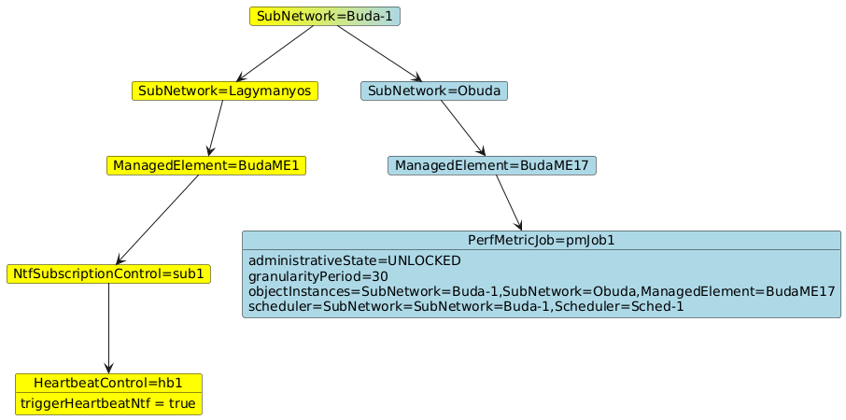
5.x.1.1-1 Example configuration, modifying two separate objects

As multiple MOIs are to be modified by changeMOIs the
- baseObjectInstance shall identify a common ancestor MOI for all MOIs to-be-modified or to-be-reported, this could potentially be the root ManagedElement or the SubNetwork. As the ManagedElements may belong to different SubNetworks the baseObjectInstance can only be set to a common ancestor Subnetwork:
"baseObjectInstance": "SubNetwork=Buda-1"
The rest of the path to each argument must be defined in the "path" element using long multi-segment strings. Each "path" element needs to specify the path from the baseObjectInstance to the individual attribute or attribute field. E.g. for updating 5 attributes the following 5 "paths" have to be created and parsed:
"path": "/SubNetwork=Lagymanyos/ManagedElement=BudaME1/NtfSubscriptionControl=sub1/HeartbeatControl=hb1/triggerHeartbeatNtf"

"path": "/SubNetwork=Obuda/ManagedElement=BudaME17/PerfMetricJob=pmJob1/administrativeState"
"path": "/SubNetwork=Obuda/ManagedElement=BudaME17/PerfMetricJob=pmJob1/granularityPeriod"
"path": "/SubNetwork=Obuda/ManagedElement=BudaME17/PerfMetricJob=pmJob1/objectInstances"
"path": "/SubNetwork=Obuda/ManagedElement=BudaME17/ PerfMetricJob=pmJob1/scheduler"
- "node Value" shall contain the new value of each attribute(element) e.g. true, UNLOCKED ,30, SubNetwork=SubNetwork=Buda-1,Scheduler=Sched-1
This means that for each updated attribute(element) the consumer has to produce a long "path" element which the consumer has to read/parse.
A computationally cheaper solution would be to use the "path" element to address each modified MOI, and let the "nodeValue" element contain all attribute changes; to have an operation that allows modifying multiple attributes of an MOI while leaving other attributes of the same MOI unchanged. That would allow the consumer to address each MOI only once. In the example above that would mean creating/parsing only 2 "path" elements instead of 5.
In Netconf, JSON Merge patch or the 3GPP JSON Merge patch this is possible using the "merge" operation. While this is describe both for the Netconf_YANG and for the OpenAPI solution sets, it is not described on stage-2.
Note: While the above example is about a SubNetwork level producer, the same problem is valid for ManagedElement level producers as even inside a single ManagedElement there are IOCs that are embedded in the ManagedElement 5 levels deep.

5.x.1.2 Problem use-case when notifying the update of multiple MOIs
When reporting the changes made in the example of the previous clause the notification notifyMOIChanges should be used. The alternative, using some of the notifications notifyMOICreation, NotifyMOIDeletion, notifyMOIAttributeValueChanges, would mean sending multiple notifications instead of one, which requires more processing and network resources.
When using notifyMOIChanges just as described above we will need to set
"objectInstance": "SubNetwork=Buda-1"
5 separate moiChanges values will be needed, where the "path" element will specify the path to each attribute separately. (The replace operation towards the PerfMetricJob=pmJob1 MOI cannot be used as that would delete all not listed attributes.)
It would be good if we could collect all the attribute changes for a single MOI into one moiChanges value, thereby requiring only a single "path" element for each MOI to be created/parsed even if multiple attributes are updated.
An operation similar to "merge" would help. However, for notifyMOIChanges there is no such operation defined on stage-2 or stage-3.
With a proposed "merge" operation only 2 paths would need to be handled:
"path": "/SubNetwork=Lagymanyos/ManagedElement=BudaME1/NtfSubscriptionControl=sub1/HeartbeatControl=hb1"
"path": "/SubNetwork=Obuda/ManagedElement=BudaME17/PerfMetricJob=pmJob1"

5.X.2 Potential requirements
REQ-MERGE-1: Add a simple solution for indicating the update of multiple attributes of multiple MOIs with a single notification while minimizing the need for parsing long "path" parameters.

5.X.3 Potential solutions
Two separate solutions are proposed for the problems described in clause 5.x.1.1 and 5.x.1.2.
a) Describe the merge operation for the changeMOIs operation on stage-2 in 28.532[12].
Note: Exact details of merge shall not be described on stage-2 as they are solution set specific and already described in RFC 6241[c] and in 3GPP TS 32.158[b].

b) Add a new "merge" value to the "moiChanges.op" parameter of the notifyMOIChanges notification. This will allow
- the (base)ObjectInstance to identify a common ancestor MOI for all MOIs to-be-modified or to-be-reported.
- the use of a single "moiChanges" value for each MOI thus avoiding the need to create/read a separate "path" element for each attribute. Within the single moiChanges value
- the "path" shall to the individual MOI
- the "value" element shall contain all modified attribute values (created, deleted, updated)
Editor’s note: How to report a deleted attribute within merge for YANG based schemas is FFS. Maybe null as a value can be used, although that’s not part of RFC 7951..
As attribute (elements) can have a complex structure too, the merge operation shall be applicable for any kind of target: MOI, attribute, attribute field, or attribute element.
The "value" element shall not contain any child MOIs, thereby ensuring that changes to separate MOIs are reported as separate "moiChange" items.

5.X.4 Evaluation of potential solutions
TBD
* * * End of Changes * * * *

