3GPP TSG-SA5 Meeting #164 S5-255441
Dallas, USA, 17 - 21 November 2025

Source: Ericsson, Huawei
Title: Pseudo-CR on Use case LBO VSMF to HCHF N47 failure scenario
Document for: Approval
Agenda item: 7.5.2
Spec: 3GPP TR 32.872
Version: 0.1.0
Work Item: FS_RoamRE_CH

Comments
Addition of new topic and use case on LBO VSMF to HCHF N47 failure scenario.

Proposed Changes
* * * First Change * * * *

5.x Topic x: Local Breakout V-SMF to H-CHF scenario

5.x.1 Use cases

5.x.1.1 Use case #x: Failures detected between the CTF and the H-CHF
In the LBO N40+N47 charging architecture, for a specific PDU session, a charging session between the V-SMF (CTF) and V-CHF and a charging session between the V-SMF (CTF) and H-CHF is to be initiated, updated or terminated. When a failure detected between V-SMF (CTF) and H-CHF. How the charging system handles the failure should be studied.

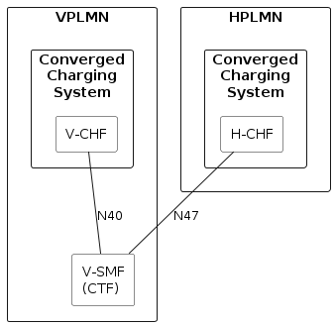
Figure 5.x.1-1: Failure detected between V-SMF(CTF) and H-CHF
The failure can happen at any time in a session, bellow are two cases described either when the V-SMF cannot reach the H-CHF or when the H-CHF cannot reach V-SMF.
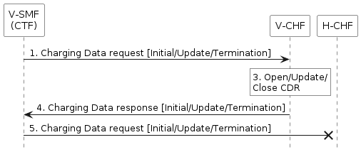
Figure 5.x.1-2: Failure at request from V-SMF(CTF) to H-CHF

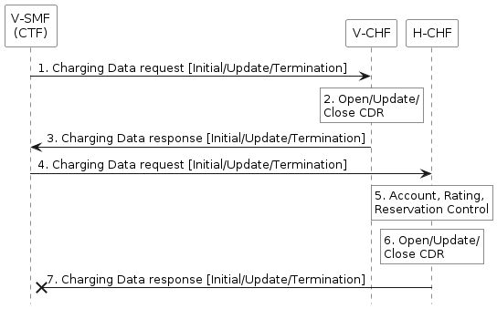
Figure 5.x.1-3: Failure at request from V-SMF(CTF) to H-CHF
The potential charging requirements for this UC are: REQ-3GPPCH-LBHC-x.

5.x.2 Potential charging requirements
REQ-3GPPCH-LBHC-x: Charging system shall support failure handling for the Local Breakout charging scenario in which a failure is detected between the CTF and the H-CHF.

5.x.3 Key issues

5.x.3.1 Key issue #x: Failure handling enhancement for failures detected between the CTF and the H-CHF
This key issue is for investigating how to support REQ-3GPPCH-LBHC-x. This investigation covers the following:
- Identification of the failure handling enhancement, if any, for the scenario in which a failure is detected between the CTF and the H-CHF;

5.x.4 Possible solutions

5.x.5 Evaluation

5.x.6 Conclusion

* * * Next Change * * * *

Annex A (informative):
PlantUML

A.1 Figures

A.1.1 Figure 5.x.1-1

@startuml
<style>
element {
BackGroundColor: white;
}
</style>

rectangle "VPLMN" {
rectangle "Converged\nCharging\nSystem" as VCCS {
rectangle "V-CHF" as VCHF
}
rectangle "V-SMF\n(CTF)" as CTF
}

rectangle "HPLMN" {
rectangle "Converged\nCharging\nSystem" as HCCS {
rectangle "H-CHF" as HCHF
}
}
VCHF -- CTF : "N40"
HCHF -- CTF : "N47"
@enduml

A.1.2 Figure 5.x.1-2

@startuml
<style>
element {
BackGroundColor: white;
}
</style>
hide footbox

participant CTF as "V-SMF\n(CTF)"
participant VCHF as "V-CHF"
participant HCHF as "H-CHF"

CTF -> VCHF : 1. Charging Data request [Initial/Update/Termination]
rnote over VCHF: 3. Open/Update/\nClose CDR
CTF <- VCHF : 4. Charging Data response [Initial/Update/Termination]
CTF ->x HCHF : 5. Charging Data request [Initial/Update/Termination]
@enduml

A.1.3 Figure 5.x.1-3

@startuml
<style>
element {
BackGroundColor: white;
}
</style>
hide footbox

participant CTF as "V-SMF\n(CTF)"
participant VCHF as "V-CHF"
participant HCHF as "H-CHF"

CTF -> VCHF : 1. Charging Data request [Initial/Update/Termination]
rnote over VCHF: 2. Open/Update/\nClose CDR
CTF <- VCHF : 3. Charging Data response [Initial/Update/Termination]
CTF -> HCHF : 4. Charging Data request [Initial/Update/Termination]
rnote over HCHF: 5. Account, Rating,\nReservation Control
rnote over HCHF: 6. Open/Update/\nClose CDR
CTF x<- HCHF : 7. Charging Data response [Initial/Update/Termination]
@enduml

* * * End of Changes * * * *

