3GPP TSG-SA5 Meeting #164 S5-255173rev1
Dallas, USA, 17 - 21 November 2025

Source: Huawei

Title: Rel-20 pCR 32.872 Failure handling of V-CHF when V-CHF detected failure of charging session with H-CHF

Document for: Approval
Agenda Item: 7.5.2

1 Decision/action requested
This is a pCR to TR 32.872 Introduce solutions on Local Breakout Inter CHFs scenario key issue2.

2 References
[1] 3GPP TR 32.872: "Study on 5GA roaming charging reliability enhancement".

3 Rationale
This pCR proposes to introduce solutions on Local Breakout Inter CHFs scenario key issue2.

4 Detailed proposal
Propose to incorporate the following change into the TR 32.872 [1]

First change

5.1.4.b Solution #2.x: V-CHF release the charging session with CTF when V-CHF detected failure of charging session with H-CHF
A possible solution for key issue #2 covering requirements REQ-3GPPCH-LBIC-2, enhanced failure handling for scenarios where a failure is detected between the V-CHF and the H-CHF.
When the V-CHF, acting as an NF consumer, detects a failure of the H-CHF, it determines how to handle the charging session with the NF (CTF) based on the operator's agreement, e.g. V-CHF may continue the session with NF (CTF) and store the charging information for settlement, as specified in clause 5.5.1.3 of 3GPP TS 32.290[3].
In the case of V-CHF decides to release the charging session between the V-CHF and CTF, the V-CHF sends a Charging Data Response or Charging Notify Request to CTF to indicate that the charging session should be released.
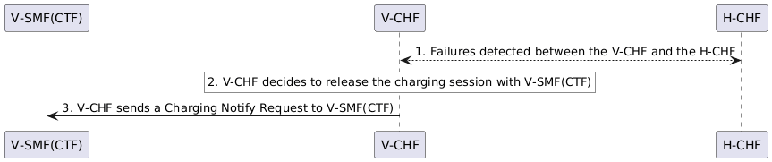
Figure 5.1.4.b-1: V-CHF terminates the charging session with CTF

5.1.4.c Solution #2.y: V-CHF suspend quota management when V-CHF detected failure of charging session with H-CHF
A possible solution for key issue #2 covering requirements REQ-3GPPCH-LBIC-2, enhanced failure handling for scenarios where a failure is detected between the V-CHF and the H-CHF.
When the V-CHF, acting as an NF consumer, detects a failure of the H-CHF, it determines how to handle the charging session with the NF (CTF) based on the operator's agreement, e.g. V-CHF may continue the session with NF (CTF) and store the charging information for settlement, as specified in clause 5.5.1.3 of 3GPP TS 32.290[3].
In the case of V-CHF decides to continue the charging session between the V-CHF and CTF in online charging scenario, the V-CHF instructs the NF consumer (CTF) to suspend quota management as specified in clause 5.3.2.5 of 3GPP TS 32.290[3], and stores the Charging Data Request(s) or charging information marked with ‘QUOTA_MANAGEMENT_SUSPENDED’ from the NF consumer (CTF).

Annex A (informative):
PlantUML

A.1 Figures

A.1.b Figure 5.1.4.b-1
@startuml
participant "V-SMF(CTF)" as CTF
participant "V-CHF" as VCHF
participant "H-CHF" as HCHF

VCHF <--> HCHF : 1. Failures detected between the V-CHF and the H-CHF

rnote over VCHF #white
2. V-CHF decides to release the charging session with V-SMF(CTF)
endrnote

VCHF -> CTF : 3. V-CHF sends a Charging Notify Request to V-SMF(CTF)

@enduml

End of change

