3GPP TSG-SA5 Meeting #164 S5-255172rev1
Dallas, USA, 17 - 21 November 2025

Source: Huawei

Title: Rel-20 pCR 32.872 Failure handling of CTF when failures detected between the CTF and the V-CHF

Document for: Approval
Agenda Item: 7.5.2

1 Decision/action requested
This is a pCR to TR 32.872 Introduce a solution on Local Breakout Inter CHFs scenario key issue1.

2 References
[1] 3GPP TR 32.872: "Study on 5GA roaming charging reliability enhancement".

3 Rationale
This pCR proposes to introduce a new solution on Local Breakout Inter CHFs scenario key issue1.

4 Detailed proposal
Propose to incorporate the following change into the TR 32.872 [1]

First change

5.1.4.a Solution #1.y: CTF detected failure
A possible solution for key issue #1 covering requirements REQ-3GPPCH-LBIC-1, enhanced failure handling for scenarios where a failure is detected between the CTF and the V-CHF. This is an application level failure handling solution.
When the V-CHF is determined not reachable by V-SMF(CTF), V-SMF(CTF) uses application level failure handling (Terminate, Continue, Retry_and_terminate) as specified in clause 5.5.1.1 of 3GPP TS 32.290 [3].
When failure handling is set to 'Continue' and a failover procedure is supported in the V-CHF and the V-SMF(CTF), the V-SMF(CTF) re-sends the request with the ‘Remote CHF resource’ to an alternative V-CHF, then the alternative V-CHF replaces the original V-CHF to interact with the H-CHF.
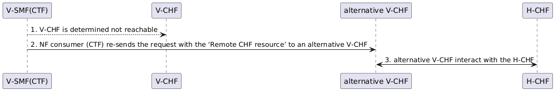
Figure 5.1.4.a-1: V-CHF re-sends the request to an alternative V-CHF

Annex A (informative):
PlantUML

A.1 Figures

A.1.a Figure 5.1.4.a-1
@startuml
participant "V-SMF(CTF)" as CTF
participant "V-CHF" as VCHF
participant "alternative V-CHF" as ACHF
participant "H-CHF" as HCHF

CTF --> VCHF : 1. V-CHF is determined not reachable
CTF -> ACHF : 2. NF consumer (CTF) re-sends the request with the ‘Remote CHF resource’ to an alternative V-CHF
ACHF <-> HCHF : 3. alternative V-CHF interact with the H-CHF

@enduml
End of change

