3GPP TSG-SA5 Meeting #164 S5-255171rev1
Dallas, USA, 17 - 21 November 2025

Source: Huawei

Title: Rel-20 pCR 32.872 Failure handling of V-CHF when failures detected between the CTF and the V-CHF

Document for: Approval
Agenda Item: 7.5.2

1 Decision/action requested
This is a pCR to TR 32.872 Introduce solutions on Local Breakout Inter CHFs scenario key issue1.

2 References
[1] 3GPP TR 32.872: "Study on 5GA roaming charging reliability enhancement".

3 Rationale
This pCR proposes to introduce solutions on Local Breakout Inter CHFs scenario key issue1.

4 Detailed proposal
Propose to incorporate the following change into the TR 32.872 [1]

First change

5.1.4.1 Solution #1.x: Handling of the charging session between V-CHF and H-CHF when V-CHF detected failure of charging session with CTF
A possible solution for key issue #1 covering requirements REQ-3GPPCH-LBIC-1, enhanced failure handling for scenarios where a failure is detected between the CTF and the V-CHF.
When the V-CHF detects that an expected charging data request for a particular session has not been received within a period of time, the charging session between the V-CHF and CTF may be maintained or released based on local configuration.
- In the case of the charging session between the V-CHF and CTF is released, the V-CHF sends a Charging Data Request [Termination] to H-CHF to release the charging session between the V-CHF and H-CHF.
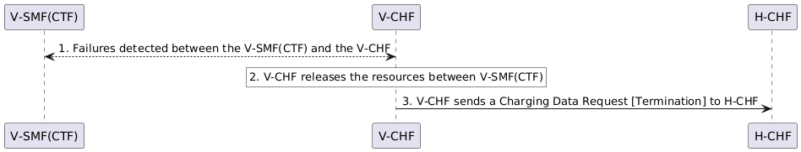
Figure 5.1.4.1-1: V-CHF terminates the charging session with H-CHF
- In the case of the charging session between the V-CHF and CTF is maintained, the V-CHF maintains the charging session between the V-CHF and H-CHF.

5.1.4.2 Solution #1.z: Handling of abnormal messages received by V-CHF
A possible solution for key issue #1 covering requirements REQ-3GPPCH-LBIC-1, enhanced failure handling for scenarios where a failure is detected between the CTF and the V-CHF.
When a Charging Data Request [Update, or Termination] received by the V-CHF, which cannot be associated to any existing charging session (i.e., resource in V-CHF), should be handled as specified in clause 5.5.1.2 of 3GPP TS 32.290[3]. Correspondingly, if the associated charging session between the V-CHF and H-CHF is not existed, the V-CHF sends a Charging Data Request [Initial] to the H-CHF to create resource.

Annex A (informative):
PlantUML

A.1 Figures

A.1.1 Figure 5.1.4.1-1
@startuml
participant "V-SMF(CTF)" as CTF
participant "V-CHF" as VCHF
participant "H-CHF" as HCHF

CTF <--> VCHF : 1. Failures detected between the V-SMF(CTF) and the V-CHF

rnote over VCHF #white
2. V-CHF releases the resources between V-SMF(CTF)
endrnote

VCHF -> HCHF : 3. V-CHF sends a Charging Data Request [Termination] to H-CHF

@enduml

End of change

