3GPP TSG SA5 Meeting #165 S5-260534
Goa, India, 9-13 February 2026

Source: Nokia
Title: Pseudo-CR on Use Case for Converged Charging for API Updates and Management Across Interconnected CAPIF Provider Domains
Document for: Approval
Agenda item: 7.5.1
Spec: 3GPP TR 28.891
Version: 0.2.0
Work Item: FS_CAPIF_Ph3_CH

Comments
New Use Case for Topic #2

Proposed Changes

* * * First Change * * * *

5.2.2.x Use Case #2.x: Converged Charging for API Updates and Management Across Interconnected CAPIF Provider Domains
An API Provider B publishes service APIs via CAPIF-4e to CAPIF Provider A's core function for discovery. Subsequently, the API Provider performs updates, unpublishes, or retrieves API information across domains. Charging is triggered for these management operations, with potential fees for cross-domain synchronization and storage usage in Provider A's domain.
Figure 5.2.2.x-1 illustrates the message flow for converged charging during API updates and management across interconnected CAPIF provider domains use case
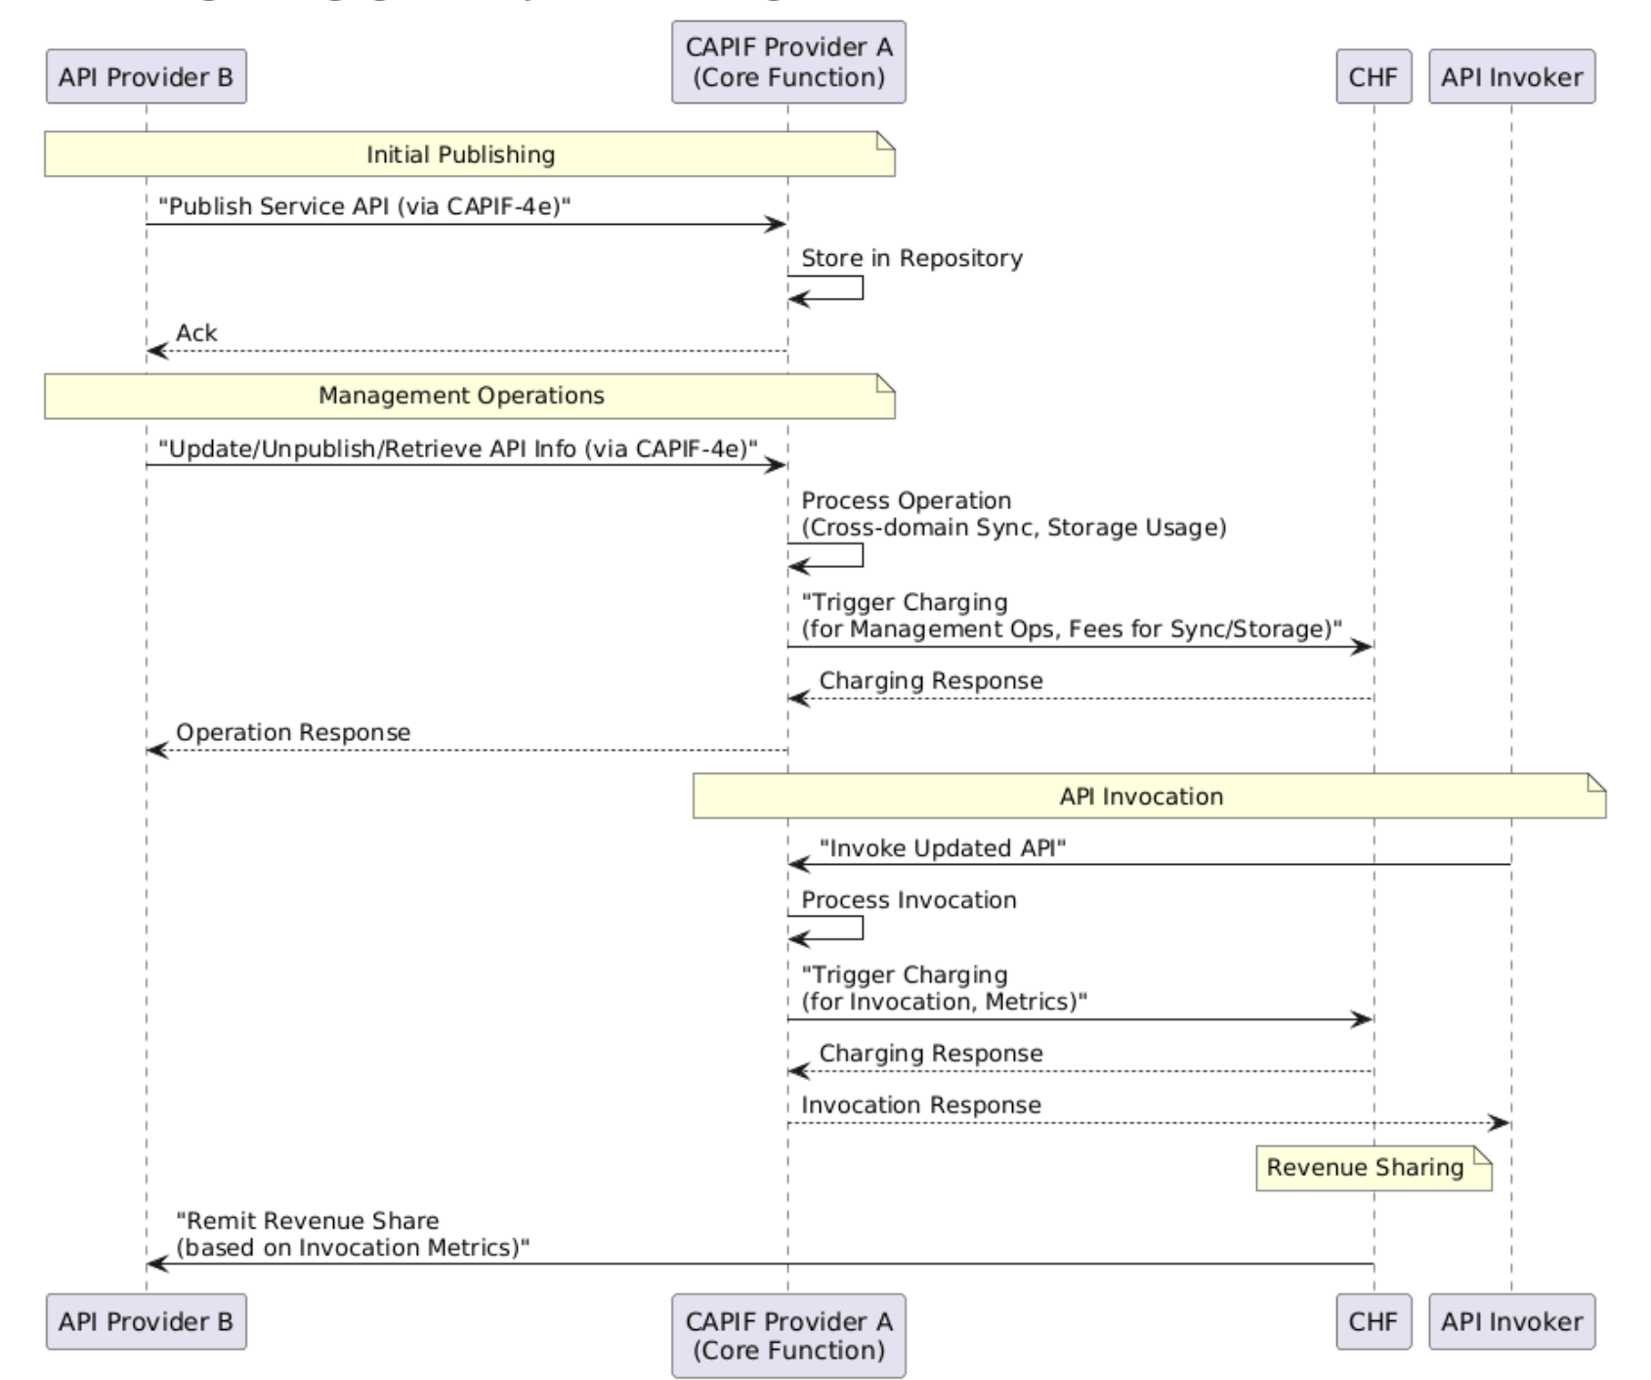
Figure 5.2.2.x-1: API Updates and Management Across Interconnected CAPIF Provider Domains
Converged Charging Message Flow
Revenue sharing may apply, where Provider A charges for hosting/management, and remits portions based on invocation metrics from updated APIs.
Charging Party: API Provider B (which may share the revenue with CAPIF Provider A)
Charged Party: API Invoker
* * * End of Changes * * * *

