3GPP TSG SA5 Meeting #165 S5-260533
Goa, India, 9-13 February 2026

Source: Ericsson
Title: Pseudo-CR on Solution topic 2 CTF placement
Document for: Approval
Agenda item: 7.5.1
Spec: 3GPP TR 28.891
Version: 0.2.0
Work Item: FS_CAPIF_Ph3_CH

Comments
Addition of charging trigger point in CCF for CAPIF-4 and CAPIF-4e solution.

Proposed Changes
* * * First Change * * * *

2 References
The following documents contain provisions which, through reference in this text, constitute provisions of the present document.
- References are either specific (identified by date of publication, edition number, version number, etc.) or non-specific.
- For a specific reference, subsequent revisions do not apply.
- For a non-specific reference, the latest version applies. In the case of a reference to a 3GPP document (including a GSM document), a non-specific reference implicitly refers to the latest version of that document in the same Release as the present document.
[1] 3GPP TR 21.905: "Vocabulary for 3GPP Specifications".
[2] 3GPP TS 23.222: "Common API Framework for 3GPP Northbound APIs".
[a] 3GPP TS 29.222: "Common API Framework for 3GPP Northbound APIs "
[b] 3GPP TS 32.290: " 5G system; Services, operations and procedures of charging using Service Based Interface (SBI)"

* * * Next Change * * * *

3.3 Abbreviations
For the purposes of the present document, the abbreviations given in TR 21.905 [1] and the following apply. An abbreviation defined in the present document takes precedence over the definition of the same abbreviation, if any, in TR 21.905 [1].
3GPP 3rd Generation Partnership Project
5GS 5g System
AEF API Exposing Function
API Application Programming Interface
CAPIF Common API Framework
CCF CAPIF Core Function
CDR Charging Data Record
CTF Charging Trigger Function

* * * Next Change * * * *

5.1.5.x Solution #1.x: CTF in CCF for CAPIF-4 and CAPIF-4e
A possible solution for key issue #1.2 covering requirement REQ-CH_CAPIF_RP-01.
The CAPIF-4 and CAPIF-4e reference points (TS 23.222 [2] clauses 6.4.7 and 6.4.10), which exists between the API publishing function within the PLMN trust domain or 3rd party trust domain and the CAPIF core function within the PLMN trust domain, is used for publishing the service API information.
For CAPIF-4and CAPIF-4e there are only two entities involved and that is the API Provider and the CCF, and since the API Provider may be outside the operator’s trusted domain the only place to trigger charging is the CCF.
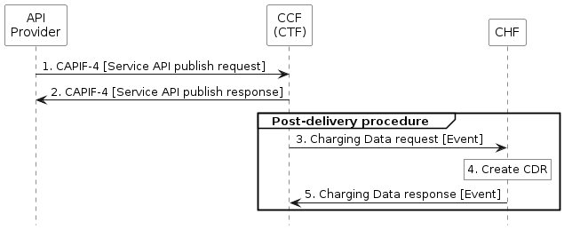
Figure 5.1.5.x-1: Publishing the service API PEC with CCF acting as CTF
Based on the flow in TS 23.222 [2] clause 8.3.
1. CAPIF-4: The API Publishing Function in the API provider domain sends a service API publish request to the CAPIF Core Function, for more details see TS 29.222 [a].
2. CAPIF-4: After the CAPIF core function have performed the publishing process the CAPIF Core Function provides a service API publish response to the API Publishing Function in the API provider domain, for more details see TS 29.222 [a].
3. Charging Data Request [Event]: The CAPIF Core Function sends Charging Data Request [Event] to the CHF for reporting the charging information including API provider id and outcome of the publishing, for more details see TS 32.290 [b].
4. Create CDR: the CHF stores received information and creates a CDR related to the service, for more details see TS 32.290 [b].
5. Charging Data Request [Event]: The CHF acknowledges by sending Charging Data Response [Event] to the CAPIF Core Function, for more details see TS 32.290 [b].

* * * Next Change * * * *

Annex x (informative):
PlantUML

x.1 Flows

x.1.1 Figure 5.1.5.x-1

@startuml
<style>
element {
BackGroundColor: white;
}
</style>
hide footbox

participant NEF as "API\nProvider"
participant CCF as "CCF\n(CTF)"
participant CHF as "CHF"

NEF -> CCF : 1. CAPIF-4 [Service API publish request]
NEF <- CCF : 2. CAPIF-4 [Service API publish response]

group Post-delivery procedure
CCF -> CHF : 3. Charging Data request [Event]
rnote over CHF: 4. Create CDR
CCF <- CHF : 5. Charging Data response [Event]
end

@enduml

* * * End of Changes * * * *

