3GPP TSG SA5 Meeting #165 S5-260530
Goa, India, 9-13 February 2026

Source: Ericsson
Title: Pseudo-CR on Solution topic 1 CTF placement
Document for: Approval
Agenda item: 7.5.1
Spec: 3GPP TR 28.891
Version: 0.2.0
Work Item: FS_CAPIF_Ph3_CH

Comments
Addition of charging trigger point in CCF for CAPIF-1 and CAPIF-1e solution.

Proposed Changes
* * * First Change * * * *

2 References
The following documents contain provisions which, through reference in this text, constitute provisions of the present document.
- References are either specific (identified by date of publication, edition number, version number, etc.) or non-specific.
- For a specific reference, subsequent revisions do not apply.
- For a non-specific reference, the latest version applies. In the case of a reference to a 3GPP document (including a GSM document), a non-specific reference implicitly refers to the latest version of that document in the same Release as the present document.
[1] 3GPP TR 21.905: "Vocabulary for 3GPP Specifications".
[2] 3GPP TS 23.222: "Common API Framework for 3GPP Northbound APIs".
[a] 3GPP TS 29.222: "Common API Framework for 3GPP Northbound APIs "
[b] 3GPP TS 32.290: " 5G system; Services, operations and procedures of charging using Service Based Interface (SBI)"

* * * Next Change * * * *

5.1.5.x Solution #1.x: CTF in CCF for CAPIF-1 and CAPIF-1e
A possible solution for ey issue #1.2 covering requirement REQ-CH_CAPIF_RP-01.
The CAPIF-1 and CAPIF-1e reference points (TS 23.222 [2] clauses 6.4.2 and 6.4.3), which exists between the API invoker and the CAPIF core function, is used for the API invoker within and outside the PLMN trust domain and to discover service APIs, to authenticate and to get authorization.
For CAPIF-1and CAPIF-1e there are only two entities involved and that is the API Invoker and the CCF, and since the API Invoker may be outside the operator’s trusted domain the place to trigger charging is the CCF.
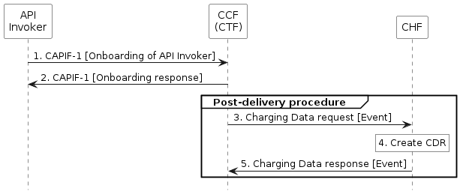
Figure 5.1.x-1: Invocation of service APIs PEC with CCF acting as CTF
Based on the flow in TS 23.222 [2] clause 8.20.
1. CAPIF-2: The API Invoker invokes an API towards the API Exposing Function in the API provider domain, for more details see TS 29.222 [a].
2. CAPIF-2: After the execution of the service provided by the API invoked the API Exposing Function in the API provider domain responds with the result, for more details see TS 29.222 [a].
3. Charging Data Request [Event]: The API Exposing Function in the API provider domain sends Charging Data Request [Event] to the CHF for reporting the charging information including API invoker id and result (e.g. failure or success) of the API invocation, for more details see TS 32.290 [b].
4. Create CDR: the CHF stores received information and creates a CDR related to the service, for more details see TS 32.290 [b].
5. Charging Data Request [Event]: The CHF acknowledges by sending Charging Data Response [Event] to the API Exposing Function in the API provider domain, for more details see TS 32.290 [b].

* * * Next Change * * * *

Annex x (informative):
PlantUML

x.1 Flows

x.1.1 Figure 5.1.x-1

@startuml
<style>
element {
BackGroundColor: white;
}
</style>
hide footbox

participant APP as "API\nInvoker"
participant CCF as "CCF\n(CTF)"
participant CHF as "CHF"

APP -> CCF : 1. CAPIF-1 [Onboarding of API Invoker]
APP <- CCF : 2. CAPIF-1 [Onboarding response]

group Post-delivery procedure
CCF -> CHF : 3. Charging Data request [Event]
rnote over CHF: 4. Create CDR
CCF <- CHF : 5. Charging Data response [Event]
end

@enduml

* * * End of Changes * * * *

