3GPP TSG SA5 Meeting #165 S5-260235rev1
Goa, India, 9-13 February 2026

Source: Huawei
Title: Rel-20 pCR 32.872 Handling of charging information stored in V-CHF
Document for: Approval
Agenda item: 7.5.2
Spec: 3GPP TR 32.872
Version: TR V0.2.0
Work Item: FS_RoamRE_CH

Comments
This pCR proposes to introduce a new solution on Local Breakout Inter CHFs scenario key issue2.

Proposed Changes
* * * First Change * * * *

5.1.4.b Solution #1.b: Handling of charging data requests stored in V-CHF
The solution for key issue #2 covering requirements REQ-3GPPCH-LBIC-2, enhanced failure handling for scenarios where a failure is detected between the V-CHF and the H-CHF.
A pre-set conditions (e.g., stored data size threshold or stored duration threshold) may be pre-configured in the V-CHF according to operator's policy. When failure is detected, the V-CHF stores the charging data requests received from V-SMF(CTF) if failure handling is set to 'Continue'.
- When the charging session remains active and the pre-set conditions in the V-CHF have not been reached, once the connection with H-CHF is restored, V-CHF sequentially forwards the stored Charging Data Requests to H-CHF.
- When the charging session remains active but the pre-set conditions in the V-CHF are reached or the charging session is terminated, the V-CHF forwards the stored Charging Data Requests and subsequence requests to local storage.

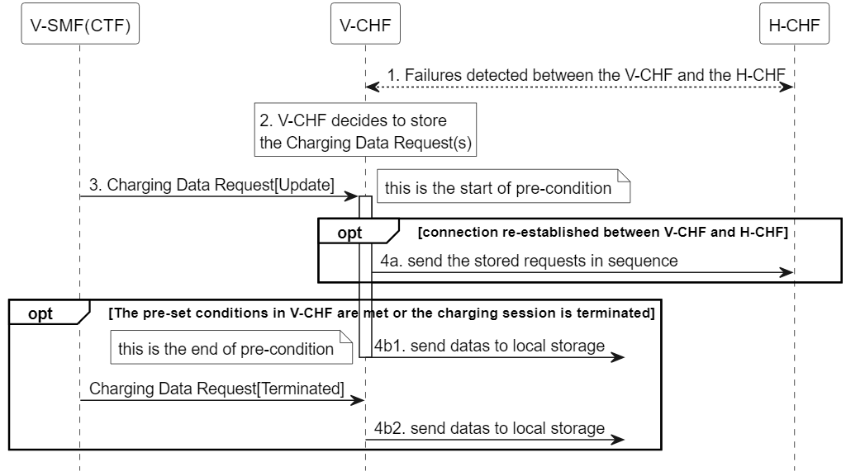
Figure 5.1.4.b-1: Handling flow of charging data requests stored in V-CHF
* * * Next Change * * * *

A.1.x Figure 5.1.4.b-1
@startuml
<style>
element {
BackGroundColor: white;
}
</style>
hide footbox

participant "V-SMF(CTF)" as CTF
participant "V-CHF" as VCHF
participant "H-CHF" as HCHF

VCHF <--> HCHF : 1. Failures detected between the V-CHF and the H-CHF
rnote over VCHF: 2. V-CHF decides to store\nthe Charging Data Request(s)
CTF -> VCHF : 3. Charging Data Request[Update]
note right : this is the start of pre-condition
activate VCHF

opt connection re-established between V-CHF and H-CHF
VCHF -> HCHF: 4a. send the stored requests in sequence
end

opt The pre-set conditions in V-CHF are met or the charging session is terminated
VCHF ->? : 4b1. send datas to local storage
deactivate VCHF
note left : this is the end of pre-condition
CTF -> VCHF : Charging Data Request[Terminated]
VCHF ->? : 4b2. send datas to local storage
end

@enduml
* * * End of Changes * * * *

