3GPP TSG SA5 Meeting #165 S5-260233rev1
Goa, India, 9-13 February 2026

Source: Huawei
Title: Rel-20 pCR 32.872 update solution #1.2
Document for: Approval
Agenda item: 7.5.2
Spec: 3GPP TR 32.872
Version: TR V0.2.0
Work Item: FS_RoamRE_CH

Comments
This pCR proposes to update handling method of abnormal messages received by V-CHF for the solution#1.2 in Topic#1.

Proposed Changes
* * * First Change * * * *

5.1.4.2 Solution #1.2: Handling of abnormal messages received by V-CHF
A possible solution for key issue #1 covering requirements REQ-3GPPCH-LBIC-1, enhanced failure handling for scenarios where a failure is detected between the CTF and the V-CHF.
When a Charging Data Request [Update, or Termination] received by the V-CHF, which cannot be associated to any existing charging session (i.e., resource in V-CHF), should be handled as specified in clause 5.5.1.2 of 3GPP TS 32.290[3], and the V-CHF needs to send the Charging Data Request [Update, or Termination] to the H-CHF.
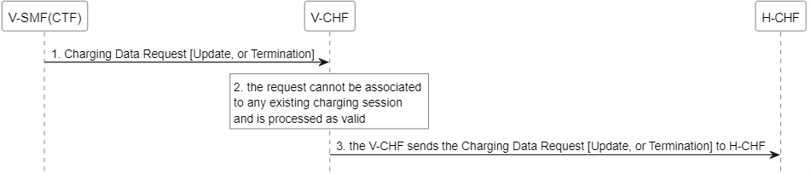
Figure 5.1.4.2-1: Message flow of abnormal messages received by V-CHF
* * * Next Change * * * *

A.1.x Figure 5.1.4.2-1
@startuml
<style>
element {
BackGroundColor: white;
}
</style>
hide footbox

participant "V-SMF(CTF)" as CTF
participant "V-CHF" as VCHF
participant "H-CHF" as HCHF

CTF -> VCHF : 1. Charging Data Request [Update, or Termination]
rnote over VCHF: 2. the request cannot be associated \nto any existing charging session \nand is processed as valid
VCHF -> HCHF : 3. the V-CHF sends the Charging Data Request [Update, or Termination] to H-CHF

@enduml
* * * End of Changes * * * *

