3GPP TSG-S4 #135 Meeting S4-260353
Goa, India, 9 - 13 February 2026
CR-Form-v12.5
CHANGE REQUEST
 | 26.813 | CR |  | rev |  | Current version:
For HELP on using this form: comprehensive instructions can be found at
https://www.3gpp.org/Change-Requests.

Proposed change affects: | UICC apps |  | ME |  | Radio Access Network |  | Core Network

Title: | pCR on gaussian-splat Avatars
Source to WG: | S4
Source to TSG: | Qualcomm Inc., Pengcheng Laboratory, China Mobile Com. Corporation
Work item code: | <Related_WIs> |  |  |  |  |  | Date: |  |  | YYYY-MM-DD
Category: | <Cat> |  |  |  |  |  | Release: |  |  | <Release>
 | Use one of the following categories:  F (correction)  A (mirror corresponding to a change in an earlier release)  B (addition of feature),  C (functional modification of feature)  D (editorial modification)  Detailed explanations of the above categories can  be found in 3GPP TR 21.900. |  |  |  |  |  |  |  | Use one of the following releases:  Rel-8 (Release 8)  Rel-9 (Release 9)  Rel-10 (Release 10)  Rel-11 (Release 11)  …  Rel-18 (Release 18)  Rel-19 (Release 19)  Rel-20 (Release 20)  Rel-21 (Release 21)
Reason for change: |  | Adding gaussian splat avatars
Summary of change:
Consequences if not approved:
Clauses affected:
 |  | Y | N
Other specs |  |  |  | Other core specifications |  |  |  | TS/TR ... CR ...
affected: |  |  |  | Test specifications |  |  |  | TS/TR ... CR ...
(show related CRs) |  |  |  | O&M Specifications |  |  |  | TS/TR ... CR ...
Other comments:
This CR's revision history:

==============First change==============

10 Advanced Avatar Formats

10.1 Gaussian Splat-based Avatars

10.1.1 Use Case
In the 3D avatar communication use case, a user is represented by a controllable avatar generated and animated from captured video signals. The avatar representation combines a deformable human mesh driven by model parameters with an associated 3D Gaussian Splat representation used for appearance enhancement. Figure X illustrates the technical processing pipeline.
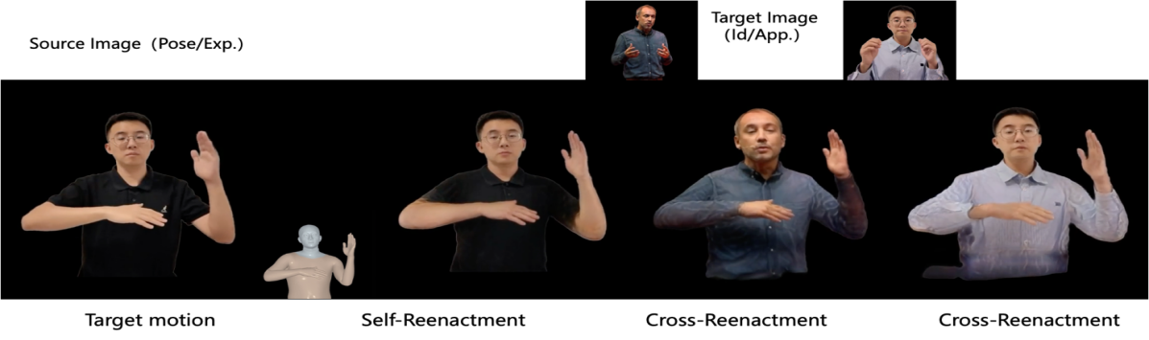
Figure X: Technical processing pipeline for 3D avatar communication using parametric human models and 3D Gaussian Splats. From left to right, captured video frames of a user are processed to extract geometric and animation parameters using parametric human representations, for example SMPL-X for body and hand motion and FLAME for facial geometry and expression. These parameters are used to reconstruct a deformable human mesh and to associate a 3D Gaussian Splat representation capturing appearance detail. During a communication session, time-varying model parameters are transmitted to the receiver and applied to drive avatar animation, while the associated 3D Gaussian Splat attributes contribute to appearance rendering.
At the sender side, the user is captured using one or more cameras. From the captured signals, geometric and animation-related parameters describing the human body, face, and hands are extracted. These parameters may be derived using parametric human body and face models, for example models such as SMPL-X for body and hand representation and FLAME for facial geometry and expression. Such models represent pose, shape, and expression in a compact parameter space.
Based on the extracted model parameters, a deformable human mesh representation of the user is reconstructed or instantiated. In addition, a 3D Gaussian Splat representation is generated to capture appearance details that are not efficiently represented by mesh geometry alone, such as fine surface detail, hair, or clothing appearance. The deformable mesh and the associated 3D Gaussian Splats together form the base avatar representation.
During a communication session, time-varying model parameters are transmitted from the sender to the receiver. These parameters are used to drive the animation of the avatar at the receiver side. The associated 3D Gaussian Splat representation is spatially aligned with the deformable mesh and follows the mesh deformation driven by the transmitted parameters.
At the receiver side, the avatar is animated using the received model parameters. Rendering combines mesh-based shading and 3D Gaussian Splat based appearance contributions to produce a visually realistic avatar representation suitable for interactive communication.
In this use case, avatar geometry is represented using a deformable mesh driven by parametric human model parameters, whereas appearance and fine detail are represented using an associated 3D Gaussian Splat representation attached to the mesh. Figure 5.5.2 illustrates the corresponding application-level use case of 3D Gaussian Splat based avatar communication
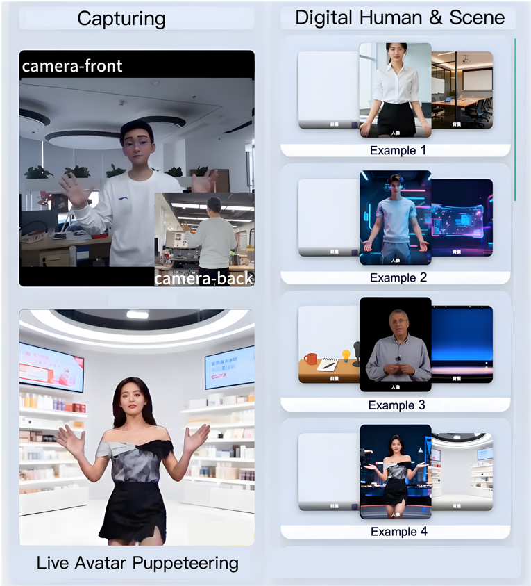
Figure Y: Use case of 3D Gaussian Splat based avatar communication. At the sender side, a real user is captured by one or more cameras. A deformable human mesh with skeletal rig and blendshapes is reconstructed from the video stream, while a 3D Gaussian Splat layer captures fine appearance details. The base avatar, consisting of the rigged mesh and static 3DGS representation, is transmitted together with a time-aligned animation stream. At the receiver side, the animation stream drives the avatar motion, and the renderer composites mesh shading with 3DGS contributions to achieve photorealistic real-time avatar communication.

10.1.2 Description and Literature Survey

10.1.2.1 Head and Face Avatar Methods

10.1.2.1.1 Background
Multiple 3DGS-based head avatar methods have been published at top conferences (CVPR 2024, SIGGRAPH 2024), covering a spectrum from purely explicit representations to hybrid approaches. The following table summarizes key methods documented in this contribution.
From an ARF and real time communication viewpoint, head and face methods differ along three practical axes:
- the binding domain used to couple Gaussians to animation, for example mesh surface anchors, UV space anchors, or volumetric anchors.
- whether any neural inference is required at runtime.
- how non FLAME components such as hair, teeth, tongue, and eye occlusion are handled.

Approaches that keep the runtime fully explicit and drive Gaussians from the same blendshape and skeletal parameters used for a mesh renderer are the most interoperable and the easiest to validate.
Table 1: Head/Face Avatar Methods
Method | FPS | Gaussians | Parametric Model | Runtime MLP | Key Feature
GaussianBlendshape (Ma et al., SIGGRAPH 2024) | 370 | 70K | Custom blendshapes | No | Linear blending identical to mesh blendshapes, 32-39 dB PSNR
SplattingAvatar (Shao et al., CVPR 2024) | 300+ | ~100K | FLAME mesh | No | Mesh-embedded via barycentric coords, 30 FPS on iPhone 13
FlashAvatar (Xiang et al., CVPR 2024) | 300 | 10-50K | FLAME | Small MLP | UV-based init on FLAME, small MLPs for expression offsets
GaussianAvatars (Qian et al., CVPR 2024) | 90-100 | ~100K | FLAME | No | FLAME-rigged, multi-view training, explicit binding
HHAvatar (Liao et al., CVPR 2024/TPAMI 2025) | ~100 | ~150K | FLAME | Temporal modules | First method for dynamic hair physics modeling
MeGA (Li et al., CVPR 2025) | ~90 | ~200K | FLAME (face) + 3DGS (hair) | No | Hybrid mesh+Gaussian, occlusion-aware blending, editable

10.1.2.1.2 Mesh embedded Gaussian Splatting
In mesh embedded approaches, each Gaussian is anchored to an animatable mesh that already supports standard blendshapes and skeletal skinning. A typical parameterization stores a triangle index plus barycentric coordinates on that triangle, and optionally a small offset vector in the local tangent normal frame. At runtime, the receiver first deforms the mesh using the incoming joint transforms and blendshape weights. The Gaussian center is then reconstructed from the animated triangle vertices using the stored barycentric weights, plus the transformed local offset. Because the reconstruction is purely algebraic, no per frame neural inference is required and the motion is deterministic.
Orientation and footprint are handled in the same spirit. A Gaussian can be stored in a local frame aligned to the triangle, for example with per axis scales and a local rotation. The local to world transform derived from the animated triangle frame transports the covariance, which keeps the projected splat stable under motion and avoids jitter. Appearance parameters such as opacity and color coefficients remain static in the base avatar unless the method explicitly models dynamic effects.
This binding strategy is attractive for standardization because it reuses the same animation signals as a mesh avatar, and because it enables graceful fallback. A mesh only renderer can ignore the Gaussian extension and still animate the avatar. A 3DGS capable renderer can render either the Gaussians alone or a hybrid mesh plus Gaussians composition, depending on device capability.
One practical limitation is that a coarse driving mesh can restrict fine scale effects such as lip roll, eyelid thickness, and hair motion. Most systems address this by using higher resolution parametric meshes, by storing local offsets that let Gaussians float above the surface, or by dedicating a subset of Gaussians to components that are not well represented by the parametric mesh.

10.1.2.1.3 Gaussian blendshapes
Gaussian blendshapes mirror classical mesh blendshape animation. Each Gaussian has a neutral set of parameters, plus a set of per expression deltas for attributes such as center position and sometimes scale and opacity. Given blendshape weights, the runtime computes a linear combination exactly like a mesh blendshape pipeline. The key advantage is again determinism and ARF friendly control, since the same blendshape weight stream can drive both mesh vertices and Gaussian deltas.

10.1.2.1.4 Hybrid methods with small MLPs
Hybrid approaches keep a parametric model for global control but add small neural modules that output residual offsets conditioned on expression, pose, or time. This can improve fine detail and handle effects that are hard to capture with purely linear blendshapes. The tradeoff is that runtime inference and model distribution become part of the interoperability story, including model versioning, determinism, and platform specific performance.
Among the head/face methods, GaussianBlendshape and SplattingAvatar stand out for real-time communication because they use purely explicit representations with no neural network at runtime, enabling deterministic rendering and direct compatibility with existing blendshape/skeletal animation pipelines as specified in the ARF Base Avatar Format.

10.1.2.2 Full-Body Avatar Methods
Full-body 3DGS avatar methods have converged on SMPL/SMPL-X parametric body models, enabling compatibility with standard skeletal animation systems.
Across the surveyed works, the body model provides a compact and standardized animation interface. The base avatar is represented by a static set of Gaussians plus binding metadata. At runtime, joint transforms derived from SMPL or SMPL-X pose parameters deform the body via skinning. Gaussians are then propagated either by surface anchoring, for example barycentric or UV coordinates on the body mesh, or by directly storing skinning weights per Gaussian. This design enables motion retargeting by sending only the pose stream, while keeping the high fidelity Gaussian appearance fixed in the base avatar.
Table 2: Full-Body Avatar Methods
Method | FPS | Gaussians | Body Model | Training | Key Feature
GauHuman (Hu & Liu, CVPR 2024) | 189 | ~13K | SMPL | 1-2 min | Fastest training, ~3.5 MB storage, KL divergence split/clone
HUGS (Kocabas et al., CVPR 2024) | 60 | ~200K | SMPL | 30 min | Disentangles human/scene
ASH (Pang et al., CVPR 2024) | ~60 | ~100K | SMPL | ~1 hour | 2D texture-space parameterization, Dual Quaternion skinning, motion retargeting
GART (Lei et al., CVPR 2024) | >150 | ~50K | SMPL | sec-min | Latent bones for non-rigid deformations (dresses, loose clothing)
ExAvatar (Moon et al., ECCV 2024) | ~60 | ~150K | SMPL-X | ~2 hours | Only SMPL-X method with unified body/face/hand animation

For full-body avatars, GauHuman achieves the best combination of minimal storage (~3.5 MB) and fast training (1-2 min), while ExAvatar is the only method providing unified body, face, and hand animation through SMPL-X, which is a critical requirement for immersive communication scenarios.
Non rigid effects are a central challenge for full body avatars. Clothing, long hair, and accessories do not follow the body surface with rigid skinning, and naive binding can lead to sliding artifacts. Methods such as latent bones or local deformation modules effectively introduce additional control points beyond the SMPL skeleton. For ARF integration it is useful to distinguish between body locked Gaussians that are fully driven by the standardized skeleton, and secondary Gaussians that may require optional control signals or local simulation.
In terms of distribution size, full body avatars can require tens to hundreds of thousands of Gaussians. Since each Gaussian includes geometry and appearance attributes, compression and level of detail become essential for real deployments. A practical ARF profile can therefore specify a default Gaussian count budget and allow progressive refinement layers for high end devices.

10.1.2.3 Animation Compatibility Classification
For the purposes of evaluating ARF compatibility, the surveyed methods can be classified into three categories based on their runtime architecture:
- Purely Explicit (no MLPs): SplattingAvatar, GaussianBlendshape, GaussianAvatars. These achieve 300-370 FPS with direct ARF mapping. Animation is driven entirely by standard skeletal joints and blendshape weights, making them fully compatible with the ARF Animation Stream Format.
- Hybrid (small MLPs): 3DGS-Avatar, FlashAvatar, HUGS. These achieve 50-100 FPS with near-real-time performance. The small MLPs add expression-dependent offsets but do not fundamentally change the animation interface. These methods can still be driven by blendshape parameters with the MLP weights distributed as part of the base avatar.
- Fully Neural: Gaussian Head Avatar, GaussianHead. These require 1-2 day training and have higher latency. They may be integrated into ARF containers as proprietary customized models.

For interoperability, the key question is not only whether an MLP exists, but whether the animation interface remains the same. If a method can be driven solely by joints and blendshape weights, then the ARF Animation Stream Format remains sufficient and the decoder only needs a renderer choice. If a method requires additional per frame latents, per frame feature maps, or learned temporal state, then the transport and synchronization requirements change and the method becomes harder to standardize.
Determinism also matters in communication. Explicit methods are naturally deterministic given fixed floating point rules and do not depend on platform specific neural inference. Hybrid methods can still be viable if the MLP is small and shipped as part of the base avatar, but conformance should define fixed operator sets and numerical tolerances. Fully neural pipelines are better treated as optional proprietary components inside an ARF container rather than a baseline interoperable tool.

==============End of change==============

