3GPP TSG-SA4 Meeting#135 S4-260239-rev1
9-13 February 2026, Goa, India

Source: Tencent
Title: Pseudo-CR on 3DGS delivery workflows for large 3DGS scenes
Spec: 3GPP TR 26.958 v0.1.1
Agenda item: 9.6
Document for: Agreement

1. Introduction
The study on 3D Gaussian Splats for mobile (FS_3DGS_MED) addresses the delivery of volumetric content across various scales. While object-centric scenes are generally bounded, the use case defined in clause 5.4 (Large 3DGS scenes), such as city-scale digital twins or extensive environments, presents unique challenges. These scenes cannot be fully loaded into the memory of a mobile device.
To support such massive environments on constrained UE, simple capability negotiation is insufficient. The delivery system must be dynamic and spatially aware, prioritizing data based on the user's instantaneous field of view.
2. Reason for Change
Transmitting a complete large-scale 3DGS scene to a mobile device may not be possible due to bandwidth, memory, and rendering limitations. A static delivery workflow would result in excessive latency and immediate resource saturation.
This contribution introduces a viewport-adaptive workflow in clause 9.2.3. It extends the capability negotiation mechanism by incorporating continuous feedback of the UE's spatial context (6DoF pose and Field of View). This allows the system to implement spatial filtering, frustum culling, and Level-of-Detail (LOD) prioritization (e.g., via tiling), ensuring that the "Rendering Budget" defined by the device's capabilities is spent efficiently on the visible regions.
The proposed workflow aligns with the viewport-dependent streaming principles established in TR 26.928 for XR services.
3. Conclusions
The proposed viewport-adaptive workflow enables the delivery of massive 3DGS experiences on mobile devices by dynamically filtering content. By combining hardware capability limits with spatial relevance, the system maximizes visual fidelity in the user's focus area while maintaining performance stability.
4. Proposal
It is proposed to agree the following changes to 3GPP TR 26.958.

* * * First Change * * * *

9 High level media data workflows
[Editor’s note: Placeholder for the description of the workflows]

9.1 All-in-client configuration

9.2 Client-server configuration

9.2.3 Viewport-adaptive workflow with capability negotiation for large scenes

9.2.3.1 Overview
For large-scale environments, such as city-scale digital twins (addressing the use case in clause 5.4), the entire scene typically exceeds the storage and rendering capacity of the UE. In this context, the delivery workflow must be extended to incorporate the user's spatial context dynamically.
In addition to the initial capability negotiation (as described in clause 9.2.2), the UE continuously transmits its 6DoF pose and Field of View (FoV) to the server, adhering to metadata formats defined in TR 26.928. The server uses this information to optimize the 3DGS stream relative to the user's perspective, ensuring the data throughput remains within the negotiated rendering budget.

9.2.3.2 Spatial optimization strategies
The environment may be partitioned into spatial tiles, with each tile available at multiple levels of detail (LOD). The server selects the appropriate LOD for each tile based on its proximity and visibility within the user's frustum. High-density tiles (e.g. LOD 4) are assigned to the center of the viewport for maximum fidelity, while lower-density tiles (e.g. LOD 1-3) are used for peripheral and distant areas. This mechanism concentrates the point budget where the user is looking, as illustrated in figure 4.
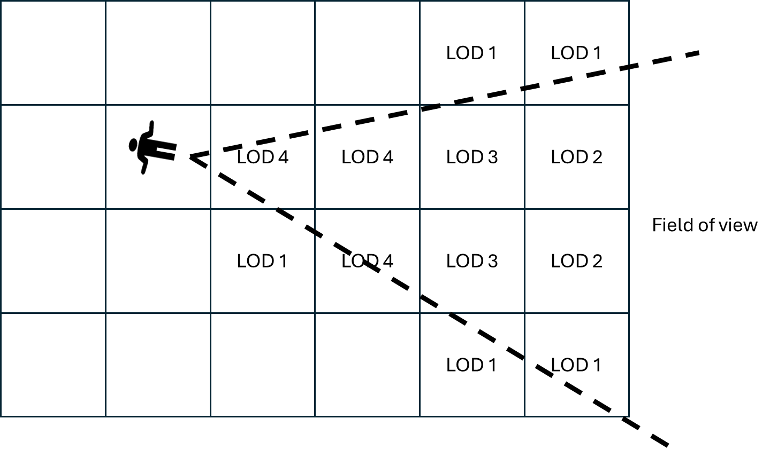
Figure 4: Example of tile and level of detail selection based on field of view.
For unstructured scenes without fixed tiles, the server performs real-time frustum culling, pruning and merging to prepare the 3DGS data to be sent to the UE. It concentrates high point density in the center of the FoV while aggressively merging or removing primitives in peripheral zones. This involves prioritizing high quality in the user's direct line of sight while aggressively simplifying peripheral areas. For instance, the server streams high-density splats for the immediate center of attention, while transmitting larger simplified splats for peripheral and distant regions.
This workflow addresses the use cases defined in clause 5.4 (Large 3DGS scene).
This workflow is agnostic to the transport protocol. It applies to both real-time streaming (e.g., DASH) and file-based content sharing (e.g., MMS, Messaging), where the server or sender optimizes the asset before transmission.

9.2.3.3 Workflow
During initialization, the server determines a rendering budget based on the UE's hardware report. This budget remains valid for the session (unless capabilities change). Subsequently, during the delivery phase, the server uses this pre-determined budget to filter and adapt the large-scale scene based on the received spatial metadata.
To enable the delivery of large-scale environments (e.g., city-scale digital twins) on constrained mobile devices, the workflow combines static capability negotiation with dynamic spatial filtering.
The process begins with a Session Initialization phase where the UE receives Service Access Information (SAI) containing essential bootstrapping parameters (e.g., Provisioning Session ID), ensuring alignment with 5GMS procedures, defined in TS 26.512.
Following initialization, the system establishes a rendering budget via a negotiation phase. To accommodate different architectures, this negotiation supports two alternative modes:
- Mode A (server decision): The UE reports a standardized Profile and Tier/Level, and the server defines the budget based on these limits.
- Mode B (Client decision): The UE explicitly requests format parameters (e.g., max point count, SH degrees, quantization), effectively setting the rendering budget based on its internal assessment.
Once the budget is established, the session enters a continuous viewport-adaptive loop. In this phase, the UE continuously transmits its spatial etadata (6DoF pose and Field of View) to the server. The server uses this metadata to perform real-time content adaptation. This ensures that the transmitted content focuses high-fidelity data strictly within the user's viewport while remaining within the pre-negotiated global budget.
Finally, the optimized 3DGS data is delivered to the UE via streaming or file download. Post-reception, the UE may also make certain local adjustments to the data received in order to reduce the complexity of the 3DGS data and adapt the rendering to its instantaneous resources. This negotiated workflow ensures that the received content complexity aligns with the hardware's processing limits, thereby preventing application crashes, frame drops, or excessive battery drain.
This unified process, covering initialization, negotiation, and the dynamic adaptation loop, is illustrated in Figure 5.
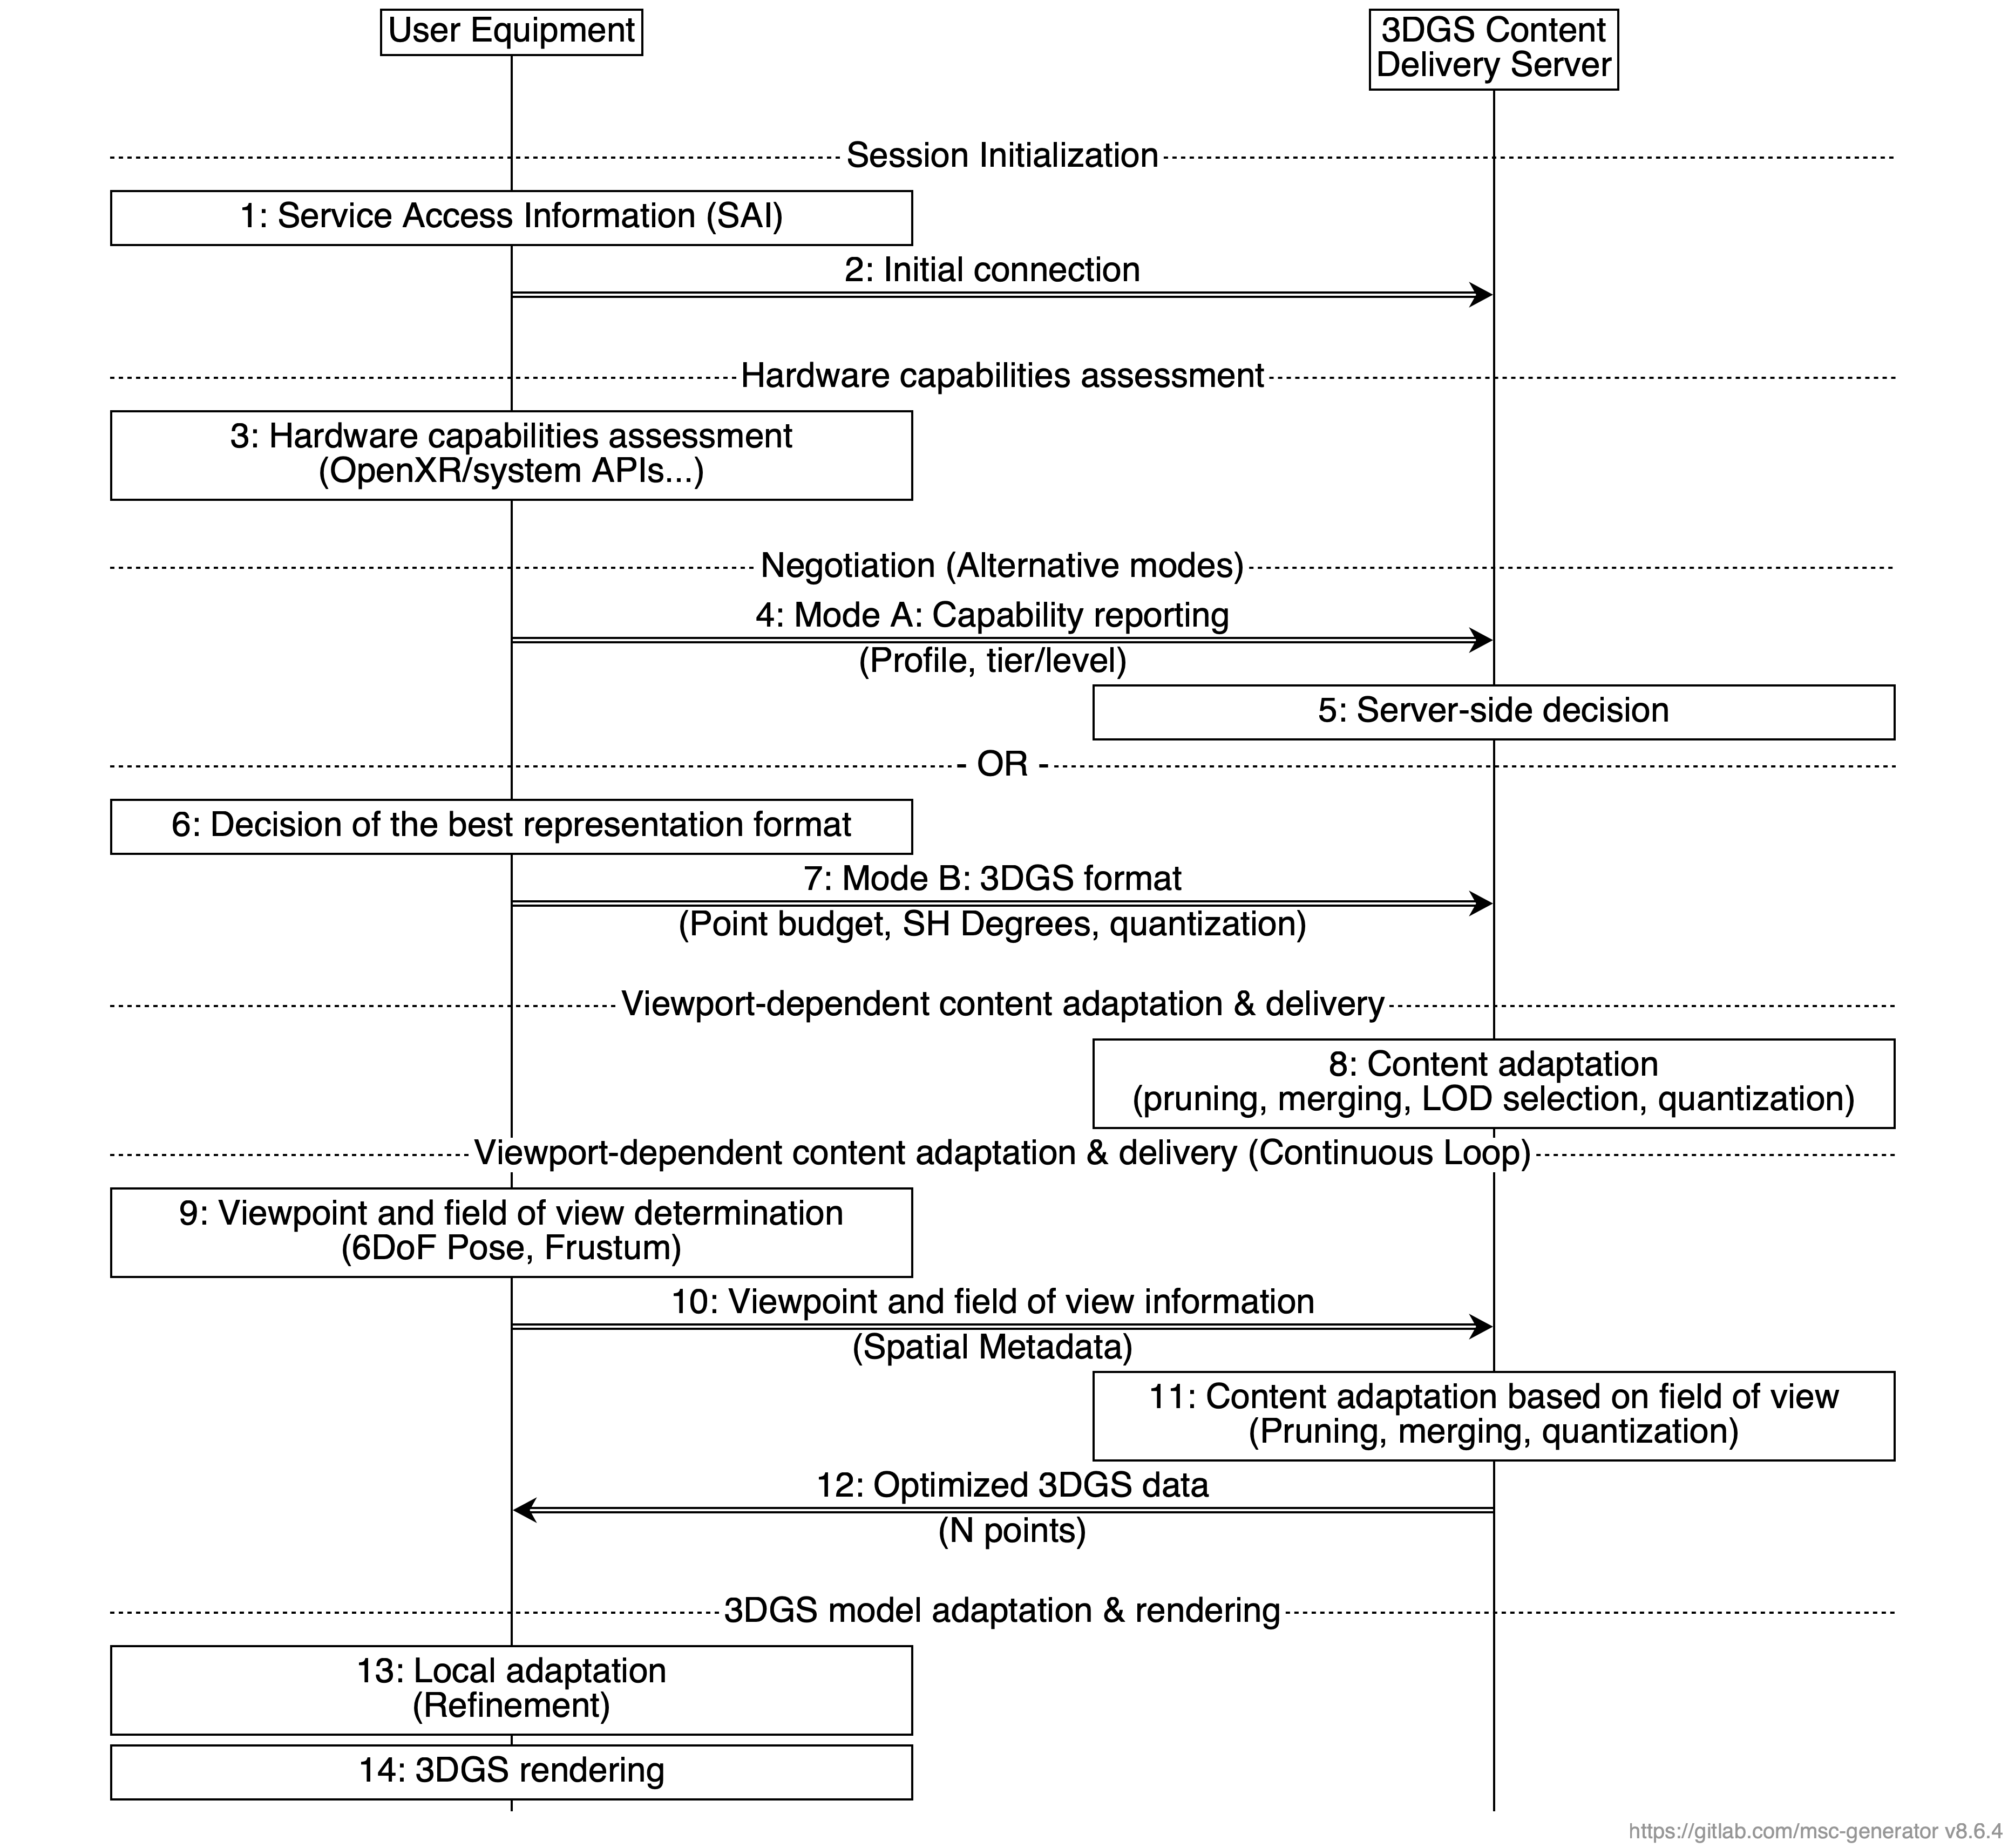
Figure 5: 3DGS delivery workflow with viewport-dependent optimization with capacity decision.
The following procedure describes the viewport-adaptive workflow where the content is dynamically filtered based on the user's spatial context. This workflow consists of the following steps:
- Session Initialization
1. Service Access Information (SAI): The 3DGS-aware application provides the Service Access Information to the media client. This bootstrapping data includes essential parameters such as the Provisioning Session ID and AF Address.
2. Initial connection: The UE establishes the initial connection with the 3DGS Content Delivery Server using the parameters derived from the SAI.
- Hardware capabilities assessment
3. Hardware capabilities assessment: The UE evaluates its internal hardware resources (e.g., GPU, memory) via system APIs or OpenXR.
- Negotiation (Alternative modes)
- Mode A (Server decision)
4. Mode A: Capability reporting: The UE reports its capabilities by mapping its hardware status to a standardized Profile and tier/level.
5. Server-side decision: The server uses the reported profile to define the global rendering budget for the session.
- Mode B (Client-centric)
6. Decision of the best representation format: The UE locally calculates the optimal configuration based on its internal assessment.
7. Mode B: 3DGS format: The UE explicitly requests content parameters, specifying the Point budget, SH Degrees, and quantization method.
- Viewport-dependent content adaptation & delivery
8. Content adaptation: Based on the negotiated budget (from Step 5 or 7), the server prepares the content strategy (e.g., LOD selection logic, tiling structure) ensuring the complexity baseline is set.
- Viewport-dependent content adaptation & delivery. The following steps are repeated continuously as the user navigates the scene:
9. Viewpoint and field of view determination: The UE calculates its current 6DoF pose and camera frustum.
10. Viewpoint and field of view information: The UE transmits this Spatial Metadata to the server.
11. Content adaptation based on field of view: The server selects the visible spatial tiles and adapts the content (pruning, merging, LOD selection, quantization) to fit the determined budget and the user's view.
12. Optimized 3DGS data: The server delivers the adapted content payload (N points) to the UE.
- 3DGS model adaptation & rendering
13. Local adaptation: The UE performs final on-device adjustments, such as discarding late packets or managing the tile buffer.
14. 3DGS rendering: The UE renders the scene.

* * * End of Changes * * * *

