3GPP TSG-SA4 Meeting#135 S4-260239
9-13 February 2026, Goa, India

Source: Tencent
Title: Pseudo-CR on 3DGS delivery workflows for large 3DGS scenes
Spec: 3GPP TR 26.958 v0.1.1
Agenda item: 9.6
Document for: Agreement

1. Introduction
The study on 3D Gaussian Splats for mobile (FS_3DGS_MED) addresses the delivery of volumetric content across various scales. While object-centric scenes are generally bounded, the use case defined in clause 5.4 (Large 3DGS scenes), such as city-scale digital twins or extensive environments, presents unique challenges. These scenes cannot be fully loaded into the memory of a mobile device.
To support such massive environments on constrained UE, simple capability negotiation is insufficient. The delivery system must be dynamic and spatially aware, prioritizing data based on the user's instantaneous field of view.
2. Reason for Change
Transmitting a complete large-scale 3DGS scene to a mobile device may not be possible due to bandwidth, memory, and rendering limitations. A static delivery workflow would result in excessive latency and immediate resource saturation.
This contribution introduces a viewport-adaptive workflow in clause 9.2.3. It extends the capability negotiation mechanism by incorporating continuous feedback of the UE's spatial context (6DoF pose and Field of View). This allows the system to implement spatial filtering, frustum culling, and Level-of-Detail (LOD) prioritization (e.g., via tiling), ensuring that the "Rendering Budget" defined by the device's capabilities is spent efficiently on the visible regions.
The proposed workflow aligns with the viewport-dependent streaming principles established in TR 26.928 for XR services.
3. Conclusions
The proposed viewport-adaptive workflow enables the delivery of massive 3DGS experiences on mobile devices by dynamically filtering content. By combining hardware capability limits with spatial relevance, the system maximizes visual fidelity in the user's focus area while maintaining performance stability.
4. Proposal
It is proposed to agree the following changes to 3GPP TR 26.958.

* * * First Change * * * *

9 High level media data workflows
[Editor’s note: Placeholder for the description of the workflows]

9.1 All-in-client configuration

9.2 Client-server configuration

9.2.3 Viewport-adaptive workflow with capability negotiation for large scenes

9.2.3.1 Overview
For large-scale environments, such as city-scale digital twins (addressing the use case in clause 5.4), the entire scene typically exceeds the storage and rendering capacity of the UE. In this context, the delivery workflow must be extended to incorporate the user's spatial context dynamically.
In addition to the initial capability negotiation (as described in clause 9.2.2), the UE continuously transmits its pose (position and orientation) and Field of View (FoV) to the server, adhering to metadata formats defined in TR 26.928. The server uses this information to optimize the 3DGS stream relative to the user's perspective, ensuring the data throughput remains within a given rendering or data rate budget.

9.2.3.2 Spatial optimization strategies
The environment may be partitioned into spatial 3DGS tiles, with each tile defined at different levels of detail (LOD). The server selects the appropriate tiles and their required LOD based on its proximity and visibility within the user's frustum. High-density tiles (e.g. LOD 4) are assigned to the center of the viewport for maximum fidelity, while lower-density tiles (e.g. LOD 1-3) are used for peripheral and distant areas. This mechanism concentrates the point budget where the user is looking, as illustrated in figure 4.
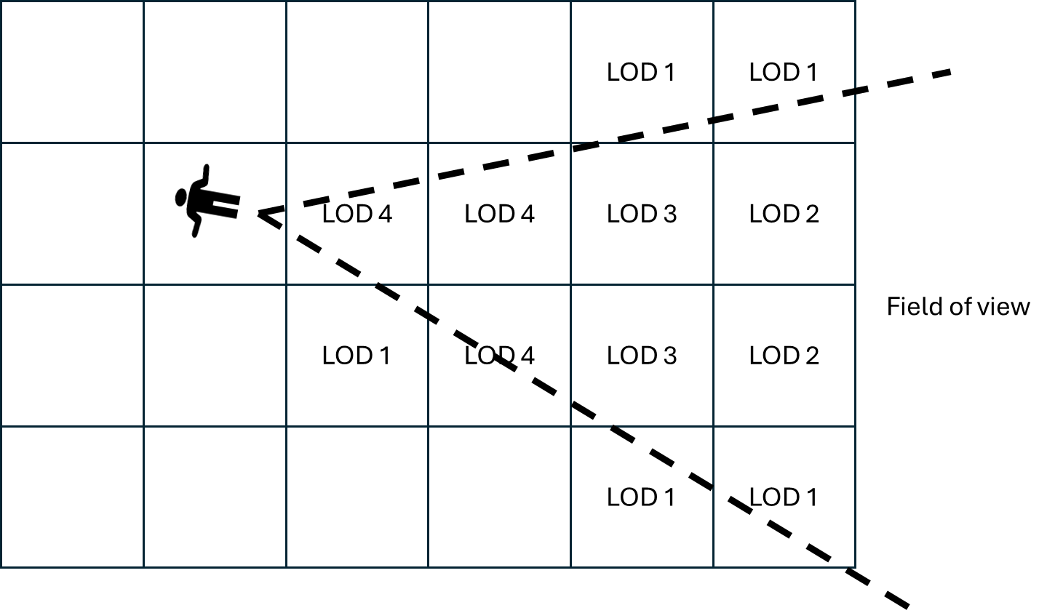
Figure 4: Example of tile and level of detail selection based on field of view.
For unstructured scenes without predefined 3DGS tiles, the server performs real-time frustum culling, pruning and merging to prepare the 3DGS data to be sent to the UE. It concentrates high point density in the center of the FoV while aggressively merging or removing primitives in peripheral zones. This involves prioritizing high quality in the user's direct line of sight while aggressively simplifying peripheral areas. For instance, the server streams high-density splats for the immediate center of attention, while transmitting larger simplified splats for peripheral and distant regions.

9.2.3.3 Server-centric decision workflow
In the server-centric decision workflow, the process is split into two distinct phases: a static initialization phase where the global rendering budget is established, and a dynamic delivery phase where the content is continuously adapted to the user's view.
During initialization, the server determines a "Rendering Budget" based on the UE's hardware report. This budget remains valid for the session (unless capabilities change). Subsequently, during the delivery phase, the server uses this pre-determined budget to filter and adapt the large-scale scene based on the received spatial metadata.
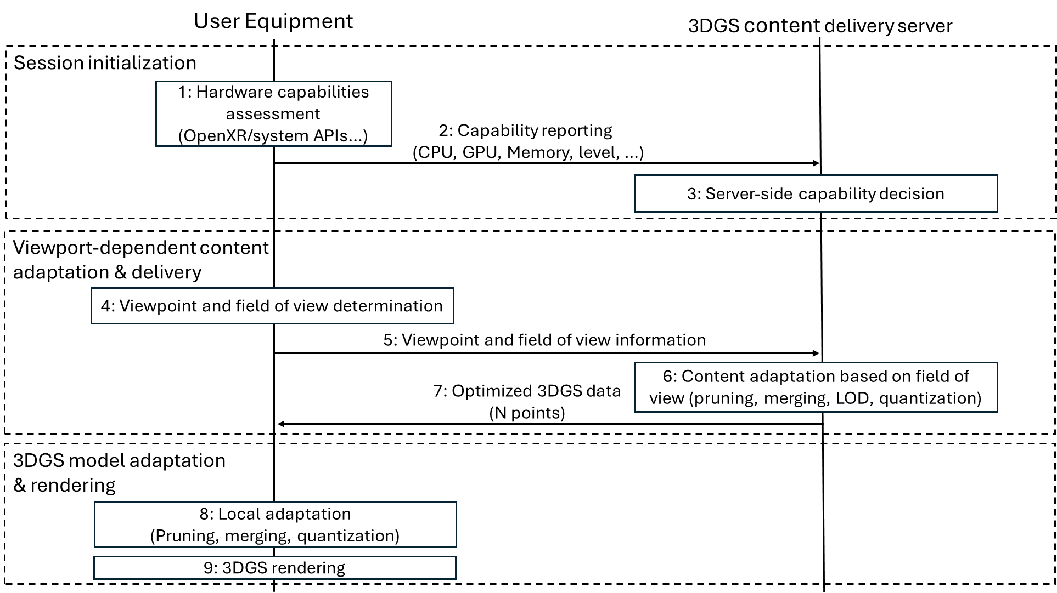
Figure 5: 3DGS delivery workflow with viewport-dependent optimization with server-centric decision.
The procedure for the server-centric viewport-adaptive workflow corresponds to:
1. Hardware capabilities assessment: The UE evaluates its internal hardware resources (e.g., GPU, memory) via system APIs or OpenXR.
2. Capability reporting: The UE transmits a comprehensive capability report to the server.
3. Server-side capability decision: Based on the report, the server defines the global rendering budget (e.g., max point count, SH degree) applicable for this session.
4. Viewpoint and field of view determination: The UE calculates its current 6DoF pose and camera frustum.
5. Viewpoint and field of view information: The UE sends this spatial metadata to the server.
6. Content adaptation based on field of view: The server selects the visible spatial tiles and adapts the content (pruning, merging, LOD selection, quantization) to fit the determined budget and the user's view.
7. Optimized 3DGS data: The server streams the adapted content payload (N points) to the UE.
8. Local adaptation: The UE performs final on-device adjustments if necessary (e.g., discarding late packets or minor pruning).
9. 3DGS rendering: The UE renders the scene.

9.2.3.4 Client-centric decision workflow
In the client-centric decision workflow, the UE explicitly requests a specific representation format during the initialization phase based on its own analysis. The server acknowledges this format.
During the delivery phase, the UE drives the spatial updates. It transmits its viewpoint, and the server's role is restricted to performing the necessary spatial operations (culling, tiling) to deliver the visible scene while strictly adhering to the format constraints (e.g. quantization, point limit) imposed by the UE during initialization.
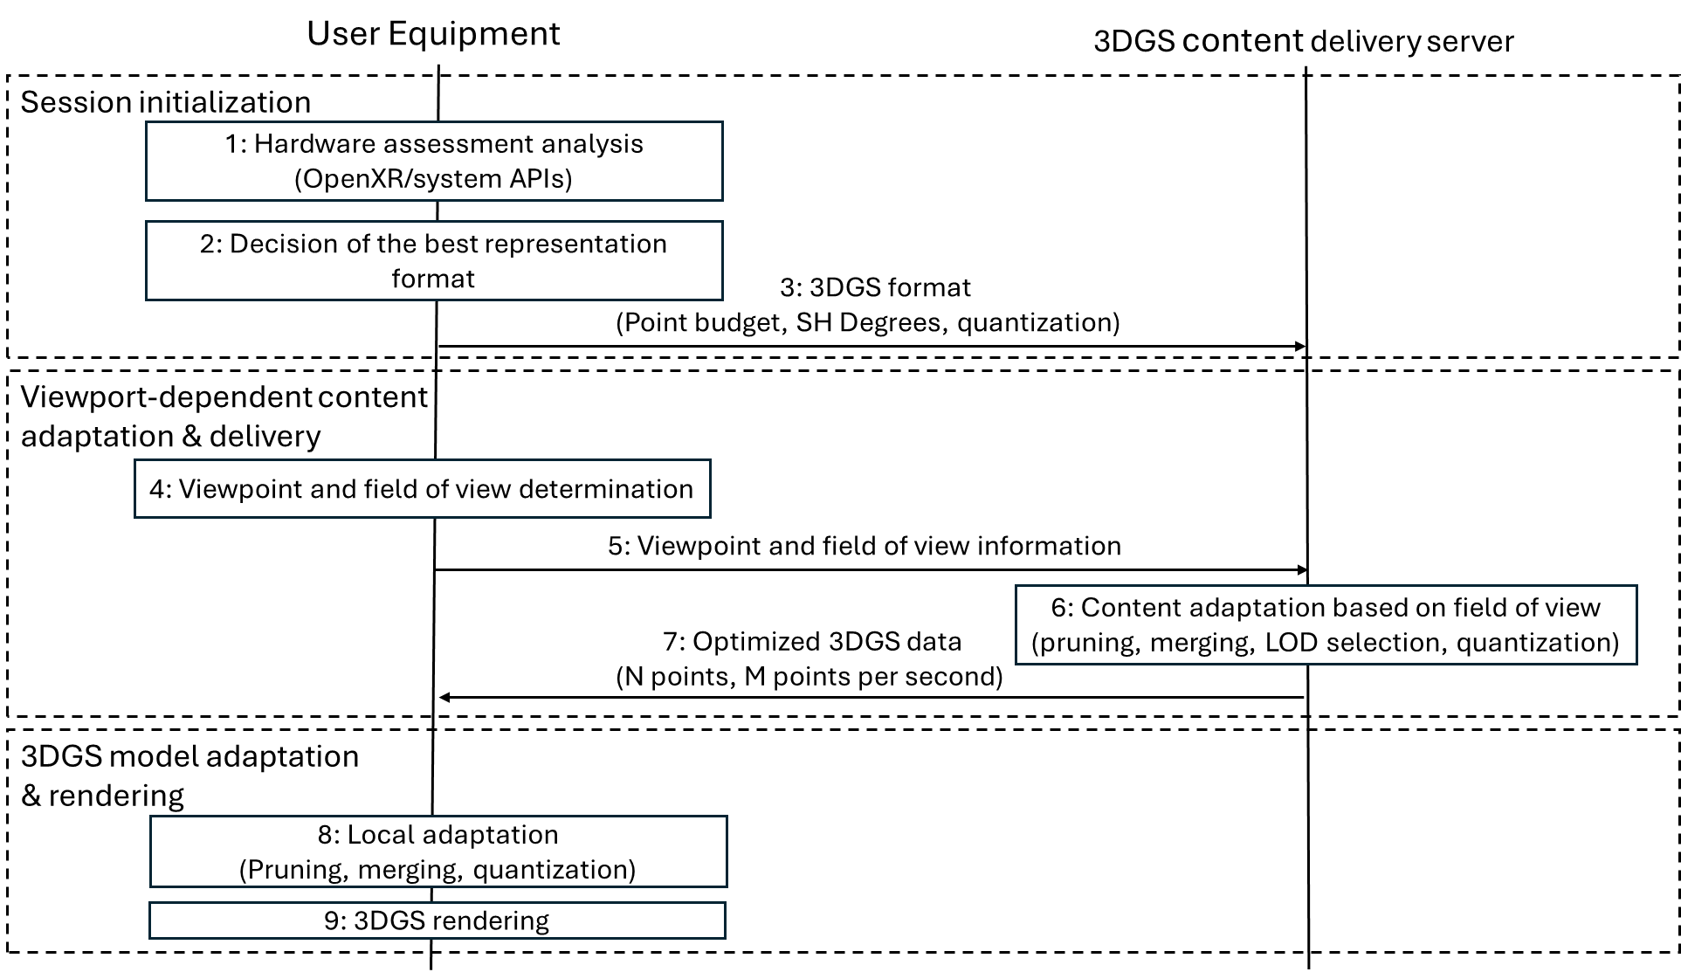
Figure 6: 3DGS delivery workflow with viewport-dependent optimization with client-centric decision.
The procedure for the client-centric viewport-adaptive workflow corresponds to:
1. Hardware assessment analysis: The UE performs an internal audit of its hardware capabilities.
2. Decision of the best representation format: Based on its analysis, the UE selects the optimal configuration (e.g., maximum point count, SH degree).
3. 3DGS format request: The UE requests the content from the server, specifying the desired format parameters (Point budget, SH Degrees, quantization).
4. Viewpoint and field of view determination: The UE calculates its current spatial position and FoV.
5. Viewpoint and field of view information: The UE sends this spatial metadata to the server.
6. Content adaptation based on field of view: The server filters the scene spatially (frustum culling/tile selection) and adapts the data (pruning/quantization) to match the format requested in step 3.
7. Optimized 3DGS data: The server delivers the visible content conforming to the requested parameters.
8. Local adaptation: The UE applies final local refinements to ensure runtime stability.
9. 3DGS rendering: The UE renders the received content.

* * * End of Changes * * * *

