3GPP TSG-SA4 Meeting#135 S4-260169-rev1
9-13 February 2026, Goa, India

Source: Tencent
Title: Pseudo-CR on 3DGS delivery workflows based on capability negotiation
Spec: 3GPP TR 26.958 v0.1.1
Agenda item: 9.6
Document for: Agreement

1. Introduction
The study on 3D Gaussian Splats (3DGS) for mobile (FS_3DGS_MED) aims to define efficient delivery and rendering mechanisms for volumetric content. 3DGS scenes are inherently heterogeneous, ranging from simple objects to massive scenes. Similarly, User Equipment (UE) capabilities vary significantly in terms of GPU power, thermal limits, and memory.
This contribution proposes a detailed client-server workflow to address these disparities through capability negotiation and adaptive streaming.
2. Reason for Change
A static delivery workflow for 3DGS carries a high risk of poor Quality of Experience (QoE) or device overheating if the content complexity exceeds the UE's rendering capabilities.
This contribution updates clause 9.2 with an adaptive workflow that introduces mechanisms for the UE to report its static and dynamic capabilities (e.g., thermal status, battery) to the server.
It also defines two negotiation modes (server-centric and client-centric) aligning with principles from TR 26.928. The proposed workflows address the content delivery requirements relative to the use cases defined in clause 5.2 (Static 3DGS scene) and clause 5.4 (Dynamic 3DGS content).
3. Conclusions
The proposed workflows ensure that 3DGS content delivery is optimized for the specific characteristics of the receiving mobile device and the user's viewing context. By formalizing the exchange of capability metrics and establishing a "Rendering Budget", the system can guarantee target frame rates and maximize session duration. It is proposed to agree on the following changes to TR 26.958.
4. Proposal
It is proposed to agree the following changes to 3GPP TR 26.958.

* * * First Change * * * *

9 High level media data workflows
[Editor’s note: Placeholder for the description of the workflows]

9.1 All-in-client configuration

9.2 Client-server configuration

9.2.1 Overview
In the client-server configuration, the heavy lifting of content preparation and storage is handled by the server, while the UE acts as the rendering endpoint. Given the significant variability in 3DGS scene complexity (ranging from thousands to millions of primitives) and the diverse performance profiles of mobile UEs, a static delivery model is often inefficient.
To guarantee efficient rendering on the UE, 3DGS models or scenes transmitted from the server must possess characteristics optimized for the device's capabilities. This ensures both efficiency and high-quality rendering.

9.2.2 Workflow with capability negotiation

9.2.2.1 Objectives
To ensure consistent Quality of Experience (QoE), specifically regarding frame rate stability and thermal management, the delivery session is initiated with a capability exchange phase. This clause describes a delivery workflow where the content is optimized based on a negotiation of device capabilities. To support different service architectures and privacy requirements, the workflow supports two negotiation modes:
- Mode A (server decision): The UE reports a generic capability Profile/Tier, and the server selects the appropriate content.
- Mode B (client decision): The UE explicitly requests specific content parameters (e.g., point count, quantization).
This workflow addresses the use cases defined in clause 5.2 (Static 3DGS scene) and clause 5.4 (Dynamic 3DGS content).
This workflow is agnostic to the transport protocol. It applies to both real-time streaming (e.g., DASH) and file-based content sharing (e.g., MMS, Messaging), where the server or sender optimizes the asset before transmission.

9.2.2.2 Workflow
To ensure consistent Quality of Experience (QoE) and prevent device overheating, the delivery session follows a negotiated workflow. This process begins with a session initialization phase where the UE receives Service Access Information (SAI), containing essential bootstrapping parameters (e.g., Provisioning Session ID, AF Address) as defined in TS 26.512, to establish the initial connection.
Following this, the UE performs an internal hardware assessment via system APIs (such as OpenXR). It evaluates static capabilities (e.g., GPU rendering capacity, memory bandwidth, max supported SH degree) and dynamic state (e.g., real-time thermal throttling status, battery level).
Based on this assessment, the negotiation proceeds via one of the following two modes:
- Mode A (server decision): In this mode, the UE acts primarily as a data provider but abstracts the hardware complexity to protect privacy and simplify signaling. Instead of transmitting raw hardware specifications, the UE reports a standardized "3DGS Capability Profile" and "Tier/Level".
- The Profile indicates supported features (e.g., supported quantization formats, compression, max SH degree).
- The Tier aggregates processing power and thermal constraints into a standardized performance level (e.g., defining a maximum sorting rate or primitive count). Upon receiving this profile, the server employs internal logic to map these tiers to a specific rendering budget and determines the appropriate Level of Detail (LOD).
- Mode B (client decision): the UE may perform the rendering budget calculation internally. The UE determines the exact representation format required. It then sends an explicit request to the server specifying the desired parameters, such as a point budget or the Spherical Harmonics degree and the quantization method.
Upon receiving this data, the server employs internal logic or lookup tables to map the profile/tier or the 3DGS representation format to a specific rendering budget. Based on the rendering budget, the server identifies or generates the most suitable version of the requested 3DGS asset.
If pre-generated Levels of Detail (LODs) are available, the server selects the specific LOD that fits strictly within the reported primitive count budget. Alternatively, the server may employ real-time optimization techniques on the source model. These may include pruning low-opacity or spatially insignificant splats, or reducing the SH degree (for example, by stripping high-order coefficients and transmitting only the Direct Color components) to reduce both network bandwidth and the client's rendering load.
Finally, the optimized 3DGS data is delivered to the UE via streaming or file download. Post-reception, the UE may also make certain local adjustments to the data received in order to reduce the complexity of the 3DGS data and adapt the rendering to its instantaneous resources. This negotiated workflow ensures that the received content complexity aligns with the hardware's processing limits, thereby preventing application crashes, frame drops, or excessive battery drain. This process is illustrated in figure 2.
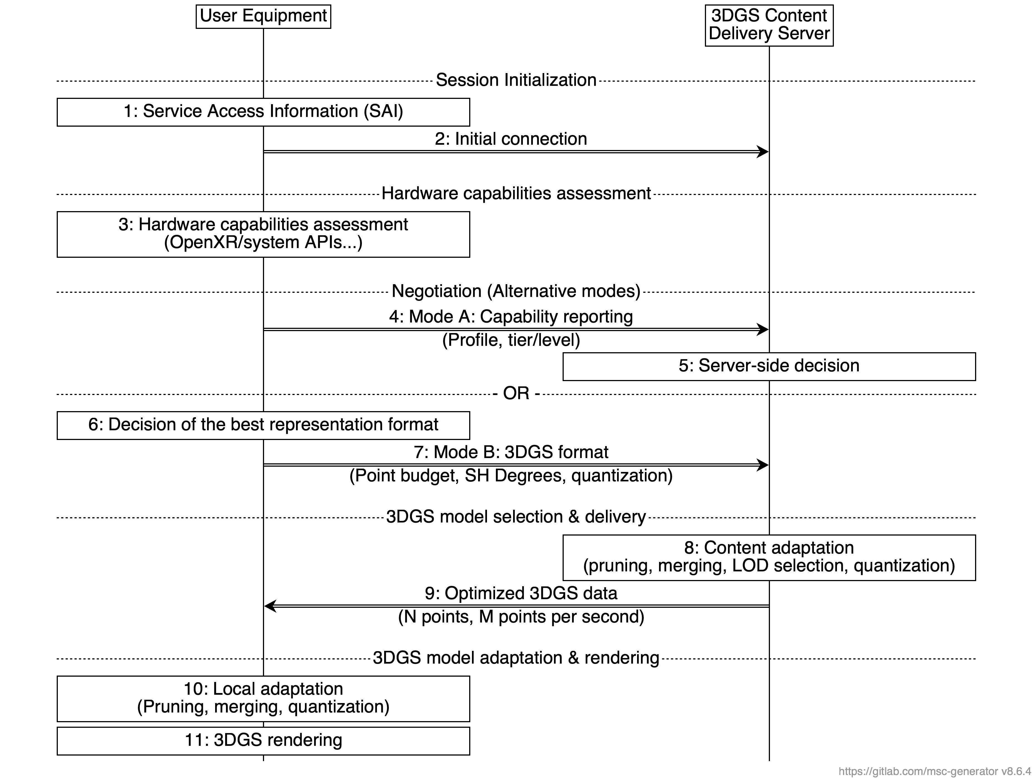
Figure 2: 3DGS delivery workflow with capability negotiation.
The following workflow procedure illustrates the negotiation and adaptation process between the UE and the content delivery server, ensuring the 3DGS stream is tailored to the device's specific hardware constraints:
- Session initialization
1. Service Access Information (SAI): The 3DGS-aware application provides the Service Access Information to the media client. This bootstrapping data includes essential parameters such as the Provisioning Session ID and the AF Address (as defined in TS 26.512).
2. Initial connection: The UE establishes the initial connection with the 3DGS Content Delivery Server using the entry point parameters derived from the SAI.
- Hardware capabilities assessment
3. Hardware assessment: The UE evaluates its hardware capabilities via internal system checks. It evaluates static hardware limits (GPU, Memory) and dynamic state (thermal status, battery level) to determine its rendering budget.
- Negociation: The negotiation proceeds via one of the following two modes:
- Mode A (server decision):
4. Capability reporting: The UE reports its capabilities by mapping its hardware status to a standardized 3DGS Profile and Tier/Level. This abstracts specific hardware details while indicating the supported complexity class.
5. Server decision: The server analyzes the received Profile/Tier to determine the appropriate LOD or adaptation settings.
- Mode B (client decision):
6. Decision of best format: The UE internally calculates the exact representation format required (e.g., calculating a specific splat count limit based on current thermal headroom).
7. 3DGS format request: The UE explicitly requests content matching specific parameters, such as the Point Budget, Spherical Harmonics degrees, and quantization method.
- 3DGS model selection & delivery
8. Content adaptation: Based on the decision, the server processes the 3DGS model through pruning, merging, LOD selection, and quantization to match the UE's capabilities.
9. Data delivery: The server delivers the optimized 3DGS data payload to the UE via streaming or file download.
- 3DGS model adaptation & rendering
10. Local adaptation: The UE may perform final on-device optimizations (such as further pruning or merging) to fit runtime memory limits and adapt the data to its hardware.
11. Rendering: The UE executes the rendering pipeline to display the adapted 3DGS content.

* * * End of Changes * * * *

