3GPP TSG-SA4 Meeting#135 S4-260168-rev1
9-13 February 2026, Goa, India

Source: Tencent
Title: [FS_3DGS_MED] Pseudo-CR on 3DGS renderer and performance benchmarking
Spec: Spec: 3GPP TR 26.958 v0.1.1
Agenda item: 9.6
Document for: Agreement

1. Introduction
The study on 3D Gaussian Splats (3DGS) for mobile (FS_3DGS_MED) aims to evaluate the feasibility of rendering high-quality volumetric content on user equipment (UE). To support this study, a reference implementation of a 3DGS player may be developed for mobile platforms. This document presents the mobile renderer features and provides preliminary experimental benchmark results obtained on a commercial mobile device.
2. Reason for Change
Current discussions in TR 26.958 regarding rendering and complexity require concrete data to validate the feasibility of real-time 3DGS on mobile hardware.
The proposed text adds a description of the features of a mobile rendering engine that could serve as a starting point for the reference implementation of the 3DGS player on UE and provides preliminary experimental results from running the 3DGS renderer on a mobile device.
The reported metrics (FPS, CPU/GPU utilization, power) help corroborate the viability of the technology and identify bottlenecks (e.g., CPU sorting, memory transfer, GPU rasterization, consumption, etc.).
This aligns with the study objectives to identify reference implementations and performance characteristics.
3. Conclusions
The experimental results demonstrate that real-time rendering of 3DGS scenes with up to 200,000 visible points is achievable on modern mid-range mobile devices (e.g., Pixel 9a) without any other improvements.
It is proposed to include these preliminary results in the Technical Report to guide future specification work.
4. Proposal
It is proposed to include the following text in Section 12 (Reference Implementation) of TR 26.958.

* * * First Change * * * *

12 Reference implementation
[Editor’s note: Placeholder for the description of the reference implementation]

12.1 Capture

12.2 Transmission

12.4 Rendering

12.4.1 Mobile renderer features
A 3DGS player on mobile platforms aims at validating the rendering pipeline on mobile devices. The application may be designed to be built using hybrid architecture:
- Native layer (e.g. C++): Handles the core rendering tasks using OpenGL ES 3.2. It implements a tile-based rasterizer inspired by the original 3DGS method, utilizing CPU sorting or Compute Shaders for efficient parallel sorting (e.g., Radix sort) of splats and Vertex and Fragment shaders for rendering.
- Application Layer (e.g. Java/Kotlin): Manages the UI, AR runtime lifecycle for camera tracking, and resource management.
The player supports loading standard .ply files and allows real-time interaction (rotation, translation, scaling). It is important to note that the current implementation and following benchmarks focus on the rendering of static 3DGS scenes. Dynamic 3DGS content would introduce additional complexity, particularly regarding decoding and data transfer rates. It includes a benchmarking mode that can vary rendering parameters dynamically.

12.4.2 Rendering process on mobile platforms
The rendering process for 3DGS relies on a hybrid CPU/GPU architecture optimized for the rasterization of semi-transparent volumes. Unlike classic mesh rendering which utilizes the Z-buffer for occlusion management, 3DGS requires strict alpha blending, necessitating that primitives be drawn from farthest to nearest (back-to-front).
On a mobile architecture, this critical depth sorting step is performed for each frame by the CPU. The processor calculates the distance of each Gaussian relative to the image plane, then orders the primitive indices using efficient parallel sorting algorithms (such as Radix Sort). Although GPU-based sorting approaches (Compute Shaders) exist, CPU sorting is often preferred on mobile devices to balance thermal load and circumvent limitations of certain graphics drivers. On this platform, the best performances are obtained using CPU sorting.
Regarding data management, the attributes of the Gaussians are loaded into video memory (VRAM) at startup. These data are stored as textures or 32-bit floating-point buffers (FP32) to ensure the precision required for covariance and color calculations. At each frame, the CPU transfers only the updated list of sorted indices to the GPU. The vertex shader then uses these indices to perform direct reads (texelFetch) from the persistent floating-point data buffers, thereby minimizing the bandwidth between the CPU and the GPU while ensuring high visual fidelity.

12.4.3 Benchmark methodology
The renderer includes a benchmarking mode that allows modifying rendering parameters dynamically. This mode may use the thermal management API to maintain consistent clock speeds during benchmarking. In this mode, the AR runtime processes and the AR environment are disabled to ensure a fair comparison and a frame per second (FPS) measurements independent of the AR API.
During benchmarking tests, two parameters are changed to evaluate their impact on the FPS and on the consumption:
- Number of Gaussians from 5000 to 485436 points.
- Spherical Harmonics degree from 0 (Diffuse color only) to 3 0 (Full view-dependence) on the full model.
The rendering pipeline used for these benchmarks reproduce the rasterization logic described in the original INRIA method [ab] to ensure visual fidelity and compatibility with standard 3DGS models. Consequently, the performance metrics presented here represent a baseline reference.

12.4.4 Preliminary experimental results

12.4.4.1 Test conditions
An evaluation of a mobile rendering capabilities was conducted with the following parameters
- Device: Google Pixel 9a (Tensor G4 chipset, middle-range device, march 2025).
- Application: Tencent 3DGS mobile player
- Build configuration: Release mode with optimizations enabled.
- Test duration: 30 seconds per configuration step to ensure thermal stability.
- 3DGS model: bicycle.ply (485,436 points).
During the evaluation, the first N points of the model are loaded. After a warmup, the performances of the system are logged. During the recording, the model is rotated at each frame to force the computation of the sorting order.

The power consumption measures are derived from the Android Battery Manager API, representing the instantaneous current draw of the entire device relative to a baseline. The captures of the tests are illustrated on figure 1.

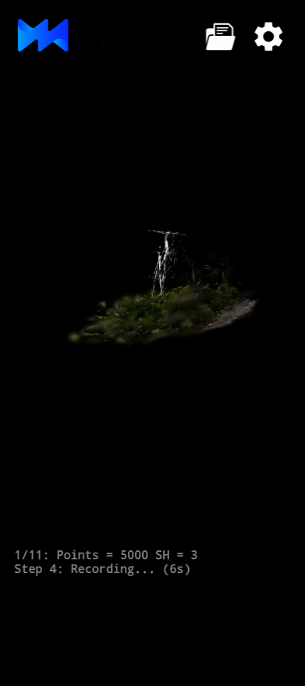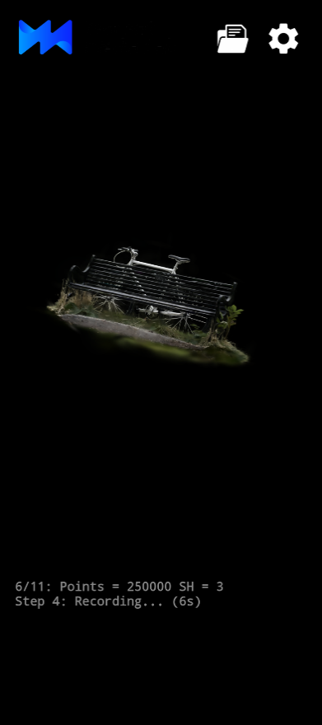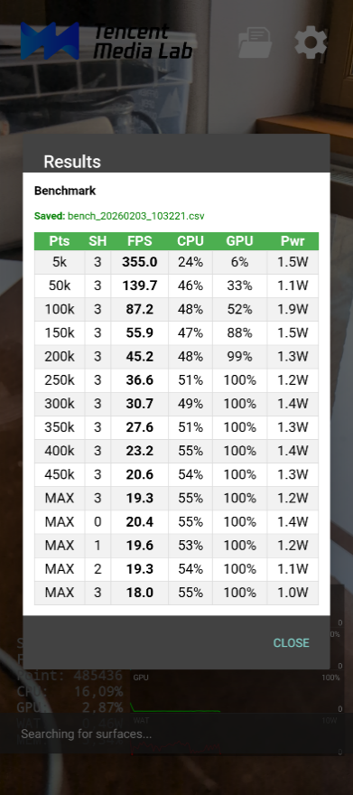
Figure 1: Screenshots of the Tencent renderer during the benchmark experience.

12.4.4.2 Impact of the number of points
The following table 1 and figure 2 illustrate the performance impact when rendering the same scene with an increasing number of Gaussian primitives (SH degree fixed at 3).
Table 1: Performance for various numbers of points (device=Pixel 9a, spherical harmonics degree=3)
Points | Frame per second | CPU load (%) | GPU load (%) | Est. Power (W)
5000 | 354.99 | 23.90 | 5.58 | 1.45
50000 | 139.67 | 46.34 | 32.88 | 1.07
100000 | 87.18 | 47.50 | 52.35 | 1.89
150000 | 55.88 | 46.74 | 87.87 | 1.47
200000 | 45.17 | 48.13 | 99.33 | 1.33
250000 | 36.59 | 50.67 | 100 | 1.20
300000 | 30.72 | 49.38 | 100 | 1.39
350000 | 27.57 | 51.02 | 100 | 1.28
400000 | 23.19 | 55.32 | 100 | 1.38
450000 | 20.65 | 54.32 | 100 | 1.28
485436 | 19.27 | 54.82 | 100 | 1.22

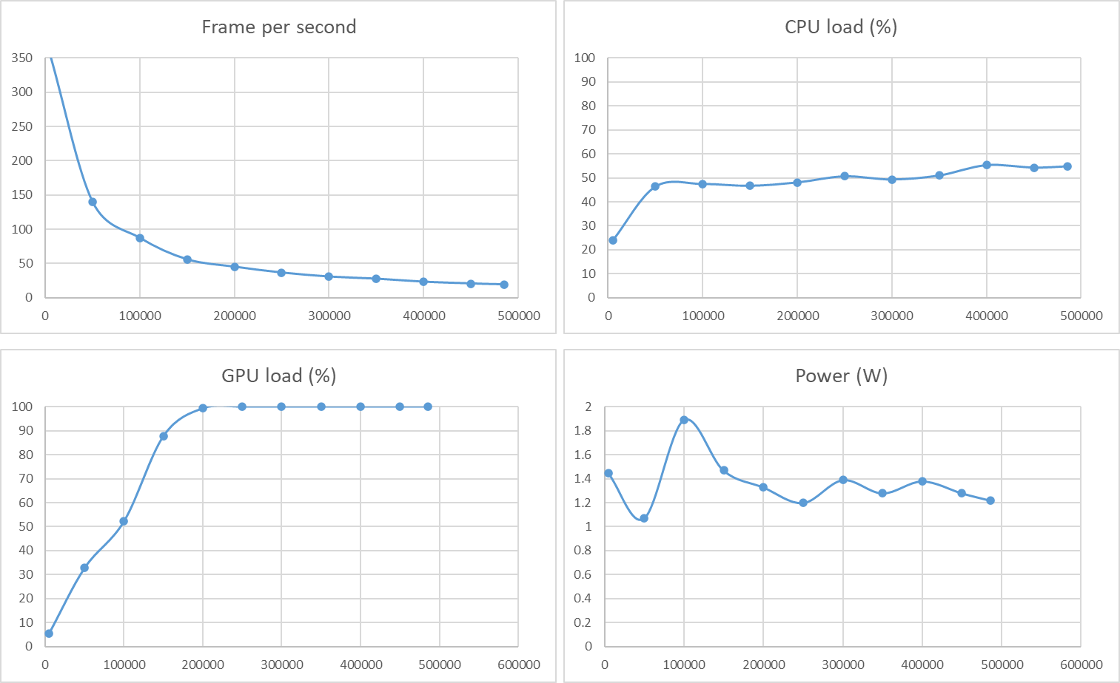
Figure 2: Evolution of the indicators in relation to the number of points.
The device approaches GPU saturation (87% load) at 150000 points and is fully saturated (99%) from 200000 points onwards. Once the GPU is saturated, the frame rate decreases linearly as the number of points increases.

12.4.4.3 Impact of spherical harmonics degree
The following table 2 and figure 3 analyse the cost of higher-order color view-dependence processing on the full model (~485k points).
Table 2: Performance for various spherical harmonics degrees (device=Pixel 9a, points=485k)
SH Degree | Frame per second | CPU load (%) | GPU load (%) | Ets. Power (W)
0 | 20.41 | 54.52 | 100 | 1.45
1 | 19.57 | 53.44 | 100 | 1.18
2 | 19.29 | 54.31 | 100 | 1.05
3 | 18.05 | 55.47 | 100 | 0.99

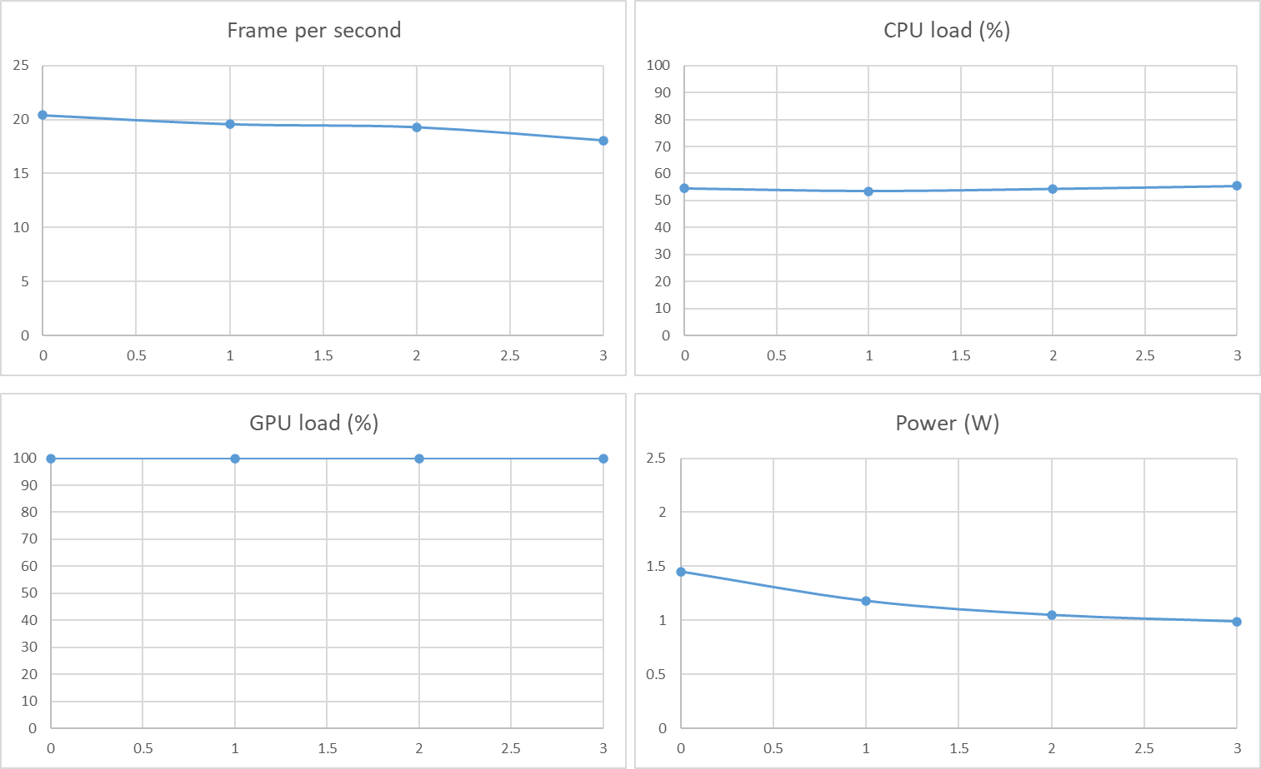
Figure 5. Evolution of indicators in relation to the degree of the spherical harmonics.
Switching from SH Degree 0 to 3 results in a moderate frame rate drop from ~20.41 FPS to ~18.5 FPS (-10,8%). This relatively low performance drop suggests that the rendering pipeline is less sensitive to the color reconstruction (performed in the vertex shader) than it is to the total number of points, which impacts the entire rasterization process: sorting, vertex shader, and fragment shader.

12.4.2.4 Analysis
These results confirm that real-time rendering of complex 3DGS scenes is feasible on current-generation mobile hardware, if scene complexity is managed (e.g., < 200k visible points).
These results suggest that allocating resources for the rendering stage of static 3DGS scenes is feasible on current-generation mobile hardware for managed complexities (e.g., < 200k visible points), though this must be balanced against the requirements of the full delivery pipeline.
Variations were observed between the results for different identical experiments. This is due to the fact that other processes may be using resources or, more generally, to the dynamic management of the device's power consumption. Therefore, these values should be considered as trends and not as fixed values.
Editor’s note: Other benchmarks may be carried out to evaluate the impact of other improvement (memory, quantification, sorting, …).
[Editor’s note: The benchmark results presented in section 12.4.3 were obtained using an internal evaluation tool running on the Android platform. While the rendering core (C++) is designed for portability, the release of this software as a public 3GPP reference implementation is subject to future confirmation.]

* * * End of Changes * * * *

