3GPP TSG-S4 Meeting#134 S4-251778

Dallas, US 17th – 21st Nov 2025

Source: Apple Inc.
Title: [VOPS] On Conformance
Agenda item: 9.5
Document for: Agreement

Introduction
This document provides and points to VOPS conformance materials: compressed bitstreams generated using available source content, the software used to generate the compressed streams, results of the validation, and updates suggested to the validator. All materials are available online [1].

Details

Source content used
The “Basket” sequence from the NAMA3DS1 database were used for this application. The library is provided under the following license and copyright terms:

These 3D videos and accompagnying data (NAMA3DS1-COSPAD1) are Copyright © 11/05/2011, UniversitÈ de Nantes / CNRS

NAMA3DS1-COSPAD1 is free software; you can redistribute it and/or modify it under the terms of the Creative Commons CC BY-NC-SA 3.0 (Attribution-NonCommercial-ShareAlike 3.0 Unported)
These videos is distributed in the hope that it will be useful, but WITHOUT ANY WARRANTY; without even the implied warranty of MERCHANTABILITY or FITNESS FOR A PARTICULAR PURPOSE. See the Creative Commons License CC BY-NC-SA 3.0 for more details.

You should have received a copy of the Creative Commons License along with this program; if not, you can also find the Creative Commons licence on the Creative Commons web site.
In addition, we kindly ask you to acknowledge these 3D video and its authors in any program or publication in which you use these 3D video. (You are not required to do so; it is up to your common sense to decide whether you want to comply with this request or not.)

For general publications, we suggest referencing: Matthieu Urvoy, Marcus Barkowsky, RomainCousseau, Yao Koudota, Vincent Ricordel, Patrick Le Callet, Jes˙s GutiÈrrez and Narciso GarcÌa, "NAMA3DS1-COSPAD1: Subjective video quality assessment database on coding conditions introducing freely available high quality 3D stereoscopic sequences", Fourth International on Quality of Multimedia Experience, Yarra Valley, July 2012.

Non-free versions of these 3D video are available under terms different from those of the Creative Commons. For these alternative terms you must purchase a license from Technology Transfer Office of the UniversitÈ de Nantes. Users interested in such a license should contact us (valorisation@univ-nantes.fr) for more information.

We have discussed these terms with the content owners and we believe that the above license term enables 3GPP to use such content for its purposes. For more information about this content we will suggest checking the following link on qualinet:
https://qualinet.github.io/databases/video/irccynivc_nama3ds1___cospad1/
Since there was an interest in producing both 8 and 10 bit content, as well as 1080p and 4K resolution material, we have upconverted some of the content from this library using the Convert tool from the HDRTools package (https://gitlab.com/standards/HDRTools). If there is any interest by the group, the configuration files for this conversion process can also be provided. Additional content could be used to generate more bitstreams, if desired.

HM software for content generation
A series of conformance bitstreams that conform to the 3GPP MV-HEVC stereo operation points, as defined in TS 26.265, were created using JVET's HM (https://vcgit.hhi.fraunhofer.de/jvet/HM) reference SW using the Merge Request “JVET-AN0292-0293: Multiview HEVC encoding and decoding including 4:4:4 profiles”, which can be found here:

https://vcgit.hhi.fraunhofer.de/jvet/HM/-/merge_requests/98

Additional changes were required in the HM’s TAppEncoder and TAppDecoder to support VPS VUI signaling in the bitstreams. Apple will update the above Merge Request with these changes in the next few days.

Bitstream configurations
We have generated 8 bitstreams as shown in Table 1. A random access configuration was used, however, for this version only 1 IRAP point is present in all bitstreams. New bitstreams will be provided in the future that will contain multiple IRAP points. The configuration files used for the generation of these bitstreams are also provided together with the compressed bitstreams at [1].

Table 1. New Multiview Conformance Bitstreams for 3GPP Applications
Bitstream Name | HEVC Profile for EL | Resolution | Bitdepth
mv-hevc-3GPP-main-1080p.h265 | Multiview Main | 1080p | 8
mv-hevc-3GPP-main-2160p.h265 | Multiview Main | 2160p | 8
mv-hevc-3GPP-main10-1080p.h265 | Multiview Main 10 | 1080p | 10
mv-hevc-3GPP-main10-2160p.h265 | Multiview Main 10 | 2160p | 10
mv-hevc-3GPP-mainExt-1080p.h265 | Multiview Extended | 1080p | 8
mv-hevc-3GPP-mainExt-2160p.h265 | Multiview Extended | 2160p | 8
mv-hevc-3GPP-mvExt10-1080p.h265 | Multiview Extended 10 | 1080p | 10
mv-hevc-3GPP-mvExt10-2160p.h265 | Multiview Extended 10 | 2160p | 10

Validation
The generated bitstreams were tested using the 3GPP “Bitstream Validator” that can be found at:
https://forge.3gpp.org/rep/sa4/vops/bitstream-validator

When using this validator, we encountered several warnings, which helped us to identify and resolve several issues with this validator. Clause 2.5 provides more detail on such issues and how they were resolved.

Updates to VOPs Validator
During the validation process using the 3GPP “Bitstream Validator” tool, we encountered several warnings, which we determined were due to implementation issues in this SW and not directly related to the generated bitstreams. More specifically, we identified and resolved the following issues:

- Layer-specific PTL Validation Rules (vops_3gpp-mv-hevc-stereo.xsd)
  - Updated all PTL constraint flag assertions to only check Layer 0 SPS using NALUnit[nuh_layer_id = 0] filter
  - Changed comparisons from boolean functions to number() conversion to handle xmlschema's type system
  - This correctly handles that Layer 1 multi-layer extension SPS inherits PTL from Layer 0

- VUI Parameters Schema Bug (hevc_common.xsd)
  - Fixed duplicate aspect_ratio_info_present_flag definition (line 22) - changed to overscan_info_present_flag
  - Made bitstream_restriction_flag optional with minOccurs="0" since it's not present when timing info is disabled

- Multi-layer Extension SPS Schema (hevc_common.xsd)
  - Added xs:choice to handle two different SPS structures:
  - Multi-layer extension SPS: has SpsMultilayerExtension directly after common fields, no VUI
  - Regular SPS: has VUI parameters and optional extensions
  - This correctly models that Layer 1 SPS has a completely different structure than Layer 0 SPS

With these updates, the validator now correctly:
- Distinguishes between Layer 0 and Layer 1 NAL units
- Shows layer information in all error messages
- Identifies specific violating NAL units with layer IDs
- Validates PTL constraints only on Layer 0 SPS (as Layer 1 inherits them)
- Handles both full SPS and multi-layer extension SPS structures

The diff file (bitstream-validator-enhancements.diff) may be used to examine the proposed updates:

5 files modified:
- bitstream_rules/hevc_common.xsd - Schema fixes for multi-layer SPS, VUI, and scaling lists
- bitstream_rules/vops_3gpp-mv-hevc-stereo.xsd - Layer-specific validation rules
- requirements.txt - Added lxml dependency
- sa4_bitstream_validator/parsers/hevc/sps.py - Fixed multi-layer SPS parsing
- sa4_bitstream_validator/validators.py - Enhanced error reporting with layer info

Open Issues
There is an open question about whether some parameters must be present in the video bitstream. Some of these parameters are already present at the System level (e.g., CMAF), and they considered to be the source of truth:
- “aspect_ratio_idc” in Sequence Parameter Set (SPS) currently is “shall”. Apple’s recommendation is that this information to not be mandatory (“should”). The bitstreams provided currently set this parameter to 0, but we can easily provide bitstreams that have this parameter set to 1 if the group wishes to either require this setting or would like to have also files that include this parameter enabled.
- This topic addressed in a proposed CR to TS 26.265.

Demo
A demo is made available during the meeting that can play the provided streams with the following interface:

- Go to selection menu:
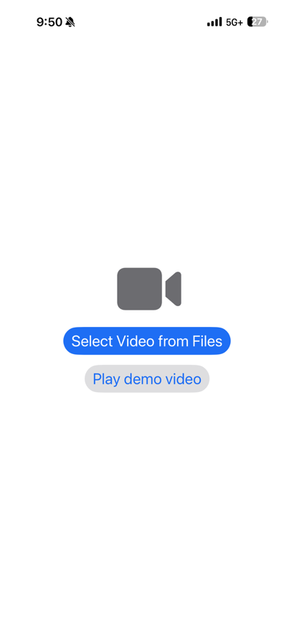
- Select the file to play:
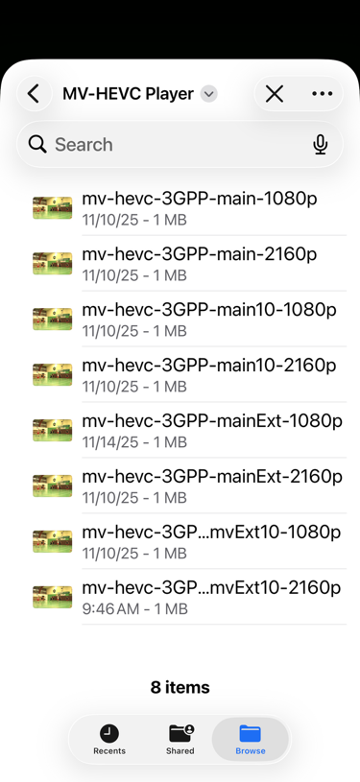

- The videos can be played from the base layer as a single view:
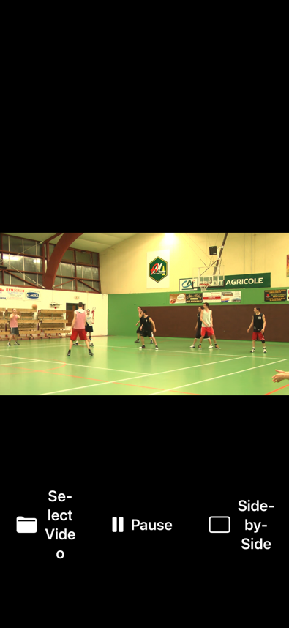
(landscape mode)
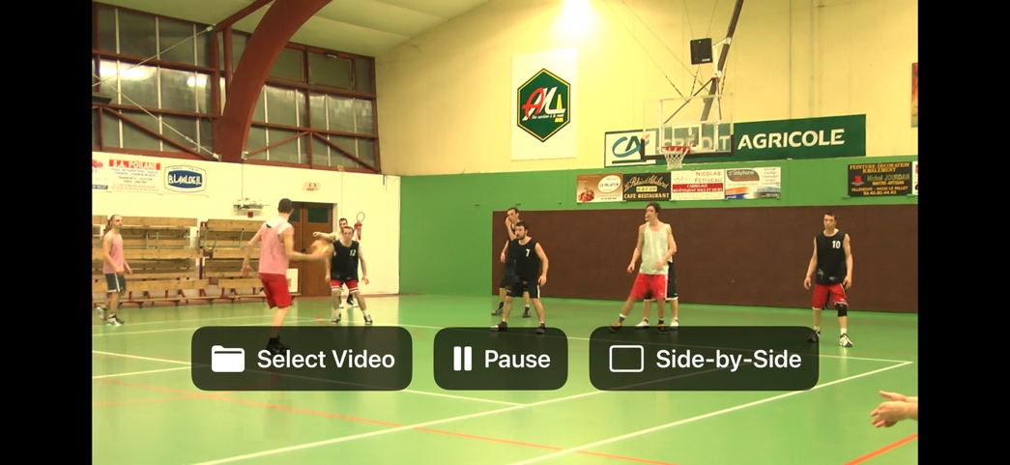

Or with side-by-side view:
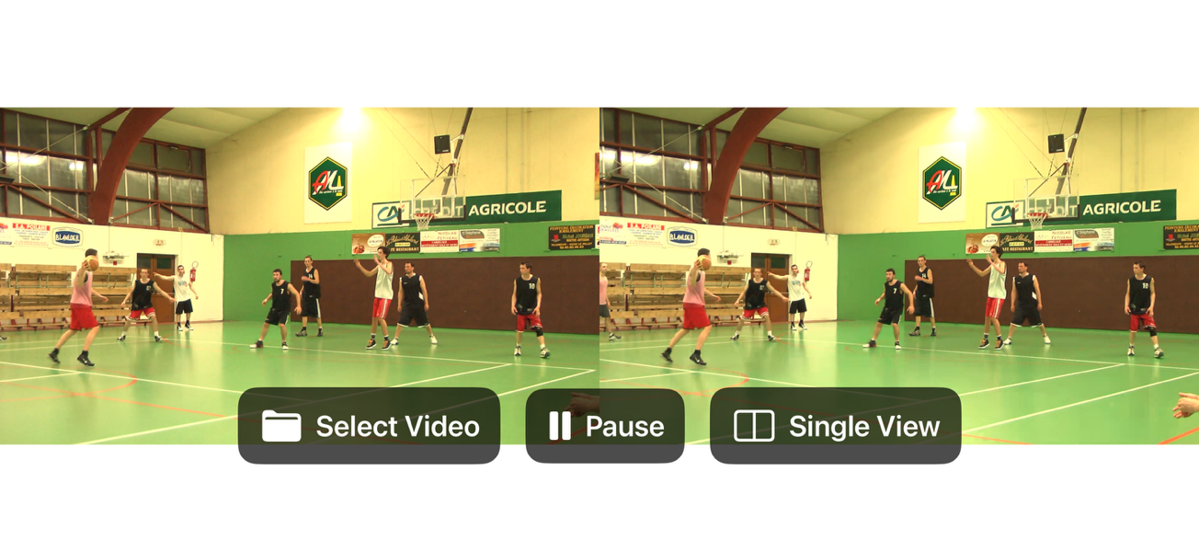

Proposal
It is proposed to add the provided conformance material for VOPS conformance work. The demo is for the purpose of viewing at the meeting

References
[1] VOPS conformance material available online: https://drive.google.com/drive/folders/1hps_M-fOcanj9pGgEY0PJhwClofSXLv2

