3GPP TSG-SA4 Meeting #134 S4-251715

Dallas, United States, 17th Nov 2025 - 21st Nov 2025
CR-Form-v12.4
CHANGE REQUEST
 | 26.265 | CR | 0001 | rev | - | Current version: | 19.0.0
For HELP on using this form: comprehensive instructions can be found at
https://www.3gpp.org/Change-Requests.

Proposed change affects: | UICC apps |  | ME | x | Radio Access Network |  | Core Network | x

Title: | [VOPS] Conformance
Source to WG: | Qualcomm Germany, Xioami…, Apple Inc., Tencent
Source to TSG: | S4
Work item code: | VOPS |  |  |  |  |  | Date: |  |  | 2025-11-09
Category: | B |  |  |  |  |  | Release: |  |  | Rel-19
 | Use one of the following categories:  F (correction)  A (mirror corresponding to a change in an earlier release)  B (addition of feature),  C (functional modification of feature)  D (editorial modification)  Detailed explanations of the above categories can  be found in 3GPP TR 21.900. |  |  |  |  |  |  |  | Use one of the following releases:  Rel-8 (Release 8)  Rel-9 (Release 9)  Rel-10 (Release 10)  Rel-11 (Release 11)  …  Rel-17 (Release 17)  Rel-18 (Release 18)  Rel-19 (Release 19)  Rel-20 (Release 20)
Reason for change: |  | Conformance is missing
Summary of change: |  | Adds conformance
Consequences if not approved: |  | Missing Conformance
Clauses affected: |  | Annex B (new)
 |  | Y | N
Other specs |  |  |  | Other core specifications |  |  |  | TS/TR ... CR ...
affected: |  |  |  | Test specifications |  |  |  | TS/TR ... CR ...
(show related CRs) |  |  |  | O&M Specifications |  |  |  | TS/TR ... CR ...
Other comments:
This CR's revision history:

==============First change (all new) ==============

Annex B:
Conformance

B.1 Introduction
This annex provides conformance-related information. Figure B.1-1 provides an overview of the conformance functionalities provided in this annex to support interoperable deployment of the operation points defined in this specification.
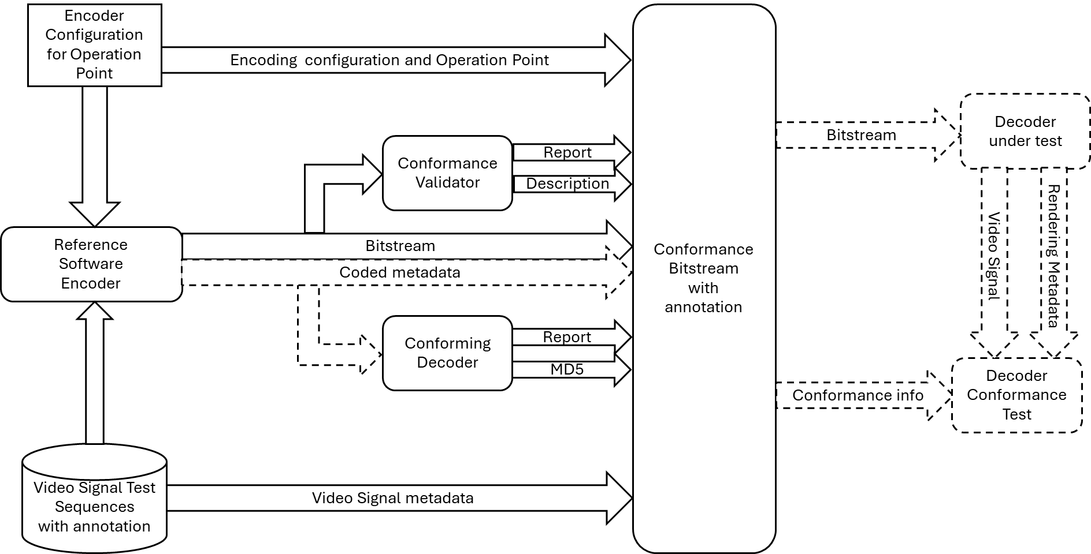
Figure B.1-1 Overview of conformance functionalities provided for this specification
Based on the overview in Figure B.1-1, the following functionalities are provided:
- A set of video signals are provided that conform to one of the representation formats defined in clause 4.4.3 of this specification. In addition, a consistent annotation of the signals using the parameters defined in clause 4.4 are defined. For details refer to Annex B.2.1.
- Workflows including reference software encoders with appropriate configuration are provided to encode the video signals to create a bitstream and potentially coded metadata that conform to the operation point. For details refer to Annex B.2.2.
- A conformance validator is defined that permits to validate the bitstream (and possibly the coded metadata) to be conforming to a specific operation point defined in this specification. For details refer to Annex B.2.3.
- A conforming decoder may be provided for certain operation points that provides a reference implementation to generate the adequate signals based on conforming bitstreams. The conforming decoder may provider information related to the output signal for example an MD5. For details refer to Annex B.2.4.
- Bitstreams that have been validated are provided with collected information including the information of the used video signal, the encoder and its configuration, the report from the validator as well as the coded metadata. In addition, decoding related information may be provided. The bitstreams are referred to as conformance bitstream. For details refer to Annex B.2.5.
This tools and functionalities provided in this Annex may be used for different purposes to support interoperable deployments. Examples for the usage of the tools are provided in Annex B.3.

B.2 Details of the conformance functions

B.2.1 Video Test Signals
Video test signals with proper annotation are provided at https://forge.3gpp.org/rep/sa4/26265/video-signals.
The video signals are annotated with a JSON document that follows the schema defined in https://forge.3gpp.org/rep/sa4/26265/video-signals/annotation.json.

B.2.2 Reference encoders and configurations
Workflows, reference encoders and configurations to generate conforming bitstreams for different operation points are provided at https://forge.3gpp.org/rep/sa4/26265/conformance/content-generation.

B.2.3 Conformance Validator
A conformance validator for testing bitstreams for conformance against the operation points defined in this specification is provided https://forge.3gpp.org/rep/sa4/26265/conformance/validator.
The validator provides a report about the level of conformance. The detailed semantics and the format of the report is for further study.
The validator also provides a detailed XML-based breakdown of the syntax and feature executed in the bitstream. The detailed semantics and the format of this document is for further study.

B.2.4 Conforming Decoders
A conforming decoder may be provided for certain operation points that provides a reference implementation to generate the adequate signals based on conforming bitstreams. The conforming decoder may provider information related to the output signal for example an MD5. Details are for further study.

B.2.5 Conformance Bitstreams
Bitstreams that have been validated are provided with collected information including the information of the used video signal, the encoder and its configuration, the report from the validator as well as the coded metadata. In addition, decoding related information may be provided. The bitstreams are referred to as conformance bitstream.
Conformance bitstreams are provided here https://forge.3gpp.org/rep/sa4/26265/conformance/bitstreams.
A schema for annotation is provided here https://forge.3gpp.org/rep/sa4/26265/conformance/bitstreams/annotation.json. Detailed semantics are for further study.

B.3 Usage examples for Conformance Functions
The conformance functions may be used for different purposes to support interoperable deployments.
- the conformance validator may be used to test bitstreams claiming to be conformant to an operation point indeed are conforming, or if not, which test assertions are not fulfilled.
- the conforming bitstreams may be used to test decoders and receivers to be able to decode and process bitstreams conforming to an operation point.

