Source: VIDEO SWG Chairman
Title: Proposed meeting agenda for VIDEO SWG during SA4#134
Document for: your information
Agenda Item: 9

9. Video SWG
9.1 Opening of the session, registration of documents
Link to online minutes: TBA

9.2 IPR, antitrust and consensus reminder
https://www.3gpp.org/ftp/tsg_sa/WG4_CODEC/TSGS4_133-e/Inbox/Drafts/Plenary/SA4-IPR-CompetionLaw-ConsensusPinciples.pptx
9.3 Reports and liaisons from other groups/meetings – Plenary A.I. 5.2-5.3
Tdoc | Title | Status

9.4 Release 19 and earlier matters – Closing plenary A.I. 13
Tdoc | Title | Status

9.5 VOPS (Video Operating Points – Harmonization and Stereo MV-HEVC) – Closing plenary A.I. 14.1
WID: SP-250818 New WID on Video Operating Points - Harmonization and Stereo MV-HEVC
Tdoc | Title | Status
Draft TS
S4-251716 | [VOPS] Essential Corrections
S4-251779 | [VOPS] Essential corrections
Conformance
S4-251715 | [VOPS] Conformance
S4-251917 | [VOPS] On Conformance
S4-251931 | [VOPS] VOPS Permanent Document for conformance work v1.0.1
S4-251778 | [VOPS] On Conformance
WI summary
S4-251780 | [VOPS] Work item summary | missing
9.6 FS_AVFOPS_MED (Study of Advanced Video Formats and Operation Points) – Closing plenary A.I. 15.5
WID: SP-251202 New SID on Advanced Video Formats and Operation Points
Tdoc | Title | Status
General
S4-251753 | [FS_AVFOPS-MED] Discussion on improvement points in TS 26.265
S4-251717 | [FS_AVFOPS_MED] Vision on Spec Development and Conformance | missing
Work plan
S4-251867 | [FS_AVFOPS-MED] Work Plan for Advanced Video Formats and Operation Points (FS_AVFOPS)
Scenario
S4-251907 | [FS_AVFOPS_MED] New scenario: Photo and video with changeable background
S4-251928 | [FS_AVFOPS_MED] New scenario: Refocusable photo and video
9.7 FS_3DGS_MED (Study on 3D Gaussian splats) – Plenary A.I. 15.6
WID: SP-251190 Study on 3D Gaussian splats
Tdoc | Title | Status
Draft TR skeleton
S4-251765 | [FS_3DGS_MED] Draft TR 26.958 v0.0.1 (Skeleton)
Representation format
S4-251875 | [FS_3DGS_MED] Pseudo-CR on 3DGS representation format
Use cases
S4-251737 | [FS_3DGS_MED] Use Cases for GS
S4-251766 | [FS_3DGS_MED] Use case #1: on-device capture and sharing of a static 3DGS
S4-251767 | [FS_3DGS_MED] Use case 2: Exploration of a large 3DGS environment
S4-251768 | [FS_3DGS_MED] Use case 3: dynamic 3DGS playback
S4-251857 | [FS_3DGS_MED] Use cases
Quality factors
S4-251858 | [FS_3DGS_MED] On defining different requirements for reference scenarios
Content generation & rendering
S4-251738 | [FS_3DGS_MED] GS generation and rendering
S4-251859 | [FS_3DGS_MED] On AI aspects
S4-251877 | [FS_3DGS_MED] Pseudo-CR on 3DGS content generation
S4-251879 | [FS_3DGS_MED] Pseudo-CR on 3DGS rendering
External activities
S4-251696 | [FS_3DGS_MED] Summary of the MPEG progress on 3DGS
Work plan
S4-251775 | [FS_3DGS_MED] Work Plan v0.1

9.8 Other Rel-20 matters including TEI – Closing plenary A.I. 14
Tdoc | Title | Status

9.9 Any other business – Closing plenary A.I. 20
Tdoc | Title | Status
S4-251787 | On 4:4:4 decoding | missing
S4-251934 | Specifications not promoted to Release 20 (Video SWG)

9.10 Close of the session - VIDEO SWG report A.I. 12.3
Tdoc | Title | Status
S4-251970 | VIDEO SWG report during SA4#134 | Gotoplen 12.3

_____________________
Tdoc “color code”: black = submitted for the meeting by the Tdoc submission deadline
gray = submitted for the meeting after the Tdoc submission deadline
blue = postponed from an earlier SA4 meeting
red = covered during this meeting
Highlighted = missing document
Highlighted = email agreement ongoing
Highlighted = status defined from email agreement process
Highlighted = go to SA4 plenary
strikethrough = withdrawn
Conclusion codes: n: noted, r: revised, a: agreed, awp: agreed without presentation, w: withdrawn, pl: go to plenary, nt: not treated

Meeting schedule (Including Indicative tropics per session)

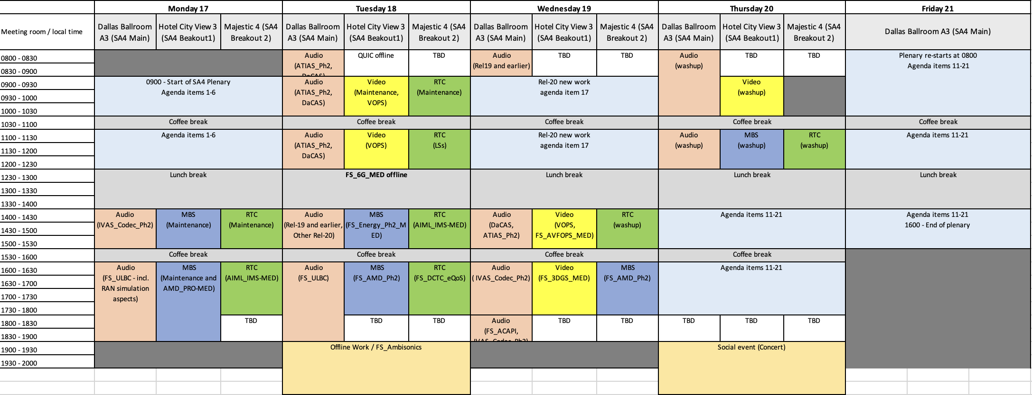
Annex A – Documents’ status
Tdoc number | Title | Source | SWG Agenda Item | Replaced by | SWG Status | SA4 A.I. for Tdocs presented at SA4 plenary*
S4-251696 | [FS_3DGS_MED] Summary of the MPEG progress on 3DGS | Nokia | 9.7
S4-251715 | [VOPS] Conformance | Qualcomm Germany | 9.5
S4-251716 | [VOPS] Essential Corrections | Qualcomm Germany | 9.5
S4-251717 | [FS_AVFOPS_MED] Vision on Spec Development and Conformance | Qualcomm Germany | 9.6
S4-251737 | [FS_3DGS_MED] Use Cases for GS | Qualcomm Sweden | 9.7
S4-251738 | [FS_3DGS_MED] GS generation and rendering | Qualcomm Sweden | 9.7
S4-251753 | [FS_AVFOPS-MED] Discussion on improvement points in TS 26.265 | Xiaomi Technology Netherlands | 9.6
S4-251765 | [FS_3DGS_MED] Draft TR 26.958 v0.0.1 (Skeleton) | Tencent Cloud | 9.7
S4-251766 | [FS_3DGS_MED] Use case #1: on-device capture and sharing of a static 3DGS | Tencent Cloud | 9.7
S4-251767 | [FS_3DGS_MED] Use case 2: Exploration of a large 3DGS environment | Tencent Cloud | 9.7
S4-251768 | [FS_3DGS_MED] Use case 3: dynamic 3DGS playback | Tencent Cloud | 9.7
S4-251775 | [FS_3DGS_MED] Work Plan v0.1 | Tencent Cloud | 9.7
S4-251778 | [VOPS] On Conformance | Apple Inc. | 9.5
S4-251779 | [VOPS] Essential corrections | Apple Inc. | 9.5
S4-251780 | [VOPS] Work item summary | Apple Inc. | 9.5
S4-251787 | On 4:4:4 decoding | Apple Inc. | 9.9
S4-251857 | [FS_3DGS_MED] Use cases | Samsung R&D Institute India | 9.7
S4-251858 | [FS_3DGS_MED] On defining different requirements for reference scenarios | Samsung R&D Institute India | 9.7
S4-251859 | [FS_3DGS_MED] On AI aspects | Samsung R&D Institute India | 9.7
S4-251867 | [FS_AVFOPS-MED] Work Plan for Advanced Video Formats and Operation Points (FS_AVFOPS) | Xiaomi Technology Netherlands | 9.6
S4-251875 | [FS_3DGS_MED] Pseudo-CR on 3DGS representation format | Tencent Cloud | 9.7
S4-251877 | [FS_3DGS_MED] Pseudo-CR on 3DGS content generation | Tencent Cloud | 9.7
S4-251879 | [FS_3DGS_MED] Pseudo-CR on 3DGS rendering | Tencent Cloud | 9.7
S4-251907 | [FS_AVFOPS_MED] New scenario: Photo and video with changeable background | Xiaomi Technology Netherlands | 9.6
S4-251917 | [VOPS] On Conformance | Qualcomm Germany | 9.5
S4-251928 | [FS_AVFOPS_MED] New scenario: Refocusable photo and video | Xiaomi Technology Netherlands | 9.6
S4-251931 | [VOPS] VOPS Permanent Document for conformance work v1.0.1 | Xiaomi Technology (Polska) sp. | 9.5
S4-251934 | Specifications not promoted to Release 20 (Video SWG) | SA4 Chair | 9.9
Tdoc number | Title | Source | Agenda item | Replaced by | SWG status | Plenary A.I.
S4-251970 | VIDEO SWG report during SA4#134 | VIDEO SWG Chair (Tencent) | - |  |  | 12.3
Annex B – Participants list (XX)

NAME | LASTNAME | COMPANY
Mike | WAZOWSKI | Monsters, Inc.

Gilles TENIOU, TENCENT ; teniou@global.tencent.com

