3GPP TSG-SA4 Meeting #134 S4-251829

Dallas, United States, 17th Nov 2025 - 21st Nov 2025
CR-Form-v12.4
CHANGE REQUEST
 | 26.114 | CR | 0598 | rev | - | Current version: | 19.1.0
For HELP on using this form: comprehensive instructions can be found at
https://www.3gpp.org/Change-Requests.

Proposed change affects: | UICC apps |  | ME | X | Radio Access Network |  | Core Network | X

Title: | Clarification on Data Channel Server
Source to WG: | Nokia
Source to TSG: | S4
Work item code: | 5G_MEDIA_MTSI_ext, TEI19 |  |  |  |  |  | Date: |  |  | 2025-11-11
Category: | F |  |  |  |  |  | Release: |  |  | Rel-19
 | Use one of the following categories:  F (correction)  A (mirror corresponding to a change in an earlier release)  B (addition of feature),  C (functional modification of feature)  D (editorial modification)  Detailed explanations of the above categories can  be found in 3GPP TR 21.900. |  |  |  |  |  |  |  | Use one of the following releases:  Rel-8 (Release 8)  Rel-9 (Release 9)  Rel-10 (Release 10)  Rel-11 (Release 11)  …  Rel-17 (Release 17)  Rel-18 (Release 18)  Rel-19 (Release 19)  Rel-20 (Release 20)
Reason for change: |  | The terminology Data Channel Server is used in TS 26.114 clause 6.2.10.1, decomposed into a number of functional entities including DC Signalling Function, Media Function and DC Application Server. To avoid confusion with Data Channel Application Server and to keep the alignment in TS 23.228 (it is not used in TS 23.228), the correction is necessary.
Summary of change: |  | Adding further clarifications in 6.2.10.1.
Consequences if not approved: |  | Risk for misinterpretation that could cause interoperability problems.
Clauses affected: |  | 6.2.10.1
 |  | Y | N
Other specs |  |  | X | Other core specifications |  |  |  | TS/TR ... CR ...
affected: |  |  | X | Test specifications |  |  |  | TS/TR ... CR ...
(show related CRs) |  |  | X | O&M Specifications |  |  |  | TS/TR ... CR ...
Other comments:
This CR's revision history:

==============First change==============

6.2.10.1 General
Support of data channel media is optional for an MTSI client and an MTSI client in terminal. For brevity, an MTSI client supporting data channel is henceforth denoted as a DCMTSI client or DCMTSI client in terminal, respectively.
To indicate support for the procedures in this clause, a DCMTSI client shall when including media feature tags as specified in TS 24.229 [7] include a +sip.app-subtype media feature tag, as specified by IETF RFC 5688 [177], with a value of "webrtc-datachannel" (the application media format used by IETF RFC 8864 [172]), regardless of data channel media being part of the SDP or not.
To indicate support for bootstrap data channel multiplexing procedures and application data channel multiplexing procedures as described by clauses 6.2.10.2 and 6.2.10.3, a DCMTSI client shall when including media feature tags as specified in TS 24.229 [7] include a g.3gpp.dc-mux media feature tag (see Annex AB for IANA registration information), regardless of data channel media being part of the SDP or not.
One or more data channel SDP media descriptions formatted according to IETF RFC 8864 [172] may be added to the SDP, alongside other SDP media descriptions such as e.g. speech, video, and text. The protocol identifier (proto value) and media format (fmt value) of a data channel SDP media description shall be set to "UDP/DTLS/SCTP" defined in IETF RFC 8864 [172] and "webrtc-datachannel" defined in IETF RFC 8841 [194], respectively.
A data channel SDP media description shall not be placed before the first SDP speech media description. SDP examples are provided in clause A.17.
If data channels are used in a session, the session setup shall determine the applicable bandwidth limit(s) as defined in clause 6.2.5.
Multiple data channels may be mapped to a single data channel SDP media description, each with a corresponding "a=dcmap" SDP attribute and stream IDs that are unique within that media description. There is no limit to the number of data channels in an SDP media description, but the aggregate of all defined data channels shall keep within the set bandwidth limit and care should be taken to avoid excessive SDP size. If the session is re-negotiated to include a changed number of data channels in an SDP media description, the bandwidth limit may either be kept constant, changing the share of bandwidth available to each individual data channel, or the bandwidth limit may be changed to accommodate the changed number of data channels, keeping individual data channel bandwidth shares. Regardless of what approach is used when changing number of used data channels in a media description, the aggregate of all defined data channels shall keep within the re-negotiated bandwidth limit.
If there is a need to use data channels with either different transport IP addresses, different UDP ports, or different SCTP ports, separate data channel SDP media descriptions shall be used, as IP address, UDP port and SCTP port are all constant per SDP media description. Multiple SCTP associations for a single channel, commonly denoted as "multi-homing", defined in IETF RFC 4960 [173] for reasons of redundancy and basically using one destination transport address at a time, is not described for use with WebRTC data channel and shall therefore not be used in this specification.
NOTE 1: The main reasons to not specify multi-homing are because it cannot use the needed separation of signalling paths for redundancy purposes in the applicable usage scenarios, and it is also not considered feasible when using SCTP on top of DTLS.
To ease data channel media implementation and ease interworking with WebRTC data channels, DCMTSI clients shall support ICE Lite and may support full ICE [184], for data channel media. DCMTSI clients supporting full ICE shall only use host candidate addresses. SDP "a=candidate" line host address information shall match corresponding SDP "c=" and "m=" line information.
NOTE 2: In typical IMS deployments, it is expected that DCMTSI clients have no need to use STUN or TURN servers with ICE. This is in line with what constitutes an ICE Lite agent.
A "data channel application" consists of an HTML web page including JavaScript(s), and optionally image(s) and style sheet(s). A "bootstrap data channel" is henceforth defined as a data channel used to retrieve data channel application(s) for a DCMTSI client in terminal, with a data channel stream ID below 1000, and using the HTTP [73] protocol as data channel subprotocol. The data channel application accessible at the HTTP root ("/") URL through a bootstrap data channel describes the graphical user interface and the logic needed to handle any further data channel usage beyond the bootstrap data channel itself. The meaning of the "authority" (host) part of the URL and consequently the "Host" HTTP header are not defined, shall be ignored on reception, and shall be set to the empty value by a DCMTSI client in terminal.
NOTE 3: Data channel stream IDs below 1000 may use a well-defined subprotocol for other features than retrieving data channel application(s). For example, the “mpeg-sd” subprotocol can be used for a data channel stream ID below 1000 for scene description-based overlays as specified in clause Y.6.9.

The data channel application is created prior to the DCMTSI call where it is intended to be used, by means left out of scope for this specification. The data channel application workflow is depicted by Figure 6.2.10.1-1 below.

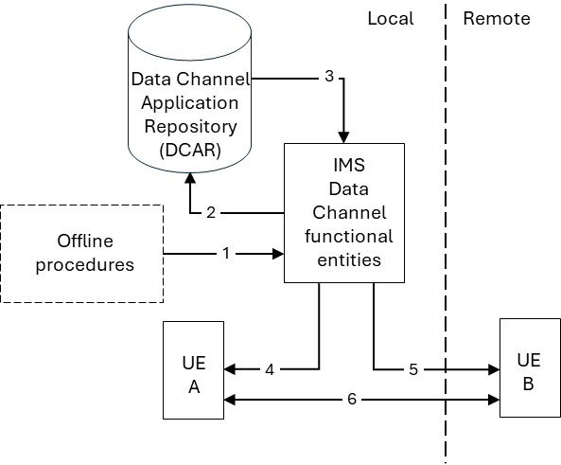
Figure 6.2.10.1-1: Data Channel Workflow
NOTE 4: IMS Data Channel functional entities in this specification can be further decomposed into a number of signalling function and media function supporting data channel services, including DC Signalling Function, Media Function and DC Application Server as specified in Annex AC of [167].
The data channel application is, referring to the numbered arrows in Figure 6.2.10.1-1:
1. Uploaded to the network, by the UE user or some other authorized party.
2. Stored in a data channel application repository in the network.
3. During the DCMTSI call where it should be used, retrieved from the repository.
4. Sent through a bootstrap data channel to the local UE A as a response of its request.
5. Sent through a bootstrap data channel to the remote UE B as a response of its request. This may happen in parallel with and rather independent of step 4.
6. Any additional data channels created and used by the data channel application itself are established (logically) between UE A and UE B. Data transmission on data channels shall not start until there is confirmation that both peers have instantiated the data channel, using the same procedures as described for WebRTC in section 6.5 of [172]. The traffic may effectively go through the IMS Data Channel functional entities , e.g., when the bootstrap and end-to-end data channels have the same anchoring point. This traffic may pass across an inter-operator border if UE A and UE B belong to different operators’ networks.
The bootstrap data channel is not intended for use directly between DCMTSI clients in terminal. DCMTSI clients in terminal that receive HTTP requests on a bootstrap data channel shall ignore such request and shall update the session by removing the SDP "a=dcmap" line with the stream ID where such HTTP request was received, and closing that stream ID.
The data channel application including its resources retrieved via a bootstrap data channel may be updated at any time, automatically or interactively, using normal HTTP procedures over the bootstrap data channel.
A bootstrap data channel shall be configured as ordered, reliable, with normal SCTP multiplexing priority. The sub-protocol for a bootstrap data channel shall be HTTP (not encapsulating HTTP in TCP), represented by the following, example SDP "a=dcmap" line, which therefore shall be present in each data channel media description in an SDP offer from a DCMTSI client in terminal:
a=dcmap:0 subprotocol="http"
Any other data channels used by the data channel application JavaScript(s) sent in the bootstrap data channel shall be represented in an updated SDP as additional "a=dcmap" lines with stream ID values starting from 1000, using stream ID numbers from the JavaScript(s).
There are multiple, possible providers of data channel applications. In Figure 6.2.10.1-1, assume that UE A is local to the operator hosting the IMS Data Channel functional entities. Further assume that UE B belongs to a different operator (remote). The user of UE A can create and use data channel applications (steps 1-4), which can also be sent to UE B (step 5). Similarly, some other authorized part associated with UE A’s operator can create data channel applications for use by UE A (steps 1-4), which can also be sent to UE B (step 5). For simplicity, there’s no IMS Data Channel functional entities and data channel application repository depicted for UE B in Figure 6.2.10.1-1, but those could be present in a more general case. Seen from the perspective of a single UE, there are then at least four possible data channel application providers:
1. The local UE user.
2. Other authorized parties associated with the local network (e.g. the local operator).
3. The remote UE user.
4. Other authorized parties associated with the remote network (e.g. the remote operator).
The HTML web content making up a data channel application in each bootstrap data channel represents a different context of user interaction and should open in a separate tab, or some corresponding user interface construct, but the details are out of scope for this specification and left open for individual implementations. It shall be possible to use and navigate between different data channel applications from different bootstrap data channels with different stream IDs that are open simultaneously.
Table 6.2.10.1-2 describes a mandatory mapping between stream ID and bootstrap channel data channel application content sources, as seen from a single (local) DCMTSI client in terminal, each of which shall be listed as separate "a=dcmap" lines with "http" subprotocol in SDP when the DCMTSI client in terminal supports receiving data channel application content from that source.
Table 6.2.10.1-2: Bootstrap Data Channel Content Sources
Stream ID | Content Source
0 | Local network provider
10 | Local user
100 | Remote network provider
110 | Remote user

NOTE 5: When the local user has defined and stored multiple, different data channel applications in the local data channel application repository, the local network provider may provide functionality in the stream ID 0 data channel application that enables a dynamic choice of which user-defined data channel application to use with stream ID 10 in the DCMTSI call.
NOTE 6: To help the SDP answerer's network to distinguish the two media descriptions (m= lines) containing bootstrap data channels with the same stream ID values transferred between two networks, the SDP offerer's network adds an "a=3gpp-bdc-used-by:sender" attribute in the media description of the bootstrap data channel(s) established between the originating UE and the terminating network, and optionally adds "a=3gpp-bdc-used-by:receiver" attribute in the media description of the bootstrap data channel(s) established between the originating network and the terminating UE, before it sends the SDP offer to the remote network. Even when there is only one bootstrap data channel contained in the media descriptions, the SDP offerer's network also needs to add an "a=3gpp-bdc-used-by:sender" attribute in the media description of the bootstrap data channel established between the originating UE and the terminating network, or add an "a=3gpp-bdc-used-by:receiver" attribute in the media description of the bootstrap data channel established between the originating network and the terminating UE.
Figure 6.2.10.1-3, referring to Figure 6.2.10.1-1 and Table 6.2.10.1-2, is depicting the stream IDs used for distribution of a data channel application owned by UE A from its local data channel repository to both UE A (stream ID 10) and its remote UE B (stream ID 110).

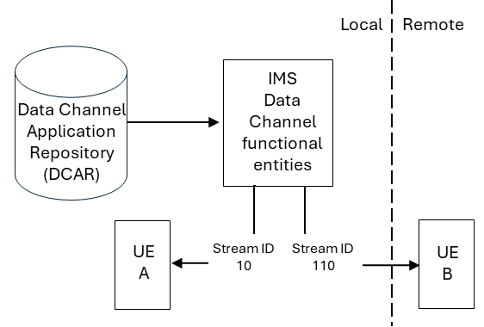
Figure 6.2.10.1-3: Distribution of local data channel application to both UE
When the user in UE A in a call with UE B selects data channel application(s) for retrieval and use, and after the new application(s) are launched, the application(s) may make use of additional data channel(s) (see step 6 of 6.2.10.1-1). In this case, UE A initiates a call upgrade to add new data channel(s) to the call for the new application(s). The SDP offer the UE A generates shall include an "a=3gpp-req-app" attribute with a "req-app-id" parameter, as defined by clause 6.2.13, to identify the requesting application as part of the media description creating application data channels for that application. The application should be configured with that identification and the network deployment should ensure that identification to be sufficiently, potentially globally, unique to avoid ambiguity. The "a=3gpp-req-app" attribute may also include an "app-dc-info" parameter to allow the application to identify a different end point when creating multiple application data channels used for communication to a network server or to the remote UE. The “a=3gpp-req-app” attribute may also include a “binding-bdc” parameter to indicate the BDC identity.
The combination of "req-app-id" and "app-dc-info" parameters allows the communicating UEs to bind the SDP offers and answers for each data channel and stream IDs being negotiated for the respective applications using these data channel stream IDs.
==============End of change==============

