ll3GPP TSG-SA WG4 Meeting #134 S4-251773

Dallas USA, 11 – 17 November, 2025

Source: InterDigital Canada
Title: [FS_DCTC_eQoS_MED] Media upstream transmission for AI inferencing
Spec: 3GPP TR 26.823 v0.0.1
Agenda item: 10.6
Document for: Agreement

1. Introduction
The Study on dynamically changing traffic characteristics and usage of enhanced QoS support in 5GS for media applications and services examines various use cases and scenarios representative of real-world media usage, such as real-time communication, streaming, short-form video download and media upstream for AI inferencing. For each scenario, corresponding test setups will be developed and documented. The primary objective is to identify how traffic patterns evolve dynamically and to explore the usage, benefits and deployment aspects of related QoS features available in the 5G System.
This contribution focuses on the media upstream for AI inferencing scenario.
2. Reason for Change
Clause 5.6 on media upstream transmission for AI inferencing is currently empty.
This document documents the media transmission for upstream AI inference service scenario that may exhibit dynamically changing traffic characteristics and describes a first set of QoE and QoS criteria and requirements.

3. Proposal
It is proposed to agree the following changes to 3GPP TR 26.823 v0.0.1.

* * * First Change * * *

2 References
The following documents contain provisions which, through reference in this text, constitute provisions of the present document.
- References are either specific (identified by date of publication, edition number, version number, etc.) or non specific.
- For a specific reference, subsequent revisions do not apply.
- For a non-specific reference, the latest version applies. In the case of a reference to a 3GPP document (including a GSM document), a non-specific reference implicitly refers to the latest version of that document in the same Release as the present document.
[1] 3GPP TR 21.905: "Vocabulary for 3GPP Specifications".
[2] 3GPP TS 26.522: "5G Real-time Media Transport Protocol Configurations".
[3] 3GPP TS 23.501: "System architecture for the 5G System (5GS)".
[4] 3GPP TS 26.822: "Study of 5G RTP protocol phase 2".
[5] 3GPP TR 23.700-70: "Study on architecture enhancement for Extended Reality and Media service (XRM); Phase 2".
[6] 3GPP TR 26.925: Technical Specification Group Services and System Aspects; Typical traffic characteristics of media services on 3GPP networks
[7] 3GPP TR 26.926: "Traffic Models and Quality Evaluation Methods for Media and XR Services in 5G Systems".
[8] 3GPP TR 26.819: “Study on Spatial Computing for Augmented Reality (AR) Services”.
[9] 3GPP TR 22.870: “Study on 6G Use Cases and Service Requirements”.
[10] 3GPP TR 26.927: “Technical Specification Group Services and System Aspects; Study on Artificial Intelligence and Machine Learning in 5G media services”
[11] 3GPP TR 26.847: “Technical Specification Group Services and System Aspects; Evaluation of Artificial Intelligence and Machine Learning in 5G media services”
[12] 3GPP TR 26.928: “Technical Specification Group Services and System Aspects; Extended Reality (XR) in 5G”.
[13] 3GPP TS 26.119 “Technical Specification Group Services and System Aspects; Device Media Capabilities for Augmented Reality Services”
[14] OpenAI ChatGPT™ https://chatgpt.com/overview
[15] Meta AI™ https://www.meta.ai/
[16] Google Gemini™ https://gemini.google.com/

* * * Second Change * * *

3.3 Abbreviations
For the purposes of the present document, the abbreviations given in TR 21.905 [1] and the following apply. An abbreviation defined in the present document takes precedence over the definition of the same abbreviation, if any, in TR 21.905 [1].
AI Artificial Intelligence
AL-FEC Application-Layer Forward Error Correction
AVC Advanced Video Coding
CDRX Connected mode discontinuous reception
CNN Convolutional Neural Network
DNN Deep Neural Network
GenAI Generative Artificial Intelligence
GCC Google Congestion Control
H.266/VVC ITU H.266/MPEG Versatile Video Coding
HE (RTP) Header Extension
HEVC High Efficiency Video Coding
IMS IP Multimedia Subsystem
IRAP Intra Random Access Picture
LLM Large Language Model
MLM Multimodal Language Model
MTSI Multimedia Telephony Service for IMS
NADA Network-Assisted Dynamic Adaptation
NAL Network Abstraction Layer
NG-RAN Next Generation Radio Access Network
NPDS Number of PDUs in a PDU Set
NTP Network Time Protocol
OS Operating System
PCC Performance-oriented Congestion Control
PSI PDU Set Importance
PSN PDU Sequence Number within a PDU Set (PSN)
PSSize PDU Set Size
PSSN PDU Set Sequence Number
PTP Precision Time Protocol
RLC Radio Link Control
rPSSize remaining PDU Set Size
RTC Real Time Communication
RTCP XR RTCP eXtended Report
RTCP RTP Control Protocol
SCReAM Self-Clocked Rate Adaptation for Multimedia
SRTP Secure RTP
UDP User Datagram Protocol
UPF User Plane Function
XR eXtended Reality

* * * Third Change * * * all new

5.6 Media upstream transmission for AI inferencing in XR

5.6.1 Description
AI inferencing can target various AI tasks such as discriminative and generative tasks.

5.6.1.1 Discriminative AI
Examples of discriminative AI tasks includes object or facial recognition, detection, or image classification. These AI tasks typically rely on a Convolutional Neural Network (CNN) model.
Scene understanding for eXtended Reality (XR) application is a typical computing service taking benefit of such discriminative AI task. An example is the segmentation, labelling and the semantic perception of user’s real environment of the XR Spatial Computing functions defined in clause 4.1 of TR 26.819 [8].
Several use cases and service requirements based on discriminative AI tasks have been defined in the TR 22.870 [9]:
- In section 6.28: Use case on network-assisted video-based AI inference task offloading for mobile embodied AI, where the upstream video data may exhibit different resolutions and error tolerance based on the application (e.g., object detection for danger detection or for number recognition).
- In section 9.12: Use case on personalized interactive immersive guided tour, where AI techniques are used for the proper placement of virtual content in the user’s fast-evolving real environment by ensuring that each group member has a good point of view of the virtual content during the guided tour.

5.6.1.2 Generative AI
Applications based on generative AI (GenAI) are becoming popular with the increasing use of applications like OpenAI ChatGPT™ [14], META AI™ [15], Google Gemini™ [16], and other applications of Large Language Models (LLM) or Multimodal Large Language Model (MLLM), with the latter allowing users to provide a variety of data types as input e.g., text, images, audio, voice, and video, as part of AI prompts or interactive queries.
Several use cases and service requirements based on generative AI have been defined in the TR 22.870 [9], for example
- In section 6.3: Use case on end-to-end AI for connected car, where an Edge-based AI system responds to a user’s question (e.g., "What is this mountain peak in front of me?") with minimal latency.
- In section 6.26: Use case on optimizing user experience for GenAI applications, where the need of understanding the traffic characteristics of GenAI applications such as visual assistant, text-to-image generation, and chatbot is pointed out for QoS/QoE management.
The media upstream transmission (e.g. image, audio, text, video or AI inference intermediate data as defined in TR 26.927 [10]) used as input for AI inferencing consists of data bursts (as described for example in section 6.26 of TR 22.870 [9]) which may exhibit different dynamically changing traffic characteristics:
- pseudo-periodic uplink data bursts corresponding, for example, to the transmission of images for continuous object recognition from user’s real environment (discriminative AI task). The image transmission rate may be modulated depending on the mobility of the user.
- aperiodic, event-based (e.g., triggered by user’s question or interaction) as for example a GenAI task.

5.6.2 Typical implementation and end-to-end procedure
The following sample scenario and end-to-end procedure for AI inferencing is provided derived from the description of section 5.6.1., addressing periodic and aperiodic upstream traffic..
- A user launches an AI enabled XR application recognizing, labelling and counting particular objects continuously in his environment when moving. He wears a lightweight AR device and requires the assistance of a remote AI Enabled application.
- The AR device transmits images or videos from user’s environment to the remote AI enabled XR Application. The media transmission rate may be modulated depending on the pose modification of the AR device.
- The remote AI enabled AR application processes the image/video and transmits the up-to-date labels and counts of these objects to the user (e.g., voice/text/graphic overlay around the object) at interactive time.
- During this process, the user requests additional information about a specific object in his field of view.
- The user request triggers uplink data traffic which includes different media prompt (text or and audio) associated to the picture/screenshot or video of the unknown object sent to the remote AI enabled application. Note: the AI enabled application may delegate the inference task to a specialised AI function.
- The AI enabled application processes the inputs, generates and transmits the answer to the user (e.g., voice/text/graphic overlay around the object) at interactive time.

A typical implementation of this end-to-end procedure is provided in Figure 5.6.2-1.

Figure 5.6.2-1: Typical implementation for AI inferencing

In a variant, the upstream AI inference traffic of this end-to-end procedure may be added to the periodic upstream XR traffic from the XR Source Management (function defined in TS 26.119 [13]) of the AR device. This XR data (e.g., pose information) may be used for remote XR processing (e.g. remote rendering).
A typical data exchange between UE and Server in this scenario is provided in Figure 5.6.2-2

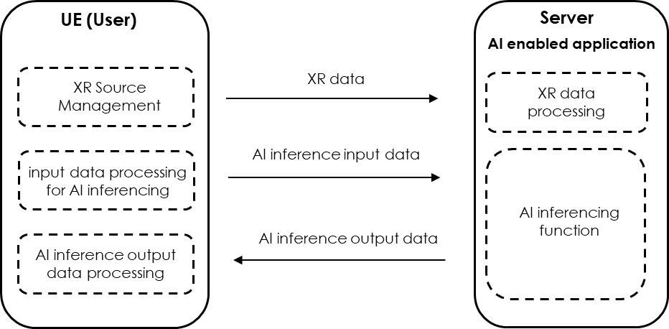
Figure 5.6.2-2: Typicalscenario for AI inferencing with XR traffic

5.6.3 Typical QoE criteria
Several QoE metrics have been defined in the section 4.4 of TR 26.847 [11].
Some of these QoE metrics, mostly related to AI inference quality, depend on the type of task performed by the AI model, e.g., mean Average Precision (mAP) for object tracking, or Word Error Rate (WER) for language translation. Other metrics are related to latency such as the start-up latency, inference latency (either local or remote), delivery latency (downlink) and end-to-end latency.

5.6.4 Typical QoS criteria
TR 26.847 [11] does not define QoS criteria and metrics for uplink data traffic.
Uplink latency: it can be expected that the input data need to be transmitted within a delay-bound (on the uplink) to enable AI inference and related output(s) to meet the expected round-trip end-to-end latency metric (corresponding to the complete response). To enable the delay-bound transmission of input data over uplink, the input data may need different QoS characteristics. These QoS characteristics are FFS.
The end-to-end latency requirement for a real-time AI inference may be similar to the requirements defined in the clause 4.2.2 of TR 26.928 [12] for the round-trip interaction delay: lower than 50ms (ultra-low latency), lower than 100ms (low latency), and lower than 200ms (moderate latency).

* * * End of Changes * * * *

