3GPP TSG-SA4 Meeting #134 S4-251772Rev1
Dallas, USA, 17th-21th Nov 2025

Source: Interdigital Finland Oy.
Title: [AIML_IMS-MED] Web App for split inferencing demonstration
Agenda item: 10.5
Document for: Discussion and Agreement

This contribution presents a simple split inferencing demonstration, inspired by the initial version presented in Geneva. It has been adapted to run as a web-based application, illustrating a concrete example applied to IMS.
The demo showcases a vision application, such as image or scene understanding, that performs various AI/ML tasks using a set of preconfigured split models integrated into the application. It supports multiple split points, enabling the demonstration of different split inference scenarios consistent with those described in the split inferencing call flow contribution (S4-251769). The implementation also incorporates the intermediate data format mechanism, as defined in the related contribution (S4-251771).
The application interface includes the following components:
- AI/ML Task Configuration: Allows the selection of the AI/ML task, model, and a preconfigured split point to be applied to the chosen model.
- Workload Distribution: Provides a visual representation of the split processing between the head inference executed on the client side (e.g., UE) and the tail inference performed on the server side (e.g., MF).
- Execution Settings: Enables the selection of the execution backend, supporting WebGPU or CPU, and WebDNN once it becomes functional.
- Quantization: Enables a basic compression scheme that reduces precision from 32-bit floating point (Float32) to 16-bit floating point (Float16).
- AI Parameter Set: Visualizes the intermediate data format parameters exchanged between the head and tail inference, illustrating how intermediate tensors are represented as defined in (S4-251771).
- Media Input and Output: Supports image upload for inference and displays the resulting output for visualization.
Selection screen
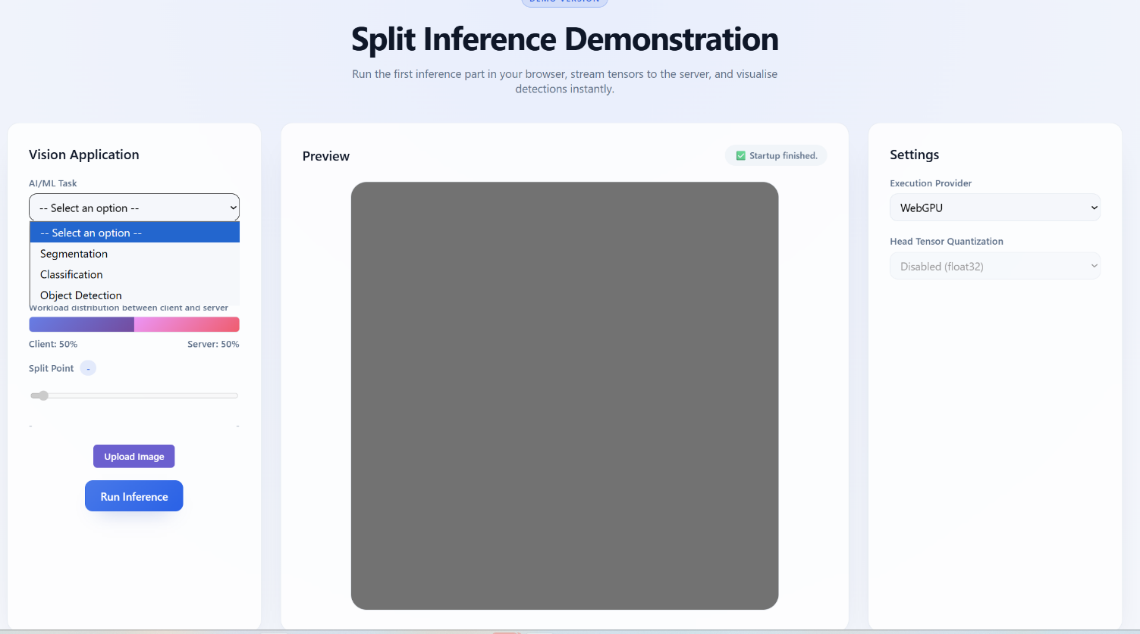

Results screen

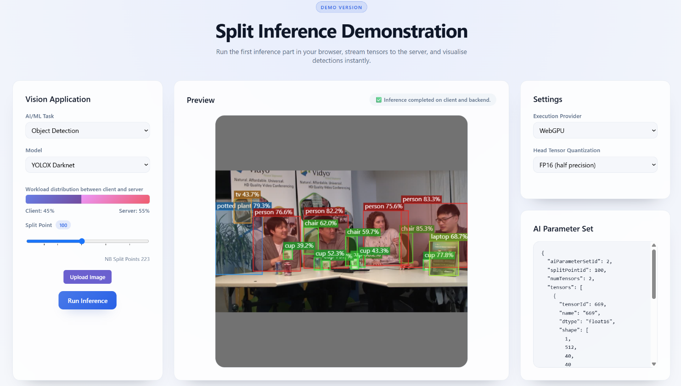
Note: We only implemented object detection tasks.

