3GPP TSG-SA4 Meeting 134 S4-251758
Dallas, United States, 17 November – 21 November 2025

Source: Huawei, HiSilicon
Title: [FS_DCTC_eQoS_MED] Use case for short video streaming
Agenda item: 10.6
Document for: Discussion and Agreement

1. Introduction
This paper presents and analyses the use case of short video streaming/download as used in popular social media platforms such as Douyin, Kuaishu, Instagram, Facebook, TikTok and others.
Independent scientific references are included to support the generality of the proposed use case [1-3].
2. Summary
Short video streaming is different from typical video on demand and linear streaming for several different reasons.
- The videos are shorter (a few seconds up to about 120 seconds or more), therefore typically they use (progressive) file download at single resolution/bit-rate instead of more complex adaptive streaming that supports adaptive bit-rate switching. There may be different bit-rate versions of videos, but typically bit-rate switching is not done during playback instead the app can chose a bit-rate before playing the video.
- The user interacts frequently by using “swipes” interaction, resulting in quick switching between videos. This requires a low start-up delay/switching time.
- Key QoE metrics include start-up delay when switching, average bit-rate, re-buffering time and a key related performance aspect is bandwidth wastage (media bytes downloaded that are eventually not consumed by the end user).
- Research in the scientific literature aims to find a balance between QoE metrics and bandwidth wastage, with the latest trend emphasizing on using deep reinforcement learning techniques.
The typical procedure of the use case is as follows: The user clicks/swipes on a video, then the video is downloaded at once (typically in progressive manner, this implies downloading first the initial part of the video (e.g. movie atom TS 26.244) followed by the rest of the bytes enabling immediate playback of the video as soon as initial part of video is received. When a user swipes and a new video is fetched in similar fashion the old video is terminated and the new video starts playing (ideally with near instantaneous gap between the videos). To achieve a low start-up delay, subsequent videos can be pre-fetched by the application, but in case the user decides not to play the next video the bandwidth is “wasted”. Due to these differences and the combined problem of data wastage and QoE optimization the topic is of interest to the research community.

3. References
[1] Jing Guo , Guanghui Zhang A Video-Quality Driven Strategy in Short Video Streaming MSWiM ’21, November Alicante, Spain
[2] Burak Kara, Gwendal Simon, Ayse B. Demir, Ali C. Begen, and Florence Agboma. Beyond Swiping through Short-Form Videos. In Mile-High Video Conference (MHV ’25), February 18–20, 2025, Denver, CO, USA. ACM,
[3] Guanghui Zhang et al. DUASVS: A mobile Data Saving Strategy in Short Form Video Streaming IEEE Transactions on services and computing vol. 16. No2 2023
[4] Jianchao He, Miao Hu, Yipeng Zhou, and Di Wu. 2020. LiveClip: Towards Intelligent Mobile Short-Form Video Streaming with Deep Reinforcement Learning. In 30th Workshop on Network and Operating System Support for Digital Audio and Video (NOSSDAV’20)
[5] 3GPP TS 26.244 Transparent end-to-end packet switched streaming service (PSS); 3GPP file format (3GP)
** CHANGE 1 **

- References
.....
[x1] Jing Guo , Guanghui Zhang A Video-Quality Driven Strategy in Short Video Streaming MSWiM ’21, November Alicante, Spain
[x2] Burak Kara, Gwendal Simon, Ayse B. Demir, Ali C. Begen, and Florence Agboma. Beyond Swiping through Short-Form Videos. In Mile-High Video Conference (MHV ’25), February 18–20, 2025, Denver, CO, USA. ACM,
[x3] Guanghui Zhang et al. DUASVS: A mobile Data Saving Strategy in Short Form Video Streaming IEEE Transactions on services and computing vol. 16. No2 2023
[x4] Jianchao He, Miao Hu, Yipeng Zhou, and Di Wu. 2020. LiveClip: Towards Intelligent Mobile Short-Form Video Streaming with Deep Reinforcement Learning. In 30th Workshop on Network and Operating System Support for Digital Audio and Video (NOSSDAV’20)
[x5] 3GPP TS 26.244 Transparent end-to-end packet switched streaming service (PSS); 3GPP file format (3GP)
[x6] 3GPP TS 26.247 Progressive Download and Dynamic Adaptive Streaming over HTTP (3GP-DASH)

** CHANGE 2 change clause**

5.5 Short Form Video Download

5.4.1 Description
Short form video download is a popular form of media consumption used in popular social media platforms.
A key difference of this form of media consumption compared to live or on demand video streaming is that videos are shorter (typically up to 120 seconds) and that users interact by “swipes” resulting in a quick switch to a different video.
Consumption of short form video content on mobile devices using 3GPP network accounts for a significant share of the video traffic in 3GPP networks.
Short form video content typically uses progressive download such as supported by the 3GPP file format TS 26.244, downloading first the movie atom that provides information about the media and then later the media samples (enclosed in an ‘mdat’ atom). The advantage of progressive download is that only a single request needs to be performed and the audio and video can be fetched simultaneously. In addition, a low start up delay can be achieved as video can start playing after the bytes representing the movie atom and initial media samples in ‘mdat’ are received.
Social media apps typically need to develop algorithms to manage the trade-off of enable good QoE (good bit-rate low start-up delay and low re-buffering) and limiting bandwidth wastage and unnecessary data usage for the consumer (video bytes downloaded that are not actively viewed by the end user). This is also an active research topic [x1-x4].

5.4.2 Example implementation and end-to-end procedures
The typical and generalized procedure for short form video download/streaming is shown in Figure 5.4.2-1. In this example a PDU Session with the default QoS is used to connect to the data network, and this PDU session is used to establish a connection to the Application Server (AS) (in this baseline it assumed the default QoS profile established for the PDU Session is used).
The UE will request an update to the page with short form videos that provides the features related to short form video playback: playing back the video with a player (shown on the right side) and the ability to “swipe” between video displayed in tiles or other interactive forms. The user clicks on a video and a requests the video. The AS is triggered and the UE downloads the related progressive 3gp/mp4 file that is stored on the AS. More advanced implementations such as discussed in the scientific literature may have a smart approach to select the target bit-rate of the file, i.e. the AS may offer the progressive download files with different encodings and with different bit-rates.
The selection mechanism is typically proprietary and part of the application. The short form video (3gp file) starts downloading and the UE can already identify the initial bytes of the stream. Specifically when the UE has identified the movie atom and several bytes of the ‘mdat’ atom it can trigger a start of playback at the player. The UE will continue to receive the bytes from the AS in the requests and the playback will continue.
Upon a swipe event (no pre-fetch) the UE makes the request for a new short form video (3gp file) and the same procedure is followed. It is assumed that the earlier request(s) already terminated, otherwise the UE may also need to terminate the earlier requests or make the new request in parallel. When sufficient bytes are received the new video can start playing. The UE may be triggered by the fact that the user behaviour seems to favour switching and/or the current video is nearing the end, it pre-fetches a new short form video. This video is downloaded and the previous short form video continues playback. Once the earlier video is completed the player immediately starts the next video that was pre-fetched.
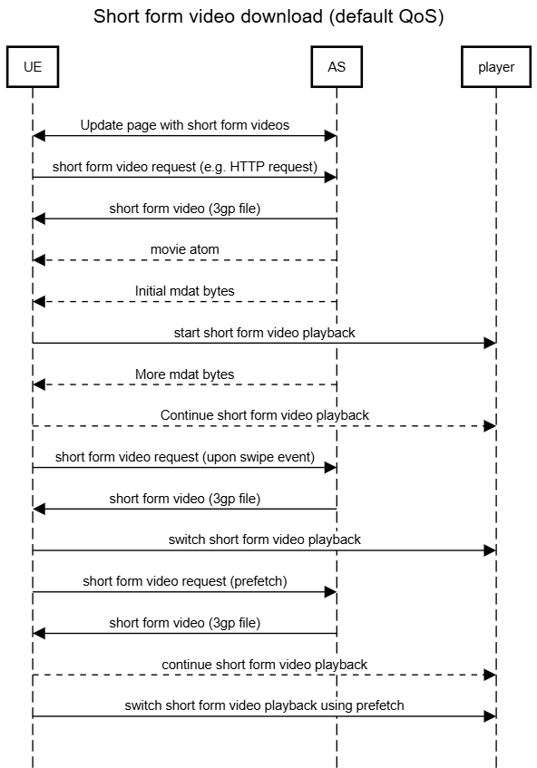
Figure 5.4.2-1example procedure for short form video download

5.4.3 Typical QoE criteria
Typical QoE metrics for Short form video download can be described as follows (according to 3GP DASH in TS 26.247 [x6] clause 10):
Quality of Experience (QoE):
- (Average) Start-up delay (i.e. the time a video start playing after a swipe)
- Average throughput / achieved bit-rate
- Initial playout delay
- Switch time (i.e. time between two sequential videos)
- Buffer Level
- Consumer bandwidth wasted/ not consumed video
- Increased battery consumption

5.4.4 Example 3GPP QoS usage
Quality of Service (QoS) related characteristics for this service are given as examples in 3GPP (TS 23.501) are defined as follows:
- 5QI 4 GBR 300 ms packet delay budget, 10^-6 packet error rate
- 5QI 6 non-GBR 300 ms packet delay budget, 10^-6 packet error rate

** END OF CHANGES **

