3GPP TSG-SA4 Meeting 134 S4-251756
Dallas, United States, 17 November – 21 November 2025

Source: Huawei, HiSilicon
Title: [FS_DCTC_eQoS_MED] Use case for On Demand Video Streaming
Agenda item: 10.6
Document for: Discussion and Agreement

1. Introduction
This paper presents the use case of on-demand video streaming.
2. Summary
Video-on-Demand Streaming is a popular way of consuming content such as movies, films, documentaries or other user generated content.
Current popular video protocols for on demand streaming include HTTP Live Streaming (HLS) and Dynamic Adaptive Streaming over HTTP (DASH). Common media application format (CMAF) and fragmented MP4 are popular formats used in streaming protocols as they can support seamless bit-rate switching and popular common encryption techniques supported on different device platforms.
Video-on-demand streaming poses some additional challenges when compared to live streaming. As content is generally available, clients can choose to download more or less of the segments based on the device and network context. For on-demand video streaming data wastage can also be a problem. Use cases exist where video on demand content can be downloaded for later consumption using background data transfer, or when connected to WiFi Network.
Streaming in the 5G System is addressed in TS 26.501, with typical procedures for DASH streaming in clause 5.7.4 of [1] covering the on-demand case. Another challenge addressed in [2] is Digital rights management, popular movies need Digital Rights management 5.14 [1] as different platforms support different DRM solutions.
The main aspect with regard to dynamic traffic characteristics for on-demand video streaming is to study the typical traffic patterns resulting from popular video no demand players.
Key performance indications include video start-up time, average stream quality achieved, reduction of upstream traffic (increasing load to the streaming system). Reduced re-buffering/freezing time.
Quality of Experience (QoE) Metrics include: Re-buffering Ratio/Duration, Start-up Delay, Average Video Bitrate, Bitrate Stability/Switches as documented in TS 26.947 [5].
In 5GS QoS model this type of traffic is associated to 5QI 4 and 6, GBR or non-GBR, 300ms maximum packet delay and packet error rate 10^-6.
3 References
[1] ISO/IEC 23009-1: "Information Technology – Dynamic Adaptive Streaming Over HTTP (DASH) – Part 1: Media Presentation Description and Segment Formats".
[2] IETF RFC 8216: "HTTP Live Streaming".
[3] ISO/IEC 23000-19: "Information Technology Multimedia Application Format (MPEG-A) – Part 19: Common Media Application Format (CMAF) for segmented media".
[4] 5G Media Streaming
[5] 3GPP TS 26.247 Progressive Download and Dynamic Adaptive Streaming over HTTP (3GP-DASH)
** CHANGE 1 **

3 References
……
[x1] ISO/IEC 23009-1: "Information Technology – Dynamic Adaptive Streaming Over HTTP (DASH) – Part 1: Media Presentation Description and Segment Formats".
[x2] IETF RFC 8216: "HTTP Live Streaming".
[x3] ISO/IEC 23000-19: "Information Technology Multimedia Application Format (MPEG-A) – Part 19: Common Media Application Format (CMAF) for segmented media".
[x4] 3GPP TS 26.501 5G Media Streaming General description and architecture
[x5] 3GPP TS 26.247 Progressive Download and Dynamic Adaptive Streaming over HTTP (3GP-DASH)
** CHANGE 2 **

5.3 Video on Demand Streaming

5.3.1 Description
Video-on-demand Streaming is a popular way of consuming content.
Current popular video protocols for on demand streaming include HTTP Live Streaming (HLS) [x1] and Dynamic Adaptive Streaming over HTTP (DASH) [x2]. Common Media Application Format (CMAF) [x3] is a popular format used by these streaming protocols as it can support bit-rate switching and popular common encryption techniques supported on different device platforms.
Streaming in the 5G System is addressed in TS 26.501, with typical procedures for DASH streaming in clause 5.7.4 of [1]. Another challenge addressed in [2] is Digital rights management, popular movies need Digital Rights management 5.14 [1] as different platforms support different DRM solutions. The support for DRM is important for both live and on demand video content.
From a mobile network perspective, on-demand video streaming can introduce data wastage in different ways. For example content is downloaded but not watched eventually. Also content may be downloaded via mobile network but later WiFi is becoming available when the video is consumed, i.e. a better condition. This is not always problematic, use cases exist where video on demand content can be downloaded for later consumption, taking advantage of favourable network conditions. Another potential challenge for video-on-demand streaming is the different dynamic patterns introduced by players for pre-fetching content which is not possible in live streaming.
Key performance indicators for video on demand streaming include video start-up time, average stream quality achieved. Reduced re-buffering/freezing time and reduced number of stream switching events. For mobile devices, in some cases other aspects can be important such as battery power saving and avoiding mobile data wastage.
Overall, video on demand streaming is usually a bit easier to achieve compared to live streaming, as in on demand streaming profiles typically all segments are available, Because of this, an efficient way to achieve video on demand streaming uses byte range request based on information provided in CMAF by the media segment index box (sidx box). However, because of this flexibility in the segment download different dynamic traffic patterns may occur. For this report the main emphasis is on typical dynamic traffic patterns introduced by on-demand video streaming and the resulting QoS requirements.

5.3.2 Typical implementation and end-to-end procedures
The typical procedure here as example focusses on on-demand streaming using DASH.
Streaming in the 5G System is addressed in TS 26.501, with typical procedures for DASH streaming in clause 5.7.4. In this clause we provide a simplified procedure to give a global overview of how video on demand streaming can work in practice and that can help us to later analyse potential video-on-demand streaming traffic characteristics.
The procedure is based on on-demand streaming such as using the on demand profile in DASH.
The simplified procedure in Figure 5.3.2-1 is explained as follows. The UE connects to the 3GPP network using required procedures and established a PDU Session connecting to the data network (this usually is already existing and not specific to the streaming application/session).
In this example, in a step to start the streaming, the default QoS flow is used to connect to application server (AS) that hosts the available streams (for the DASH case made available as mpd files).
The user at the UE selects the stream/mpd it is interested to watch by a request to the Application Server (AS).
Initialization segments should be downloaded for the different media types (e.g. audio, video, text), then also segment index segment can be downloaded which contains information about all the bit-rates (also for each media type).
Based on the information in the media presentation description and information at the device and possibly the initialization segments, if needed a DRM license exchange with the DRM server is performed, possibly involving several exchanges of information to enable the UE to get a license that it can use to decode and render the media content.
Then, initial media segments are requested from the AS and playback can start at the player.
The UE keeps requesting media segments based on the information in the segment index box, and in case it detects a network degradation it may switch to lower bit-rate segments. In some case when the network is good it may also switch to a higher bit-rate, some players start playing from a lower bit-rate to enable faster start-up time.
The new segments are also passed to the player and played back.
The segment download and playback continues until all segments are downloaded and the stream is ended or earlier when the user closes the stream.
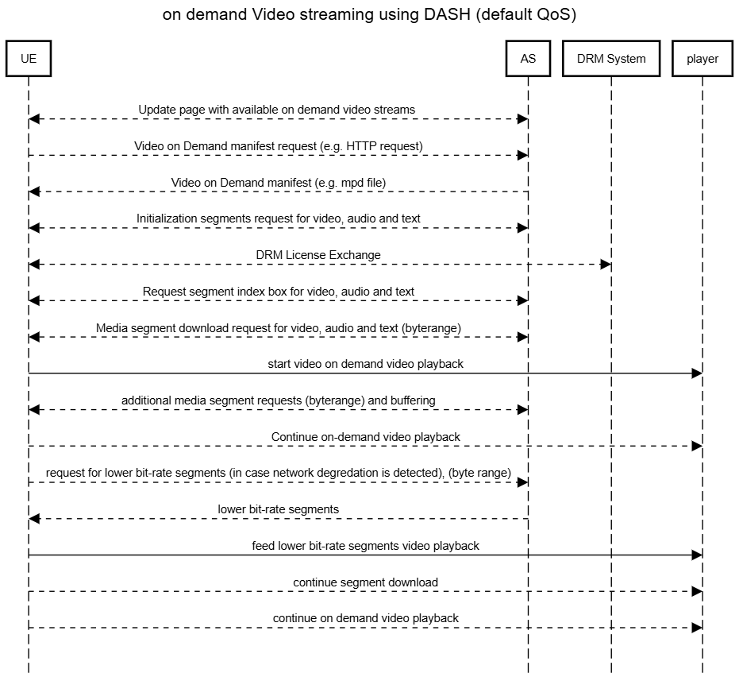
Figure 5.3.2-1 typical procedure for video on demand streaming

5.3.3 Typical QoS and QoE criteria
Typical QoS and QoE metrics for Live Streaming described as follows:
Quality of Experience (QoE) Metrics documented in 3GPP in TS 26.247 [x5] include:
- Representation switch events
- Average throughput
- Initial Playout delay
- Media startup delay
In the 5GS QoS model this type of traffic in TS 23.501 this type of traffic is characterized by different 5QI's given as examples that could meet the QoS needs of such a service:
- 5QI 4: with GBR QoS Flow, 300ms maximum packet delay budget and packet error rate 10^-6 and averaging window is 2000 ms.
- 5QI 6: with non-GBR QoS Flow, 300ms maximum packet delay budget and packet error rate 10^-6.
** END OF CHANGES **

