3GPP TSG-SA4 Meeting 134 S4-251755
Dallas, United States, 17 November – 21 November 2025

Source: Huawei, HiSilicon
Title: [FS_DCTC_eQoS_MED] Use case for Live Streaming
Agenda item: 10.6
Document for: Discussion and Agreement

1. Introduction
This paper presents the use case of live video streaming.
2. Summary
Live Video Streaming is popular way of distributing content. It is often used for television services (e.g. internet based television) or in other tailored streaming applications (e.g. live sports streaming or ad supported channels).
Another use case is digital live radio that can use live streaming technologies.
Current popular video protocols for live streaming are HTTP Live Streaming (HLS) and Dynamic Adaptive Streaming over HTTP (DASH). Common media application format (CMAF) is a popular format used in streaming protocols. CMAF can support bit-rate switching and popular encryption techniques supported on different device platforms.
Live streaming typically uses similar mechanisms as video on demand streaming for delivery (i.e. sequential segment download). However, in live streaming segments are becoming gradually available and it is not possible to download many segments ahead of the playback. This may make the successful and in-time downloading of segments more critical for live streaming as less media segments may be buffered compared to video-on-demand streaming. Another reason for smaller buffering in live streaming is that typically a lower end-to-end latency is desired (i.e. from capture to playback).
Streaming in the 5G System is addressed in TS 26.501, with typical procedures for DASH streaming in clause 5.7.4 of [1]. Another challenge addressed in [2] is Digital rights management including the content preparation. Popular movies and other premium content need Digital Rights management 5.14 [1]. Different platforms support different DRM solutions this also applies to live streaming and is one challenges in the content preparation. 5G Media streaming also supports dynamic policy enabling 5G QoS monitoring and early congestion marking and other QoS related provisioning features.
From a mobile network perspective, for live video streaming one of the problems pointed out, is that some segment can introduce significant latency (probably caused by radio transmission error affecting the HTTP/TCP/protocol stack). Such latencies can disrupt live radio streaming services. It is worthy to explore what traffic characteristics and QoS mechanisms can be used to cover these cases.
Another issue for live streaming is the start-up delay (i.e. service setup time), channel switching delay in addition to latency.
Key performance indications include video start-up time, average stream quality achieved, reduction of upstream traffic (increasing load to the streaming system), and reduced re-buffering/freezing time.
Quality of Experience (QoE) Metrics include: Re-buffering Ratio/Duration, Start-up Delay, Average Video Bitrate, Bitrate Stability/Switches as documented in TS 26.947 [5].
Additional popular metrics include the Mean Opinion Score (MOS), VMAF (Video Multimethod Assessment Fusion).
In 5GS QoS model this type of traffic is associated to 5QI 6, non-GBR, 300ms maximum packet delay and packet error rate 10^-6.

3. References
[1] ISO/IEC 23009-1: "Information Technology – Dynamic Adaptive Streaming Over HTTP (DASH) – Part 1: Media Presentation Description and Segment Formats".
[2] IETF RFC 8216: "HTTP Live Streaming".
[3] ISO/IEC 23000-19: "Information Technology Multimedia Application Format (MPEG-A) – Part 19: Common Media Application Format (CMAF) for segmented media".
[4] 5G Media Streaming General description and architecture
[5] 3GPP TS 26.247 Progressive Download and Dynamic Adaptive Streaming over HTTP (3GP-DASH)

** CHANGE 1 **

2 References
……
[x1] ISO/IEC 23009-1: "Information Technology – Dynamic Adaptive Streaming Over HTTP (DASH) – Part 1: Media Presentation Description and Segment Formats".
[x2] IETF RFC 8216: "HTTP Live Streaming".
[x3] ISO/IEC 23000-19: "Information Technology Multimedia Application Format (MPEG-A) – Part 19: Common Media Application Format (CMAF) for segmented media".
[x4] 3GPP TS 26.501 5G Media Streaming General description and architecture
[x5] 3GPP TS 26.247 Progressive Download and Dynamic Adaptive Streaming over HTTP (3GP-DASH)
[x6] ETSI TS 103 770 Digital Video Broadcasting (DVB); Service Discovery and Programme Metadata for DVB-I
[x7] ETSI TS 285 103 Digital Video Broadcasting (DVB); MPEG-DASH Profile for Transport of ISO BMFF Based DVB Services over IP Based Networks
** CHANGE 2 **

3.1 Terms
Live Streaming Streaming with not all segments being available for download

** CHANGE 2 (replace clause 5.4)**

5.4 Live Streaming

5.4.1 Description
Live Video Streaming is a form of streaming where content is becoming gradually available, resembling to some extend television broadcasts. With time more media is becoming available.
Live Video Streaming is popular way of distributing content. It is often used for television services (e.g. Internet based television such as DVB-I [x6] with delivery using DVB-DASH [x7]) or in other streaming applications (e.g live sports streaming apps or ad supported channel apps).
Another use case is digital live radio that can use live streaming technologies.
Current popular video protocols for live streaming are HTTP Live Streaming (HLS) [x1] and Dynamic Adaptive Streaming over HTTP (DASH) [x2]. Common media application format (CMAF) [x3] is a popular format used in streaming protocols. CMAF can support bit-rate switching and popular encryption techniques supported on different device platforms. In 3GPP adaptive streaming protocols were developed in [x5].
Live streaming (using DASH or HLS) typically uses similar mechanisms as video-on-demand streaming for delivery (i.e. sequential segment download). However, in live streaming segments are made available over time and it may not be possible to download many segments ahead of the playback. This may make the successful and in-time downloading of segments more critical for live streaming as less media segments may be buffered compared to video-on-demand streaming. As a lower end-to-end latency is desired (i.e. from capture to playback), smaller buffering in live streaming is often used.
Streaming in the 5G System is addressed in TS 26.501, with typical procedures for DASH streaming in clause 5.7.4 of [x1]. Another challenge addressed in [x1] is Digital rights management including the content preparation. Popular movies and other premium content need Digital Rights management. Different playback system platforms support different DRM solutions and this also applies to live streaming. 5G Media streaming[x4] also supports dynamic policy enabling 5G QoS monitoring and early congestion marking and other QoS related provisioning features for the streaming delivery.
There are many challenges in deploying live streaming that are independent from the mobile network, such as setting up the content preparation head-end and content delivery networks and overall distributed caching strategy to meet performance requirements. However, from a mobile network perspective, for live video streaming one of the problems faced in practice is that some segments can introduce significant latency (probably caused by radio transmission error affecting the HTTP/TCP/protocol stack). Such latencies can disrupt live radio and/or video streaming services. It is worthy to explore what traffic characteristics and QoS mechanisms can be used to cover these cases.
Another issue for live streaming is the start-up delay (i.e. service setup time), channel switching delay in addition to latency (capture to playback). Loss of some initial segment data may result in delayed startup and increased startup time.
Live Streaming also has many challenges in the back-end e.g. redundant content generation, failover support and dynamic ad insertion. For this study these points are not taken into consideration unless they explicitly relate to the dynamic traffic characteristics in the mobile network and related 5G QoS features.

5.4.2 Typical implementation and end-to-end procedures
The end-to-end procedure example in the clause focuses on streaming using DASH [x1].
Streaming in the 5G System is addressed in TS 26.501, with typical procedures for DASH streaming in clause 5.7.4 [x4].
In this clause we provide a simplified procedure to give a global overview of how live streaming can operate in practice that can help us to later analyse traffic characteristics in the wild or in testbed environments.
The procedure is based on live streaming such as using the mpeg live profile in MPEG-DASH. For more detailed procedures of streaming in 5G Media streaming see [x4]. In practice both 5G media streaming and conventional media streaming (without explicit 5G support) are deployed in 5G networks.
The simplified procedure for live streaming is shown in Figure 5.4.2-1. The UE connects to the 3GPP network using required procedures and establishes a PDU Session with the data network with the default QoS flow. Improved/enhanced QoS usage is the subject of this report, and solutions may consider dynamic policy using media session handler and specific application function as supported in [x4]. The step of connecting to the data network that host the AS is not shown in the procedure in Figure 5.4.2-1.
The first (optional) step is for the UE to retrieve a list of available video streams from the Applications server. The UE then selects an MPD/stream based on its preference, e.g. selection of an internet television channel. The live MPD/manifest is retrieved by the UE. Potentially the UE requests license in a license exchange with a DRM System in case content is encrypted. The UE then request the initialization segments. Then, it will request the media segments (based on availability). When the UE has received enough segments it will start the live media playback at the player. Based on segment availability additional segments are requested by the UE and the playback continues. The UE requests updated MPD/manifest in time and based on this updated MPD more media segments are requested based on the segment availability. The live media playback continues. In case the user/UE does not terminate the stream the playback and periodical segment/mpd requests continue and the stream keeps playing.

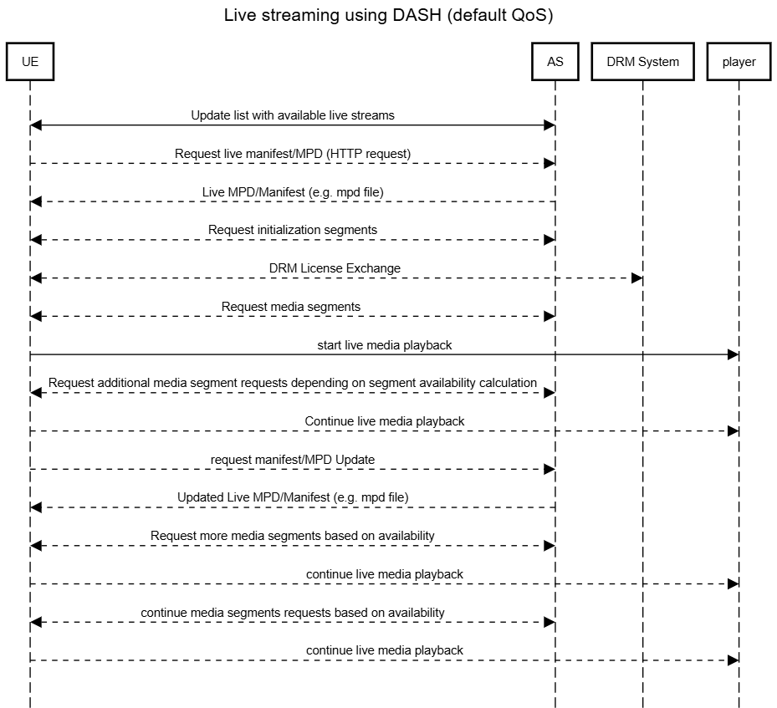
Figure 5.4.2-1 typical procedure for live video streaming

5.4.3 Typical QoS and QoE criteria
Typical QoS and QoE metrics for Live Streaming described as follows:
Quality of Experience (QoE) Metrics documented in 3GPP in TS 26.247 [x5] include:
- Representation switch events
- Average throughput
- Initial Playout delay
- Media startup delay

In 5GS QoS model this type of traffic is as example in TS 23.501 associated to 2 different 5Q:
- 5QI 6, non-GBR QoS Flow, 300ms maximum packet delay and packet error rate 10^-6, see clause 5.7.4 of TS 23.501.
- 5QI 4, GBR QoS Flow, 300ms maximum packet delay and packet error rate 10^-6, see clause 5.7.4 of TS 23.501.

** END OF CHANGES **

