3GPP TSG-SA4 Meeting 134 S4-251754
Dallas, United States, 17th – 21th November 2025

Source: Huawei, HiSilicon
Title: [FS_DCTC_eQoS_MED] Use case for upstream/downstream AI inferencing
Agenda item: 10.6
Document for: Discussion and Agreement

1. Introduction
This paper presents the use case of upstream and downstream AI inferencing (including split inferencing), where a part of the AI inferencing happens at the server or network and part at the UE. The source data comes from the UE or from the network. The descriptions maps to the agreed text/use case from TS 26.927 clause 5.2.3.

** CHANGE 1 **

2 References
The following documents contain provisions which, through reference in this text, constitute provisions of the present document.
- References are either specific (identified by date of publication, edition number, version number, etc.) or non-specific.
- For a specific reference, subsequent revisions do not apply.
- For a non-specific reference, the latest version applies. In the case of a reference to a 3GPP document (including a GSM document), a non-specific reference implicitly refers to the latest version of that document in the same Release as the present document.
[1] 3GPP TR 21.905: "Vocabulary for 3GPP Specifications".
[2] 3GPP TS 26.522: "5G Real-time Media Transport Protocol Configurations".
[3] 3GPP TS 23.501: "System architecture for the 5G System (5GS)".
[4] 3GPP TS 26.822: "Study of 5G RTP protocol phase 2".
[5] 3GPP TR 23.700-70: "Study on architecture enhancement for Extended Reality and Media service (XRM); Phase 2".
[6] 3GPP TR 26.925: Technical Specification Group Services and System Aspects; Typical traffic characteristics of media services on 3GPP networks
[7] 3GPP TR 26.926: "Traffic Models and Quality Evaluation Methods for Media and XR Services in 5G Systems".
[x1] 3GPP TR 26.927 “Study on Artificial Intelligence and Machine Learning in 5G media services”
[x2] 3GPP TR 26.847 “Evaluation of Artificial Intelligence and Machine learning in 5G media services”
[x3] 3GPP TR 22.870: “Study on 6G Use Cases and Service Requirements”.
[x4] 3GPP TR 22.874: “Study on traffic characteristics and performance requirements for AI/ML
model transfer in 5GS”.

** CHANGE 2 **

5.6 Media upstream/downstream AI inferencing

5.6.1 Description
An AI/ML operation/model may be split into multiple parts according to the current task and environment. The intention is to offload the computation-intensive, energy-intensive parts to network endpoints, whereas leaving the privacy-sensitive and delay-sensitive parts at the end UE. In that case, the UE executes the operation/model up to a specific part/layer and then sends the intermediate data to the network endpoint, the network endpoint then executes the remaining parts/layers and feeds the inference results back to the UE. Alternatively, the network endpoint may firstly execute the operation/model up to a specific part/layer and then sends intermediate data to the UE, which then executes the remaining parts/layers before consuming the inference results.
This split inference process is for example defined in the use case of section 6.10 of TR 22.870 [x3], where a home robot and the network negotiate and perform the layer split distributed inference together to provide timely perception and action guidance for the robot within complex real-world environments.
Another use case on image recognition is defined in section 5.1 of TR 22.874 [x4] where the AI/ML splitting operation allows to complete an image recognition task by optimizing the computation, communication and energy resources over the AI/ML endpoints.

Clause 5.2.3 of TR 26.927 [x1] describes the split inferencing process, with both upstream and downstream transmission of intermediate AI data that have favourable network transmission properties (e.g. privacy conservation, lower bit-rate etc.). This way the inferencing process is distributed and intermediate data is transferred with preferable properties.
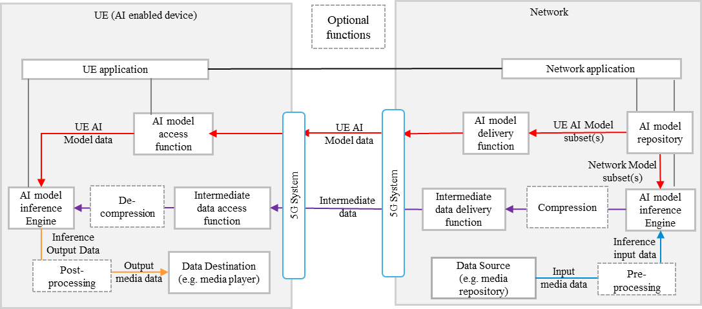
Figure 5.6.1-1: Basic architecture for split inference between the network and UE, with media data source in the network or from the UE via the network [x1]
Figure 5.6.1-1 shows the basic architecture for split inferencing between the network and the UE, where the media data source comes from the network. The first part of the AI/ML model is executed on the network side and the second part on the UE.
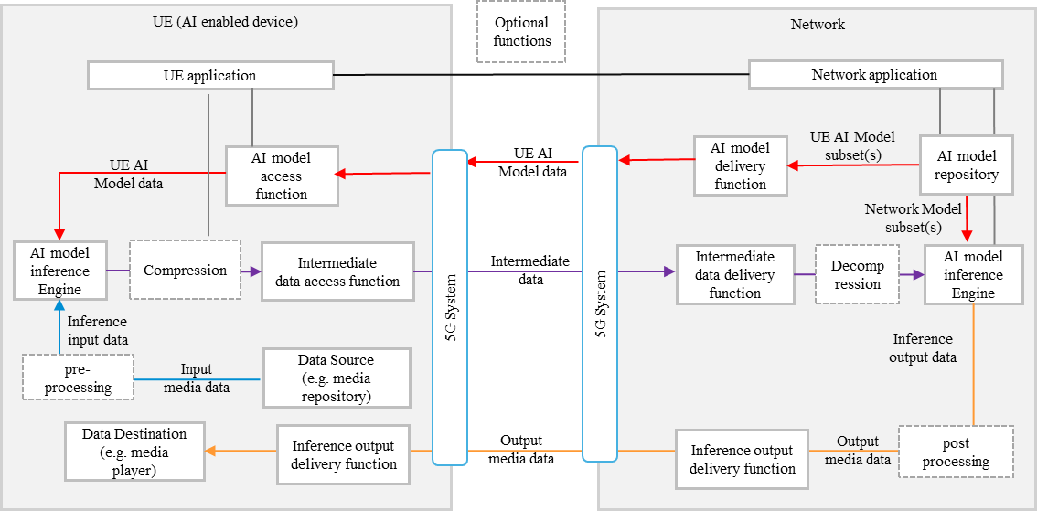
Figure 5.6.1-2: Basic architecture for split inference between the UE and network, with media data source in the UE [x1]
Figure 5.6.1-2 shows a basic architecture for split inferencing between the UE and the network, where the media data source originates from the UE, the first part of the inference is performed in the UE, the second part in the network. The resulting output data is finally sent back to the UE.

5.6.2 Example End-End procedures
Figure 5.6.2 from TS 26.927 shows a basic workflow for split inference between the network and UE. Steps for the procedures shown are described below. The related formats for transmission are discussed in clause 6 of TS 26.927 [x1].

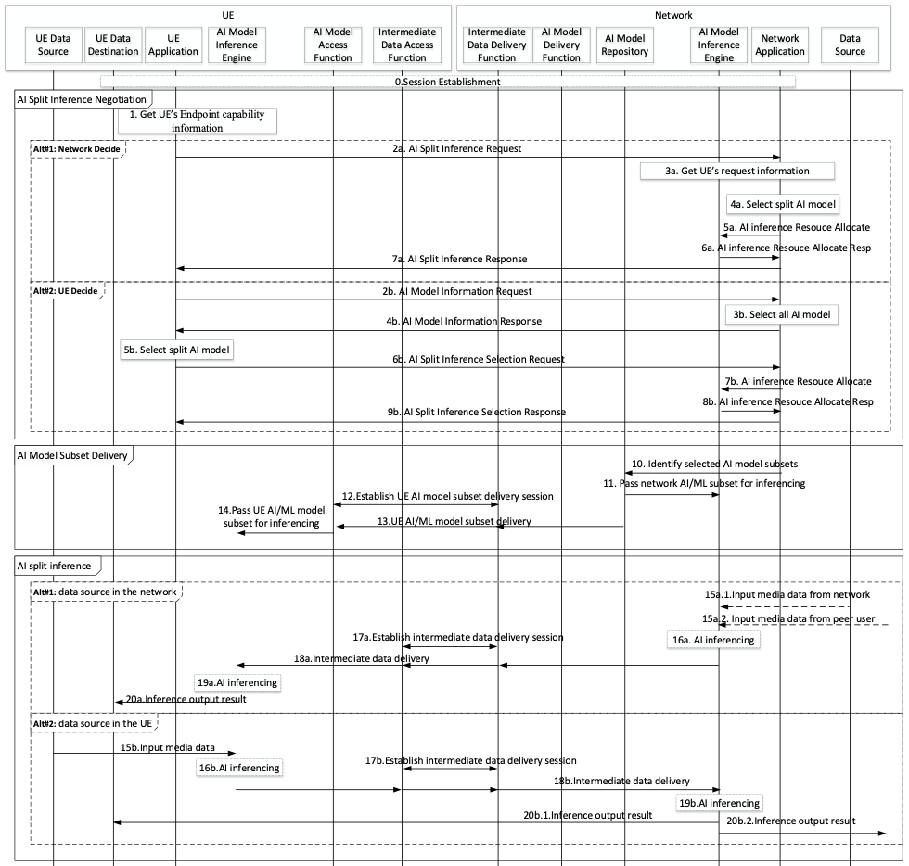
Figure 5.2.3-3: Basic workflow for split inference between the network and UE [x1]
The detailed steps of the sequence diagram procedure are documented in clause 5.2.3.2 of TS 26.927.
A simplified implementation (Figure 5.2.2-4) with the data source and local rendering in the UE may be used for evaluation.

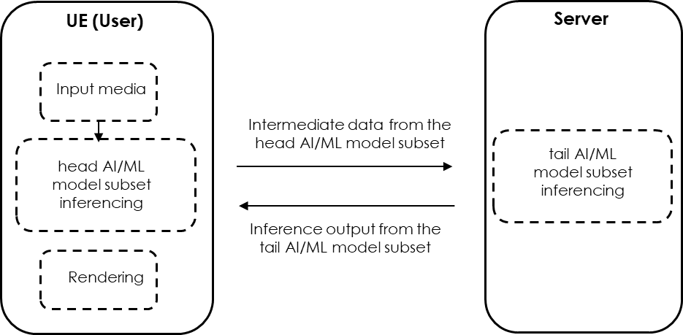
Figure 5.2.2-4: Simplified implementation of AI split inferencing with data source and local rendering in the UE

5.6.3 Quality of experience metrics
Typical Quality of Experience metrics include time to result (response time) and accuracy of the result.
It may depend on the use case (i.e. real-time industrial inference versus non-real time inferencing).

5.6.3 Quality of experience metrics

In the 5GS QoS model this type of traffic for real time inferencing is associated different 5QI values (i.e. see clause 5.7.4 of TS 23.501):
- 5QI 85: delay critical GBR QoS flow with 5 millisecond packet delay budget 10^-5 packet error rate and 255 maximum burst volume
- 5QI 88: delay critical GBR QoS flow with 10 millisecond packet delay budget 10^-3 packet error rate and 1125 maximum burst volume
- 5QI 89: delay critical GBR QoS flow with 15 millisecond packet delay budget 10^-4 packet error rate and 17000 bytes maximum burst volume
- 5QI 90 delay critical GBR QoS flow with 20 millisecond packet delay budget 10^-4 packet error rate and 63000 bytes maximum burst volume
Extensive evaluation is available in TR 26.847 including open points for further investigation.

