3GPP TSG-SA WG4 Meeting #134 S4-251947

Dallas, US, - November 2025 Revision of S4-251865

Source: China Mobile Com. Corporation, InterDigital Communication, Pengcheng Laboratory, LG Electronics Inc, CATT, Deutsche Telekom, ZTE, Nokia, Samsung, KDDI

Title: New SID on Beyond 2D Video Phase 2

Document for: Agreement

Agenda Item: 17.1

3GPP™ Work Item Description
Information on Work Items can be found at http://www.3gpp.org/Work-Items
See also the 3GPP Working Procedures, article 39 and the TSG Working Methods in 3GPP TR 21.900

Title: Study on Beyond 2D Video Phase 2

Acronym: FS_Beyond2D_Ph2

Unique identifier: XXXXXX

Potential target Release: Rel-20

1 Impacts

Affects: | UICC apps | ME | AN | CN | Others (specify)
Yes |  | X |  | X
No | X |  | X |  | X
Don't know

2 Classification of the Work Item and linked work items

2.1 Primary classification

This work item is a …

X | Study
 | Normative – Stage 1
 | Normative – Stage 2
 | Normative – Stage 3
 | Normative – Other*
* Other = e.g. testing

2.2 Parent Work Item

Parent Work / Study Items
Acronym | Working Group | Unique ID | Title (as in 3GPP Work Plan)
FS_Beyond2D | SA4 | 1030008 | Evaluation and Characterization of Beyond 2D Video Formats and Codecs

2.3 Other related Work Items and dependencies
Other related Work /Study Items (if any)
Unique ID | Title | Nature of relationship
960046 | Real-time Transport Protocol Configurations | May reference RTP-based solution for transporting beyond 2D video content.
950014 | Immersive Real-time Communication for WebRTC | May reference transport protocols and payload formats for the distribution of beyond 2D video content.
870011 | Feasibility Study on 5G Video Codec Characteristics | May reference video codecs for different beyond 2D video content and defined scenarios for work flows.
1000017 | Evaluation of new HEVC coding tools | May reference HEVC profile.

3 Justification
NOTE: The supporting members propose doing the work either in a new study as described in this SID or integrate the format/media related work in another study such as FS_6G_MED. and network related work in respectively FS_QStream, FS_Q4RTC-MED or FS_AVFOPS. The results of the herein described studies should be published in TR 26.956
..
In Rel-19, TR 26.956 studied and documented existing and emerging beyond 2D video formats and compression technologies, including stereoscopic video, dense dynamic point clouds, multi-view video plus depth, dynamic mesh, NeRF (Neural Radiance Fields), 3D Gaussian Splatting, and Light Field. However, due to time constraints, the following aspects were left for further study:
- For dynamic mesh, there are several points to be addressed:
- The dynamic mesh content generation for offline productions in prosumer case (e.g. social media) and for real-time applications need to be studied.
- In Rel-19, TR 26.956 described objective metrics (both point-based and image-based methods) and subjective evaluations for dynamic mesh based on a reference, but no actual tests have been performed as work in MPEG had not sufficiently evolved at the release of the first version of the technical report. Objective and subjective tests should be studied at the same level as has been already done for dynamic point clouds.
- For dynamic mesh without a reference (e.g., AI-generated), objective metrics or subjective methodologies for visual quality evaluation have not been studied. Study the framework that aims to evaluate the quality of AI generated dynamic meshes without requiring reference models. The idea is to decouple geometric and appearance information from textured 3D meshes. Geometric information includes global semantic features and structural quality features, while appearance information includes global semantic features and texture quality features. By fusing and comparing the global semantic features of geometry/appearance with the text semantic features extracted from text prompts, semantic alignment quality features are obtained. Finally, the framework integrates geometric structure quality features, texture quality features, and semantic alignment quality features, dynamically adjusting the contribution of each evaluation dimension to derive an overall quality score.
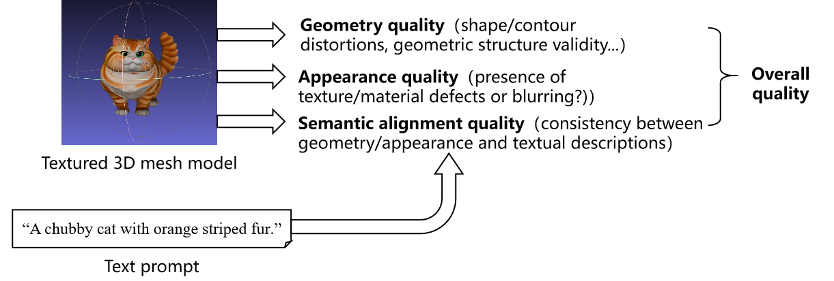

- Multi-view video, is used in broadcast over IP services (such as XfinityTM Multiview+https://www.xfinity.com/hub/tv-video/multiview, YouTubeTM TV https://www.lifewire.com/use-multiview-in-youtube-tv-7724672). In Rel-19, TR 26.956 primarily described a DASH-based delivery method. More efficient delivery methods to achieve cross-terminal, cross-network transmission needs to be further studied. Further alignment with the generalized media delivery architecture defined in TS 26.501/506 should be achieved.
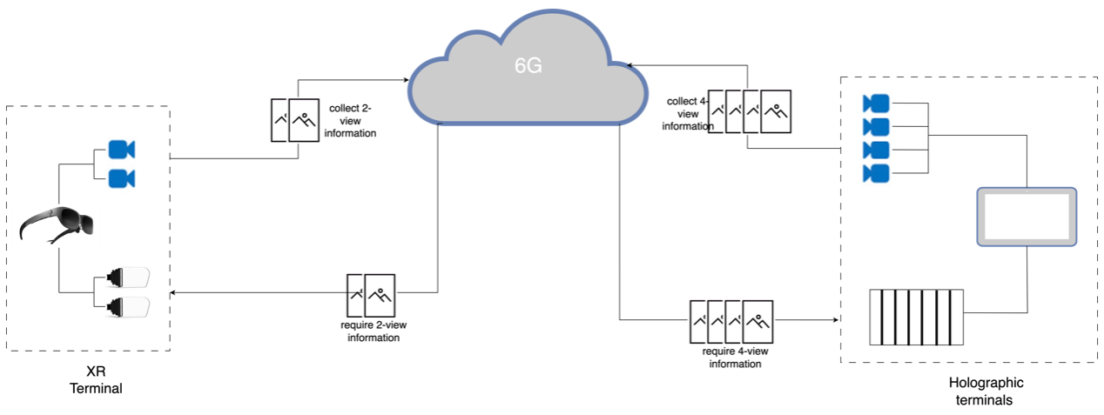
Terminal A requires left and right eye view contents for display and is equipped with binocular cameras to collect 2-view information; Terminal B requires 4-view contents for display and has 4 cameras to collect 4-view information. When A and B communicate, the 2-view information collected by A's acquisition device cannot be directly applied to device B for display, and the 4-view information obtained by B cannot be directly applied to device A for display.
- In Rel-19, TR 26.956 did not address network optimizations. In Rel-20, further clarification on the network demands (e.g., latency, storage, and computing resources) for the end-to-end transmission and media processing of Beyond 2D video content need to be studied.
Additionally, in Rel-19, TR 26.956 identified three reference scenarios for Beyond 2D video and their corresponding workflows: 1) UE-to-UE stereoscopic video live streaming; 2) Streaming of professionally produced volumetric video with a single asset containing people; 3) Streaming of multi-view content with depth. Other scenarios, such as messaging, and real-time communication, may also be considered in Rel-20 work. For example, SA1 6G study TR 22.870 has identified use cases relevant to Beyond 2D video:
- 9.12 Use case on personalized interactive immersive guided tours, where volumetric video with a single asset is generated in a prosumer production environment.
- 6.27 Use case on network-assisted video-based AI inference task offloading for mobile embodied AI, Use case on network-assisted video-based AI inference task offloading for mobile embodied AI, devices such as robots and UAVs equipped with multiple cameras are required to capture and upload multi-modal concurrent data streams (e.g., video, point clouds) for network-based AI inference. These streams are transmitted via a unified bearer network to a network-based platform or third party platforms for distributed AI inference tasks, including multi-modal perception, 3D digital twin modeling, trajectory planning, and task orchestration. This supports various embodied tasks in educational, home, industrial, and special environments, such as automatic inspection and troubleshooting, human-computer interaction and remote operation. This use case may have significant demands on the uplink, requiring both high data rates and low communication latency.
For mobile embodied AI use case:
- Study the video-based data acquisition and collection system for the embodied AI system.
- Analyze the traffic characteristics and evaluate whether there is any additional requirements and extension on network and media capability .
- Validate assumptions from other groups (e.g., SA1) regarding data flows and media-related requirements, and investigate the trade-off between transmitting raw media streams and processed data.
- Define and document fidelity metrics and latency requirements for further analysis and investigation.

4 Objective
The study item has the following objectives:
- Study and document the following aspects related to dynamic mesh:
- The dynamic mesh content generation for both offline production in prosumer cases (e.g., social media) and for real-time applications.
- Objective or subjective methods for evaluating D-Mesh visual quality, particularly for non-reference content.
- Evaluate dynamic mesh formats with existing and emerging compression technologies (notably MPEG V-DMC with HEVC), providing objective results and videos for subjective testing.
NOTE 1: Reuse existing performance results from MPEG or other standard organizations, fitting in the evaluation framework defined in 3GPP may be considered and is recommended to be done. If there are no suitable existing performance results, communication with MPEG to ask for potential further evaluation on selected topics may be done, but 3GPP may also initiate the evaluation independently of MPEG.
- Identify and document more efficient delivery methodologies and potential network optimizations that supports low-latency transmission of beyond 2D video content across different terminals and networks.
- Identify and document potential new scenarios, such as Use Case 9.12 and Use Case 6.27 from the SA1 6G study, along with the corresponding workflows (capturing, encoding, packaging, delivery, decoding, and rendering).
- If time permits, study and document Beyond 2D video formats that have not yet been covered in TR 26.956.
- Identify potential areas for normative work as the next phase and communicate with other 3GPP WGs regarding relevant aspects related to the study to the extent needed.

5 Expected Output and Time scale

New specifications {One line per specification. Create/delete lines as needed}
Type | TS/TR number | Title | For info  at TSG# | For approval at TSG# | Rapporteur
 |  |  | SA#110 | SA#113

Impacted existing TS/TR {One line per specification. Create/delete lines as needed}
TS/TR No. | Description of change | Target completion plenary# | Remarks
TR 26.956 | Complement the already published Beyond2D report with more scenarios/use cases, additional test results, additional metrics, …

6 Work item Rapporteur(s)
Jiayi Xu, xujiayi@chinamobile.com

7 Work item leadership
SA4

8 Aspects that involve other WGs
None identified.

9 Supporting Individual Members
Supporting IM name
China Mobile Com. Corporation
InterDigital Communication
Pengcheng Laboratory
LG Electronics Inc
CATT
Deutsche Telekom
ZTE
Nokia
Samsung
KDDI

