3GPP SA4-MBS SWG #134 S4-251849r01

Dallas (TX, US), 17-21 November 2025

CR-Form-v12.0
CHANGE REQUEST
 | 26.942 | CR | 0012 | rev | 0 | Current version: | 19.0.0
For HELP on using this form: comprehensive instructions can be found at
http://www.3gpp.org/Change-Requests.

Proposed change affects: | UICC apps |  | ME | X | Radio Access Network |  | Core Network | X

Title: | [FS_Energy_Ph2_MED] Solution for KI4 on Energy-related configuration by the Application Service Provider for media delivery services
Source to WG: | Samsung Electronics Co., Ltd.
Source to TSG: | S4
Work item code: | FS_Energy_Ph2_MED |  |  |  |  |  | Date: |  |  | 2025-11-17
Category: | B |  |  |  |  |  | Release: |  |  | Rel-20
 | Use one of the following categories:  F (correction)  A (mirror corresponding to a change in an earlier release)  B (addition of feature),  C (functional modification of feature)  D (editorial modification)  Detailed explanations of the above categories can  be found in 3GPP TR 21.900. |  |  |  |  |  |  |  | Use one of the following releases:  Rel-8 (Release 8)  Rel-9 (Release 9)  Rel-10 (Release 10)  Rel-11 (Release 11)  …  Rel-15 (Release 15)  Rel-16 (Release 16)  Rel-17 (Release 17)  Rel-18 (Release 18)
Reason for change: |  | Addition of a solution to Key Issue 4 on Energy-related configuration by the Application Service Provider for media delivery services.
Summary of change: |  | Addition of a clause 7.1x adding a a solution to on Key Issue 4 on Energy-related configuration by the Application Service Provider for media delivery services
Consequences if not approved: |  | No solution proposed for the KI.
Q
Clauses affected: |  | 7.1, 7.11
 |  | Y | N
Other specs |  |  | X | Other core specifications
affected: |  |  | X | Test specifications
(show related CRs) |  |  | X | O&M Specifications
Other comments:
This CR's revision history:

2nd Change

7.1 Mapping of Solutions to Key Issues
Table 7.1-1: Mapping of solutions to Key Issues
Solutions
 | KI#1 | KI#2 | KI#3 | KI#4 | KI#5 | KI#6
#1 |  |  | X
#2 |  |  | X
#3 |  | X
#4 | X
#5 | X
#6 | X | X
#7 | X
#8 |  | X
#9 | X
#10 |  |  |  | X

These solutions are simply candidate solutions. Their inclusion in the following clauses does not imply that they have been agreed upon or endorsed. Any decisions and work to be done for the normative work will be detailed in the conclusions of this Technical Report.
3rd change
(All new text)

7.1x Solution #1x: Energy event driven media service degradation

7.1x.1 Key Issue mapping
This Candidate Solution addresses Key Issue #4.

7.1x.2 Functional description

7.1x.2.1 Introduction
Whilst there are media streaming features related to QoS, such as network assistance and dynamic policies, these features do not take into account energy considerations related to either that of the network, or that of the media itself.
By using energy-related information about the network obtained via the Energy Information Function (EIF), the 5GMS AS and RTC AS may be able to optimise media sessions by means of energy-driven service degradations. Since fluctuations in network energy consumption and the corresponding energy-related information originates in the EIF, a pragmatic approach to energy-driven service degradations would be driven and triggered by the 5GMS AF or RTC AF (or by the Energy Information AF instantiated by them) through the knowledge of such energy information.
A simple degradation example may be the reporting or notification of the degraded QoS by the 5GMS AF or RTC AF to the UE (similar to that used in dynamic policies), but in this case the UE is unable to distinguish QoS degradation due to network connection problems, sudden congestion, or other factors. If a QoS degradation is the result of energy-related aspects leading to a service policy change applied to that specific UE, then this degradation cannot be resolved regardless of how the UE may attempt to use different Application Servers (e.g. multiple DASH servers). By providing additional information to the UE regarding the energy-driven service degradation, the UE may then be able to make a best effort reaction decision to the service degradation.
This Candidate Solution introduces a mechanism for allowing the Media AF (or the Energy Information AF instantiated in it) to notify the Media Client in the UE of an energy-driven service degradation in the form of energy event information, enabling the Media Client to make informed decisions about adapting media delivery in reaction to the energy-driven QoS degradation event.

7.1x.2.2 Reference architecture for energy event driven media service degradation in the generalised Media Delivery System
Figure 7.1x.2.2-1 depicts a reference architecture that realises this candidate solution in the generalised Media Delivery architecture defined in TS 26.501 [23] and TS 26.506 [59].
Figure 7.1x.2.2-1: Reference architecture for energy event driven media service degradation in the generalised Media Delivery System
The core principle of this architecture is to leverage the existing methods for the delivery of energy event information from the Energy Information AF instantiated in the Media AF to the Energy Information Collector instantiated in the Media Client. Energy information collected from the Energy Information Function by the Energy Information AF is used to determine any necessary QoS degradation decisions, the result of which may also trigger the delivery of energy event information to the Media Client.
The solution reuses functions already defined for collection and exposure of energy-related information to the UE:
- The Energy Information AF instantiated in the Media AF.
- The Energy Information Collector instantiated in the Media Session Handler.
The solution reuses the existing reference points defined in the generalised Media Delivery architecture, as well as reference point E12 already defined for the exposure of energy-related information by the EIF to the Energy Information AF in the instantiation of solution #5 in clause 7.6.

7.1x.2.3 Baseline information

7.1x.2.3.1 Per-UE energy-related policy information
Energy-related policy information determines, for example, whether a UE is subscribed to energy credits, which in turn enables the option for the UE to lift energy-degraded restrictions. Subscribed policy information may also determine what information attributes the UE can receive regarding the scope of degradation in energy event information.

7.1x.2.3.2 Energy Event Information
This clause describes the high-level requirements for Energy Event Information used for the purpose of driving energy-driven service degradation in this Candidate Solution. Energy Event Information is generated by the Energy Information AF based on the network energy status (information from the EIF) as well as policy information for the corresponding UE (see clause 7.1x.2.3.1), and is delivered to the UE Media Client.
Table 7.1x.2.3.1-1: Baseline Energy Event Information
Abstract element | Semantics / constraints (abstract)
Energy-degraded bit rate | The degraded bit rate value of the current media delivery session due to energy impacts (see NOTE).
Original bit rate without degradation | The bit rate value which can be achieved by the media delivery session if the system’s energy situation improves, or if energy restrictions are lifted for the client.
Predicted duration or end time of degradation | Indicates the duration or end time of the QoS degradation currently applied to the client. If the network does not know the end time, the end time may continue to increase in subsequent events, or an unknown duration may be specified.
Scope of degradation | Indicates the scope of the QoS degradation. Depending on the scope specified, the client and/or user may be provided with additional information regarding the nature of the energy QoS degradation. For example:  - When specified as UE or user, the temporary network performance degradation applies only to the current device or the user’s subscription plan, allowing the user to use other companion devices or understand why neighbours are not experiencing the same performance degradation.  - When specified as cells, the performance degradation may resolve when moving to an area served by a different cell. One or more cell identifiers are listed as being affected by the degradation.  - When specified as service location, the performance degradation applies to the currently selected service location on the Media AS and the Media Client may switch to a difference service location.  - When specified as network, the device user can understand that the policy-based performance degradation applies to all mobile subscribers.
Degradation cause | Indicates whether the QoS degradation is due to network-to-device transmission or the processing consumed by the network server (e.g. Media AS).
NOTE: The degraded bit rate value may or may not be the same as the recommended bit rate made known to the Media Session Handler at reference point M5 via Network Assistance notifications, which takes into account other factors known to the Media AF, such as network congestion.

7.1x.3 Procedures
Figure 7.1x.3-1 below details the different steps for energy event driven media service degradation based on the functional description and architecture outlined in clause 7.1x.2.

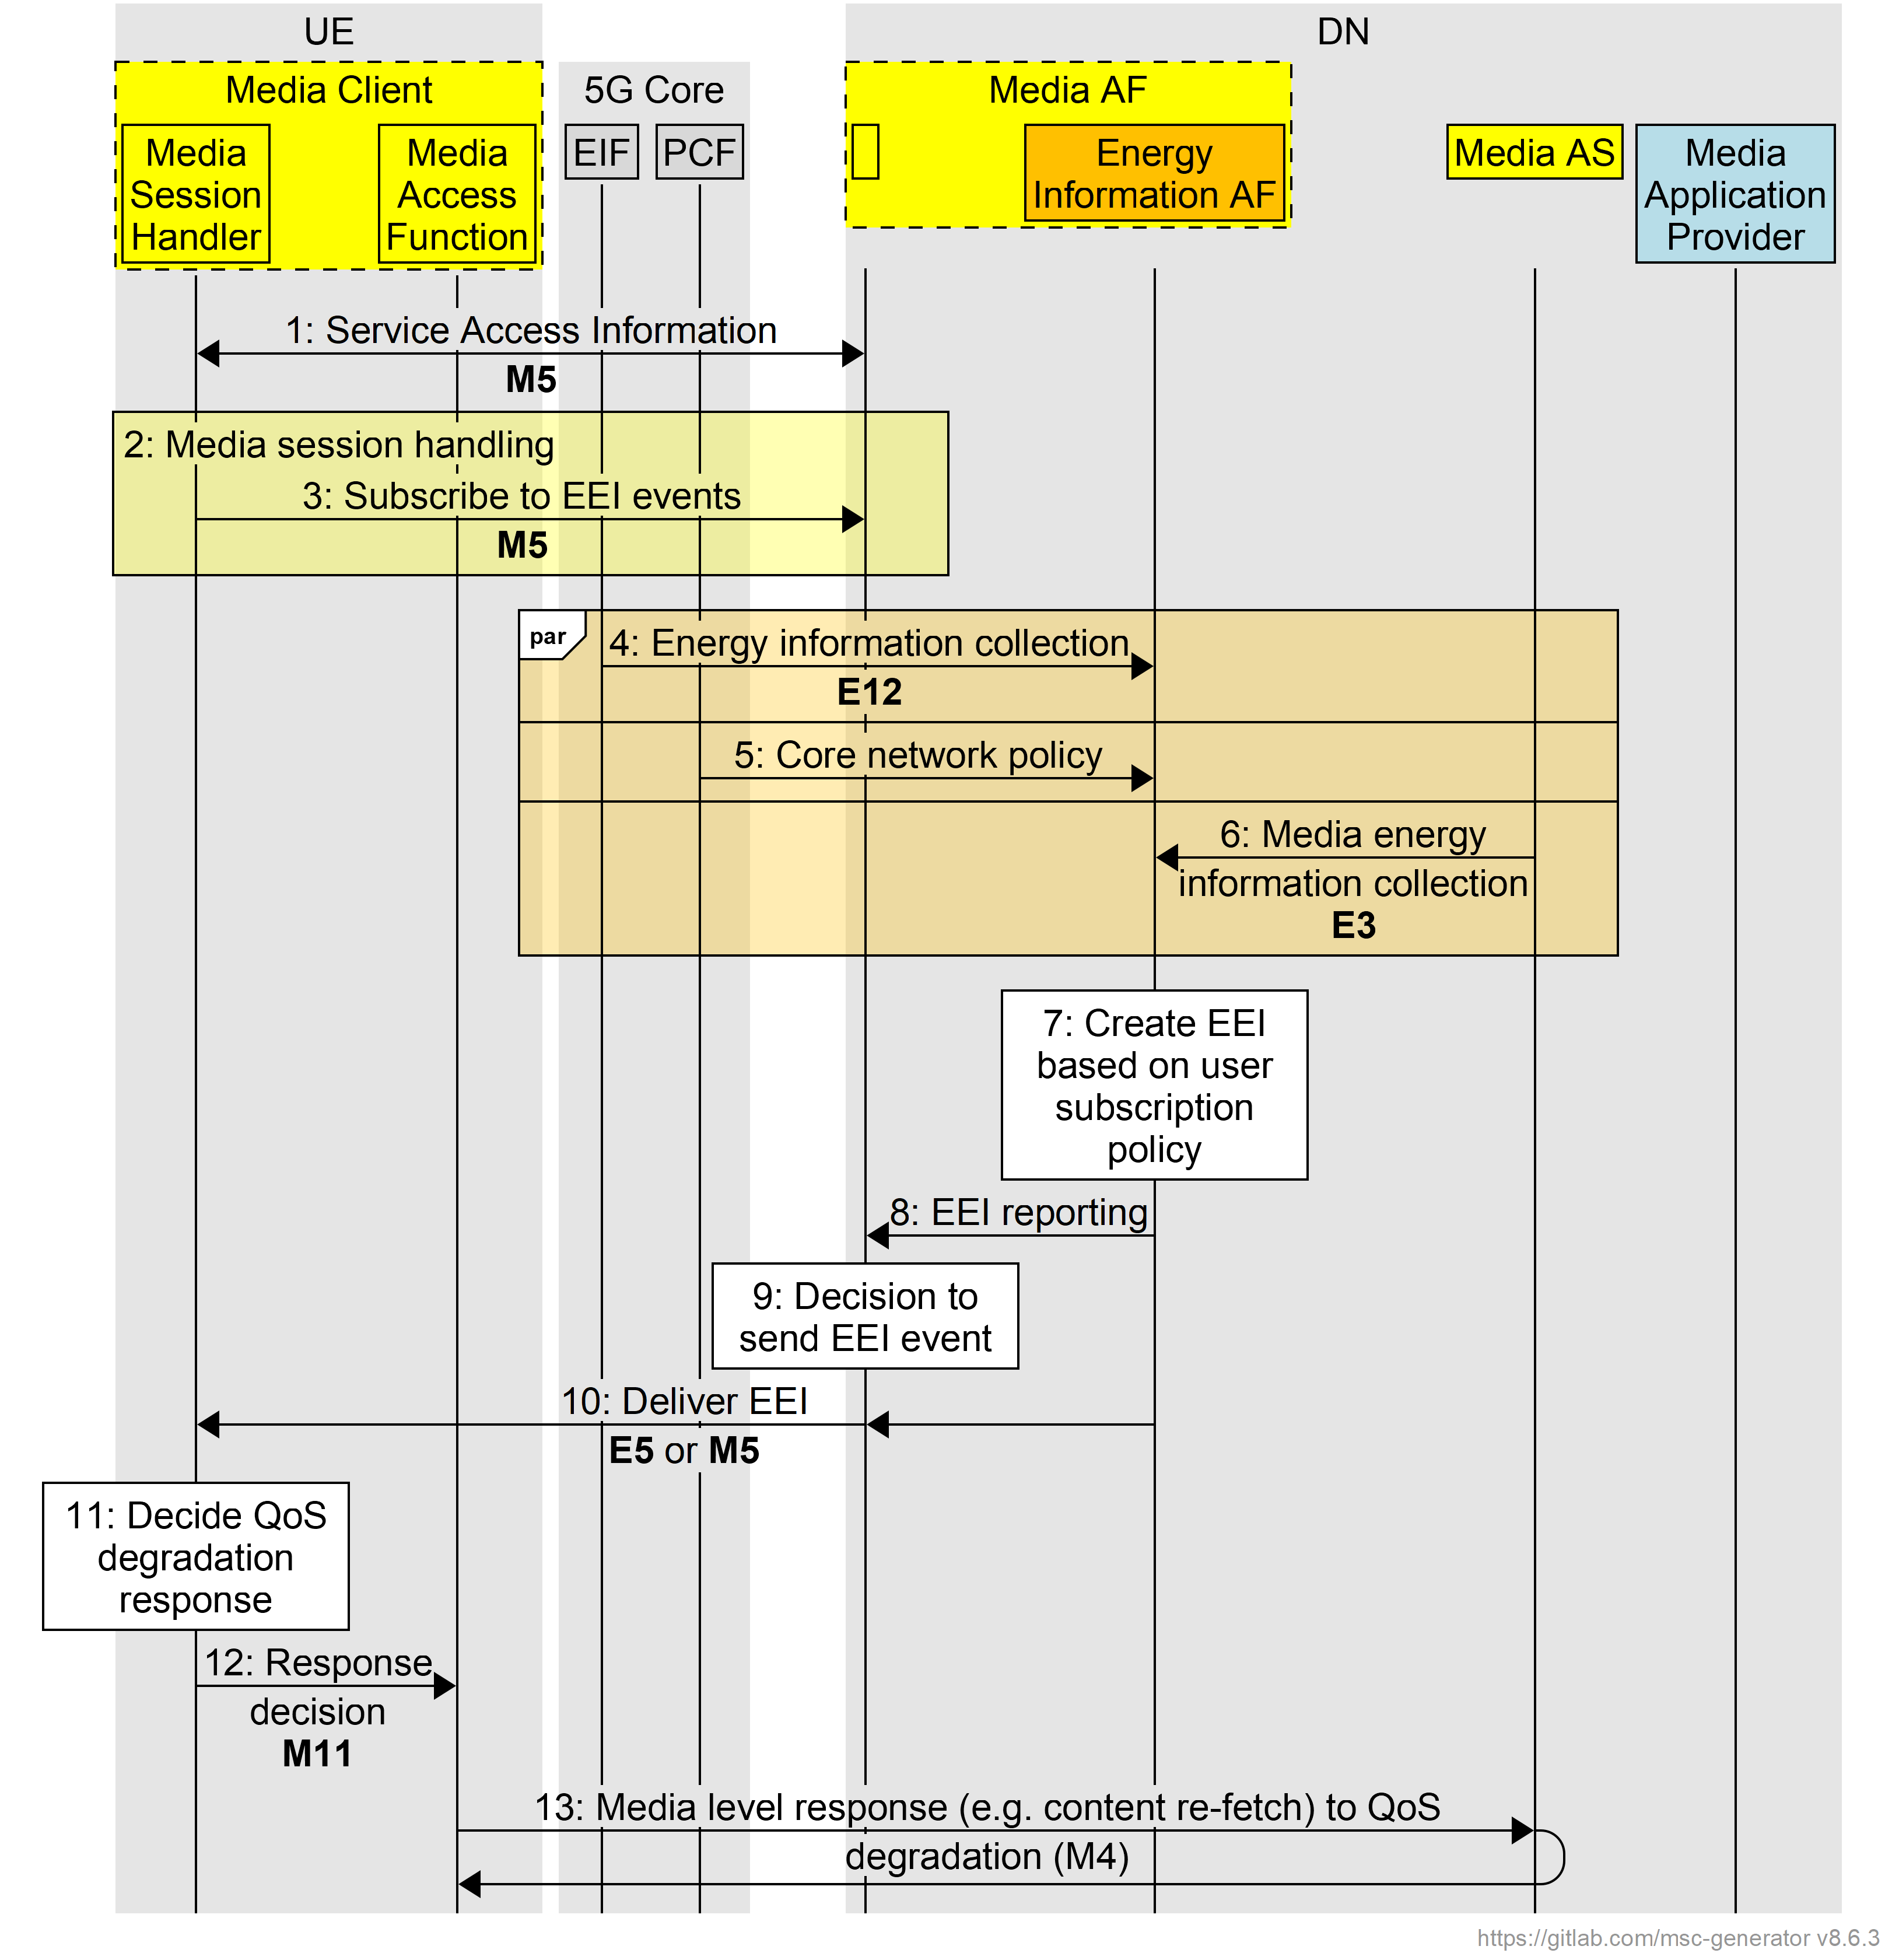
Figure 7.1x.3-1: Procedures for client-driven selection of stream variants or delivery paths based on energy characteristics in the generalised Media Delivery System
1. The Service Announcement procedures between the UE and network includes the exchange of Service Access Information.
2. Media session handling is set up at reference point M5 between the Media Session Handler and the Media AF.
3. During the setup in step 2, the UE may request and subscribe to energy event information (EEI) events related to energy-based media service degradation. Other features such as Network Assistance and Dynamic Policy may also be requested.
4. Network-related energy information is collected by the Energy Information AF and the Energy Information Function.
5. Policy information specific to the UE (in particular related to energy) may also be collected by the Energy Information AF.
6. Energy information related to the processing of media contents (such as encoding) may also be collected from the Media AS by the Energy Information AF.
7. Using the energy information collected in steps 4 to 6, the Energy Information AF instantiated in the Media AF generates Energy Event Information (EEI).
8. The latest EEI is prepared by the Energy Information AF.
9. The decision of whether to send and when to send the EEI to the client UE is determined by the Energy Information AF. This decision may depend on multiple factors including any change in the degraded bit rate, or other mechanisms such as periodic notification.
10. EEI is delivered by the Media AF (or the instantiated Energy Information AF) to the Energy Information Collector instantiated in the Media Session Handler.
11. Upon receiving the EEI from the Energy Information Collector, the Media Session Handler may use the information to decide on a QoS degradation response.
12. The response decision and possible corresponding media level response is made known to the Media Access Function.
13. The Media Access Function initiates the media level response to the QoS degradation with the Media AS.

7.1x.5 Summary
This candidate solution proposes a mechanism to enable energy driven media service degradation, in particular:
1. The collection of network energy information and media-related information in the network by the Energy Information AF. This information is used to generate energy event information for describing any energy related service degradations for a particular client device.
2. Targeted energy event information is shared with the client device in order to aid the client in making any media-session related responses to service degradation.
This approach compliments the network driven nature of network energy fluctuations, whilst also enabling the consideration of specific user device energy-related policies as well as energy aspects related to media related processes.
The solution aims to provide such information for the client to differentiate service degradations due to energy impacts as opposed to other existing factors such as traffic congestion, whilst at the same time encouraging the use of already existing reference points and features to minimise complexity.

7.1x.6 Potential normative requirements
This candidate solution supports energy-driven service degradation in the form of Energy Event Information (EEI). By subscribing to Energy Event Information in the form of asynchronous notifications, a UE may be able to identify the reason and scope of the energy degradation, thereby enabling it to react appropriately to the service degradation event. Potential requirements for normative work to enable this candidate solution include the following.

The EEI generated by the Energy Information AF includes the following mandatory abstract elements:
1. Energy-degraded bit rate: the current bit rate reduced because of energy constraints.
2. Original bit rate: the bit rate achievable when energy restrictions are lifted.
3. Prediction duration or end time of degradation: optional, if known.
4. Scope of degradation: indicating whether the impact applies to UE, user, cell, service location, or network.
5. Degradation cause: specifying whether the cause is network-to-device transmission or server-side processing.
Regarding energy-related information collected by the Energy Information AF and used as inputs for EEI generation:
6. The Energy Information AF may obtain real-time network energy status from the Energy Information Function (EIF) and may collect all energy-related data used for QoS decisions using the existing service at reference point E12.

7. The Energy Information AF may collect UE-specific energy policies.
8. Media-related energy consumption data of the Media AS (e.g., encoding load energy) via a new generic energy reporting service exposed by Application Servers at reference point E5.

Regarding Media Client subscription to Energy Event Information (EEI) notifications:
9. The ability for the Media Client to subscribe to receive EEI notifications from the Media AF (or the Energy Information AF instantiated in it) related to energy-driven media service degradation. The subscription may include a periodicity parameter (see below).
Regarding transmission of EEI:
10. EEI notifications are sent by the Media AF to the Media Session Handler via reference point M5 or by the Energy Information AF instantiated in the exchange at reference point E5 or M5.
Regarding the timing of EEI delivery:
11. The Energy Information AF may determine when to transmit EEI to the UE based on:
a. Any change in the degraded bit rate.
b. Periodic notification intervals negotiated in the notification subscription.
c. Other specific triggers.
12. The timing behaviour may be specified as either event-driven or periodic, with configurable parameters.
Regarding processing of EEI by the Media Client in the UE:
13. Upon receipt of EEI, the Media Session Handler may be required to:
a. Evaluate the EEI content.
b. Decide on an appropriate QoS degradation response.
c. Communicate the chosen action to the Media Access Function.

14. The Media Access Function may be required to enact the media-level response (e.g., adjust stream variant, switch delivery path) based on the decision received from the Media Session Handler.

End of changes

