3GPP SA4 WG4 meeting #134 S4-251823r03

Dallas, Texas, 17-21 November 2025
CR-Form-v12.0
CHANGE REQUEST
 | 26.942 | CR | 0013 | rev | 0 | Current version: | 19.0.0
For HELP on using this form: comprehensive instructions can be found at
http://www.3gpp.org/Change-Requests.

Proposed change affects: | UICC apps |  | ME | X | Radio Access Network |  | Core Network | X

Title: | [FS_Energy_Ph2_MED] Solution for KI#5 Optimization of media sessions based on UE energy consumption
Source to WG: | Nokia
Source to TSG: | S4
Work item code: | FS_Energy_Ph2_MED |  |  |  |  |  | Date: |  |  | 2025-11-10
Category: | B |  |  |  |  |  | Release: |  |  | Rel-20
 | Use one of the following categories:  F (correction)  A (mirror corresponding to a change in an earlier release)  B (addition of feature),  C (functional modification of feature)  D (editorial modification)  Detailed explanations of the above categories can  be found in 3GPP TR 21.900. |  |  |  |  |  |  |  | Use one of the following releases:  Rel-8 (Release 8)  Rel-9 (Release 9)  Rel-10 (Release 10)  Rel-11 (Release 11)  …  Rel-15 (Release 15)  Rel-16 (Release 16)  Rel-17 (Release 17)  Rel-18 (Release 18)
Reason for change: |  | In KI#5, following is one of the objective defined to study further:  - Would it be useful to expose energy-related information about the network obtained via the EIF to media delivery systems to help Application Servers optimize their media sessions in an energy-efficient way?  In this contribution, we propose a solution to address the above part of the key issue.
Summary of change: |  | Addition of a clause 7.15 adding a solution to Key Issue #5
Consequences if not approved: |  | KI#5 may remain unresolved.
Q
Clauses affected: |  | 7.1, 7.15
 |  | Y | N
Other specs |  |  | X | Other core specifications
affected: |  |  | X | Test specifications
(show related CRs) |  |  | X | O&M Specifications
Other comments:
This CR's revision history:

1ST Change

7.1 Mapping of Solutions to Key Issues
Table 7.1-1: Mapping of solutions to Key Issues
Solutions
 | KI#1 | KI#2 | KI#3 | KI#4 | KI#5 | KI#6
#1 |  |  | X
#2 |  |  | X
#3 |  | X
#4 | X
#5 | X
#6 | X | X
#7 | X
#8 |  | X
#9 | X
#10 |  |  |  |  |  | X
#11(a) |  |  |  |  | X
#11 (b) |  |  |  |  | X
12 |  |  |  |  |  | X
#13 |  |  |  |  |  | X

These solutions are simply candidate solutions. Their inclusion in the following clauses does not imply that they have been agreed upon or endorsed. Any decisions and work to be done for the normative work will be detailed in the conclusions of this Technical Report.
2nd change
(All new text)

7.15 Solution #13: Optimization of media sessions based on UE energy consumption

7.15.1 Key Issue mapping
This candidate solution addresses Key Issue #5 Optimization of media sessions based on UE energy consumption described in clause 6.5.

7.15.2 Functional description

7.15.2.1 Introduction
This candidate solution proposes a method that allows a UE/user to dynamically adjust the codec settings based on the information received from the user’s mobility pattern and UE energy consumption (including UE battery status). By leveraging real-time energy consumption predictions under mobility conditions and the UE's location within the cell, the Media Application Provider, in collaboration with the Mobile Network Operator, ensures that media sessions are energy-efficient while maintaining acceptable Quality of Experience (QoE) during mobility.
As an example, consider the scenario of a user wishing to watch a 90-minute football match on his UE during an evening commute. The content is available at a variety of video resolutions (e.g. 2k lines). The UE/user or the Application identifies that the current UE battery level will not last for the duration of the whole match at the current QoE and, in order to be able to watch the whole match, the support of the network is needed to optimise the media delivery QoE based on its energy consumption prediction. This indeed helps both the UE and the network in saving energy.

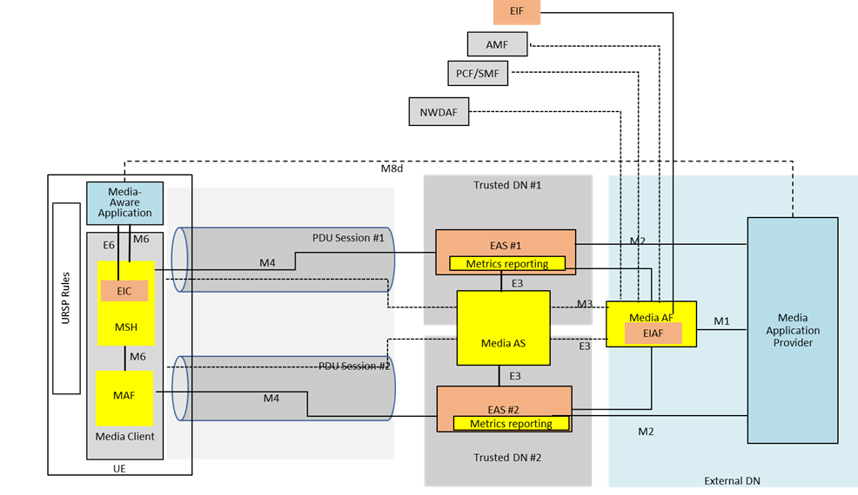
In the described mechanism, the 5GC plays a key role by providing timely network signaling that enables the UE, the Media Delivery System, and the Energy Information AF to coordinate energy-optimised behaviour during mobility. The 5GC’s service-based interfaces allow different control-plane functions to exchange energy-related information, mobility events, and session parameters necessary for the Media AF to adapt service delivery without degrading QoE.
During an ongoing media session, the following signaling contributions from the 5GC support the scenario:
Mobility Event Reporting and Forecasting (AMF → Media AF / Energy Information AF)
The AMF notifies registered AFs about UE mobility events, such as handovers, changes in access type, or entry into defined network areas—through event exposure mechanisms. These events allow the Energy Information AF to anticipate changes in radio conditions or cell load that may affect energy consumption, triggering optimised media delivery adjustments.
UE and Radio Capability Information (AMF / SMF → Media AF)
The 5GC can provide the Media AF with up-to-date information about UE capabilities, supported RATs, and PDU Session characteristics. This enables the Media Delivery System to select energy-efficient media profiles, codecs, or delivery modes compatible with the UE’s current context.
Policy Control and QoS Adaptation (PCF ↔ Media AF / SMF)
Through interactions with the PCF, the Media AF can request or be informed of QoS policy changes that influence energy consumption, for example, adaptations in QoS flow priorities or allocations. The SMF translates these policies into updates for the RAN, ensuring that energy-optimised media delivery does not violate service requirements.
Network Data analytics (NWDAF / PCF → Media AF)
When available, analytics from NWDAF regarding traffic patterns, load, or predicted network conditions can be shared with the Media AF or Energy Information AF. This signalling supports proactive media adaptation, for instance, prefetching or buffer-filling prior to entering an energy-critical area.
Exposure of Network Energy-Related Information (via NEF)
The Energy Information AF may obtain network-level energy exposure data (e.g., cell-specific energy constraints, power saving mode states) via the NEF. This provides the UE and Media AF with insights into when to reduce bitrate, switch delivery modes, or schedule data transfers more efficiently.
Together, these signalling flows allow the Media Delivery System to react dynamically to the UE’s mobility context and network energy state. As a result, the UE can maintain a high-quality media experience while minimising unnecessary energy consumption during transitions across cells, RATs, or network conditions.

The following description outlines the process by which a User Equipment (UE) selects media content for viewing and dynamically adjusts the media codec for optimized energy consumption based on mobility patterns, battery status, and service requirements. The process begins with setting up the media session and progresses through energy management, codec adaptation based on mobility, and continuous media playback.
- UE energy information collection: The user selects media contentusing a Media-aware Application running on the UE, during mobility. The Media-aware Application prepares to start the media delivery session. The Media-aware Application triggers the initiation of a media delivery session with the Media Session Handler. The Media Session Handler communicates with the Energy Information Collector (EIC) instantiated inside it, which gathers data on energy consumption trends based on the UE's mobility. This includes monitoring the impact of location on energy use, as UEs use more power when they are at the cell edge compared to being near the centre of the cell . A context is created in the EIC that includes an energy consumption prediction related to the UE’s mobility as described in clause 7.6.2.1 of the present document.

2. Codec adaptation based on energy consumption status and mobility pattern: The Media Session Handler now requests information from the Energy Information AF about predicted energy consumption based on the UE’s mobility pattern. This results in the Energy Information AF subscribing to receive this information from the Energy Information Function (EIF), which in turn subscribes to receive energy consumption data from the 5GC as specified in clause 5.51 of TS 23.501 This provides real-time data on the UE’s energy usage based on its mobility patterns. The EIF receives real-time energy consumption predictions that reflect the expected power usage of the UE, given its current location relative to the serving cell and its predicted movement. The NWDAF analytics engine analyses the UE’s mobility pattern to predict the energy consumption over the course of the media delivery session. These predictions help to fine-tune the media streaming experience, balancing energy efficiency with quality of service.
Energy consumption data received from the EIF, including predictions based on the UE's mobility, is shared by the Energy Information AF with the Energy Information Collector (EIC) instantiated in the Media Session Handler to inform future decision-making.
- Based on the received energy consumption data and the current battery status of the UE, the Media Session Handler selects the most energy-efficient media rendition or encoding parameter set (i.e., the media encoding that which would consume less energy) to use for media delivery. For instance, for downlink media streaming, it’s typically more a choice between renditions of the media (called Adaptation Sets in MEPG-DASH) using the same codec at different bit rates or video resolutions. For uplink media streaming, the Media Streamer could adjust its encoding bit rate to consume less energy. For the RTC System, the selection could be a request to the RTC AS to transcode the media to a different bit rate.
This decision aims to balance the quality of the media stream with the UE's energy constraints. The following factors are taken into account in this decision:
- Battery level: If the UE is low on battery, a more energy-efficient codec with lower bit rate requirements may be chosen.
- Mobility pattern: The codec selection should also consider whether the UE is moving between cells, which could affect power consumption.
- The Media Access Function (MAF) requests media encoding for the media session from the Media Session Handler. This could be as stated above, for instance, for downlink media streaming, it’s typically more a choice between renditions of the media (called Adaptation Sets in MEPG-DASH) using the same codec at different bit rates or video resolutions. For uplink media streaming, the Media Streamer could adjust its encoding bit rate to consume less energy. For the RTC System, the selection could be a request to the RTC AS to transcode the media to a different bit rate.
The Media Session Handler take the following factors into consideration while choosing the optimal codec:
- Media content type: (e.g., video quality, resolution).
- Content duration: (short or long streaming sessions).
- UE mobility pattern: (whether the user is stationary or moving).
- Energy consumption: (current battery status and power consumption based on movement).
3. Media session update and media delivery: The Media Session Handler informs the Media Access Function of the selected media encoding, ensuring that the media content is delivered using the optimal parameter set by the Media AS. The media is delivered using the chosen encoding, with energy considerations integrated into the delivery process. This ensures a balance between energy efficiency and end user Quality of Experience.

7.15.3 Procedures
Figure 7.15.3-1 below details the different steps for optimization of media sessions based on UE energy consumption and determining UE mobility characteristics.
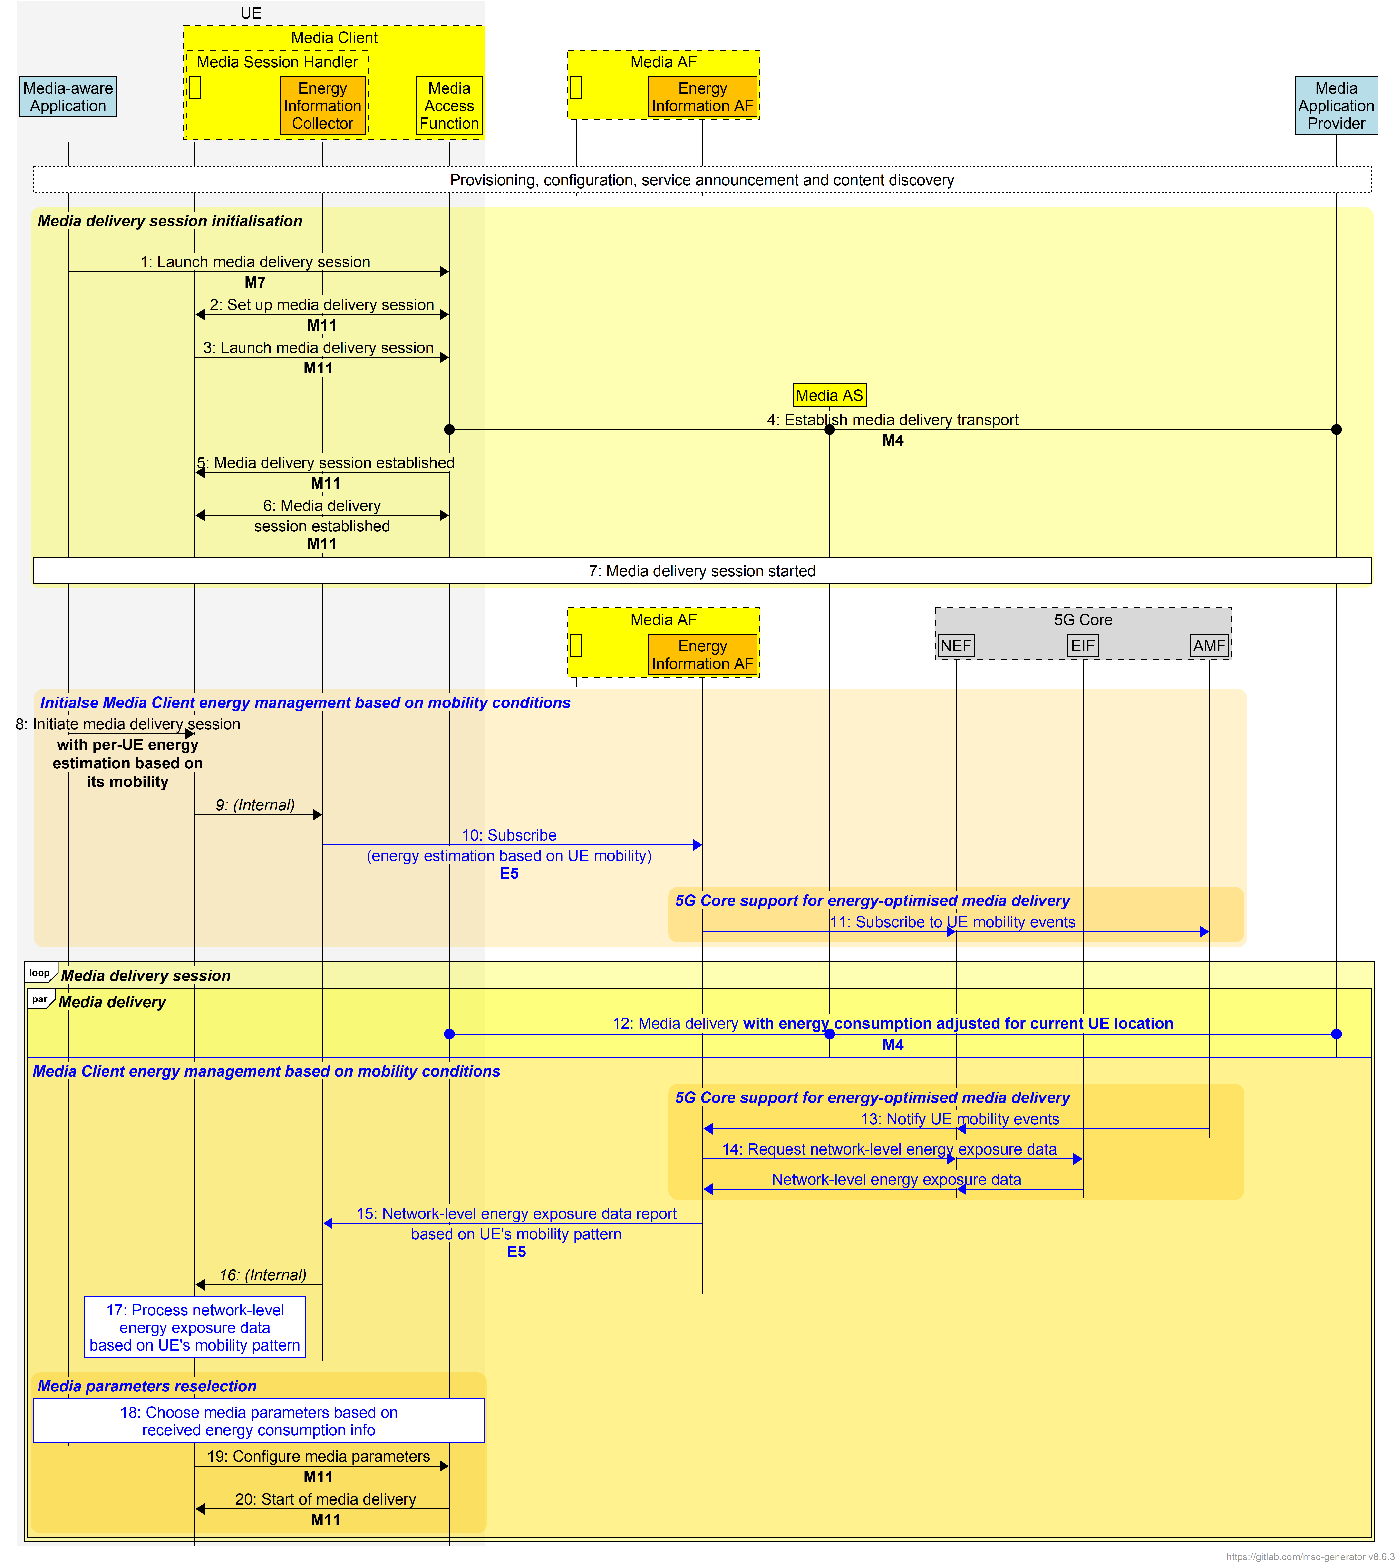
Figure 7.15.3-1: Procedures for optimization of media sessions based on UE energy consumption
The working assumptions are:
- Initial connection set-up is established between the UE and the Media AS.
Call flow steps:
1. The Media-aware Application asks the Media Access Function to launch a media delivery session.
2. The Media Session Handler coordinates the media delivery session setup with the Media Access Function.
3. The Media Session Handler requests the Media Access Function to establish a transport connection.
4. The Media Access Function establishes a transport connection with the Media AS.
5. Media session is set-up between Media Session handler and Media Access function.
6. The Media Access Function notifies the Media Session Handler that it has established the media delivery session.
7. The media delivery session starts.
Next, Media Client energy management based on UE mobility is initialised:
8. The Media-aware Application initiates energy information collection considering the UE's mobility status via the Media Session Handler.
9. The Media Session Handler invokes the Energy Information Collector instantiated in it via an internal client API.
10. The Energy Information Collector instantiated within the Media Session Handler registers/subscribes with the Energy Information AF to get energy estimations tied to the UE’s mobility (i.e., how movement will affect energy). The Media Session Handler initiates a context with the Energy Information Collector instantiated inside it, informing the Energy Information Collector to start receiving energy consumption estimates based on the UE's mobility from the 5G Core.
11. The Energy Information AF subscribes to UE mobility events from the AMF (via the NEF, if necessary).
12. Media content is delivered between the Media Access Function, the Media AS and the Media Application Provider.
In parallel with media delivery:
13. The AMF notifies the Energy Information AF of events such as cell handovers or access network changes.
14. Based on this information received from the AMF, the Energy Information AF now also queries the EIF possibly via the NEF) to obtain network-level energy-related data (cell constraints, power-saving states, etc.) and the requested network-level energy information is returned to the Energy Information AF.
15. The Energy Information AF reports network energy exposure and mobility-driven energy estimates to the Energy Information Collector.
16: The Energy Information Collector reports this to the Media Session Handler.
17. The Media Session Handler processes these inputs to decide whether adaptation of the media delivery session is needed.
18. Based on the energy info and mobility prediction, the Media Session Handler selects appropriate media parameters (for example, by adjusting the uplink encoding bit rate or by selecting a different media representation) to reduce energy use while preserving QoE.
19. The Media session Handler informs the Media Access Function of the new media parameters.
21. The MAF/AF/AS coordinate the media session modification
22. The session is modified (QoS, codec, source AS) as required and the MAF signals the MSH to start/resume playback with the new settings.
23. The Media playback loop continues; the UE keeps monitoring mobility and energy signals and repeats the subscribe→notify→adapt cycle as needed.
24. The media session is re-established and continues with the new codec, and content delivery continues from the new AS that is delivering the appropriate codec.

7.13.4 Summary
This Candidate Solution defines a mechanism enabling a UE to optimise the energy consumption of an on-going media delivery session during mobility based on energy-related information received from the Energy Information AF instantiated in the Media AF. In association with the Energy Information AF and the EIF, the functions of the Media Delivery System collaborate with the 5G Core and/or the Media Application Provider to minimise service impact during mobility. In the described mechanism, the 5G Core plays a key role by providing timely network signalling that enables the UE, the Media Delivery System, and the Energy Information AF to coordinate energy-optimised behaviour during mobility. The 5G Core’s service-based interfaces allow different control-plane functions to exchange energy-related information, mobility events, and session parameters necessary for the Media AF to adapt service delivery without degrading QoE. Together, these signaling flows allow the Media Delivery System to react dynamically to the UE’s mobility context and network energy state. As a result, the UE can maintain a high-quality media experience while minimising unnecessary energy consumption during transitions across cells, RATs, or network conditions.
End of changes

