3GPP SA4 WG4 meeting #134 S4-251822r02

Dallas, Texas, 17-21 November 2025
CR-Form-v12.0
CHANGE REQUEST
 | 26.942 | CR | 0014 | rev | 0 | Current version: | 19.0.0
For HELP on using this form: comprehensive instructions can be found at
http://www.3gpp.org/Change-Requests.

Proposed change affects: | UICC apps |  | ME | X | Radio Access Network |  | Core Network | X

Title: | [FS_Energy_Ph2_MED] Solution for KI5 Client-based Media Application Server selection
Source to WG: | Nokia
Source to TSG: | S4
Work item code: | FS_Energy_Ph2_MED |  |  |  |  |  | Date: |  |  | 2025-11-17
Category: | B |  |  |  |  |  | Release: |  |  | Rel-20
 | Use one of the following categories:  F (correction)  A (mirror corresponding to a change in an earlier release)  B (addition of feature),  C (functional modification of feature)  D (editorial modification)  Detailed explanations of the above categories can  be found in 3GPP TR 21.900. |  |  |  |  |  |  |  | Use one of the following releases:  Rel-8 (Release 8)  Rel-9 (Release 9)  Rel-10 (Release 10)  Rel-11 (Release 11)  …  Rel-15 (Release 15)  Rel-16 (Release 16)  Rel-17 (Release 17)  Rel-18 (Release 18)
Reason for change: |  | Addtion of a solution to Key Issue 5 on Media Application Server Energy management.
Summary of change: |  | Addition of a clause 7.13 adding a solution to Key Issue #5 on Media Application Server Energy management.
Consequences if not approved: |  | KI#5 will not be solved.
Q
Clauses affected: |  | 7.1, 7.13
 |  | Y | N
Other specs |  |  | X | Other core specifications
affected: |  |  | X | Test specifications
(show related CRs) |  |  | X | O&M Specifications
Other comments:
This CR's revision history:

1ST Change

7.1 Mapping of Solutions to Key Issues
Table 7.1-1: Mapping of solutions to Key Issues
Solutions
 | KI#1 | KI#2 | KI#3 | KI#4 | KI#5 | KI#6
#1 |  |  | X
#2 |  |  | X
#3 |  | X
#4 | X
#5 | X
#6 | X | X
#7 | X
#8 |  | X
#9 | X
#10 |  |  |  |  |  | X
#11(a) |  |  |  |  | X
#11 (b) |  |  |  |  | X

These solutions are simply candidate solutions. Their inclusion in the following clauses does not imply that they have been agreed upon or endorsed. Any decisions and work to be done for the normative work will be detailed in the conclusions of this Technical Report.

2nd change
(All new text)

7.13 Solution #11 (b): Client-based Media Application Server selection based on asynchronous notification to the Media Client or content steering

7.13.1 Key Issue mapping
This solution candidate addresses Key Issue #5 (Media Application Server Energy management) described in clause 6.5.

7.13.2 Functional description

7.13.2.1 Introduction
This candidate solution proposes a method that allows to re-selectApplication Servers (ASs) hosting different multimedia contents like audio codecs, video codecs, sensor servers from multiple different service locations to collaborate for (downlink) media delivery session when a UE client downloads multimedia contents such as video, audio and sensor signals from individual ASs service locations based on the UE application QoE requirements (e.g., resolution, bit rate, etc.) while taking also into account the various characteristics (e.g. AS load, AS energy consumption, AS current QoE metrics, etc.) of each individual ASs which are delivering the media contents. As a concrete example, "F-droid" is an Android app which allows the user to stream real-time sensor data from a UE to WebSocket clients, etc.
This solution leverages interfaces at existing reference points in the Media Delivery System enabling communication between a Media Application Provider and the 5G System, particularly for exchanging Quality of Experience (QoE) data. These interfaces are enhanced with network energy-related characteristics, allowing the Media Application Provider to use this information for service location reselection. In particular the solution leverages extensions for edge processing defined for the 5GMS System in clause 4.5 of TS 26.501 [26501] and for the RTC System in clause 6 of TS 26.506 [26506] in which instances of the Media AS are deployed as Edge Application Server (EAS) instances and they offer different service locations to the Media Client.

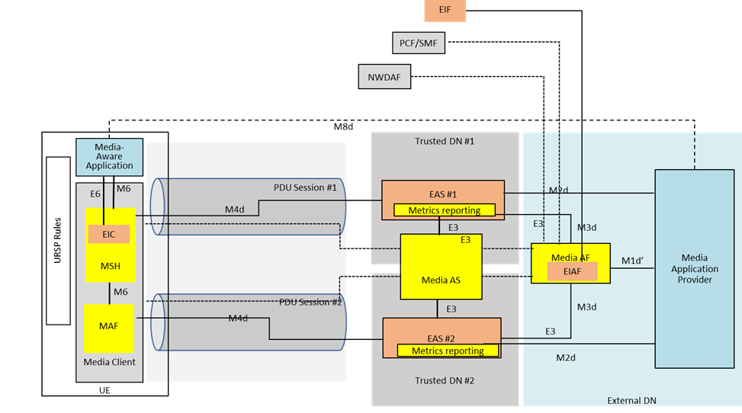
Figure 7.13.2-1: Illustration of application servers reselection based on energy characteristics
This collaboration scenario shown in figure 7.13.2-1 represents the case of accessing two different Data Networks using the same network slice. A CDN server (e.g., 5GMS AS service location) is either deployed in each of the trusted Data Networks, or presents a multi-homed interface at reference point M4 through each of the trusted DNs.
The Media Application Provider negotiates with the MNO to provision a network slice as described in clause 4.3 of TR 26.941. The operator provisions the network slice, and provides connectivity services to both the DNs through the slice.
The Media Application Provider may deliver Service Access Information through reference point M8. The Service Access Information delivered to the Media-aware Application may have information about different service locations accessible through each of the DNs. For example, an enterprise may utilise an enterprise-specific CDN (e.g., hosting enterprise-related video tutorials). 5G Media Streaming sessions for enterprise-related video tutorials use the PDU Session terminating in the enterprise-specific service location, while some other video tutorial requests are sent through PDU Sessions terminating at a different service location. The Energy Information AF instantiated in the Media AF of figure 7.13.2-1 is in relaton with the architecture of clause 7.6.
In the above architecture, how to relocate the Edge AS based on the QoE requirements of the UE in combination with energy usage/characteristics of the AS? Imagine a case when the media application is accessing media content from AS#1. Can the AF relocate the UE now to AS#2 based on: (a) the energy consumption of AS#1? (b) the QoE requirements of the application?
The Application Function (AF) may need to relocate the Edge AS considering different scenarios e.g. AS load, AS energy consumption, AS current QoE metrics, etc. In some deployments this would require collective relocation.

7.13.3 Procedures
Figure 7.12.3-2 below details the different steps for application server re-selection process.

Figure 7.13.3-1: Procedures for application server re-selection based on energy characteristics
The call flows and procedures are described below:
Assumption: The Application Provider may deliver Service Access Information through reference point M8. The Service Access Information delivered to the media aware Application may have information about different Service Operation Points accessible through each of the DNs. For example, an enterprise may utilise an enterprise-specific service location of the Media AS (e.g., hosting enterprise-related video tutorials). 5G Media Streaming sessions for enterprise-related video tutorials use the PDU Session terminating in the enterprise-specific service location of the Media AS, while some other video tutorial requests are sent through PDU Sessions terminating in a different service location of the Media AS.
Solution 1: Client-based Media Application Server selection based on asynchronous notification to the Media Client : It is described in detail below:
1 to 8. In the below call flow, steps 1 to 8 are retained from TS 26.501, which is common steps followed to establish any media downlink session establishment.
These steps follow the usual step-up while establishing a downlink media delivery session between the UE and the media application server. The media application requests a downlink media session, following which an downlink media session is established, and the media is transferred to the UE client from the Application Provider. Downlink media session starts at Step 8. Based on Step 1 to 8, an on-going media session is established.
9. Following this, once the session is established, in step 9, EIAF subscribes to EIF to be informed and to receive energy-related information from the different NFs.

Step 10-15: Reporting UE-related and apps-related QoE metrics.
10. The OAM periodically requests the UE to report its current QoE. It first reaches the 5G ore entities, such as PCF and SMF.
11. The 5G core forwards this request to the AF.
12. The Media AF inturn forwards this to Media Session handler (MSH).
13. The Media Session handler (after querying the current QoE information from Media access function/Media Player), reports this information to the Media AF.
14. The Media AF now forwards this information to the 5G core, which in turn forwards this to the OAM. This way, the UE periodically reports the QoE metrics upon request from the OAM. This could be for instance, based on the QMC framework, as described in clause TS 36.300 Clause 23.16,
where UE provides application relevant metrics, limited to a certain duration of X ms, in order to protect the user privacy.
Step 16-20: Reporting Application Server related metrics.
16. The EIAF requests the EIF to report the energy-related characteristics of Media AS from individual service locations . This could be for instance, the total KW/hr of energy consumed by each Media AS service location for a particular time period. This time period is left to the Media Application Service Provider or the owner of Media AS of the service location to define.
17. EIF collects (or retrieves) the energy-related information of each Media AS service locations.
18. EIF reports this energy-related information to the EIAF.. Following this, the EIAF forwards this information to the AF.
19. Based on this information, the Media AF now internally processes the received energy-related information about the ASs. .
20. The Media AF maps the UEs with ASs, based on the BaseURL of the service location of the AS as well as based on the reported UE-related metrics and the service location of AS energy-related information.
Step 21 to 28: Application Server service location re-selection based on the reported energy-related characteristics.
21. The AF sends the new configuration information to the UE client (Media session Handler), with the list of new available application servers (ASs) with their service locations, as per clause 5.19.3.3. of the present document. This could be sent as a meta-data to the UE client, via M5 interface via Service Access Information which may include Media Player Entry URLs and BaseURL of the AS endpoint.
22. The UE client is allowed to select another new service location of Media AS most suitable for its current session without modifying the on-going session.
23. This is done based on the information provided in the Media Player Entry by the Media Session Handler, the Media Access Function request a new energy-efficient Media AS service location and as a result a new service location of Media AS is selected.
24. The UE client sends a new request to modify the existing session to the Media AF,
25. This is forwarded to the respective service location of the Media AS from the Media AF as described per clause 5.1 of TS 26.501.
26. The existing media delivery session now successfully modified with the new service location of the Media AS.
27. Media transfer from the most energy efficient server is sent to the Media Player
28. This is informed to the Media Session Handler.
Alternative solution 2: Steps 29 to 36: Client-based Media Application Server selection based on content steering:
29. Here, all steps are similar to alternative 1 mentioned above, except for step 29, where the service location of Media AS selection is configured in the Media AS as per TS 26.512. The content steering service instantiated in the 5GMSd AS is configured by the Media AF . This implies the configuration of the content steering service at reference point M3d.
30. This selected service location of Media AS is sent to the UE client without sending a list of available service locations of the Media ASs as meta-data .
31. The UE client connects to the new service location of the edge media application server (AS) .
32.The UE client sends a new request to modify the existing session to the Media AF.,
33. This is forwarded to the respective service location of the media application server from the Media AF .
34. The existing downlink media delivery session now successfully modified with the new service location of the media AS.
35 and 36. Media transfer continues.

7.13.4 Summary
This candidate solution introduces a mechanism for enabling Media Application Providers to dynamically select the most energy-efficient Media AS service location. The proposed methods are applicable to downlink media sessions, but also for uplink media sessions and RTC communication sessions. This is based on the following factors:
1. UE application and characterisation data: Information pertaining to the User Equipment (UE), factors such as, current QoE, and application-specific needs (e.g., resolution, bit rate).
2. Energy efficiency metrics from Network Operator: Energy-related characteristics of the application servers, provided by the mobile network operator. These metrics, including server power consumption profiles and energy performance indicators, are transmitted through the Energy Information Function (EIF) to the Energy and Infrastructure Application Function (EIAF) within the Media Application Function (Media AF).

3. Dynamic steering and load balancing by the Media AF: The Media AF serves as a steering entity that processes the collected data and applies intelligent algorithms to dynamically select the most energy-efficient server or delivery path. This ensures that the UE is routed to a Media AS service location with the optimal energy efficiency characteristics, based on both real-time network conditions and the UE’s application needs.
This approach aims to optimise the energy consumption of multimedia content delivery, particularly video streaming services, while maintaining service quality within defined thresholds by enabling client-based Media Application Server selection based on asynchronous notification to the Media Client or content steering as specified in TS 26.512. This implies the configuration of the content steering service at reference point M3d.

The candidate solution operates entirely within the network layer, which involves the UE, QoE characteristics as the steering and optimisation mechanisms are fully supported by standard adaptive streaming frameworks. This ensures compatibility with existing adaptive streaming ecosystems, preserving end-user experience while reducing the environmental footprint of content delivery.
End of changes

