3GPP SA4 WG4 meeting #134 S4-251821r03

Dallas, Texas, 17-21 November 2025
CR-Form-v12.0
CHANGE REQUEST
 | 26.942 | CR | 0015 | rev | 0 | Current version: | 19.0.0
For HELP on using this form: comprehensive instructions can be found at
http://www.3gpp.org/Change-Requests.

Proposed change affects: | UICC apps |  | ME | X | Radio Access Network |  | Core Network | X

Title: | [FS_Energy_Ph2_MED] Solution for KI #6 Client-driven management of media delivery service energy optimisation
Source to WG: | Nokia
Source to TSG: | S4
Work item code: | FS_Energy_Ph2_MED |  |  |  |  |  | Date: |  |  | 2025-11-17
Category: | B |  |  |  |  |  | Release: |  |  | Rel-20
 | Use one of the following categories:  F (correction)  A (mirror corresponding to a change in an earlier release)  B (addition of feature),  C (functional modification of feature)  D (editorial modification)  Detailed explanations of the above categories can  be found in 3GPP TR 21.900. |  |  |  |  |  |  |  | Use one of the following releases:  Rel-8 (Release 8)  Rel-9 (Release 9)  Rel-10 (Release 10)  Rel-11 (Release 11)  …  Rel-15 (Release 15)  Rel-16 (Release 16)  Rel-17 (Release 17)  Rel-18 (Release 18)
Reason for change: |  | Addtion of a solution to Key Issue #6 on Client-driven management of media delivery service energy optimisation.
Summary of change: |  | Addition of a clause 7.14 adding a solution to Key Issue #6 on Client-driven management of media delivery service energy optimisation.
Consequences if not approved: |  | KI#6 may remain unresolved.
Q
Clauses affected: |  | 7.1, 7.14
 |  | Y | N
Other specs |  |  | X | Other core specifications
affected: |  |  | X | Test specifications
(show related CRs) |  |  | X | O&M Specifications
Other comments:
This CR's revision history:

1ST Change
(All New Text)

4.2.2.6 Requesting QoE insights from the NWDAF
To support energy-efficient media delivery, the Media AF may request QoE-related insights from the NWDAF. By exposing analytics on predicted service performance, or network conditions affecting user experience, the NWDAF enables data analytics consumers to anticipate potential QoE impacts during an ongoing session. These analytics could potentially help the MediaDelivery System take informed decisions, such as adjusting media profiles, buffer strategies, or delivery modes before quality deteriorates. As a result, the system can optimise energy consumption while maintaining acceptable QoE levels across varying network scenarios. This requires interactions between the Media AF and NWDAF. This is specified in clause 5.2.19 of TS 23.502 [23502], clause 6.2.2 of TS 23.503 [23503], and clauses 6.1.2.2, 6.2.8 and 6.4.3 of TS 23.288 [23288].
The interactions between these functions typically follow this pattern:
1. AF Request: The AF may need specific network analytics, such as QoE impacts, to optimize its service. It can request this information from the 5G Core network.
2. Intermediate NF role: The request from the AF is usually handled by an intermediate NF, often the PCF or the NEF, which then interacts with the NWDAF on the AF's behalf.
3. NWDAF interaction: The intermediate NF (e.g., PCF) sends a request or subscription to the NWDAF for the desired analytics via standard Nnwdaf services (e.g., Nnwdaf_AnalyticsInfo_Request/Subscribe).
4. Data collection and analytics: The NWDAF collects relevant data from various data sources, including the SMF, using service-based interfaces (e.g., an Smf_EventExposure service) to gather information related to PDU sessions or UE behaviour.
5. Analytics provision: The NWDAF processes the data and provides the analytics (e.g., QoE impact estimation) to the consuming NF (e.g., PCF). This can be a one-time response and/or periodic notifications.
6. Policy enforcement/information transfer: The consuming NF (e.g., PCF) uses this information to make policy decisions (e.g., updating QoS policies) and instructs the SMF to enforce them. The results may also be shared back with the originating AF, allowing the application to adapt (e.g., performing rate adaptation).
In essence, the SMF acts as both a data source for the NWDAF and an execution point for policies influenced by NWDAF analytics, while the AF initiates the need for analytics, typically as a consumer, via other NFs in the 5G core.
2nd change

7.1 Mapping of Solutions to Key Issues
Table 7.1-1: Mapping of solutions to Key Issues
Solutions
 | KI#1 | KI#2 | KI#3 | KI#4 | KI#5 | KI#6
#1 |  |  | X
#2 |  |  | X
#3 |  | X
#4 | X
#5 | X
#6 | X | X
#7 | X
#8 |  | X
#9 | X
#10 |  |  |  |  |  | X
#11(a) |  |  |  |  | X
#11 (b) |  |  |  |  | X
12 |  |  |  |  |  | X

These solutions are simply candidate solutions. Their inclusion in the following clauses does not imply that they have been agreed upon or endorsed. Any decisions and work to be done for the normative work will be detailed in the conclusions of this Technical Report.
2nd change
(All new text)

7.14 Solution #12: Client-driven management of media delivery service energy optimisation

7.14.1 Key Issue mapping
This solution candidate addresses Key Issue #6 (Client-driven management of media delivery service energy optimisation) described in clause 6.6.

7.14.2 Functional description

7.14.2.1 Introduction
Mobile networks may prioritise energy efficiency in either the network or the UE or both depending upon various situations. While energy-saving techniques aim to optimise energy consumption without compromising service quality, trade-offs may sometimes be necessary. To identify potential energy-saving opportunities, networks may target specific user devices consuming excessive energy and offer incentives for reducing energy consumption in exchange for service adjustments. The network should assess whether target users would accept proposed service adjustments that may result in QoS degradation. Not all users may be willing to tolerate such changes, especially if their current services or content received by service at special time or location are sensitive to performance reductions. If a user agrees to the adjustments, the UE and network can explore potential mitigation strategies to minimise the impact on service experience and QoE.
To this end, the following issues have been identified:
1. How can a user's tolerance for reduced QoS and QoE be determined?
2. How can the AF propose the strategies to minimise the impacts on end user service experience and QoE?
3. How can the UE prioritise strategies to minimise the impacts on the QoE?
This Candidate Solution proposes method by which the Energy Information AF proposed in clause 7.6 can assess the QoS degradation (in collaboration with the 5GC and/or the Media Application Provider) and notifies a UE application when QoS degradation is imminent due to either network or UE energy saving or both. This enables the UE to proactively adjust QoE metrics, minimizing the impact on user experience. This Candidate Solution is based on the following:
1. Triggering the energy saving toward Energy Information AF. Authorized entities, such as 5GC or Media Application Providers can trigger the Energy Information AF to request a UE to reduce its QoE. This could be a mix of real time triggering (e.g. in the case of 5GC) and policies provisioned in advance (e.g. ASP with green media streaming contracts). This can occur due to network and/or UE energy-saving initiatives. For instance, the 5GC might decide to reduce QoS (e.g. allocated bandwidth) and trigger energy saving through the Energy Information AF along with the proposed, either QoS or QoE ranges. Additionally, Media Application Providers holding contracts with cloud providers or 5GC may initiate energy saving towards the Energy Information AF. In another example, a Media Application Provider with a UE contract for green media streaming could trigger energy saving due to energy status of cloud and 5GC resources.
2. Assessing the User tolerance to QoE degradation. When an AF receives an energy saving request (in collaboration with the 5GC and/or the Media Application Provider), it assesses the potential impact on the user's QoE. By comparing the requested QoE parameters with predefined thresholds, the AF determines the acceptable levels of QoE degradation. If the request includes specific QoS ranges instead of QoE, the AF may request the NWDAF to estimate QoE impacts as described in clause 4.2.2.6. The AF may check the user's subscription for agreed-upon QoE levels. If these levels align with the estimated/requested QoE degradation, no user approval is needed, but user feedback is collected. Otherwise, the Energy Information AF requests user approval by sending an asynchronous notification message to the Energy Information Client in the UE, specifying the potential QoE impact.
3. UE Controlling the QoE. Upon receiving a request for potential QoE degradation, the Energy Information Client in the UE assesses its current status and determines how to respond in a way that minimises the impact on its service experience. In order for this to happen, the Energy Information Client needs to decide whether its application could tolerate a degradation in its current QoE or not. And when it does, the application should be able to manage its current QoE without too much degradation (i.e. reducing the QoE below the certain pre-defined threshold).

7.14.2.2 Architecture mapping
Figure 7.14.2.2-1 depicts a reference architecture that realises this candidate solution in the general (i.e., non-media-specific) case.
Figure 7.14.2.2-1: Generic reference architecture for collection and exposure of energy-related information between EIF and EIAF
The following functions are defined in this generic reference architecture:
- The Energy Information AF is an Application Function in the Data Network with some or all of the following responsibilities, depending on its current provisioning state:
- Validates the provisioning of an Energy Information Exposure Specification which represents the configuration of the Energy Information required to be exposed to the Media Application Provider (see clause 7.8). The Energy Information Exposure Specification allows the Media Application Provider to define the Energy Information to be exposed to the Media-aware Application, and thus to the subscriber.
- Subscribes to and consumes NF Energy Information from the Energy Information Function at reference point E12 as defined in TS 23.501 [72]) with required granularities (UE, PDU session and/or QoS flow) in accordance with the parameters of the Energy Information Exposure Specifications.
- Subscribes to and consumes AS Energy Information from the Application Server at reference point E3 in accordance with the parameters of the Energy Information Exposure Specification.
- Collates, prepares and exposes the above Network Energy Information to the Energy Information Collector instantiated in the Media Session Handler of the Media Client via the data plane at reference point E5 in accordance with the Energy Information Exposure Specification.
- The Energy Information Collector is a UE function with some or all of the following responsibilities, depending on its current configuration:
- Acquires an Energy Information collection configuration derived from the Energy Information Exposure Specifications provisioned by all Media Application Providers from the Energy Information AF. The Energy Information collection configuration may direct the Energy Information Collector to collect energy information from the UE at different granularities, e.g. UE, PDU Session and/or QoS flow, as described in clause 5.51.2.3 of TS 23.501 [72] and/or for individual applications.
- The NWDAF and the Energy Information AF may interact in one of the following ways as below. However, it should be noted that there is no direct, dedicated "reference point" between the Application Function (AF) and the Network Data Analytics Function (NWDAF) in the 3GPP TS 23.501 specification. Instead, the interactions occur in a service-based architecture manner, primarily through intermediate functions:
- Via the Network Exposure Function (NEF): The most common way for an external AF to interact with core network functions like the NWDAF is via the NEF. The reference point between the NEF and the AF is N33. The NWDAF then interacts with the NEF using the Nnef service-based interface.
- Via the Policy Control Function (PCF): The AF often interacts with the PCF to influence policy decisions using reference point N5. The PCF, as a consumer of analytics, then interacts with the NWDAF using the N23 reference point to obtain the necessary data (e.g., QoE impacts).
- Direct interaction (service-based): In some deployments, the AF may be considered a trusted entity within the operator's domain and can act as a direct consumer or producer of data to the NWDAF via the service-based interface (Nnwdaf services). In this case, it is a service-based interaction rather than a numbered reference point.
The relevant reference points for communication involving the Energy Information AF and NWDAF are therefore N5 (via PCF) and N33 (via NEF).

7.14.3 Procedures
Figure 7.14.3-1 below details the different steps for client-driven management of media delivery service energy optimisation.
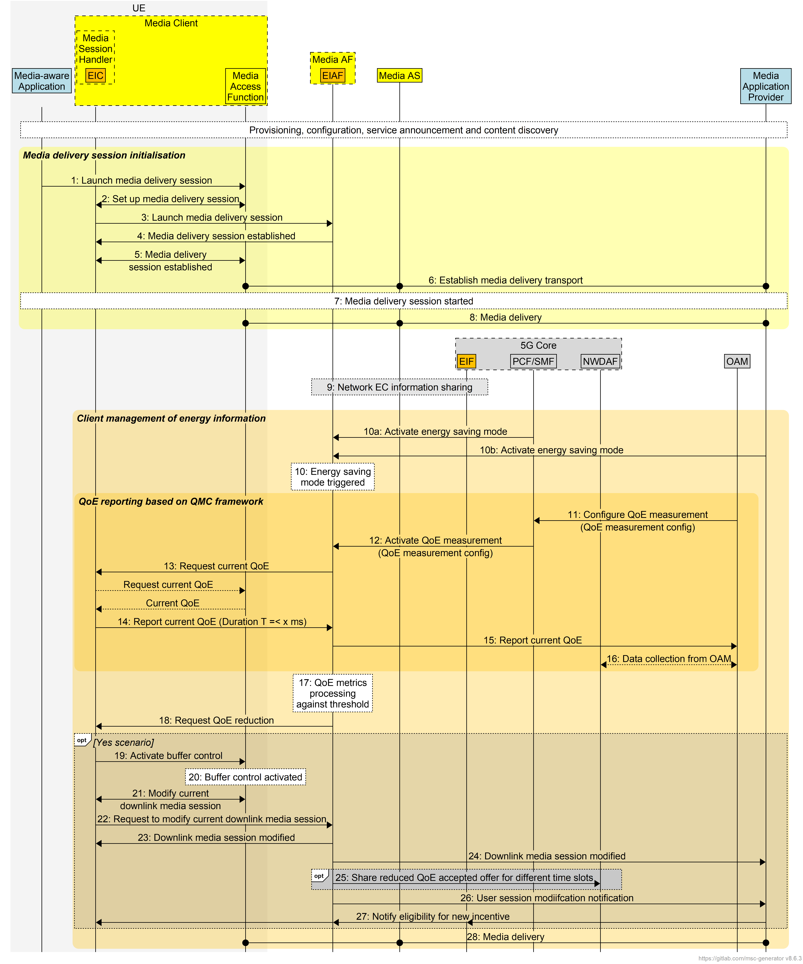
Figure 7.14.3-1: Procedures for Client-driven management of media delivery service energy optimisation
The working assumptions are:
- initial connection set-up is established between the UE and the Application Server (Provisioning, configuration, Service Announcement and content discovery).
Call flow steps:
Steps 1 to 8 follow the usual step-up while establishing a downlink media delivery session between the UE and the media application server. The media application requests a downlink media session, following which an downlink media session is established, and the media is transferred to the UE client from the Application Provider. Downlink media session starts at Step 8. This may be applicable to uplink media session as well.
9: The energy-related characteristics/information of the network, which are collected, stored in EIF are shared with the Media Application Provider via reference point E1. This is now shared between the EIF of the 5GC and the Energy Information AF instantiated in the Media AF via reference point E12.
Steps 10 to 15 relate to client management of energy information received from the EIF/EIAF:
10a: At a particular time window, say between 12 noon and 14h, which is peak hours data traffic period, the Media Application Provider decides to reduce the energy consumption of its Applications Servers. The Media Application Provider energy saving trigger contains the possible ranges of QoE. This could be provisioned in advance and operate by clockwork according to a schedule as well could be based on real-time trigger.
[Note: Why is the Media Application Provider responsible for reducing the energy consumption? To answer this question, text from KI#2 description of TR 26.942 is placed here for reference: “For instance, when a Mobile Network Operator (MNO) deploys a communication service to fulfil application service requirements, such as those of a gaming application, it is crucial for the customer – whether an Application Service Provider (ASP) or an industry vertical – to ensure that the application service minimizes energy consumption for both end users and the data network”.
10b: The request may come from the EIF to the Energy Information AF EIAF via reference point E12 to inform the Energy Information Collector to request UE media player to degrade the QoE as a result of QoS degradation due to network and/or UE energy saving. How the 5GC can determine the possible QoE ranges are based on the following steps in 5GC:
- UE subscription QoE reduction authorization is added to UDM.
- SMF will select the specific UE for a specific application to reduce the QoS.
- SMF will register to Observed Service Experience analytics for the specific UE with candidate QoS parameter sets and Application ID from NWDAF.
[Note: There was a proposed solution in the August meeting in SA2, which the consumer NF may provide candidate QoS parameter Sets and Application IDs for Observed Service Experience analytics are determined in S2-2408611.]
- NWDAF will provide the possible predicted QoE to the SMF.
- SMF optionally can checks UDM (UE subscription QoE reduction authorization) that if UE agrees already for such QoE degradations.
- SMF will send the energy saving trigger AF with the QoE ranges.
Figure 7.14.3-2: 5G core procedure to trigger the energy saving towards AF
10: The Energy Information AF receives this request and activates the energy saving mode.
[Note: The AF decides which UEs under the control of this particular AF could be activated to energy saving mode based on the received request energy saving trigger.]
11 to 15: The Energy Information AF requests all or some UEs (which are under its control) to report their current QoE metrics via reference point M4. The UE reports its current QoE. The UE shall decide to limit this for a duration of X ms.
[Note: QoE configuration and reporting can already optionally be specified by the QoE Measurement Collection (QMC) functionality in TR 26.942 KI#6. QoE metrics reporting shall be based on the existing standardized practices such as QMC. It would be good to reuse the QMC functionality e.g. based on TS 26.114. QoE metrics are reported by the UE to the AF, either via "in-band" with media requests at a reference point designated as M4 (specifically M4d for downlink streaming) or via the out-of-band via M5. The reporting can be triggered by specific events, follow a defined frequency/probability, or be location-dependent, all as configured by the AF]
[Note: On the topic of UE consent in order to have its QoE being reported, text from KI#2 description of TR 26.942 is placed here for reference: “NOTE 1: It is presumed that the user has granted consent for its UE data to be collected, reported and subsequently exposed by means outside the scope of the study or following normative work.”]
16: NWDAF collects the data from OAM in order to perform further analytics.
17: As soon as the Energy Information AF receives the QoE metrics reported by the UE, the Energy Information AF starts processing the recevied QoE metrics.
[Note: The received QoE metrics shall be compared against a standard value which are already pre-defined by the Application Service Provider (ASP) within the AF. For instance, the preferred video resolution quality of all (or some) users between 12 noon and 14h which are connected to a particular AF shall be limited to 720p only. or it is possible that AF receives the energy saving request with possible QoS degradations. Hence, the AF based on the receieved QoS degradation can request the NWDAF for the possible QoE for that specific UE based on the requested QoS ranges.]
18: After such comparison, the AF now requests all (or some) of users to reduce their QoE (for instance, video resolution), if they are using higher QoE metrics (for intance 4K resolution).
[Note: AF before requesting the UE to reduce the QoE may be able to check with the 5GC or ASP about the user subscriptions. In this scenario, if UE already has agreed to have such QoE degradtion, AF will reduce the QoE without asking UE approval and it will continue from step 13. Or it is possible that 5GC or ASP before triggering AF for energy saving, they have already checked the UE susbscription info and they will address that in their request.]
19 & 20: If the UE agrees to reduce its QoE, the Media Access Function of the UE activates buffer control.
[Note: There could be a timer in the AF after sending the request to UE, If the UE response has not receievd by the AF after specific time (i.e. X min), it means that UE does not agree with the QoE degradtion and it will continue from step 23.]
21: The on-going media session is required to be modifed between the Media Access Function and the Media Session Handler.
22: The Media Session Handler requests now the Media AF to modify the ongoing media delivery session, i.e. by requesting a different (new) dynamic QoS policy.
23 & 24: The AF thus modifies the ongoing media delivery session.(by reaching the PCF/SMF as decribed under 10b.)
25: (optional) This information could be optionally shared by the Energy Information AF with the NWDAF (which will allow to retrive this information in the future). Here the accepted QoE ranges by the users will be stored which can be used by the Media Application Provider or 5GC for analytics.
26 & 27: .

.
.
The EIAF can share the observed service experience information with the Network Data Analytics Function (NWDAF) in the 5G Core Network, as explained in clause 4.2.2.6 of the present document. The NWDAF can then perform analytics (e.g., on UE communication patterns or potential QoS issues) and provide insights to other Network Functions (NFs) like the Policy Control Function (PCF) to assist with dynamic QoS policy decisions. The collected data can be exposed as events to other authorised entities, such as a Media Application Provider's Event Consumer AF, allowing for broader analysis and integration with other systems. The Media Application Provider can use the metrics to understand the quality of service delivery and make real-time or long-term adjustments to enhance user experience. In addition, the Media Application Provider may choose to provide incentive to users who agree to reduce their QoE in order for the Media Application Service Provider or the 5G network operator to perform energy saving operations.
Otherwise, the UE does not agree to reduce its QoE, it will not activate the buffer control and therefore the on-going downlink media delivery session continues unmodified between Media Access Function and the Media Session Handler. Media is delivered as before.
28: The Media Application Provider continues to provide media to the Media Access Function in the UE via the Media AS, possibly with reduced QoE.

7.13.4 Summary
This candidate solution defines a mechanism enabling Media AF to manage energy-saving operations that may cause QoS (Quality of Service) and QoE (Quality of Experience) degradation. The Media AF collaborates with the 5GC (5G Core) and/or Media Application Providers to assess user tolerance to QoE degradation and coordinate adaptive strategies between the network and the User Equipment (UE) to minimize service impact.
NOTE: This solution is in contrast with the Alternate QoS Profile feature specified in clause 5.7.1.2a of TS 23.501 [23501] and its handling in the context of notification control as specified in clause 5.7.2.4, specifically clause 5.7.2.4.1b for "Notification control with Alternative QoS Profiles" which allows the network (specifically the NG-RAN) to dynamically adapt the Quality of Service for applications that can handle varying QoS levels in order to save network energy.
Key Functional Aspects
- Energy-Saving Trigger Toward AF
  - Energy-saving actions can be triggered by authorized entities such as:
    - 5GC: Initiates QoS adjustments (e.g., bandwidth reduction) for network energy saving.
    - ASPs: Initiate energy-saving requests based on service agreements or cloud resource status.
  - The AF receives these requests along with proposed QoS/QoE ranges and initiates downstream procedures to manage QoE impacts.
- Assessment of User Tolerance to QoE Degradation
  - Upon receiving an energy-saving request, the AF evaluates the potential QoE impact:
    - Compares requested QoE parameters with predefined QoE thresholds or user-specific subscription data.
    - If only QoS parameters are provided, the AF may use the NWDAF (Network Data Analytics Function) to estimate QoE degradation.
  - Decision logic:
    - If degradation is within user’s pre-agreed QoE range → proceed automatically, with optional feedback collection.
    - If degradation exceeds the allowed range → user approval is required, specifying the expected QoE impact.
- UE-Controlled QoE Adaptation
- The UE application evaluates whether it can tolerate the requested QoE degradation.
- If acceptable, the UE adjusts application behaviour to minimize QoE impact (e.g., adaptive bit rate reduction, buffering control, or resolution adjustment).
- The UE ensures QoE remains above predefined thresholds, maintaining acceptable user experience despite lower resource allocation.
This Candidate Solution:
- Enables dynamic coordination between the Media AF, 5GC, Media Application Provider and UE for energy-efficient operation.
- Provides a framework for user-aware energy-saving decisions based on tolerance to QoE degradation.
- Allows the network and UE to jointly optimise energy consumption while maintaining service continuity and acceptable QoE.
End of changes

