3GPP TSG-SA WG4 Meeting #135 S4-260234
9-13 February 2026, Goa, India
Source: InterDigital New York
Title: 6GMedia - work topic 2- Characteristics of AI-enabled applications
Agenda Item: 11.1
Document for: Discussion and Decision

Introduction
This contribution proposes use-cases and elaborates on the key characteristics of new applications XR and AI-enabled mobile applications and services. This contribution provides observations and proposals for work topic 2 of the 6GMedia study to enable interoperable and widespread deployment of these services.

Use cases
The following use-cases are representative of the diversity of XR and mobile AI-enabled applications and services.

For Augmented Reality (AR) applications and services, the insertion of virtual content (including 2D or immersive video) in user’s real environment requires AI-based Spatial Computing functions (e.g., segmentation, semantic perception of the real environment) as those defined in the clause 4.1 of TR 26.819.[26819]

The use case on personalized interactive immersive guided tour (clause 9.12 of TR 22.870) requires AI inference for the proper placement of virtual content in the user’s fast-evolving real environment by ensuring that each group member has a good point of view of the virtual content during the guided tour.

Video or image analysis (e.g., for object detection, scene recognition) on mobile devices often requires remote AI processing with adaptive upstream video quality adjustments (e.g., different resolutions and error tolerance) as described in the use case on network-assisted video-based AI inference task offloading for mobile embodied AI (clause 6.28 of TR 22.870).

For conversational services, including chatbot or avatar-based communication, AI techniques are used for real-time translation, media transformation (e.g., image to video, 2D video to avatar) as described in the use case on AI-assisted multi-modal communication service (clause 6.42 of TR 22.870).

For context-aware recommendation and notification, generative AI is used to answer the user’s questions related to their environment as described in the use case on end-to-end AI for connected car (clause 6.3 of TR 22.870), where an Edge-based AI system responds to a user’s question (e.g., "What is this mountain peak in front of me?") with minimal latency.

The training, transfer, and update of an AI model requires the transmission of AI data (e.g., training data, AI/ML model, AI inference data) as described in the use case on AI/ML model training and inference (clause 6.25 of TR 22.870).

Discussion

3.1 Heterogeneous and Multimodal Mobile application and services
Mobile AI-enabled applications and services are highly heterogeneous and multimodal. Media types encompass a mix of video, image, audio, text, haptics, and sensor data.
Further AI-enabled applications also exchange AI/ML data [TR 26.927] such as prompt/text (e.g., corresponding to user’s request for generative AI), AI model parameters (e.g., graph representation, weights) or compressed/uncompressed intermediate data resulting from inference tasks, potentially distributed across endpoints. (e.g., encrypted embeddings from iOS enhance vision search and Android edge AI [embeddings])
Table-1: Representative multimodality in AI-enabled applications.
AI Use Case | Data and Media Modality | Potential codecs and data representation formats to be considered
AR | UL: video, audio, Prompt, Inference data  DL: video, audio, dynamic 3D media (mesh, gaussian, point cloud), haptics, spatial description from inference results (e.g., labels) | MPEG haptics , Scene description enhancements, dynamic mesh, and upcoming dynamic gaussian splat codecs.  W3C Media Annotations
Real-time Object Detection / Scene Understanding | UL: video/images, prompt, inference data  DL: video/images or audio, haptics, inference results (e.g., labels, bounding boxes) | Feature representation (e.g., embeddings), MPEG-7 descriptors learned based compression such as MPEG FCM.
Speech Recognition / Conversational AI | UL & DL: Audio, text, inference data | ULBC [ULBC], Inference data such as token, embeddings
Model Learning / Model Updates | UL & DL: Model, model parameters. (graphs/weights) | ONNX [ONNX], GGUF [GGUF], MPEG NNC [NNC],
Avatar communication services | 3D object or 2D image, audio, haptics, avatar animation stream | Upcoming MPEG avatar, gaussian and mesh codecs.
Context-aware recommendation/notification with Generative AI | audio, video, prompts, inference results (e.g., audio, video or may be annotation, labels, scores, confidence values, coordinates, masks, or structured outputs, etc.) | W3C Media Annotations, MPEG-7 descriptors

Observation 1: AI-enabled applications and services require heterogenous media types along with AI prompt, AI/ML data, AI model parameters (e.g., graph representation, weights) or intermediate data (compressed/uncompressed) issued from inference tasks potentially distributed across endpoints.
Proposition 1: SA4 should study the support of additional media modality and codecs or their enhancements for 6G, building upon 5G and 5GA studies.
Proposition 2: SA4 should define terminology applicable for AI/ML data (feature, token, embeddings, latent, intent, etc.), study the relevant AI representation formats to ensure a common understanding across WGs and study which interchangeable format/codecs are applicable.
Observation 2: Some AI-enabled applications and services (e.g., AR, object detection, scene understanding) require remote AI-based Spatial Computing functions such as those defined in TR 26.819.
Proposition 3: SA4 should identify and study a set of spatial compute functions that may benefit from off-device processing for mobile AI-enabled applications and services
3.2 QoS granularity and QoE-driven dynamic media adaptation
The traffic characteristics of these applications are uplink-heavy and can differ greatly across modalities. For example, continuous video capture for AI-driven use cases often results in high-rate, periodic uplink traffic, whereas AI applications that process audio or sensor data typically generate lower-rate, aperiodic, and bursty transmissions. Furthermore, the overall traffic composition and intensity can change dynamically in response to user behavior, interaction patterns, mobility patterns, and environmental factors.
Real-time use cases such as AR and conversational AI demand ultra-low latency and high data rates to support fluid interactive experiences. It is expected that background-learned tasks (possibly unrelated to media services) may occur simultaneously and be demanding on the device and network. To meet these varied requirements, context-awareness needs to be exposed to ensure dynamic adaptation of the different modalities to the 6G network condition, particularly in uplink. These optimizations are key to delivering consistent QoS/QoE for users interacting with pervasive AI-powered devices and demanding XR applications.
Table-2: Representative AI Traffic Network Requirements
AI Use Case | Typical Data Rate | Latency Requirement | Reliability | Need for QoE-based dynamic media adaptation
AR | High | Real-time | Mid | High
Real-time Object Detection / Scene Understanding | High | Real-time | Mid | High
Speech Recognition / Conversational AI | Mid | Real-time | Mid | Mid
Model Learning / Model Updates | High | Non-real-time | Mid | Low
Avatar communication services | High | Real-time | Mid | High
Context-aware Recommendation / Notification | Mid | Real-time | Mid | Mid

Observation 3: The diversity of applications and modalities across AI-enabled applications and services, render the evaluation and classification of traffic characteristics challenging.
Proposition 4: When studying traffic characteristics for AI-enabled applications and services, SA4 should aim at developing generic QoS and QoE mechanisms suitable across the diversity of traffic patterns.
Observation 4: Some AI-enabled applications and services require temporal dependency and synchronization between these different media modalities and AI data, especially for real-time or delay-bound AI inference.
Observation 5: These applications are characterized by uplink-intensive, bursty or continuous, and multi-modal traffic with diverse latency sensitivity and QoE impact. Multimodal media transmission needs to be adaptive based on the fluctuations in 6G network connectivity, especially in uplink.
Observation 6: Current QoS frameworks may lack the application and context awareness, granularity, and adaptability needed to accurately characterize and efficiently support such traffic under dynamic 6G network conditions.
Proposition 5: SA4 should study the necessary enhancement to QoS framework enabling finer granularity and context awareness.
Proposal 6: SA4 should specify the procedures for real-time QoE-based adaptation of multimodal media and define QoE metrics for real-time and delay-bound AI inference.

3.3 New protocols
It is also important to recognize that both AI-enabled services/applications and the underlying transport protocols are rapidly evolving. Advancements in transport protocols (e.g., QUIC-based, HTTP/3-based) are being developed to suit the use-cases described in section 2. These ongoing evolutions can have a substantial impact on the observed traffic characteristics, including latency, reliability, and resource utilization.
In Rel-19, SA2 specified different techniques for delivering Media Related Information (MRI) – such as PDU Set and dynamic traffic characteristics information – when the XRM traffic is end-to-end encrypted as is the case when QUIC is used. Clause 5.37.9 of TS 23.501 specifies various options for relaying MRI over the N6 interface.
Observation 8: These new transport protocols will impact the media transmission in terms of reliability, latency, and traffic characteristics.
Proposal 7: SA4 should characterize the impact of QUIC-based protocols on the delivery of AI data and on the traffic characteristics of AI applications and services over QUIC-based protocols especially for real-time or delay-bound applications.
Observation 9: In Rel-18 and Rel-19, SA4 has specified solutions in TS 26.522 that enable RTP senders to transmit MRI using RTP header extensions.
Proposal 8: SA4 should study the potential integration of the extensions SA2 has defined for QUIC-based transport solutions into the media delivery architecture. For the RTC architecture, this would be done by leveraging the FS_Q4RTC-MED study and applied to these AI-enabled applications.

3.4. Multi-Device Scenarios
AI-enabled services and applications are increasingly deployed across a wide range of mobile and wearable devices, such as smartphones, AI glasses, smartwatches, fitness devices, companion compute devices, etc. These services commonly involve continuous sensing, media capture and processing, on-device or distributed AI inference, and frequent data exchange with the network. AI-enabled services are often inherently multi-devices, with different devices contributing sensing, media, compute, display, or connectivity functions. This trend introduces new QoS and QoE challenges taking into account adaptation of modalities and formats, coordination of AI processing with partial or full offload, as well as correlation of traffics across UEs. [Meta Orion] [Meta glasses] [Meta display glasses]
Observation 7: AI-enabled services increasingly operate across heterogeneous multi-devices associated with the same user, rather than being confined to a single UE. Modalities, AI processing may be distributed across the different UEs.
Observation 8: Existing system assumptions are largely UE-centric and do not address the QoS and QoE requirements of multi-device AI-enabled applications and services.
Proposal 8: SA4 should study the impact of multi-devices on the QoS and QoE framework.
Observation 9: QoS enhancement and QoE-driven dynamic media adaptation need to operate across heterogenous multi-devices associated with the same user.
Proposition 9: SA4 should consider heterogenous multi-devices associated with the same user for the definition of QoE metrics and for the study of potential enhancement to QoS for real-time and delay-bound AI inference.
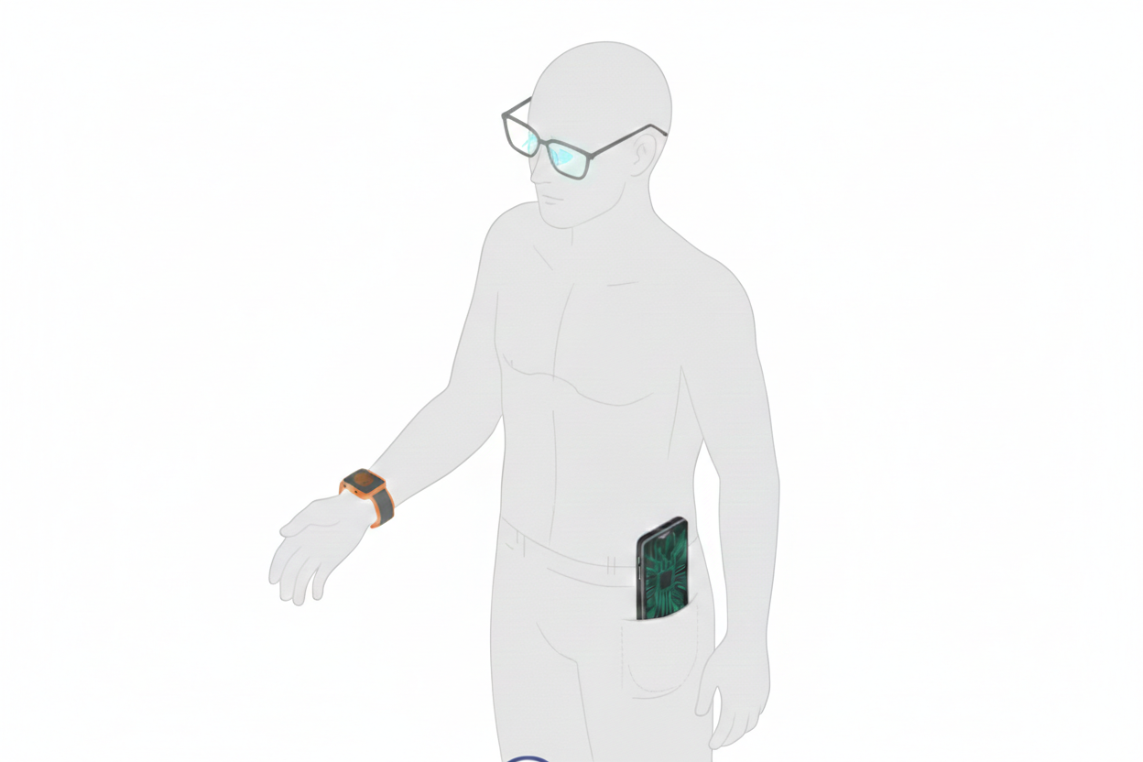
Figure 1. UE tethering: AI-enabled services are delivered across multiple user devices, such as smartphones and wearables, where the multi-devices rely on a tethered UE that provides cellular connectivity and coordination via 3GPP and/or non-3GPP links.[R2-2600480]

Conclusion
In this paper, we discuss our views on the key characteristics and requirements of AI enabled mobile applications and services.

Heterogeneous and Multimodal Mobile application and services
Observation 1: AI-enabled applications and services require heterogenous media types along with AI prompt, AI/ML data AI model parameters (e.g., graph representation, weights) or compressed/uncompressed intermediate data issued from inference tasks, potentially distributed across endpoints.
Proposition 1: SA4 should study the support of additional media modality and codecs or their enhancements for 6G, building upon 5G and 5GA studies.
Proposition 2: SA4 should define terminology applicable for AI/ML data (feature, token, embeddings, latent, intent, etc.), study the relevant AI representation formats to ensure a common understanding across WGs and study which interchangeable format/codecs are applicable.
Observation 2: Some AI-enabled applications and services (e.g., AR, object detection, scene understanding) require remote AI-based Spatial Computing functions such as those defined in TR 26.819.
Proposition 3: SA4 should identify and study a set of spatial compute functions that may benefit from off-device processing for mobile AI-enabled applications and services
QoS granularity and QoE-driven dynamic media adaptation:
Observation 3: The diversity of applications and modalities across AI-enabled applications and services, render the evaluation and classification of traffic characteristics challenging.
Proposition 4: When studying traffic characteristics for AI-enabled applications and services, SA4 should aim at developing generic QoS and QoE mechanisms suitable across the diversity of traffic patterns.
Observation 4: Some AI-enabled applications and services require temporal dependency and synchronization between these different media modalities and AI data, especially for real-time or delay-bound AI inference.
Observation 5: These applications are characterized by uplink-intensive, bursty or continuous, and multi-modal traffic with diverse latency sensitivity and QoE impact. Multimodal media transmission needs to be adaptive based on the fluctuations in 6G network connectivity, especially in uplink.
Observation 6: Current QoS frameworks may lack the application and context awareness, granularity, and adaptability needed to accurately characterize and efficiently support such traffic under dynamic 6G network conditions.
Proposition 5: SA4 should study the necessary enhancement to QoS framework enabling finer granularity and context awareness.
Proposal 6: SA4 should specify the procedures for real-time QoE-based adaptation of multimodal media and define QoE metrics for real-time and delay-bound AI inference.
Multi-Device Scenarios:
Observation 7: AI-enabled services increasingly operate across heterogeneous multi-devices associated with the same user, rather than being confined to a single UE. Modalities, AI processing may be distributed across the different UEs.
Observation 8: Existing system assumptions are largely UE-centric and do not address the QoS and QoE requirements of multi-device AI-enabled applications and services.
Proposal 8: SA4 should study the impact of multi-devices on the QoS and QoE framework.
Observation 9: QoS enhancement and QoE-driven dynamic media adaptation need to operate across heterogenous multi-devices associated with the same user.
Proposition 9: SA4 should consider heterogenous multi-devices associated with the same user for the definition of QoE metrics and for the study of potential enhancement to QoS for real-time and delay-bound AI inference.
Conclusion
It is proposed to discuss and agree the above proposals as part of the 6GMedia study and document them in the TR, in a section 6.X.

References
[TR 26.819] 3GPP TR 26.819: "Study on Spatial Computing for Augmented Reality (AR) Services"
[TR 22.870] 3GPP TR 22.870: "Study on 6G Use Cases and Service Requirements"
[TR 26.927] 3GPP TR 26.927: "Study on Artificial Intelligence and Machine learning in 5G media services"
[TS 23.501] 3GPP TS 23.501: "System architecture for the 5G System (5GS) "
[TS 26.522] 3GPP TS 26.522: "5G Real-time Media Transport Protocol Configurations"
[FS_Q4RTC-MED] xxx
[embeddings] https://ai.google.dev/edge/mediapipe/solutions/vision/image_embedder/
[ONXX] https://onnx.ai/
[GGUF] https://huggingface.co/docs/hub/gguf
[NNC] "ISO/IEC 15938-17:2024 Information technology - Multimedia content description interface - Part 17: Compression of neural networks for multimedia content description and analysis”, Edition 2, ISO/IEC, January 2024.
[Meta Orion] Meta Orion, the next-generation AR/AI glasses platform https://www.meta.com/emerging-tech/orion/
[Meta glasses] Meta AI glasses https://www.meta.com/ai-glasses/
[Meta Display glasses] Meta display glasses https://www.meta.com/ai-glasses/meta-ray-ban-display/
[R2-2600480] Key Characteristics and Requirements of Mobile AI, Meta, Qualcomm Incorporated, NTT DOCOMO, INC., NVIDIA, Verizon, KDDI.

