Source: Editor
Title: DaCAS-2: Test methodologies and requirements v0.7

Document for: AGREEMENT
Agenda item: 7.5 / 15.1

Revision history:
Date | Meeting | Subject/Comment | Old | New
2025-05-22 | SA4#132 | Initial version including S4aA250021, S4-250967 | N/A | 0.1
2025-06-16 | Audio SWG AH Meetings Post SA4 #132 Telco on DaCAS | Addition of compensation method from S4Aa250054 and single source recording scenario from S4Aa250055, editorial updates | 0.1 | 0.2
2025-07-22 | SA4#133-e | Addition of the agreed content from S4-251375, S4-251466, S4-251472. | 0.2 | 0.3
2025-11-17 | Audio SWG AH Meetings Post SA4 #133-e Telco on DaCAS | Addition of agreed content from S4aA250107 | 0.3 | 0.4
2025-11-19 | SA4#134 | Addition of the agree content from S4-251891, S4-251979, and description on the test scripts for evaluation | 0.4 | 0.5
2026-02-08 | Audio SWG AH Meetings Post SA4 #134e Telco on DaCAS | Addition of the agreed content from S4aA260008 | 0.5 | 0.6
2026-02-11 | SA4#135 | Addition of the agreed content from S4-260294 and S4-260296 | 0.6 | 0.7

Scope
As outlined in the scope of the DaCAS WID, several points need to be considered:
- The test methodologies and requirements are based on relevant sending side terminal audio quality test methods defined in TS 26.260.
- The evaluation may be conducted on the databases processed by the example solution.

Introduction
The Pdoc is structured according to the relative objectives that are in scope of DaCAS:
- Definition of minimum performance requirement/objective criteria for raw microphone signal performance and characteristics including, e.g., expected compensation of the microphone signals: e.g., directional response, SNR, frequency response.
- Evaluation of available immersive audio capture example solutions based on relevant sending side terminal audio quality test methods defined in TS 26.260.
- Verification and potential revision of the minimum performance requirement/objective criteria for raw microphone signal performance and characteristics based on how the example solutions perform under the audio quality test methods defined in TS 26.260.
- Potential alignment with TS 26.260 and 26.261.
- In addition, potential test methodologies for subjective tests and requirements are collected

Requirements for raw and compensated microphone signals

Raw microphone signals

Requirements
[
Editor’s note: Decision needed whether to have normative or informative requirements/recommendations.
[Raw microphone input for DaCAS example solutions shall comply with the requirements specified in Table 1.]
Table 1 Raw microphone signal requirements
Feature | Requirement | Recommendation
Raw frequency response (excluding resonances) | TBD | Minimum captured frequency (-3dB point) should be below 100 Hz  Frequency response above the minimum frequency and below the resonances should be as flat as possible.
Resonances | Shall be above 6 kHz | Should be above 8 kHz.
SNR | Shall be at least 54 dB | Should be at least 60 dB
Sensitivity | TBD | [Level should be below -25 dBFS ($±$1 dB) with 1 kHz sine signal @ 94 dB SPL]
Directivity | TBD | Recommended to have omnidirectional characteristics. Other directivity patterns are not generally excluded.  Microphone directivity characteristics shall be documented clearly.
ADC bit depth | [The ADC bit depth shall be at least 16 bits] | The ADC bit depth should be 24 bits.
Acoustical Overload Point | [Shall be at least 120 dB SPL @ 10% THD] | Should be at least 130 dB SPL @ 10% THD
NOTE: It is expected that all the raw integrated microphones comply with the above requirements. In addition, it is favorable to have as similar characteristics as possible for all raw integrated microphones.
]

Compensation on microphone signals
Any raw microphone compensation, including the approaches outlined in the section 3.2.2, are considered as optional in the development of example solutions. Example solution developers may selectively adopt the solutions outlined in the section 3.2.2 or any other solution based on specific application requirements. If other solutions are adopted, these shall be documented.

If proponents provide compensated signals as part of the target device database, the proponent shall provide compensation filter specification with the relevant data and the instruction how the filters are applied to the raw microphone signals. In addition, proponent may provide only the compensation filter specification and instructions how to apply them, instead of the compensated signals.

Requirements
[
Editor’s note: Decision needed whether to have normative or informative requirements/recommendations.
Compensated microphone input for DaCAS example solutions shall comply with the requirements specified in Table 2.
Table 2 Compensated microphone signal requirements
Feature | Requirement | Recommendation
Compensated frequency response | When compensation processing is applied to the same signal as used for designing the compensation filters:  - Compensated frequency response shall be within ‘Required’ mask defined in Table 3  - Differences between compensated frequency responses shall be within ‘Required’ mask defined in Table 4 | Compensated frequency response should be considered in the context of isotropic equalization target.  When compensation processing is applied to the same signal as used for designing the compensation filters:  - Compensated frequency response should be within ‘Recommended’ mask defined in Table 3  - Differences between compensated frequency responses should be within ‘Recommended’ mask defined in Table 4
Phase properties | TBD | Compensation processing should compensate sound source direction independent phase differences between integrated microphone responses.

Table 3 Compensated microphone sensitivity/frequency mask
 | Required |  | Recommended
Frequency (Hz) | Upper limit (dB) | Lower limit (dB) | Upper limit (dB) | Lower limit (dB)
100 | 4 |  | 2
200 | 4 | -4 | 2 | -2
5000 | 4 | -4 | 2 | -2
12500 | 4 | -6 | 2 | -3
16000 | 4 |  | 2
NOTE: All sensitivity values are expressed in dB on an arbitrary scale.

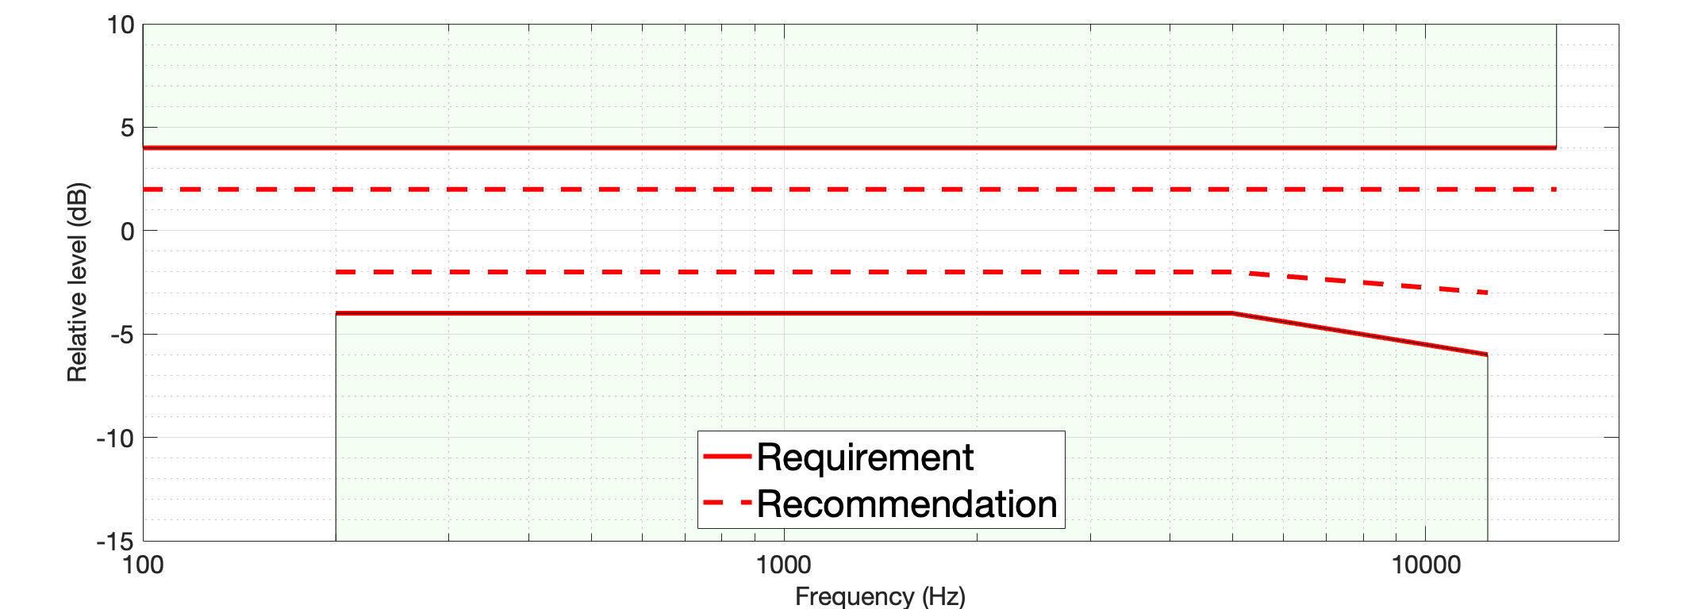
Figure 1 Compensated microphone response masks

Table 4 Compensated microphone sensitivity/frequency difference mask
 | Required |  | Recommended
Frequency (Hz) | Upper limit (dB) | Lower limit (dB) | Upper limit (dB) | Lower limit (dB)
100 | 2 |  | 1 | -1
200 | 2 | -2 | 1 | -1
5000 | 2 | -2 | 1 | -1
12500 | 2 | -4 | 1 | -2
16000 | 2 |  | 1
NOTE: All sensitivity values are expressed in dB on an arbitrary scale.

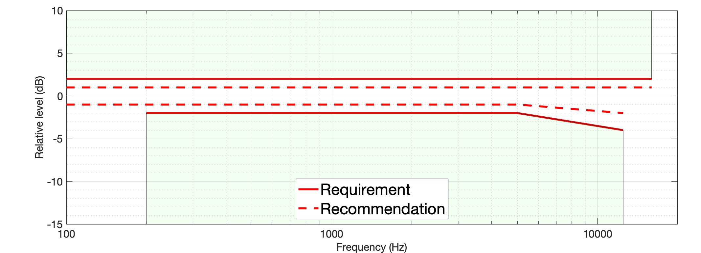
Figure 2 Compensated microphone response difference masks
]

Compensation processing
[

Diffuse field based raw microphone compensation method
Following compensation method proposal is integrated from the input document [4].

Derivation of compensation filters

Recording environment and requirements

The proposed method requires a quiet room with low reverberation, e.g. a listening room, and a surround loudspeaker layout of ideally 7.1.4, (or a known loudspeaker layout with locations towards the front, rear and sides, and at least some height differentiation). The signal to be recorded is a diffuse series of uncorrelated pink noise signals played out of the 7.0.4 loudspeakers, omitting the subwoofer due to differences in frequency response.

The target device is placed at the center of the room, in a landscape orientation, and positioned such that the camera is pointing towards the center speaker, or front of the room. The source has successfully applied the approach with 10 seconds of noise recordings, along with 15 seconds of silence for estimation of the noise floor.

Gain matching between microphones

By observing respective average frequency responses of the device microphone recorded signals, a broadband relative gain can be derived per channel, G(ch), to bring any outlier microphones in line with the rest. In principle this step may not be required, if the device microphones are closely matched.

Equalization estimation

The device descriptions provided in [1] are sufficient to model theoretical impulse responses (including equalization and delay) from a particular direction to the microphone position on the device surface, without accounting for porting effects. This is sufficient, as including the port geometries increases the complexity of the required models, and measuring the port geometries would be quite difficult. Any small errors in measuring the port geometries could also have profound effects on the modelled output.

Using the modelled impulse responses from the known loudspeaker directions to the device microphone positions, as derived from a model of the specified device geometry, a set of simulated device microphone signals may be created. These simulate the combined effect of the incoming diffuse noise field at the microphone positions on the surface of the device.

By comparing the simulated device signals and real device recordings, an estimate of an equalization can be calculated to account for the port resonances. Given the room requirements stated above, the source assumes that the effects of the room are negligible compared to the effects of the device geometry. It is also assumed that the MEMS mics have a flat response.

Details:
- Calculate a smoothed average device signal DFT log magnitude, dev(ch,f) and smoothed average simulated reference signal DFT log magnitude, sim(ch,f). Based on experience, the specific smoothing method is less important.
- Subtract the smoothed average device DFT from the smoothed average simulated reference DFT in the log magnitude domain, to obtain a set of equalization gains that model the port resonances only.

port(ch,f) = sim(ch,f) – dev(ch,f)
- Convert the port spectrum to a banded spectrum, port(ch,b), e.g. ERB or similar, to reduce the number of stored parameters. The banded responses may be normalised to abide by some sensible rule, e.g. response of mic 1 is 0dB at 1kHz.
- Given the assumption of flat MEMS mic responses, the resonances of each microphone port can then be observed and modelled by hand from the resulting banded responses, port(ch,b), using simple filters. This creates a new parametric banded spectrum that accounts only for the observed resonances, EQ(ch,b). The final equalization coefficients are thus derived only from the observed microphone port resonances.

Noise floor estimation

The silence recording from the target device is used to generate a banded per channel noise floor estimate for the target device, NF(ch,b).

Compensation processing

The microphone compensation processing can be performed in the DFT domain, using the following steps:
- Convert the input DFT spectrum to the banded spectrum, in log magnitude domain, spec(ch,b).
- Calculate gains that compensate for the noise floor

g(ch,b) = (spec(ch,b) – NF(ch,b))/(spec(ch,b) + eps).
- Expand the noise floor gains and the EQ gains to DFT bins, g(ch,f) and EQ(ch,f).
- Apply a combined compensation gain G(ch) * EQ(ch,f) * g(ch,f) to the input spectrum bins, to perform gain matching between microphones, equalization of the porting effects and noise floor.
Editor’s note: Clarification needed whether the applied gain is in linear or log scale.

Editor’s note: Status of this method is to be clarified.
]
[

IMPro method
Following compensation method proposal is integrated from the input document [6] and [11]. Further information about the IMPro measurement can be found from [7].

IMPro calculation
Integrated microphone pressure frequency response $H_{m}$ is calculated by dividing the measured integrated microphone output signal's response $U_{m}$ with probe signal output signal response $U_{p}$ measured at the reference point at the sound port inlet according to following equation
$H_{m}=H_{probe}\frac{U_{m}}{U_{p}}\text{, }\text{[units/Pa]}$ (1)
where is $H_{probe}$ is the calibration frequency response of the probe microphone [7]. Note the notation is slightly modified from [7] to clarify time domain and frequency domain representation.

Compensation filter target response
Let
- M: number of device microphones
- ${u_{p}}_{i}\left(t\right)$: pressure at $i$th microphone sound inlet where $i=1,2,…,M$
- $h_{m_{i}}\left(t\right)$: impulse response of the integrated microphone response using IMPro
- $f_{i}\left(t\right)$: equalization filter for microphone signal compensation
- ${u_{m}}_{i}\left(t\right)$: raw microphone signal output for $i$th microphone
- $y_{i}\left(t\right)$: Compensated at $i$th microphone output

Each microphone captures a raw microphone signal
$${u_{m}}_{i}\left(t\right)={u_{p}}_{i}\left(t\right)*h_{m_{i}}\left(t\right)$$

Compensated microphone output signal can be defined as follows
$$y_{i}​\left(t\right)={u_{m}}_{i}​\left(t\right)*f_{i}​\left(t\right)={u_{p}}_{i}\left(t\right)*h_{m_{i}}\left(t\right)*f_{i}​\left(t\right)$$
The target equalization filter $f_{i}\left(t\right)$ response compensates for integrated microphone response within the target frequency response mask such it corresponds to delayed pressure signal at the sound inlet without loss of information such that:

$$h_{m_{i}}\left(t\right)*f_{i}\left(t\right)≈δ\left(t-τ\right), ∀i∈\left\{1,…,M\right\}$$

In frequency domain the compensation filter target frequency response can be defined as:
$F_{i}\left(ω\right)=\frac{e^{-jωτ}​}{H_{m_{i}}​\left(ω\right)},∀i$ (2)
within the range of target frequency response mask $ω_{low}≤ ω≤ ω_{high}$

Microphone component manufacture data sheets specify commonly free field frequency response characteristics including sensitivity tolerances typically normalized at 1kHz. If target UE uses the same component type for all microphones, the transducer differences are quite well understood based on manufacturer component specification. Use of different types of microphones open additional questions on how different components operate under different environmental conditions. The designer should consider all different factors and try to minimize variations between different microphones.

Proposed integrated microphone calibration method
Integrated microphone array calibration is performed using following steps:
- Perform IMPro measurements for all device microphones [1]
  - Prepare UE software enabling raw microphone recording from all DUT microphones
  - Setup loudspeaker and device setup for measurement having at about 0.5-2m source distance
  - Prepare the measurement signal stimulus (sine sweep) and check the loudspeaker playback levels approximately 30dB above background noise level while avoiding signal clipping
  - Calibrate probe microphone(s) using a probe calibrator or calibrated measurement microphone
  - Perform IMPro measurement by measuring pressure signal at sound inlet using the probe microphone while DUT is recording all microphone signals
  - Time-align measured signals audio signals
  - Calculate integrated microphone pressure frequency response $H_{m_{i}}$ for each microphone $i=1,2,…,M$ according to equation (1)

- Calculate compensation filter for the integrated microphone output
  - Measure IMPro frequency responses $H_{m_{i}}$ from reference sample device or average measurement results from sufficiently many devices for statistical relevance
  - Design linear equalization filters according to (2) such that responses align within
    - equalization filter frequency response mask and
    - equalization filter frequency response difference mask

- Implement equalization filter in UE software providing compensated microphone signal output

- Process recorded raw microphone signals ${u_{m}}_{i}\left(t\right)$ with equalization filters $f_{i}\left(t\right)$ to compensated microphone output signals $y_{i}​\left(t\right)$

- Verify that compensated microphone output signal $y_{i}​\left(t\right)$ satisfies frequency response mask requirements
  - Check that all microphone signals are equalized to satisfy equalization filter frequency response mask ensuring target timbre for compensated microphone signals
  - Check that all microphone signals are equalized to satisfy equalization filter frequency response difference mask to ensure that spatial algorithms can assume that compensated microphone responses do not distort magnitude or phase of the spatial audio information present in acoustic signal at sound inlet ports
  - Check that output signal $y_{i}​\left(t\right)$ is effectively a delayed version of pressure signal at sound inlet with constant delay $δ\left(t-τ\right), ∀i$

Applicability condition for synchronized IMPro measurement
If the UE employs non-identical microphone integrations (e.g., different acoustic port lengths, meshes, gaskets, baffles or cavity geometries) such that inter-microphone propagation delay differences may be non-negligible, the IMPro measurement used for clauses 2.2 and 2.3 need to address the relative inter-channel propagation delays (RIPD).
This requirement is fulfilled by either:
- Synchronized IMPro acquisition: all probe signal(s) and all UE microphone signals are acquired with a shared, repeatable time base or,
- IMPro acquisition with a probe-array: simultaneous probe measurements are performed at all relevant inlets during the UE recording.

Use of probe-array assumes calibrated probe microphones that need to be calibrated at the same time to common calibration reference, and the actual measurement of the UE microphones is done preferably as single multichannel recording with as many probe microphones as there are microphones in the UE. This way inspection of the probe microphone positioning can be checked for all microphones at once before the measurement.
Another measurement approach would be to use two or more probe microphones where one of the microphones is set as a reference microphone providing a synchronization reference and the other microphone(s) are used to measure all other integrated microphones. This sequentially synchronized approach needs to ensure that microphone movement does not introduce other changes in the measurement setup.
NOTE 1: This clause does not alter the IMPro calculation, or the compensation target defined in 2.2 and 2.3.
]

[

Evaluation procedure
Following content is incorporated based on the input document [8].

Overview
Following procedure is used to evaluate DaCAS example solutions:
- Self-evaluation approach for example solutions will be used as presented in section 4.2.1.
- There is provided a time window for optional cross-evaluation, i.e., cross-evaluation may be performed as defined in section 4.2.2 by the interest proponents on a ‘best-effort’ basis. Sufficient time for optional cross-evaluation should be provided. For optional cross-evaluation the documentation guidelines may be relaxed.
- High-level documentations guidelines are followed as present in the section 4.3.
- At least informal assessment against requirements in 3GPP TS 26.261 [9] is made.

Procedure

Self-evaluation
- Evaluation of the example solution is done by the proponent providing the example solution
- Proponent processes the recordings used for the evaluation with the example solution
- Proponent performs the objective evaluation (e.g., with the evaluation scripts described in DaCAS-2) for the example solution output signals. Subjective evaluation is recommended, methods and details TBD.
- Proponent provides a detailed documentation on the evaluation procedure and obtained results

Optional cross-evaluation
- In addition to self-evaluation, any 3GPP member company, denoted as cross-evaluation lab, may evaluate one (or more) example solution(s) provided by a proponent
- Cross-evaluation lab runs the evaluation script (defined in DaCAS-2) with the example solution’s output signals
- Depending on the cross-evaluation lab’s interest and available effort, the cross-evaluation may be done directly for the processed example solution output signals provided by the self-evaluation proponent, or by running the evaluated example solution with the recordings used for the evaluation and performing the evaluation for the processed output signals
- Cross-evaluation lab provides a detailed documentation on the evaluation procedure and obtained results

Editor’s note: Clarify what cross-evaluation comprises and how it is documented in the specification. Clarify in the specification whether the self- or cross-evaluation is done and how. Minimum dataset for the evaluation is TBD.

Documentation guidelines
Whether the evaluation is done by the proponents themselves, or in a cross-evaluation manner, the documentation shall comprise at least following:
- How the evaluation was done in such detail that the evaluation procedure can be repeated by others. In addition, the documentation should allow the comparison of different example solutions and should provide sufficient understanding of the example solution performance. Thus, evaluation report shall include at least:
  - Target device(s) used for the evaluation
  - Description of the example solution input signals
  - Details on the example solution output signals, including IVAS input format(s)
  - Example solution output signals used for the evaluation shall be provided
  - Evaluation and corresponding documentation shall consider any specific IVAS input format characteristics (e.g., application of IVAS input format specific evaluation methods)
  - Evaluation results, including any observations during the evaluation procedure that might have influence on the results

For self-evaluation, the following can be considered:
  - Self-evaluation may include additional tests for realistic capture scenarios not covered in TS 26.260 or DaCAS-2 permanent document, and/or a wider set of recordings may be used than what is provided by the time the evaluation begins. In such case, all the additional recordings used for the evaluation shall be made available and the additional test methods shall be properly documented to enable repetition or later application for other example solutions.

]

Test methodologies
Following content is based on the input documents [1], [2] and [5].

Objective Test Methodologies for Immersive Capture Audio Systems

Test conditions

Recording setups and scenarios for tests

Single source scenario
To obtain suitable recordings for evaluating single source capture, following recording scenario is used. The same recordings can be used for assessing the loudness, frequency response, and directional information of the target device and example solution combinations.
Table 1 Recording scenario for single sound source evaluation scenario
No | 3
Sound source | High quality loudspeaker  Recommended to use loudspeaker that complies with clause 4.0.2 in 3GPP TS 26.260 (including provisional values).
Source signal | British English single talk sequence according to the ITU-T P.501
Source signal characteristics | Language: English  Gender: Male, Female  Range: 20Hz-20kHz  Length: 35.4 s  Level: -27 dB RMS  Sample Rate: 48 kHz  Bit depth: 16 bit
Sound source calibration | Loudness: Source signal playback calibrated to 75 dB SPL according to the clause 5.5.1 of 3GPP TS 26.260.  Frequency response: The spectrum of the acoustic signal produced by the loudspeaker shall be equalized with a measurement microphone positioned on the main loudspeaker axis at 1 m from the loudspeaker membrane. The achieved equalized spectrum in 1/3rd octave bands, when measured in the test environment, shall be within ±1 dB from 100 Hz to 200 Hz and shall be within ±0.5 dB from 200 Hz to 20 kHz.
Acoustic environment | Anechoic chamber OR acoustically well treated room with short reverberation (room compliant e.g., with Clause 6.1. in ETSI TS 103 224, or with clause 8 in ITU-T BS.1116).  Recommended environment is an anechoic chamber according to the clause 4.0.3 of 3GPP TS 26.260.
Detailed Positioning | Source distance:  - 0.8 – 1.5m  Source direction: Loudspeaker diaphragm towards the UE  Source angles:  - For Hand-held (e.g., smartphone-type devices in landscape and portrait orientations) and Headset devices angles according to the Table 5 in Section 5.6.4.1 of 3GPP TS 26.260.  - For table-mounted devices (e.g., smartphone-type devices in table orientation), azimuth angles 0°, ±30°, ±60°, ±90°, ±120°, ±150°, elevation angle 26.6° (see clause 5.4.2.5 in 3GPP TS 26.260)
Reference recording
Description/additional info | More information can be found from 3GPP TS 26.260  Applied sound source, acoustic environment, and mounting of the device shall be clearly documented.  Depending on the targeted capture capability of the evaluated example solution, a subset of recorded sound source angles may be used for the evaluation

[

Multi-source scenario for ISM evaluation
To ensure the availability of suitable reference signals for the evaluation of ISM capturing solutions following recording procedure is followed for multi-source recording scenarios targeting ISM capturing solutions:
- Record sound sources individually. These individual sound source recordings correspond to the reference signals used for the evaluation of ISM capturing solutions.
- Sum up the individual sound source recordings to obtain final input signals to example solutions. This is feasible since it is foreseen that the raw microphone signals must be recorded.

Table 2 Recording scenarios for multi-source ISM evaluation
No | 9 | 10
Sound source | According to “Sound source” specified in Table 1 in section 4.1.2.1 of [1] | According to “Sound source” specified in Table 1 in section 4.1.2.1 of [1]
Source signal | British English single talk sequence according to the ITU-T P.501 | British English single talk sequence according to the ITU-T P.501
Source signal characteristics | Language: English  Gender: Male, Female  Range: 20Hz-20kHz  Length: 35.4 s  Level: -27 dB RMS  Sample Rate: 48 kHz  Bit depth: 16 bit | Language: English  Gender: Male, Female  Range: 20Hz-20kHz  Length: 35.4 s  Level: -27 dB RMS  Sample Rate: 48 kHz  Bit depth: 16 bit
Sound source calibration | According to “Sound source calibration” specified in Table 1 in section 4.1.2.1 of [1] | According to “Sound source calibration” specified in Table 1 in section 4.1.2.1 of [1]
Acoustic environment | According to “Acoustic environment” specified in Table 1 in section 4.1.2.1 of [1] | According to “Acoustic environment” specified in Table 1 in section 4.1.2.1 of [1]
Detailed Positioning | UE positioning/orientation: UE lying flat on a table, screen facing up  Source distance: 0.5-1 m, equal distance of both sources to UE  Source direction: Loudspeaker diaphragm towards the center of the UE  Source height (relative to UE): 0.4 m  Source angles:  Azimuth angle combinations (2 sources active simultaneously): [-90°, 90°], [-110°, 70°], [-110°, 90°] | UE positioning/orientation: UE in hand-held mode, landscape orientation, screen oriented towards sources  Source distance: 0.3-0.5 m, equal distance of both sources to UE  Source direction: Loudspeaker diaphragm towards the center of the UE  Source height (relative to UE): 0 m  Source angles:  Azimuth angle combinations (2 sources active simultaneously): [-30°, 30°],  [-45°, 45°], [-30°, 45°]
Reference recording | The reference recordings correspond to the individual sound source recordings obtained by following the outlined recording procedure. | The reference recordings correspond to the individual sound source recordings obtained by following the outlined recording procedure.
Description/additional info | Recording procedure  - Record sound sources individually  - Sum up the individual sound source recordings to obtain final input signals to example solutions. This is feasible since it is foreseen that the raw microphone signals must be recorded.  Sources at different locations should use different sequences as the source signal.  The following overlap pattern of the two sources should be implemented: only source 1 active (25%) -> only source 2 active (25%) -> source 1 + source 2 active (50%)  Device types: This scenario is applicable only for smartphone-type devices | Recording procedure  - Record sound sources individually  - Sum up the individual sound source recordings to obtain final input signals to example solutions. This is feasible since it is foreseen that the raw microphone signals must be recorded.  Sources at different locations should use different sequences as the source signal.  The following overlap pattern of the two sources should be implemented: only source 1 active (25%) -> only source 2 active (25%) -> source 1 + source 2 active (50%)  Device types: This scenario is applicable only for smartphone-type devices

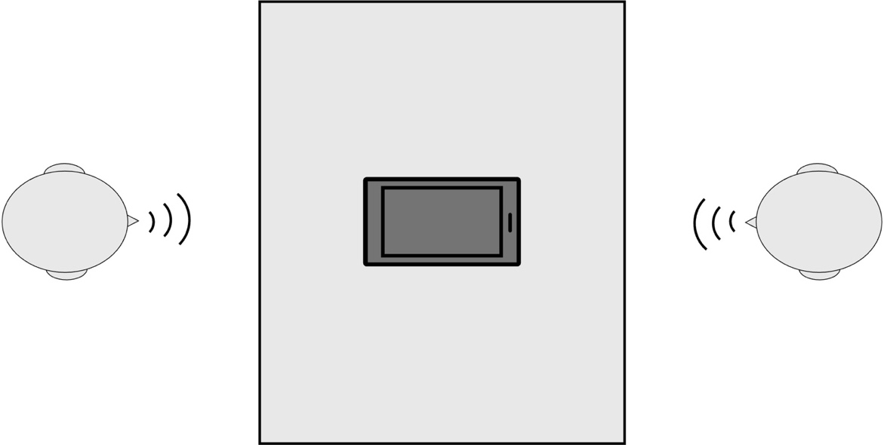

Figure 1 Sketch of recording scenario X-1

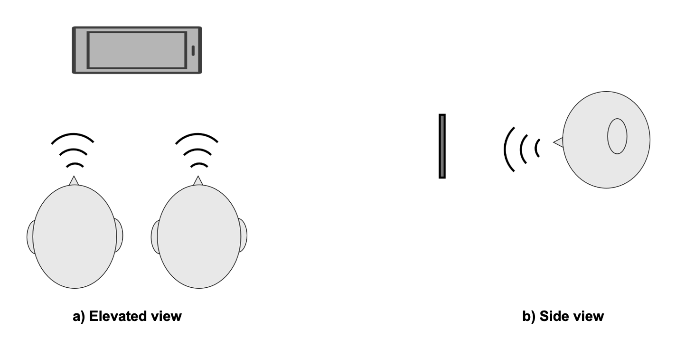
Figure 2 Sketch of recording scenario X-2

]

Recording databases for objective evaluation

Test methods
[

Delay
For example immersive audio solution, the delay of interest is the algorithmic delay, i.e., delay from inserting the input signal to example solution to obtaining the output signal (signal in IVAS input format). By assessing only the delay caused by the example solution, impact of testing inaccuracies and acoustic path can be mitigated. However, it is recognized, that there are many dependencies on the obtained delay of the example solution, e.g., platform where the example solution is run.

Loudness
For assessing the loudness of example solution/target device -combination in send direction, following procedure shall be used:
- The recordings according to the recording scenario [X (Single source objective test)]] defined in clause 4.1.2.1 for sound source direction (φ = 0°, θ = 0°) shall be made.
- The recorded audio signal is processed with the example solution under test.
- The loudness analysis is done according to clause 5.6.2 of TS 26.260

Editor’s note (pending discussion under ATIAS):
- Additionally ITU-R BS.1770/P.700 via potential Binaural rendering could be considered.

Frequency response

Frequency response for Stereo, SBA and MASA capture
For assessing the frequency response of example solution/target device combination in send direction, following procedure shall be used:
- The recording according to the recording scenario [X (Single source objective test)]] defined in clause 4.1.2.1 for sound source direction (φ = 0°, θ = 0°) shall be made.
- The recorded audio is processed with the example solution under test.
- The frequency response shall be analyzed according to clause 5.6.3 in 3GPP TS 26.260.

Frequency response for ISM capture
For assessing the frequency response of ISM capture in send direction, following procedure shall be used:
- The recording according to the recording scenarios [X-1] and [X-2] defined in clause 4.1.2.2 shall be made.
- The recorded audio is processed with the example solution under test.
- For each object, calculate the frequency response according to TS 26.260 [2] clause 5.6.3.2, using the corresponding individual sound source recording as reference signal

Directional information
For assessing the directional information of example solutions, test methodology based on clause 5.6.4 of TS 26.260 [3] is used for Stereo, SBA and MASA formats. Assessment is done directly to the example solution output, excluding any assumptions on transmission.
Assessing a directional information of example solution/target device -combination in send direction, following procedure shall be used:
- The recordings according to the recording scenario [X (Single source objective test)] defined in clause 4.1.2.1 for all defined sound source directions shall be made.
- The recorded audio signals are processed with the example solution under test.
- The directional measurement and applied metric shall be computed as defined in clause 5.6.4 of 3GPP TS 26.260.

Editor’s note:
- For other formats than Stereo, SBA and MASA, intermediate rendering to one of the supported format via IVAS reference renderer could be considered.
]
[

Test script for objective evaluation

General
Editor’s note:
- Following content is based on the input documents S4aA250106, S4aA250122 and S4-251827
- licensing information, requirements and environment will be added in future revisions.
- The missing components—database reading, loudness test rendering, generate final report, using the right reference signal, and support for different formats—will be added after the details in DaCAS‑2 are added, including the setup of database and the setup of the reference signal (in dBFS).
- The further updated version will propose to upload to repo under the Audio subgroup.
To evaluate example solutions, test script under the DaCAS WI is developed. The programming language of the test script is Python. The test script can be found from: forge.3gpp.org/rep/sa4/audio/dacas

Detailed description
Example solutions process the recording database into IVAS input format files, optionally accompanied by associated metadata. A dedicated test database will be generated, then the scripts are expected to process this test database and generate the test result.
To the test of loudness, frequency response (single source), and directional information (single source) the recorded audio signal is processed with the example solution under test. Therefore, the script is designed to read the entire audio signal, convert it to floating-point and perform these evaluations offline. The current version includes support for directional information analysis in stereo recordings.
The script includes the following core functions:
- read_wav_file: Reading wav format files with 16-, 24-, or 32 bit-depth. Possible supporting of pcm format can be added if such files are included in the database.
- estimate_delay_whole: Calculating the delay between two channels across the whole signal duration, based on Annex C of TS 26.260[3].
- p56_active_level: Estimating speech active level using ITU-T Recommendation P.56[4].
- compute_panorama: Estimating stereo panorama following the methodology described in TS 26.260[3].
- frequency_response computes the 1/12‑octave bandwidth spectrum using ISO‑3 R40 preferred numbers for frequencies from 100 Hz to 12 kHz

Editor’s note: Support for different formats will be added in future

- p79_slr computes Send Loudness Rating according to TS26.260[4]

Editor’s note: The IVAS reference renderer will be added in the future, and the decision on whether use ITU-R BS.1770/P.700 via potential Binaural rendering need be made by the group.
]

Subjective Test Methodologies for Immersive Capture Audio Systems

Test conditions

Recording setups and scenarios for test

Recording database for tests

Test methods

Requirements

Requirements for objective test methodologies

Delay

Loudness

Frequency response

Directional information

Requirements for subject test methodologies

…

References
- S4aA250021: “On objective performance evaluation”, Nokia
- S4-250957: “On performance evaluation”, Nokia
- 3GPP TS 26.260: “Objective test methodologies for the evaluation of immersive audio systems”, Release 18
- S4aA250054: “On raw microphone signal compensation”, Dolby Laboratories, Inc.
- S4aA250055: “Single source scenario for performance evaluation”, Nokia
- S4-251466: “Compensation of integrated microphone responses”, Nokia
- Cozens J., Hämäläinen M, Pekkarinen M, IMPro – Method for Integrated Microphone Pressure Frequency Response Measurement Using a Probe Microphone, AES 158th Convention, Warsaw, Poland 2025 May 22–24. https://aes2.org/publications/elibrary-page/?id=22907

- S4-251979: “Performance evaluation of ISM capturing solutions”, Fraunhofer IIS
- S4aA260008: “Proposed high-level definition of DaCAS example solution evaluation”, Nokia, Fraunhofer IIS, Dolby Laboratories, Inc.
- 3GPP TS 26.261: “Terminal audio quality performance requirements for immersive audio services”, Release 19

[11] S4-260296: “Device microphone array characterization”, Nokia

Arvi Lintervo, Nokia

