Source: Rapporteur FS_ULBC
Title: Permanent Document FS_ULBC
Version: 0.6.0
Agenda item: 7.
Document for: Agreement

Revision history:
Version | Date | Meeting | TDOC | Subject/Comment
0.1.0 | 2025-05-23 | SA4#132 | S4-251151 | Initial draft
0.1.1 | 2025-05-23 | SA4#132 | S4-251154 | Update Clause 5.2 to include the methodology of obtaining channel characteristics
0.1.2 | 2025-07-14 | SA4#133-e | S4-251270 | Update Clause 5.2.2 to include RAN simulation model for ULBC over NTN based on the agreed T-doc S4aA250069.
0.2.0 | 2025-07-25 | SA4#133-e | S4-251550 | Update Clause 5.2.1.3 to include IMS voice over UP NIDD in GEO-based NTN;  Add Clasue 5.2.2.4.1 to include alternative methodology for determining ULBC bit rate;  Add Clasue 5.2.2.4 to capture the open issues for ULBC simulation.
0.3.0 | 2025-11-11 | SA4#134 | S4-251811 | Clause 5.2.2.2 (Bundling Time): Updated per agreed Tdoc S4aA250272.  Clause 5.2.2.3 (Downlink Simulation Parameters): Updated per agreed Tdoc S4aA250266.  Clause 5.2.2.4 (Link Budget Assumptions): Updated per agreed Tdoc S4aA250277.  Clause 5.2.2.5 (Open Issues): Updated per agreed Tdoc S4aA250208.  Clause 6.2.1 (Complexity and Memory): Updated per agreed Tdoc S4aA250267.
0.4.0 | 2025-11-21 | SA4#134 | S4-252108 | Clause 5.2.2.2: Add10 degree channel model parameters per agreed Tdoc S4-251806.  Clause 5.2.3.1: Report company provided simulation results.
0.5.0 | 2026-02-03 | SA4#135 | S4-260146 | Clasue 5.2.1.3: Add EN: 'Voice packets shall be transported over UP'.  Clause 5.2.2: Updated per agreed Tdoc S4-252129 and S4aA250138.
0.6.0 | 2026-02-12 | SA4#135 | S4-260434 | Clasue 5.2.1.3: Updated as per agreed S4-260386  Clause 5.2.2.3: Updated per agreed Tdoc S4-260310  Clause 5.2.2.5: Updated per agreed Tdoc S4-260370  Add clause 6.3.2: Analysis on complexity evaluation with WMOPS as per agreed Tdoc S4-260415  Add Clause 6.4: additional design consideration as per agreed Tdoc S4-260432  Add clause 8.1: Analysis on complexity for DAC as per agreed Tdoc S4-260445, S4-260444, S4-260446, S4-260443  Add clause 10: considerations on deliverable as per agreed Tdoc S4-260233  Add Annex A: Living document for design constraints as per agreed Tdoc S4-260299

1 Introduction
The present document compiles candidate changes, open issues, incomplete text, dependencies from other group, action items, and considered timeline to 3GPP TR 26.940 “Study on Ultra Low Bitrate Speech Codecs”. TR 26.940 aims for developing recommendations for potential normative work on an ultra-low bit rate codec for voice over Geostationary Orbit (GEO) satellites.
The following clauses and subclauses are structured according to the objectives that are in scope of the FS_ULBC SID [1]:
1. Document the application scenarios for ultra-low bit rate communication services taking into account the use cases and potential requirements documented in TR 22.887 related to IMS Voice Call Using GEO Access.
2. Study GEO channel characteristics and derive service-related dependencies, e.g. bitrates, mouth-to-ear delay or loss/delay/jitter profiles.

NOTE: Any impact of ultra-low bitrate voice codec in NB-IoT services is outside of the scope of the study and is expected to be addressed by other working groups.
3. Identify the relevant design constraints for such a codec, in coordination with other WGs, including
- Bit rates
- Sample rate and audio bandwidth
- Frame length
- Complexity and memory demands
- Algorithmic delay
- Packet loss concealment (PLC)
- Potential use of noise suppression as part of the codec
- Discontinuous transmission including voice activity detection and comfort noise
- Speech quality
- Robustness to non-speech input
4. Provide some evidence that the design criteria can be met, for example existing reference codecs.
5. Define performance requirements and identify appropriate test methodologies, regarding speech quality, intelligibility, conversational quality, in particular taking into account
a) Clean speech and noisy speech
b) Tandeming with existing IMS voice codecs
c) Clean channel and GEO channel conditions
6. Identify or develop objective measures to verify the design constraints as necessary (e.g., to measure complexity and memory demands)
7. Identify relevant reference codecs for comparison and evaluation purposes.
8. Coordinate work with other 3GPP groups e.g. SA2, RAN, CT1, and others as needed.
9. Define potential normative work item objectives and timeline.
This working procedure of TR and p-doc includes:
- Maintain one TR and one p-doc (this document)
- All contributions to the TR are expected to be submitted using pCRs
- Both pCRs and discussion papers may be be used to contributed to the p-doc.
- Brackets should be avoided when possible, and when used:
- Restricted to values only
- Never applied to complete text blocks
- Open issues in the TR are to be documented in the p-doc, for example the prioritization of application scenarios and related technical assumptions.
- The p-doc should keep track of the status of the individual study item objectives.

2 References
[1] SP-250378, "SID on Ultra Low Bitrate Speech Codec", China Mobile Com. Corporation, vivo, Fraunhofer IIS, Qualcomm Incorporated, Spreadtrum, Dolby Laboratories Inc., Xiaomi, Huawei, 2025.
[26132] 3GPP TS 26.132: “Speech and video telephony terminal acoustic test specification”.
[38811] 3GPP TR 38.811, “Study on New Radio (NR) to support non-terrestrial networks”.
[38821] 3GPP TR 38.821, “Solutions for NR to Non-Terrestrial Networks (NTN)”.
[36321] TR 36.321, "Evolved Universal Terrestrial Radio Access (E-UTRA); Medium Access Control (MAC) protocol specification".
[36763] 3GPP TR 36.763, “Study on Narrow-Band Internet of Things (NB-IoT) / enhanced Machine Type Communication (eMTC) support for Non-Terrestrial Networks (NTN)”.
[23700] 3GPP TS 23.700-19, “Study on Integration of satellite components in the 5G architecture; Phase 4”.
[36213] TS 36.213, “Evolved Universal Terrestrial Radio Access (E-UTRA); Physical layer procedures”.
[2] 3GPP TR 38.811: Study on New Radio (NR) to support non-terrestrial networks
[3] Tdoc S4-251390: [FS_ULBC] On ULBC bit rate spacing
[4] Tdoc S4aA250058: Simulation results for FS_ULBC, Beijing Xiaomi Mobile Software
[5]
Tdoc S4aA250259: Contribution process for ULBC RAN simulation, Erlangen, Germany, Sept 23-25, 2025.
- Tdoc S4aA250069: On the remaining parameters for the RAN simulation for ULBC over NTN, Online, June 18, 2025
- 3GPP TS 23.700-19 V1.2.0, “Study on Integration of satellite components in the 5G architecture; Phase 4”

- Tdoc S2-2509293: Interim conclusions on KI#1 Support of Support of IMS voice call over NB-IoT NTN via GEO satellite connecting to EPC, vivo, China Mobile, MediaTek Inc., ZTE, Verizon, Ericsson, CATT, Nokia, Skylo, Thales, China Telecom, Spreadtrum, Xiaomi, OPPO, China Unicom, LG Electronics, Apple, Samsung, NTT DOCOMO, CSCN, SHARP
- ITU-T Software Tool Library 2024 User’s Manual
- https://docs.pytorch.org/tutorials/beginner/onnx/export_simple_model_to_onnx_tutorial.html
- https://support.apple.com/en-au/111831
- https://www.gsmarena.com/oppo_find_x5_pro-11236.php
- https://pypi.org/project/ptflops/
- S4aA250127 “[FS_ULBC] On complexity evaluation of ULBC audio codec”
- G.191 : Software tools for speech and audio coding standardization
- https://github.com/openitu/STL/tree/dev/src/wmc_tool
- https://docs.qualcomm.com/doc/80-70015-15B/topic/snpe-port-model.html
- https://apple.github.io/coremltools/docs-guides/source/unified-conversion-api.html
- https://soc-developer.semiconductor.samsung.com/global/development/ai-studio/document/documentation/ai-studio/features-overview/ir-converter
- https://mediatek.gitlab.io/genio/doc/tao/ml-mtk-tao.html#nvidia-tao-toolkit
- https://ai.google.dev/edge/litert/conversion/overview
- https://github.com/sithu31296/PyTorch-ONNX-TFLite
- https://developer.huawei.com/consumer/en/doc/hiai-Guides/dev-process-0000001052965551
- https://docs.pytorch.org/docs/stable/jit.html
- https://www.cadence.com/en_US/home/tools/silicon-solutions/compute-ip/hifi-dsps/hifi-5s.html
- https://developer.arm.com/community/arm-community-blogs/b/architectures-and-processors-blog/posts/arm-cortex-a55-efficient-performance-from-edge-to-cloud

3 Definitions of terms, symbols and abbreviations

3.1 Terms
For the purposes of the present document, the following apply:
example: text used to clarify abstract rules by applying them literally.

3.2 Symbols
For the purposes of the present document, the following symbols apply:
<symbol> <Explanation>

3.3 Abbreviations
For the purposes of the present document the following apply

4 Application scenarios
Editor’s Note:
- Document the application scenarios for ultra-low bit rate communication services taking into account the use cases and potential requirements documented in TR 22.887 related to IMS Voice Call Using GEO Access.
- Additional study areas or use cases, such as IMS voice call over NGSO or TN should be added with lower priority if time permits and once the exact requirements can be given.

4.1 Scenario 1: IMS Voice Call over GEO

4.1.1 Extracted technical assumptions and open issues

4.1.1.1 Assumptions for [Main] Scenario
The following assumptions apply for [Main] Scenario described in clause 4.2.2.2.
- For the connection “UE1 – GEO satellite – Ground station” (UE1 uplink), the transmission data rate is significantly limited ([1-3] kbit/s), requiring an ultra-low bit rate codec fitting the transmission data rate for this link.
- For the connection “Ground station – GEO satellite – UE1” (UE1 downlink), the transmission data rate is expected to be limited similarly to UE1 uplink.
- For both uplink and downlink of UE1 it is expected that the link is subject to transmission errors reflecting GEO satellite access
Editor’s Note: "expected" should be replaced by more technical evidence when available (e.g., after coordination with RAN groups).
- The delay in uplink and downlink of UE1 is expected to be greater than the one of typical terrestrial networks.
Editor’s Note: "expected" should be replaced by more technical evidence when available (e.g., after coordination with RAN groups)
- For the connection "Core Network – UE2" (UE2 downlink), the transmission data rate of a regular TN network is available. This link could be covered either by an existing IMS codec (transcoding necessary) or by the same ultra-low bit rate codec as used for the satellite link (transcoding-free).
- To ensure seamless communication across different network types, roaming, etc. transcoding functionality in core network is likely needed.
Editor’s Note: More details may be added.

4.1.1.2 Assumptions for [Sub]-Scenario
The following assumptions apply for [Sub]-Scenario described in clause 4.2.2.3.
- For both connections "UE1 – GEO satellite – Ground station" and "Ground station – GEO satellite – UE2" the transmission data rate is significantly limited ([1-3] kbit/s), requiring an ultra-low bit rate codec fitting this transmission data rate for these links.
- This scenario may allow both transcoded (ULBC existing IMS speech codecs ULBC) and transcoding-free operation (ULBC end-to-end)
Editor’s Note: More details may be added.

X Scenario X: TBD

5 Channel characteristics and service-related dependencies
Editor’s Note:
Study GEO channel characteristics and derive service-related dependencies, e.g. bitrates, mouth-to-ear delay or loss/delay/jitter profiles as priority.

5.1 Architectural components and interfaces

5.1.1 Scenario 1: IMS Voice Call over GEO

5.1.X Scenario X:TBD

5.2 Channel characteristics
Editor’s Note:
- Study bitrates and loss/delay/jitter profiles.

5.2.1 Scenario 1: IMS Voice Call over GEO

5.2.1.1 Introduction
This clause introduces the methodology of obtaining channel characteristics and results for developing design constraints and performance requirements for a codec supporting the main scenario as documented in Clause 4.2.1: IMS Voice Call over GEO.

5.2.1.2 Delay error profiles
The delay-error profile is a model used to describe the network impairments—particularly delay and packet loss—that can impact real-time conversational services such as IMS voice call. Such profile typically reveals the GEO satellite channel characteristics and will be used to evaluate codec robustness, guide jitter buffer design and ensure a fair and comparable testing.

5.2.1.3 End to end simulation model to derive delay error profiles
The intention of this methodology is to reuse the simulation model defined in Annex E of TS 26.132 [26132] to produce the delay error profile.
This Annex E reference LTE access scenario is illustrated in Figure 5.2.1.3-1. Building on the main scenario defined in Clause 4.2.1, the corresponding end-to-end GEO access scenario is shown in Figure 5.2.1.3-2 and Figure 5.2.1.3-2a. The primary distinction between the reference LTE scenario and the GEO voice main scenario lies in the introduction of the “new GEO channel” and the potential inclusion of the Non-IP Data Delivery option in the protocol stack as illustrated in Figure 5.2.1.3-2a.
Fig.5.2.1.3-1: End-to-end channel of VoLTE using LTE access
Fig.5.2.1.3-2: End-to-end channel of main scenario for IMS voice call using NB-IoT (GEO) satellite access
Fig.5.2.1.3-2a: End-to-end channel of main scenario for IMS voice call using NB-IoT (GEO) satellite access with Non-IP Data Delivery
Based on the functional description in Table E.1 of TS 26.132, the following input parameters are required to implement the simulation model:

BLER_tx / BLER_rx:
These parameters are required to simulate block error rates in both uplink and downlink.
NOTE: the resulted error trace based on Clause 5.2.2 will be used to serve as the BLER_tx/BLER_rx.
[max_tx / max_rx:
These define the maximum number of HARQ retransmissions for uplink and downlink respectively, which fall under RAN2 scope. In current specifications, NB-IoT supports at most two HARQ processes, which face constraints in high-latency GEO satellite scenarios. For IMS voice over GEO, HARQ feedback is suggested to be disabled per the standard of Release 18 [5].]
drx_cycle_length:
This parameter represents the duration of the DRX (Discontinuous Reception) cycle in milliseconds. It determines how frequently the device wakes up to monitoring possible scheduling grant. This parameter affects packet scheduling and transmission timing in the simulation context Annex E of TS 26.132. In addition, the values for LTE are 20-40ms, whether these values are suitable for GEO scenarios should be confirmed with RAN2.
mis_eNB1_eNB2:
This parameter represents the scheduling time mis-align between the two eNBs. In GEO scenarios, it indicates how long packets wait in the buffer before the next transmission opportunity. This should be determined primarily by RAN2 (responsible for dynamic scheduling or Semi-Persistent Scheduling) with possible input from RAN1 about physical layer timing relationship aspects.
[max_net_delay / min_net_delay:
These represent the delay range between eNB1 and eNB2. For GEO voice, they are considered similar to the LTE scenario, and legacy parameter values can be reused.]
Editor’s NOTE: whether the model for the delay between eNB1 and eNB2 for LTE scenarios well reflects the delay in deployment is FFS.
nFrames:
This refers to the number of frames for the simulation. In the reference LTE scenario, one IP packet corresponds to 20 ms of speech. In contrast, the GEO voice scenario introduces additional considerations shown as follows due to the propagation delay from GEO satellite altitude.
- Speech sequence (frame length): For GEO, a longer frame length may be used. The maximum frame length of 80 ms, as defined by 3GPP, is assumed in this simulation. Final confirmation is expected from SA4.
- Voice packet size: This depends on the protocol overhead as illustrated in Figure 5.2.1.3-3 for the reference LTE access scenario and Figure 5.2.1.3-4 for the GEO voice main scenario.As concluded in in TR 23.700-19 [7] , the voice packets shall be transported over the NB-IoT (GEO) user plane (i.e., using DRB and S1-U) via a single PDN connection, and the transportation mechanism of RoHC is recommended as illustrated in Fig. 5.2.1.3-4 (left) and the transport mechanism using removal and restoration of parts of RTP/UDP/IP headers is optional as illustrated in Fig. 5.2.1.3-4 (right) .

Fig. 5.2.1.3-3: VoIP RTP packet in reference LTE access scenario
Fig.5.2.1.3-4: Example of RTP packet in GEO voice main scenario
- RTP Payload Size: This is computed as the product of frame length and codec bit rate.
Editor’s Note: whether the size of RTP payload affects the delay-error profile is FFS.
Once the parameters regarding GEO channel are confirmed, the simulation methodology as described in Table E.1 will be updated with these new parameters and used to produce the required delay-error profiles.

5.2.2 Simulation Model to generate error traces and derive codec bitrates
The NTN link consists of a service link (between the UE and the satellite) and a feeder link (between the satellite and the ground station). The bottleneck is the service link due to the limited TX power and small antenna at the UE. The feeder link is typically characterized by large capacity and high reliability and can be abstracted as an ideal link in the end-to-end simulation. The RAN simulation addresses the service link only.
The objective is to generate multiple loss traces for a combination of frame loss rate (target BLER), raw bitrate (TBS), voice bundling period and Doppler spread, while maintaining channel consistency among different combinations.
The multiple loss traces are the result of using multiple random seeds, and the number is 10. For each combination, all 10 seeds are used in generating the error traces.
NOTE: 10 seeds will finally be confirmed after the demonstration of the feasibility of reasonable simulation workload.
Each trace represents a duration of 400 seconds (or 6.67 minutes). Therefore, for 80ms bundling, there are 5000 TBs, and for 160ms bundling there are 2500 TBs.
The RAN simulation contribution process follows [5].

5.2.2.1 Link budget analysis
TR36.763 [36763] performed link budget analysis for 3GPP Set 1 GEO and 23dBm UE. The following CNR values are adopted as the baseline:
- UL CNR = 2.6dB, 0dBi UE antenna gain, 3.75kHz SCS, 1 tone, UE maximum TX power 23dBm
- DL CNR=-3.3dB, 0dBi UE antenna gain, 15kHz SCS, 12 tones, 1 UE receive antenna, noise figure of 7dB.
The potential sources of deviation in the link budget from the 3GPP assumptions are analyzed in [6].
5.2.2.2 Uplink simulation parameters
The following parameters are for the uplink of the service link.
Channel model: NTN-TDL-C [38811]
Elevation angle: Table 5.2.2.2-1 shows 10 degree channel model parameters.
Table 5.2.2.2-1 NTN-TDL-C at elevation alpha=10 degrees
Tap # | Normalized delay | Power in [dB] | Fading distribution
1 | 0 | -0.0146 | LOS path
1 | 0 | -24.96 | Rayleigh
2 | 21.66 | -37.714 | Rayleigh

Modulation: QPSK, pi/2 BPSK, pi/4 QPSK [36213]
Subcarrier Spacing (SCS): 3.75kHz, 15kHz [36213]
Number of tones: 1 for 3.75kHz SCS and 15kHz SCS [36213]
Number of repetitions: companies will report the number of repetitions for each simulation
Voice bundling period: 80ms, 160ms, 320ms
NOTE: the 40ms bundling is not considered because for SCS 3.75kHz the minimum time-domain allocation is 32ms and it leaves insufficient time for downlink data (NPDSCH) and control (NPDCCH) transmissions in the same 40ms time interval.
Doppler spread: 1Hz, 5 Hz
Target BLER: 1%, 2%, 6%, 10%
Editor’s Note: whether a fixed target BLER will be used is FFS.
Maximum Achievable SNR values: (3GPP SET-1 UL SNR) – 10*log₁₀(B/3.75) + (P - 23dBm) + G + [X] dB, where
- 3GPP SET-1 UL SNR (=2.6dB) is the UL SNR for a single tone at 3.75kHz, 23dBm UE power, 0dBi UE antenna gain, as considered in TR36.763 [36763].
- B is the bandwidth, taking values 3.75kHz, 15kHz
- P is the maximum UE transmission power, taking value 23 dBm, 26 dBm, 31 dBm,
- G is the difference between the UE antenna gain and that assumed in TR36.763 [36763], and it is from 0 up to -5.5dBi,
- X is TBD (to be reported by companies) to account for lower loss (e.g., lower scintillation loss), and/or better performance of commercial satellites.
TBS values and PHY bitrates: The TBS values are selected from table 16.5.1.2-2 for NB-IoT for NPUSCH in TS36.213 and the corresponding PHY bitrates and codec bitrate (assuming 7 bytes of packet header) are calculated for each bundling period, as shown in Table 5.2.2.1-1, 5.2.2.1-2, and 5.2.2.1-3.
NOTE 1: The final size of packet header depends on the conclusions reached by SA2 and RAN, including whether 1-byte MAC header is feasible.
NOTE 2: The packet header is only counted once, regardless of how many voice frames are bundled together.
NOTE 3: The precise relationship between the voice frame duration and the bundling time depends on the RTP payload design. In the case of multiple voice frames bundled together, the loss of a single Transport Block (TB) means the loss of multiple consecutive voice frames.
Table 5.2.2.1-1 TBS and PHY bitrate for 80ms bundling
TBS (bits) | 144 | 256 | 328 | 424
PHY bitrate (kbps) | 1.8 | 3.2 | 4.1 | 5.3
Codec bitrate (kbps) | 1.1 | 2.5 | 3.4 | 4.6

Table 5.2.2.1-2 TBS and PHY bitrate for 160ms bundling
TBS (bits) | 208 | 424 | 600 | 808
PHY bitrate (kbps) | 1.30 | 2.65 | 3.75 | 5.05
Codec bitrate (kbps) | 0.95 | 2.30 | 3.40 | 4.70

Table 5.2.2.1-3 TBS and PHY bitrate for 320ms bundling
TBS (bits) | 328 | 776 | 1096 | 1544
PHY bitrate (kbps) | 1.025 | 2.425 | 3.425 | 4.825
Codec bitrate (kbps) | 0.850 | 2.250 | 3.250 | 4.650

Editor’s NOTE: The need of 320ms bundling option should be revisited after the channel simulation results are available.
Editor’s NOTE: Company can report candidate values of TBS.
Channel consistency: The same set of channel realizations are used across all combinations.

5.2.2.3 Downlink simulation parameters
Only the parameters that are different from the uplink are listed here.
SCS: 15kHz [36213]
Number of tones: 12 [36213]
Achievable SNR: (3GPP SET-1 DL SNR) + G + [Y] dB, where
- 3GPP SET-1 DL SNR (=-3.3 dB) is the DL SNR for 12 tones at 15kHz subcarrier spacing and 1 UE receive antenna as considered in TR36.763 [36763].
- G is the difference between the UE antenna gain and that assumed in TR36.763 [36763], and it is from 0 up to -5.5dBi,
- [Y] is TBD (to be reported by companies) to account for more UE receive antennas (2 receive antennas instead of 1, providing an increase up to 3dB), lower loss (e.g., lower scintillation loss), better G/T values and/or better performance of commercial satellites.
Editor’s NOTE:
- Four companies [S4-251272,R1-2506170,R1-2505366,R1-2505941] reported Y=3 due to G/T from field measurements, -28.6dB/K, NF = 4dB, being 3dB better than the 3GPP assumed value -31.6dB/K.However, no consensus has been reached in RAN1 at this stage.
TBS values and PHY bitrates: The TBS values are selected from table 16.4.1.5.1-1 for NB-IoT for NPDSCH in TS36.213 and the corresponding PHY bitrates and codec bitrate (assuming 7 bytes of packet header) are calculated for each bundling period, and they are identical as those in clause 5.2.2.2.

5.2.2.3 Frame structure
For dynamic scheduling, an example frame structure for Half-duplex FDD for the 80ms bundling period is shown in Figure 5.2.2.3-1. The duration of NPDSCH is 4ms and can take a different value depending on the DL SNR.
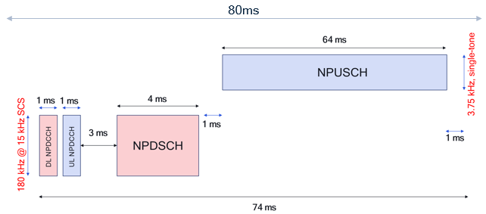
Figure 5.2.2.3-1 An example frame structure for 80ms bundling period and dynamic scheduling
NOTE: For UL, other possible frequency allocations are 1, 3, 6 and 12 tones with15 kHz per tone, and the choice depends on the UL channel capacity and the DL channel capacity.
If semi-persistent scheduling (SPS) is specified by RAN for NB-IoT NTN, an example frame structure is shown in Figure 5.2.2.3-2. The NPDSCH now can be anywhere in the first 15ms (considering that a minimum gap of 1 ms to the NPUSCH needs to be maintained).

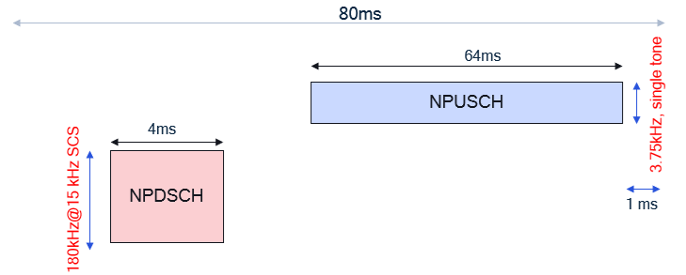
Figure 5.2.2.3-2 An example frame structure for 80ms bundling period and SPS
Figure 5.2.2.3-3 shows a scheme based on “Cell_specific_Koffset” approach, which does not depend on the “TA report UE capability”.
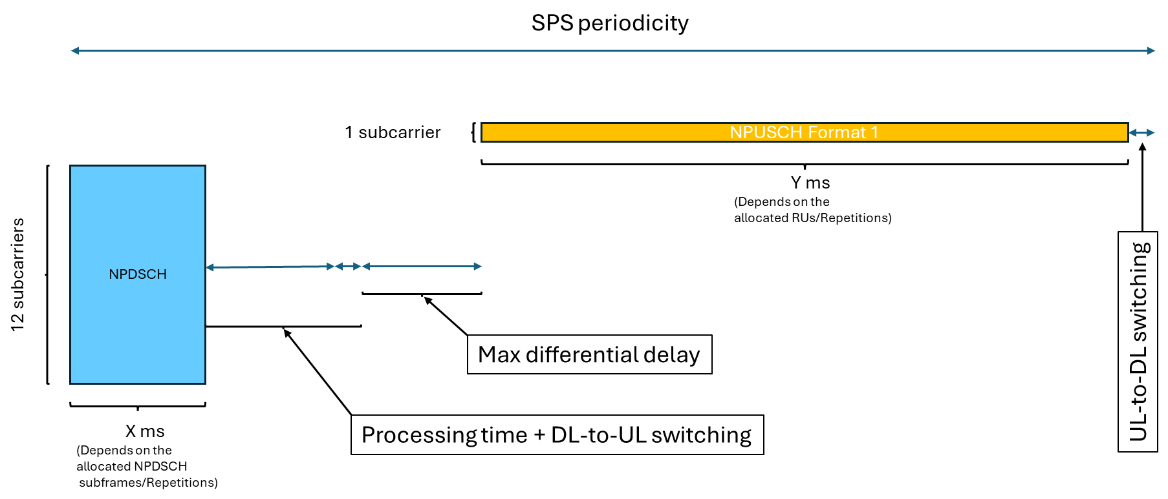
Figure 5.2.2.3-3 SPS scheme based on “Cell_specific_Koffset” approach, which does not depend on the “TA report UE capability”.
Notes: The gap between DL and UL can consist of:
- A “Processing time + DL-to-UL switching”: It can be discussed whether the time for decoding the DL transport block needs to be considered or not, but at least the time that a “half-duplex device” requires for switching from DL-to-UL shall be considered which is 1 ms.
- The “Max differential delay” shall be considered for the network to handle the different round-trip delays of different UEs in the NTN cell. The value of “Max differential delay” will vary depending on deployment
Editor’s note: The range of the “Max differential delay” is TBC.
- Figures 5.2.2.3-2 and 5.2.2.3-3 lead to the same bitrate if the following conditions (for 80ms bundling) are true:
  - “Max differential delay” is 10ms
NOTE: This is the case where, within the cell footprint, the distance between the point that is closest to the satellite and the point that is farthest to the satellite is smaller than 1500km
- X + Y <= 68ms
SA4 considers these conditions will be met in most practical scenarios and will take beam size that is no larger than 1500km as one reference for codec simulation purposes.
- Figures 5.2.2.3-2 and 5.2.2.3-3 lead to the same bitrate if the following conditions (for 160ms bundling) are true:
  - “Max differential delay” is 10ms
NOTE: This is the case where, within the cell footprint, the distance between the point that is closest to the satellite and the point that is farthest to the satellite is smaller than 1500km
- X + Y <= 148ms
SA4 considers these conditions will be met in most practical scenarios and will take beam size that is no larger than 1500km as one reference for codec simulation purposes.
Note: RAN1 reply LS stated:
- “Although the example Figure 5.2.2.3-1 is supportable by RAN1 specifications in most scenarios, it may not be supportable in the case where the cell is very large (e.g. >3000km), when the UE does not support TA report and the network does not support UE-specific K-offset. The example Figure 5.2.2.3-1 itself also requires the UE to be configured with two HARQ processes and with HARQ feedback disabled.”
- RAN1/2 have not yet started the work on designing SPS. Therefore, RAN1 currently cannot confirm whether the example frame structure for SPS (related to Figure 5.2.2.3-2 and associated text) will be supported.

5.2.2.4 Assumptions and Open Issues for NB-IoT GEO Simulation
This clause documents the assumptions and open issues that require further investigation.
Issues | Description | Status
1. UE Power Class | Whether to use the specified 23 dBm power class for NTN NB-IoT or the broader range of power (e.g., 26, 29, 31, and 37 dBm) supported by commercial UEs remains undecided, as no consensus has been reached. | Solved: The current values 23dBm, 26dBm, and 31dBm in the PD are confirmed..Higher maximum UE transmission power (e.g., up to 37dBm) is FFS pending the outcome of the RAN4 study RP-251867 expected to be completed by March 2027
2. Latitude-Dependent Loss | Scintillation loss should be set to 2.2 dB or 0 dB, depending on latitude. As specified in TR 38.821, the impact becomes negligible and shall be consider to zero for beyond the ±20° latitude. | Solved: The simulation accounts for latitude-dependent loss using the X term.
3. Elevation Angles | A proposal has been made to keeping both 2.3° and 12.5° elevation angles in the simulation to consider the worst-case scenario for maintaining acceptable quality. | Solved: The simulation accounts for elevation angles using the X term.  Pending. A new 10-degree channel model has been introduced and may increase the feasible TBS.
4. UL/DL Guard Time | An assumption of a 1 millisecond (ms) guard time for UL/DL switching is used in link budget analyses. The feasibility of this duration may need to be confirmed by RAN. | Pending: Needs to be confirmed by RAN.
5. Determine candidate TBS values | Whether to adopt the other potential TBS values need further verification.  - Xiaomi's proposal: S4aA250035  - Fraunhofer's: S4aA250031  - Skylo’s proposal: S4-251540  - Dolby's proposal: S4-251390  - Huawei’s proposal: S4aA250230  - Qualcomm’s proposal: S4-251548  - vivo’s proposal: S4aA250215 | Unsolved
6.Approaches to select TBS | Three approaches were provided in S4aA250072, and requires further discussion. One of these approaches is described in detail in clause 5.2.2.4.1 | Unsolved
7. Overall Simulation Methodology Description | There is a recognized need to have a high-level description of how the simulation would be run, including parameters to optimize and result parameters. | Pending: A general description of the simulation model and parameters has been documented in P-doc Clause 5.2.2.
8. Simulation Channel Model | NTN-TDL-C or NTN-TDL-C5 | Solved , NTN-TDL-C is used
9. Protocol Overhead | Clarify packet header overhead for different combinations of user plane, control plane, and IP vs. non-IP needs to be confirmed by RAN2 and SA2.  Clarify packet header overhead for the agreed User Plane (UP) transport mechanisms:  1) Transport of IP packets (UP/IP, RoHC recommended); and  2) Transport using removal and restoration of parts of RTP/UDP/IP headers (UP/non-IP). | Update based on SA2 [6]: Voice packets shall be transported over the User Plane using a single PDN connection . Control Plane transport is excluded.  Regarding protocol overhead, SA2 specified that the transport mechanism of IP packets is mandatory (UP/IP, use of RoHC is recommended), whereas the transport mechanism using removal and restoration of parts of RTP/UDP/IP headers is optional (UP/non-IP).  Pending: Exact overhead values for the "removal and restoration" mechanism (UP/non-IP) depends on the specific RTP fields selected for removal (may be decided by SA4).
10. Repetition numbers | It was proposed to specify and report the number of repetitions in the simulation. | Solved
11.RX G/T for downlink | A 3dB better value observed in the field compared to current assumptions by RAN. | Pending. An EN has been added in P-doc 5.2.2.3 to capture field-measured data.

5.2.2.4.1 Methodology for Determining ULBC Bit Rate
Editor’s Note: The methodology described in this clause remains an open issue.

5.2.2.4.1.1 Introduction
To give ULBC proponents the design freedom to deliver the most optimized candidate codec proposals, the following steps are needed:
- Agree on a set of relevant operation points in terms of maximum achievable receive SNRs for which ULBC candidates will be evaluated. This set should cover the range from marginal operation to good and essentially error-free operation and include fading based on NTN-TDL-C [2] channel modelling. Care should be taken that this covers the full range of receive SNRs for which IMS Voice Call over GEO is expected to operate.
- Define performance requirements for each of the receive SNR operation points.
- For each of the potential bundling times out of the set of 80, 160 and 320 ms, agree on a set of potential source bit rates that candidate solutions could use. This set should be based on presently discussed transport formats in terms of the following transport format parameters TBS, SCS, MCS, NRep.
Note: With the presently discussed transport format parameters, a range of potential source bit rates from 825 – 4650 bits/s is achieved. However, the granularity of possible bit rates in that range appears insufficient and unequal. The source addresses this point in a separate contribution [3].
- For each potential source bit rate, determine the optimum transport format parameter combination SCS, MCS, NRep that lead to best possible transmission performance at that bit rate. This could be done based on BLER vs SNR curves like those presented in [4].
- Produce packet loss patterns for each bundling time and each potential source bit rate for the set of relevant maximum achievable receive SNRs (after channel modelling). For a codec selection, it should be made sure that the specific loss patterns used in a comparative evaluation are unknown to any proponent.
- Compare ULBC candidates with each other on the basis of performance requirements for the relevant receive SNRs. Based on the choice of source bit rate and bundling time, a given candidate codec will be subjected to the corresponding packet loss patterns.
NOTE: Although the ULBC codec selection should primarily be done for GEO NTN Nb IoT (as prioritized in the SID), it may be beneficial to ensure that the candidate codecs are additionally tested for other conditions/use cases than NTN NB IoT where the BLER can assumed to be independent of the source bit rate, e.g., Terrestrial IMS (1% BLER target usually), OTT (ideal channel (0% BLER)) and, potentially, extreme conditions (e.g. 10% BLER or typical long losses due to blockage).

5.2.2.4.1.2 Example
The following example illustrates how a ULBC proponent could find the best possible bitrate for its solution such that the voice quality is optimized.
Assume that the proponent has a design that allows operation at two net (codec) bitrates, at 0.95 kbps and 3.4 kbps. The proponent seeks to determine whether the low or the high bitrate option would lead to better voice quality.
Additionally, assume that the study is done for UL and that the bundling time is 160 ms. In that case, and further assuming that the IP overhead (after header compression) is 7 bytes, a TBS of 208 bits would be chosen for the low-rate option, while a TBS of 600 bits would be chosen for the high-rate option.
Furthermore, the UE tx power assumptions and link budget assumptions according to Tdoc S4aA250058 [4] are taken, namely, leading to the following receive CNR/SNR values based on the link budget analysis of this document:
Table 5-1 [5]: CNR results under different parameter assumptions
 | SCS/BW | UE power | UL CNR
Config. 1 | 3.75kHz/3.75kHz | 23dBm | 8.66 dB
Config. 2 | 15kHz/15kHz | 23dBm | 2.64 dB
Config. 3 | 3.75kHz/3.75kHz | 26dBm | 11.66 dB
Config. 4 | 15kHz/15kHz | 26dBm | 5.64 dB
Config. 5 | 3.75kHz/3.75kHz | 29dBm | 14.66dB
Config. 6 | 15kHz/15kHz | 29dBm | 8.64dB
Config. 7 | 3.75kHz/3.75kHz | 31dBm | 16.66dB
Config. 8 | 15kHz/15kHz | 31dBm | 10.64dB

To facilitate a comparison of the achievable voice quality with the two ULBC bitrate options, BLER patterns are generated using NTN-TDL-C [2] channel modelling in the following steps.
Initially, among the available transport format parameter configurations, the one that offers best transmission performance is chosen.
For TBS = 208 bits, the choice is made among the configurations shown in the following table (with tx-time =128 ms) :
Table 5-2: Possible transport format configurations for TBS=208 bits and 160 ms bundling
Configuration | TBS | SCS | MCS | Number of RU | Repetition number | PHY bitrate(kbps)
#1 | 208 | 15 | 0 | 8 | 2 | 1.3
#2 | 208 | 15 | 3 | 4 | 4 | 1.3
#3 | 208 | 15 | 12 | 1 | 16 | 1.3
#4 | 208 | 3.75 | 3 | 4 | 1 | 1.3
#5 | 208 | 3.75 | 12 | 1 | 4 | 1.3

For TBS = 600 bits, the choice is made among the configurations shown in the following table (with tx-time =128 ms):
Table 5-3: Possible transport format configurations for TBS=600 bits and 160 ms bundling
Configuration | TBS | SCS | MCS | Number of RU | Repetition number | PHY bitrate(kbps)
#1 | 600 | 15 | 15 | 2 | 8 | 3.75
#2 | 600 | 3.75 | 15 | 2 | 2 | 3.75

Subsequently, for the selected configurations that are found most suitable, generate the following BLER patterns using an NTN-TDL-C [3] channel simulator:
Table 5-4: BLER patterns to be generated for low and high rate for 4 relevant UE tx power settings
UE power | Low rate (TBS=208 bits) | High rate (600 bits)
23 dBm | ep-ul-208-23dBm | ep-ul-600-23dBm
26 dBm | ep-ul-208-26dBm | ep-ul-600-26dBm
29 dBm | ep-ul-208-29dBm | ep-ul-600-29dBm
31 dBm | ep-ul-208-31dBm | ep-ul-600-31dBm
Next, prepare proponent codec simulation such that it can be operated with inserted packet loss using the BLER patterns generated in the previous step.
Proceed to run codec simulation using these patterns, encoding suitable test speech material. The input speech data is assumed to be called ‘inp_speech.wav’. The simulation generates output speech data files for the different applied BLER patterns. The following output files are generated:
Table 5-5: Output speech files for low and high rate options for the different UE tx power settings
Low rate (TBS=208 bits) | High rate (600 bits)
out_speech-ul-208-23dBm.wav | out_speech-ul-600-23dBm.wav
out_speech-ul-208-26dBm.wav | out_speech-ul-600-26dBm.wav
out_speech-ul-208-29dBm.wav | out_speech-ul-600-29dBm.wav
out_speech-ul-208-31dBm.wav | out_speech-ul-600-31dBm.wav
Lastly, evaluate the quality of the output speech, e.g. in a listening test. The quality evaluation will have to consider that the four tx power settings may result in different respective quality levels. To get to an overall voice quality judgement, it will be needed to make some (weighted) averaging of the obtained opinion scores.
NOTE: It is important to note that the quality is expected to increase with higher UE tx power since fewer packet losses are expected to occur. Moreover, it may be expected that the high rate codec option may show relatively degraded quality especially for low UE tx power. On the other hand, the low rate option of the codec may be limited due to low bit rate and that bitrate option may not benefit from higher UE tx power conditions since the transmission for low UE tx power may already be essentially error-free. The evaluation would provide deeper insight and let the proponent choose the best option overall.
Furthermore, note that speech files of a reference system to be used as performance requirements could be generated in a very similar fashion. Assuming that such a reference codec would operate at e.g. 1.5 kbps, the task would be to identify the TBS and transport format configuration that would be most suitable to transport payloads of this reference codec over the GEO NTN NB-IoT channel, generate the corresponding BLER patterns for the relevant UE tx power settings and then generate the respective output speech files to be used as performance requirement.

5.2.3 Results
Editor’s Note: the results are FFS

5.2.3.1 Report on Companies Provided Simulation Results
This clause summarizes the preliminary simulation results contributed by the companies in SA4.
Table 5-6: Simulation Results for 80ms bundling period for ULBC over NB-IoT NTN GEO channel
Bundling Period | Company Name | Simulation Results
80 | Qualcomm | S4-251739
80 | Company A
80 | Company B
80 | Company C

5.2.X Scenario X:TBD

5.3 service-related dependencies
Editor’s Note:
- Study mouth-to-ear delay.

5.3.1 Scenario 1: IMS Voice Call over GEO

5.3.X Scenario X:

6 Design constraints
Editor’s Note:
2.. Identify the relevant design constraints for such a codec, in coordination with other WGs, including:
- Bit rates
- Sample rate and audio bandwidth
- Frame length
- Complexity and memory demands
- Algorithmic delay
- Packet loss concealment (PLC)
- Potential use of noise suppression as part of the codec
- Discontinuous transmission including voice activity detection and comfort noise
- Speech quality
- Robustness to non-speech input
- Identify or develop objective measures to verify the design constraints as necessary (e.g., to measure complexity and memory demands)

[6.0 The status of DCs
External Dependency | Information from External Groups | SA4's Assumption | Open Issues
DC: Bitrates |  | e.g., A preliminary set of bitrates assumed by SA4 includes xxx-xxkpbs.
DC: DTX/CNG
DC: Frame length | e.g., S4-XXXXX an LS from RAN that indicats that the frame length should...
DC: PLC loss/dly/error proiles
DC: Alg. Delay

Interdependency | Core Influencing Factors | Progress | Open Issue
DC: Bitrate | Frame length (Major and External)
DC: Bitrate | Robust Non-Speech
DC: Bitrate | Evidence DCs
DC: Bitrate | Noise Supression
DC: Bitrate | Study GEO channel characteristics, derive service-related dependencies (Major and External)
DC: Complexity, Memory | Objective Measures (Major)
DC: Complexity, Memory | DC:Robust Non-Speech
DC: Complexity, Memory | DC: noise suppression
DC: Complexity, Memory | Evidence DCs
DC: Sample rate, audio bandwidth | Evidence DCs
]

6.1 General
The following clauses present the design constraints (DC) for an Ultra Low Bitrate Codec for the use in application scenarios as given in clause 4. Clause 6.2 outlines the DC parameter and clause 6.3 outlines objective verification methods of some DC parameter.

6.1.1 Complexity and Memory demands
A list of devices of different type which may support ULBC is shown below:
- Handheld mobile phones
- Smart watches
- Smart glasses/head mounted devices
- TCU (Telematics Control Unit)
- CPE (Customer Premises Equipment)
- Vehicles
- Other possible IoT devices
[It is recommended to consider ULBC solutions that are implementable on DSP/CPU/NPU enabled UE devices.
Since some of the low-end UEs might be based on DSP processors only, ULBC solutions should be implementable on DSP enabled UE devices, e.g., audio processing DSPs available in mobile phones for voice communication with complexity figure less than 500WMOPS measured on a C reference code and the ROM memory space less than 20MB assuming 32bit/parameter (or 5M model parameters).
Editor’s note: What is meant by DSP enabled UE devices needs to be defined.
]
Editor’s note: The metric for complexity estimation and the exact limits are TBD.

6.3 Design Constraint Verification
Editor’s note: Algorithmic delay verification method for AI based codecs required.

6.3.1 Complexity Verification
While the complexity constraints for the ULBC codec may be based on theoretical, platform-agnostic metrics (such as MACs/FLOPs for AI-based components and WMOPS for traditional signal processing components), model size and precision, it can be beneficial to ensure that these metrics are meaningful for real-world deployment. The details of such verification process and the stage at which such verification may happen is FFS.

6.3.2 Analysis on complexity evaluation with WMOPS
In clause 18.12.7 (page 293) of [8], examples of WMOPS calculation with floating point code are listed. The sample scripts with simple operators and use the WMC tool to exam the WMOPS as written follow:
Note：The version of WMC tool used need to be clarified.

6.3.2.1 Analysis on Operator ‘Move’
Relate example in Table 18.4 of [8]:
Table 6.3.2.1-1: Example of Operator ‘Move’
Operation | Counter used | Explanation
b = a / L | MULT(1); | When L is constant; (1/L) is a constant too, so b = a*(1/L)
Test Code:
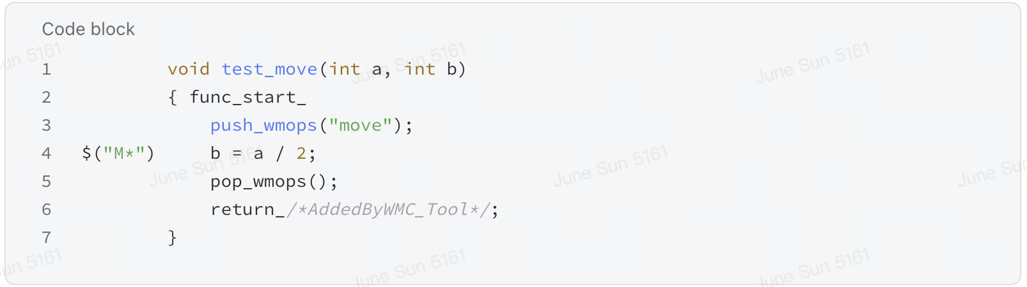
Output of WMC tool:
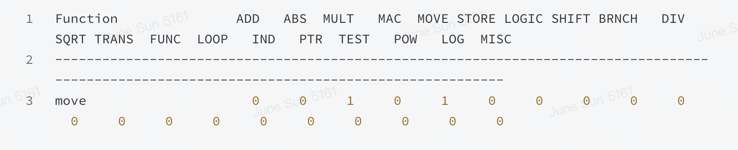
Table 6.3.2.1-2: Output of Operator ‘Move’
Output in theory | Output of WMC | Difference
1 MULT | 1 MULT + 1 MOVE | 1 MOVE

6.3.2.2 Analysis on Operator ‘++’
Relate example in Table 18.4 of [8]:
Table 6.3.2.2-1: Example of Operator ‘++
Operation | Counter used | Explanation
(*rnd_T0)++ | ADD(1); STORE(1); | It can be replaced by *rnd_T0 = *rnd_T0 +1;

Test Code:
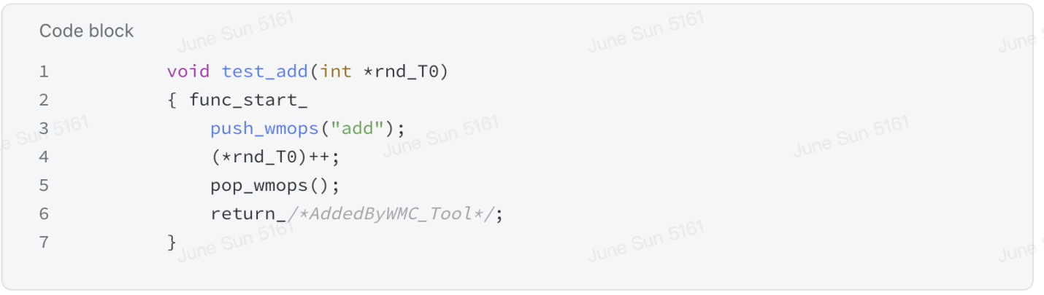
Output of WMC tool:
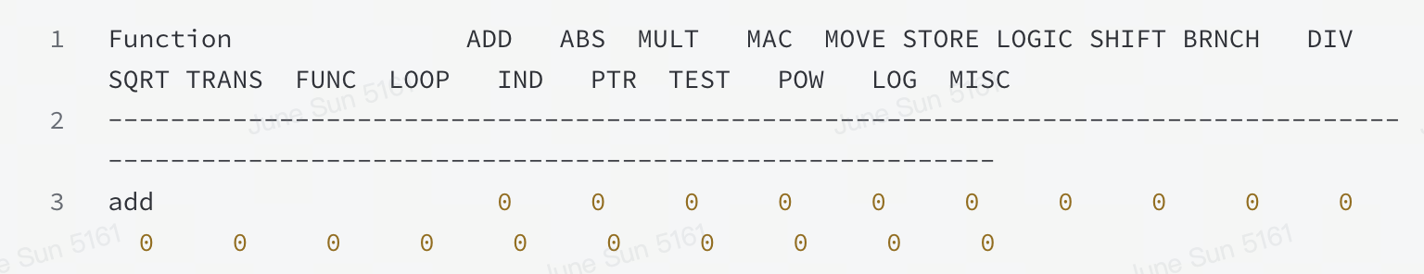
Table 6.3.2.2-2: Output of Operator ‘++’
Output in theory | Output of WMC | Difference*
1 ADD + 1 STORE | 0 | 1 ADD + 1 STORE
NOTE: * This difference may not influence the actual complexity as pointer increment can be done in combination with other operations with a DSP with no extra cost.

6.3.2.3 Analysis on Operator ‘AND/OR’
Relate example in Table 18.4 of [8]:
Table 6.3.2.3-1: Example of Operator ‘AND/OR’
Operation | Counter used | Explanation
If (a!=b || c==d){…} | ADD(2); BRANCH(1); TEST(1); | BRANCH for if, TEST for additional condition, ADD for two tests against non-zero value
Test code:
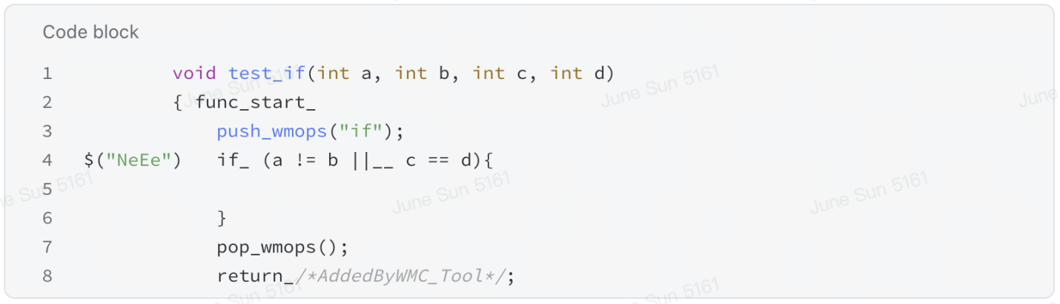
Output of WMC tool:
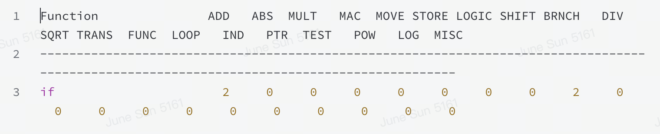
Table 6.3.2.3-2: Output of Operator ‘AND/OR’
Output in theory | Output of WMC | Difference
2 ADD + 1 BRANCH+1TEST | 2 ADD + 1 BRANCH | 1 TEST

6.3.2.4 Analysis on Operator ‘Indirect addressing’
Relate example in Table 18.4 of [8]:
Table 6.3.2.4-1: Example of Operator ‘Indirect addressing’
Operation | Counter used | Explanation
Indice[0] = indirect_dico1[indice[0]] | INDIRECT(2) | Double indirection
Test code:
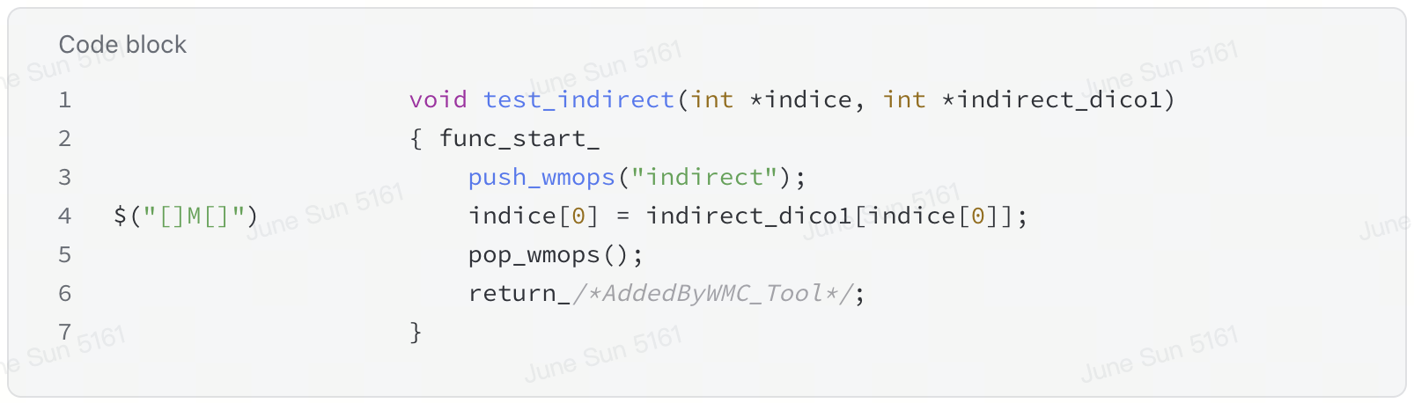
Output of WMC tool:
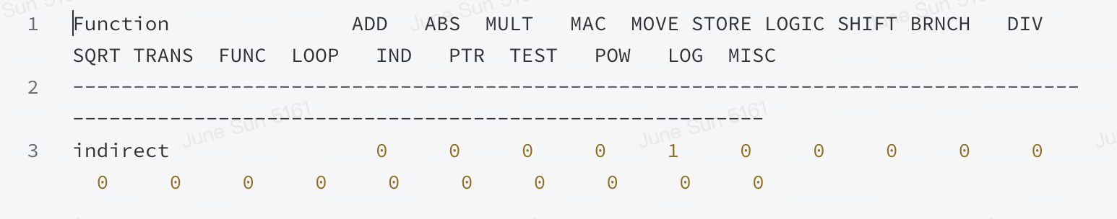
Table 6.3.2.4-2: Output of Operator ‘Indirect addressing’
Output in theory | Output of WMC | Difference
2 IND | 1 MOVE | 2 IND; 1 MOVE
Editor’s Note: In the actual version of the wmops, the indirection seems not to be penalized anymore.

6.3.2.5 Analysis on Operator ‘move’
By design, the instrumentation tool is not counting arithmetic operations inside the array subscript. Relate example in Table 18.3 of [8]:
Table 6.3.2.5-1: Example of Operator ‘MOVE’
Operation | Counter | Example | Complexity weights
Indirect addressing | INDIRECT() | a=b.c,a=b[c],a=b[c][d],a=*b,a=*(b+c)22,  st−>array  st−>value | 2

Test code:
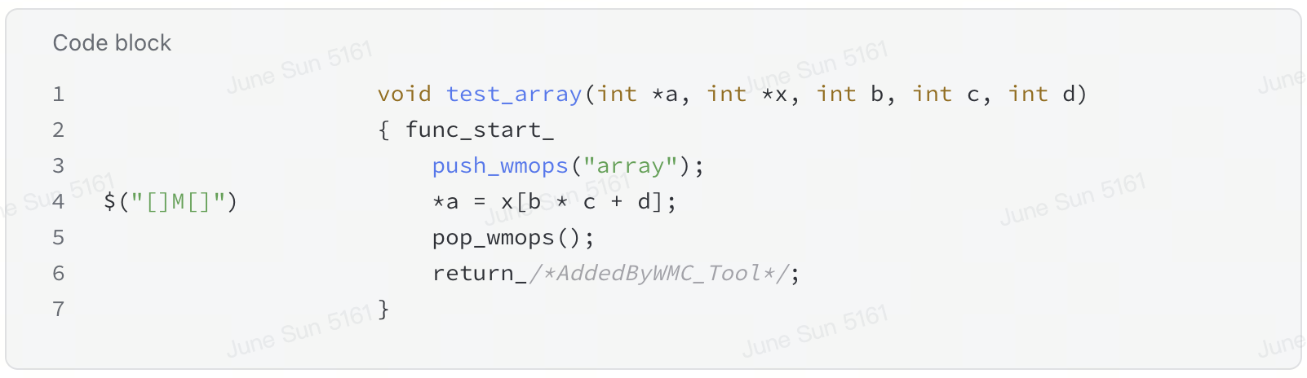
Output of WMC tool:
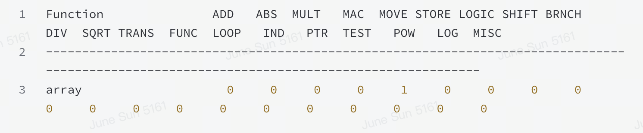
Table 6.3.2.5-2: Output of Operator ‘MOVE’
Output in theory | Output of WMC | Difference
1 MOVE | 1 MOVE
Editor’s NOTE: Pointer arithmetic is not taken into account.

6.3.2.6 Observations
The following observations have been derived from the analysis above:
- Difference has been observed between the description in ITU-T standards documentation and WMC tool implementation on WMOPS. There are cases where WMC tools counted both more operators and less operators. Some of these difference may influence the WMOPS data of an codec significantly, such as the counting of operator ‘MOVE’ and the instrumentation inside arrays.
- The influence of these observed WMOPS calculation differences in Clause 2 on an AI codec are to be further investigated.
- These differences need to be carefully handled and the way of calculating the WMOPS need to be clearly defined if WMOPS is included as one of the metrics for ULBC complexity.

6.4 Additional Design Considerations

6.4.3 Complexity metric
The computational complexity metric for ULBC is defined by counting
- WMOPS for the classic DSP‑based components,
- MAC for the ML‑based components, and
- combine those to a common value according to WMOPS + w · MACs, where w is a ML weighting factor to be defined and expected to be less than 1 to reflect the vectorization capability of the matrix multiplications.
Editor’s note: Further complexity metrics like model size, activations, memory accesses may be considered.
This hybrid complexity evaluation approach is intended to offer a balanced trade‑off between continuity with established practice and more suitability for emerging ML‑based codec designs. The following table provides some examples of processing units and their vectorization capabilities which may serve as a basis to derive the ML weighting factor w.
Table 6.4.3-1 Example capabilities of processing units regarding vectorization
Chip | Type | Vectorization | Reference
HiFi 5s | DSP | 32 8x8 bit MAC  16 32x16 bit MAC  8 32x32 bit MAC | [25]
ARM Cortex A55 | CPU | 16 8x8 MAC  8 16x16 MAC (FP) | [26]

Editor’s note: A maximum value needs to be defined as computational complexity limit in design constraints. Based on this principle, a similar metric can be defined for memory counting. More information provided in [X]
Editor’s note: More example capabilities may be added to the table.
Editor’s note: S4-260241 On complexity estimation of ULBC

8 Existing technologies and feasibility evidence
Editor’s Note:
Provide some evidence that the design criteria can be met, for example existing reference codecs.

8.1 Complexity analysis for DAC like fully convolutional architecture

8.1.1 Experiment 1 (Dolby contribution)
The original ~70M DAC model size was modified by reducing the number of params in each encoder and decoder block. The models were re-trained specifically for around 1 kbps bitrate at 32 kHz sampling rate. With this, the source generated models of size 20 M, 15 M, 9 M and 3 M params with float32 precision without changing the general DAC architecture (model details provided in Table 2.1).
For theoretical complexity analysis, GMACS was computed by inferencing the modified models using ptflops [13] library. The GMACS values are captured in Table 2.1 and Figure 2.1 shows that GMACS increase almost linearly with model size.
Table 8.1.1-1. Model information
Model size | Encoder rates | GMACS
20 M | 4,4,8,10 | 5.14
15 M | 4,4,8,10 | 4.03
9 M | 4,4,8,10 | 2.39
3 M | 4,4,8,10 | 0.79
NOTE 1: The GMACS mentioned in Table 2.1. were obtained with the given encoder rates. For a given model size, the GMACS may vary with the variation in encoder rates.
NOTE 2: The encoder rates mentioned in Table 2.1. correspond to a stride of 1280. The quality evaluation with the mentioned stride is FFS
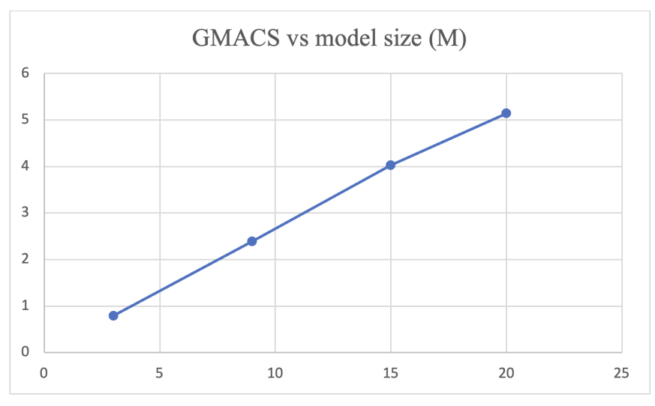
Figure 8.1.1-1 GMACS increase with model size
For RTF analysis, modified DAC pytorch models were converted to ONNX [10] and referenced using ONNX runtime library along with XNNPACK execution provider on a set of smartphones.
The ONNX model inferencing was done on frame-by-frame basis to simulate a use case that is closer to a voice communication use case. In a single experiment, each ONNX model (encoder+quantizer+decoder) was inferenced with 80 ms frame size over a period of 2 minutes (total 1500 inferences in the same session). This experiment was repeated 5 times and max RTF were computed as follows.
$$Max RTF=\frac{\max\left(encode+quantizer+ decode frame processing time\right)}{80}$$
Two smartphones (device 1 [11] and device 2 [12]) released in 2022 and 2023 were used in this experiment. All experiments were done with 1 thread only. During the session run, CPU activity was monitored and the CPU core selection is noted in Table 2.2. Figure 2.2 and 2.3 show RTF increase with model size for both the devices.
Table 8.1.1-2. RTF Results
 | Specification/comments | Model size | Max RTF (high performance) | Max RTF (power efficient) | CPU core selection
Device 1 | Release year: 2023  CPU: Hexa-core (2x3.46 GHz (P core) + 4x2.02 GHz (E core)) | 20 M | 0.39 | 0.9 | Note 3
Device 1 |  | 15 M | 0.29 | 0.74 | Note 3
Device 1 |  | 9 M | 0.19 | 0.57 | Note 3
Device 1 |  | 3 M | 0.09 | 0.31 | Note 3
Device 2 | Release year: 2022  CPU: Octa-core (1x3.00 GHz Cortex-X2 & 3x2.50 GHz Cortex-A710 & 4x1.80 GHz Cortex-A510) | 20 M | 0.63 | 0.81 | Note 4
Device 2 |  | 15 M | 0.43 | 0.66 | Note 4
Device 2 |  | 9 M | 0.29 | 0.44 | Note 4
Device 2 |  | 3 M | 0.13 | 0.18 | Note 4

Note 3: With device 1, it was observed that all frames are not processed with the same core. Majority of the frames were processed with P core (high performance) while some frames were processed with E core (power efficient).
Note 4: With device 2, it was observed that all frames were processed with the high-performance Cortex-X2 core. However, the CPU frequency switched between 2.4 GHz and 1.8 GHz. Majority of frames were processed with 2.4 GHz (high performance) while some frames were processed with 1.8 GHz (power efficient).

Figure 8.1.1-2 RTF increase with model size (high performance mode)

Figure 8.1.1-2 RTF increase with model size (power efficient mode)

8.1.1.1 Observations
The following observations can be drawn when running various models on smartphone CPUs (devices released in 2022-2023) with 80ms frame-based processing as defined in clause 2.1:
- For all devices listed, modified DAC model (20 M) at 32 kHz shows a max RTF=0.63 in high performance mode and RTF=0.9 in power efficient mode.
- For all devices listed, modified DAC model (15 M) at 32 kHz shows a max RTF=0.43 in high performance mode and RTF=0.74 in power efficient mode.
- For all devices listed, modified DAC model (9 M) at 32 kHz shows a max RTF=0.29 in high performance mode and RTF=0.57 in power efficient mode.
- For all devices listed, modified DAC model (3 M) at 32 kHz shows a max RTF=0.13 in high performance mode and RTF=0.31 in power efficient mode.

8.1.2 Experiment 2 (vivo contribution)
To ensure the results are representative of consumer hardware, we utilized a standard Android mobile device and a rigorous frequency-locking methodology to eliminate dynamic frequency scaling noise.

8.1.2.1 Model Configuration
To assess the scalability of the proposed solution, eight distinct model variants (designated " enc8dec144" to " enc64dec1536") were evaluated. The codec architecture is based on a fully convolutional encoder-decoder structure employing Residual Vector Quantization (RVQ) [3]. All variants operate with a frame length of 40ms, and all variants have the same total up/down-sampling factor (2 * 4 * 5 * 8 = 8 * 5 * 4 * 2 = 320). The evaluation covers three input sampling rates: 8 kHz (corresponding to 320 samples), 16 kHz (640 samples), and 32 kHz (1280 samples). For the purpose of this analysis, the models were exported to ONNX format using Float32 precision.
Table 8.1.2.1-1 Model Variants & Complexity Analysis
Variant | Params (M) | Size (MB) | GFLOP  counts (8k) | GFLOP  counts (16k) | GFLOP  counts (32k) | MFlops/s (8k) | MFlops/s (16k) | MFlops/s (32k)
enc8dec144 | 1.09 | 4.3 | 0.01 | 0.02 | 0.04 | 218.5 | 439.2 | 880.6
enc12dec288 | 2.89 | 11.1 | 0.03 | 0.06 | 0.11 | 698.8 | 1406.2 | 2821.0
enc16dec384 | 4.94 | 18.9 | 0.05 | 0.10 | 0.20 | 1241.0 | 2497.2 | 5009.7
enc19dec456 | 6.85 | 26.1 | 0.07 | 0.14 | 0.28 | 1743.3 | 3508.0 | 7037.3
enc24dec576 | 10.76 | 41.0 | 0.11 | 0.22 | 0.45 | 2789.2 | 5612.6 | 11259.6
enc32dec768 | 18.90 | 71.9 | 0.20 | 0.40 | 0.80 | 4955.9 | 9972.6 | 20006.1
enc40dec960 | 29.34 | 111.7 | 0.31 | 0.62 | 1.25 | 7741.0 | 15577.1 | 31249.4
enc64dec1536 | 74.50 | 283.6 | 0.79 | 1.59 | 3.20 | 19807.3 | 39857.9 | 79959.3

8.1.2.2 Device Under Test (DUT) Environment
The experimental evaluation was conducted on a device under test (DUT) featuring the MediaTek Dimensity 1200 system-on-chip (SoC). This 6nm chipset was selected to represent a typical mid-range consumer performance profile. The inference engine employed was ONNX Runtime v1.14+, configured to use the CPU execution provider in single-threaded mode. To characterize the heterogeneous processing capabilities of the SoC, test execution was explicitly pinned to specific CPU clusters: the Efficiency cluster (Cortex-A55), the Performance cluster (Cortex-A78), and the Prime core (Cortex-A78+)
To ensure reproducibility, thermal services and power HALs were disabled, and CPU frequencies were clamped via /proc/ppm and sysfs to fixed operating points. RTF was calculated as:
$$RTF=\frac{\text{ Inference Time }(\text{ Encoder }+\text{ Quantizer }+\text{ Decoder })}{\text{ Audio Duration }(40 ms)}$$

8.1.2.3 Results and Analysis

8.1.2.3.1 Complexity Scaling vs. Bandwidth
Figure 8.1.2.3.1-1 illustrates the relationship between model complexity and parameters. An analysis of the operating points at 8 kHz, 16 kHz, and 32 kHz reveals a significant trend. Although the parameter count is invariant for a specific model configuration (e.g., enc32dec768 utilizes 18.9M parameters across all rates), the complexity at 32 kHz is notably higher.
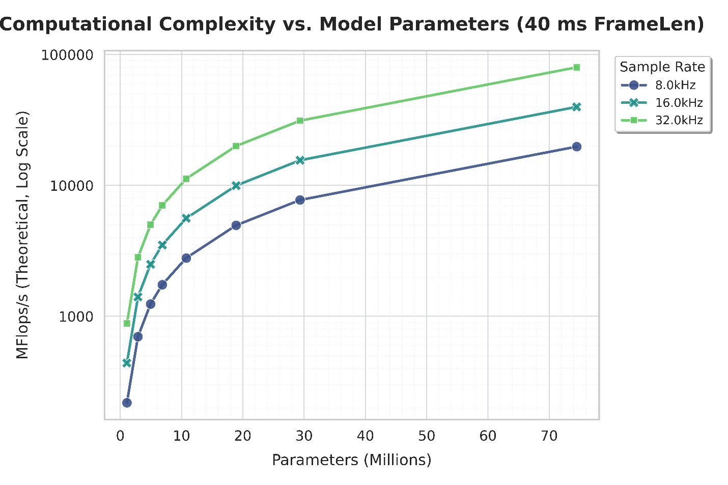
Figure 8.1.2.3.1-1 Complexity Scaling vs Model Parameters
The complexity metrics for the enc32dec768 variant are summarized as follows:
- 8kHz: ~0.20 GFLOP counts, corresponding to 4955.9 MFlops/s
- 16kHz: ~0.40 GFLOP counts, corresponding to 9972.6 MFlops/s
- 32kHz: ~0.80 GFLOP counts, corresponding to 20006.1 MFlops/s
For a given model variant, the computational complexity at 32 kHz is observed to be approximately double that of 16 kHz and four times that of 8 kHz. This confirms that higher sampling rates incur a proportional computational penalty.

8.1.2.3.2 Real-Time Factor (RTF) Analysis
The real-time performance of the codec was evaluated across three distinct frequency tiers (Low, Mid, and High), corresponding to the rows of the 3x3 analysis grid depicted in Figure 2. The low tier (Tier 1) represents an energy-conserving state with the Cortex-A55 cores clocked at 750 MHz, the Cortex-A78 at 902 MHz, and the Prime A78+ at 1.108 GHz. The mid tier (Tier 2) reflects a typical sustained workload, increasing frequencies to 1.0 GHz for the A55, 1.162 GHz for the A78, and 1.137 GHz for the Prime core. Finally, the high tier (Tier 3) simulates a high-performance state approaching sustained limits, with the A55 running at 1.725 GHz, the A78 at 1.451 GHz, and the Prime core at 1.632 GHz.
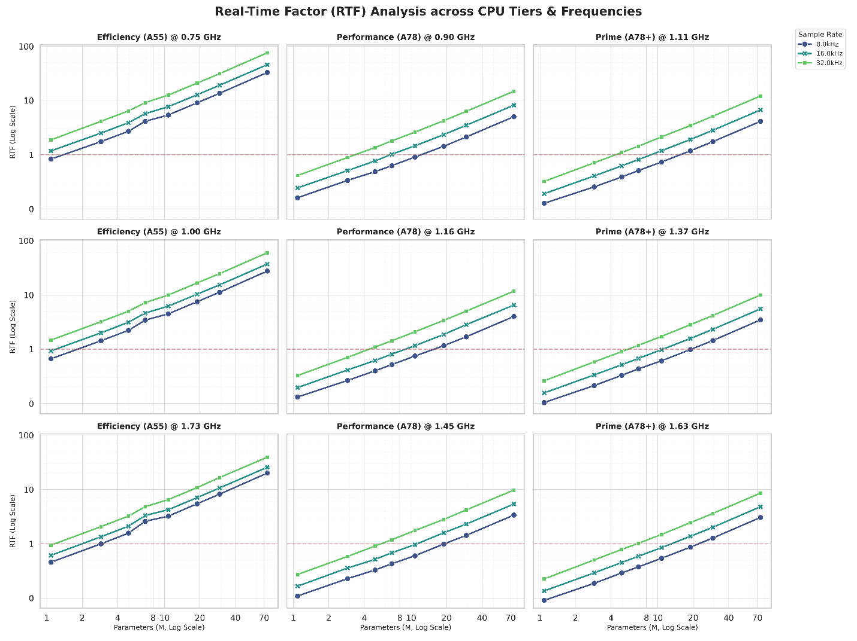
Figure 8.1.2.3.2-1 Tier 1: Low Frequency (A55@750M, A78@902M, A78+@1.1G)

8.1.2.3.2.1 Tier 1: Low Frequency (A55@750M, A78@902M, A78+@1.1G)
At this energy-conserving operating point, computational resources are significantly constrained. On the efficiency cluster (Cortex-A55 @ 750 MHz), performance is severely limited; even at an 8 kHz sampling rate, only the most compact models (e.g., enc8dec144) maintain real-time operation. At 16 kHz and 32 kHz, the RTF rapidly exceeds 1.0, rendering high-fidelity audio processing unfeasible.
The performance cluster (Cortex-A78 @ 902 MHz) exhibits rapid saturation at 32 kHz, limiting feasibility to very small models with fewer than 3 million parameters. At 16 kHz, low-complexity models are supported, though performance limits are reached around 8 million parameters. Conversely, 8 kHz operation offers reasonable headroom, supporting models up to approximately 10 million parameters.
The prime core (Cortex-A78+ @ 1.108 GHz) demonstrates trends similar to the Performance cluster but benefits from the increased clock speed, extending the feasible limit for 16 kHz operation closer to the 10 million parameter threshold.

8.1.2.3.2.2 Tier 2: Mid Frequency (A55@1.0G, A78@1.16G, A78+@1.37G)
This tier represents a typical "sustained" workload state.
On the efficiency cluster (Cortex-A55 @ 1.0 GHz), performance shows improvement for 8 kHz inputs, supporting models up to approximately 2 million parameters. However, 16 kHz and 32 kHz operation remain largely out of reach for any model larger than enc8dec144 or enc12dec288.
For the performance cluster (Cortex-A78 @ 1.162 GHz), 32 kHz operation is still constrained, with a feasible limit around 5 million parameters. At 16 kHz, feasibility extends to approximately 10 million parameters, effectively covering the "Low Complexity" profile. The 8 kHz operating point demonstrates robust performance for models up to 20 million parameters.
Interestingly, the prime core (Cortex-A78+ @ 1.37 GHz) operates at a slightly lower frequency than the performance core in this tier. This results in performance parity or a slight regression compared to the A78 cluster, confirming that clock speed is the primary differentiator in this specific configuration.

8.1.2.3.2.3 Tier 3: High Frequency (A55@1.73G, A78@1.45G, A78+@1.63G)
This tier reflects high-performance states, approaching the sustained limits of the device.
On the efficiency cluster (Cortex-A55 @ 1.73 GHz), the increased frequency provides tangible benefits. At 8 kHz, the core can now support models up to approximately 3 million parameters. Support at 16 kHz extends to roughly 2 million parameters, while at 32 kHz, feasibility is limited to models around 1 million parameters.
The performance cluster (Cortex-A78 @ 1.451 GHz) demonstrates significant scaling. At 32 kHz, the feasible limit reaches approximately 7 million parameters. Reducing the sample rate to 16 kHz extends this limit to 10 million parameters, while at 8 kHz, the core can support models up to 20 million parameters. This scaling behavior reinforces the inverse relationship between sample rate and model size capacity.
The prime core (Cortex-A78+ @ 1.632 GHz) offers the highest performance headroom in this configuration. It can safely execute 8 million parameter models at 32 kHz. At 16 kHz, support extends comfortably to 10 million parameters, and at 8 kHz, the limit reaches approximately 20 million parameters, mirroring the Performance cluster's ceiling for lower sample rates.

8.1.2.3.3 Maximum Performance Envelope
To establish the absolute upper bound of real-time feasibility on the DUT, we analyzed the performance of both the efficiency and performance cores at their maximum locked frequencies, as illustrated in Figure 3.
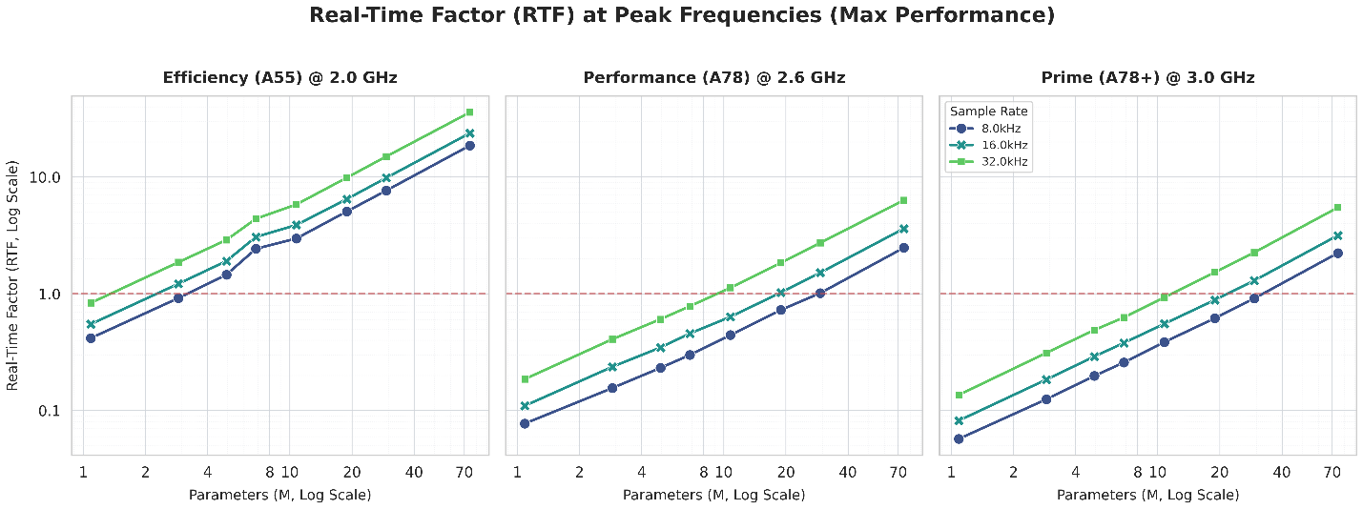
Figure 8.1.2.3.3-1 RTF Analysis at Peak Frequency per CPU Tiers

8.1.2.3.3.1 Efficiency Core (Target: Cortex-A55 @ 2.0 GHz)
Even at peak frequency, the efficiency core remains highly constrained by model size. Models exceeding approximately 5 million parameters, such as enc16dec384, begin to fail real-time constraints (RTF > 1.0) at sampling rates of 8 kHz and above. The observed latency on the A55 cluster suggests it is unsuitable for models with large weight matrices.

8.1.2.3.3.2 Performance Core (Target: Cortex-A78 @ 2.6 GHz)
Focusing on the Cortex-A78 (performance core) provides the most relevant benchmark for ULBC, as it represents the sustained compute capability of modern mobile devices. The experimental data reveals a precise "Complexity vs. Bandwidth" trade-off, where the feasible parameter count is inversely proportional to the sampling rate.
At a 32 kHz sampling rate, the RTF curve crosses the 1.0 threshold near the 10 million parameter mark, approximately corresponding to the enc24dec576 variant. At this high sample rate, models larger than enc24dec576 saturate the core, making 10 million parameters the practical hard limit for High-Fidelity ULBC candidates.
Reducing the bandwidth to a 16 kHz sampling rate allows the feasible model size to effectively double. The limit is observed around 20 million parameters, specifically near the enc32dec768 variant. While enc32dec768 runs near the limit, the larger enc40dec960 model fails to meet real-time constraints. This indicates a linear relationship between bandwidth reduction and parameter capacity.
Further halving the bandwidth to an 8 kHz sampling rate extends the feasible envelope to approximately 39 million parameters. At this operating point, enc40dec960 (29M parameters) is safe, but the trend line suggests failure before reaching the enc64dec1536 variant.

8.1.2.3.3.3 Prime Core (Target: Cortex-A78+ @ 3.0 GHz)
The Prime core offers the highest performance on the SoC. The results generally mirror the trends observed on the standard performance (A78) core but with slight improvements in headroom due to the higher clock frequency. The feasible limits at each operating point are consistent with the A78 findings (e.g., the 32 kHz limit remains near the 10M-15M parameter range).
While the prime core processes individual frames faster, the bandwidth bottleneck remains the dominant factor. The higher clock speed provides a slightly larger safety margin for models that are borderline on the A78, such as enc24dec576 at 32 kHz, but it does not fundamentally shift the feasible model size category.

8.1.3 Alignment Analysis on Complexity of DAC model
This clause provides a detailed analysis of the discrepancy between Experiment 1 and Experiment 2. It demonstrates that "Model Size" is an insufficient metric for constraining complexity across different neural architectures, or even within the same architecture (e.g., DAC). Instead, it shows that GMACS (Giga Multiply-Accumulate Operations per Second) provides a robust, linear correlation with RTF across different architectures, sampling rates, and frame rates.

8.1.3.1 Architectural Analysis and Discrepancy Resolution

8.1.3.1.1 The "Model Size" Trap
Initial comparisons suggested that a 3M parameter model operating at 32 kHz (from clause 8.1.1) had a similar computational footprint to a 3M parameter model operating at 16 kHz (from clause 8.1.2). Intuitively, the 32 kHz model should be significantly more expensive.
To understand this, we performed a detailed breakdown comparison between the clause 8.1.2 (16k, ~3M) and clause 8.1.1 (32k, ~3M) architectures using an identical evaluation method:
Table 8.1.3.1-1 Detailed breakdown comparison between the Experiment 2 (16k, ~3M) and
Experiment 1 (32k, ~3M)
Metric | Experiment 2 (16k, ~3M) | Experiment 1 (32k, ~3M)
Input Rate | 16,000 Hz | 32,000 Hz
Total Stride | 320 (2x4x5x8) | 1280 (4x4x8x10)
Latent Rate | 50.0 Hz | 25.0 Hz
Encoder MACs (M) | 436.30 | 461.92
Quantizer MACs (M) | 2.25 | 0.50
Decoder MACs (M) | 984.50 | 1037.12
Total MFlops/s | 1423.05 | 1499.54
Analysis:
- The Experiment 1 (32k, ~3M) model runs at a 2x Higher Input Rate (32k vs 16k), increasing the computational cost of the Encoder (shallow layers).
- The Experiment 1 (32k, ~3M) model uses a 4x Higher Stride (1280 vs 320), effectively reducing the Latent Rate to 25Hz (compared to the Standard 50Hz).
- This reduced latent rate significantly lowers the Decoder cost (fewer frames to upsample) compared to what a 32kHz model would typically require with standard striding.
- The higher input cost balances with the lower decoder/latent cost, resulting in a total MFlops/s that is comparable to the Experiment 2 (16k, ~3M) model.
Consequently, two models with the same parameter count can have vastly different runtimes depending on where those parameters are located (shallow vs. deep layers) and the stride configuration.

8.1.3.1.2 Verification of Complexity Metrics
To validate this analysis, the theoretical complexity (GMACS) was recalculated for the models in question to ensure alignment.
- We apply the standard conversion where$1\text{ GMAC }≈2\text{ GFLOPs}$
- The Experiment 1 (32k, ~3M) model at 32 kHz yields ~1,499.5 MFlops/s.
- $1499.5/2≈750\text{ MMACS }≈0.75\text{ GMACS}$
- This aligns closely with the reference value of 0.79 GMACS reported in Experiment 1.

8.1.3.2 GMACS as the Metric
When the extensive RTF data from Experiment 2 is plotted against GMACS (rather than Model Size), the data aligns approximately.
As shown in Figure 8.1.3.2-1 below, the analysis of the combined dataset, the relationship between GMACS and RTF becomes linear and architecture-agnostic.
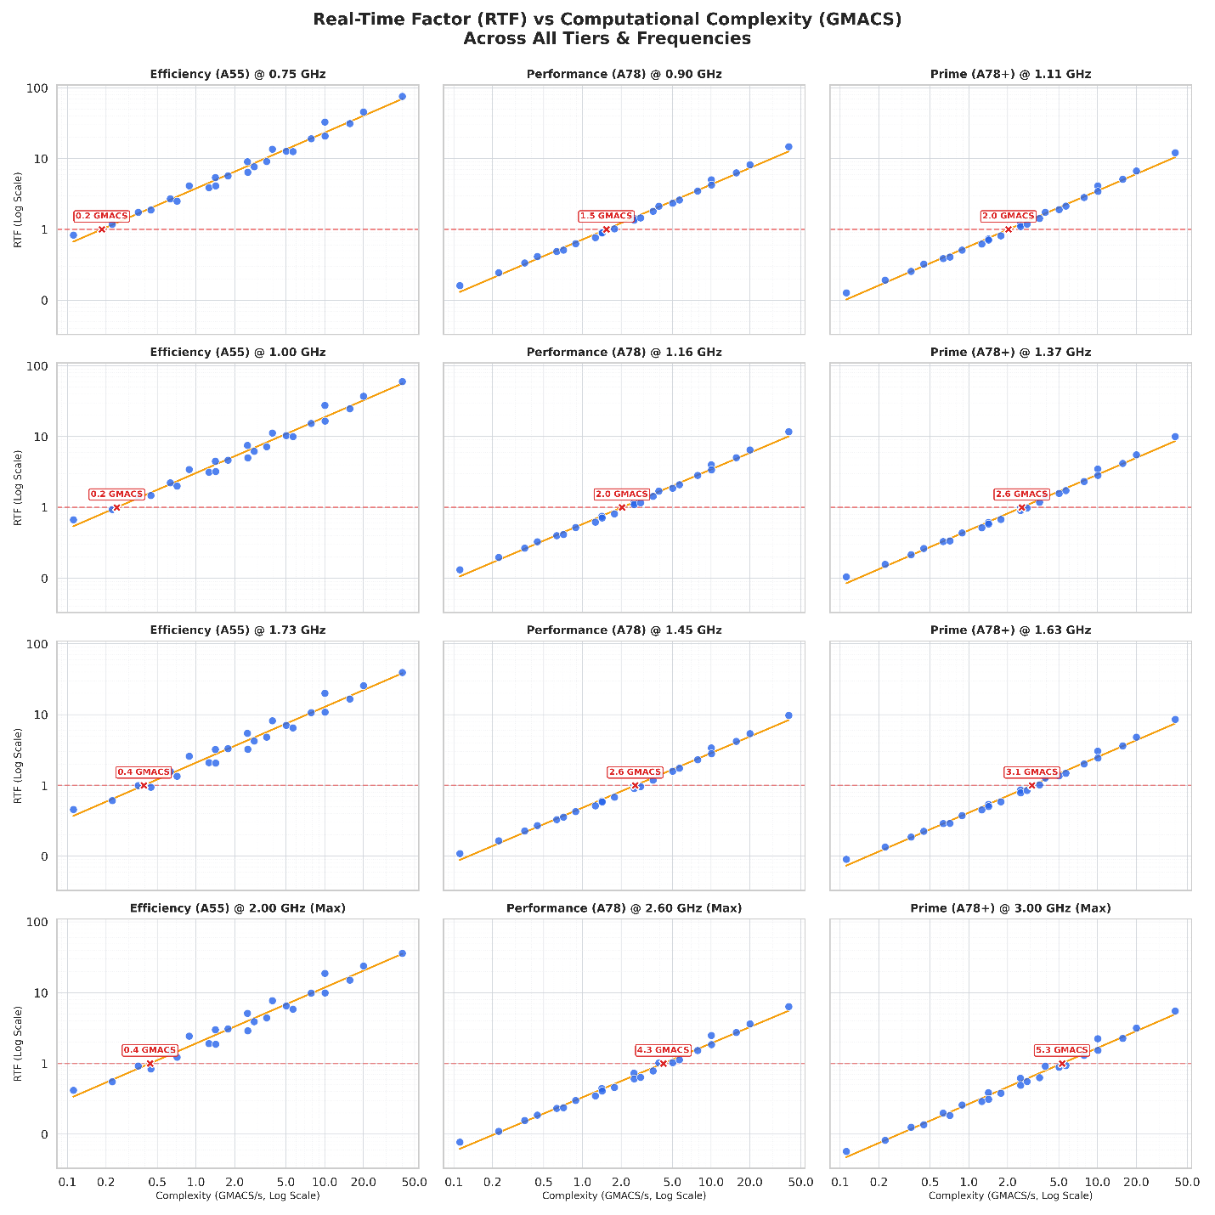
Figure 8.1.3.2-1 refers to the updated analysis plotting RTF vs GMACS using the extensive dataset from Experiment 2, which includes variants operating at 8, 16, and 32 kHz across different CPU cores and frequencies. The analysis demonstrates that these diverse data points exhibit a consistent linear trend.
Key Findings:
- RTF scales linearly with GMACS across different CPU tiers (Efficiency, Performance, Prime).
- A specific GMACS budget (e.g., 2.0 GMACS) yields a predictable RTF on a target CPU core and frequency, regardless of whether that complexity comes from a high-sample-rate input or a large parameter count in the decoder.
- This metric decouples the complexity constraint from specific architectural choices (like stride or latent rate), allowing codec designers flexibility in optimization.
- An analysis of the high-complexity data points shows further alignment. In Experiment 2, 20M model (~5.14 GMACS) demonstrates an RTF of 0.9 in a power-efficient execution mode (utilizing a mix of P and E cores) on a high-end 2023 device. This aligns well with the trend observed In Experiment 2 analysis on a mid-range Prime Core (3.0 GHz), where a complexity of ~5.3 GMACS corresponds to an RTF of approximately 1.0. Given the performance delta between the hardware platforms, these values suggest a consistent relationship between GMACS and real-time feasibility

8.1.3.3 Conclusion
By adopting GMACS as the primary complexity metric, it resolve the apparent discrepancies between different contribution data. This allows for a unified set of requirements that accurately reflects the real-time capability of mobile devices.

8.1.4 Analysis of AI Codec Complexity Scaling
To understand how complexity scales with model architecture, we analyzed several variants of the open-source DAC codec [3].

8.1.4.1 Methodology
Instead of using a single pre-trained model, we created seven "dummy" model variants based on the 16kHz configuration from the codec's open-source repository. This base configuration (16khz.yml) defines the core architecture, including:
# Model setup
DAC.sample_rate: 16000
DAC.encoder_dim: 64
DAC.encoder_rates: [2, 4, 5, 8]
DAC.decoder_dim: 1536
DAC.decoder_rates: [8, 5, 4, 2]
For all "dummy" variants, only the encoder_dim and decoder_dim were modified. The encoder and decoder rates (strides) were kept constant across all tests. This ensures all variants have the same total up/down-sampling factor (2 * 4 * 5 * 8 = 8 * 5 * 4 * 2 = 320) and thus the same minimum required frame size. For a 16kHz sample rate, this corresponds to a 20ms (320 samples) frame, which was used for all analysis.
This was achieved by modifying the core architectural parameters, specifically the encoder latent dimension (encoder_dim) and the decoder latent dimension (decoder_dim). These dimensions were scaled together in a bundled setup, creating specific encoder-decoder pairings (e.g., enc8dec144, enc12dec288, enc16de384, enc24dec576, enc32dec768, enc40dec960, enc64dec1536) to represent a range of potential model configurations.
For each of these seven variants, we measured the following complexity metrics for a 16kHz, 20ms frame:
- Model Parameters (Millions): The total number of trainable parameters in the model.
- Theoretical Complexity (MFLOP counts per second, MFLOP/s): The computational load calculated using the thop [4] profiling library, which has already aligned between S4aA250264 [2] and S4aA250231 [5].
- WMOPS (Weighted Million Operations Per Second): The complexity measured using the traditional WMOPS methodology [6], calculated separately for the encoder and decoder.
Note1: To perform this measurement, each AI model operation (e.g., convolution, activation) was first implemented in pure C. The source files were then annotated and compiled using the ITU-T STL wmc_tool [6] to generate the WMOPS figures.
Note2: An example of the tool's output for the enc12dec288 (which means the encoder_dim is 12 and decoder_dim is 288 in the dummy setup) encoder component is shown below:
--- Complexity analysis [WMOPS] ---
#define FRAMES_PER_SECOND 50.0 // in wmc_auto.c
|------ SELF ------| |--- CUMULATIVE ---|
routine calls min max avg min max avg
--------------- ------ ------ ------ ------ ------ ------ ------
node__block_block_0_Conv[WMC_AUTO] 1.00 1.543 1.543 1.543 1.543 1.543 1.543
node_Sin_170[WMC_AUTO] 1.00 4.995 4.995 4.995 4.995 4.995 4.995
node_Pow_172[WMC_AUTO] 1.00 4.995 4.995 4.995 4.995 4.995 4.995
node_Add_174[WMC_AUTO] 1.00 0.387 0.387 0.387 0.387 0.387 0.387
node__block_block_1_block_block_0_block_block_1_Conv[WMC_AUTO] 1.00 16.354 16.354 16.354 16.354 16.354 16.354
……………………………………………………
node__block_block_4_block_block_4_Conv[WMC_AUTO] 1.00 22.167 22.167 22.167 22.167 22.167 22.167
node_Sin_518[WMC_AUTO] 1.00 0.288 0.288 0.288 0.288 0.288 0.288
node_Pow_520[WMC_AUTO] 1.00 0.288 0.288 0.288 0.288 0.288 0.288
node_Add_522[WMC_AUTO] 1.00 0.058 0.058 0.058 0.058 0.058 0.058
node__block_block_6_Conv[WMC_AUTO] 1.00 5.578 5.578 5.578 5.578 5.578 5.578
--------------- ------ ------ ------ ------
total 20.00 648.227 648.227 648.227

Note3: The WMOPS metric is highly sensitive to the algorithmic efficiency of the C implementation style. Because the wmc_tool counts operations directly from the source code. A naive implementation of an AI operator (e.g., using unoptimized nested loops) will yield a significantly higher operation count than a code-optimized version, even if the logic is identical. Consequently, the reported values may vary by an order of magnitude depending on the optimization effort of source C code.

8.1.4.2 Complexity vs. Model Dimensions
The analysis reveals a clear, non-linear relationship between the model's latent dimensions and its resulting parameters and computational load. As the encoder_dim and decoder_dim are increased, the model parameters and MFLOP/s scale quadratically (or faster), not linearly.
This is visualized in Figure 8.1.4.2-1 (Parameters vs. Dimension) and Figure 2 (MFLOP/s vs. Dimension). These figures plot the component-wise complexity against its respective latent dimension. It is important to note that the points on the encoder (left) and decoder (right) plots are linked; each pair of points corresponds to one of the bundled setups (e.g., the enc8dec144 which means the encoder_dim is 8 and decoder_dim is144 in the dummy setup).
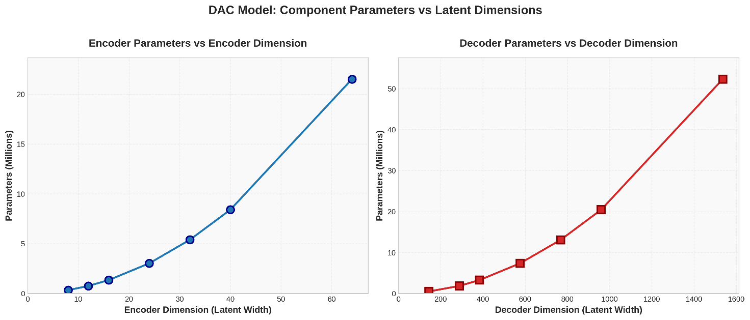
Figure 8.1.4.2-1 DAC Model Component Parameters vs. Latent Dimensions
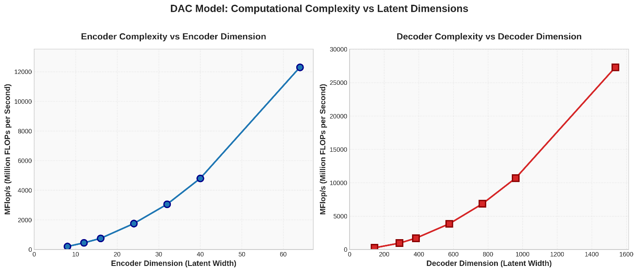
Figure 8.1.4.2-2 DAC Model Computational Complexity (MFLOP/s) vs. Latent Dimensions

8.1.4.3 WMOPS vs. Model Parameters
A key finding is the relationship between the AI model's size (in Millions of Parameters) and its complexity measured in traditional WMOPS. Figure 3 plots the measured Encoder WMOPS and Decoder WMOPS against the total model parameters for each of the seven variants.
Several observations on DAC model can be made from this data:
- There is a clear correlation between the number of model parameters and the resulting WMOPS, when using the same model architecture with the same C optimization level.
- The decoder's complexity (in WMOPS) scales significantly faster and is substantially higher than the encoder's complexity for all variants, which the DAC model arranges more parameters and complexity for decoder to get better re-constructed audio quality.
- The growth in WMOPS for both encoder and decoder appear to be linear relative to the increase in parameters.
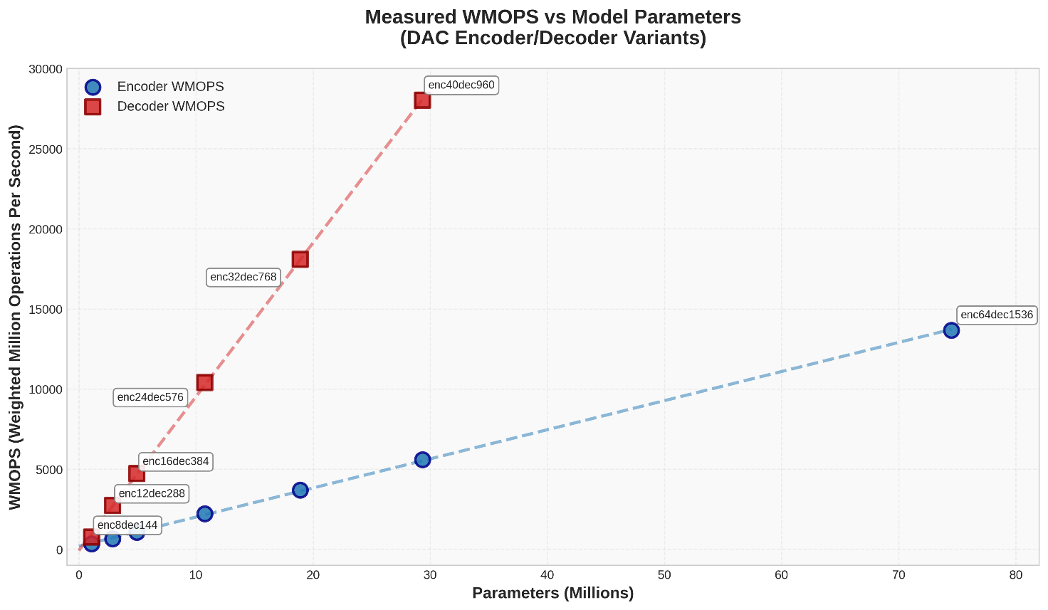
Figure 8.1.4.3-1 Measured WMOPS vs. Model Parameters (DAC Encoder/Decoder Variants)

8.1.4.4 Summary of Scaled Variants
Table 8.1.4.4-1 provides a summary of the complexity metrics for all seven analyzed DAC model variants. This data clearly shows the rapid scaling of all metrics as the encoder and decoder dimensions are increased.
Table 8.1.4.4-1 Complexity Metrics for Scaled DAC Model Variants (16kHz, 20ms frame)
Variant | Enc Dim | Dec Dim | Params (M) | GFLOP  counts | MFLOP/s | WMOPS Enc | WMOPS Dec
enc8dec144 | 8 | 144 | 1.09 | 0.009 | 437.09 | 333.92 | 760.53
enc12dec288 | 12 | 288 | 2.89 | 0.028 | 1397.63 | 648.23 | 2732.96
enc16dec384 | 16 | 384 | 4.94 | 0.050 | 2481.98 | 1060.79 | 4724.38
enc24dec576 | 24 | 576 | 10.76 | 0.112 | 5578.38 | 2228.92 | 10399.00
enc32dec768 | 32 | 768 | 18.90 | 0.198 | 9911.72 | 3693.56 | 18093.30
enc40dec960 | 40 | 960 | 29.34 | 0.310 | 15482.00 | 5599.48 | 28019.70
enc64dec1536 | 64 | 1536 | 74.50 | 0.792 | 39614.50 | 13675.30 | 70766.69

8.1.4.5 Observations and Conclusion
Based on the analysis of the DAC model variants, we observe the following :
- For the DAC model, there is a clear linear relationship between Theoretical Complexity (MFLOP/s), Model Parameters, and the measured WMOPS. As the MFLOP/s or parameter count increases, the WMOPS value increases linearly, provided the C coding style remains consistent.
- Increasing the model's internal dimensions causes complexity to grow quadratically. Even small increases in dimensions lead to disproportionately large jumps in MFLOP/s and WMOPS.
- The WMOPS score depends heavily on source C code efficiency.

7 Performance requirements
Editor’s Note:
1.Define performance requirements and identify appropriate test methodologies, regarding speech quality, intelligibility, conversational quality, in particular taking into account:
- Clean speech and noisy speech
- Tandeming with existing IMS voice codecs
- Clean channel and GEO channel conditions
2.Identify relevant reference codecs for comparison and evaluation purposes.

7.1 The status of PRs.
 | Core Influencing Factors | Progress | Open Issue
Performance requirements/speech quality | DC: Sample rate and audio bandwidth
Performance requirements/speech quality | DC: Bitrates (External)
Performance requirements/speech quality | DC: Frame length
Performance requirements/speech quality | DC: PLC (External)
Performance requirements/speech quality | DC: Algorithmic Delay
Performance requirements/speech quality | DC: Complexity, Memory
Performance requirements/speech quality | Test Methodolgies
Performance requirements/speech quality | DC:noise suppression
Performance requirements/speech quality | DC:DTX/CNG
Performance requirements/speech quality | DC:Robust Non-Speech
Performance requirements/speech quality | Evidence DCs
Performance requirements/speech quality | Reference codec

7.2 Clean speech and noisy speech

7.3 Tandeming with existing IMS voice codecs

7.4 Clean channel and GEO channel conditions

9 Test methodologies

10 Considerations on deliverables

10.1 Model format as intermediate representation

10.1.1 Background
Considerations for a ULBC reference implementation entirely in C, for complexity evaluations have been discussed in [14], [18].
Reference implementations for earlier generations of 3GPP speech and audio codecs are in C. Having a reference implementation entirely in C may help utilize some of the existing STL tools for WMOPS and memory estimation [15] [16]. However, using the WMC tool [16] for instrumenting an ML-based speech codec may not effectively consider vector & parallel compute optimizations.
In the following limitations of leveraging WMC tool [15] [16] for theoretical complexity measurement are listed:
- The weights reported in Table 18.3 of [15] do not account for the vectorized implementations of matrix multiplications that are widely used in AI-based processing. Consequently, any theoretical complexity estimation from the WMC tool may not reflect the actual runtime complexity and potentially not account for the diversity of various target platforms.
- Hardware and platform dependencies: C implementation may be platform‑specific that relies on intrinsics and vectorization pragmas. It may not be easily portable to specialized NPUs for example without substantial rewrites or vendor‑specific libraries.
- Unoptimized reference code: A reference C code may be unoptimized for certain platforms.
- Compiler and toolchain dependencies: Intrinsics and vectorization pragmas are compiler-specific.
- Maintenance burden during the standard development: Maintaining a reference C implementation up to date with new ML operators and architectures may be costly and error-prone.

10.1.2 Definitions
A graph format describes a neural network as a computational graph: nodes represent operations (e.g., convolutions, activations), and edges represent tensors flowing between them. It usually captures only the structure of the computation, not the trained parameters.
A model format (e.g., ONNX .onnx, CoreML .mlmodel) typically combines a graph representation, the trained parameters (e.g., weights, biases, etc.) and optionally metadata (e.g., input/output dimensions, etc.). Such model formats can be self-contained and directly runnable on compatible runtimes.
A model format can then serve as an intermediate representation (IR) between the high-level framework where the ML model is designed and the runtimes (e.g. TensorRT, ONNX RT, vendor runtimes) where it is executed. The intermediate representation of a model may be used inside tooling pipeline to analyze, transform, and optimize the model before final execution or deployment.
It should be noted that PyTorch does not contain a graph format and requires therefore a model definition as Torchcode.
In the following, the advantages of using a model format as an IR for standardization are discussed, as well as the support of different open-source model formats across various AI engines.

10.1.3 Advantages
Platform portability
Model format and IR specify what is computed (the structure and parameters of the model), not how it is executed on a given processor. The same graph or IR can be compiled or translated to different target processors (CPUs, GPUs, DSPs, NPUs) using custom toolchains.
It is also usually framework-agnostic and models can be exported from different training frameworks (e.g., PyTorch, TensorFlow) into a common format.
As a result, specifying a model format or IR allows each vendor to use their own toolchain to generate optimized code for their hardware.
Hardware evolution
Dedicated AI processors and hardware evolve fast. Model formats provide a future-proof method to make use of the latest developments (at least for the ML parts of ULBC) while providing compatibility and keeping maintenance effort low.
Combination with standard C-code
ULBC may consist of ML parts and classic signal processing parts written in ANSI C which can be combined using a backend runtime in C for the ML part. Consequently, a reference implementation of ULBC in C can be established as provided for other 3GPP codecs.

10.1.4 Overview of common ML model formats
The Table 10.1.4-1 summarizes the common ML model formats available.
Table 10.1.4-1. Overview of ML model formts

Format | Type / Scope | Pros | Cons
ONNX | Framework-agnostic Intermediate Representation | Cross-framework portability, widely supported on different runtimes and hardware; good for interchange  Runs natively on different recent OS (Windows and Linux)  Dedicated C/C++ Runtime available | Operator coverage limitations may require implementation of custom operations.  Support of dynamic graph limited.
TensorFlow Lite (TFLite / LiteRT) | Edge/embedded-focused IR (FlatBuffer) | Optimized for mobile/edge; strong Android ecosystem; tools for quantization & model optimization  Dedicated C/C++ Runtime available | Primarily TensorFlow-centric; partially vendor specific maintenance.
PyTorch/Python | Torch.nn.Module  and  checkpoints | Easy prototyping in ML research.  Highly optimized tools supporting conversion to vendor specific HW engine formats | In its native format, it is suboptimal for real-world testing, e.g. stream-processing, combination with classic DSP, not optimized for embedded platforms.  Dependency to Python and other packages versioning and long-term compatibility.  No C/C++ runtime without python dependencies.
TorchScript | PyTorch-specific serialized IR | It converts regular PyTorch nn.Module models into a static computational graph without dependencies to Python.  It preserves model logic; supports custom ops. Can be used as source representation for conversion to vendor-specific deployment-IRs.  Runtime through LibTorch possible only for C++ API | PyTorch-specific  TorchScript is tagged as deprecated and will be replaced by ExportedProgram[24]
ExportedProgram and ExecuTorch | Two IRs:  ExportedProgram and  ExcuTorch .pte | Intended to replace TorchScript pipeline. ExportedProgram is the new canonical PyTorch export IR.  Dedicated C++ Runtime available for .pte IR which can be compiled from ExecutedProgam IR. | PyTorch-specific  ExportedProgram IR needs to be compiled to another IR to be used in a ExecuTorch RT and any vendor-specific RT.  New pipeline still not completely mature and stable for various operations and backends
OpenVINO IR | Intel/CPU-centric IR | Strong optimization for Intel CPUs/GPUs; good tooling on PC/server | Not a natural fit for mobile SoCs; extra step for mobile vendors
Proprietary vendor IRs (CoreML, DLC, CIRCLE, etc.) | Vendor-specific internal IR | Highly optimized for specific hardware; used by vendor SDKs | Not portable across vendors; require conversions from an open IR like ONNX/TFLite
A PyTorch model format preserves the full dynamism, custom operations, and intricate control flow of underlying tensors, states, etc. This makes it the "source" for the model, providing the reference across various model conversion environments and therefore may allow best flexibility, transparency, and direct programmatic control for ML codec deployment. However, this approach may come at the cost of long-term compatibility as the PyTorch format is evolving and may behave platform and version dependent.
NOTE: A model format such as PyTorch (*.pth or .pt) typically saves the `state_dict`, which is a Python dictionary mapping layer names to their learned parameter tensors (e.g., weights, biases, etc). Loading such a model requires the prior definition of its neural network architecture as a Python class. This class must then be instantiated, and the `state_dict` subsequently loaded into the instantiated model. The `state_dict` itself only stores the parameter values and does not encapsulate the network's computational structure, which is instead provided by the Python class.
In contrast, formats like ONNX or TFLite, are primarily designed for inference deployment and cross-platform compatibility, often involving a conversion process that may abstract away or simplify certain aspects of the original PyTorch graph. While these formats are excellent for optimized execution on target hardware, they may represent a static, optimized snapshot of the model, which may be less flexible for iterative optimization or when dealing with complex, framework-specific constructs. As these formats have been developed as platform interchangeable model formats and are established as industry standards, a certain long term compatibility can be assumed.
In any case, the ULBC ML parts will likely be based on pyTorch format which can be converted to other stable formats such as ONNX or TFLite.

10.1.5 SoC AI Engines and Model Format Support
Major smartphone System-on-Chips (SoCs) are equipped with a range of AI processing hardware, including dedicated Neural Processing Units (NPUs), Digital Signal Processors (DSPs), and Tensor Processing Units (TPUs, where applicable), in addition to leveraging general-purpose GPUs and CPUs. SoC manufacturers provide their own specialized runtime environments and software development kits (SDKs) to harness the power of these accelerators [17-24]. Consequently, these vendors often utilize native or preferred internal model formats (sometimes referred to as vendor-specific intermediate representations) that are highly optimized for their particular hardware architecture.
Despite these proprietary preferences, a common pattern across the industry is the provision of mechanisms to convert models originating from popular, open-source machine learning frameworks. This typically includes formats like ONNX, TFLite, and direct conversions from frameworks such as PyTorch and TensorFlow, allowing developers to train models using their preferred high-level frameworks and then deploy them onto diverse hardware ecosystems, ensuring broad compatibility while still benefiting from hardware capabilities. From [17-24], PyTorch, Tensorflow, ONNX, and TFLite formats can be considered potential baseline formats.

10.1.6 Summary
A model-format / IR-based reference implementation has clear advantages over a pure C reference implementation:
- It decouples algorithm definition from hardware-specific implementation.
- It leverages existing SoC vendor compilers, AI accelerators, and runtimes.
- It is significantly more portable, maintainable, and future-proof across targets.
Based on these observations, it is recommended for ULBC that the reference implementation should be based on an ML model-format and any potential auxiliary signal processing steps in C as per below:
- A neural network model-format including the operator set and version.
- Both ONNX and PyTorch as ML model-formats as part of the reference implementation.
- The I/O interfaces of these ML models and any auxiliary signal processing steps in C.
- The reference implementation can be used to illustrate integration, allow verification, and testing.

11 Considered work plan for potential normative work

Annex A: Design Constraints Living Document

A.1 Introduction
This annex is intended to capture the current status of the design constraints in a living document within SA4 for FS_ULBC, some of them have not yet been fully agreed.

A.2 ULBC design constraints proposals
Table A.2-1 summarizes the current status of discussions on the design constraints.
Table A.2-1: Design Constraints Proposals
Sampling Frequency and Audio Bandwidth | S4-251918  Support of [8, 16, 32] kHz / [NB, WB, SWB] required  Editor’s Notes:  - Support of 8 kHz justified for interoperability. Would NB be just tested and supported “externally” based on some external resampling?  - Support of 48 kHz may be considered at higher bitrate operation  Support at least a single model (e.g. SWB)?  S4-251794->S4-260157  The ultra low bitrate codec shall support sampling rates of 8kHz (NB) and 16kHz (WB).  S4-251808  The ultra low bitrate codec supports any combination of the following input and output sampling rates: 8 kHz, 16kHz and 32kHz.  The choice of the supported audio bandwidth per bitrate is up to the codec proponent.  S4-260255  - Single sample rate: e.g. 16 kHz  - Audio bandwidth: up to WB  Note: Sample rate and bandwidth requirement may depend on agreed target bitrate | S4-251918  Many neural codecs operate at 24 kHz, this specific sampling rate should be discussed.  There may be complexity considerations associated to this box; joint decisions with other design constraints may be needed.  S4-251794->S4-260157  The supported audio bandwidth for:  - NB ranges from 50 – 4000Hz  - WB ranges from 50 – 8000Hz  S4-251808  For transcoding, all deployed sampling rates need to be supported.  For subjective tests, ULBC candidates should be compared at the same bitrate and at 16 kHz as well as 32 kHz sampling rate, which allows candidates to optimize performance for NB/WB (16 kHz) or NB/WB/SWB (32 kHz) depending on the bitrate.  S4-260175  Note: NB audio is typically sampled at 8 kHz with an audio bandwidth of 100 – 3500 Hz. WB audio is typically sampled at 16 kHz with an audio bandwidth of 50 – 7000 Hz. SWB audio is typically sampled at 32 kHz with an audio bandwidth of 50 – 14000 Hz. FB audio typically provides an audio bandwidth up to 20000 Hz.
Number of audio channels | S4-260175  The ULBC candidate codecs shall support mono coding with one channel input and one channel output.
Bit Rates | S4-251792  The ULBC candidate codecs shall operate at bitrates lower than [3.00]kb/s
Frame length | S4-251918  [Multiple of 20 ms]  S4-260175  The candidate codecs shall operate with a coding frame size of multiple of 20 ms.  S4-260255  - Corresponding to SPS/bundling period (160 ms) or sub-multiples thereof | S4-251918  Dependency: RAN simulations and system considerations  S4-260175  Since larger than 20ms bundling time periods will be used, codec proponents should be allowed to consider solutions with larger than 20ms frame sizes
Algorithmic Delay | S4-260175  The algorithmic delay shall be less than [coding frame size + x]ms  S4-260255  Algorithmic delay excl. framing:  e.g. <= 80 ms (0.5 * SPS/bundling period) | The algorithmic delay is defined as the frame size buffering delay plus any other delays inherent in the codec algorithm (e.g., look-ahead, sample-rate conversion, and decoder post-processing)
Complexity | S4-260175  Complexity limits are applied according to the following categories. The computational complexity and program ROM (PROM) of the candidate codecs for each category shall be measured with ITU-T STL2009 [4] as the observed worst-case encoder + observed worst-case decoder complexity within the same category [5], [6]  Computational:  wMOPS: Less than [x]wMOPS  Memory:  RAM:  ROM:  Program ROM:  S4-251807  - The model size per operation mode is less than [5-10] million parameters.  - The total number of parameters is less than [Z] million  S4-260142  - Complexity: single Model Size < 3M parameters and < 600MMACS.  - RAM: < 3M parameters assuming no switching between operation modes. (Whether switching will be supported FFS).  ROM: < 15M parameters.  S4-260241  The source proposes to define a computational complexity metric by counting  - WMOPS for the DSP‑based components,  - MAC for the ML‑based components, and  - combine those to a common value according to WMOPS + w · MACs, where w is a ML weighting factor  Finally, a maximum value needs to be defined as computational complexity limit in design constraints. Based on this principle, a similar metric can be defined for memory counting.  S4-260255  - Limited; the limits should be sufficiently low to not preclude deployment on current-generation smartphones  - TBD MMAC/s  E.g. 3 M parameters | S4-260175  The ULBC Codec should be implementable on a mobile device using today’s technology. Increased computational complexity and memory usage should be commensurate with the gain in quality of user experience (e.g. higher audio bandwidth such as SWB or stereo if it is supported) or with increased efficiency (e.g. lower bit rate for same quality when compared to a reference codec).
Potential use of noise suppression as part of the codec | S4-251918  If noise suppression is supported inside ULBC, it is expected that there is a mechanism to disable noise suppression in the codec [7],[8]  Editor’s Notes: Clarifications needed:  - Need to support noise suppression in UBLC? (typically vendor specific, defined outside the codec)  - Impacts on test methodology, DTX operation/performance  S4-251848  ULBC should be robust to noisy speech with low SNR, noise and other non-speech input.  ULBC should be able to reconstruct a background noise representation in at least certain configuration  S4-251881-> S4-260220  If noise suppression is supported as part of the candidate codec, it can be disabled to preserve background signals  S4-251908  For active speech, noise suppression within ULBC is allowed.  S4-260137 (regular call)  Noise preservation is not required and noise suppression as part of the codec may be applied  S4-260137 (eCall)  Background noise preserved during the call at least for the direction from vehicle to emergency response center. For the opposite direction, noise preservation may not be required.  S4-260255  - No requirement to provide noise suppression  - Required capability to handle and reconstruct noisy speech input with moderate to high SNR;  Note: Noise reconstruction capability is primarily enforced through performance requirements | S4-251918  Motivations:  - Disabling noise suppression is required to test feature apart  - Avoid tandeming in real operation  IMS voice communication is defined in TS 22.228, GEO satellite access has no specific requirement on noise handling  S4-251848  Editor’s note 1: May need to be in performance requirement  Editor’s note 2: Noise reconstruction may only be enabled in certain configurations and be limited to certain types of noises.  S4-251881-> S4-260220  Editor’s note 1: Requirement to disable noise suppression may be considered in connection with specific operating bit rate(s)  Editor’s note 2: Solution behaviour w.r.t. potential noise suppression is primarily enforced via performance requirements. The default operation for tests is with noise suppression disabled.
Jitter Buffer Management (JBM) | S4-260175  A JBM solution conforming to the requirements in TS 26.114, except for the functional requirement in sub-clause 8.2.2 of TS 26.114: “Speech JBM used in MTSI shall support all the codecs as defined in clause 5.2.1”, shall be provided with the candidate codecs.
Rate switching | S4-260175  The candidate codecs shall perform rate switching upon command to the encoder throughout the entire bit rate range at arbitrary frame boundaries. The rate switching may imply switching between different bandwidths | S4-260175  Due to the Bundling period and the associated TBS, switching might have to happen at the boundary of bundling period
Packet loss concealment (PLC) | S4-251918  A PLC solution shall be provided by the ULBC candidate codecs  Editor’s Notes:  - Typical loss profiles/characteristics to be clarified  Support of redundancy to be clarified  S4-260255  Required; capable of addressing single agreed-upon target bit rate and operation point of IMS Voice Call over GEO (see above) | S4-251918  Support of JBM to be added as extra box  S4-260175  Need to be able to handle BLER up to [x%]
RTP payload format | S4-260175  Candidate codecs shall provide an RTP payload format specification supporting the full set of features and functionality of the ULBC candidate codecs.
DTX | S4-260175  The candidate codecs shall provide a complete VAD/DTX/CNG framework. It shall be possible to operate the codec with DTX on or DTX off.  S4-251881-> S4-260220  The candidate codec shall provide a framework for voice activity detection (VAD) and discontinuous transmission (DTX) with comfort noise generation (CNG). It shall be possible to operate the codec with DTX on or DTX off.  S4-251918  Support required  Editor’s Note: Typical radio characteristics and optimizations (SPS, DRX, bitrate) to be clarified  Editor’s Note: Typical radio characteristics and optimizations (SPS, DRX, bitrate) to be clarified  S4-260137 (regular call)  Support  S4-260137 (eCall)  No DTX support during the call at least for the direction from vehicle to emergency response center  S4-260255  - No requirement to support DTX  Note: No separate DTX-related performance requirement. | S4-251881-> S4-260220  Editor’s note: Operation relating to DTX on and disabling/enabling potential noise suppressor may need to be clarified
Robustness to non-speech input | S4-251881-> S4-260220  The candidate codec shall be robust to noisy speech (stationary noise 5-15 dB, non-stationary noise 10-25 dB), background signals during and between speech segments, and other non-speech input signals | Editor’s note: May need to be in performance requirement  S4-251881-> S4-260220  Editor’s note 1: May need to be in performance requirements  Editor’s note 2: Relevant background signals, etc. to be further defined as part of performance requirements, these include both stationary and non-stationary background signal types
Output gain limitation | S4-260175  The ULBC candidate codecs shall not amplify the output signal relative to the input signal beyond limits.  Editor’s Note: Similar limits and methodology to measure the amplification are described in the EVS-7a,b processing plan permanent document.

