3GPP TSG SA WG4 #135 S4-260313
Goa, India, Feb 9-13, 2026 Revision of S4-260256

Title: Feasible TBS values and packet loss traces for 80ms bundling period for ULBC over NB-IoT NTN GEO channel

Source: Qualcomm Inc.
Agenda item: 7.8

Document for: Discussion

1. Background
This paper presents the simulation results for the 80ms bundling period following the Simulation One (“target QoS based simulation”) methodology in S4-251664 [1].
The simulation results include:
- feasible TBS values
- packet loss traces for optimal configurations
- system capacity

2. Labeling of the packet loss traces
Each simulation has the following parameters, following the PD [2].
Simulation parameter | Range | Abbreviation in file name of the trace
direction | uplink  downlink | UL  DL
TBS | For 80ms bundling period: 144, 256, 328, 424 | TBS
Bundling period | 80, 160, 320 (ms) | bund
Doppler spread | 1Hz, 5Hz | Doppler
Number of RX | UL: 1  DL: 1, 2 | RX
SCS | UL:3.75kHz, 15kHz  DL: 15 kHz | SCS
Number of tones | UL: 1 for 3.75kHz SCS; 1, 3, 6, 12 for 15kHz SCS  DL: 15 | tone
Duration of NPUSCH or NPDSCH | UL: determined by I_{TBS}, I_{RU}, N_{rep}, and bundling period  DL: determined by I_{TBS}, I_{SF}, N_{rep}, and bundling period
seed | 10 | Seed
BLER | 1%, 2%, 6%, 10% | BLER
UE power class | 23dBm, 26dBm, 31dBm | PC

The traces are labeled in the following format:
- UL: TBSx_BLERy_bundz_UL_Dopplerm_SCSnk_tonet_ums_PCzdBm_Seedk.txt
  - TBS is x bits
  - BLER is y per cent
  - Bundling period is z ms
  - Uplink (UL)
  - Doppler spread is m Hz
  - SCS is n kHz
  - Number of tones is t
  - NPUSCH duration is u ms
  - PCzdBm: feasible with UE power class z dBm (when UE transmits at power not greater than z dBm) or higher
  - Seed is k
- DL: TBSx_BLERy_bundz_DL_Dopplerm_RXn_dms_Seedk.txt
  - TBS is x bits
  - BLER is y per cent
  - Bundling period is z ms
  - Down link (DL)
  - Doppler spread is m Hz
  - Number of UE RX is n
  - NPDSCH duration is d ms
  - Seed is k
Examples:
TBS144_BLER10_bund80_UL_Doppler5_SCS15k_tone1_64ms_PC23dBm_seed2.txt
TBS144_BLER6_bund80_DL_Doppler5_RX2_4ms_seed7.txt

3. Optimal configurations
DMRS bundling is assumed as in [3]. The scheduling timing uncertainty is assumed to be negligible, which means that either the beam footprint size is below [X], or that TA reporting and UE-specific Koffset is enabled.
The simulation is for Simulation One in [1]. Its goal is to find the best configuration to maximize the system capacity at the given per-UE performance which for the simulation study is denoted by BLER. The bitrate is another important aspect, but since the TBS is given, BLER is the only metric for the per-UE performance.

As discussed in [1], significant simulation workload reduction can be achieved if we can find the optimal configurations from a vast number of possible configurations and generate packet loss traces only for these configurations.

The optimality criterion is a tradeoff between the per-UE performance (in terms of TBS and BLER) and the system capacity.

A TBS is considered feasible if a configuration exists and meets the BLER requirement and the UE power class constraint.

Once the optimal configurations are found, packet loss traces are generated for them.

3.1 scenario: 80 bundling period, TBS 144, 1 UE RX

We first look at DL. For DL, the frequency-domain resource allocation is fixed at 180 kHz and the only variable is the duration of the resource allocation determined by the number of subframes (N_{SF}) and the number of repetitions (N_{rep}). For simulation, 5 consecutive DL durations among the allowed DL durations for TBS 144 are selected. DMRS bundling and long NRS for channel estimation [3] are assumed. The BLER’s are shown in Figure 1. Note that -3.3 dB is the maximum achievable SNR for all 5 durations.

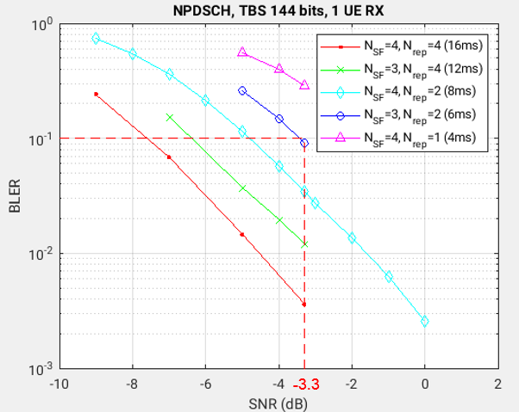
Figure 1 BLER vs SNR for NDPSCH with TBS 144 bits and 1 UE RX

1% BLER

For 1% BLER, it is met only by the 16ms NPDSCH (N_{SF}=4, N_{rep}=4). Given the bundling period 80ms, the network can schedule at most 80/16=5 UEs.

For UL, the maximum allowed duration is 48ms (resulting from N_{RU}=6, SCS 15kHz and one tone). This configuration has a coding rate 0.1458, already lower than the rate (1/3) of the Turbo code mother code. Therefore, increasing the number of tones while keeping the UE transmission power fixed does not improve the performance. This 48ms NPUSCH configuration is optimal and is chosen for the UL simulation. The simulation results are shown in Figure 2(a). The required SNR to meet 1% BLER is 0.0 dB, which corresponds to 26.4dBm UE TX power as seen in Figure 2(b).

Note: Figure 2 (a) shows the BLER vs SNR, which marks the SNRs 2.6dB and -3.4dB for 3.75kHz SCS and 15kHz SCS respectively, both for 1 tone and 23dBm UE TX power. Figure 2 (b) gives the BLER but as function of the UE TX power.

2% BLER

For 2% BLER, it is met by the 16ms NPDSCH and 12ms NPDSCH (N_{SF}=3, N_{rep}=4). Because the objective is to optimize the system capacity, the 12ms NPDSCH is chosen. Given the bundling period 80ms, the network can schedule at most floor(80/12)=6 UEs.

For UL, the maximum allowed duration is 64ms. It may result from a first configuration (N_{RU}=8, SCS 15kHz and one tone) or a second configuration (N_{RU}=2, SCS 3.75kHz and one tone). The first configuration is better than the second configuration because the coding rate of the first is less than 1/3 while the coding rate of the second is larger than 1/3. Also, because the coding rate of the first configuration is already less than 1/3, there is no need to consider other configurations that differ only in the number of tones. Thus, this 64ms NPUSCH configuration (N_{RU}=8, SCS 15kHz and one tone) is chosen for the UL simulation. Based on the simulation results in Figure 2(a), the required SNR to meet 2% BLER is -2.2dB, which corresponds to 24.2dBm UE TX power as seen in Figure 2(b).

6% BLER

For 6% BLER, for similar reason given for the 2% BLER, the 8ms NPDSCH (N_{SF}=4, N_{rep}=2) is chosen. Given the bundling period 80ms, the network can schedule at most 80/8=10 UEs.

For UL, following the argument for the case of 2% BLER, the 64ms NPUSCH configuration (N_{RU}=8, SCS 15kHz and one tone) is chosen for the simulation. Based on the simulation results in Figure 2(a), the required SNR to meet 6% BLER is -3.2dB, which corresponds to 23.2dBm UE TX power as seen in Figure 2(b).

10% BLER

For 10% BLER, for similar reason given for the 2% BLER, the 6ms NPDSCH (N_{SF}=3, N_{rep}=2) is chosen. Given the bundling period 80ms, the network can schedule at most floor(80/6)=13 UEs. However, to meet the 10% BLER requirement, the UL must use the 64ms NPUSCH configuration (N_{RU}=8, SCS 15kHz and one tone) because the 64ms NPUSCH configuration (N_{RU}=2, SCS 3.75kHz and one tone) cannot meet the BLER requirement. The resulting system capacity is 12 UEs/cell.

For UL, following the argument for the case of 2% BLER, the 64ms NPUSCH configuration (N_{RU}=8, SCS 15kHz and one tone) is chosen for the simulation. Based on the simulation results in Figure 2(a), the required SNR to meet 10% BLER is -3.7dB, which corresponds to 22.7dBm UE TX power as seen in Figure 2(b).

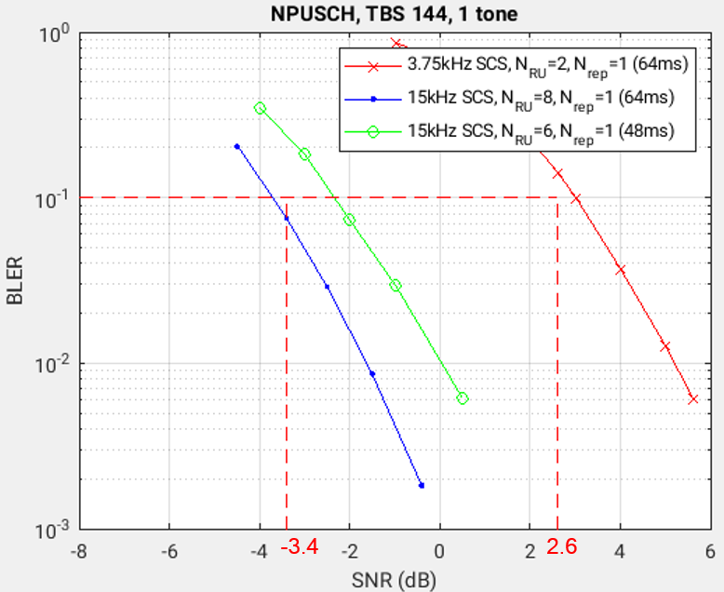  (a) | 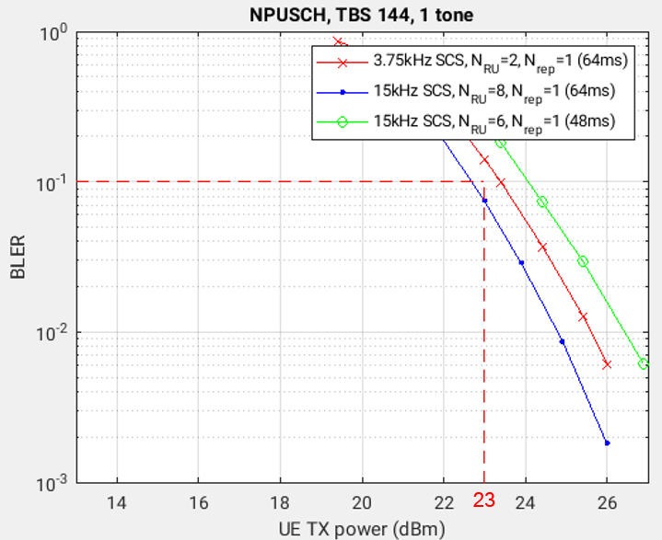  (b)
Figure 2 For TBS 144 bits, (a) BLER vs SNR and (b) BLER vs UE TX power

The optimal configurations are shown in the table below:
Table 1 Optimal configurations for TBS 144 and 1 UE RX
 | 10% | 6% | 2% | 1%
UL config | N_{RU}=8, N_{rep}=1, SCS 15kHz, 1 tone (64ms) | N_{RU}=8, N_{rep}=1, SCS 15kHz, 1 tone (64ms) | N_{RU}=8, N_{rep}=1, SCS 15kHz, 1 tone (64ms) | N_{RU}=6, N_{rep}=1, SCS 15kHz, 1 tone (48ms)
Required UE TX power (dBm) | 22.7 | 23.2 | 24.2 | 26.4
Required SNR (dB) | -3.7 | -3.2 | -2.2 | 0.0
DL config | N_{SF}=3, N_{rep}=2 (6ms) | N_{SF}=4, N_{rep}=2 (8ms) | N_{SF}=3, N_{rep}=4 (12ms) | N_{SF}=4, N_{rep}=4 (16ms)
DL required SNR (dB) | -3.4 | -4.0 | -4.1 | -4.6
System capacity | 12 | 10 | 6 | 5

From the table we see that:
- For the UE power class 23dBm, only 10% BLER is achievable (the green column in the table) with a system capacity 13 UEs per cell, and other BLERs are not achievable and thus the system capacities at those BLERs are zero.
- For the UE power class 26dBm, only 10%, 6% and 2% BLERs are achievable (the green columns and the blue column in the table).
- For the UE power class 31dBm, all BLERs (10%, 6%, 2%, 1%) are achievable (the green columns, the blue column and the yellow column in the table).

3.2 scenario: 80ms bundling period, TBS 144, 2 UE RX

The DL BLER curves for 2 UE RX are shown in Figure 3.

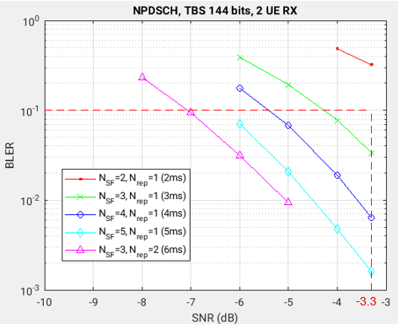
Figure 3 BLER for NPDSCH for 80ms bundling period, TBS 144 bits, and 2 UE RX

1% BLER

For DL, the 4ms configuration (N_{SF}=4, N_{rep}=1) is the shortest configuration that meets the 1% BLER, and the required SNR is -3.6dB. The DL can accommodate 80/4=20 UEs.

For UL, there is no difference between 1 UE RX and 2 UE RX. Therefore, the BLER curves in Figure 2 can be reused. Given the bundling period of 80ms, NPDSCH duration of 4ms, minimum 2 ms for UL/DL switches, and the constraint of RUs for TBS 144 and repetitions, the maximum NPUSCH duration is 64ms.

For 23dBm UE power class, it is not possible to meet 1% BLER in the UL. The system capacity is 0.

For 26dBm UE power class, two configurations, “3.75kHz and 64ms (N_{RU}=2, N_{rep}=1, SCS 3.75kHz, 1 tone)” and “15kHz and 64ms (N_{RU}=8, N_{rep}=1, SCS 15kHz, 1 tone)” can meet the 1% BLER, but the “15kHz and 64ms” configuration can support only 12 UEs in the UL. Therefore, the “3.75kHz and 64ms” configuration is optimal, and the required SNR is 5.24dB, corresponding to 25.64dBm UE TX power. The system capacity is min(20,48)=20 UEs/cell.

For 31dBm UE power class, since “3.75kHz and 64ms” already supports 48 UEs in the UL, greater than the 20 UEs supported in the DL, there is no need to consider smaller UL resource allocation. Therefore, the optimal configuration and the system capacity are the same as in the case of 26dBm UE power class.

2% BLER

For DL, the 4ms (N_{SF}=4, N_{rep}=1) is the shortest configuration that meets the 2% BLER, and the required SNR is -4.0dB. The DL can accommodate 80/4=20 UEs.

For UL:
- For the 23dBm UE power class, it is not possible to meet 1% BLER in the UL. The system capacity is 0.
- For the 26dBm UE power class, the optimal configuration is “3.75kHz and 64ms (N_{RU}=2, N_{rep}=1, SCS 3.75kHz, 1 tone)” and the required SNR is 4.6dB, the corresponding UE TX power is 25.0dBm, the system capacity is 20UEs/cell.
- For the 31dBm UE power class, the result is the same as the case of 26dBm UE power class

6% BLER

For DL, the 4ms (N_{SF}=4, N_{rep}=1) is the shortest configuration that meets the 2% BLER, and the required SNR is -4.9dB. The DL can accommodate 80/4=20 UEs.

For UL:
- For the 23dBm UE power class, it is not possible to meet 1% BLER in the UL. The system capacity is 0.
- For the 26dBm UE power class, the optimal configuration is “3.75kHz and 64ms (N_{RU}=2, N_{rep}=1, SCS 3.75kHz, 1 tone)” and the required SNR is 3.5dB, the corresponding UE TX power is 23.9dBm, the system capacity is 20UEs/cell.
- For the 31dBm UE power class, the result is the same as the case of 26dBm UE power class.

10% BLER

For DL, the 3ms (N_{SF}=3, N_{rep}=1) is the shortest configuration that meets the 2% BLER, and the required SNR is -4.3dB. The DL can accommodate floor(80/3)=26 UEs.

For UL:
- For the 23dBm UE power class, the 64ms NPUSCH configuration (N_{RU}=8, SCS 15kHz and one tone) meets 1% BLER. The system capacity is min(26,12)=12.
- For the 26dBm UE power class, the optimal configuration is “3.75kHz and 64ms (N_{RU}=2, N_{rep}=1, SCS 3.75kHz, 1 tone)” and the required SNR is 3.0dB, the corresponding UE TX power is 23.4dBm, the system capacity is min(48,26)=26UEs/cell.
- For the 31dBm UE power class, the result is the same as the case of 26dBm UE power class.

Table 2 Optimal configurations for TBS 144 and 2 UE RX and 23dBm UE power class
 | 10% | 6% | 2% | 1%
UL config | N_{RU}=8, N_{rep}=1, SCS 15kHz, 1 tone (64ms) | infeasible | infeasible | infeasible
Required UE TX power (dBm) | 22.7
Required SNR (dB) | -3.7
DL config | N_{SF}=3, N_{rep}=1 (3ms)
DL required SNR (dB) | -3.4
System capacity | 12

Table 3 Optimal configurations for TBS 144 and 2 UE RX and 26dBm and 31dBm UE power classes for step 3.1 in [1]
 | 10% | 6% | 2% | 1%
UL config | N_{RU}=2, N_{rep}=1, SCS 3.75kHz, 1 tone (64ms) | N_{RU}=2, N_{rep}=1, SCS 3.75kHz, 1 tone (64ms) | N_{RU}=2, N_{rep}=1, SCS 3.75kHz, 1 tone (64ms) | N_{RU}=2, N_{rep}=1, SCS 3.75kHz, 1 tone (64ms)
Required UE TX power (dBm) | 23.4 | 23.9 | 25.0 | 25.6
Required SNR (dB) | 3.0 | 3.5 | 4.6 | 5.2
DL config | N_{SF}=3, N_{rep}=1 (3ms) | N_{SF}=4, N_{rep}=1 (4ms) | N_{SF}=4, N_{rep}=1 (4ms) | N_{SF}=4, N_{rep}=1 (4ms)
DL required SNR (dB) | -4.3 | -4.9 | -4.0 | -3.6
System capacity | 26 | 20 | 20 | 20

3.3. scenario: 80 bundling period, TBS 256, 2 UE RX

The DL performance is shown in Figure 4. The UL performance is shown in Figure 5.

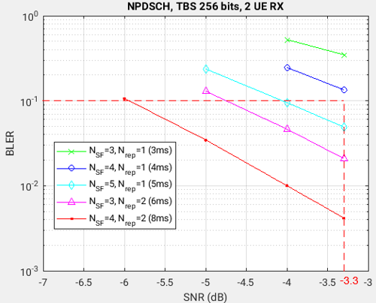
Figure 4 BLER for NPDSCH for 80ms bundling period, TBS 256 bits, and 2 UE RX

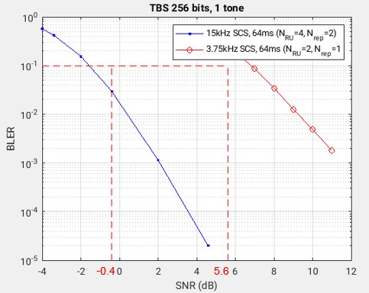  (a) | 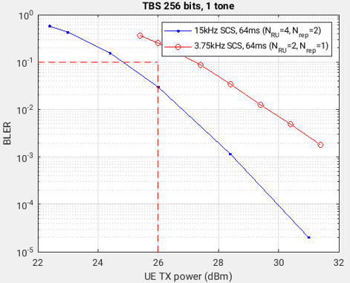  (b)
Figure 5 NPUSCH for TBS 256: (a) BLER vs SNR, (b) BLER vs UE TX power

1% BLER

For 1% BLER, it is met only by the 8ms NPDSCH (N_{SF}=4, N_{rep}=2), and the required SNR is -4.00dB. Given the bundling period 80ms, the network can schedule at most 80/8=10 UEs.

For NPUSCH, the optimal configuration is the 64ms configuration (N_{RU}=8, N_{rep}=1, SCS 15kHz and one tone)
- For 23dBm UE, not possible, the system capacity is 0
- For 26dBm UE, not possible, the system capacity is 0
- For 31dBm UE, the required SNR is 0.4dB, corresponding to UE TX power is 26.8dBm, and the system capacity is 10UEs.
2% BLER

For 2% BLER, it is met only by the 8ms NPDSCH (N_{SF}=4, N_{rep}=2), and the required SNR is -4.56dB. Given the bundling period 80ms, the network can schedule at most 80/8=10 UEs.

For NPUSCH, the optimal configuration is the 64ms configuration (N_{RU}=8, N_{rep}=1, SCS 15kHz and one tone)
- For 23dBm UE, not possible
- For 26dBm UE, not possible
- For 31dBm UE, the required SNR is -0.11dB, corresponding to UE TX power is 26.3dBm, and the system capacity is 10UEs.

6% BLER

For 6% BLER, it is met only by the 5ms NPDSCH (N_{SF}=5, N_{rep}=1), and the required SNR is -3.52dB. Given the bundling period 80ms, the network can schedule at most 80/5=16 UEs.

For NPUSCH, the optimal configuration is among 64ms configuration (N_{RU}=8, SCS 15kHz and one tone) or (N_{RU}=2, SCS 3.75kHz and one tone)
- For 23dBm UE, not possible
- For 26dBm UE, the optimal configuration is the 64ms configuration (N_{RU}=8, N_{rep}=1, SCS 15kHz and one tone) and required SNR is -1.1dB, corresponding to 25.3dBm UE TX power, and the system capacity is min(16,12)=12.
- For 31dBm UE, the optimal configuration is the 64ms configuration (N_{RU}=2, N_{rep}=1, SCS 3.75kHz and one tone) and the required SNR is 7.38dB, corresponding to 28.8dBm UE TX power, and the system capacity is min(16,48)=16UEs.

10% BLER

For 10% BLER, it is met only by the 5ms NPDSCH (N_{SF}=5, N_{rep}=1), and the required SNR is -4.06dB. Given the bundling period 80ms, the network can schedule at most 80/5=16 UEs.

For NPUSCH, the optimal configuration is among 64ms configuration (N_{RU}=8, N_{rep}=1, SCS 15kHz and one tone) or (N_{RU}=2, SCS 3.75kHz and one tone)
- For 23dBm UE, not possible
- For 26dBm UE, the 64ms configuration (N_{RU}=8, SCS 15kHz and one tone), and the required SNR is -1.6dB, corresponding to 24.8dBm UE TX power.
- For 31dBm UE, the optimal configuration is the 64ms configuration (N_{RU}=2, N_{rep}=1, SCS 3.75kHz and one tone) and the required SNR is 6.80dB, corresponding to 27.2dBm UE TX power, and the system capacity is min(16,48)=16.

Table 4 Optimal configurations for TBS 256 and 2 UE RX and 26dBm UE power class
 | 10% | 6% | 2% | 1%
UL config | N_{RU}=8, N_{rep}=1, SCS 15kHz, 1 tone (64ms) | N_{RU}=8, N_{rep}=1, SCS 15kHz, 1 tone (64ms) | infeasible | infeasible
Required UE TX power (dBm) | 24.8 | 25.3
Required SNR (dB) | -1.6 | -1.1
DL config | N_{SF}=5, N_{rep}=1 (5ms) | N_{SF}=5, N_{rep}=1 (5ms)
DL required SNR (dB) | -4.1 | -3.5
System capacity | 12 | 12

Table 5 Optimal configurations for TBS 256 and 2 UE RX and 31dBm (blue and yellow columns) UE power class
 | 10% | 6% | 2% | 1%
UL config | N_{RU}=2, N_{rep}=1, SCS 3.75kHz, 1 tone (64ms) | N_{RU}=2, N_{rep}=1, SCS 3.75kHz, 1 tone (64ms) | N_{RU}=8, N_{rep}=1, SCS 15kHz, 1 tone (64ms) | N_{RU}=8, N_{rep}=1, SCS 15kHz, 1 tone (64ms)
Required UE TX power (dBm) | 27.2 | 27.8 | 26.3 | 26.8
Required SNR (dB) | 6.8 | 7.4 | -0.1 | 0.4
DL config | N_{SF}=5, N_{rep}=1 (5ms) | N_{SF}=5, N_{rep}=1 (5ms) | N_{SF}=4, N_{rep}=2 (8ms) | N_{SF}=4, N_{rep}=2 (8ms)
DL required SNR (dB) | -4.1 | -3.5 | -4.6 | -4.0
System capacity | 16 | 16 | 10 | 10

3.4. scenario: 80ms bundling period, TBS 328, 2 UE RX

The DL performance is shown in Figure 6, and the UL performance is shown in Figure 7.

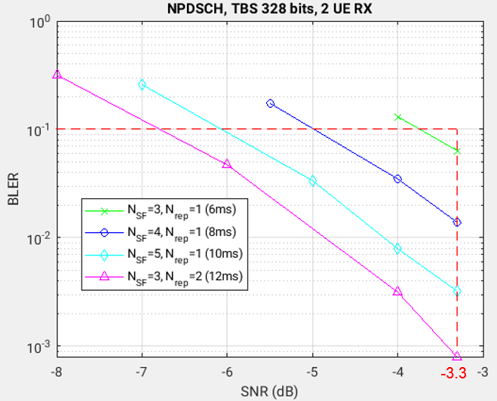
Figure 6 BLER for NPDSCH for 80ms bundling period, TBS 328 bits, and 2 UE RX

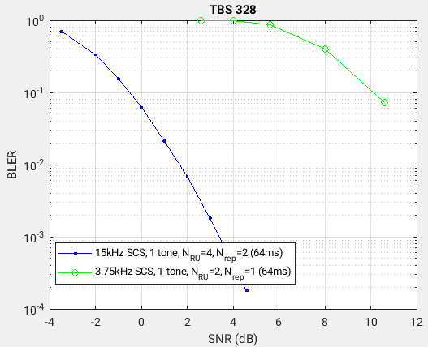  (a) | 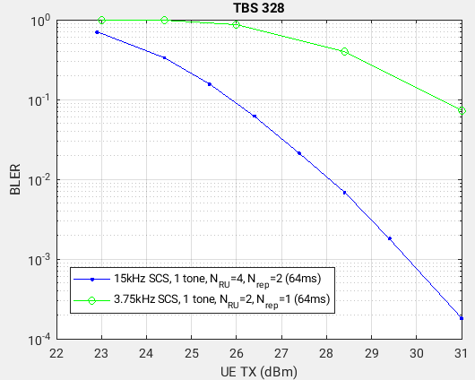  (b)
Figure 7 NPUSCH for TBS 328: (a) BLER vs SNR, (b) BLER vs UE TX power

The optimal configurations are shown in Table 6 and Table 7.

Table 6 Optimal configurations for TBS 328 and 2 UE RX and 26dBm UE power class
 | 10% | 6% | 2% | 1%
UL config | N_{RU}=8, N_{rep}=1, SCS 15kHz, 1 tone (64ms) | infeasible | infeasible | infeasible
Required UE TX power (dBm) | 25.88
Required SNR (dB) | -0.52
DL config | N_{SF}=6, N_{rep}=1 (6ms)
DL required SNR (dB) | -3.74
System capacity | 12

Table 7 Optimal configurations for TBS 328 and 2 UE RX and 31dBm UE power classes for step 3.1 in [1]
 | 10% | 6% | 2% | 1%
UL config | N_{RU}=2, N_{rep}=1, SCS 3.75kHz, 1 tone (64ms) | N_{RU}=4, N_{rep}=2, SCS 15kHz, 1 tone (64ms) | N_{RU}=4, N_{rep}=2, SCS 15kHz, 1 tone (64ms) | N_{RU}=4, N_{rep}=2, SCS 15kHz, 1 tone (64ms)
Required UE TX power (dBm) | 30.5 | 26.4 | 27.5 | 28.1
Required SNR (dB) | 10.10 | 0.03 | 1.05 | 1.66
DL config | N_{SF}=6, N_{rep}=1 (6ms) | N_{SF}=4, N_{rep}=2 (8ms) | N_{SF}=4, N_{rep}=2 (8ms) | N_{SF}=5, N_{rep}=2 (10ms)
DL required SNR (dB) | -3.74 | -4.50 | -3.58 | -4.16
System capacity | 13 | 10 | 10 | 8

3.5. scenario: 80 bundling period, TBS 424, 2 UE RX

For TBS 424, the granularity of NPDSCH time-domain configuration is coarse at 5ms.

The DL performance is shown in Figure 8, and the UL performance is shown in Figure 9.

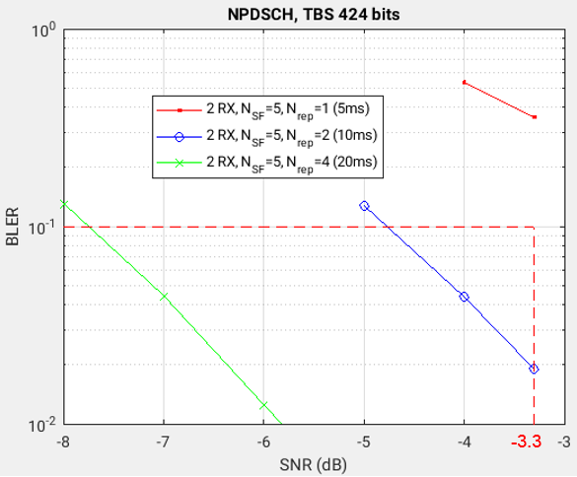
Figure 8 BLER for NPDSCH for 80ms bundling period, TBS 424 bits, and 2 UE RX
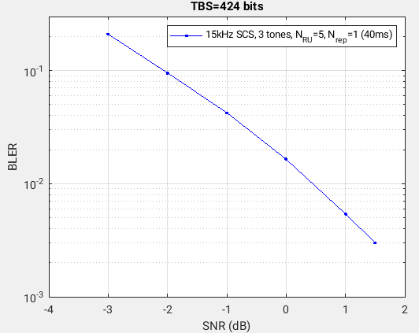  (a) |  | 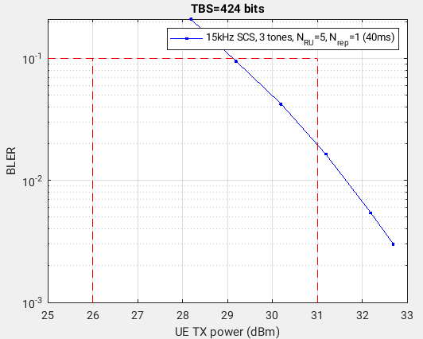  (b)
Figure 9 NPUSCH for TBS 424: (a) BLER vs SNR, (b) BLER vs UE TX power

The optimal configurations are shown in Table 8.
Table 8 Optimal configurations for TBS 424 and 2 UE RX and 31dBm UE power class
 | 10% | 6% | 2% | 1%
UL config | N_{RU}=5, N_{rep}=1, SCS 15kHz, 3 tones (40ms) | N_{RU}=5, N_{rep}=1, SCS 15kHz, 3 tones (40ms) | N_{RU}=5, N_{rep}=1, SCS 15kHz, 3 tones (40ms) | infeasible
Required UE TX power (dBm) | 29.10 | 29.73 | 30.96
Required SNR (dB) | -2.07 | -1.44 | -0.21
DL config | N_{SF}=5, N_{rep}=2 (10ms) | N_{SF}=5, N_{rep}=2 (10ms) | N_{SF}=5, N_{rep}=2 (10ms)
DL required SNR (dB) | -4.78 | -4.29 | -3.35
System capacity | 4 | 4 | 4

4. Feasible TBS values

Observation: for 80ms bundling period, UE power class up to 31dBm, all TBS values (i.e., 144, 256, 328, 424) are feasible for BLERs 1%, 2%, 6% and 10%, except that TBS 424 is not feasible at 1% BLER.

5. Packet loss traces

The packet loss traces are in the attached zip file named traces.zip for all 4 TBS values 144, 256, 328 and 424, with 391 traces.

6. Proposal

It is important to give a workable example on how to determine the configurations to be simulated that are based on the best tradeoff between per-UE performance and system capacity. Therefore, we propose the following.

Proposal: include clauses 2 through 5 above to the PD or TR.

References

[1] S4-251664, “RAN simulation methodology for ULBC” Qualcomm, 3GPP SA4 #134, Dallas, Nov 17-21, 2025.
[2] S4-251585, Permanent Document FS_ULBC, 3GPP TSG SA WG4 #133-e, July 18-25, 2025.
[3] S4-251303, “Scenarios for RAN simulation calibration for ULBC over NTN”, Qualcomm, vivo, Xiaomi, Huawei Technologies Co. Ltd, 3GPP TSG SA WG4 #133-e, July 18-25, 2025.

