3GPP TSG SA WG4 #135 S4-260311
Goa, India, Feb 9-13, 2026 Revision of S4-260214

Title: [FS_ULBC] Feasible bitrates for the NTN-TDL-C channel model with 10-degree elevation angle

Source: Qualcomm Incorporated, Xiaomi
Agenda item: 7.8 FS_ULBC

Document for: Agreement

1 Background
At the SA4 #134 meeting, a new channel model, the NTN-TDL-C channel model for the 10-degree elevation angle, was agreed, as documented in the permanent document v0.4.0 S4-252108. This channel model was in addition to the initial channel model in Table 6.9.2-3 of TR 38.811 that had been agreed in the permanent document.
Now with two channel models, the TBS values in the Tables 5.2.2.1-1, 5.2.2.1-2 and 5.2.2.1-3 in the permanent document should be determined by the union of the supported TBS values for both channel models. Additionally, we found that the new channel model is more consistent with field data than the initial channel model is. Based on field data for a NB-IoT GSO service and a handheld device, we observed that the gap between the 1 percentile SNR and the 50 percentile SNR is between 1 to 3 dB, while for the initial channel model the gap is about 6dB and for the new channel model the gap is about 1dB.
S4-251739 derived the feasible bitrates for the initial channel model, assuming DMRS bundling. In this paper, we report on the maximum feasible bitrate for the new channel model.

2 Simulation results
At the SA4 #134 meeting, there were discussions on the impact of DMRS bundling and the uncertainty in scheduling timing (which occurs when the cell size is very large and neither the UE-specific Koffset nor the TA report is supported).
In our simulation, we consider the worst case DMRS bundling, i.e., assuming no DMRS bundling, and the impact of uncertainty in scheduling timing, and specifically consider the following two scenarios:
- Scenario 1: 80ms bundling period, 2 UE RX, 15kHz SCS, Doppler spread 5Hz, without DMRS bundling, no uncertainty in scheduling timing
- Scenario 2: 80ms bundling period, 2 UE RX, 15kHz SCS, Doppler spread 5Hz, without DMRS bundling, 10ms uncertainty in scheduling timing
The target BLER for both uplink and downlink is set to 2%. The maximum supported TBS values and the minimum resource allocations to meet the BLER requirement are as follows:
- Scenario 1: TBS 936, uplink: 15kHz SCS, 3 tones, 48ms (N_{RU}=6, N_{rep}=2); downlink: 24ms (N_{SF}=6, N_{rep}=4)
- Scenario 2: TBS 680, uplink: 15kHz SCS, 3 tones, 40ms (N_{RU}=5, N_{rep}=2); downlink: 20ms (N_{SF}=5, N_{rep}=4)
The uplink simulation results are shown in Figure 1. For a UE transmitting at the power of 31dBm, for TBS 936 the BLER is 1.5%, and for TBS 680 the BLER is 0.2%.
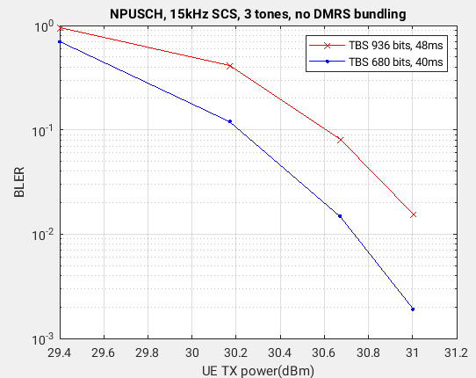
Figure 1 BLER vs UE TX power for TBS 936 and 48ms NPUSCH, and TBS 680 and 40ms NPUSCH

For TBS 936 bits in the downlink, the 24ms configuration yields a BLER of 1.1% at -3.3dB SNR.
For TBS 680 bits in the downlink, the 20ms configuration yields a BLER of 0.5% at -3.3dB SNR.

3 Proposal

The proposed change includes the following:
- Add TBS 936 and TBS 680 and an additional value between 680 and the current maximum TBS value (424) to the TBS table for the 80ms bundling period in the permanent document v.0.4.0.
- Add new TBS values to the TBS tables for 160ms and 320 ms bundling periods accordingly.
- Change the “codec bitrate” to “net bitrate” to indicate that the “net bitrate” is the bitrate available for the codec and does not require a codec to operate at the bitrate.

1st Change

TBS values and PHY bitrates: The TBS values are selected from table 16.5.1.2-2 for NB-IoT for NPUSCH in TS36.213 and the corresponding PHY bitrates and net bitrate available to the codec (assuming 7 bytes of packet header) are calculated for each bundling period.
NOTE 1: The final size of packet header depends on the conclusions reached by SA2 and RAN, including whether 1-byte MAC header is feasible.
NOTE 2: The packet header is only counted once, regardless of how many voice frames are bundled together.
NOTE 3: The precise relationship between the voice frame duration and the bundling time depends on the RTP payload design. In the case of multiple voice frames bundled together, the loss of a single Transport Block (TB) means the loss of multiple consecutive voice frames.

Table 5.2.2.1-1 TBS and PHY bitrate for 80ms bundling
TBS (bits) | 144 | 256 | 328 | 424 | 584 | 680 | 936
PHY bitrate (kbps) | 1.8 | 3.2 | 4.1 | 5.3 | 7.3 | 8.5 | 11.7
Net bitrate (kbps) | 1.1 | 2.5 | 3.4 | 4.6 | 6.6 | 7.8 | 11.0

NOTE 4: TBS 936 is achievable with the 10-degree NTN-TDL-C channel model, no DMRS bundling, no uncertainty in scheduling timing, and 31dBm UE maximum TX power.
NOTE 5: TBS 680 is achievable with the 10-degree NTN-TDL-C channel model, no DMRS bundling, 10ms uncertainty in scheduling timing, and 31dBm UE maximum TX power.
Table 5.2.2.1-2 TBS and PHY bitrate for 160ms bundling
TBS (bits) | 208 | 424 | 600 | 808 | 1096 | 1384 | 1736
PHY bitrate (kbps) | 1.30 | 2.65 | 3.75 | 5.05 | 6.85 | 8.65 | 10.85
Net bitrate (kbps) | 0.95 | 2.30 | 3.40 | 4.70 | 6.50 | 8.30 | 10.55

NOTE 6: TBS 1736 is achievable with the 10-degree NTN-TDL-C channel model, no DMRS bundling, no uncertainty in scheduling timing, and 31dBm UE maximum TX power.
NOTE 7: TBS 1384 is achievable with the 10-degree NTN-TDL-C channel model, no DMRS bundling, 10ms uncertainty in scheduling timing, and 31dBm UE maximum TX power.

Table 5.2.2.1-3 TBS and PHY bitrate for 320ms bundling
TBS (bits) | 328 | 776 | 1096 | 1544 | 2024 | 2536
PHY bitrate (kbps) | 1.025 | 2.425 | 3.425 | 4.825 | 6.325 | 7.925
Net bitrate (kbps) | 0.850 | 2.250 | 3.250 | 4.650 | 6.150 | 7.750

NOTE 8: TBS 2536 is achievable with the 10-degree NTN-TDL-C channel model, no DMRS bundling, no uncertainty in scheduling timing, and 31dBm UE TX power.
NOTE 9: TBS 2024 is achievable with the 10-degree NTN-TDL-C channel model, no DMRS bundling, 10ms uncertainty in scheduling timing, and 31dBm UE TX power.

