3GPP TSG SA WG4#135 S4-260209
Goa, India, 9 – 13 February 2026

Source: vivo Mobile Communication Co.
Title: [FS_ULBC] Alignment Analysis on Complexity of DAC model
Spec: 3GPP TR 26.940 v0.4.0
Agenda item: 7.8
Document for: Discussion/Agreement

1. Introduction
In this meeting, several companies have presented complexity analyses for AI-based codecs suitable for ULBC. notably S4-260165 [1] (Dolby et al.) and S4-260155 [2] (vivo et al.).
While both contributions agree on the general feasibility of AI codecs on modern smartphones, there appeared to be a discrepancy when comparing "Model Size" (parameter count) to Real-Time Factor (RTF). Specifically, for a model of a similar parameter count (e.g., ~3M parameters), the reported complexity and RTF varied significantly between the architectures tested in [1] and [2]. For instance, the [1] ~3M parameter model (32 kHz) requires 0.79 GMACS, whereas the equivalent [2] ~3M parameter model (32 kHz) requires approximately 1.41 GMACS (derived from 2821 MFlops/s). In fact, the [1] model's complexity (0.79 GMACS) aligns more closely with the [2] model operating at 16 kHz (~0.70 GMACS), despite the difference in sampling rate.
This contribution provides a detailed analysis of this discrepancy. It demonstrates that "Model Size" is an insufficient metric for constraining complexity across different neural architectures, or even within the same architecture (e.g., DAC). Instead, we show that GMACS (Giga Multiply-Accumulate Operations per Second) provides a robust, linear correlation with RTF across different architectures, sampling rates, and frame rates.

2. Architectural Analysis and Discrepancy Resolution

2.1 The "Model Size" Trap
Initial comparisons suggested that a 3M parameter model operating at 32 kHz (from [1]) had a similar computational footprint to a 3M parameter model operating at 16 kHz (from [2]). Intuitively, the 32 kHz model should be significantly more expensive.
To understand this, we performed a detailed breakdown comparison between the [2] (16k, ~3M) and [1] (32k, ~3M) architectures using an identical evaluation method:

Table 1: Detailed breakdown comparison between the [2] (16k, ~3M) and [1] (32k, ~3M)
Metric | [2] (16k, ~3M) | [1] (32k, ~3M)
Input Rate | 16,000 Hz | 32,000 Hz
Total Stride | 320 (2x4x5x8) | 1280 (4x4x8x10)
Latent Rate | 50.0 Hz | 25.0 Hz
Encoder MACs (M) | 436.30 | 461.92
Quantizer MACs (M) | 2.25 | 0.50
Decoder MACs (M) | 984.50 | 1037.12
Total MFlops/s | 1423.05 | 1499.54
Analysis:
- The [1] (32k, ~3M) model runs at a 2x Higher Input Rate (32k vs 16k), increasing the computational cost of the Encoder (shallow layers).
- The [1] (32k, ~3M) model uses a 4x Higher Stride (1280 vs 320), effectively reducing the Latent Rate to 25Hz (compared to the Standard 50Hz).
- This reduced latent rate significantly lowers the Decoder cost (fewer frames to upsample) compared to what a 32kHz model would typically require with standard striding.
- The higher input cost balances with the lower decoder/latent cost, resulting in a total MFlops/s that is comparable to the [2] (16k, ~3M) model.
Consequently, two models with the same parameter count can have vastly different runtimes depending on where those parameters are located (shallow vs. deep layers) and the stride configuration.

2.2. Verification of Complexity Metrics
To validate this analysis, the theoretical complexity (GMACS) was recalculated for the models in question to ensure alignment.
- We apply the standard conversion where $1\text{ GMAC }≈2\text{ GFLOPs}$.
- The [1] (32k, ~3M) model at 32 kHz yields ~1,499.5 MFlops/s.
  - $1499.5/2≈750\text{ MMACS }≈0.75\text{ GMACS}$.
  - This aligns closely with the reference value of 0.79 GMACS reported in [1].

3. GMACS as the Metric
When the extensive RTF data from [2] is plotted against GMACS (rather than Model Size), the data aligns approximately.
As shown in Figure 1 below, the analysis of the combined dataset, the relationship between GMACS and RTF becomes linear and architecture-agnostic.
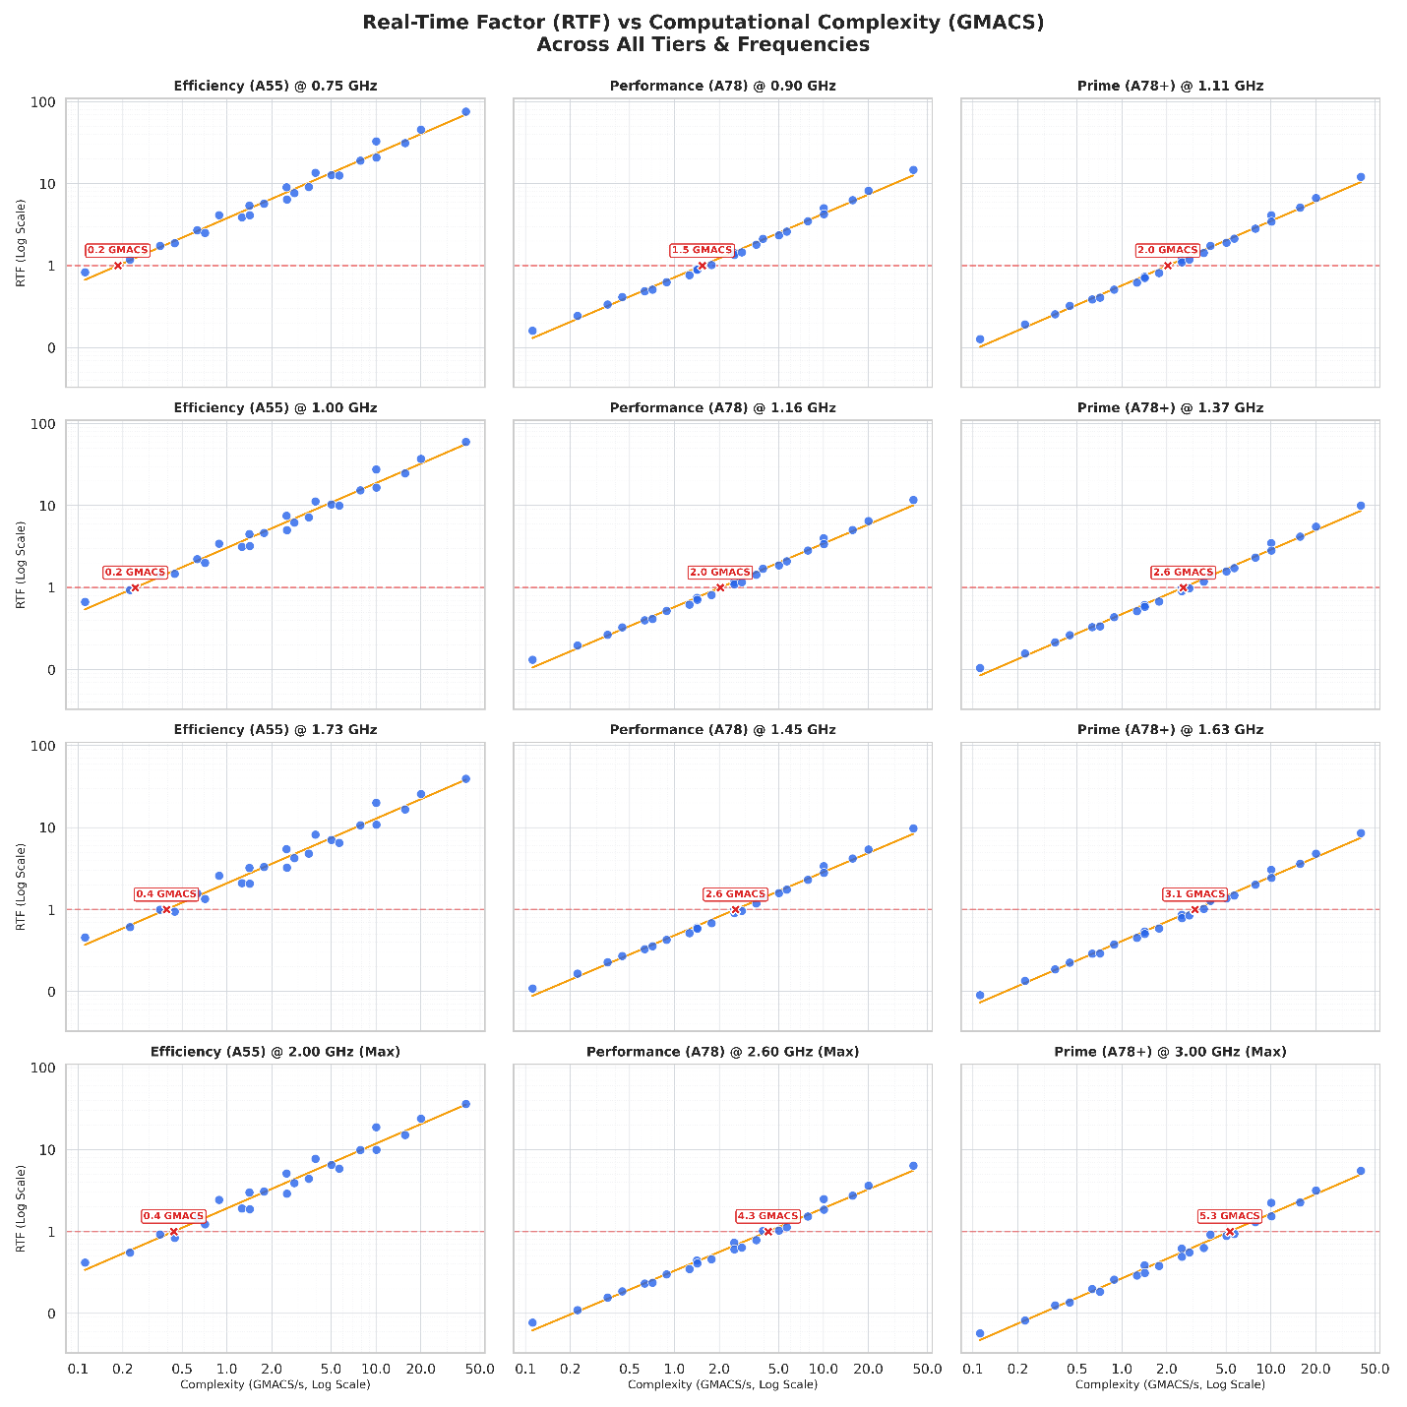 Figure 1 refers to the updated analysis plotting RTF vs GMACS using the extensive dataset from [2], which includes variants operating at 8, 16, and 32 kHz across different CPU cores and frequencies. The analysis demonstrates that these diverse data points exhibit a consistent linear trend.
Key Findings:
- RTF scales linearly with GMACS across different CPU tiers (Efficiency, Performance, Prime).
- A specific GMACS budget (e.g., 2.0 GMACS) yields a predictable RTF on a target CPU core and frequency, regardless of whether that complexity comes from a high-sample-rate input or a large parameter count in the decoder.
- This metric decouples the complexity constraint from specific architectural choices (like stride or latent rate), allowing codec designers flexibility in optimization.
- An analysis of the high-complexity data points shows further alignment. [2] 20M model (~5.14 GMACS) demonstrates an RTF of 0.9 in a power-efficient execution mode (utilizing a mix of P and E cores) on a high-end 2023 device. This aligns well with the trend observed in [2] analysis on a mid-range Prime Core (3.0 GHz), where a complexity of ~5.3 GMACS corresponds to an RTF of approximately 1.0. Given the performance delta between the hardware platforms, these values suggest a consistent relationship between GMACS and real-time feasibility

4.Conclusion
By adopting GMACS as the primary complexity metric, we resolve the apparent discrepancies between different contribution data. This allows for a unified set of requirements that accurately reflects the real-time capability of mobile devices.

5. Proposal
We propose to include the analysis presented in this contribution into PDoc. Specifically, the text should capture the findings that Model Size is not a consistent proxy for complexity across varying architectures (e.g., high-stride vs. low-stride), and that GMACS/GFLOPs demonstrates a strong linear correlation with real-time performance on mobile devices. Documenting this analysis will provide a solid basis for defining the complexity constraints for the ULBC candidate.

References
[1] S4-260165, "[FS_ULBC] On ULBC complexity and RTF analysis"
[2] S4-260155, "[FS_ULBC] Analysis of AI Codec Real-Time Performance (RTF) and Complexity Scaling"

