3GPP TSG SA WG4#135 S4-260159
Goa, India, 9 – 13 February 2026

Source: vivo, Samsung, Spreadtrum, MediaTek Inc.
Title: [FS_ULBC] On codec bitrate and capacity discussion for ULBC
Spec: 3GPP TR 26.940 v0.4.0
Agenda item: 7.8
Document for: Discussion/Agreement

1. Introduction
TBS and codec bitrate for evaluation is still noted with ‘companies reported’, this contribution will try to provide some analysis from following aspects:
- Provide Multiplexed UE number analysis
- Confirm the TBS/Codec bitrate values

2. Reason for Change

Multiplexed UE number analysis
For one configuration of candidate TBS, the performance of many configurations can be higher than target BLER, the left resources can be reserved for scheduling of more UEs as shown in Figure 1. In general, different UEs can be scheduled by TDM manner for both UL and DL, furthermore, different UEs can also be scheduled by FDM manner for UL since NPUSCH may occupy few subcarriers among the whole 180kHz bandwidth. For example, the FDM number for UL would be 48 and 12 for 3.75kHz SCS and 15kHz SCS with single tone, respectively. Then, considering that the call is bi-directional, the final supported UE numbers should the minimum value of UL dan DL, which can be computed as
$$Multiplexed UE number=\min_{N}{\{\left(N_{UL,FDM}*N_{UL,TDM}\right),N_{DL,TDM}\}}$$

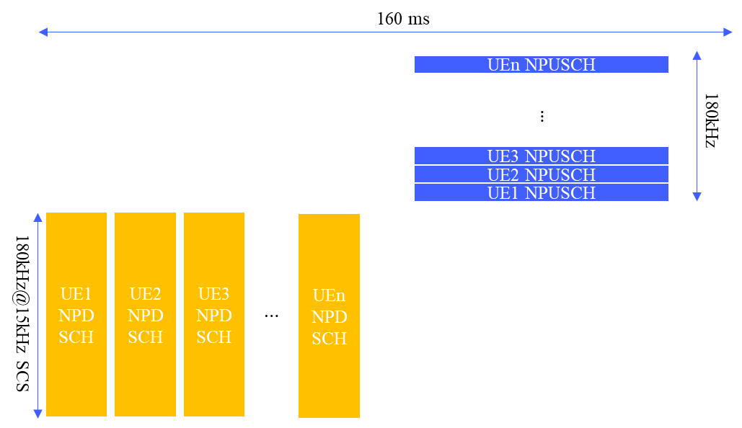
Figure 1 Frame structure of multiplexed UE
Based on the above equation, multiplexed UE number are summarized in the following Figures with 2% BLER consideration under 50-degree elevation channel model. In the Figures 2, it can be observed that the capacity for UE power with 23 dBm is very poor and the performance would be improved with high power UE. At the same time, the capacity increase with the ptime value.
Furthermore, an analysis assuming a 2% BLER under a 10-degree elevation channel model was also conducted. The detailed results of this evaluation are provided in the Annex.
In addition, since the transmission data rate is assumed as [1-3]kbps by SA1, it should be regarded as a benchmark. It can be observed from Figure 2, even with the highest UE power of 31dBm and codec bitrate of 2.5kbps, the capacity is as poor as 10 UEs. Whereas for codec bitrate higher than 3kbps, the capacity would be further reduced. It is also worth noting that the commercial deployed GEO system, Tiantong, operates within a 0.8-2.4kbps range, as referenced in clause 5.2.1.3 of the document [1]. This real-world example lends further support to the 1-3kbps benchmark, suggesting that the ULBC study would benefit from focusing on bitrates below 3kbps.
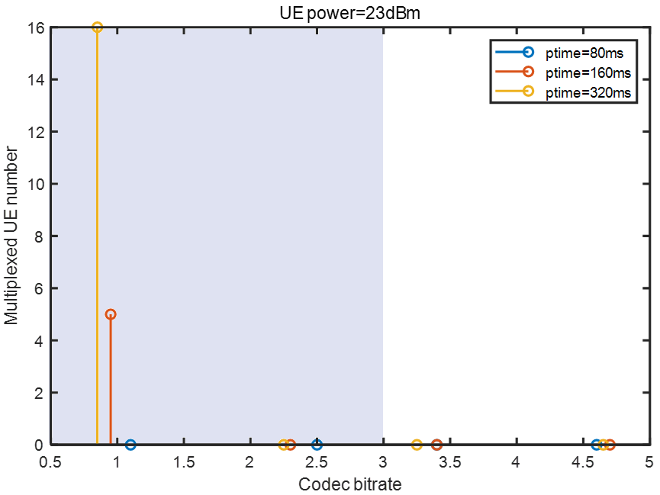 | 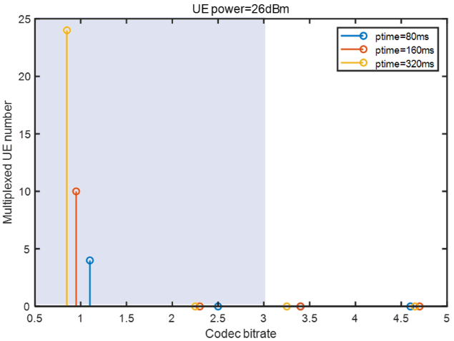
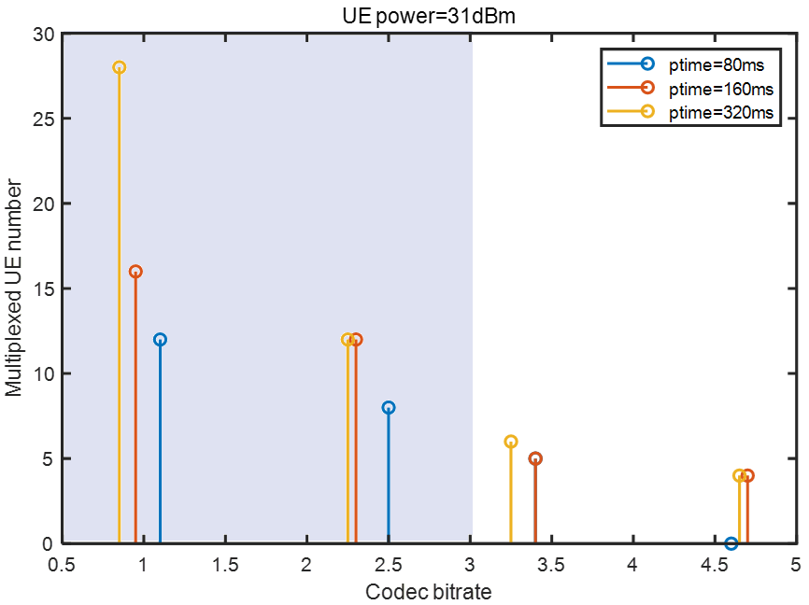
Figure 2 Multiplexed UE number for different codec bitrate on different UE power (23dBm, 26dBm and 31dBm) in 50-degree elevation channel model
Note: For half-duplex NB-IoT UEs, capacity is binary: if a configuration causes the required transmission time (either the DL transmission time /UL transmission time /Sum of DL and UL transmission time) to exceed the bundling time, the capacity is zero, and adding more carriers will not fix this logical deadlock. For viable configurations, i.e., capacity is not zero, system capacity may scale linearly as the deployed carriers.
Observation 1: For a given codec bitrate, higher UE transmit power lead to higher capacity (multiplexed UE number).
Observation 2: For codec bitrate of about 3kbps, the capacity is as poor as 10 UEs with UE power of 31dBm. And the capacity would be further reduced when codec bitrate increased, for example, no more than 5 UEs for codec bitrate of 4.5kbps.

Candidate TBS/Codec bitrate determination
Based on the above preliminary analysis and observations, the following TBS are proposed:
Table 1 Proposed TBS for evaluation
TBS (bits) | 88 | 120 | 144 | 176 | 224 | 256
PHY bitrate (kbps) | 1.1 | 1.50 | 1.80 | 2.20 | 2.80 | 3.20
Codec bitrate(kbps) | 0.4 | 0.80 | 1.10 | 1.50 | 2.10 | 2.50

TBS (bits) | 120 | 144 | 176 | 208 | 256 | 328 | 392 | 424
PHY bitrate (kbps) | 0.75 | 0.9 | 1.10 | 1.30 | 1.60 | 2.05 | 2.45 | 2.65
Codec bitrate(kbps) | 0.4 | 0.55 | 0.75 | 0.95 | 1.25 | 1.70 | 2.10 | 2.30

TBS (bits) | 208 | 256 | 328 | 440 | 552 | 680 | 808
PHY bitrate (kbps) | 0.65 | 0.8 | 1.02 | 1.38 | 1.73 | 2.12 | 2.52
Codec bitrate(kbps) | 0.475 | 0.625 | 0.85 | 1.20 | 1.55 | 1.95 | 2.35

3. Proposal
Proposal 1: Agree that the codec bitrate should be bound to be less than 3kbps.
Proposal 2: Agree the following changes to 3GPP TR 26.940 [2].

* * * First Change * * *

5.2.2.2 Uplink simulation parameters
The following parameters are for the uplink of the service link.
Channel model: NTN-TDL-C [38811]
Modulation: QPSK
Subcarrier Spacing (SCS): 3.75kHz, 15kHz
Number of tones: 1 for 3.75kHz SCS and 15kHz SCS
Number of repetitions: companies will report the number of repetitions for each simulation
Voice bundling period: 80ms, 160ms, 320ms
NOTE: the 40ms bundling is not considered because for SCS 3.75kHz the minimum time-domain allocation is 32ms and it leaves insufficient time for downlink data (NPDSCH) and control (NPDCCH) transmissions in the same 40ms time interval.
Doppler spread: 1Hz, 5 Hz
Target BLER: 1%, 2%, 6%, 10%
Editor’s Note: whether a fixed target BLER will be used is FFS.
Maximum Achievable SNR values: (3GPP SET-1 UL SNR) – 10*log₁₀(B/3.75) + (P - 23dBm) + G + [X] dB, where
- 3GPP SET-1 UL SNR (=2.6dB) is the UL SNR for a single tone at 3.75kHz, 23dBm UE power, 0dBi UE antenna gain, as considered in TR36.763.
- B is the bandwidth, taking values 3.75kHz, 15kHz
- P is the maximum UE transmission power, taking value 23 dBm, 26 dBm, 31 dBm,
- G is the difference between the UE antenna gain and that assumed in TR36.763, and it is from 0 up to -5.5dBi,
- X is TBD (to be reported by companies) to account for lower loss (e.g., lower scintillation loss), and/or better performance of commercial satellites.
TBS values and PHY bitrates: The TBS values are selected from table 16.5.1.2-2 for NB-IoT for NPUSCH in TS36.213 and the corresponding PHY bitrates and codec bitrate (assuming 7 bytes of packet header) are calculated for each bundling period.
NOTE 1: The final size of packet header depends on the conclusions reached by SA2 and RAN, including whether 1-byte MAC header is feasible.
NOTE 2: The packet header is only counted once, regardless of how many voice frames are bundled together.
NOTE 3: The precise relationship between the voice frame duration and the bundling time depends on the RTP payload design. In the case of multiple voice frames bundled together, the loss of a single Transport Block (TB) means the loss of multiple consecutive voice frames.
Table 1 TBS and PHY bitrate for 80ms bundling
TBS (bits) | 88 | 120 | 144 | 176 | 224 | 256
PHY bitrate (kbps) | 1.1 | 1.5 | 1.8 | 2.20 | 2.80 | 3.2
Codec bitrate (kbps) | 0.4 | 0.8 | 1.1 | 1.50 | 2.10 | 2.5

Table 2 TBS and PHY bitrate for 160ms bundling
TBS (bits) | 120 | 144 | 176 | 208 | 256 | 328 | 392 | 424
PHY bitrate (kbps) | 0.75 | 0.9 | 1.1 | 1.30 | 1.60 | 2.05 | 2.45 | 2.65
Codec bitrate (kbps) | 0.4 | 0.55 | 0.75 | 0.95 | 1.25 | 1.70 | 2.10 | 2.30

Table 3 TBS and PHY bitrate for 320ms bundling
TBS (bits) | 208 | 256 | 328 | 440 | 552 | 680 | 808
PHY bitrate (kbps) | 0.65 | 0.8 | 1.025 | 1.38 | 1.73 | 2.12 | 2.52
Codec bitrate (kbps) | 0.475 | 0.625 | 0.850 | 1.20 | 1.55 | 1.95 | 2.35

Channel consistency: The same set of channel realizations are used across all combinations.
* * * End Change * * *

4. Annex
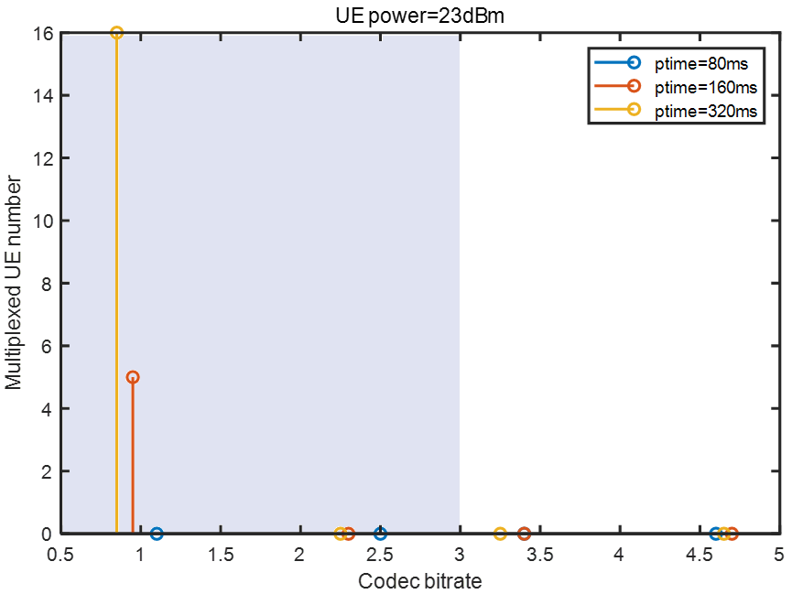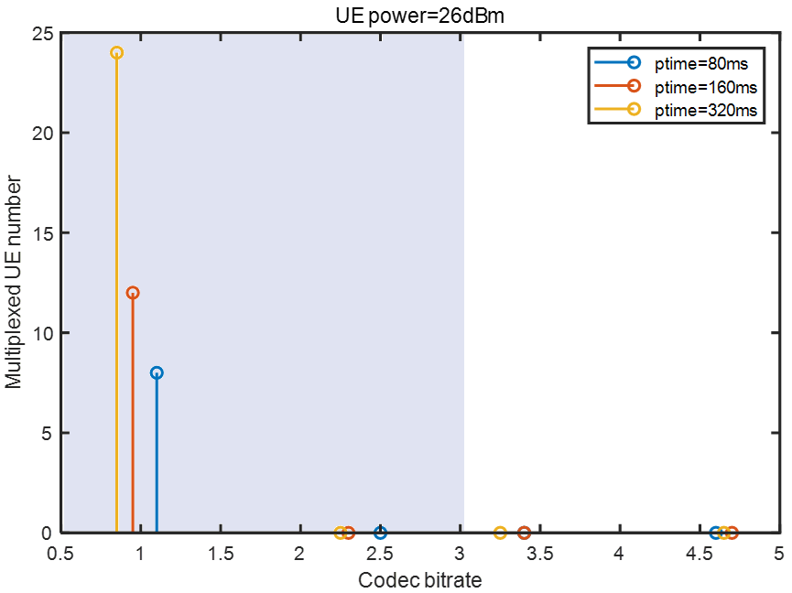

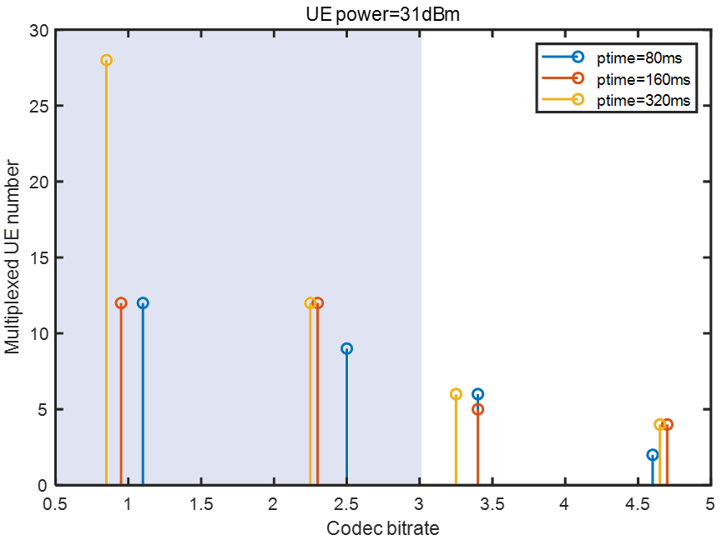

Figure 3 Multiplexed UE number for different codec bitrate on different UE power (23dBm, 26dBm and 31dBm) in 10-degree elevation channel model

Reference
[1] T/TAF 241.1—2024, "Technical requirements and test methods for mobile intelligent terminals supporting satellite communication— Part 1: Multi-mode Tiantong satellite terminal". https://www.taf.org.cn/StdDetail.aspx?uid=4baed0fd-88ac-48c2-811b-cec30a22ec59&stdType=TAF (Chinese Stardand)
[2] TR 26.940, "Study on Ultra Low Bitrate Speech Codecs".

