3GPP TSG SA WG4#135 S4-260158
Goa, India, 9 – 13 February 2026 Reversion of S4-251793

Source: vivo Mobile Communication Co.,
Title: [FS_ULBC] Analysis of AI Codec Complexity Scaling
Spec: 3GPP TR 26.940 v0.4.0
Agenda item: 7.8
Document for: Discussion/Agreement

1. Introduction
For the standardization of the new ULBC codec [1], establishing a relevant method for evaluating complexity is essential. Previous contributions (e.g., S4aA250264 [2]) have highlighted the potential gap between theoretical complexity metrics (e.g., FLOPs) and practical, on-device performance (e.g., Real-Time Factor).
A complementary aspect to this discussion is understanding how these complexity metrics scale, not just with frame size, but with the AI model's architecture itself. As AI-based codecs may be proposed with different model sizes or "operating points" (e.g., trading off quality for complexity), it is crucial to understand the relationship between model architecture, theoretical complexity, and traditional metrics.
To investigate this, this contribution provides a complexity analysis of a publicly available AI codec (DAC [3]), where different "dummy" variants of the model were created by scaling the model's internal latent dimensions (DAC.encoder_dim and DAC.decoder_dim). The analysis maps the relationship between model parameters, theoretical FLOPs, and traditional WMOPS, providing data to help inform the setting of a reasonable complexity constraint framework.

2. Analysis of AI Codec Complexity Scaling
To understand how complexity scales with model architecture, we analyzed several variants of the open-source DAC codec [3].

2.1. Methodology
Instead of using a single pre-trained model, we created seven "dummy" model variants based on the 16kHz configuration from the codec's open-source repository. This base configuration (16khz.yml) defines the core architecture, including:
# Model setup
DAC.sample_rate: 16000
DAC.encoder_dim: 64
DAC.encoder_rates: [2, 4, 5, 8]
DAC.decoder_dim: 1536
DAC.decoder_rates: [8, 5, 4, 2]
For all "dummy" variants, only the encoder_dim and decoder_dim were modified. The encoder and decoder rates (strides) were kept constant across all tests. This ensures all variants have the same total up/down-sampling factor (2 * 4 * 5 * 8 = 8 * 5 * 4 * 2 = 320) and thus the same minimum required frame size. For a 16kHz sample rate, this corresponds to a 20ms (320 samples) frame, which was used for all analysis.
This was achieved by modifying the core architectural parameters, specifically the encoder latent dimension (encoder_dim) and the decoder latent dimension (decoder_dim). These dimensions were scaled together in a bundled setup, creating specific encoder-decoder pairings (e.g., enc8dec144, enc12dec288, enc16de384, enc24dec576, enc32dec768, enc40dec960, enc64dec1536) to represent a range of potential model configurations.
For each of these seven variants, we measured the following complexity metrics for a 16kHz, 20ms frame:
- Model Parameters (Millions): The total number of trainable parameters in the model.
- Theoretical Complexity (MFLOP counts per second, MFLOP/s): The computational load calculated using the thop [4] profiling library, which has already aligned between S4aA250264 [2] and S4aA250231 [5].
- WMOPS (Weighted Million Operations Per Second): The complexity measured using the traditional WMOPS methodology [6], calculated separately for the encoder and decoder.
- Note1: To perform this measurement, each AI model operation (e.g., convolution, activation) was first implemented in pure C. The source files were then annotated and compiled using the ITU-T STL wmc_tool [6] to generate the WMOPS figures.
- Note2: An example of the tool's output for the enc12dec288 (which means the encoder_dim is 12 and decoder_dim is 288 in the dummy setup) encoder component is shown below:
--- Complexity analysis [WMOPS] ---
#define FRAMES_PER_SECOND 50.0 // in wmc_auto.c
|------ SELF ------| |--- CUMULATIVE ---|
routine calls min max avg min max avg
--------------- ------ ------ ------ ------ ------ ------ ------
node__block_block_0_Conv[WMC_AUTO] 1.00 1.543 1.543 1.543 1.543 1.543 1.543
node_Sin_170[WMC_AUTO] 1.00 4.995 4.995 4.995 4.995 4.995 4.995
node_Pow_172[WMC_AUTO] 1.00 4.995 4.995 4.995 4.995 4.995 4.995
node_Add_174[WMC_AUTO] 1.00 0.387 0.387 0.387 0.387 0.387 0.387
node__block_block_1_block_block_0_block_block_1_Conv[WMC_AUTO] 1.00 16.354 16.354 16.354 16.354 16.354 16.354
……………………………………………………
node__block_block_4_block_block_4_Conv[WMC_AUTO] 1.00 22.167 22.167 22.167 22.167 22.167 22.167
node_Sin_518[WMC_AUTO] 1.00 0.288 0.288 0.288 0.288 0.288 0.288
node_Pow_520[WMC_AUTO] 1.00 0.288 0.288 0.288 0.288 0.288 0.288
node_Add_522[WMC_AUTO] 1.00 0.058 0.058 0.058 0.058 0.058 0.058
node__block_block_6_Conv[WMC_AUTO] 1.00 5.578 5.578 5.578 5.578 5.578 5.578
--------------- ------ ------ ------ ------
total 20.00 648.227 648.227 648.227

- Note3: The WMOPS metric is highly sensitive to the algorithmic efficiency of the C implementation style. Because the wmc_tool counts operations directly from the source code. A naive implementation of an AI operator (e.g., using unoptimized nested loops) will yield a significantly higher operation count than a code-optimized version, even if the logic is identical. Consequently, the reported values may vary by an order of magnitude depending on the optimization effort of source C code.

2.2. Complexity vs. Model Dimensions
The analysis reveals a clear, non-linear relationship between the model's latent dimensions and its resulting parameters and computational load. As the encoder_dim and decoder_dim are increased, the model parameters and MFLOP/s scale quadratically (or faster), not linearly.
This is visualized in Figure 1 (Parameters vs. Dimension) and Figure 2 (MFLOP/s vs. Dimension). These figures plot the component-wise complexity against its respective latent dimension. It is important to note that the points on the encoder (left) and decoder (right) plots are linked; each pair of points corresponds to one of the bundled setups (e.g., the enc8dec144 which means the encoder_dim is 8 and decoder_dim is144 in the dummy setup).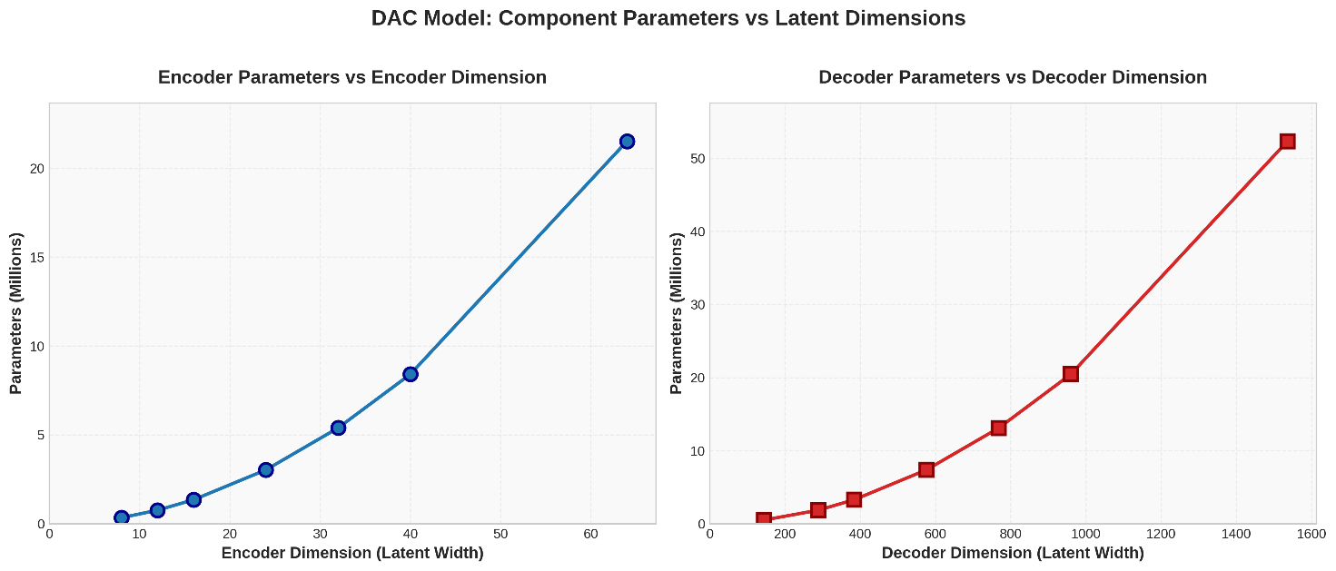
Figure 1: DAC Model Component Parameters vs. Latent Dimensions
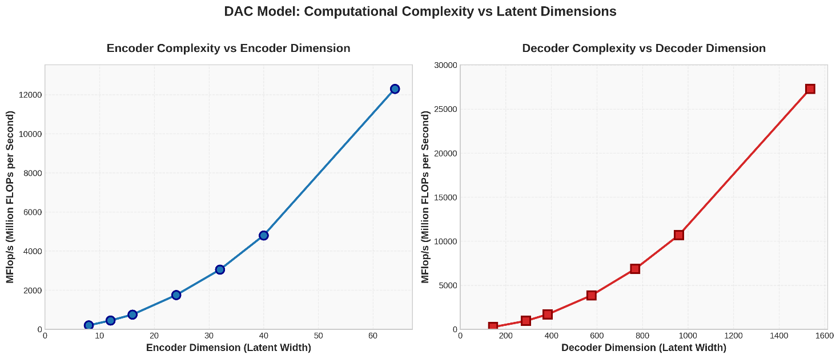
Figure 2: DAC Model Computational Complexity (MFLOP/s) vs. Latent Dimensions

2.3. WMOPS vs. Model Parameters
A key finding is the relationship between the AI model's size (in Millions of Parameters) and its complexity measured in traditional WMOPS. Figure 3 plots the measured Encoder WMOPS and Decoder WMOPS against the total model parameters for each of the seven variants.
Several observations on DAC model can be made from this data:
- There is a clear correlation between the number of model parameters and the resulting WMOPS, when using the same model architecture with the same C optimization level.
- The decoder's complexity (in WMOPS) scales significantly faster and is substantially higher than the encoder's complexity for all variants, which the DAC model arranges more parameters and complexity for decoder to get better re-constructed audio quality.
- The growth in WMOPS for both encoder and decoder appear to be linear relative to the increase in parameters.
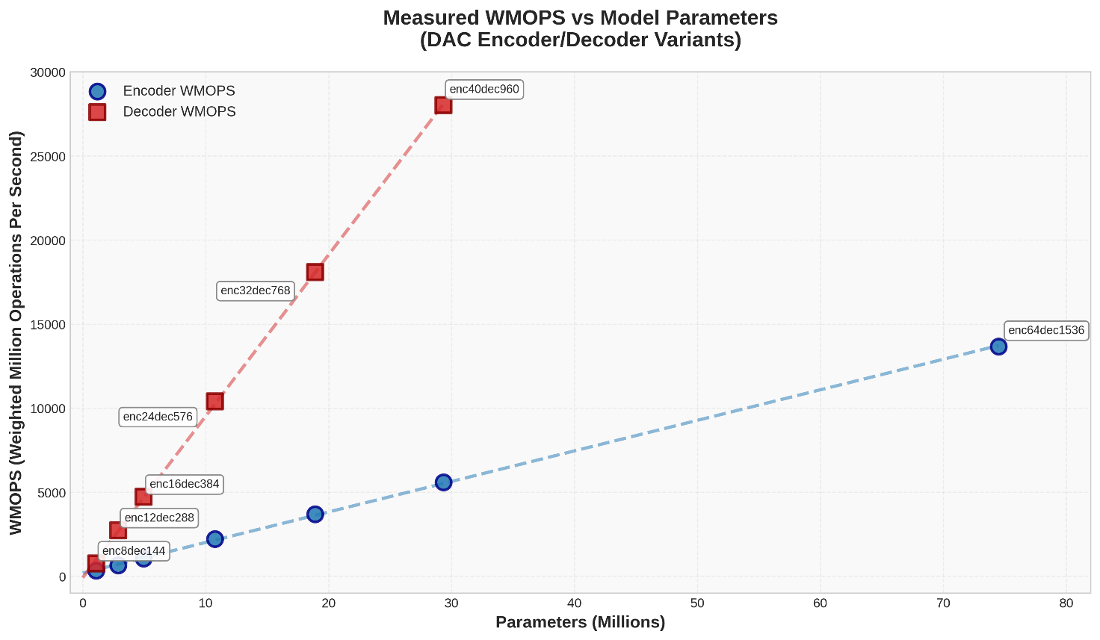
Figure 3: Measured WMOPS vs. Model Parameters (DAC Encoder/Decoder Variants)

2.4. Summary of Scaled Variants
Table 1 provides a summary of the complexity metrics for all seven analyzed DAC model variants. This data clearly shows the rapid scaling of all metrics as the encoder and decoder dimensions are increased.
Table 1: Complexity Metrics for Scaled DAC Model Variants (16kHz, 20ms frame)
Variant | Enc Dim | Dec Dim | Params (M) | GFLOP  counts | MFLOP/s | WMOPS Enc | WMOPS Dec
enc8dec144 | 8 | 144 | 1.09 | 0.009 | 437.09 | 333.92 | 760.53
enc12dec288 | 12 | 288 | 2.89 | 0.028 | 1397.63 | 648.23 | 2732.96
enc16dec384 | 16 | 384 | 4.94 | 0.050 | 2481.98 | 1060.79 | 4724.38
enc24dec576 | 24 | 576 | 10.76 | 0.112 | 5578.38 | 2228.92 | 10399.00
enc32dec768 | 32 | 768 | 18.90 | 0.198 | 9911.72 | 3693.56 | 18093.30
enc40dec960 | 40 | 960 | 29.34 | 0.310 | 15482.00 | 5599.48 | 28019.70
enc64dec1536 | 64 | 1536 | 74.50 | 0.792 | 39614.50 | 13675.30 | 70766.69

3. Observations and Conclusion
Based on the analysis of the DAC model variants, we observe the following :
- For the DAC model, there is a clear linear relationship between Theoretical Complexity (MFLOP/s), Model Parameters, and the measured WMOPS. As the MFLOP/s or parameter count increases, the WMOPS value increases linearly, provided the C coding style remains consistent.
- Increasing the model's internal dimensions causes complexity to grow quadratically. Even small increases in dimensions lead to disproportionately large jumps in MFLOP/s and WMOPS.
- The WMOPS score depends heavily on source C code efficiency.

4 Proposal
It is proposed to capture the above analysis into PDoc.

Reference
[1] SP-250378, "New SID on Ultra Low Bitrate Speech Codec".
[2] S4aA250264, "[FS_ULBC] Considerations on measuring ULBC complexity ".
[3] Descript, Inc., "Descript Audio Codec (DAC)," Version 0.0.1, Feb. 2023. [Online]. Available: https://github.com/descriptinc/descript-audio-codec
[4] Lyken, "pytorch-OpCounter." GitHub, 2018. [Online]. Available: https://github.com/Lyken17/pytorch-OpCounter.
[5] S4aA25023, "On complexity measurement for ULBC"
[6] WMC tool, Voice Age, [Online]. Available: https://github.com/malenov/STL/tree/dev/src/wmc_tool

