3GPP TSG-SA4 Meeting #134 S4-251971

Dallas, United States, 17th Nov 2025 - 21st Nov 2025
CR-Form-v12.4
CHANGE REQUEST
 | 26.260 | CR | 0008 | rev | - | Current version: | 19.0.0
For HELP on using this form: comprehensive instructions can be found at
https://www.3gpp.org/Change-Requests.

Proposed change affects: | UICC apps |  | ME | x | Radio Access Network |  | Core Network

Title: | New test methods for immersive UEs
Source to WG: | HEAD acoustics GmbH
Source to TSG: | S4
Work item code: | ATIAS_Ph2 |  |  |  |  |  | Date: |  |  | 2025-11-18
Category: | B |  |  |  |  |  | Release: |  |  | Rel-19
 | Use one of the following categories:  F (correction)  A (mirror corresponding to a change in an earlier release)  B (addition of feature),  C (functional modification of feature)  D (editorial modification)  Detailed explanations of the above categories can  be found in 3GPP TR 21.900. |  |  |  |  |  |  |  | Use one of the following releases:  Rel-8 (Release 8)  Rel-9 (Release 9)  Rel-10 (Release 10)  Rel-11 (Release 11)  …  Rel-17 (Release 17)  Rel-18 (Release 18)  Rel-19 (Release 19)  Rel-20 (Release 20)
Reason for change: |  | New test methods are required
Summary of change:
Consequences if not approved: |  | New test methods for performance evaluation of immersive UEs are not available.
Clauses affected: |  | …
 |  | Y | N
Other specs |  |  | x | Other core specifications |  |  |  | TS/TR ... CR ...
affected: |  | x |  | Test specifications |  |  |  | TS/TR 26.261 CR 002
(show related CRs) |  |  | x | O&M Specifications |  |  |  | TS/TR ... CR ...
Other comments:
This CR's revision history:

==============First change==============

Introduction
Audio is a key component of an immersive multimedia experience and 3GPP systems are expected to deliver immersive audio with a high Quality of Experience. However, industry agreed methods to assess the Quality of Experience for immersive audio are relatively few and the present document seeks to address this gap by providing objective test methods for the assessment of immersive audio.

1 Scope
The present document specifies objective test methodologies for 3GPP immersive audio systems including channel based, object based, scene-based, parametric and hybrids of these formats. The objective evaluation methods described in the present document are applicable to audio capture, coding, transmission and rendering as indicated in their corresponding clauses. They also include testing of IVAS-based UEs [26].

2 References
The following documents contain provisions which, through reference in this text, constitute provisions of the present document.
- References are either specific (identified by date of publication, edition number, version number, etc.) or non-specific.
- For a specific reference, subsequent revisions do not apply.
- For a non-specific reference, the latest version applies. In the case of a reference to a 3GPP document (including a GSM document), a non-specific reference implicitly refers to the latest version of that document in the same Release as the present document.
[1] 3GPP TR 21.905: "Vocabulary for 3GPP Specifications".
[2] J. Fliege und U. Maier: "A two-stage approach for computing cubature formulae for the sphere," Dortmund University, 1999.
[3] ISO 3745 - Annex A: "Acoustics - Determination of sound power levels and sound energy levels of noise sources using sound pressure -- Precision methods for anechoic rooms and hemi-anechoic rooms - Annex A: General procedures for qualification of anechoic and hemi-anechoic rooms".
[4] ISO/R 1996-1972: "Acoustics – Assessment of noise with respect to community response".
[5] ANSI S1.4: "Specifications for Sound Level Meters".
[6] ISO 3: "Preferred numbers – Series of preferred numbers".
[7] B. Rafaely, “Analysis and design of spherical microphone arrays,” IEEE Transactions on Speech and Audio Processing, no. 13, 2005, pp. 135 – 143
[8] M. Poletti, “Unified Description of Ambisonics Using Real and Complex Spherical Harmonics,” Ambisonics Symposium 2009, June 25-27, 2009, Graz, Austria.
[9] Recommendation ITU-T G.100.1 (06/2015): "The use of the decibel and of relative levels in speechband telecommunications".
[10] Recommendation ITU-T P.56 (12/2011): "Objective measurement of active speech level".
[11] Recommendation ITU-T P.57 (06/2021): "Artificial ears".
[12] Recommendation ITU-T P.58 (03/2023): "Head and torso simulator for telephonometry".
[13] Recommendation ITU-T P.79 (11/2007): "Calculation of loudness ratings for telephone sets".
[14] Recommendation ITU-T P.501 (05/2020): "Test signals for use in telephonometry".
[15] Recommendation ITU-T P.581 (07/2022): "Use of head and torso simulator for hands-free and handset terminal testing".
[16] Recommendation ITU-T P.340 (05/2000): "Transmission characteristics and speech quality parameters of hands-free terminals".
[17] Recommendation ITU-T P.341 (03/2011): "Transmission characteristics for wideband digital loudspeaking and hands-free telephony terminals".
[18] Recommendation ITU-T P.380 (07/2022): "Electro-acoustic measurements on headsets".
[19] Recommendation ITU-T P.381 (03/2023): "Technical requirements and test methods for analogue wired headsets or headphones and corresponding universal interface of terminals".
[20] Recommendation ITU-T P.382 (03/2023): "Technical requirements and test methods for analogue wired multi-microphone headsets or headphones and corresponding universal interface of terminals".
[21] Recommendation ITU-T P.383 (03/2023): "Technical requirements and test methods for digital headsets or headphones and corresponding interfaces of terminals".
[22] Recommendation ITU-T P.700 (06/2021): "Calculation of loudness for speech communication".
[23] Recommendation ITU-R BS.1770-5 (11/2023): "Algorithms to measure audio programme loudness and true-peak audio level".
[24] IEC 60268-1:1985: "Sound system equipment. Part 1: General".
[25] IEC 61260-1:2014: "Electroacoustics - Octave-band and fractional-octave-band filters - Part 1: Specifications".
[26] 3GPP TS 26.131: "Speech and video telephony terminal acoustic test specification".
[27] 3GPP TS 26.132: "Speech and video telephony terminal acoustic test specification".
[28] 3GPP TS 26.250: "Codec for Immersive Voice and Audio Services - General overview".
[29] 3GPP TS 26.253: " Codec for Immersive Voice and Audio Services; Detailed Algorithmic Description incl. RTP payload format and SDP parameter definitions".
[30] 3GPP TS 26.254: "Codec for Immersive Voice and Audio Services - Rendering".
[31] 3GPP TS 26.258: "Codec for Immersive Voice and Audio Services; C code (floating-point)".
[32] ETSI TS 103 224: "A sound field reproduction method for terminal testing including a background noise database", 11/2025.
[33] USB Implementors' Forum: "HID Usage Tables for USB", Version 1.5.
[34] H. Wittek and G. Theile: "The recording angle – based on localisation curves", proceedings of the 112th AES convention, Munich, 2002.
[35] Recommendation ITU-T G.122 (03/1993): "Influence of national systems on stability and talker echo in international connections".
[36] ETSI ES 202 396-1: "Speech quality performance in the presence of background noise; Part 1: Background noise simulation technique and background noise database", 2025-11.
[37] IEC 61672-1: "Electroacoustics - Sound level meters - Part 1: Specifications".
[38] M. Kentgens, M. Bárány, A. Hallmann, C. Nelke, “Head-Tracked Spatial Audio: What is the Motion-to-Sound Latency of your Device?”, AES International Conference on Headphone Technology, Espoo, Finland, August 2025.

3 Definitions, symbols and abbreviations

3.1 Definitions
For the purposes of the present document, the terms and definitions given in 3GPP TR 21.905 [1] and the following apply. A term defined in the present document takes precedence over the definition of the same term, if any, in 3GPP TR 21.905 [1].
spherical coordinates: A coordinate system with x-axis pointing to the front, y-axis to the left and z-axis to the top, with the distance $r$ from the origin, the azimuth $ϕ$ in mathematical positive orientation (counter-clockwise) and the elevation angle $θ$ relative to the z-axis (with 0 degrees pointing to the equator and +90 degrees pointing to the North pole). See Figure 0.

Figure 0: Spherical coordinate system
Coded Formats: The format represented in the IVAS coded frames, which is generally the input format to the encoder.
User Capture: A use case where the user's voice is the primary intended signal to be captured by the UE.
Spatial Capture: A use case where acoustic scenes that include directional and/or diffuse sound sources are intended to be captured by the UE.
Stereo Panorama: the spatial image of a stereo signal, in which the sound source directions lie in a range from -100% (left) to 100% (right).
Half-circular planar capture: A spatial capture capability providing differentiation of source azimuth directions between -90° and 90° in the 0° elevation plane.
Full-circular planar capture: A spatial capture capability providing differentiation of source azimuth directions between -180° and 180° in the 0° elevation plane.
3D spherical capture: A spatial capture capability that is an extension of Full-circular planar capture and that additionally provides differentiation of sources at different elevation angles.
Noise suppression mode: applied noise suppression setting by the UE.
Maximum noise suppression mode: noise suppression setting that applies most noise suppression available to the UE
Default noise suppression mode: noise suppression setting that applies default noise suppression available to the UE and that is typically less than the Maximum and greater than the Minimum setting available to the UE.
Minimum noise suppression mode: noise suppression setting that applies least noise suppression available to the UE.
Disabled noise suppression mode: noise suppression setting that disables noise suppression in the UE.

3.2 Symbols
For the purposes of the present document, the following symbols apply:
(A) A-weighting
dB Decibel
dBFS Digital level in dB, where 0 dBFS refers to the RMS level of a DC-free sinusoidal signal exercising the full scale of the digital interface/file.
dBm0 Digital overload point in dB
dBov Digital level in dB, where 0 dBov refers to the RMS level of a DC-free rectangular signal exercising the full scale of the digital interface/file.
dBPa Sound pressure level in dB, referenced to 1 Pa
dBSPL Sound pressure level in dB, referenced to 2E-5 Pa
dBV Voltage level in dB, referenced to 1 V
f Frequency (in Hertz)
Hz Unit of frequency (Hertz)
$G\left(f\right)$ Frequency response of measured versus reference signal
LA_{eq} Sound level in dB equivalent to the total A-weighted sound energy measured over a stated period of time.
L_{eq} Sound level in dB equivalent to the unweighted sound energy measured over a stated period of time.
Ω Electrical resistance in Ohm
$\hat{P}\left(f\right)$ Spectral magnitude of measured signal
$P_{ref}\left(f\right)$ Spectral magnitude of reference signal
${\hat{P}}_{k}\left(f\right)$ Spectral magnitude of measured signal (k-th channel)
${\hat{P}}_{l}^{m}\left(f\right)$ Spectral magnitude of measured Ambisonics degree l and index m.
Pa Unit of pressure (Pascal)
ϕ Azimuth angle (phi)
r Distance from a point in space to the origin of the spherical coordinate system (radius of sphere)
RCV Receiving (direction)
SND Sending (direction)
θ Elevation angle (theta)
T_{R} UE delay in receiving direction
T_{TER} Test equipment delay in receiving direction
T_{S} UE delay in sending direction
T_{TES} Test equipment delay in sending direction
V Unit of voltage (Volt)
$ζ\left(ϕ\right)$ Estimate for a single source direction in the stereo panorama that is physically positioned in direction $ϕ$ relative to the capturing device

3.3 Abbreviations
For the purposes of the present document, the abbreviations given in 3GPP TR 21.905 [1] and the following apply. An abbreviation defined in the present document takes precedence over the definition of the same abbreviation, if any, in 3GPP TR 21.905 [1].
EXT External output
FOA First-Order Ambisonics
HATS Head-And-Torso Simulator
HFRP Hands-free Reference Point
HID Human Interface Device
HOA2 Higher-Order Ambisonics (2nd order)
HOA3 Higher-Order Ambisonics (3rd order)
HRP HATS Reference Point
ILD Interaural Level Difference
ISM Independent Stream with Metadata
ITD Interaural Time Difference
IVAS Immersive Voice and Audio Services
ISAR Immersive Audio for Split Rendering Scenarios
LKFS Loudness, K-weighted, relative to Full Scale
MASA Metadata-Assisted Spatial Audio
MRP Mouth Reference Point
N3D Normalization (full) 3-Dimensional (of an Ambisonics signal)
NR Noise Rating
OMASA Objects (ISM) with Metadata-Assisted Spatial Audio
OSBA Objects (ISM) with Scene-Based Audio
RLL Receive Loudness Level
RLR Receive Loudness Rating
SBA Scene-Based Audio (Ambisonics)
SLR Send Loudness Rating
SN3D Schmidt Normalization (semi) 3-Dimensional (of an Ambisonics signal)
SR Split Rendering
SS System Simulator
TC Transport Channel (for MASA)
THD Total Harmonic Distortion
USB Universal Serial Bus

4 Objective Test Methodologies for Immersive Audio Systems

4.0 General

4.0.1 Applicability
This clause describes general objective test methodologies for immersive audio systems. For testing IVAS-based devices, refer to clause 5.

4.0.2 Test equipment
Unless specified otherwise, the accuracy of electric and acoustic measurements made by test equipment shall meet the requirements defined in clause 5.3 of 3GPP TS 26.132 [27].
For tests with head tracking, HATS rotation around the axis of rotation (yaw axis) should be realized using a HATS with motorized head rotation or comparable equipment consisting of P.57-compliant artificial ears mounted on a turntable or swivel apparatus (denoted as "motorized HATS" in the following clauses). For dynamic head-tracking measurements, the equipment is subject to angular velocity and noise emission requirements as specified in the respective test directives. Moreover, dynamic head-tracking measurements require the equipment to provide some kind of sensing mechanism for tracking orientation over time. For motorized or manual rotations of HATS and/or UE, error in orientation (elevation and azimuth) shall not exceed ±2°.
Requirements on the motorized HATS self-noise are defined for the continuous and repeated left-right/right-left movement as specified in step 4 of clause 5.7.5.4. The averaged noise spectrum of each (left and right) ear signal measured with an open ear-canal (without device mounted) shall not exceed the following limits:
- 30°dBSPL for frequencies greater than 100 Hz
- 10 dBSPL for frequencies greater than 1500 Hz
NOTE 1: A motorized rotation of HATS and/or UE is recommended. Some UEs may not have a natural reference orientation (which, for instance, may be defined by the direction of a screen). In this case, the UE may reset the reference direction automatically after a span of time, e.g., to the current device orientation. This should be taken care of during the measurement. The measurement with the rotated HATS and/or UE should be performed quickly enough to prevent the reference direction from being spuriously readjusted. Therefore, it benefits from automation.
NOTE 2: Dynamic head-tracking measurements mimic the behaviour of typical human head rotation. Angular rotation velocities and noise emission limits are required that may not be met by standard turntables.
Head-and-torso simulators (HATS) used for acoustic testing are specified in ITU-T Recommendation P.58 [12], corresponding artificial ears for testing in receiving direction are specified in ITU-T Recommendation P.57 [11] (Type 3.3 or Type 4).
NOTE 3: For testing insert-type earphones (one of the Headset UE types) in receiving direction, a Type 4 artificial ear is recommended.
In sending direction, HATS equipped with mouth simulators (or equivalent stand-alone mouth simulator) used as a single sound source for spatial or user capture (see clause 5.4.1) in the test arrangement shall comply with ITU-T P.58 [12] and ITU-T P.581 [15]. An artificial mouth of a HATS can be replaced with an equivalent stand-alone mouth simulator, unless:
- the UE is tested in receiving direction (artificial ears are required), or
- headset UE or handset UE is tested (HATS is necessary to mount the UE).
Unless otherwise specified, active loudspeakers (or passive loudspeakers with an amplification system) used in this specification shall meet the following requirements:
- The spectrum of the acoustic signal produced by the loudspeaker shall be equalized under free field conditions with a measurement microphone positioned on the main loudspeaker axis at 1 m from the loudspeaker membrane. The achieved equalized spectrum in 1/3rd octave bands, when measured in the test environment, shall be within ±1 dB from 100 Hz to 200 Hz and shall be within ±0.5 dB from 200 Hz to 20 kHz.
- THD ≤ [0.5 %] when measured at 1 m on axis with an 85 dBSPL sinusoidal signal for frequencies ≥ 100 Hz
- THD ≤ [2%] when measured at 1 m on axis with an 85 dBSPL sinusoidal signal for frequencies ≥ 50 Hz and < 100 Hz.
- Maximum long-term level ≥ 96 dBSPL when measured at 1 m on axis with the simulated programme signal defined in clause 7 of IEC 60268-1 [24].
- A self-generated noise level ≤ [5 dBSPL(A)], when measured at 1 m on axis in a free-field environment.
NOTE 4: For certain tests, e.g., when measuring the self-generated noise of the UE, the loudspeakers may need to be disabled to prevent their self-generated noise from impacting the results.

4.0.3 Test environment acoustic properties
The test environment (anechoic chamber) shall contain a free-field volume, wherein free-field sound propagation conditions shall be observed. The free-field sound propagation conditions shall be observed down to a frequency of 200 Hz. Qualification or verification of this requirement can be conducted using the methods and limits for deviation from ideal free-field conditions as specified in ISO 3745 [3] or ITU-T P.340 [16].
For testing headset UE in receiving direction, the test environment according to clause 6.1 of ETSI TS 103 224 [32] may be used.
NOTE: The usage of the test environment according to ETSI TS 103 224 for other UE types and use cases is for further study.
The equivalent continuous sound level of the test environment in each 1/3rd octave band, L_{eq}(f) shall be less than the limits of the NR15 curve and should be less than the limits of the NR10 curve, when following the noise rating (NR) determination procedures in [4].

4.1 Objective Test Methodologies for Assessment of Immersive Audio Systems in the Sending Direction

4.1.1 Diffuse-field Send Frequency Response for Scene-based Audio

4.1.1.1 Introduction
This test is applicable to UEs capturing scene-based audio (e.g. First and Higher Order Ambisonics).
NOTE: Currently, the test method uses a periphonic loudspeaker array for generation of a diffuse soundfield. Additional loudspeaker setups for the derivation of the diffuse sound field are under consideration.
The test environment acoustic properties shall meet the requirements in clause 4.0.3.

4.1.1.2 Definition
The Diffuse-field Send Frequency Response for Scene-based Audio is defined as the transfer function, $G\left(f\right)$, between:
$\hat{P}\left(f\right)$, the estimated sound pressure magnitude spectrum obtained from a diffuse-field scene-based audio capture and reference synthesis at the geometric center of a free-field volume; and
$P\left(f\right)$, the sound pressure magnitude spectrum obtained from a diffuse-field microphone recording the same diffuse field at the origin of a spherical coordinate system.
Figure 1 describes a typical block diagram for the scene-based audio sending direction with measurement points when using a periphonic loudspeaker array.
Figure 1: Scene-based audio capture block diagram for sending direction measurements
Definition of Equivalent Spatial Domain
The equivalent spatial domain representation, w(t), of a N^{th} order Ambisonics soundfield representation c(t) is obtained by rendering c(t) to K virtual loudspeaker signals w_{j} (t), 1 ≤ j ≤ K, with K = (N+1)². The respective virtual loudspeaker positions are expressed by means of a spherical coordinate system, where each position lies on the unit sphere, i.e., a radius of 1. Hence, the positions can be equivalently expressed by order-dependent directions Ω_{j}^{(N)}=(θ_{j}^{(N)}, φ _{j}^{(N)}), 1 ≤ j ≤ K, where θ_{j}^{(N)} and φ _{j}^{(N)} denote the inclinations and azimuths, respectively. These directions are defined according to [2] and reproduced in Annex A for convenience.
The rendering of $c\left(t\right)$into the equivalent spatial domain can be formulated as a matrix multiplication:
w(t) = (Ψ^{(N,N)})⁻¹ ⋅c(t),
where (⋅)⁻¹ denotes the inversion.
The matrix Ψ^{(N,N)} of order N with respect to the order-dependent directions Ω_{j}^{(N)} is defined by:
Ψ^{(N,N)} := [S₁^{(N)} S₂^{(N)} … S_{K}^{(N)}],
with:
$S$_{j}^{(N)} := [S₀⁰(Ω_{j}^{(N)}) S₋₁⁻¹(Ω_{j}^{(N)}) S₋₁⁰(Ω_{j}^{(N)}) S₋₁¹(Ω_{j}^{(N)}) S₋₁¹(Ω_{j}^{(N)}) … S_{N}^{N}(Ω_{j}^{(N)})]^{T} ,
where S_{n}^{m}(⋅) represents the real valued spherical harmonics of the order n and degree m as defined in [8].
The matrix Ψ^{(N,N)} is invertible so that the HOA representation c(t) can be converted back from the equivalent spatial domain by:
c(t) = Ψ^{(N,N)}·w(t)

4.1.1.3 Test method with periphonic array

4.1.1.3.1 Test Conditions
Periphonic loudspeaker array
a) A periphonic loudspeaker array shall be placed within the free-field volume with the geometric center of the periphonic loudspeaker array coinciding with the geometric center of the free-field volume.
b) The periphonic loudspeaker array shall have a radius greater or equal than 1 meter.
c) The periphonic loudspeaker array shall be composed of (N+1)² coaxial loudspeaker elements. Each of the (N+1)² coaxial loudspeaker elements shall be equalized (if necessary) according to the requirements in Clause 4.0.2. N should be equal to 4.
d) The (N+1)² coaxial loudspeaker elements shall be positioned according to the azimuth and elevation coordinates given in Annex B.
e) All coaxial loudspeaker elements shall be oriented such that their acoustic axis intersects at the geometric center of the free field volume.
f) The radius of each coaxial loudspeaker element shall be such that, at the geometric center of the free-field volume, the far field approximation for the coaxial loudspeaker axial pressure amplitude decay holds true.
g) The active loudspeakers (or passive loudspeakers with an amplification system) should meet the requirements in Clause 4.0.2

4.1.1.3.2 Measurement
Reference Spectrum measurement for periphonic loudspeaker array method
a) A diffuse-field / random incidence, or multi-field microphone is mounted in the free-field volume such that the tip of the microphone corresponds to the geometric center of the free-field volume and the geometric center of the periphonic loudspeaker array.
NOTE 1: Diffuse-field / random incidence microphones, are described in [5].
b) (N+1)² decorrelated pink noise signals are played simultaneously over each of the (N+1)² coaxial loudspeakers of the periphonic loudspeaker array.
c) The playback level is adjusted such that the LAeq, measured over a 30s time window at the geometric center of the periphonic loudspeaker array, is equal to 78dBSPL(A) ± 0.5dB.
d) The reference sound pressure at the geometric center of the free-field volume, p(t), is captured with the diffuse-field or multi-field microphone.
e) The magnitude spectrum of the reference sound pressure, P(f), is calculated for the 1/12th octave intervals as given by the R40 series of preferred numbers in [6].
NOTE 2: For ideal (calibrated) loudspeakers, the P(f) spectra should have equal energy in each 1/12th octave intervals.
Estimated Spectrum measurement
a) The scene-based audio capture device under test is mounted in the free-field volume such that its geometric center coincides with the geometric center of free-field volume and the geometric center of the periphonic loudspeaker array.
b) (N+1)² decorrelated pink noise signals are played simultaneously over each of the (N+1)² coaxial loudspeakers of the periphonic loudspeaker array. The pink noise signals shall be identical to the signals used for the reference spectrum measurement.
c) The B-format scene-based audio format representation (compressed or uncompressed, depending on the use case being tested) is stored for offline analysis.
d) The B-format scene-based audio format representation is uncompressed (if necessary) and converted to an equivalent spatial domain representation of order N_{DUT} (B-Format to ESD conversion in Figure 1), where N_{DUT} corresponds to the Ambisonics order of the device under test.
e) $\hat{p}\left(t\right)$, the estimate of the sound field at the geometric center of the free-field volume and periphonic loudspeaker array, is synthesized using the equivalent spatial domain representation of order N_{DUT}.
NOTE 3: $\hat{p}\left(t\right)$ can be taken from the W component of the B-Format signal, as an alternative to implementing the B-Format to ESD conversion in step d).
f) The magnitude spectrum of the estimated sound pressure, $\hat{P}\left(f\right)$, is calculated for the 1/12th octave intervals as given by the R40 series of preferred numbers in [6].
Calculation of send frequency response for scene-based audio
The send frequency response for scene-based audio, G(f), is calculated as $G\left(f\right)=\frac{\hat{P}\left(f\right)}{P\left(f\right)}$.

4.1.1.4 Test method with loudspeaker array and turn table

4.1.1.4.1 Test Conditions
Loudspeaker array
a) A calibrated loudspeaker array shall be placed within the free-field volume.
b) The loudspeaker array shall comprise one or several semi-arcs having a radius greater or equal than 1 meter. The radius shall be reported.
c) The loudspeaker array shall be composed of N+1 loudspeaker elements. The ambisonic order N shall be reported.
d) Each loudspeaker in the array shall be calibrated with a frequency response of [at least 100 Hz-20,000 Hz] and minimum phase response.
e) The coordinates of the loudspeaker elements are defined according to a Gaussian spherical grid [7] of order N. Directions shall comply with Annex B.1 and the N+1 elevations of the spherical grid shall be reported.
Turn table
a) A turn table with a resolution of 0.5 degrees shall be used. The rotation axis of the turn table and the vertical axis of the semi-arcs shall be aligned The turn table shall be adjusted in height so that the device under test is positioned at the geometric center of the loudspeaker array.
b) For measurement, an azimuth step of 180/(N+1) degrees shall be used.

4.1.1.4.2 Measurement
Reference Spectrum measurement
a) A diffuse-field / random incidence, or multi-field microphone is mounted in the free-field volume such that the tip of the microphone corresponds to the geometric center of the free-field volume and the geometric center of the loudspeaker array.
NOTE 1: Diffuse-field / random incidence microphones, are described in [5].
Repeat steps b-c) with an azimuth angular resolution of 180/(N+1) degrees:
b) An exponential sweep sine signal is played over each of the N+1 loudspeakers of the loudspeaker array.
c) The impulse response at the geometric center of the loudspeaker array p(t) is measured for each loudspeaker position.
d) The magnitude spectrum of the reference sound pressure, P(f), is calculated for the 1/12th octave intervals as given by the R40 series of preferred numbers in [6].
NOTE 2: For ideal (calibrated) loudspeakers, the P(f) spectra should have equal energy in each 1/12th octave intervals.
Estimated Spectrum measurement
a) The scene-based audio capture device under test is mounted in the free-field volume such that its geometric center coincides with the geometric center of free-field volume and the geometric center of the loudspeaker array.
b) Repeat steps b-c) with an azimuth angular resolution of 180/(N+1) degrees:
c) An exponential sweep sine signal is played over each of the N+1 loudspeakers of the loudspeaker array. The sweep signals shall be identical to the signals used for the reference spectrum measurement.
d) The impulse response at the geometric center of the loudspeaker array p(t) is measured for each loudspeaker position.
e) The magnitude spectrum of the estimated sound pressure, $\hat{P}\left(f\right)$, is calculated for the 1/12th octave intervals as given by the R40 series of preferred numbers in [6].
Calculation of send frequency response for scene-based audio
The send frequency response for scene-based audio, G(f), is calculated as $G\left(f\right)=\frac{\hat{P}\left(f\right)}{P\left(f\right)}$.
Due to practical constraints (e.g. reflections on turn table), measurements for specific elevations (e.g. < - degrees) may be unreliable and discarded. In this case, the above measurement procedure may be conducted in two phases by measuring only directions for one hemisphere (e.g. top hemisphere, with elevations >0) in each phase. The device under test shall be flipped upside down between the two phases, and this two-phase approach shall be reported.

4.1.2 Directional response measurement for scene-based audio

4.1.2.1 Definition
The directional response for scene-based audio is defined as the transfer function, represented as an impulse response, h(θ_{i}, φ_{i}), between a device under test and a loudspeaker located at an equal distance r and L predefined directions, (θ_{i}, φ_{i}), i=1,...,L.

4.1.2.2 Test conditions
The test environment acoustic properties shall meet the requirements in clause 4.0.3.
Loudspeaker array
A loudspeaker array comprising L loudspeakers located at a set of predefined directions (θ_{i}, φ_{i}), i=1,...,L, from the geometric center of the loudspeaker array shall be used.

4.1.2.3 Measurement
For each loudspeaker position (θ_{i}, φ_{i}), i=1,...,L , the following procedure shall be used:
a) An exponential sweep sine test signal is played over the loudspeaker.
NOTE: The impact of codec on the exponential sweep sine test signal needs to be verified before performing the measurements. An activation signal may be needed.
b) The impulse response h(θ_{i}, φ_{i}) at the geometric center of the loudspeaker array is measured.

4.2 Objective Test Methodologies for Assessment of Immersive Audio Systems in the Receiving Direction

4.2.1 Headset Binaural Diffuse-field Receive frequency response for Scene-based audio

4.2.1.1 Introduction
This test is applicable to UEs rendering scene-based audio (e.g. First and Higher Order Ambisonics) over a binaural headset.

4.2.1.2 Definition
The Headset Binaural Diffuse-field Receive Frequency Response for Scene-based Audio (for left and right ears) is defined as the transfer function, G_{L,R} (f), between:
a) P_{L,R}(f), the binaurally recorded sound pressure magnitude spectra, obtained when a diffuse field signal in the equivalent spatial domain representation, w(t), is played on the DUT; and
b) P_{ref L,R}(f), the reference sound pressure magnitude spectra, obtained by direct convolution of the diffuse field signal in the equivalent spatial domain representation, w(t) with its corresponding set of HRTFs.

4.2.1.3 Test Conditions
The test environment acoustic properties shall meet the requirements in clause 4.0.3.
The set of HRTFs used by the UE shall be documented and available to the test lab.

4.2.1.4 Measurement
Reference sound pressure magnitude spectra
The reference sound pressure magnitude spectra are derived offline. The reference sound pressure magnitude spectra for the left and right ears, P_{ref L,R} (f) is the frequency domain representation of the convolution between the set of equivalent spatial domain signals, w(t), with its corresponding set head related transfer functions h _{L,R}(t), for each direction j in an equivalent spatial domain of order N_{DUT ,} i.e.:
$$P_{ref L,R}\left(f\right)=F(\sum_{j=1}^{{(N_{DUT}+1)}^{2}}{w_{j}\left(t\right)*h_{j L,R}(t))}$$
The signals w_{j}(t), for 1 ≤ j ≤ (N_{DUT} +1)², are uncorrelated pink noise signals of 30s length.
Binaurally recorded sound pressure magnitude spectra
The binaurally recorded sound pressure magnitude spectra is obtained as follows:
a) The binaural headset is placed on a HATS.
b) The DUT shall be configured such that the set of HRTFs used for binaural rendering correspond to the HATS used for testing.
c) The DUT volume control (if any) is adjusted for its nominal setting.
d) The binaural time-domain signals are recorded with HATS.
e) The binaurally recorded sound pressure magnitude spectra, P_{L,R}(f) is obtained by taking the Fourier transform of the binaurally recorded time-domain signals.
Calculation of headset binaural diffuse-field receive frequency response for scene-based audio
The headset binaural diffuse-field frequency response for scene-based audio, G(f), is calculated for each supported Ambisonics order N_{DUT} as:
$$G\left(f\right)=\frac{P_{L,R} (f)}{P_{ref L,R} (f)}$$

4.2.2 Nominal System Sensitivity in Receive Direction for Channel-based audio

4.2.2.1 Introduction
This test is applicable to UEs rendering channel-based audio (e.g. 7.1.4) over a binaural headset.

4.2.2.2 Definition
The nominal system sensitivity in receive direction for channel-based audio is defined as the difference between the sound pressure level (in dBSPL(A)) produced by the DUT on HATS and the root mean square of the digital test signal (in dBFS).

4.2.2.3 Test Conditions
The test environment acoustic properties shall meet the requirements in clause 4.0.3.
The specific HATS used for the recording shall be described in the test report. The set of HRTFs used by the UE shall be documented and available to the test lab.

4.2.2.4 Measurement
For each audio channel supported by the DUT, a pink noise signal with -18 dBFS RMS level is played, with the signals played only one channel at a time.
The LAeq (in dBSPL(A)) is measured continuously for a period of 30 s for each of the left and right ears.
The sensitivity G_{i L,R} is expressed as the difference of the recorded sound pressure levels at the left and right ears and the root mean square digital level of the pink noise test signal, i.e. -18 dBFS.
$$G_{i L,R}={LA}_{eq}-18$$

4.2.3 Motion to Sound Latency in Dynamic Binaural Rendering Systems

4.2.3.1 Introduction
Motion to Sound latency is the time difference between the event of a change in head rotation and when the immersive audio signal is finally compensated for the head motion. The method in this specification is intended to verify that the overall motion-to-sound latency that a user experiences upon rotating their head is within acceptable limits.
The method allows full measurement of motion to sound, i.e. including both the latency of the head tracking sensor as well as the audio playback. This includes all components of a real setup and therefore contains all possible causes of additional latency that a user may experience.
The method also provides a latency value for the isolated audio processing of the binaural renderer without the aforementioned external hardware, assuming that the binaural renderer can process audio data as an audio processing plugin that can be evaluated in isolation.
NOTE: This method requires synchronized playback of two renderer instances and may not be suitable for the measurements of UEs where such synchronization is not possible.

4.2.3.2 Requirements
The following will be required:
Software:
- Audio processing software to run and record output of two renderers simultaneously
- Head tracker software
Hardware:
- Host machine for audio processing
- Head tracker hardware
- Stereo audio recording interface
- Stereo audio playback interface
- Mechanical setup to rotate the head tracking sensor in a precise and reproducible way
An exemplary hardware setup can be seen below in Figure 2, the method however can also be implemented using different systems under test and accompanying equipment:
Figure 2: Hardware Overview (Setup in Position 1 on the left, Position 2 on the right)
The audio processing environment uses two parallel signal chains, each containing its own instance of the same binaural renderer being tested. The test is concerned only with yaw angles, so values of pitch and roll should be set to zero at the beginning of the test and can be ignored thereafter.
Figure 3: Generic Audio Processing Environment
The initial conditions are that Rendering Chain 1 (RC1) has a static yaw head rotation angle of 0 degrees and RC2 uses the physical rotation of the head tracker to get its yaw value. A white noise signal is virtually placed directly in front of the listener (0 degrees azimuth, elevation), meaning that rotation of the arm directly affects how the white noise source is rendered.

4.2.3.3 Calibration
The first step is to calibrate the final position of the rotating arm (Position 2 / P2). The rotating arm is moved manually and requires only a limited range of motion - from some small rotation away from the table (Position 1 / P1), 20 to 30 degrees will be ample, through until contact with the table (P2). The arm should be placed at P2 and set up so that this position also corresponds to 0 degrees yaw.

4.2.3.4 Evaluation Environment
An object within the evaluation environment, e.g. using Max/MSP, should be created to set the value of yaw to exactly 0 degrees once the real value of yaw (received from the head tracker) is <0.2 degrees.
NOTE: This tolerance value was chosen to be as small as possible while ensuring that it does not bounce (dependent on the accuracy of the tracking system)
This object should be designed to latch to zero once the actual value is under the tolerance threshold, so that any small accidental rebound of the rotating arm does not affect the yaw angle fed to the renderer - it artificially remains at exactly 0, which is important to ensure that both rendering chains have exactly the same head rotation when the arm is in its final position (P2). The output from the evaluation environment is captured by the recording audio interface, which therefore includes any latency introduced by playback.

4.2.3.5 Data acquisition
A test run begins by starting to record on the recording audio interface. The rotating arm is set to Position 1, then the audio processing set running and starts feeding the input source to both renderer instances. A microphone is positioned near the contact point at the table. This mono room microphone will be recorded synchronously with the output from the evaluation environment, with its purpose being to log the point of contact of the arm with the table, which should be done with a good amount speed and vigour so that the microphone picks up a loud knock at the table. Shortly after this (one or two seconds for example), with the test run now complete, playback and recording can be stopped.
Some milliseconds after the collision, the latest yaw value detected by the tracking system will have been passed into the evaluation environment (t_{Tracking}). With the target yaw value now reached (latched to zero in Max), both rendering chains will have the identical values of head rotation and therefore, after some further short delay, the output of both renderer instances will be identical.

4.2.3.6 Data Analysis
The overall motion-to-sound latency (tM2S) is taken as the time from the moment of collision until the point at which the two output signals are identical.
To easily visually inspect when this point occurs, one output channel of one signal chain (e.g. RC1-left) is subtracted from the same output channel of the complementary signal chain (RC2-left).
NOTE 1: This could be done manually in audio editor software after processing, but this would require recording at least three channels synchronously (one from each renderer chain, and one of the room microphone). Instead, the subtraction of signals can be done within Max/MSP, meaning only the output of this operation (one channel) and the room microphone can conveniently be recorded with a stereo audio interface. In addition to the stereo WAVE file recorded by a separate audio application, the Max/MSP application also writes to a separate mono WAVE file once it detects that it is in the final tolerated yaw position (latched on). This mono WAVE contains only the subtracted signals as described above, from which the tMspProc time can also be measured.
Evaluation is performed offline in audio editor software. The tMspProc time is measured from the start of the file until the point at which consecutive zero samples begin. This value encompasses any motion-to-sound latency caused by the tested renderer chain as well as any other latency caused by Virtual Studio Technology (VST) plugin framework buffering. The tMspProc time shall be measured from the audio frame boundary at which the latched-on yaw value is activated and applied within that audio frame.
NOTE 2: Since the yaw rotation update rate of the tracker is typically in the range of a few milliseconds, there is a framing mismatch when compared to the audio framing, but this mismatch will not be incorporated in the tMspProc value but rather only in the tM2S measurement.
An example measurement of the tMspProc is displayed in Figure 4. For tM2S this is measured by selecting the duration between the visible collision peak in the microphone channel and the point at which the other channel reduces to silence. Figure 5 shows an example measurement for the motion-to-sound latency.
Figure 4: tMspProc latency measurement
Figure 5: Motion-to-sound (tM2S) latency measurement
In Figure 5 the room recording is on the top, subtracted renderer output is on the bottom. Marked region is the time passed since the arm hits the table (recorded knock) and when the subtracted binaural renderer output reaches silence.
NOTE 3: Unlike the tMspProc measurement, the tM2S measurement is taken from signals recorded from hardware audio interfaces, hence it is not possible to look for continuous silence since the resulting file will always contain some noise added by the digital-to-analog and analog-to-digital converters. For this reason, it is important to ensure a high signal-to-noise ratio in the signal provided to audio interfaces, to make it easier to inspect where the cancellation occurs.

5 Objective Test Methodologies for IVAS-based UEs

5.1 Overview
This clause adds objective test methodologies specific to IVAS-based UEs. It provides for testing of UEs on either an acoustical or an electrical interface. In case of acoustical interface testing, a HATS (head and torso simulator) is used for a realistic simulation of an average user. A motorized turntable, or a HATS with motorized head rotation, is used to test head-tracking behavior of the UE under test. In contrast to speech-based mono telephony, which typically aims to suppress the acoustical background noise, IVAS-based UEs may capture and/or reproduce spatial information of the acoustic scene.

5.2 Interface Definitions
UE testing is realized by connecting a terminal to a test system composed of a system simulator and a reference client. The system simulator simulates the access network, provides core network functionalities and a point of interconnection (POI). The reference client serves as the far-end communication endpoint at the POI and provides IVAS encoder, decoder and rendering functionalities. Test sequences are both captured and fed into the reference client for sending and receiving direction tests, as illustrated in Figure 6. Alternatively, IVAS encoding, decoding, and rendering can be part of the system simulator instead of the reference client. No further transcoding beyond linear PCM shall take place.
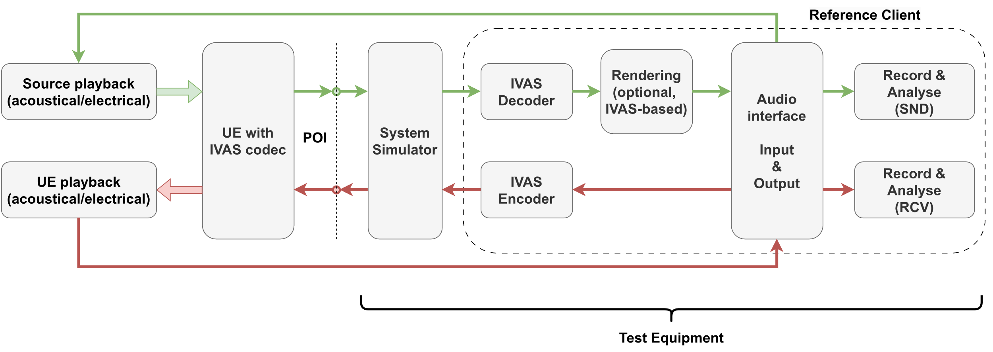
Figure 6: General test setup with UE and reference client
If any conversion from/to analogue signals are required by any component of the test equipment or for analysis purposes, an overload point of 3.14 dBm0 shall be used for all encoded or decoded signal channels (same definition as in 3GPP TS 26.132 [27] for mono signals). The relationship between levels measured in dBm0, dBV and dBov is described in clause 8 of ITU-T G.100.1 [9].
The details of the acoustical and electrical test setup as well as IVAS session parameters are UE-type-dependent and are given in the following clauses.

5.3 Test conditions

5.3.1 Test environment acoustic properties
The test environment acoustic properties shall meet the requirements in clause 4.0.3.

5.3.2 System simulator and reference client
The system simulator configuration and radio conditions on the air interface shall be as specified in clause 4.2 of 3GPP TS 26.132 [27]. Unless otherwise specified for the respective test, the system simulator shall provide an error-free radio connection to the UE under test.
The UE shall be connected to a system simulator and test equipment supporting the IVAS codec [28]. Unless specified otherwise, 48 kHz sampling rate and fullband mode shall be used.
Since UEs may provide different capabilities for sending (capture) and receiving (rendering) direction, a bidirectional communication may not be symmetric regarding IVAS Coded Formats, noise suppression modes and corresponding bitrates.
During negotiating and exchange of session parameters via Session Description Protocol (SDP), the UE advertises its Coded Formats in sending and receiving direction, as well as corresponding bitrate ranges. If supported by the UE, the UE advertises its initial noise suppression mode(s) for the session via ns-mode-init or ns-mode-init-send SDP parameter.
- The reference client shall advertise via SDP the IVAS audio format for testing sending and receiving direction along with corresponding bitrate as specified in Table 1 as the requested capabilities. The reference client shall select the noise suppression mode under test (see clause xxx), if applicable. The noise suppression mode shall not be changed during testing.
- For sending direction, the decoder in the reference client shall be configured for the EXT decoder output format, if not specified otherwise by any test method.
- For receiving direction, the encoder in the reference client shall be configured for the Coded Format envisioned for testing.
Table 1: Bitrates per audio format used for testing
Coded Format | Subformat | Bitrate for testing  (kbit/s) | Max. bitrate  (kbit/s)
Stereo | Stereo | 80 | 256
 | Binaural | 80 | 256
ISM | 1 | 80 | 128
 | 2 | 80 | 256
 | 3 | 80 | 384
 | 4 | 80 | 512
 | FOA | 80 | 512
SBA | HOA2 | 80 | 512
 | HOA3 | 80 | 512
MASA | 1 TC | 80 | 512
 | 2 TC | 80 | 512
OSBA |  | 80 | 512
OMASA |  | 80 | 512
Multichannel | 5.1 | 80 | 512
 | 7.1 | 80 | 512
 | 5.1.2 | 80 | 512
 | 5.1.4 | 80 | 512
 | 7.1.4 | 80 | 512

In a split rendering session (when split rendering coded format is negotiated during SDP negotiation as per TS 26 253 Annex A), during negotiating and exchange of session parameters via Session Description Protocol (SDP), the UE advertises its supported transport codec, degree of freedom as well as bitrate ranges in sending and receiving direction.
- The reference client shall advertise via SDP the transport codecs and degree of freedom for testing sending and receiving direction along with corresponding bitrate as specified in Table 1a as the preferred and only capabilities.
- For sending direction, the post-renderer in the reference client shall be configured for binaural output format
- For receiving direction, the pre-renderer in the reference client shall be configured for the SR Coded Format (as mentioned in Annex A of TS 26 253) envisioned for testing.
Table 1a: Bitrates per DoF used for ISAR testing
Transport codec | Dof | Bitrate for testing (kbit/s) | Max. bitrate (kbit/s)
LC3Plus | 3 | 512 | 512
LCLD | 0 | 256 | 512
LC3Plus | 3 | 512 | 512
LCLD | 0 | 256 | 512

NOTE 1: Void.
NOTE 2: The maximum bitrates listed in Table 1 and Table 1a are provided for information and may not be supported by all UEs.
NOTE 3: Other configurations of ISAR (see [28]) are for further study.

5.3.3 Test equipment
The same requirements as specified in clause 4.0.2 apply for IVAS-based testing.

5.4 Test arrangement

5.4.1 Capture modes
To simulate a single sound source, either a loudspeaker or a HATS equipped with an artificial mouth (or equivalent stand-alone mouth simulator) positioned relative to the UE at a certain angle/distance is used. Two different types of use cases are distinguished:
1) User capture, where the sound source is always a HATS equipped with an artificial mouth and typically only speech (or speech-like) test signals are used.
2) Spatial capture, where the sound source is one or more loudspeakers positioned around the UE. Unless otherwise specified, the default sound source direction (for single source tests) is located at 0° azimuth and 0° elevation.
Both capture modes are illustrated in Figure 7. The applicable capture mode is part of the test arrangement selection process, which is described in clause 5.4.2.1. Some test methods may only be applicable for one or the other capture mode.

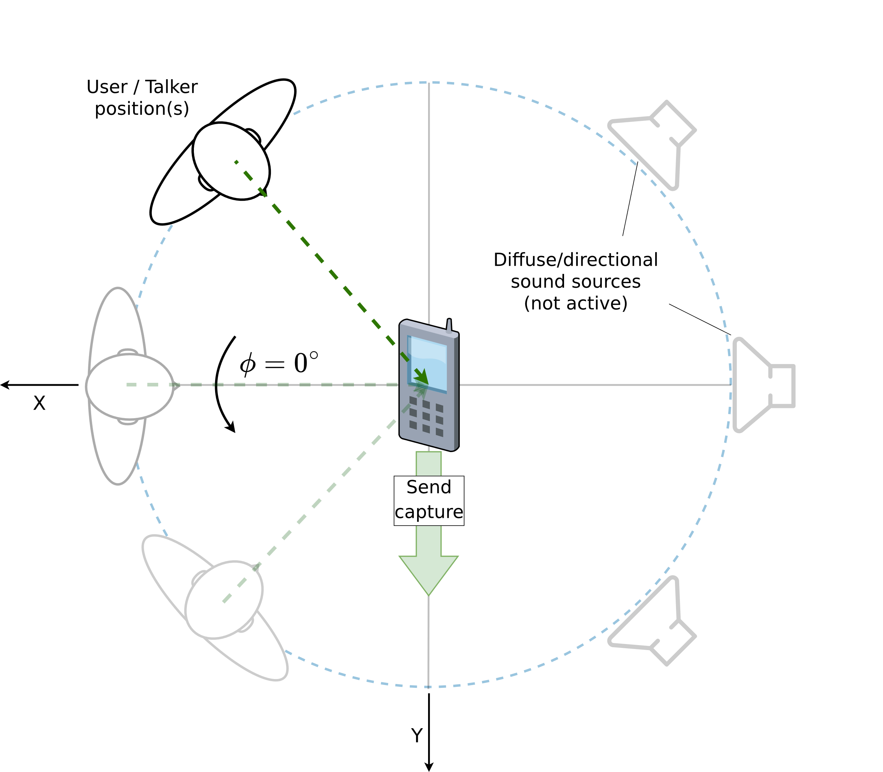 | 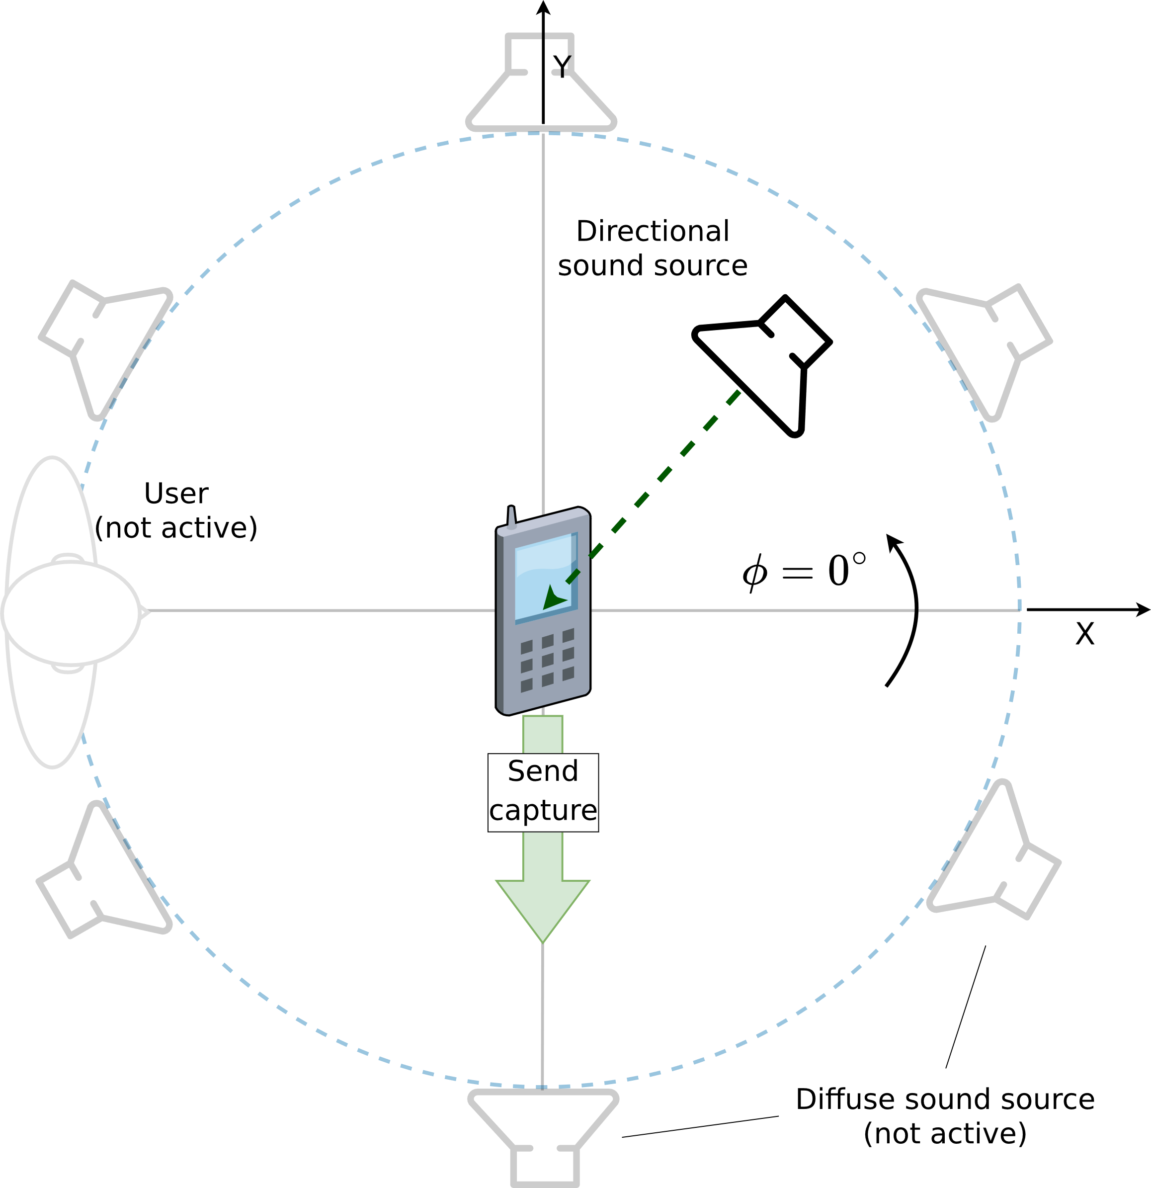
Figure 7: Device orientation and sound sources for User Capture (left) and Spatial Capture (right)
NOTE: Figure 7 is indicative and the illustrated example does not refer to any specific test arrangement or method. Diffuse sound fields for Spatial Capture are out of scope for IVAS-based UE testing in the present document.

5.4.2 UE types and positioning

5.4.2.1 Overview
An IVAS-enabled UE may support one or more UE types. Each UE type is composed of a SND-UE-type and a RCV-UE-type.
- The SND-UE-type is a combination of a certain audio capturing mode (which can be acoustic or electric) and a negotiated coded format (see clause 5.3.2).
- The RCV-UE-type is a combination of a negotiated coded format (see clause 5.3.2) and a certain audio playback mode (acoustic or electric).
- Each audio capturing/playback mode has a corresponding physical test arrangement.
NOTE 1: The definition of IVAS-enabled UE types is more complex than in 3GPP TS 26.132 [27]. Due to the variety of new applications that are enabled by the IVAS codec, the capture and playback Coded Formats and/or rendering configuration may not necessarily be the same in sending and receiving direction.
UEs may support multiple Coded Formats in sending and receiving direction, which are negotiated during call setup. At least one supported Coded Format shall be tested in all directions supported by the UE, which is selected according to the following priority:
1) Format specified by the manufacturer (if applicable).
2) Preference of the UE, as indicated during negotiation in SDP.
3) Test operator selects format based on form factor and envisioned use case of the UE.
The IVAS format for each tested direction shall be documented in the test report. Other available supported formats may be tested as well to ensure best-possible compatibility with other UE types.
Complementary to the well-defined IVAS formats, capturing/playback modes and corresponding interfaces are given in the following clauses along with several UE types, which may be applicable in SND and/or RCV. All UE types with acoustical interfaces assume that microphones and loudspeakers/headset of the UE are either integrated into the device or that necessary additional off-the-shelf equipment (like e.g., headset, microphone array, loudspeaker array) is either bundled with the device or explicitly recommended by the manufacturer.
If no acoustical interface is available, the electrical interface shall be tested and the test setup according to clause 5.4.2.7 applies.
NOTE 2: If testing at the electrical interface is not possible for important technical reasons (e.g., due to a non-standardized electrical interface), an acoustic test may be carried out with suitable third-party equipment, which is, e.g., recommended by the manufacturer. This allows to perform tests at an acoustic interface to informally assess the performance of the UE (without applying requirements).
The physical test arrangement used for UE testing in sending and receiving direction is in general specified by the manufacturer by:
- Referencing one of the following clauses (recommended),
- Referencing a test arrangement from other standards (e.g., ITU-T P.340 [16] or P.341 [17]),
- Specifying an individual test arrangement.
In case no instructions on the test arrangement are provided by the manufacturer, the test operator shall select one based on the envisioned use case, form factor, etc. from either one of the following clauses or from other standards. If no suitable test arrangement can be identified for certain UEs with acoustical interface, the test operator may set up an individual arrangement or modify an existing one. In any case, the arrangement used for testing shall be documented in the test report.
If not specified otherwise or explicitly excluded in the test description, all methods for sending and receiving direction are applicable for all UE types and all Codec Formats (see Table 1).

5.4.2.2 Handset UE
The EVS-compatible mono mode of IVAS shall be tested according to clause 9 of TS 26.132 [27]. Requirements according to clause 7 of 3GPP TS 26.131 [26] apply.
Immersive testing for handset UE is not included in the present document due to the following reasons:
- RCV: Monaural listening typically cannot provide any directional spatial information.
- SND: The device is typically located close to the user's head, which can limit the capture of spatial information.
NOTE: Immersive audio formats may also be applicable to handset UEs, for example, to capture ambient sound at the near end. However, so far, test methods are not specified for handset UE and are for further study.

5.4.2.3 Headset UE
The test setup for headset UE for sending and receiving directions is shown in Figure 8. It applies to all devices that provide a head-worn acoustical frontend. The acoustical frontend may either be internal or external to the UE device. In the latter case, it may be connected via wired or wireless link (e.g., analogue jack, Bluetooth, or USB).
The head-worn acoustical frontend may provide headtracking data through a wired or wireless link (see Figure 8), which can be used for rendering binaural audio in receiving direction.
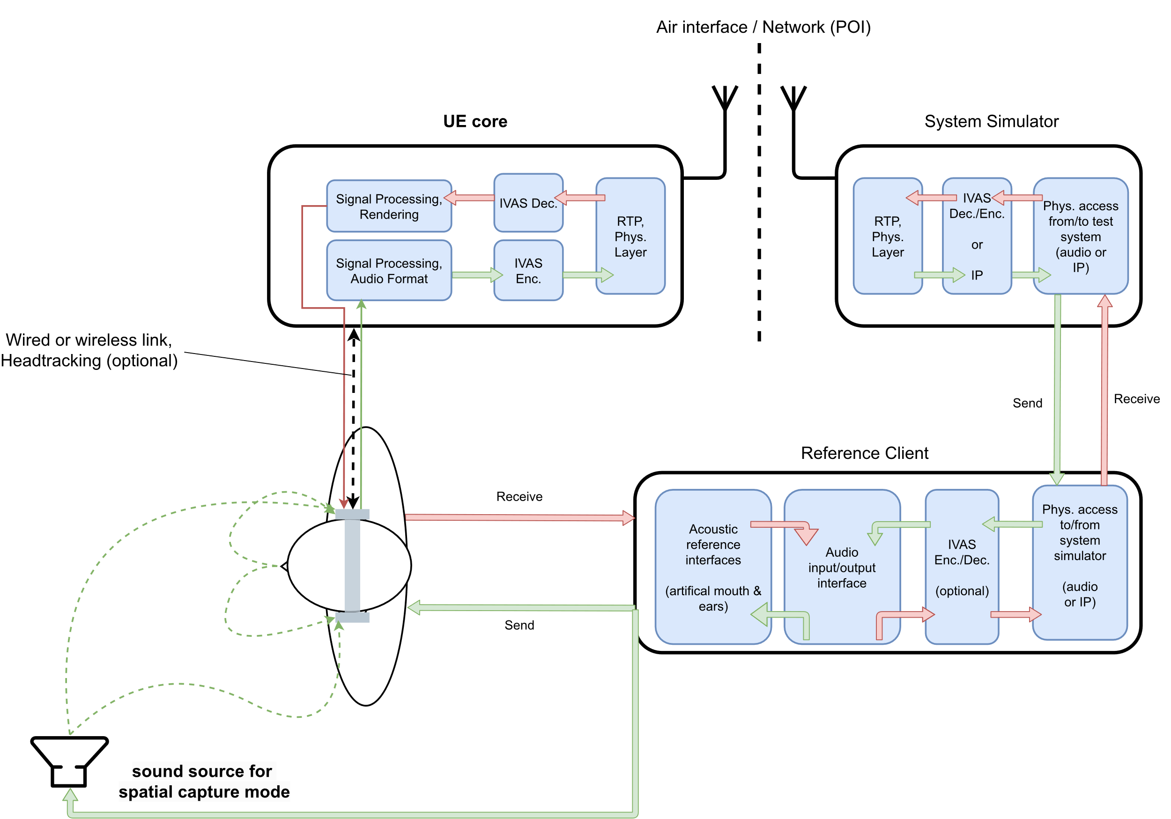
Figure 8: Headset UE and test equipment
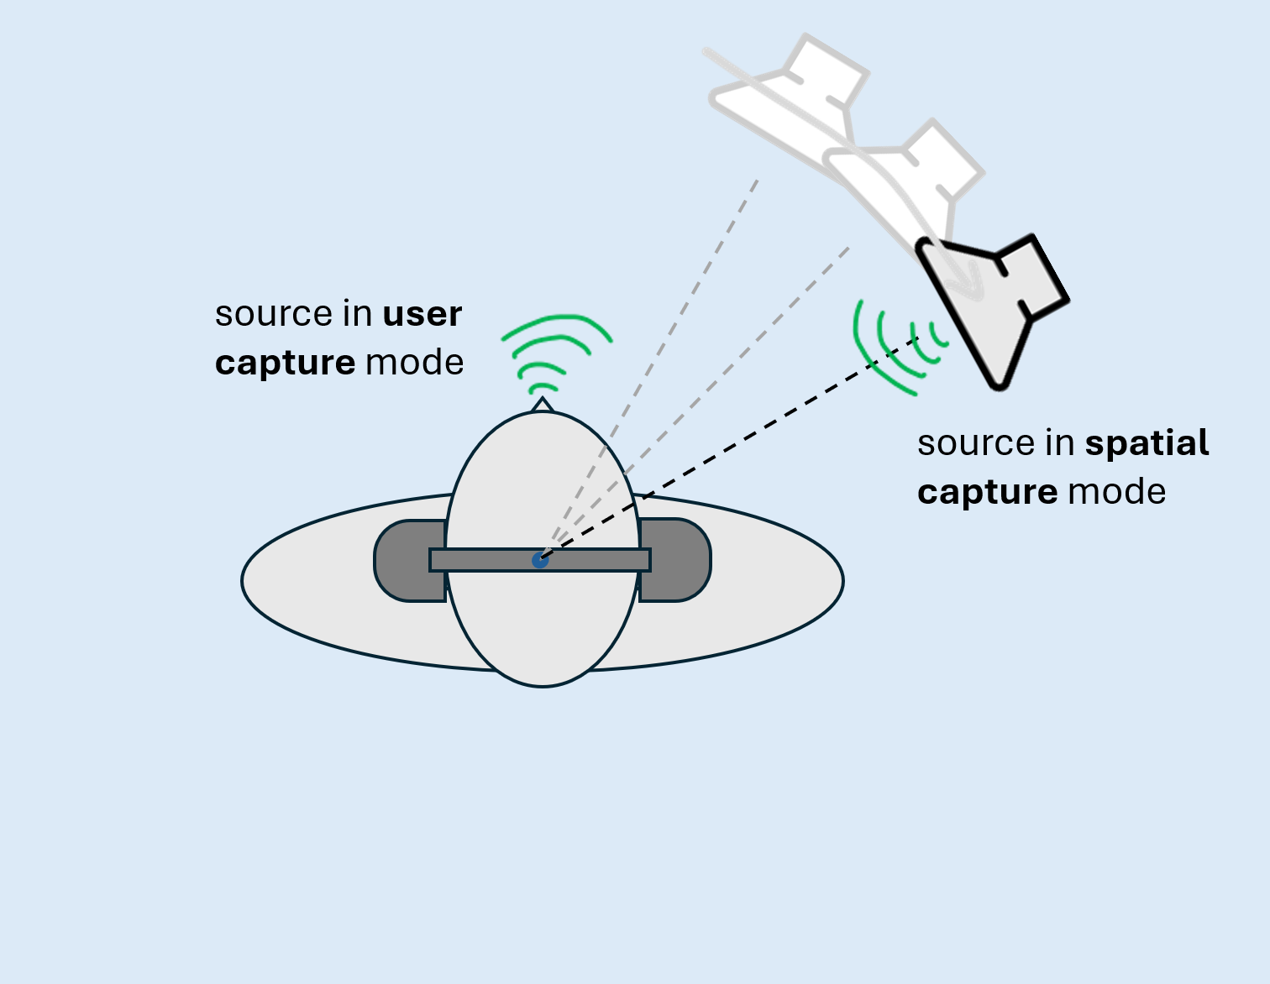
Figure 9: Sound source positioning for Headset UE tests

If not stated otherwise, headsets shall be placed on the HATS in their recommended wearing position. Sound source positioning for sending tests is illustrated in Figure 9. For the purposes of sound source rotation, the HRP of the HATS is considered the geometric center of the UE.
User capture
The sound source for User Capture is the artificial mouth of the HATS wearing the headset. The playback level at MRP shall be calibrated to -4.7 dB Pa.
Spatial capture
If not specified otherwise, the single sound source arrangement for Spatial Capture is a loudspeaker positioned at 0° azimuth and elevation and at 1 m relative to the HRP of the HATS wearing the headset device. The playback levels at HRP (in the absence of HATS) shall be calibrated to 75 dBSPL according to clause 5.5.1.

5.4.2.4 Handheld hands-free UE
The test setup for handheld hands-free UE for sending and receiving directions is shown in Figure 10. It applies to all devices that can be held in front of the user.
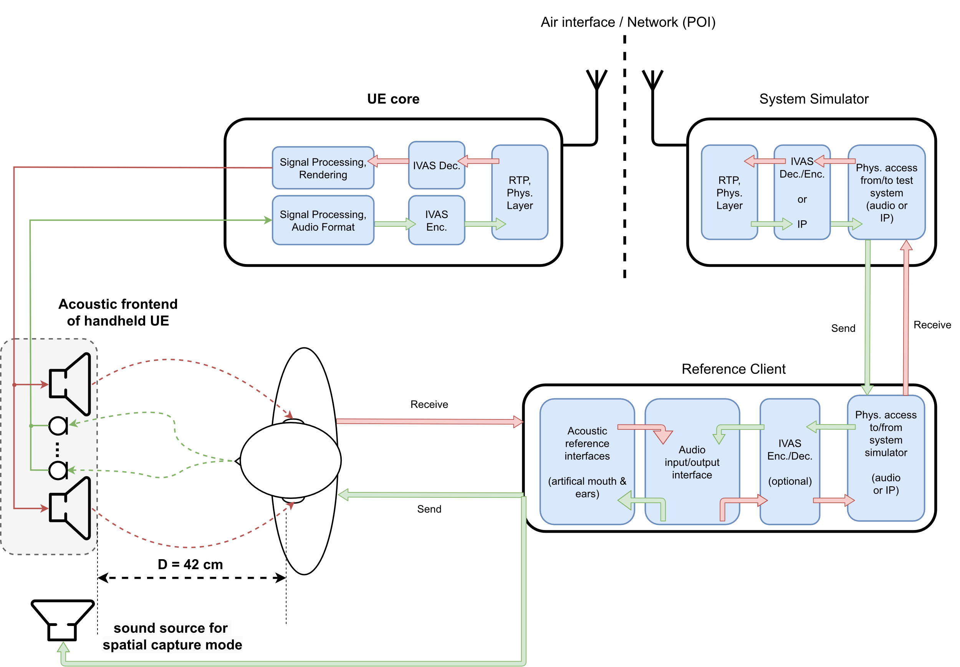
Figure 10: Handheld hands-free UE and test equipment
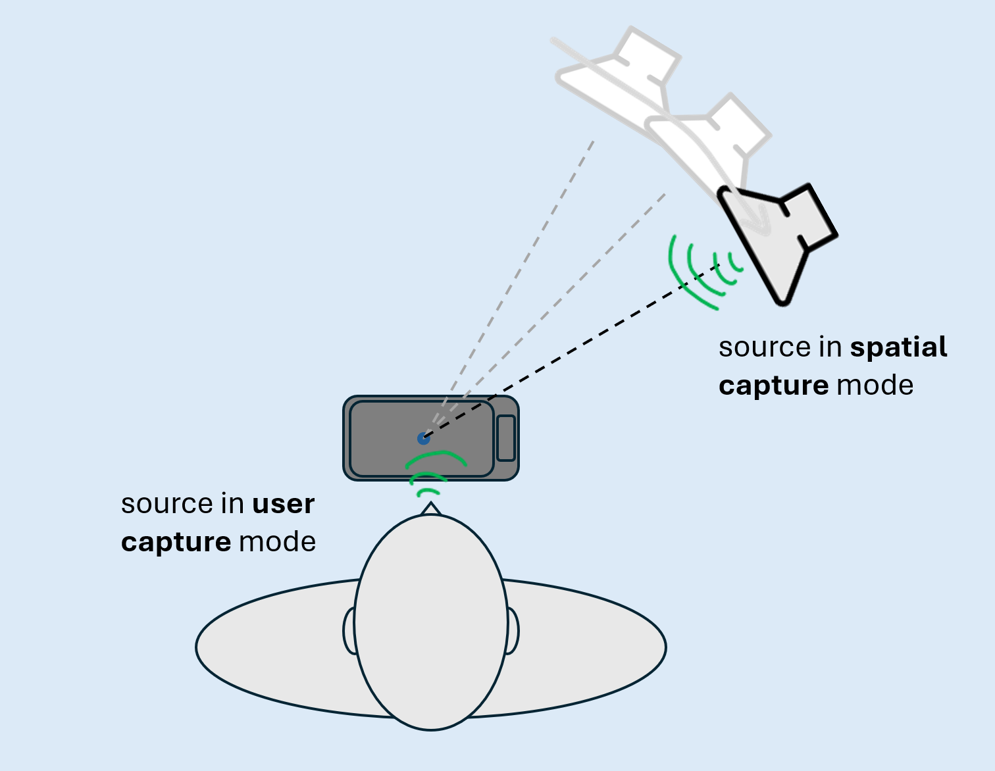
Figure 11: Sound source positioning for Handheld UE tests

The UE orientation (landscape/portrait and top/bottom position, front/back side facing the user) used for testing is specified by the manufacturer. If such information not available, the orientation depends on the capture mode.
The test fixture (e.g., microphone stand) used to mount the handheld hands-free UE for the measurements should be as acoustically transparent as possible and should not obstruct any of the input microphones.
If not specified otherwise, the arrangement for receiving direction is a HATS positioned at 42 cm from the center point of the visual display of the UE (same setup as in TS 26.132 [27] for handheld hands-free). Sound source positioning for sending tests is illustrated in Figure 11.
User capture
The sound source for User Capture is the artificial mouth of the HATS. The HATS is positioned the same way as in receiving direction. If applicable, different geometries of this setup are considered in corresponding test methods (for e.g., multi-talker scenarios or speech from certain angles). The playback levels at MRP shall be calibrated to -1.7 dB Pa.
If no manufacturer-defined orientations are defined, the UE shall be positioned in portrait mode, whereas the front side is facing the user.
Spatial capture
If not specified otherwise, the single sound source for Spatial Capture is a loudspeaker positioned at 0° azimuth and 0° elevation and at 1 m relative to the geometric center of the handheld hands-free UE. The playback levels at the UE shall be calibrated to 75 dBSPL according to the clause 5.5.1. If applicable, different geometries of this setup are considered in corresponding test methods (for e.g., multiple sources from different angles).
If no manufacturer-defined orientations are defined, the UE shall be positioned in landscape mode (top edge of the device turned to the left), whereas the front side is facing the user.
NOTE: Spatial capture typically targets at acoustic scenes opposite to the user of the device. Therefore, the simulated user/HATS is not considered as an integral part of the Spatial capture setup, as the acoustic impact of the simulated user/HATS in such a setup is for further study.

5.4.2.5 Table-mounted UE
The test setup for table-mounted hands-free UE for sending and receiving direction is shown in Figure 12. It applies to all hands-free devices that are intended for usage on tables (like e.g., conference devices). In contrast to handheld hands-free UE, the reflections of the table are explicitly included in the test setup.
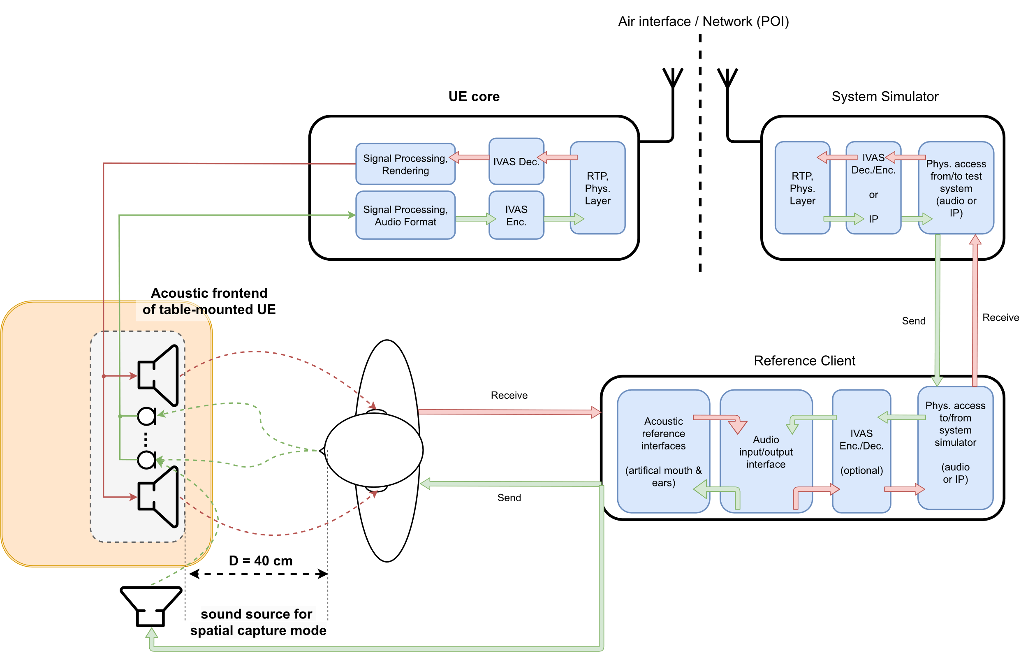
Figure 12: Table-mounted hands-free UE and test equipment
Figure 12 shows an example with a distance of D = 40 cm between front of the UE and lip reference plane of the user, which corresponds to the desktop hands-free setup as specified in Recommendation ITU-T P.341 [17], which is also referenced in 3GPP TS 26.132 (width W = 40 cm, height H = 30 cm). In general, multiple sub-setups may be considered for this UE type, like e.g., the "group audio terminal" position (see clause 4.2.4 of P.341 [17]) or the softphone/laptop-based setups 3GPP TS 26.132 [27].
NOTE: The term "table-mounted hands-free" is suggested here instead of "desktop hands-free", as used in e.g., 3GPP TS 26.132. The intention for this is to explicitly address also different/larger setups like e.g., conferencing scenarios with multiple microphones and loudspeaker arrays.

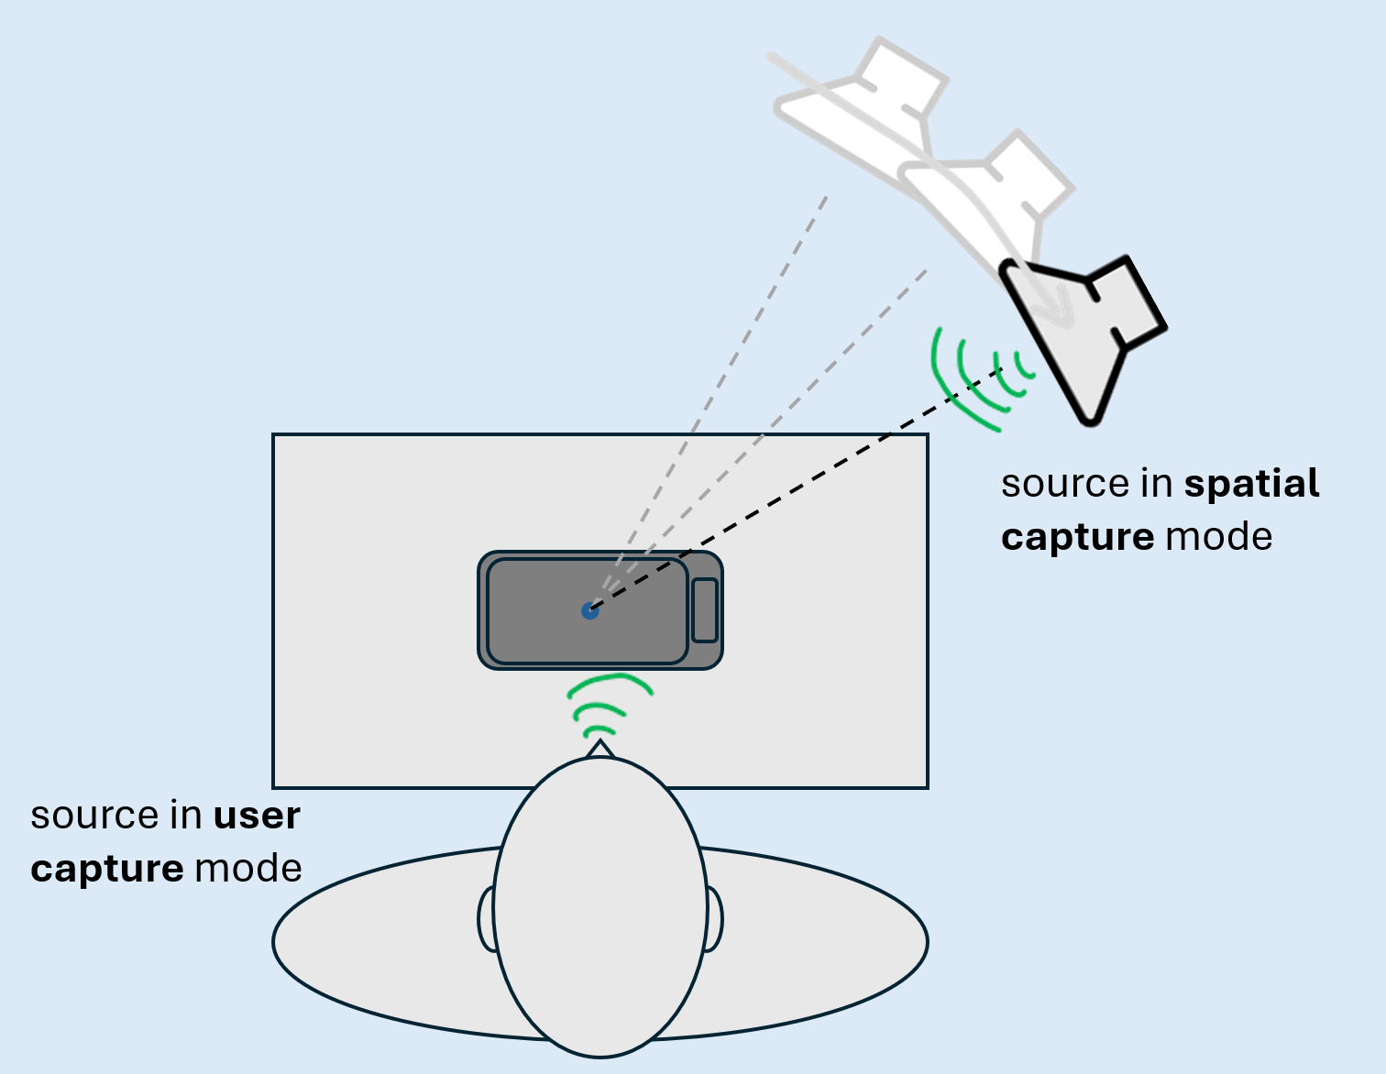
Figure 13: Sound source positioning for Table-mounted UE tests
If not specified otherwise, the arrangement for receiving direction is a HATS positioned at a distance of 40 cm between UE and lip reference plane and a height of 40 cm. Sound source positioning for sending tests is illustrated in Figure 13.
User capture
The sound source for User Capture is the artificial mouth of the HATS. The HATS is positioned the same way as in receiving direction. The playback levels at MRP shall be calibrated to -1.7 dB Pa.
Spatial capture
If not specified otherwise, the single sound source for Spatial Capture is a HATS or loudspeaker positioned at a height H = 40 cm above the table and at a width of 80 cm in front of the geometric center of the table-mounted UE. In spherical coordinate system, this corresponds to 0° azimuth, 26.6° elevation and 89.4 cm. The playback levels at the HFRP shall be calibrated to -24.7 dBPa.

5.4.2.6 Loudspeaker UE
The test setup for loudspeaker hands-free UE for receiving direction is shown in Figure 14. It applies to multichannel loudspeaker systems and speaker arrays, e.g., soundbars or automotive infotainment systems.
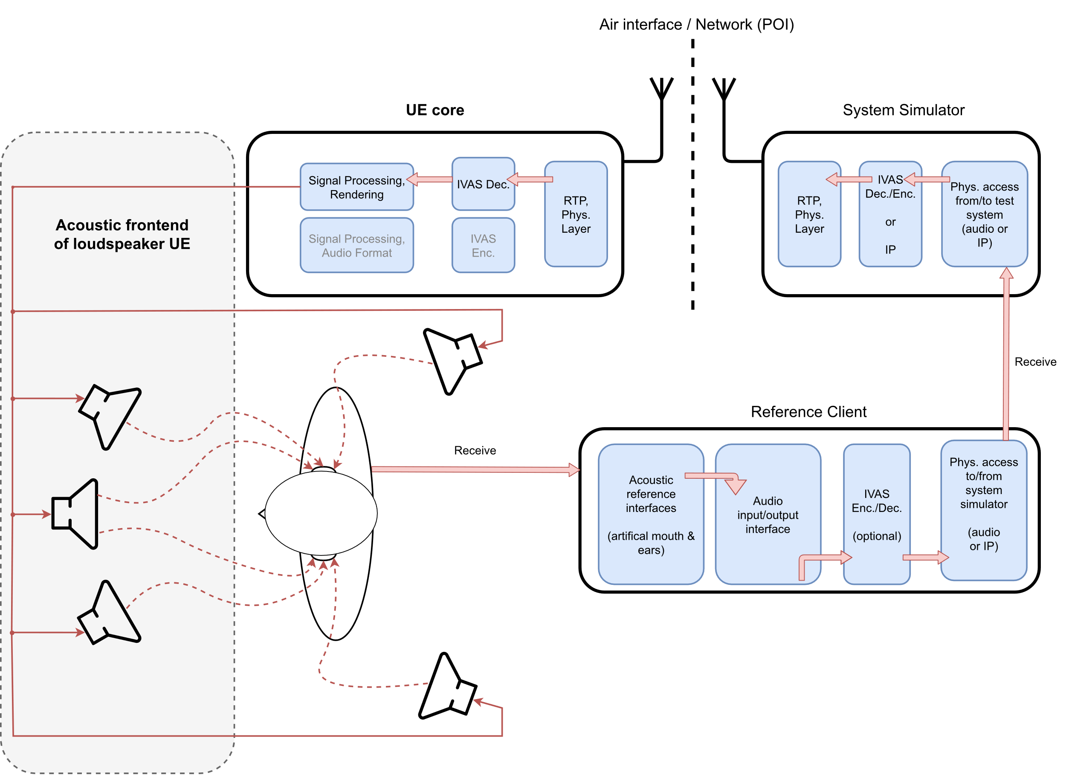
Figure 14: Loudspeaker hands-free UE and test equipment

5.4.2.7 Electrical interface UE
The test setup for electrical interface UE for sending and receiving directions is shown in Figure 15. It applies to all devices that do not provide integrated or associated equipment for capturing and/or reproduction of immersive audio. Wired or wireless digital audio interfaces according to Recommendation ITU-T P.383 [21] (e.g., Bluetooth or USB) are commonly used. Note that the interface may also be realized via an analogue jack plug, which provides up to two channels in receiving and sending direction (see Recommendations ITU-T P.381 [19] and ITU-T P.382 [20]).
The device may provide an additional input for head tracking data that can be used for rendering the receiving direction (e.g., Bluetooth or USB with HID profile [33]).
Different equipment may be connected to the electrical interface UE such that the combination of UE and additional equipment will behave like one of previous UE types (e.g., headset or loudspeaker). Test methods apply according to the envisioned use-case. The default test signal for electrical insertion of a single sound source shall correspond to the envisioned use case.
EXAMPLE: If the electrical interface of an UE is envisioned to connect a third-party immersive headset (e.g., with headtracking functionalities), the default test signal contains a virtual single sound source at the default source position specified for headset UE (see clause 5.4.2.3). Only test methods for headset UE are applicable in this case.
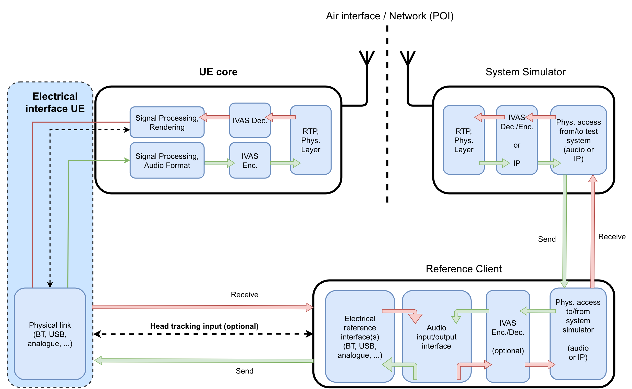
Figure 15: Electrical interface UE and test equipment

5.4.2.8 Simultaneous Capture
Immersive UEs may comprise two or more simultaneously active capturing interfaces in the sending direction. These interfaces may correspond to one of the SND-UE-types specified in the previous clauses (e.g., Headset UE, Handheld hands-free UE, or Table-mounted Hands-free UE) or may include additional accessory equipment (e.g., an external microphone).
For such UEs provided by a single manufacturer, the primary test setup shall be selected as follows:
- If multiple SND-UE-types could be considered equally relevant, the manufacturer shall specify the primary setup (if available).
- If no manufacturer-defined primary setup is provided, the setup shall correspond to the SND-UE-type that is most relevant for the current capture mode under test (see clause 5.4.1), as chosen by the test operator.
In general, a manufacturer-defined test setup shall always take precedence over the setups specified in the present document. The selected primary test setup shall be documented in the test report.
EXAMPLE 1: Conferencing scenario: A Handheld hands-free UE (or Table-mounted UE) is used with one or more accessory microphones placed on a table or held by the user. For the user capture mode, the test setup for the Handheld hands-free UE (or Table-mounted UE) shall be used as the primary setup, as the user primarily interacts with this device.
EXAMPLE 2: Combined Headset and Handheld UE: A Headset UE is connected to a Handheld hands-free UE, where the internal microphones of the Handheld UE are combined with the binaural microphones of the Headset UE to enhance immersive capture.
- For user capture mode, the Handheld hands-free UE shall be considered the primary interface, as it is the main communication device.
- For spatial capture mode (e.g., recording a concert), the Headset UE shall be selected as the primary setup if the Handheld UE functions as an auxiliary microphone extension.

5.4.3 UE configuration
For testing, the UE shall be configured for the relevant and/or envisioned use cases as described in clause 5.4.2.
UEs shall be tested as is, i.e., without the test operator enabling/disabling signal enhancement features or functionalities after the UE initialization.
NOTE: If the test operator observes corrupted results and/or low UE performance for certain measurements, the tests may be repeated with such modifications (enabling/disabling signal enhancement features or functionalities) for the purposes of tracking and documenting possible root causes of the problem.
Unless stated otherwise, if a volume control is provided in receiving direction, the setting is chosen such that the nominal receiving loudness is met as closely as possible.

5.4.4 Noise suppression mode configuration

5.4.4.1 Overview
UEs may support multiple noise suppression modes in UE sending direction as specified in Annex A of TS 26.253 [29]. The noise suppression modes to be tested are selected according to the following priority options:
1) Supported noise suppression mode(s) as indicated during negotiation in SDP as described in 5.4.4.2
2) If option 1 is not available, supported noise suppression mode(s) are tested as specified by the manufacturer
3) If options 1 and 2 are not available, all tests are conducted, and the results are evaluated with respect to the requirements for the noise suppression modes.
All send noise suppression modes supported by the UE (up to four) shall be tested and documented in the test report.

5.4.4.2 Noise suppression mode configuration via SDP
The UE may indicate its supported noise suppression mode(s) via SDP using ns-mode-init or ns-mode-init-send parameter. The applied noise suppression mode(s) for testing shall be configured by negotiating the parameter for the session, if applicable. For testing UE with different noise suppression modes, the following SDP parameter mapping applies:
- If 'none' value is configured for the session, this corresponds to Disabled noise suppression mode, denoted as ns-disabled in the following.
- If 'min' value is configured for the session, this corresponds to Minimum noise suppression mode, denoted as ns-min in the following.
- If 'def' value is configured for the session, this corresponds to Default noise suppression mode, denoted as ns-default in the following.
- If 'max' value is configured for the session, this corresponds to Maximum noise suppression mode, denoted as ns-max in the following.
Further information on the IVAS Media Type Registration and Offer-Answer Model Considerations for ns-mode-init and ns-mode-init-send SDP parameters are described in clauses A.4.1 and A.4.3.1 in 3GPP TS 26.253 Annex A [29], respectively.
EXAMPLE: If the UE indicates that it supports ns-default and ns-max noise suppression modes via ns-mode-init parameter, both modes are tested. Two individual test calls are established with the reference client, one using ns-default value, and other using ns-max value. Relevant tests for each supported noise suppression mode are then conducted.
5.4.5 Setup for ambient sound field simulation
The setup for simulating realistic ambient noises in a lab-type environment is described in ETSI TS 103 224 [32], which contains a description of the recording arrangement for realistic ambient noises, a description of the setup for loudspeaker arrangement suitable to simulate an ambient noise field in a lab type environment, and a database of realistic ambient noises. For improved periphony, augmented loudspeaker setup for spatial audio testing comprising 16 loudspeakers defined in Clause 6.0.2 in TS 103 224 should be used for tests.
For headset UE, the symmetric microphone array for binaural applications according to clause 5.4 of ETSI TS 103 224 [32] shall be used for the equalization and calibration of the ambient sound field reproduction. The HATS and the headset UE mounted to it are placed to the geometric centre of the loudspeaker array. The ambient sound fields as provided in Table 1b shall be used for testing, which also specifies time ranges via start and duration that are used for several analyses in the following clauses.
Table 1b: Ambient sound fields used for headset UE
Ambient Sound Field | Start (s) | Duration (s) | Averaged Sound Pressure Level  of Microphone Array Elements  (in dBSPL(A))
Rock Concert | - | 30 | 95
Downtown Scene | - | 30 | 70
Kindergarden | - | 30 | 60
Nature Scene | - | 30 | 40
NOTE: Ambient sound field recordings as well as analysis ranges should be provided by the manufacturer. These may be replaced by specific recordings if/when they become available in the database of ETSI TS 103 224.

For handheld hands-free UE, the asymmetric microphone array (handheld setup) according to clause 5.3.2 of ETSI TS 103 224 [32] shall be used for the equalization and calibration of the ambient sound field reproduction. The handheld hands-free UE is placed in the geometric centre of the loudspeaker array. When testing in user capture mode (communication scenarios), HATS shall be present during the calibration/equalization routine. The ambient sound fields as provided in Table 1c shall be used for testing, which also specifies time ranges via start and duration that are used for several analyses in the following clauses.
Table 1c: Ambient sound fields used for hands-free UE
Ambient Sound Field | Start (s) | Duration (s) | Averaged Sound Pressure Level  of Microphone Array Elements  (in dBSPL(A))
Rock Concert | - | 30 | 95
Downtown Scene | - | 30 | 70
Kindergarden | - | 30 | 60
Nature Scene | - | 30 | 40
NOTE: Ambient sound field recordings as well as analysis ranges should be provided by the manufacturer. These may be replaced by specific recordings if/when they become available in the database of ETSI TS 103 224.

For table-mounted hands-free UE, the asymmetric microphone array (handheld setup) according to clause 5.3.3 of ETSI TS 103 224 [32] shall be used for the equalization and calibration of the ambient sound field reproduction. In accordance with clause 5.4.2.5, the table-mounted hands-free UE is placed in the geometric centre of the loudspeaker array. The ambient sound fields as provided in Table 1d shall be used for testing, which also specifies time ranges via start and duration that are used for several analyses in the following clauses.
Table 1d: Ambient sound fields used for table-mounted UE
Ambient Sound Field | Start (s) | Duration (s) | Averaged Sound Pressure Level  of Microphone Array Elements  (in dBSPL(A))
[Round table conversation] | - | 10 | 65-70
Kitchen_desktop.wav | 5 | 10 | 66.7
Officeroom_desktop.wav | 5 | 10 | 54.9
Conference3_desktop.wav | 5 | 10 | 53.6
NOTE: Wave filenames correspond to the database provided in clause 8.2 of ETSI TS 103 224. Ambient sound field recordings not included in ETSI TS 103 224 should be provided by the manufacturer (including analysis ranges).

For electrical interface UE with binaural input format, ambient sound field recordings according to Table 1e shall be used for electrical insertion, which can be found in clause 8.2 of ETSI ES 202 396-1 [36]. The binaural input signal shall be calibrated as provided in clause 5.5.1 to the levels specified in Table 1e, which also specifies time ranges via start and duration that are used for several analyses in the following clauses.
Table 1e: Ambient sound fields used for electrical interface UE and binaural input format
Ambient Sound Field | Start (s) | Duration (s) | Averaged Sound  Pressure Level  in dBSPL(A) | Target loudness  In LKFS
RockMusic01m48k_ETSI_3m18s_1sRamp.wav | 30 | 10 | 73.8 | -16.5
Kindergarten_Noise1_binaural ( 0.00-30.00 s).wav | 5 | 10 | 72.6 | -26.0
Outside_Traffic_Crossroads_binaural ( 0.00-20.00 s).wav | 5 | 10 | 71.2 | -26.0
Nature1_Forrest_Noise_binaural ( 0.00-30.00 s).wav | 20 | 10 | 41.6 | -46.0
NOTE: Wave filenames correspond to the database provided in clause 8.1 of ETSI TS 103 224.

5.5 Test signals

5.5.1 Test signal calibration
The input signal levels for testing receiving direction or testing with an electrical interface in sending direction shall be calibrated by means of a calibration factor, which is determined according to the iterative procedure illustrated in Figure 16. The rendering of the input signal to the target format shall be done via external IVAS reference renderer, which is defined in clause 6 of 3GPP TS 26.254 [30]. The rendered output format shall be set to 7.1+4 output, except if the format of the input signal is already multichannel or stereo. The level is then calculated according to ITU-R BS.1770 [23] for these intermediate signals. If the difference between measured and target level exceeds 0.5 LKFS the procedure is repeated for up to ten iterations.

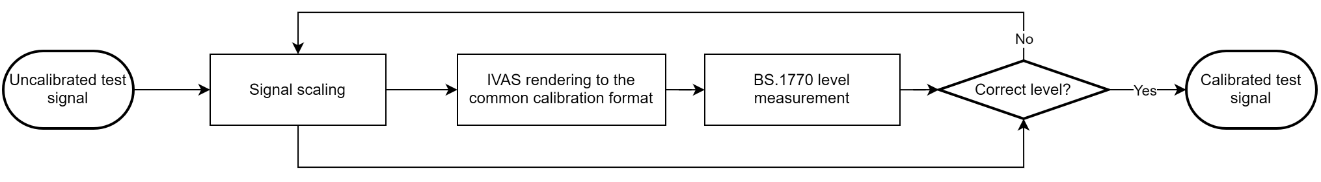
Figure 16: Test signal input level adjustment procedure for receiving tests
For mono real speech signals, acoustical and electrical calibration of test signals shall be carried out with active speech level according to ITU-T P.56 [10], calculated over the complete test sequence.

5.5.2 Virtual positioning
For testing of a single, directional sound source in receiving direction and sending direction with an electrical interface, the test signal shall be positioned virtually to represent the tested source direction.
Object-based audio
Unless specified otherwise, the source position of the test signal shall be set by format specific metadata as defined in Table 2. No further metadata fields shall be set.
Table 2: Object-based audio format specific metadata
Azimuth | Elevation | Spread | Gain
According to the tested azimuth | According to the tested elevation | 0 | 1

Scene-based audio
Unless specified otherwise, the source position of the test signal shall be set by a multi-component Ambisonics (ACN/SN3D) signal that represents a source from the particular incidence angle. To generate the test signal, first the virtually positioned object-based format is created. Then the IVAS external renderer according to 3GPP TS 26.254 [30] is used to obtain the desired signal in scene-based audio output format from the object-based input.
Metadata-assisted spatial audio
Unless specified otherwise, the source position of the test signal shall be set by the format specific metadata. The applied descriptive metadata for every frame and the applied spatial metadata for every time-frequency tile shall be set as defined in Table 3 and Table 4. The fields of the MASA metadata format are specified in Annex A of 3GPP TS 26.258 [31]. Unless specified otherwise, the source signal shall be applied to each transport channel used for testing.
Table 3: Applied descriptive metadata
MASA format descriptive common metadata parameters | Assigned values for every metadata frame
Format descriptor | Default
Number of directions | 1 (bit value 0)
Number of channels | 1 or 2 (bit value 0 or 1), depending on the number of applied transport channels
Source format | Bit values 00 (Default/unknown)
Variable description | 12 bit zero-padding (Default/unknown)

Table 4: Applied spatial metadata
MASA format spatial metadata parameters | Assigned values for every time-frequency tile in all MASA metadata sub-frames
Direction Index | According to the tested azimuth and elevation
Direct-to-total energy ratio | 1.0
Spread coherence | 0.0
Diffuse-to-total energy ratio | 0.0
Surround coherence | 0.0
Remainder-to-total energy ratio | 0.0

Multichannel audio
To generate the test signal, first the virtually positioned object-based format is created. Then the IVAS external renderer according to 3GPP TS 26.254 [30] is used to obtain the desired signal in multichannel audio output format from the object-based input.

5.5.3 Loudness calculation for immersive audio formats
The loudness level, K-weighted, relative to full scale (LKFS) for all immersive audio formats supported by the IVAS codec and captured at the POI in send direction is calculated according to ITU-R BS.1770 [23]. The method supports stereo and all multichannel formats as input signals directly.
If the signal to be analysed is not already in one of these formats, the external IVAS reference renderer according to clause 6 of 3GPP TS 26.254 [30] shall be used to render the signal to 7.1+4 output format, which is then used for the loudness level calculation according to ITU-R BS.1770 [23].

5.6 Test methods for sending direction

5.6.1 Delay
The UE delay testing in sending direction, T_{S}, is illustrated in Figure 17. The reference client decodes and renders the input bitstream to a common analysis-dependent format. For the rendering step, the IVAS renderer [30] shall be used.
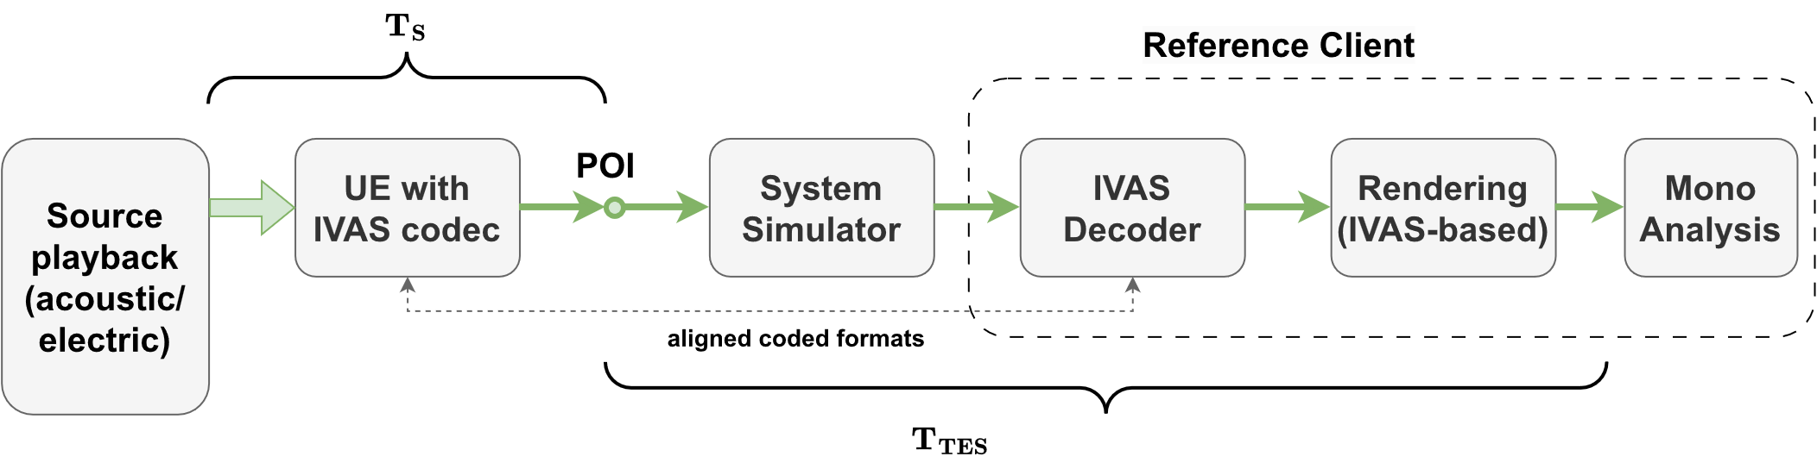
Figure 17: Test setup for sending loudness and delay
Test method
1) The default arrangement for a single sound source as defined in clause 5.4.2 is set up according to the UE type. The UE under test and the reference client are connected and configured as described in the clause 5.3.2.
2) The test signal to be used for the measurements shall be the British-English single talk sequence described in clause 7.3.2 of Recommendation ITU-T P.501 [14], which is calibrated as specified in clause 5.4.2 for the corresponding UE type and the tested capture mode (user or spatial).
3) For acoustic measurements, the UE is mounted as described in the clause 5.4.2. The sound source corresponding to the tested capture mode (user or spatial) is positioned accordingly. The test signal is played back via the acoustic source.
For measurements with electrical interface UE, the test signal virtually positioned as described in clause 5.4.2.7. The generated source signal is played back via insertion into the electrical interface.
4) The renderer in the reference client shall be configured to mono output.
5) The UE delay in sending direction T_{S} is obtained between the acoustical sound source and the electrical POI of the test equipment. The source signal is used as a reference for the cross-correlation analysis described in Annex C, which is used to determine T_{S}.
6) The measured delay shall be compensated by the delay T_{TES} introduced by the test equipment (including possible contributions of the rendering to mono).

5.6.2 Loudness
The UE delay testing in sending direction is illustrated in Figure 17. The reference client decodes and renders the input bitstream to a common analysis-dependent format. For the rendering step, the IVAS renderer [30] shall be used.
Test method
1) The default arrangement for a single sound source as defined in clause 5.4.2 is set up according to the UE type. The UE under test and the reference client are connected and configured as described in the clause 5.3.2.
2) The test signal to be used for the measurements shall be the British-English single talk sequence described in clause 7.3.2 of Recommendation ITU-T P.501 [14], which is calibrated as specified in clause 5.4.2 for the corresponding UE type and the tested capture mode (user or spatial).
3) For acoustic measurements, the UE is mounted as described in clause 5.4.2. The sound source corresponding to the tested capture mode (user or spatial) is positioned accordingly. The test signal is played back via the acoustic source.
For measurements with electrical interface UE, the test signal virtually positioned as described in clause 5.4.2.7. The generated source signal is played back via insertion into the electrical interface.
4) The renderer in the reference client shall be configured to mono output.
5) The UE loudness in sending direction is obtained by Send Loudness Rating (SLR) according to ITU-T P.79 [13] in wideband mode. The calculation is carried out as specified in clause 8.2.3.1 of 3GPP TS 26.132 [27], except that the active speech level of the reference signal shall be calibrated to -1.7 dBPa.

5.6.3 Frequency response (single source)

5.6.3.1 Test method
The following procedure shall be used:
1) The default arrangement for a single sound source as defined in clause 5.4.2 is set up according to the UE type. The UE under test and the reference client are connected and configured as described in the clause 5.3.2.
2) The test signal to be used for the measurements shall be the British-English single talk sequence described in clause 7.3.2 of Recommendation ITU-T P.501 [14], which is calibrated as specified in clause 5.4.2 for the corresponding UE type and the tested capture mode (user or spatial).
3) For acoustic measurements, the UE is mounted as described in clause 5.4.2. The sound source corresponding to the tested capture mode (user or spatial) is positioned accordingly. The test signal is played back via the acoustic source.
For measurements with electrical interface UE, the test signal virtually positioned as described in clause 5.4.2.7. The generated source signal is played back via insertion into the electrical interface.
4) The frequency response of the decoded output signal shall be calculated according to the format-specific definitions of the following clause. For all formats, 1/12th octave intervals as given by the R40 series of preferred numbers in ISO 3 [6], for frequencies from 100 Hz to 12 kHz (inclusive) apply. The reference magnitude spectrum $P_{ref}\left(f\right)$ is the 1/12th octave spectrum of the test signal.

5.6.3.2 IVAS format-specific definitions
Stereo & Object-based audio
The frequency response of a stereo or object-based audio signal is defined as a ratio of the magnitude spectrum ${\hat{P}}_{k}\left(f\right)$ of each audio channel k and the reference magnitude spectrum $P_{ref}\left(f\right)$. Thus, for each stereo audio signal channel k, the frequency response is determined by:
$G_{k}\left(f\right)=\frac{{\hat{P}}_{k}\left(f\right)}{P_{ref}\left(f\right)}$
Scene-based audio
The magnitude spectrum $\hat{P}\left(f\right)$ of a scene-based audio signal is determined by evaluating the root mean square of the magnitude spectrum of the ${\left(N+1\right)}^{2}$ Ambisonics coefficients ${\hat{P}}_{l}^{m}\left(f\right)$:
$\hat{P}\left(f\right)=\sqrt{\frac{1}{{\left(N+1\right)}^{2}}\sum_{l=0}^{N}{\sum_{m=-l}^{l}{\left(2l+1\right){\left({\hat{P}}_{l}^{m}\left(f\right)\right)}^{2}}}}$
Letters $l$ and $m$ respectively denote Ambisonics degree and index. The factor $\sqrt{2l+1}$ renormalizes the SN3D-normalized coefficients to N3D. The N3D-normalized root-mean-square of the coefficient-domain magnitude spectrum is equivalent of determining the root-mean-square in the spatial domain, evaluated on a uniform sampling grid (Parseval’s theorem).
The frequency response is defined as the ratio of $\hat{P}\left(f\right)$ and the reference magnitude spectrum $P_{ref}\left(f\right)$. The frequency response is determined by:
$G\left(f\right)=\frac{P\left(f\right)}{P_{ref}\left(f\right)}$
Metadata-assisted spatial audio
The frequency response of a metadata-assisted spatial audio signal is defined as a ratio of the magnitude spectrum ${\hat{P}}_{k}\left(f\right)$ of each transport channel k nd the reference magnitude spectrum $P_{ref}\left(f\right)$. Thus, for each MASA transport channel k, the frequency response is determined by:
$G_{k}\left(f\right)=\frac{{\hat{P}}_{k}\left(f\right)}{P_{ref}\left(f\right)}$

5.6.4 Directional information (single source)

5.6.4.1 Test method
This test method applies to the spatial capture mode.
The default arrangement for a single sound source is used, as defined in clause 5.4.2 for each UE type and UE orientation, if applicable (only handheld hands-free UE). The decoded and rendered output format shall be the same as the IVAS audio format used by the UE. At least L = 7 directions shall be evaluated, as indicated in Table 5 to evaluate half-circular planar capture capabilities. If full-circular planar capture capabilities are specified by the manufacturer for the UE, L = 12 directions according to Table 5 shall be evaluated. If 3D spherical capture capabilities are specified by the manufacturer for the UE, L = 20 directions according to Table 5 shall be evaluated.
In case the setup is realized with a turntable, the device shall be rotated around the vertical center of the UE.
Table 5: Additional source directions
i | ϕ_{i} [°] | θ_{i} [°] | Capture capability
1 | -90 | 0 | Half-circular planar
2 | -60 | 0 | Half-circular planar
3 | -30 | 0 | Half-circular planar
4 | 0 | 0 | Half-circular planar
5 | 30 | 0 | Half-circular planar
6 | 60 | 0 | Half-circular planar
7 | 90 | 0 | Half-circular planar
8 | 120 | 0 | Full-circular planar
9 | 150 | 0 | Full-circular planar
10 | 180 | 0 | Full-circular planar
11 | 210 | 0 | Full-circular planar
12 | 240 | 0 | Full-circular planar
[13 | -90 | 30] | 3D spherical
[14 | -45 | 30] | 3D spherical
[15 | 0 | 30] | 3D spherical
[16 | 45 | 30] | 3D spherical
[17 | 90 | 30] | 3D spherical
[18 | 135 | 30] | 3D spherical
[19 | 180 | 30] | 3D spherical
[20 | 225 | 30] | 3D spherical

For each sound source direction (ϕ_{i}, θ_{i}) and i = 1, ..., L, the following procedure shall be used:
1) The test signal to be used for the measurements shall be the British-English single talk sequence described in clause 7.3.2 of Recommendation ITU-T P.501 [14], calibrated to an active speech level according to clause 5.5.1.
2) The UE under test and the reference client are connected and configured as described in the clause 5.3.2.
3) Acoustical interface: The UE is mounted as described in clause 5.4.2 and the acoustic source is positioned such that the source direction under test is met. The test signal is played via the acoustic source.
Electrical interface: The test signal is generated by virtually placing the acoustic source such that the source direction under test is met as described in clause 5.4.2.7.
4) The output format-dependent directional metric calculations shall be done as defined in the following clause for the tested format.

5.6.4.2 IVAS format specific definitions
Stereo
The estimated source directions in the stereo panorama $ζ\left(ϕ\right)$ shall be calculated as follows:
1) The left and right channel signals ($s_{L}\left(k\right), s_{R}\left(k\right)$) are recorded by the test equipment.
2) The inter-channel time difference ($ICTD\left(ϕ_{i}\right)=Δ_{τ}$) is determined as described in Annex C between the signals $s_{L}\left(k\right)$ and $s_{R}\left(k\right)$.
3) The inter-channel level difference (ICLD) is determined as follows:
a) The active speech level according to Recommendation P.56 [10] is calculated separately for $s_{l}\left(k\right)$ and $s_{r}\left(k\right)$, resulting in $L_{L}$ and $L_{R}$.
b) The ICLD for source direction $ϕ_{i}$ is calculated as:
$ICLD\left(ϕ_{i}\right)=L_{L}-L_{R}$
4) The equivalent level difference $Δ\left(ϕ_{i}\right)$ for source direction $ϕ_{i}$ is calculated as:
$Δ\left(ϕ_{i}\right)=ICLD\left(ϕ_{i}\right)+ICTD\left(ϕ_{i}\right)⋅17.3 \frac{\text{dB}}{\text{ms}} \text{[dB]}$
5) The estimated source directions in the stereo panorama $ζ\left(ϕ_{i}\right)$ is calculated according to [34] as:
$ζ\left(ϕ_{i}\right)=100⋅\left\{\begin{matrix}\frac{Δ\left(ϕ_{i}\right)}{13.5 } & \text{for} & \left|Δ\right|≤6.75 \text{dB} \\ \left(-{32\left|\frac{Δ\left(ϕ_{i}\right)}{\text{dB}}\right|}^{3}+288{\left|\frac{Δ\left(ϕ_{i}\right)}{\text{dB}}\right|}^{2}+20736\left|\frac{Δ\left(ϕ_{i}\right)}{\text{dB}}\right|-6561\right)⋅\frac{\operatorname{sign}{Δ\left(ϕ_{i}\right)}}{273375} & \text{for} & 6.75 \text{dB}<\left|Δ\right|<18 \text{dB} \\ \operatorname{sign}{Δ}\left(ϕ_{i}\right) & \text{for} & \left|Δ\right|≥18 \text{dB}\end{matrix}\right. \text{[\%]}$

Scene-based audio
Direction of arrival analysis with scene-based audio shall be conducted as follows:
1) From the SBA signal decoded by the reference client, only the first four Ambisonics component channels (FOA) in time-domain B-format representation are used, i.e., higher order Ambisonics components are discarded. These four FOA components are referred to as $W$, $Y$, $Z$, $X$ in ACN notation.
2) Each channel is segmented into time-domain frames of 20 ms length. The frames are referred to by frame index $m$, leading to a sequence of frames $w_{m}$, $y_{m}$, $z_{m}$, $x_{m}$.
3) Intensity parameters $i_{x}$, $i_{y}$, $i_{z}$ for the three catesian directions are calculated as follows:
$\left(\begin{matrix}i_{x} \\ i_{y} \\ i_{z}\end{matrix}\right)=-\sum_{m}{g\left(w_{m}\right)\left(\begin{matrix}x_{m}^{'} \\ y_{m}^{'} \\ z_{m}^{'}\end{matrix}\right)w_{m}}.$
The gating function $g\left(w_{m}\right)$ equals 1, if the input frame $w_{m}$ to the function is larger than -48 dBov; otherwise, it equals 0.
4) The direction of arrival estimation $\left({\hat{ϕ}}_{i},{\hat{θ}}_{i}\right)$is calculated based on the intensity parameter using the equations:
${\hat{ϕ}}_{i}=atan2\left(i_{y}, i_{x}\right)⋅\frac{180°}{π}$,
${\hat{θ}}_{i}=\text{atan}\text{2}\text{(}i_{z}\text{, }\sqrt{i_{x}^{2}+i_{y}^{2}})⋅\frac{180°}{π}$
The traditional arctangent function (arctan(x/y)) is not in itself sufficient to uniquely resolve the correct quadrant, thus the two-argument version "atan2" is used:
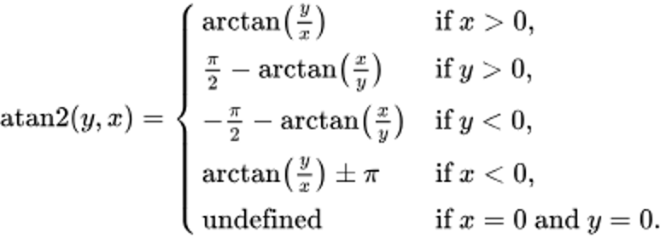
5) The estimated sound source direction of arrival $\left({\hat{ϕ}}_{i},{\hat{θ}}_{i}\right)$ is compared to the direction of the sound source (ϕ_{i}, θ_{i}).

Metadata-assisted spatial audio
Direction of arrival analysis with metadata-assisted spatial audio shall be done as follows:
1) The decoded MASA signal is captured by the test equipment. The decoded MASA metadata includes estimated direction indices and direct-to-total energy ratio quantities $r_{dir}\left(k,n,m\right)$ for each subframe $n$ and MASA spatial metadata frequency band $k$ in every metadata frame $m$. Direction indices are further converted to the direction angular values $\left(ϕ^{'}\left(k,n,m\right),θ^{'}\left(k,n,m\right)\right)$ as described in clause 5.5.2.2 of 3GPP TS 26.253 [29]. The energy $E\left(k,n,m\right)$ of the transport channel(s) is estimed for each subframe and MASA spatial metadata frequency band in every frame. The MASA format time-frequency resolution and metadata parameters are further described in 3GPP TS 26.258 Annex A [31].
2) Estimated direction angular values (in radians) are mapped into Cartesian coordinate vectors $X$, $Y$ and $Z$ over all subframes $N=4$ in every frame $M$ and MASA spatial metadata frequency bands $K=20$ as:
$X=\sum_{m}^{M}{\sum_{n}^{4}{\sum_{k}^{20}{(cos{{(ϕ}^{'}(k,n,m))}⋅\cos\left(θ^{'}\left(k,n,m\right)\right)⋅r_{dir}(k,n,m)⋅E(k,n,m))}}}$
$Y=\sum_{m}^{M}{\sum_{n}^{4}{\sum_{k}^{20}{\left(\sin\left(ϕ^{'}\left(k,n,m\right)\right)⋅\cos\left(θ^{'}\left(k,n,m\right)\right)⋅r_{dir}\left(k,n,m\right)⋅E\left(k,n,m\right)\right),}}}$
$Z=\sum_{m}^{M}{\sum_{n}^{4}{\sum_{k}^{20}{(\sin\left(θ^{'}\left(k,n,m\right)\right)⋅r_{dir}(k,n,m)⋅E(k,n,m)))},}}$
where $k$ is the index of the MASA spatial frequency band, $n$ is the index of the subframe and $m$ is the index of the frame.
3) The sound source direction estimation $\left({\hat{ϕ}}_{i},{\hat{θ}}_{i}\right)$in degrees is calculated based on the mapped Cartesian coordinate vectors using the equations:
ϕi=arctan2Y, X⋅180°π,
θi=arctan2(Z, X2+Y2)⋅180°π
See previous definition of the function "atan2".
4) The estimated sound source direction $\left({\hat{ϕ}}_{i},{\hat{θ}}_{i}\right)$ is compared to the direction of the sound source (ϕi, θi)θi,φi.

5.6.5 Acoustic Echo Control
One of the most relevant aspects for traditional as well as for immersive speech communication is that the generation and insertion of echo signals in send direction should be avoided wherever possible.
The compressed British-English single talk sequence described in clause 7.3.3 of Recommendation ITU-T P.501 [14] is used to simulate a conversation at the far-end. To evaluate echo cancellation performance with immersive audio playback/capture, the individual talkers are virtually arranged in different positions according to Table 5a and as visualized in Figure 17a, including also dynamic movements of certain talkers.
Table 5a: Source direction of each sentence in test signal
# | Talker | Time range [s] |  | Source direction [°]
 |  | From | To | From | To
1 | M1 | 0.0 | 3.1 | 0 | 0
2 | M2 | 3.1 | 5.3 | 0 | 90
3 | M3 | 5.3 | 8.1 | 90 | 90
4 | F1 | 8.1 | 10.7 | 90 | -90
5 | F2 | 10.7 | 13.6 | -90 | -90
6 | F3 | 13.6 | 16.9 | 180 | 180
7 | F4 | 16.9 | 19.8 | 0 | 0
8 | F5 | 19.8 | 22.5 | 0 | 90
9 | F6 | 22.5 | 25.7 | 90 | 90
10 | M4 | 25.7 | 29.1 | 90 | -90
11 | M5 | 29.1 | 32.3 | -90 | -90
12 | M6 | 32.3 | 35.4 | 180 | 180

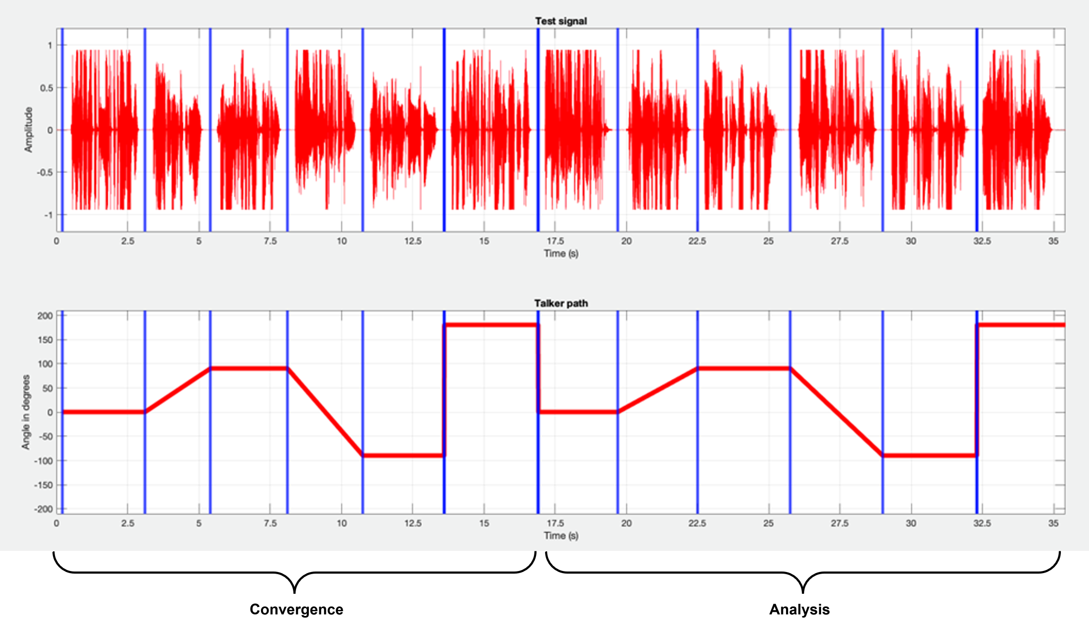
Figure 17a: Sentence directions in the test signal
Test method
The test method applies for SND-/RCV-UE-types with an acoustical interface.
The calculation of terminal coupling loss (TCL) is based on the attenuation between the rendered input signal and rendered output signal versus frequency bands. For the rendering step, the IVAS renderer [30] shall be used. The following common measurement steps are applicable for all types of UE modes:
1) The source signal to be used for the measurements shall be the compressed British-English single talk sequence described in clause 7.3.3 of Recommendation ITU-T P.501 [14].
2) The test signal sentences shall be virtually positioned according to clause 5.5.2. The source directions per sentence according to Table 5a shall be applied.
3) The input signal shall be calibrated to -20 LFKS.
4) The first 17.0 s of the test signal (6 sentences) are discarded from the analysis to allow for convergence of the acoustic echo canceller. The analysis is performed over the remaining length of the test sequence (last 6 sentences).
5) The external renderer in the reference client shall be configured to mono output.
6) The analysis shall be conducted in 1/3-octave band intervals as given by the R.10 series of preferred numbers in ISO 3 [54] for each stereo audio channel. For the calculation, the averaged measured echo level at each frequency band is referred to the averaged, rendered test signal level measured in each frequency band, denoted as echo loss in the following.
7) TCL is calculated according to Annex B.4 of Recommendation ITU-T G.122 [35], which utilizes tabulated data for any frequency range between f0 and fN. a s unweighted echo loss from 100 Hz to 8 kHz by the following equations:
Le=C-10log10i=1N(Ai+Ai-1)(log10fi-log10fi-1)
C=10log10(2⋅(log10fN-log10f0)
Where:
A0 is the output/input power ratio at frequency f0=100 Hz,
Ai the ratio at frequency fi,
AN the ratio at frequency fN=8 kHz.

5.6.6 Ambient sound field transparency

5.6.6.1 Ambient sound field loudness
The following test methods applies to all noise suppression modes.
Test method
1) The UE under test and the reference client are connected and configured as described in clause 5.3.2. The UE is mounted as described in clause 5.4.2.
2) The ambient sound field generation as defined in clause 5.4.5 is set up according to the corresponding UE type.
3) For acoustic measurements, the ambient sound field (test signal) is played back via the loudspeaker array.
For electrical interface, the test signal is played back via insertion into the electrical interface.
4) The captured signal is recorded at the POI and then decoded to the coded audio format of the UE.
5) The UE loudness level, K-weighted (LKFS) in sending direction is calculated according to clause 5.5.3.
6) The test is repeated for each ambient sound field in the corresponding tables of clause 5.4.5.

5.6.6.2 Ambient sound field frequency response
The following test method only applies to noise suppression modes ns-disabled, ns-min and ns-default (see clause 5.4.4.2).
Test method
1) The UE under test and the reference client are connected and configured as described in clause 5.3.2. The renderer in the reference client shall additionally be configured to mono output. The UE is mounted as described in clause 5.4.2.
2) The ambient sound field generation as defined in clause 5.4.5 is set up according to the corresponding UE type.
3) For acoustic measurements, the ambient sound field (test signal) is played back via the loudspeaker array.
For electrical interface, the test signal is played back via insertion into the electrical interface.
4) The captured signal is recorded at the POI and the renderer in the reference client shall be configured to mono output.
5) The frequency response of the decoded and rendered output signal shall be calculated according to the format-specific definitions of the clause 5.6.3.2. For all formats, 1/12th octave intervals as given by the R40 series of preferred numbers in ISO 3 [6], for frequencies from 100 Hz to 12 kHz (inclusive) apply.
6) The reference magnitude spectrum is the 1/12th octave spectrum of a reference microphone positioned in the geometric center of the UE. In the case of headset UE, the reference magnitude spectrum is the 1/12th octave spectrum of a binaural downmix of the ambient sound field captured by the HATS in the absence of the headset UE (corresponds to the HRP).
7) The test is repeated for each ambient sound field in the corresponding tables of clause 5.4.5.

5.6.6.3 Ambient sound field temporal characteristics
The following test method only applies to noise suppression modes ns-disabled, ns-min and ns-default (see clause 5.4.4.2).
Test method
1) The UE under test and the reference client are connected and configured as described in clause 5.3.2. The renderer in the reference client shall additionally be configured to mono output. The UE is mounted as described in clause 5.4.2.
2) The ambient sound field generation as defined in clause 5.4.5 is set up according to the corresponding UE type.
3) For acoustic measurements, the ambient sound field (test signal) is played back via the loudspeaker array.
For electrical interface, the test signal is played back via insertion into the electrical interface.
4) The captured signal is recorded at the POI and the renderer in the reference client shall be configured to mono output.
5) The decoded and rendered signal is referred to the recorder signal with a reference microphone positioned in the geometric center of the UE as level versus time analysis according to IEC 61672 [37], using an integration time of 250 ms. The result represents the differences in temporal structure between the transmitted and reference ambient sound field. In the case of headset UE, the reference signal is binaural downmix of the ambient sound field captured by the HATS in the absence of the headset UE (corresponds to the HRP).
6) The test is repeated for each ambient sound field in the corresponding tables of clause 5.4.5.

5.7 Test methods for receiving direction

5.7.1 Delay
Test method
The assessment of receiving UE delay is illustrated in Figure 18. The default arrangement (acoustical or electrical interface) in receiving direction as defined in clause 5.4.2 for each UE type is used.
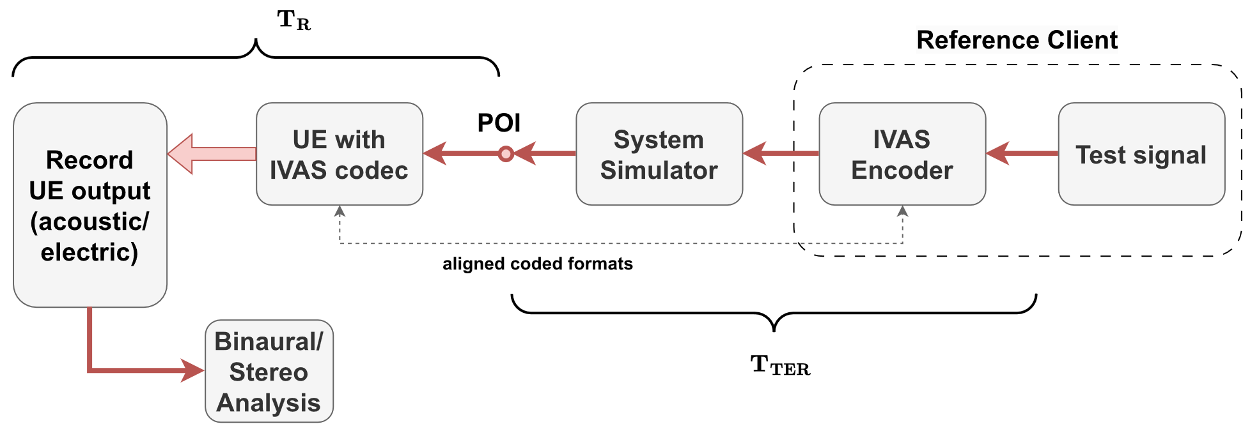
Figure 18: Test setup for receiving delay

1) The source signal to be used for the measurements shall be the British-English single talk sequence described in clause 7.3.2 of Recommendation ITU-T P.501 [14].
2) Virtual source positioning according to clause 5.5.2 is used to generate the test signal from the source signal.
3) The test signal is calibrated to a loudness of -26 LKFS as defined in clause 5.5.1.
4) The UE is setup according to clauses 5.4.2 and 5.3.2. The UE and the reference client connection is setup according to clause 5.4.2, the source signal is encoded by the reference client, and inserted at the POI to the UE.
5) The capture of the UE output is carried out via:
a) acoustical interface (headphones or loudspeakers): recording via diffuse-field equalized HATS.
b) electrical interface: recording via corresponding reference interface. If the captured audio format is not stereo or binaural, the default IVAS binaural renderer is used to generate a binaural signal. To calibrate the digital signal into the (pseudo-)acoustical domain, it is assumed that a level of -26 dBov corresponds to an acoustical level of 73 dBSPL (-21 dBPa).
6) The UE delay in receiving direction is obtained between the electrical POI of the test equipment and the recorded signals at both ears. The cross-correlation analysis described in Annex C is carried out for both ear signals, using the mono source signal as reference. To obtain the overall delay T_{R}, the results for left and right ears are averaged.
7) The measured delay shall be compensated by the delay T_{TER} introduced by the test equipment. If applicable, also the binaural renderer for the electrical interface is compensated.

5.7.2 Loudness

5.7.2.1 Test method
1) The source signal to be used for the measurements shall be the British-English single talk sequence described in clause 7.3.2 of Recommendation ITU-T P.501 [14].
2) Virtual source positioning according to clause 5.5.2 is used to generate the test signal from the source signal.
3) The test signal is calibrated to a loudness of -26 LKFS as defined in clause 5.5.1.
4) The UE is setup according to the clause 5.4.2. The UE and the reference client connection is setup according to clause 5.3.2, the source signal is encoded by the reference client, and inserted at the POI to the UE.
5) The capture of the UE output is carried out via …
a) acoustical interface (headphones or loudspeakers): recording via diffuse-field equalized HATS.
b) electrical interface: recording via corresponding reference interface.
If the captured audio format is not stereo or binaural, the default IVAS binaural renderer is used to generate a binaural signal. To calibrate the digital signal into the (pseudo-)acoustical domain, it is assumed that a level of -26 dBov corresponds to an acoustical level of 73 dBSPL (-21 dBPa).
6) The LLR in phon is calculated according to clause 8.3.3 of Recommendation ITU-T P.700 [22] with the captured or rendered binaural signal.
7) The same binaural signal should be used to calculate Receiving Loudness Rating (RLR) according to Recommendation ITU-T P.79 [13] for comparison to 3GPP TS 26.131 [26].
a) The inverse diffuse-field correction according to Annex A of Recommendation ITU-T P.58 [12] is applied on left and right channel of the recording to obtain the signal at DRP. Then DRP-to-ERP correction is applied.
b) The reference signal used for the RLR calculation is the original test signal specified in step 1), calibrated to -16 dBm0.
c) The RLR is calculated according to clause 8.2.3.2 of 3GPP TS 26.132 [27].

5.7.2.2 IVAS format specific definitions
Stereo
The test signal shall be used for both stereo channels.

5.7.3 Frequency response (single source)

Table 6: Source directions for assessing for sensitivity/frequency characteristics
Source azimuth [°] | Source elevation [°]
0 | 0
180 | 0
0 | 90
90 | 0
-90 (270) | 0

For each tested sound source direction listed in Table 6, the following procedure shall be used:
1) The source signal to be used for the measurements shall be the British-English single talk sequence described in clause 7.3.2 of Recommendation ITU-T P.501 [14].
2) Virtual source positioning according to clause 5.5.2 is used to generate the test signal from the source signal.
3) The test signal is calibrated to a loudness of -26 LKFS as defined in clause 5.5.1.
4) The UE and the reference client are setup according to clauses 5.4.2 and 5.3.2, the source signal is encoded by the reference client, and inserted at the POI to the UE.
5) The sensitivity/frequency characteristics are measured as described in TS 26.132 [27] and are reported for the left and the right ears/channels.
The sensitivity/frequency characteristics may in addition be measured and reported for other positions.

5.7.4 Interaural differences for binaural rendering
The test method only applies to headset UE or electrical interface UE (if intended for headset usage).
The test method evaluates binaural cues for test signals from different source directions as given in Table 8. If the UE supports head tracking, the test is performed for the reference direction with no HATS rotation and additionally for rotated HATS orientations. To apply requirements independently of the head rotation, the source directions in Table 8 are stated relative to the head orientation. Hence, the overall source direction is composed of the stated direction plus the head orientation. For the electrical interface test, the orientation information shall be passed to the electrical interface. For the acoustical test, HATS rotation shall be realized as described in clause 5.3.3.
Table 7: Source directions for assessing interaural time and level differences (relative to head orientation)
i | Source azimuth ϕ_{i} [°] | Source elevation θ_{i} [°]
1 | 0 | 0
2 | 180 | 0
3 | 0 | 90
4 | 90 | 0
5 | -90 (270) | 0

For each tested sound source direction, the following procedure shall be used:
1) The source signal to be used for the measurements shall be the British-English single talk sequence described in clause 7.3.2 of Recommendation ITU-T P.501 [14].
2) If the UE supports head-tracking, the horizontal plane HATS orientations ${\tilde{φ}}_{j}∈\left\{0°, -30°, +30°\right\}$ are tested. Otherwise, only the default HATS orientation (${\tilde{φ}}_{j}=0°$) is tested.
3) For each simulated source direction (ϕ_{i}, θ_{i}) as listed in Table 7 and each HATS orientation ${\tilde{φ}}_{j}$ under test, the following procedure is repeated:
a) The HATS is oriented to ${\tilde{φ}}_{j}$.
b) Virtual source positioning according to clause 5.5.2 is used to generate the test signal from the source signal. The source direction ($ϕ_{i}+{\tilde{φ}}_{j}, θ_{i}$) is applied.
c) The test signal is calibrated to a loudness of -26 LKFS as defined in clause 5.5.1.
d) The UE and the reference client are setup according to clauses 5.4.2 and 5.3.2, the test signal is encoded by the reference client, and inserted at the POI to the UE.
e) The left and right signals from the UE are captured electrically or acoustically.
f) The ILD is defined as the difference between right and left levels (in dB) and is calculated for octave bands with center frequencies 500 Hz, 1000 Hz, 2000 Hz, 4000 Hz and 8000 Hz. Octave bandpass filters according to IEC 61260-1 [25] shall be used.
g) The ITD is defined as the difference in delay between right and left ear. For the calculation, the signal is prefiltered with a highpass filter with cut-off frequency 200 Hz and a lowpass filter with cut-off frequency 2000 Hz. Both filters shall use a filter order of four, which corresponds to a roll-off of 24 dB per octave. The ITD is calculated over the whole signal length using the cross-correlation method described in Annex C.

5.7.5 Motion-to-Sound Latency

5.7.5.1 Overview
The test method applies to headset UEs providing headtracking functionality.
The test setup is as described in clause 5.4.2.3. A motorized HATS or comparable apparatus suitable for dynamic head-tracking measurements as described in clause 4.02 is used. The measurement apparatus shall be capable of realizing the below-stated movement trajectory. It shall feature a sensing mechanism that tracks the point in time at which the apparatus passes 0° orientation with a tolerance of ±2 ms. An example setup is illustrated in Figure 18a.
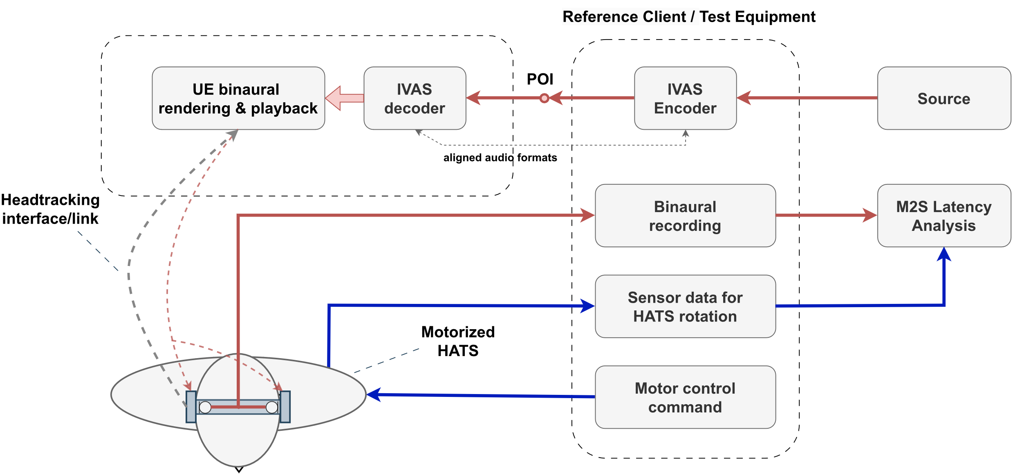
Figure 18a: Setup for measuring M2S latency using a motorized HATS
The motion-to-sound latency test for ISAR is conducted in a similar way as described above. In this case, the ISAR bitstream is transmitted over headtracking interface/link and the headset UE performs post-rendering including pose correction. The binaural signal from post-renderer is transmitted to binaural recording block in reference/client for M2S latency computation. The detailed setup is illustrated in Figure 18b.
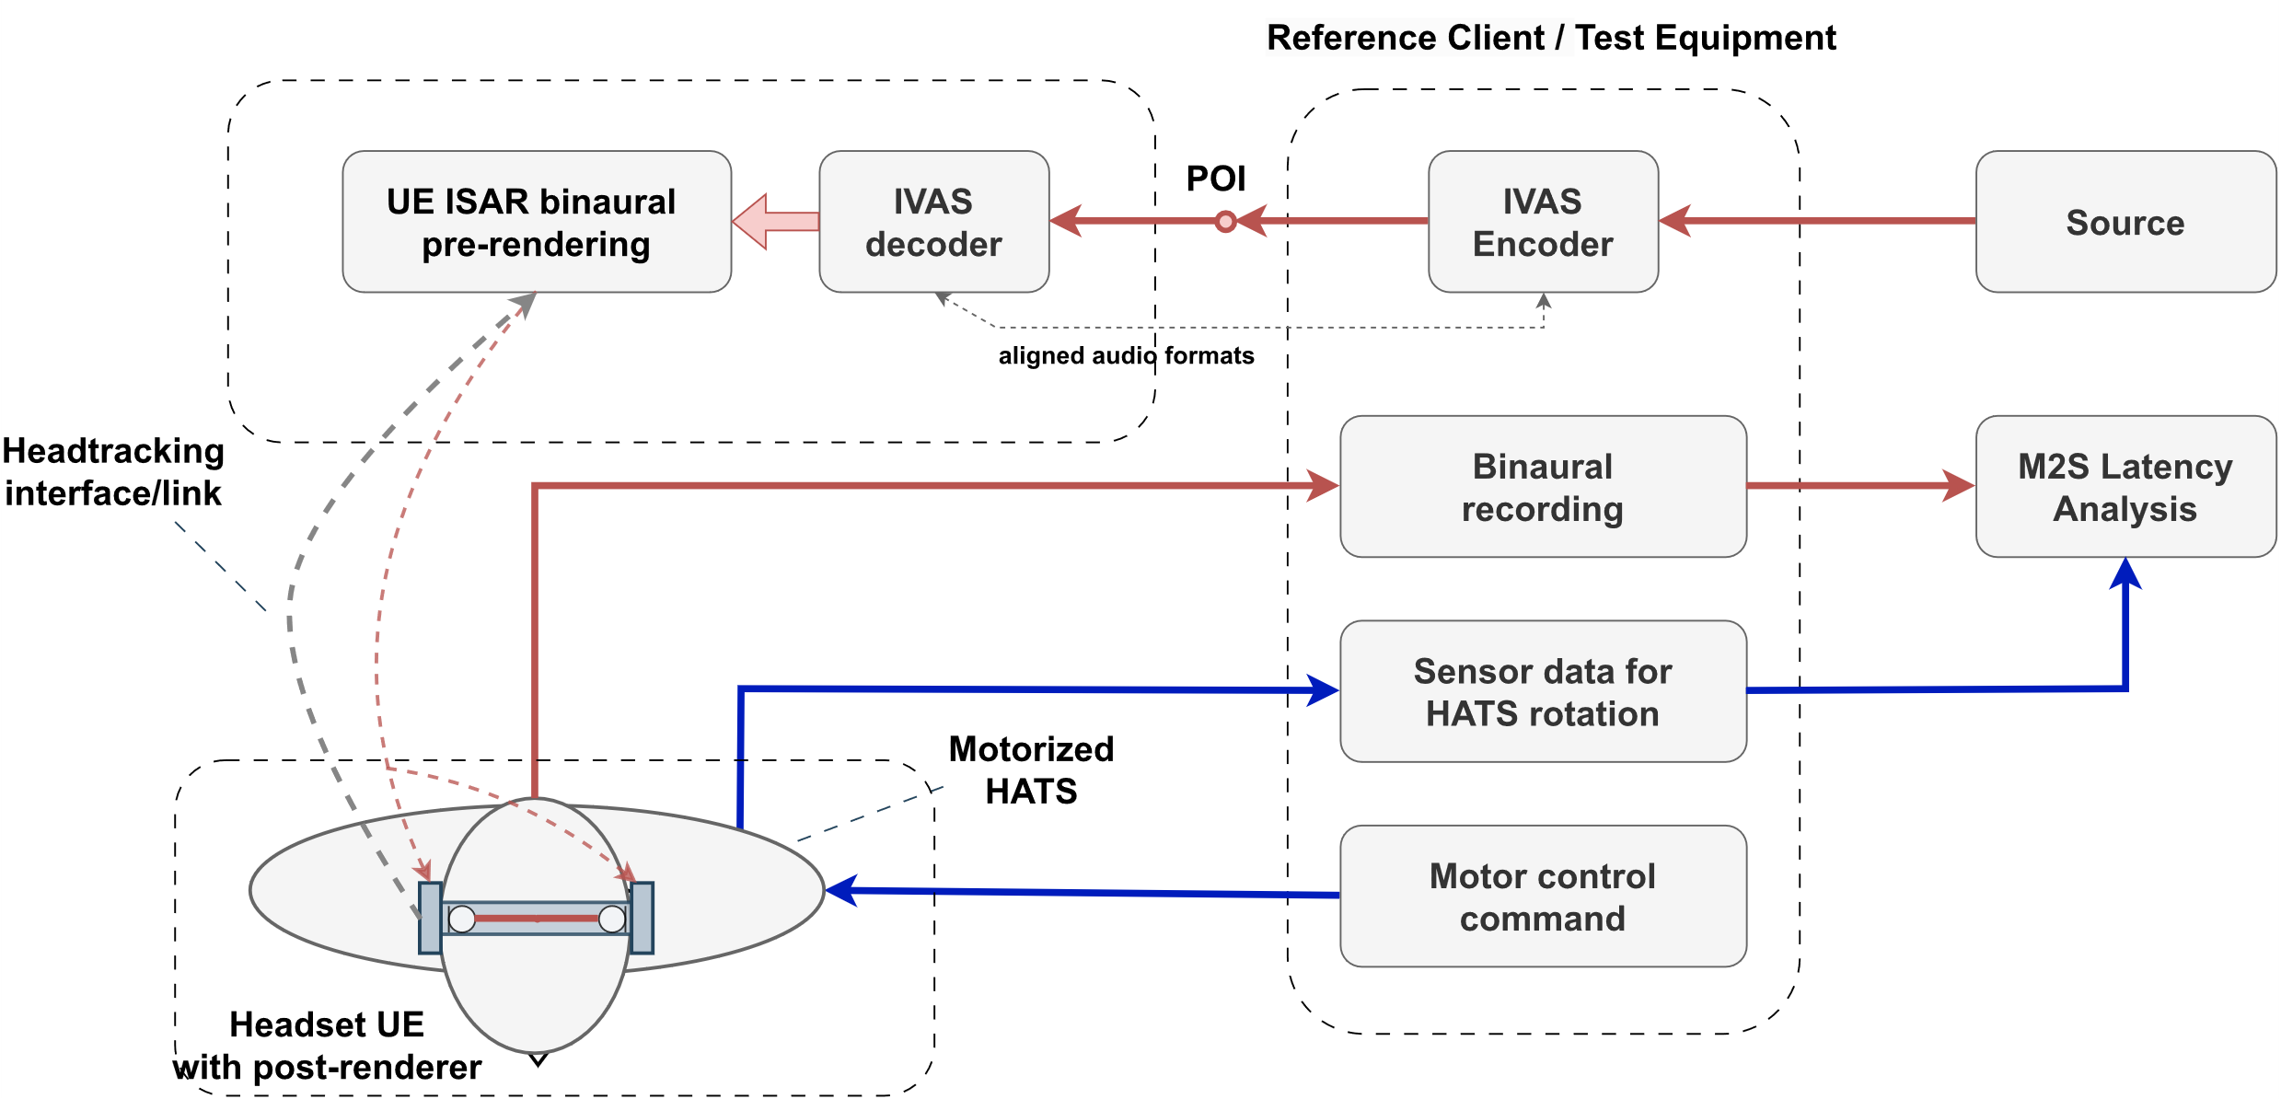
Figure 18b: Setup for measuring M2S latency with IVAS split rendering (ISAR) using a motorized HATS

5.7.5.2 Test signal and noise filtering
The test signal to be used for the measurements in receive direction shall be the periodic multitone signal according to [38] with period length 1 ms. The measured left and right ear signals are each filtered with a narrow zero-phase filter that is designed to suppress noise of the measurement apparatus while not impacting the relevant components of the test signal above 1.5 kHz, as illustrated in Figure 18c.
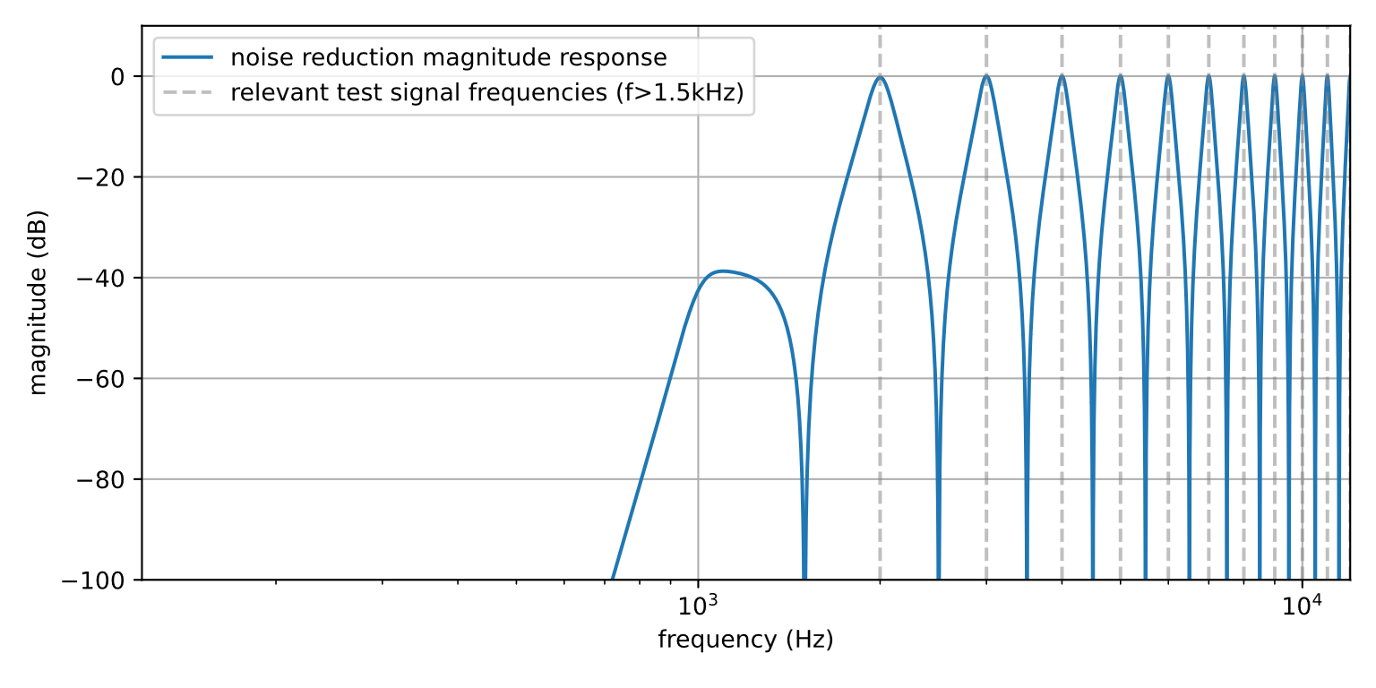
Figure 18c: Frequency response of noise reduction filter
After signal filtering, the residual noise spectrum averaged versus time of each (left and right) ear signal shall not exceed 25 dB SPL measured with for the continuous and repeated left-right/right-left movement as specified in step 4 of clause 5.7.5.4 and with mounted device.

5.7.5.3 Analysis
The test method evaluates interaural level differences that are calculated from the artificial ear signals with the following algorithm:
1) The filtered signals are denoted as xlk and xrk with sample index k and shall be made available at a sampling rate of fs=48 kHz.
2) The interaural level difference (ILD) is determined on the pre-processed left and right ear signals xlk and xrk, respectively. The ILD is calculated on short frames with index λ and can be stated as
ILDλ=max-ILDmax,minILDmax, 10log10k=0L-1xr2Rλ+kk=0L-1xl2Rλ+kdB.
For the calculation, frame length L=96 and hop size R=24 are used. The ILD is limited to
-ILDmin≤ILD(λ)≤ILDmax, with ILDmin/max=±12 dB.
3) The ILD is then smoothed over P=201 frames using a moving average with
ILDλ=1Pr=-P-12P-12ILDλ+r.
Time instances per frame index λ are determined by
tλ=1fsRλ+L-12.

5.7.5.4 Test method
The motion-to-sound (M2S) latency measurement shall be conducted as follows:
1) The signal shall be virtually positioned to 0° azimuth and 0° elevation (frontal position for 0° head orientation) as described in clause 5.5.2. The signal shall be calibrated to -20 LFKS as described in clause 5.5.1.
2) The UE and the reference client are set up according to clauses 5.4.2 and 5.3.2, the source signal is encoded by the reference client and inserted at the POI to the UE. In case a volume control is provided in receive direction, it shall be set to nominal setting as identified by clause 5.7.2.
3) The motorized HATS is oriented to 0°. For ILD calibration, the ear signals are captured for a duration of2-5 s without applying any motion to the UE. Then, ILDλ is determined for the ILD calibration sequence and an average ILD (denoted as ILD0°) is calculated as the mean of ILDλ.
4) The dynamic part of the measurement (in motion) is conducted as follows:
a) The motorized HATS rotates continuously and repeatedly between +60° (start orientation) and -60°. The 0° orientation shall be passed Nmeas=14 times, i.e., 7 times for each direction of rotation, so that a total of Nmeas partial estimates of M2S latency are determined. The duration between two zero-crossings shall be less than 2.0 s.
b) In the angle range between -10° and +10°, the angular velocity shall be constant with a nominal angular velocity of 108°/s.
c) During motion, the left and right ear signals and the time stamps t0(i) (where the motorized HATS passes 0° orientation) are captured for i=1,…, Nmeas.
5) After the last orientation is reached, the motorized HATS is immediately oriented to 0°. Step 3) is repeated to obtain the verification ILD, denoted as ILD0°,v.
6) The M2S latency time is calculated as follows for each zero-crossing i=1,…, Nmeas of the orientation:
a) The smoothed ILD versus time ILD(i)λ is determined.
b) The time stamp t1(i) of the sound signal passing 0° orientation is determined by identifying the zero-crossing of ILD(i)λ- ILD0°.
c) The M2S latency for the i-th measurement is determined by T(i)=t1(i)-t0(i).
7) The overall M2S latency is determined by calculating the median of T(i).
The principle of motion-to-sound analysis and determination of t1(i) and t0(i) is illustrated in Figure 18d.
NOTE 1: Before starting the measurement, the UE shall be initialized to match its reference (or zero) orientation with the HATS oriented to 0° and the UE shall be in active headtracking mode.
NOTE 2: The measurement method presented requires a constant reference orientation. In some IVAS UE use-cases, a DUT may intentionally adapt its reference orientation over time, for instance, based on the average of past orientations. The measurement method is not suited for such cases.

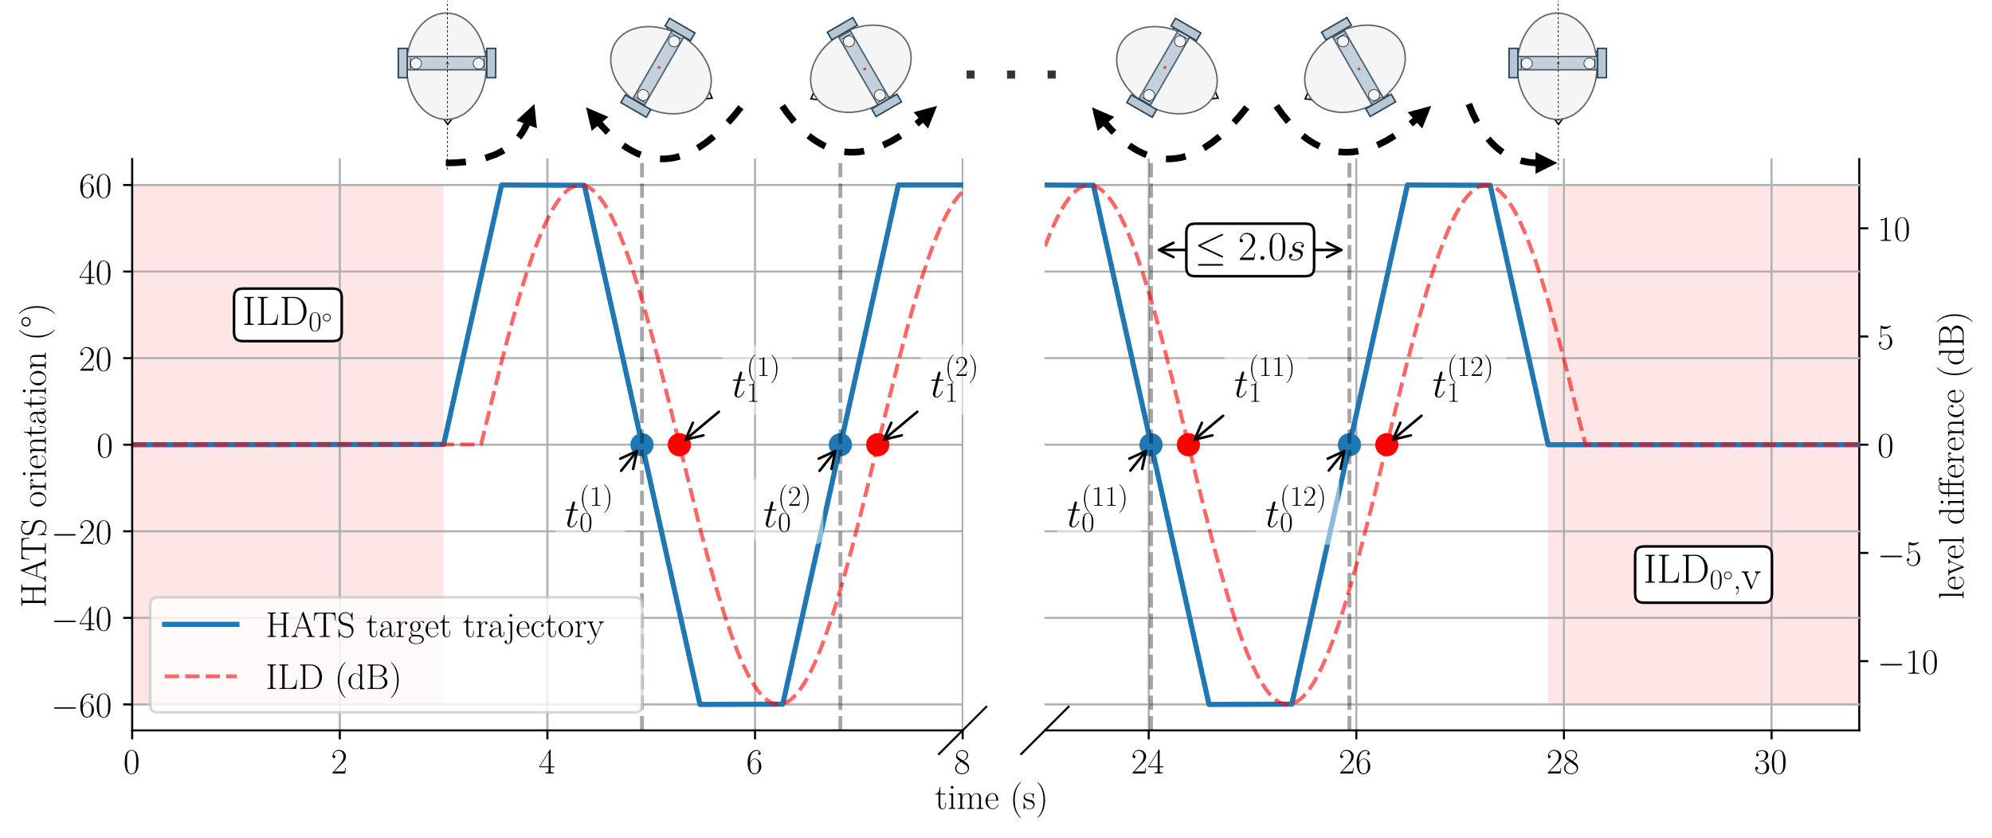
Figure 18d: Example setup for measuring M2S latency using a motorized HATS

Annex A (normative):
Order dependent directions
The following tables order-dependent directions $Ω_{j}^{(N)}=({ϕ_{j}^{\left(N\right)},θ}_{j}^{\left(N\right)}), 1≤j≤K$, where $θ_{j}^{(N)}$ and $ϕ_{j}^{(N)}$ denote the elevations and azimuths in radians, respectively.

Index $j$ | $$θ_{j}^{(N=1)}$$ | $$ϕ_{j}^{(N=1)}$$
1 | 1.570796 | 0
2 | -0.339837 | 0
3 | -0.339837 | 2.094395
4 | -0.339837 | -2.0944

Index $j$ | $$θ_{j}^{(N=2)}$$ | $$ϕ_{j}^{(N=2)}$$
1 | 1.570796 | 0
2 | -0.790277 | 0
3 | 0.363207 | -1.95668
4 | 0.363207 | 1.956682
5 | -0.844382 | -1.95668
6 | 0.009757 | -3.14159
7 | -0.844382 | 1.956681
8 | 0.245128 | 0.687124
9 | 0.245129 | -0.68712

Index $j$ | $$θ_{j}^{(N=3)}$$ | $$ϕ_{j}^{(N=3)}$$
1 | 1.570796 | 0
2 | 0.716698 | 0
3 | -0.461173 | 1.119907
4 | -1.034310 | -0.25283
5 | 0.492174 | 1.155586
6 | -0.165812 | 2.040481
7 | -0.461172 | -1.38118
8 | -0.165813 | 0.270692
9 | 0.001916 | -2.20417
10 | 0.653709 | 2.297267
11 | 0.653709 | -2.80293
12 | -0.192680 | 3.010956
13 | -1.079056 | 2.154919
14 | 0.001915 | -0.63529
15 | 0.616834 | -1.41973
16 | -0.887326 | -2.46809

Index $j$ | $$θ_{j}^{(N=4)}$$ | $$ϕ_{j}^{(N=4)}$$
1 | 1.570796 | 0
2 | 0.747578 | 0
3 | -0.168324 | -2.00759
4 | 0.846499 | 1.927637
5 | 0.234515 | -1.41208
6 | 0.699165 | -2.10001
7 | 0.307091 | 2.512927
8 | 0.130649 | 1.667633
9 | -0.677517 | 1.442383
10 | 0.136843 | -0.60062
11 | -1.317269 | 0.329968
12 | -0.433118 | -1.18621
13 | -0.231864 | 2.983332
14 | 0.174242 | -2.69222
15 | -0.599985 | 0.507602
16 | -0.382009 | 2.208977
17 | -0.009394 | 0.952319
18 | -1.013813 | -1.71565
19 | 0.696199 | 0.934402
20 | -0.602139 | -0.38654
21 | -1.041921 | 2.675958
22 | -0.623111 | -2.62842
23 | 0.054056 | 0.165012
24 | 0.855489 | -1.02504
25 | 0.808243 | -3.13121

Index $j$ | $$θ_{j}^{(N=5)}$$ | $$ϕ_{j}^{(N=5)}$$
1 | 1.570796 | 0
2 | -0.454100 | 0
3 | 0.323739 | -1.19666
4 | -1.175381 | 0.184066
5 | 0.947221 | 0.124282
6 | -0.193698 | -2.84022
7 | 0.500281 | -1.84701
8 | -0.663529 | 0.698758
9 | -0.613332 | 2.280239
10 | -0.588043 | -2.28482
11 | 0.946645 | -2.37569
12 | 0.333311 | 2.883411
13 | 0.967374 | -1.18504
14 | 0.436854 | -2.76846
15 | 0.510141 | 0.763488
16 | -0.063811 | -0.46491
17 | 0.048266 | -2.27504
18 | -0.148392 | 1.762138
19 | 0.945735 | 2.804486
20 | -0.125777 | -1.69175
21 | -0.241518 | -1.0321
22 | -0.063824 | 0.509415
23 | -1.240392 | -1.95737
24 | 0.542172 | -0.567
25 | 0.043647 | 2.319619
26 | -0.291045 | 2.853233
27 | -0.841101 | -3.07101
28 | -1.213891 | 2.113132
29 | -0.706626 | -1.50877
30 | -0.774625 | -0.65404
31 | -0.707445 | 1.464227
32 | 0.990842 | 1.373127
33 | -0.122664 | 1.112751
34 | 0.598614 | 2.113949
35 | 0.306690 | 0.057137
36 | 0.381934 | 1.457925

Index $j$ | $θ_{j}^{(N=6)}$ | $$ϕ_{j}^{(N=6)}$$
1 | 1.570796 | 0
2 | 0.720144 | 0
3 | -0.308365 | 3.024454
4 | 0.068431 | 2.080642
5 | -0.495677 | -2.21373
6 | -0.018779 | -2.03598
7 | 0.426043 | 1.678014
8 | -0.259742 | 0.964363
9 | 0.179320 | -3.03552
10 | -0.249618 | -2.70206
11 | 1.074183 | 0.581055
12 | -0.781172 | -2.80103
13 | 0.457849 | 0.550136
14 | 0.523951 | -1.98436
15 | -0.006246 | -0.51212
16 | -0.788507 | -1.1411
17 | 0.228181 | -2.48765
18 | -0.418110 | -1.62282
19 | -0.512688 | -0.57506
20 | 0.572140 | 2.286204
21 | -0.867576 | -0.08741
22 | -0.624799 | 0.547028
23 | -0.446687 | 1.878965
24 | -0.789667 | 2.746717
25 | 1.047763 | -0.76025
26 | 0.247192 | -1.01978
27 | 0.720143 | 1.162107
28 | -0.081819 | 1.507148
29 | 0.226040 | 1.062706
30 | 0.709088 | -2.68135
31 | -0.249096 | -1.08377
32 | 0.573959 | 2.91352
33 | 1.069121 | 2.939099
34 | 0.135381 | -1.53966
35 | -0.057504 | 0.473238
36 | -0.975369 | -1.95522
37 | -0.666036 | 1.294994
38 | -1.146922 | 0.887936
39 | -0.357070 | 2.427548
40 | 0.200642 | -0.01608
41 | -0.965084 | 1.97199
42 | 0.681666 | -1.35341
43 | 0.112434 | 2.651183
44 | 0.528475 | -0.57647
45 | 1.003627 | 1.857517
46 | -1.275974 | -0.77916
47 | 1.051102 | -2.01121
48 | -1.315079 | 3.087768
49 | -0.326694 | -0.00446

Annex B (normative):
Directions in Gaussian spherical grid

B.1 Definition
A Gaussian grid of order N consists of 2(N+1)² points associated to directions $Ω_{i,j}^{(N)}=\left(θ_{i}^{(N)},ϕ_{j}^{(N)}\right)$, $0≤i≤N$ and $0≤j<2(N+1)$, where $θ_{i}^{(N)}$ and $ϕ_{j}^{(N)}$ denote the elevation and azimuth, respectively. These directions are defined as follows [7]: The elevations $θ_{i}^{(N)}$ are computed as the zeros of the (N+1)-th degree Legendre polynomial
$P_{N+1}\left(cos⁡(θ_{i}^{(N)})\right)=0$, while the azimuths are given by $ϕ_{j}^{(N)}=\frac{2πj}{2(N+1)}$ (in radians) or j.180/(N+1) (in degrees), $0≤j<2(N+1)$.
Directions in test setup shall comply with the theoretical values $Ω_{i,j}^{(N)}$ with an accuracy of +/-0.5 degree for all azimuths and +/-0.5 degree for elevations in the range [-80,+80] degrees. For elevation >80 degrees and <-80 degrees, the accuracy shall be respectively +4/-0.5 degrees and +0.5/-4 degrees.

B.2 Example loudspeaker array
An example implementation with an ambisonic order N = 29 is described below:
- A turn table with constant step size of 6 degrees and starting at 0 degree (to obtain 60 positions in azimuth).
- Two fixed semi-arcs of radius 2.5 meters separated in azimuth by 90 degrees with 15 loudspeakers on each semi-arc; the elevations of loudspeakers are given (in degrees) by -85, -80, -74, -68, -62, -56, -50, -44, -38, -32, -27, -21, -15, -9, -3, 3, 9, 15, 21, 27, 32, 38, 44, 50, 56, 62, 68, 74, 80, 85, where succesive values are alternatively allocated to each semi-arc.
NOTE: In practice, the elevation of -85 degrees may be replaced by a nearby value (e.g. -82 degrees) to leave room for the mounting structure at the bottom of the loudspeaker array.

Annex C (normative):
Cross-correlation analysis
The following analysis method is used to determine the time difference (delay) between two time-discrete signals $x\left(k\right)$ and $y\left(k\right)$ by applying segmental cross-correlation with period T (in samples) and overlap L (in percent).
If not specified otherwise, a sampling rate of 48 kHz is assumed.
The envelope $E\left(i,τ\right)$ of the segmental cross-correlation function $Φ_{xy}\left(i, τ\right)$ between $x\left(k\right)$ and $y\left(k\right)$ is calculated by means of the Hilbert transformation:
$E\left(i,τ\right)=\sqrt{{\left[Φ_{xy}\left(i,τ\right)\right]}^{2}+{\left[H\left\{Φ_{xy}\left(i,τ\right)\right\}\right]}^{2}}$
$H\left\{Φ_{xy}\left(i,τ\right)\right\}=\sum_{u=-\frac{T}{2}}^{+\frac{T}{2}}{\frac{Φ_{xy}\left(i,u\right)}{π\left(τ-u\right)}}$
$Φ_{xy}\left(i,τ\right)=\frac{1}{T}\sum_{k=\frac{-T}{2}}^{\frac{T}{2}}{x\left(i,k\right)⋅y\left(i,k+τ\right)}$
Each segment $i$ has a duration of T samples, using an overlap of L percent. The time difference $Δ_{τ}$ is then determined by the time lag $τ$ that provides the maximum value.
$\overline{E}\left(τ\right)=\frac{1}{N}\sum_{i=1}^{N}{E\left(i,τ\right)}$
$Δ_{τ}=\underset{τ}{argmax}{\overline{E}\left(τ\right)}$
For expected shorter time differences (up to ~85 ms), T = 8192 and L = 50% are recommended.
For expected longer time differences (up to ~1.4 s), T = 131072 and L = 50% are recommended.
If an aggregate value over the whole signal sequence is to be determined, T shall comprise the whole signal length (no overlap).

==============End of change==============

