CR-Form-v12.3
CHANGE REQUEST
 | 26.252 | CR | 0005 | rev | 2 | Current version: | 19.0.0
For HELP on using this form: comprehensive instructions can be found at
http://www.3gpp.org/Change-Requests.

Proposed change affects: | UICC apps |  | ME | X | Radio Access Network |  | Core Network | X

Title: | Updates related to IVAS conformance testing of TS 26.258 and TS 26.251
Source to WG: | Dolby Laboratories Inc., Ericsson LM, Fraunhofer IIS, Huawei, Nokia, NTT, Orange, Panasonic Holdings Corporation, Philips International B.V. VoiceAge Corporation, Qualcomm Inc.
Source to TSG: | S4
Work item code: | IVAS_Codec_Ph2 |  |  |  |  |  | Date: |  |  | 2025-11-11
Category: | B |  |  |  |  |  | Release: |  |  | Rel-19
 | Use one of the following categories:  F (correction)  A (mirror corresponding to a change in an earlier release)  B (addition of feature),  C (functional modification of feature)  D (editorial modification)  Detailed explanations of the above categories can  be found in 3GPP TR 21.900. |  |  |  |  |  |  |  | Use one of the following releases:  Rel-8 (Release 8)  Rel-9 (Release 9)  Rel-10 (Release 10)  Rel-11 (Release 11)  …  Rel-17 (Release 17)  Rel-18 (Release 18)  Rel-19 (Release 19)  Rel-20 (Release 20)
Reason for change: |  | Missing IVAS bit-exact conformance for TS 26.251 and non-bit-exact conformance testing for TS 26.258
Summary of change: |  | Add bit-exact conformance for TS 26.251  Add non-bit-exact conformance testing for TS 26.258
Consequences if not approved: |  | Implementers will not be able to check if their implementation is conformant to IVAS specifications
Clauses affected: |  | 1, 2, 4.1, 5.1, 7.1, 7.2.1 (new heading), 7.2.2 (new), 7.2.3 (new), Annex A (new), Readme.txt (separate file), electronic attachment
 |  | Y | N
Other specs |  |  | X | Other core specifications |  |  |  | TS/TR ... CR ...
affected: |  |  | X | Test specifications |  |  |  | TS/TR ... CR ...
(show related CRs) |  |  | X | O&M Specifications |  |  |  | TS/TR ... CR ...
Other comments:
This CR's revision history: |  | Rev 1: Adding non-BE conformance tests for fixed-point implementations and non-BE conformance tests for Metadata output files  Rev 2: Removing non-BE conformance tests for fixed-point implementations.

==============First change==============

1 Scope
The present document specifies the digital test sequences for the Immersive Voice and Audio Services (IVAS) codec. These sequences shall be used in conformance testing for implementations of the IVAS codec (3GPP TS 26.253), Rendering (3GPP TS 26.254), Error Concealment of Lost Packets (3GPP TS 26.255) and Jitter Buffer Management (JBM) (3GPP TS 26.256) and its reference C code specifications, which are 3GPP TS 26.258 (floating-point) and 3GPP TS 26.251 (fixed-point). In addition, the present document specifies procedures for conformance testing.
==============Next change==============

2 References
The following documents contain provisions which, through reference in this text, constitute provisions of the present document.
- References are either specific (identified by date of publication, edition number, version number, etc.) or non-specific.
- For a specific reference, subsequent revisions do not apply.
- For a non-specific reference, the latest version applies. In the case of a reference to a 3GPP document (including a GSM document), a non-specific reference implicitly refers to the latest version of that document in the same Release as the present document.
[1] 3GPP TR 21.905: "Vocabulary for 3GPP Specifications".
[2] 3GPP TS 26.250: "Codec for Immersive Voice and Audio Services (IVAS); General overview".
[3] 3GPP TS 26.251: "Codec for Immersive Voice and Audio Services (IVAS); C code (fixed point)".
[4] 3GPP TS 26.253: "Codec for Immersive Voice and Audio Services (IVAS); Detailed Algorithmic Description including RTP payload format and SDP parameter definitions".
[5] 3GPP TS 26.254: "Codec for Immersive Voice and Audio Services (IVAS); Rendering".
[6] 3GPP TS 26.255: "Codec for Immersive Voice and Audio Services (IVAS); Error concealment of lost packets".
[7] 3GPP TS 26.256: "Codec for Immersive Voice and Audio Services (IVAS); Jitter Buffer Management".
[8] 3GPP TS 26.258: "Codec for Immersive Voice and Audio Services (IVAS); C code (floating- point)".
[9] 3GPP TS 26.444: "Codec for Enhanced Voice Services (EVS); Test Sequences".
[10] ETSI TS 103 634 V1.4.1 (2023-03), "Digital Enhanced Cordless Telecommunications (DECT); Low Complexity Communication Codec plus (LC3plus)".
[11] 3GPP TS 26.249: "Immersive Audio for Split rendering scenarios”.

==============Next change==============

4.1 Introduction
This specification provides digital test sequences that shall be used to test conformance for an implementation of the IVAS codec (TS 26.253 [4]), Rendering (TS 26.254 [5]), Error Concealment of Lost Packets (TS 26.255 [6]) and Jitter Buffer Management (JBM) (TS 26.256 [7]), and its reference C code specifications, which are TS 26.258 [8] (floating-point) and 3GPP TS 26.251 [3] (fixed-point). An overview of the IVAS Codec specifications is found in TS 25.250 [2].
A standard compliant implementation of the above specifications shall pass the conformance tests according to clause 7. The necessary test sequences can be found in the corresponding ZIP files according to the attached Readme.txt file.
NOTE: The test sequences apply to specific version(s) of the IVAS codec as indicated by the name of the ZIP file, e.g., IVAS-FL-1.0. The codec version number is used to have consistent numbering across reference C code specifications.
Clause 5 describes the format of the files, which contain the digital test sequences. Clause 6 describes the test sequences for the IVAS codec, including rendering, error concealment of lost packets, and jitter buffer management. Clause 7 describes the conformance testing procedure for implementations of the IVAS codec.

==============Next change==============

5.1 Introduction to test sequence format
This clause provides information on the format of the digital test sequences for the IVAS codec (TS 26.253 [4]), Rendering (TS 26.254 [5]), Error Concealment of Lost Packets (TS 26.255 [6]) and Jitter Buffer Management (JBM) (TS 26.256 [7]) and its reference C code specifications, which are TS 26.258 [8] (floating-point) and TS 26.251 [3] (fixed-point).
==============Next change==============

7.1 Bit-exact Conformance
For an implementation to be declared conformant according to the bit-exact conformance test procedure, the output sequences of the corresponding feature being implemented (IVAS encoder, IVAS decoder, IVAS renderer, JBM, ISAR pre-renderer, ISAR post-renderer) shall match bit-exactly the reference test sequences provided in the corresponding ZIP files in accordance with clause 6, including clause 6.3.1 for mono operation of the IVAS encoder and IVAS decoder. This applies for all implementations of the IVAS codec (TS 26.253 [4]), Rendering (TS 26.254 [5]), Error Concealment of Lost Packets (TS 26.255 [6]) and Jitter Buffer Management (JBM) (TS 26.256 [7]), and its reference C code specifications, which are 3GPP TS 26.258 (floating-point) and 3GPP TS 26.251 (fixed-point).

If optional features are implemented, the corresponding conformance tests shall pass.
==============Next change==============

7.2 Non-Bit-exact Conformance

7.2.1 Non-Bit-exact Conformance for IVAS floating-point operations

7.2.1.1 IVAS floating-point mono operation
For IVAS mono operation (of and IVAS encoder or IVAS decoder), if an implementation under test is based on floating–point code (TS 26.258 [8]) and the output sequences are not bit-exact to the test sequences according to clause 6, the non-bit-exact conformance testing procedure defined in TS 26.444 [9] shall be used to test the conformance.
If optional features are implemented, the corresponding conformance tests shall pass.

7.2.1.2 IVAS floating-point conformance in stereo and immersive operation
If an implementation under test is based on the reference floating–point code (TS 26.258 [8]) and the output sequences are not bit-exact to the test sequences according to clause 6, the non-bit-exact conformance testing process defined here shall be used to test the conformance.
A conformant floating-point implementation of the IVAS codec shall be compliant to the reference specification in TS 26.250 [3] by implementing all the algorithmic steps of the IVAS codec, further specified in 3GPP TS 26.253 (Detailed Algorithmic Description) [4], 3GPP TS 26.254 (IVAS rendering) [5], 3GPP TS 26.255 (Packet Loss Concealment (PLC) of Lost Packets) [6], 3GPP TS 26.256 (Jitter Buffer Management (JBM)) [7] and 3GPP TS 26.249 Immersive Audio for split rendering scenarios (ISAR) [11].
If a floating-point implementation uses the Jitter Buffer Management (JBM) according to TS 26.256 [7], the implementation shall be compliant to the reference specification in TS 26.253 [4] by implementing all the algorithmic steps of 3GPP TS 26.256 (Jitter Buffer Management (JBM)).
If a floating-point implementation uses the renderer according to TS 26.254 [5], the implementation shall be compliant to the reference specification in TS 26.253 [4] by implementing all the algorithmic steps of 3GPP TS 26.254 (IVAS rendering).
If a floating-point implementation uses the Immersive Audio for Split rendering (ISAR) according to TS 26.249 [11], the implementation shall be compliant to the reference specification in TS 26.253 [4] by implementing all the algorithmic steps of 3GPP TS 26.249 (Immersive Audio for Split rendering (ISAR)).

An implementation shall be tested for non-bit-exact conformance using two specific tests:
- Decoder test comparing the implementation decoder with TS 26.258 [8] decoder.
- Encoder test comparing the implementation encoder with TS 26.258 [8] encoder.
Both encoder and decoder tests shall pass for the implementation to be declared conformant. Figure 7.1 shows the flow chart of the non-bit-exact conformance process.
In addition to the encoder and decoder conformance tests, if an implementation uses the Jitter Buffer Management (JBM) according to TS 26.256 [7], then it shall be tested for non-bit-exact conformance using:
- Jitter Buffer Management (JBM) test comparing the implementation JBM with TS 26.258 [8] decoder.
In addition to the encoder and decoder conformance tests, if an implementation uses the IVAS rendering according to TS 26.254 [5], then it shall be tested for non-bit-exact conformance using:
- Renderer test comparing the implementation encoder with TS 26.258 [8] renderer.
In addition to the encoder and decoder conformance tests, if an implementation uses the IVAS split rendering according to TS 26.254 [5], then it shall be tested for non-bit-exact conformance using two specific tests:
- Split rendering pre-renderer test comparing the implementation split renderer with TS 26.258 [8] decoder and renderer
- Split rendering post-renderer test comparing the implementation split renderer with TS 26.258 [8] split renderer post-renderer.
Non-bit-exact conformance is defined based on comparisons with WAV output files and metadata output files. Metadata output files are ISM metadata (with .csv file extension) and MASA metadata (with .met file extension) output files.

The tests with WAV output files described in more details in Annex A.
The tests with Metadata output files shall yield a maximum deviation from the reference that is not larger than the threshold specified in Annex A.3.1.2, where the maximum deviation is measured separately per metadata parameter for each metadata format.

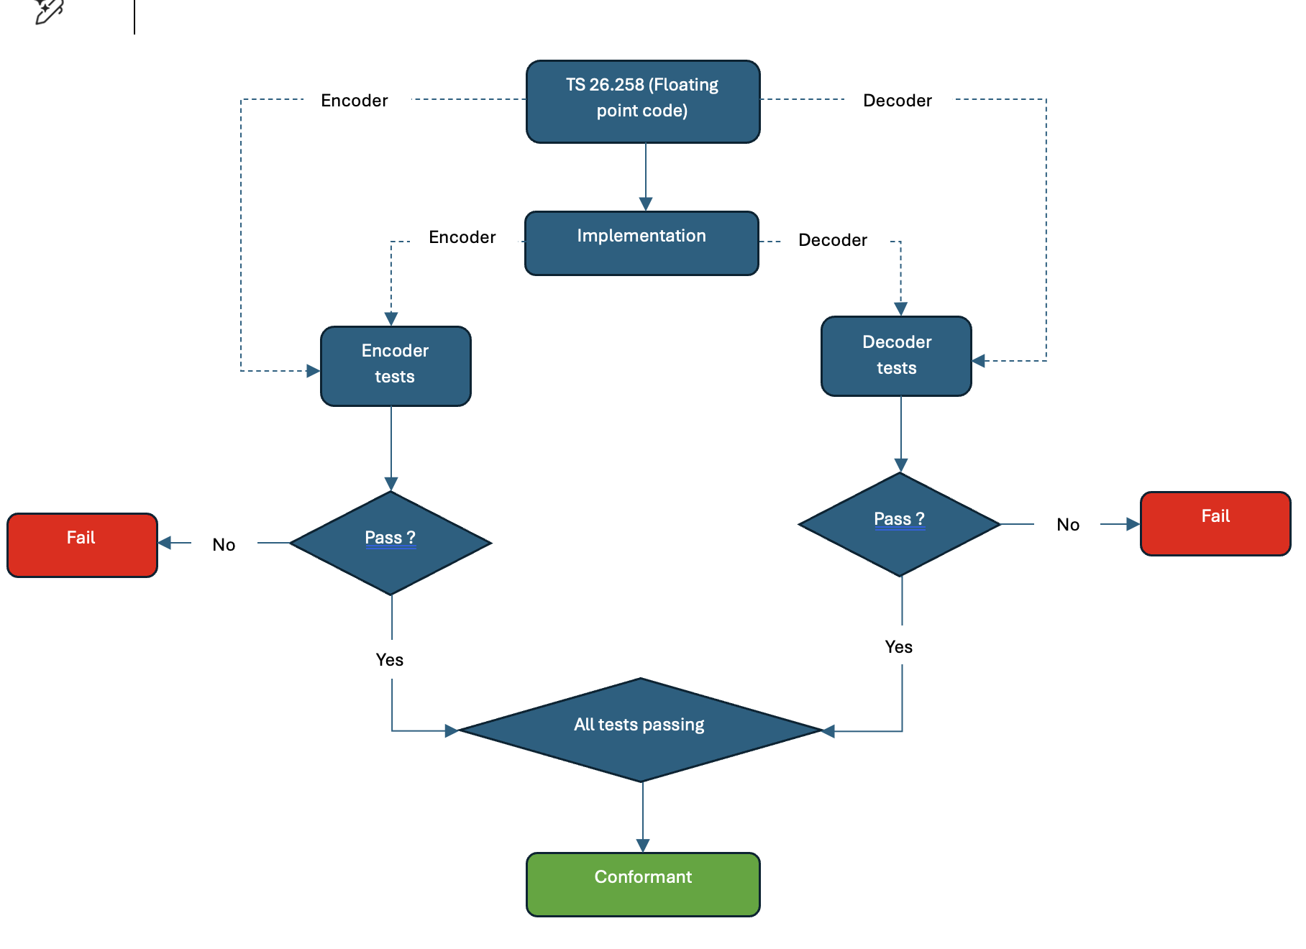
Figure 7.1: Non-bit-exact conformance process

7.2.3 Running the Tests
The executables and scripts illustrating how to run the tests are included in the ZIP of the floating-point test sequences. Annex A provides more details on the tests. In the case of discrepancy between the procedure described in Annex A and the scripts provided in the ZIP file, the procedure of the scripts provided prevail.
For all IVAS tests, including encoder, decoder, JBM, renderer and split renderer, instructions on how to operate the implementation under test to run the tests are contained in the text file Readme.md. The scripts require certain Python® packages (instructions on Python® packages are contained in the Readme file) and an additional tool, wav-diff.exe (instructions on how to download it are contained in the Readme file). The IVAS test scripts are run by executing a Python® script:
- runConformance.py (instruction on how to use the script are provided in the Readme.md)
The reference files for MLD encoder and decoder tests are also included in the zip file.
The implementation will be declared conformant if all encoder and decoder tests are passed.
The reference files for MLD JBM, Rendering and Split rendering tests are also included in the zip file.
The implementation of JBM will be declared conformant if all JBM tests are passed.
The implementation of IVAS rendering will be declared conformant if all IVAS rendering tests are passed.
The implementation of IVAS split rendering will be declared conformant if all IVAS split rendering (ISAR) tests are passed.

==============Next change==============

Annex A: Tools Description (normative)

A.1 Decoder Test

A.1.1 General Considerations
The WAV signals under test are obtained by running the bit-stream included in this specification through the Decoder under Test (Figure A.1). The reference decoder is built from the floating-point code of TS 26.258 [8] if conformance is tested according to clause 7.2.1.2.
NOTE: The reference decoders must be built following the procedures and for the platforms as specified in [8] or [3], respectively.
Figure A.1: Flow diagram for the decoder test using signal-based metrics
The MLD metric, as defined in clause A.1.2, is used to test the non-bit-exact floating-point implementation. This metric is calculated on the reference WAV signal xREF(t) and the WAV signal under test xTST(t) based on 20ms frames. The frames of the two signals will be time aligned, this means the delay compensation in IVAS encoder and decoder remains ON (the default configuration).
The number of samples N for a 20ms frame size is defined by N=fs∙0.02, where fs represents the sampling rate.

A.1.2 Metrics
The Loudness Difference (LD) is used as defined in A.2.2 of [9]. Given that the IVAS decoder output can have multiple channels, the MLD per 20 ms frame is computed as the maximum of MLD values of all the channels in that frame.
The LD should be below a threshold ThMLD based on a reference value plus some headroom as defined below.
The headroom is defined as fixed value, currently set to 0.1.
ThMLDn=0.1+ LDrefn
Then for each file a MLD could be defined as
MLD=minThMLDn-Ndiffn
Where, Ndiff is MLD per 20ms frame as defined in A.2.2 of [9].
The test file will be considered equivalent to the reference file if the MLD is positive or equal to 0, i.e. the Loudness Difference does not exceed the threshold for all the frames.
LDref is defined by reference implementations of the reference c-code on various reference platforms listed in clause A.4:
For each frame of each test sequence, the maximum LD value of all reference implementations defines a corridor, the ‘refline’. This then leads to a profile for each IVAS test sequence, which contains on a 20ms frame basis an allowed LDref value relative to the reference. Allowed differences in implementations under test (IuTs) are thus limited to the tolerable differences by the different compilers used for the refline generation.
All the test sequences need to pass for the implementation to be conformant.

A.2 Encoder Test

A.2.1 General Consideration
The reference bitstreams are taken from the encoded floating-point test sequences of this specification. Figure A.3 shows the flow diagram of the encoder conformance test according to clause 7.2.1.2 for a floating-point implementation.
NOTE: The reference encoders and decoders must be built following the procedures and for the platforms as specified in [8] or [3], respectively.
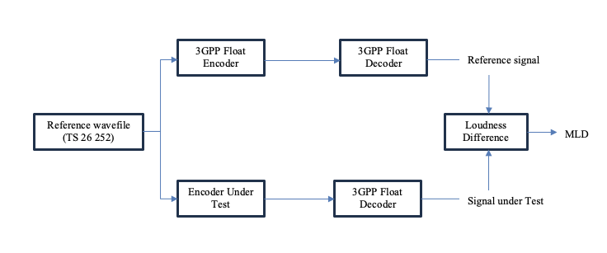
Figure A.3: Flow diagram for the encoder test using MLD Loudness Difference metric
All encoder test sequences from this specification will be encoded using the encoder implementation under test. The bit-stream obtained will be then decoded using the 3GPP reference float decoder from TS 26.258 [8] to obtain the test signals. The test signals will then be compared with the reference signal from this specification. Since the loudness tool (presented in clause A.2.2) operates on 48 kHz sample rate only, additional resampling is applied before processing.

A.2.2 Metrics
As defined in A.1.2.
All the test sequences need to pass for the implementation to be conformant.

A.3 Thresholds and Criteria

A.3.1 Thresholds and Criteria for IVAS floating-point operations

A.3.1.1 MLD Thresholds for WAV comparisons

MLD thresholds are defined using MLD corridor defined in clause A.1.2.

A.3.1.2 Thresholds for Medatata comparisons
For Metadata output files of IVAS floating-point operations a deviation threshold is defined for each metadata format separately.
For ISM metadata format, each metadata parameter is defined to have a separate threshold. The threshold of 0 applies to each metadata parameter.
For MASA metadata format, each spatial metadata parameter is defined to have a separate threshold. The threshold of 0 applies to each spatial metadata parameter.

A.4 Reference Implementations
To get the MLD corridor as the threshold values for non-BE conformance tests, as set of references implementations were used. Table A.8 list the implementations used for references, including compiler, target platform, compiler setting. These implementations are based on mainstream compilers and platforms and used the latest version of IVAS code defined in TS 26.258 [8]. These implementations are not bit-exact between themselves or with the 3GPP reference implementation (Ubuntu 24.04, Clang 18, O0).
Table A.4: List of Reference Implementations
Name | Platform | Compiler | Optimization | OS
Xeon_gcc_v11_o0 | Intel(R) Xeon(R) W-1290 | GCC v11 | O0 | Linux
Xeon_gcc_v11_o2 | Intel(R) Xeon(R) W-1290 | GCC v11 | O2 | Linux
Xeon_gcc_v11_o3 | Intel(R) Xeon(R) W-1290 | GCC v11 | O3 | Linux
Xeon_clang_v14_o2 | Intel(R) Xeon(R) W-1290 | Clang v14 | O2 | Linux
Xeon_clang_v14_o3 | Intel(R) Xeon(R) W-1290 | Clang v14 | O3 | Linux
Windows_ | Visual Studio 2017 (v141) | MSVC 2017, toolset 2015 | O0 | Windows 10
 | Visual Studio 2017 (v141) | MSVC 2017, toolset 2015 | O2 | Windows 10

==============Next change==============

##############################################################################################################################

Readme.txt file for IVAS test sequences - Nov 2025

The test sequences for the IVAS codec are, due to their size, not directly attached to the specification file, but stored at:

ftp://ftp.3gpp.org/Specs/archive/26_series/26.252/test_sequences/

The filename is:

26252_IVAS-FL-3.0.zip for floating-point (TS 26.258)

26252_IVAS-FX-3.0.zip for fixed-point (TS 26.251)

Note that the files will be updated with each new version of the IVAS source code specifications,

so that the corresponding version numbers of the related test sequences always match the codec version.

Contact:

Andrijana Brekalo (Technical Officer) / Dongwook Kim (3GPP Specifications Manager)

3GPP MCC

andrijana.brekalo@etsi.org / dongwook.kim@etsi.org

##############################################################################################################################

==============End of changes==============

