Source: Nokia
Title: Compensation of integrated microphone responses
Document for: Discussion & Agreement
Agenda Item: 7.6 – DaCAS

1. Introduction
The source proposes an acoustic measurement method that enables microphone signal compensation for microphone arrays for spatial audio capture and application. The method is based on Integrated Microphone Pressure Frequency Response Measurement (IMPro) [1], which characterizes the signal path from the microphone’s sound inlet to its raw microphone signal output.
The acoustic signal path from the sound source to the captured microphone signal can be divided into two main parts:
- Device external acoustic scattering: This part relates to the device’s shape and surrounding scattering objects, which are essential for the favorable placement of the microphone inlet port on the device’s outer surface. The pressure signal at the microphone inlet contains all relevant information about the sound source and serves as a foundation for spatial audio processing.
- Device internal acoustic path and microphone transducer response: This includes the acoustic sound port from the device surface to the microphone transducer, encompassing the port’s geometry, any ingress protection materials, and the transducer’s frequency response.
While the external scattering properties can be measured or simulated, accurately estimating the integrated pressure frequency response is significantly easier through direct measurement than through modeling. Recent study on free-field frequency response synthesis has shown that the synthesized hybrid free-field directional frequency responses closely match real measured responses and a hybrid technique can be applied to commercial device with integrated microphones [2].
The proposed method for integrated microphone measurement and signal compensation is grounded in physical principles, making it intuitive and making it easy to understand and identify possible design and microphone integration problems. The measured IMPro data provides solid basis for the compensation of integrated microphone responses imperfections and enables the design of linear compensation filters without compromising overall system performance.

2. Free-field frequency response synthesis
Traditional spatial audio device characterization relies on turntable-based frequency response measurements with loudspeaker sources. IMPro offers an alternative approach that separates device internal acoustic from device external acoustics. Device external acoustics can be simulated using available simulation tools.

2.1 IMPro measurement responses
In [2], IMPro measurements were provided for two devices;
- DaCAS Device B: In the case of Four-Microphone Prototype Device B (here DaCAS Device B for short) [3] we expected similar microphone responses for all six microphones (where the DaCAS configuration [7] uses four of the six microphones) except microphone 3, which has a shorter microphone port and therefore lower resonance. Small variations between microphone may be explained by positioning of the microphone relative to the microphone port and placement of sealing gasket.
- Commercial smartphone: Commercial example device has 3 microphones and an IP68 rating protecting against dust and can withstand being submerged in water. As expected, resonances of commercial device microphone integration leads to lower resonance frequencies with broader Q-factor.

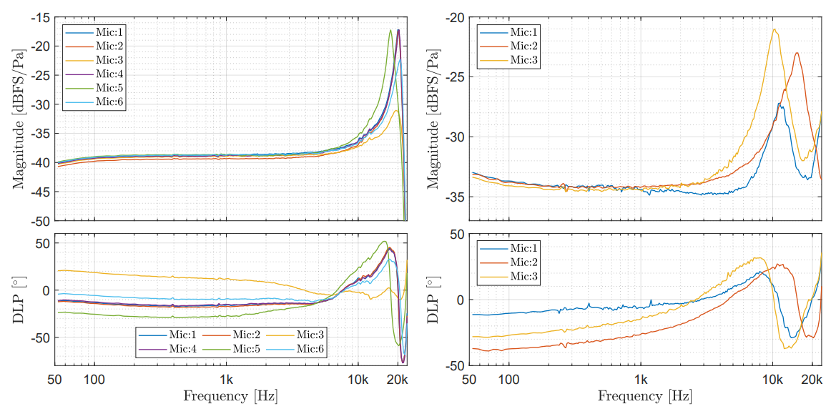
(a) (b)
Figure 1 (a) IMPro magnitude and phase responses for DaCAS Device B microphones (left column); (b) IMPro responses for a commercial smartphone with three microphones (right column). DLP indicates deviation from linear phase.

2.2 Synthesized free-field responses
When IMPro measurement results, illustrated in Figure 1, are combined acoustic simulation results of device external acoustic describing simulated acoustic waveform scattering around the device, it is possible to synthesize data that is comparable to free-field measurements agreed for DaCAS device characterization in [4]. Detailed explanation of free-field frequency response synthesis method utilizing IMPro measurement of integrated microphones has been presented in [2].
Free-field frequency responses synthesized for DaCAS Device B [4] are illustrated in Figure 2. The left-hand side column illustrates traditional free field response measurement made in an anechoic chamber. The middle column provides the synthesized free-field response combining IMPro responses from device microphones with BEM simulation results of the target device in free field. Simulated device geometry was carefully aligned with measurement geometry to minimize differences between compared methods. Magnitude response differences have been illustrated in the right-hand side column. Differences indicate that free-field measurements in anechoic chamber have more measurement noise because averaging of repeated IMPro measurements (N=20) reduce noise for all source directions, whereas averaging of anechoic free-field measurements for each source direction could slow down the practical lab measurements excessively. The magnitude response difference $∆H$ has been saturated to $±2$dB for visualization purposes.

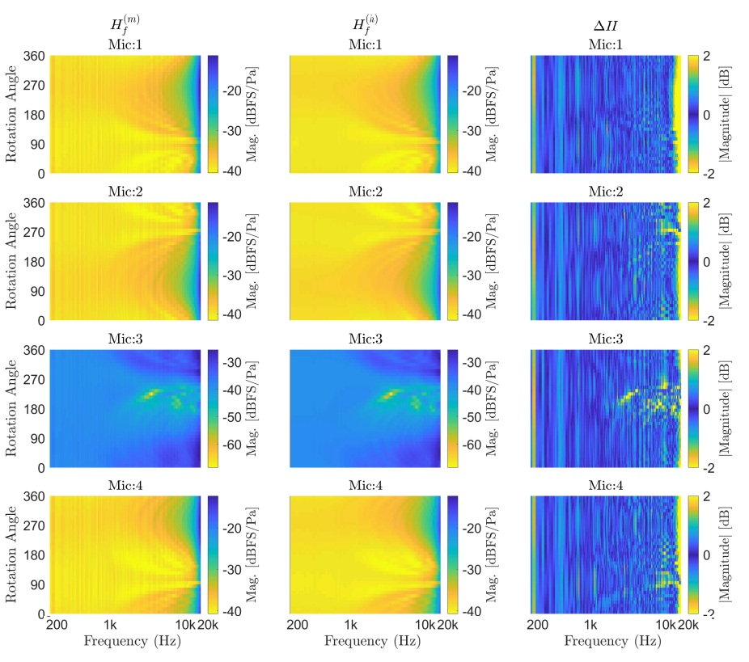
Figure 2 First column presents frequency responses measured DaCAS Device B in anechoic chamber, second column shows frequency response with integrated microphone response (IMPro) combined with simulated response, and the third column presents the magnitude difference of these alternative methods for all rotations.

To validate the approach on real commercial hardware, the same free-field synthesis was applied to a commercial smartphone. Figure 3 demonstrates that the proposed method delivers comparable evaluation results for commercial devices.

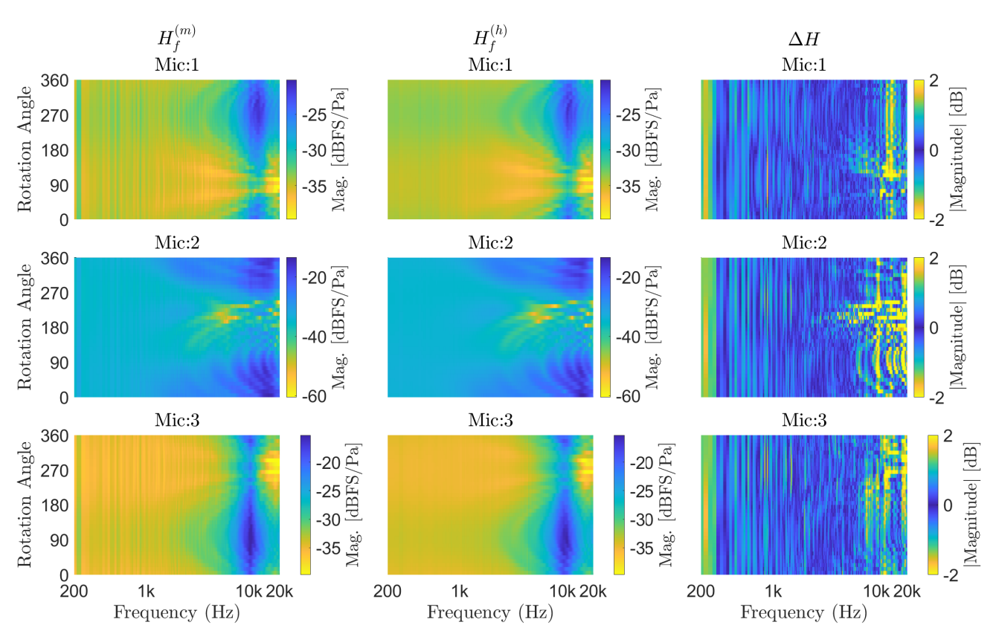
Figure 3 First column present frequency responses measured of commercial device in anechoic chamber, second column shows frequency response with integrated microphone response (IMPro) combined with simulated response, and the third column presents the magnitude difference of these alternative methods for all rotations.

3. On integrated microphone response compensation
UEs need to compensate integrated microphone responses by equalizing their frequency response to compensate microphone integration imperfections. IMPro measurements enable accurate characterization of device microphones for this purpose. Device manufacturers have detailed information about the microphone characteristics, and this information can be used at least in two alternative ways:
- Device manufacturers provide compensated microphone signals for all microphones equalized to agreed target, or
- Device manufacturers deliver unprocessed, ‘raw’, microphone signals with product design microphone metadata describing microphone frequency response characteristics. This metadata can be then leveraged to compensate microphone signals for spatial audio processing.
In both cases it is important to measure integrated microphone characteristics accurately so that microphone signal compensation is based on valid data. The first method where device is providing readily compensated microphone signals for audio algorithms provides a simple approach to address microphone imperfections in the device software. This could be also supported efficiently by incorporating equalization targets in the audio measurement tools or test suites for testing IVAS capture compliance. This would have the advantage that possible design changes could be implemented by the manufacturing in case it would be challenging to satisfy the targets for microphone signal compensation.
The second method has the advantage that device manufacturers can report integrated microphone characteristics to audio software. This enables different application to implement application specific equalization targets. However, we believe that sufficient consistency for IVAS application would require reference equalization filter implementation that manufacturers could utilize or replace with more optimized implementations. Both approaches can leverage microphone signal compensation method based on IMPro measurements, which was integrated to the DaCAS-2 permanent document [6].

4. Summary
This contribution shows that IMPro measurements enable accurate characterization of the integrated microphone pressure frequency response. Furthermore, the measured data can be efficiently combined with acoustic simulations to characterize device at much higher spatial resolution that was proposed for recording scenarios in [6].
The IMPro method supports isotropic definition of compensated microphone response masks as equalization targets. Equalization can be implemented by providing compensated microphone signals aligned to a target sensitivity/frequency mask and a microphone sensitivity/frequency difference mask [6].
The source proposes that if proponents provide compensated signals as part of the target device database, the proponent shall provide compensation filter specification with the relevant data and the instruction how the filters are applied to the raw microphone signals. In addition, proponent may provide only the compensation filter specification and instructions how to apply them, instead of the compensated signals.

References
[1] Cozens J., Hämäläinen M, Pekkarinen M, IMPro – Method for Integrated Microphone Pressure Frequency Response Measurement Using a Probe Microphone, AES 158th Convention, Warsaw, Poland, May 2025. https://aes2.org/publications/elibrary-page/?id=22907
[2] Cozens, J., Hämäläinen M., Pekkarinen M. – Free-field Frequency Response Synthesis with IMPro Measurement Data, AES 159th Convention, Long Beach US, Nov 2025. https://aes2.org/publications/elibrary-page/?id=23086
[3] S4-250936: “On compensated microphone pressure frequency response measurement”, Nokia
[4] S4-251464 DaCAS-1: Target devices and databases v0.3".
[5] S4-251466 Compensation of integrated microphone responses, Nokia
[6] S4-251477: “DaCAS-2: Test methodologies and requirements v0.3”
[7] S4-251563: Draft TS 26.533, v0.2.0

