3GPP TSG-SA WG4 Meeting #134 S4-251979
Dallas, US, 17 – 21 November 2025
Revision of S4-251868

Source: Fraunhofer IIS
Title: Performance evaluation of ISM capturing solutions
Agenda item: 7.6
Document for: Discussion and agreement

1. Introduction

While the evaluation of ISM capturing solutions is covered by the single-source test methods and recording scenario included in the current DaCAS-2 permanent document [1] and in TS 26.260 [2], multi-source evaluation suitable for ISM capturing example solutions has not been addressed so far. Initial discussion on multi-source evaluation has been triggered in [3] and [4], targeting SBA capturing solutions specifically. In this document, we propose agreement for additional recording scenarios and objective performance test methods for ISM capturing example solutions, focusing on multi-source scenarios.

2. Recording scenarios and procedure

To enable multi-source evaluation of ISM capturing solutions, we propose two additional recording scenarios to be included in the database, which are detailed in Table 1. The proposed recording scenarios target smartphone-type devices and should therefore be made for all available smartphone-type target devices.
- Teleconferencing scenario (X-1, Figure 1): Smartphone lying flat on a table, screen facing up, 2 speakers positioned along the long axis of the smartphone within a certain opening angle
- Video call scenario (X-2, Figure 2): Smartphone in hand-held mode, landscape orientation, 2 speakers facing the screen/front camera
The proposed recording scenarios are also attached as recording_scenarios.xlsx.

To ensure the availability of suitable reference signals for the evaluation of ISM capturing solutions, we propose that the following recording procedure is followed for multi-source recording scenarios targeting ISM capturing solutions:
- Record sound sources individually. These individual sound source recordings correspond to the reference signals used for the evaluation of ISM capturing solutions.
- The final input signals to example solutions are obtained by either:
  - Summing up the individual sound source recordings. This is feasible since it is foreseen that the raw microphone signals must be recorded.
  - Or performing an additional recording with all sound sources active simultaneously.
If a. and b. are both available, the example solution provider can choose which one to use as input signal to the example solution.

Table 1 Recording scenarios for multi-source ISM evaluation
No | X-1 | X-2
Sound source | High quality loudspeaker  Recommended to use loudspeaker that complies with clause 4.0.2 in 3GPP TS 26.260 (including provisional values). | High quality loudspeaker  Recommended to use loudspeaker that complies with clause 4.0.2 in 3GPP TS 26.260 (including provisional values).
Source signal | British English single talk sequence according to the ITU-T P.501 | British English single talk sequence according to the ITU-T P.501
Source signal characteristics | Language: English  Gender: Male, Female  Range: 20Hz-20kHz  Length: 35.4 s  Level: -27 dB RMS  Sample Rate: 48 kHz  Bit depth: 16 bit | Language: English  Gender: Male, Female  Range: 20Hz-20kHz  Length: 35.4 s  Level: -27 dB RMS  Sample Rate: 48 kHz  Bit depth: 16 bit
Sound source calibration | Loudness: Source signal playback calibrated to 75 dB SPL according to the clause 5.5.1 of 3GPP TS 26.260.  Frequency response: The spectrum of the acoustic signal produced by the loudspeaker shall be equalized with a measurement microphone positioned on the main loudspeaker axis at 1 m from the loudspeaker membrane. The achieved equalized spectrum in 1/3rd octave bands, when measured in the test environment, shall be within ±1 dB from 100 Hz to 200 Hz and shall be within ±0.5 dB from 200 Hz to 20 kHz. | Loudness: Source signal playback calibrated to 75 dB SPL according to the clause 5.5.1 of 3GPP TS 26.260.  Frequency response: The spectrum of the acoustic signal produced by the loudspeaker shall be equalized with a measurement microphone positioned on the main loudspeaker axis at 1 m from the loudspeaker membrane. The achieved equalized spectrum in 1/3rd octave bands, when measured in the test environment, shall be within ±1 dB from 100 Hz to 200 Hz and shall be within ±0.5 dB from 200 Hz to 20 kHz.
Acoustic environment | Anechoic chamber OR acoustically well treated room with short reverberation (room compliant e.g., with Clause 6.1. in ETSI TS 103 224, or with clause 8 in ITU-T BS.1116).  Recommended environment is an anechoic chamber according to the clause 4.0.3 of 3GPP TS 26.260. | Anechoic chamber OR acoustically well treated room with short reverberation (room compliant e.g., with Clause 6.1. in ETSI TS 103 224, or with clause 8 in ITU-T BS.1116).  Recommended environment is an anechoic chamber according to the clause 4.0.3 of 3GPP TS 26.260.
Detailed Positioning | UE positioning/orientation: UE lying flat on a table, screen facing up  Source distance: 0.5-1 m, equal distance of both sources to UE  Source direction: Loudspeaker diaphragm towards the center of the UE  Source height (relative to UE): 0.4 m  Source angles:  Azimuth angle combinations (2 sources active simultaneously): [-90°, 90°], [-110°, 70°], [-110°, 90°] | UE positioning/orientation: UE in hand-held mode, landscape orientation, screen oriented towards sources  Source distance: 0.3-0.5 m, equal distance of both sources to UE  Source direction: Loudspeaker diaphragm towards the center of the UE  Source height (relative to UE): 0 m  Source angles:  Azimuth angle combinations (2 sources active simultaneously): [-30°, 30°],  [-45°, 45°], [-30°, 45°]
Reference recording | The reference recordings correspond to the individual sound source recordings obtained by following the outlined recording procedure. | The reference recordings correspond to the individual sound source recordings obtained by following the outlined recording procedure.
Description/additional info | Recording procedure  - Record sound sources individually  - The final input signals to example solutions are obtained by either:  - Summing up the individual sound source recordings. This is feasible since it is foreseen that the raw microphone signals must be recorded.  - Or performing an additional recording with all sound sources active simultaneously.  If a. and b. are both available, the example solution provider can choose which one to use as input signal to the example solution.  Sources at different locations should use different sequences as the source signal.  The following overlap pattern of the two sources should be implemented: only source 1 active (25%) -> only source 2 active (25%) -> source 1 + source 2 active (50%)  Device types: This scenario is applicable only for smartphone-type devices | Recording procedure  - Record sound sources individually  - The final input signals to example solutions are obtained by either:  - Summing up the individual sound source recordings. This is feasible since it is foreseen that the raw microphone signals must be recorded.  - Or performing an additional recording with all sound sources active simultaneously.  If a. and b. are both available, the example solution provider can choose which one to use as input signal to the example solution.  .  Sources at different locations should use different sequences as the source signal.  The following overlap pattern of the two sources should be implemented: only source 1 active (25%) -> only source 2 active (25%) -> source 1 + source 2 active (50%)  Device types: This scenario is applicable only for smartphone-type devices

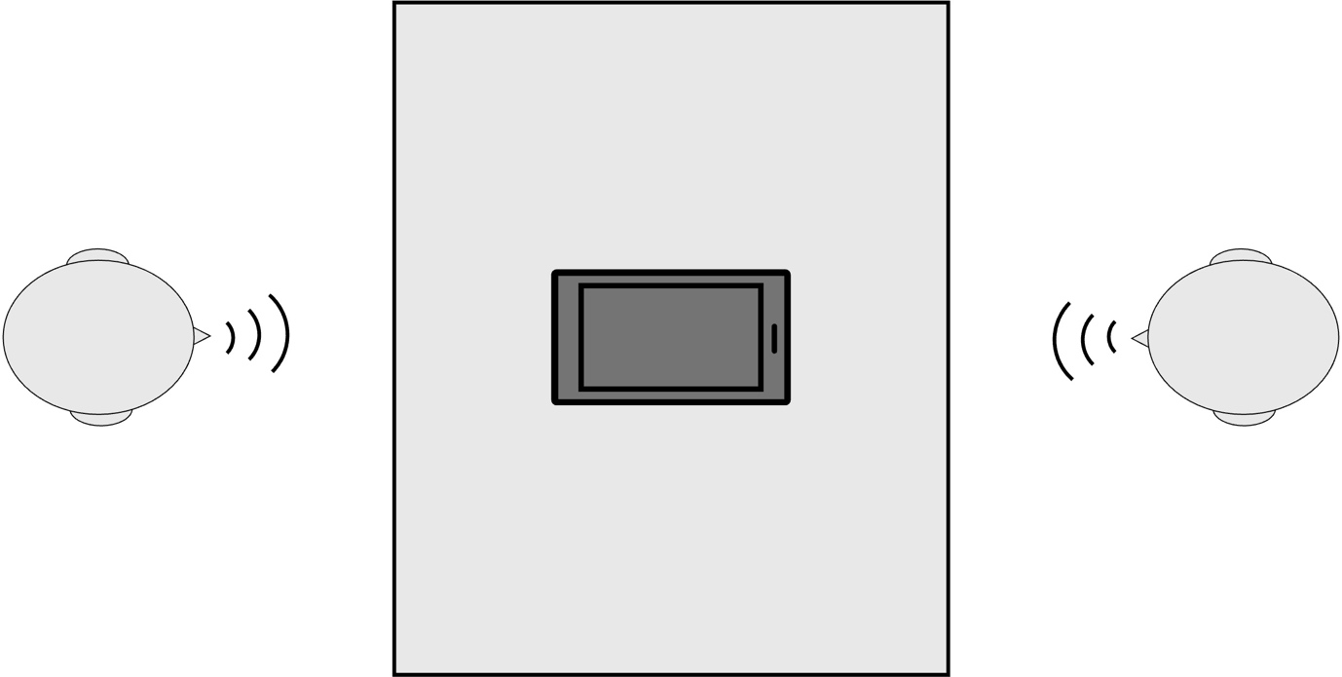

Figure 1 Sketch of recording scenario X-1

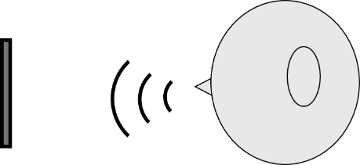
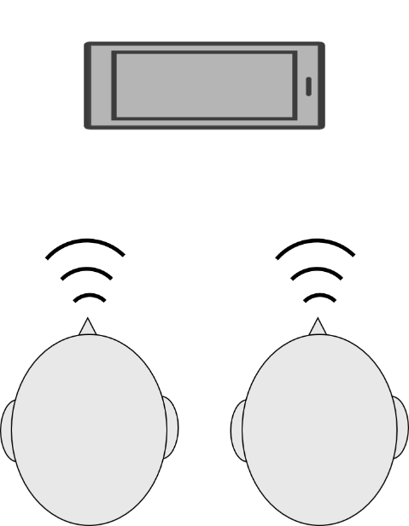

a) Elevated view b) Side view

Figure 2 Sketch of recording scenario X-2

3. Objective performance evaluation

Considering ISM capturing example solutions in multi-source scenarios, a number of requirements can be identified (assuming a mapping of n sources to n objects):
- The loudness and frequency response of each object should be sufficiently close to that of the corresponding source signal
- Distortion of the extracted objects should be below an acceptable threshold
- The crosstalk between objects should be below an acceptable threshold
- Sources should not switch between objects (also if sources are moving or are silent for a long time)

Having these requirements in mind, we propose to extend the frequency response test method defined in [1] section 4.1.4.3 to ISM capturing solutions in multi-source scenarios:
- Calculate one frequency response measure per object
- For each object, calculate the frequency response according to TS 26.260 [2] clause 5.6.3.2, using the corresponding individual sound source recording as reference signal

4. Conclusion

Updates present in Sections 2 and 3 targeting multi-source evaluation for ISM capturing solutions are proposed to be included in the DaCAS-2 permanent document.

5. References

[1] S4-251477: “DaCAS-2: Test methodologies and requirements v0.3”
[2] 3GPP TS 26.260: “Objective test methodologies for the evaluation of immersive audio systems”, Release 18
[3] S4-251330: “Performance Evaluation for SBA solutions & Recording scenarios”
[4] S4aA250101: “Performance Evaluation for SBA solutions”

