3GPP TSG-SA WG4 Meeting #134 S4-251750
Dallas, USA, 17 – 21 November 2025 revision of S4-251364

Source: HEAD acoustics GmbH, Nokia, Qualcomm Incorporated
Title: Update to Permanent Document ATIAS-2 v0.6
Agenda item: 7.7 / 14.2
Document for: Agreement

1 Introduction
The present document collects candidate changes to 3GPP TS 26.260 [2] on test methods for immersive UEs that were proposed during the work item ATIAS_Ph2 [1]. If applicable, associated requirements for 3GPP TS 26.261 [3] are included as well.
The following clauses and subclauses are structured according to the objectives that are in scope of the ATIAS_Ph2 WID:
- Consider additional requirements corresponding to the test methods in TS 26.260 and/or update requirements marked as TBD for sending and receiving characteristics of terminals in TS 26.261.
- Define new test methods and performance requirements/objectives, for the assessment of capture and playback of complex sound scenes, i.e., sound scenes with more than one source and from more than one defined direction.
- Define new test methods and performance requirements/objectives for the assessment of acoustic echo control. Test methods may be either completely new or be based on existing ones for mono telephony (from e.g., TS 26.132). In the latter case, it has to be investigated if and how such methods can be adapted for UEs providing immersive audio playback and/or capture capabilities.
- Define test methods and performance requirements/objectives for the assessment of binaural rendering in receive direction, including headtracking and motion-to-sound latency. Electrical as well as acoustical interfaces should be considered.
- Consideration of aspects, that are based on other ongoing work items, such as complexity level definitions in IVAS_Codec_Ph2.
NOTE: Updates to TS 26.259, in support of the development of the objective tests, are out of scope of this permanent document.
Each candidate change (i.e., updates to existing text or new clauses) is described in a separate subclause and contains:
- a brief summary and status of the proposed change
- a list of TDocs that initially proposed and further supported the change, as well as other related inputs
- all necessary changes to 3GPP TS 26.260 [2] and/or 3GPP TS 26.261 [3]. To reduce overhead and workload during drafting, the changes are prepared for a direct transfer into formal CRs.
This working procedure was preferred by the SA4 Audio SWG over continuously developed CRs, as it allows to add and track complementary information, avoiding also "changes over changes" in the history of the permanent document.

2 References
The following references are used in the present document, but not in the candidate changes.
[1] 3GPP SP-241314, "WID on Terminal Audio quality performance and Test methods for Immersive Audio Services, Phase 2," HEAD acoustics GmbH, Qualcomm Incorporated, Nokia Corporation, Dolby Sweden AB, Orange, Xiaomi, Melbourne, 2024.
[2] 3GPP TS 26.260: "Objective test methodologies for the evaluation of immersive audio systems", V18.1
[3] 3GPP TS 26.261: "Terminal audio quality performance requirements for immersive audio services", V18.0

3 Changes on references
The following references are not yet included in TS 26.260/261 but are used in the candidate changes in the present document.
[32] ETSI TS 103 224: "A sound field reproduction method for terminal testing including a background noise database", 2025-11.
[X1] Recommendation ITU-T G.122 (03/1993): "Influence of national systems on stability and talker echo in international connections".
[X2] ETSI ES 202 396-1: "Speech quality performance in the presence of background noise; Part 1: Background noise simulation technique and background noise database", 2025-11.
[X3] IEC 61672-1: "Electroacoustics - Sound level meters - Part 1: Specifications".
[X3] M. Kentgens, M. Bárány, A. Hallmann, C. Nelke, “Head-Tracked Spatial Audio: What is the Motion-to-Sound Latency of your Device?”, AES International Conference on Headphone Technology, Espoo, Finland, August 2025.
[X4] Politis, A., & Gamper, H. (2017, October). Comparing modeled and measurement-based spherical harmonic encoding filters for spherical microphone arrays. In 2017 IEEE Workshop on Applications of Signal Processing to Audio and Acoustics (WASPAA) (pp. 224-228).

4 Changes on test setup

4.1 UE types

4.1.1 Summary
Specify test setups for UEs that are composed of multiple UE types (e.g. headset and handheld).
Progress: Initial discussion

4.1.2 Related documents
TDoc | Title / Source | Notes
S4-242015 | "On acoustic echo control testing and on UE type combinations", Nokia. | Identified the gap in UE type definitions
SA4aA250003 | "On testing simultaneous SND-UE-types", Nokia. | Further considerations regarding combined UE types

4.1.3 Changes for TS 26.260
Start change [

5.4.2.8 Simultaneous Capture
Immersive UEs may comprise two or more simultaneously active capturing interfaces in the sending direction. These interfaces may correspond to one of the SND-UE-types specified in the previous clauses (e.g., Headset UE, Handheld hands-free UE, or Table-mounted Hands-free UE) or may include additional accessory equipment (e.g., an external microphone).
For such UEs, the primary test setup shall be selected as follows:
- If multiple SND-UE-types could be considered equally relevant, the manufacturer shall specify the primary setup (if available).
- If no manufacturer-defined primary setup is provided, the setup shall correspond to the SND-UE-type that is most relevant for the current capture mode under test (see clause 5.4.1).
In general, a manufacturer-defined test setup shall always take precedence over the setups specified in the present document.
EXAMPLE 1: Conferencing scenario: A Handheld hands-free UE (or Table-mounted UE) is used with one or more accessory microphones placed on a table or held by the user. For the user capture mode, the test setup for the Handheld hands-free UE (or Table-mounted UE) shall be used as the primary setup, as the user primarily interacts with this device.
EXAMPLE 2: Combined Headset and Handheld UE: A Headset UE is connected to a Handheld hands-free UE, where the internal microphones of the Handheld UE are combined with the binaural microphones of the Headset UE to enhance immersive capture.
- For user capture mode, the Handheld hands-free UE shall be considered the primary interface, as it is the main communication device.
- For spatial capture mode (e.g., recording a concert), the Headset UE shall be selected as the primary setup if the Handheld UE functions as an auxiliary microphone extension.

] End change

4.2 Bitrates used for testing

4.2.1 Summary
In a discussion on performance requirements during a conference call, the question of bitrates used per coded format was raised. In TS 26.260, Table 1 contains only TBD values so far. In addition, at the time when this clause was drafted, it was still unclear if a fixed/realistic bitrate should be used for testing (similar as in TS 26.131/132) – or if test-dependent adaptations are possible/allowed.

4.2.2 Related documents
TDoc | Title / Source | Notes
S4-251235 | "Report from Audio SWG teleconference on ATIAS_Ph2 (23 June 2025)", SA4 Audio SWG Vice-Chair (Orange). | Initial request for clarification on bitrates used for testing was made during this conference call.

4.2.3 Changes for TS 26.260
Start change [

5.3.2 System simulator and reference client
The system simulator configuration and radio conditions on the air interface shall be as specified in clause 4.2 of 3GPP TS 26.132 [27]. Unless otherwise specified for the respective test, the system simulator shall provide an error-free radio connection to the UE under test.
The UE shall be connected to a system simulator and test equipment supporting the IVAS codec [28]. Unless specified otherwise, 48 kHz sampling rate and fullband mode shall be used.
Since UEs may provide different capabilities for sending (capture) and receiving (rendering) direction, a bidirectional communication may not be symmetric regarding IVAS Coded Formats and corresponding bitrates.
During negotiating and exchange of session parameters via Session Description Protocol (SDP), the UE advertises its supported and preferred Coded Formats in sending and receiving direction, as well as corresponding bitrate ranges.
- The reference client shall advertise via SDP the envisioned IVAS audio format for testing sending and receiving direction along with corresponding bitrate as specified in Table 1 as the preferred and only capabilities.
- For sending direction, the decoder in the reference client shall be configured for the EXT decoder output format, if not specified otherwise by any test method.
- For receiving direction, the encoder in the reference client shall be configured for the Coded Format envisioned for testing.
Table 1: Bitrates per audio format used for testing
Coded Format | Subformat | Bitrate for testing  [kbit/s] | Max. bitrate  [kbit/s]
Stereo | Stereo | 80 | 256
 | Binaural | 80 | 256
ISM | 1 | 80 | 128
 | 2 | 80 | 256
 | 3 | 80 | 384
 | 4 | 80 | 512
 | FOA | 80 | 512
SBA | HOA2 | 80 | 512
 | HOA3 | 80 | 512
MASA | 1 TC | 80 | 512
 | 2 TC | 80 | 512
OSBA |  | 80 | 512
OMASA |  | 80 | 512
Multichannel | 5.1 | 80 | 512
 | 7.1 | 80 | 512
 | 5.1.2 | 80 | 512
 | 5.1.4 | 80 | 512
 | 7.1.4 | 80 | 512
NOTE: The maximum bitrates are provided for information.

NOTE 1: Default bitrate configurations for testing are for further study.
NOTE 2: The maximum bitrates listed in Table 1 may not be supported by all UEs.

The bitrate shall be provided by the network operator configuration. If the bitrate is not available from the operator, the maximum bitrate supported by the UE shall be used. The test operator shall report the bitrate used for testing.

In a split rendering session (when split rendering coded format is negotiated during SDP negotiation as per TS 26 253 Annex A), during negotiating and exchange of session parameters via Session Description Protocol (SDP), the UE advertises its supported transport codec, degree of freedom as well as bitrate ranges in sending and receiving direction.
- The reference client shall advertise via SDP the transport codecs and degree of freedom for testing sending and receiving direction along with corresponding bitrate as specified in Table 2 as the preferred and only capabilities.
- For sending direction, the post renderer in the reference client shall be configured for binaural output format
- For receiving direction, the pre renderer in the reference client shall be configured for the SR Coded Format (as mentioned in Annex A of TS 26 253) envisioned for testing.
Table 2: Bitrates per DoF used for ISAR testing
Transport codec | Dof | Bitrate for testing (kbit/s) | Max bitrate (kbit/s)
Lc3Plus | 3 | 512 | 512
LCLD | 0 | 256 | 512
Lc3Plus | 3 | 512 | 512
LCLD | 0 | 256 | 512

NOTE 1: The various other configurations of ISAR (see [28]) are for further study.

To Do:
- check if list of coded formats is complete add ISAR?

- Note 1-3 and the last paragraph could/should be deleted?
- Same principle as in TS 26.131/132 no "default" bitrate anymore, just one?
- If level 1 bitrates are consistently used, Table 1 is actually obsolete?

] End change

5 hanges on test methods and requirements

5.1 Acoustic echo control

5.1.1 Summary
Introducing test method for evaluating performance of acoustic echo control (AEC), which is adapted from existing specifications for IVAS-based UEs.
Progress: Stable test method, requirement is missing (SA4#132)

5.1.2 Related documents
TDoc | Title / Source | Notes
S4-242015 | "On acoustic echo control testing and on UE type combinations", Nokia. | Adapted test method for PDoc
S4-241840 | "Test methods for UE acoustic echo control", HEAD acoustics GmbH. | Provided useful information on AEC test methods
S4-250960 | "On applied test signal for AEC assessment ", Nokia. | Improved test signal containing moving talkers

5.1.3 Changes for TS 26.260
Start change [
5.5.6 Acoustic Echo Control
One of the most relevant aspects for traditional as well as for immersive speech communication is that the generation and insertion of echo signals in send direction should be avoided wherever possible.
[The compressed British-English single talk sequence described in clause 7.3.3 of Recommendation ITU-T P.501 [14]] is used to simulate a conversation at the far-end. To evaluate echo cancellation performance with immersive audio playback/capture, the individual talkers are virtually arranged in different positions according to Table T1 and as visualized in Figure F1, including also dynamic movements of certain talkers.
Table T1: Source direction of each sentence in test signal
# | Talker | Time range [s] |  | Source direction [°]
 |  | From | To | From | To
1 | M1 | 0.0 | 3.1 | 0 | 0
2 | M2 | 3.1 | 5.3 | 0 | 90
3 | M3 | 5.3 | 8.1 | 90 | 90
4 | F1 | 8.1 | 10.7 | 90 | -90
5 | F2 | 10.7 | 13.6 | -90 | -90
6 | F3 | 13.6 | 16.9 | 180 | 180
7 | F4 | 16.9 | 19.8 | 0 | 0
8 | F5 | 19.8 | 22.5 | 0 | 90
9 | F6 | 22.5 | 25.7 | 90 | 90
10 | M4 | 25.7 | 29.1 | 90 | -90
11 | M5 | 29.1 | 32.3 | -90 | -90
12 | M6 | 32.3 | 35.4 | 180 | 180

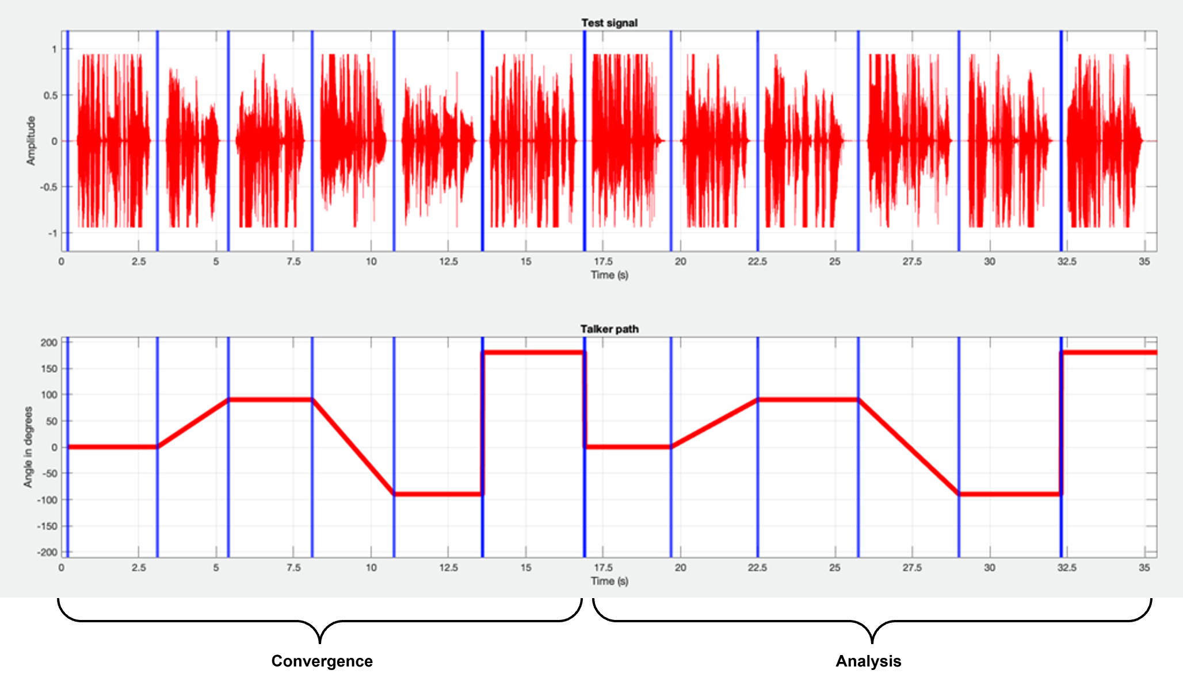
Figure F1: Sentence directions in the test signal
Test method
The calculation of terminal coupling loss (TCL) is based on the attenuation between the rendered input signal and rendered output signal versus frequency bands. For the rendering step, the IVAS renderer [30] shall be used. The following common measurement steps are applicable for all types of UE modes:
1) The source signal to be used for the measurements shall be [the compressed British-English single talk sequence described in clause 7.3.3 of Recommendation ITU-T P.501 [14].]
2) The test signal sentences shall be virtually positioned according to clause 5.5.2. The source directions per sentence according to Table T1 shall be applied.
3) The input signal shall be calibrated to -20 LFKS.
4) The first 17.0 s of the test signal (6 sentences) are discarded from the analysis to allow for convergence of the acoustic echo canceller. The analysis is performed over the remaining length of the test sequence (last 6 sentences).
5) The external renderer in the reference client shall be configured to mono output.
6) The analysis shall be conducted in 1/3-octave band intervals as given by the R.10 series of preferred numbers in ISO 3 [54] for each stereo audio channel. For the calculation, the averaged measured echo level at each frequency band is referred to the averaged, rendered test signal level measured in each frequency band, denoted as echo loss in the following.
7) TCL is calculated according to Annex B.4 of Recommendation ITU-T G.122 [X1], which utilizes tabulated data for any frequency range between $f_{0}$ and $f_{N}$. a s unweighted echo loss from [100/300] Hz to [8/6.7] kHz by the following equations:
$L_{e}=C-10\log_{10}{\sum_{i=1}^{N}{(A_{i}+A_{i-1})(\log_{10}{f_{i}-\log_{10}{f_{i-1})}}}}$
$C=10\log_{10}{(2⋅{(log}_{10}{f_{N}-\log_{10}{f_{0}}})}$
Where:
$A_{0}$ is the output/input power ratio at frequency $f_{0}=[100 / 300]$ Hz,
$A_{i}$ the ratio at frequency $f_{i}$,
$A_{N}$ the ratio at frequency $f_{N}=[8 / 6.7]$ kHz.
The test method applies for SND-/RCV-UE-types with an acoustical interface. Electrical interface UE or UEs with mixed electrical/acoustical interface are for further study.

Editor's note / further considerations:
- Step 7) adapted from ITU-T P.381 (reference to " trapezoidal rule" is actually wrong), where also a different frequency range is specified. Done
- ambience or reverberation could be additionally simulated on the test signal ATIAS_Ph3

] End change

5.1.4 Changes for TS 26.261
Start change [
Editor's note: Since the test method is adapted from mono telephony, the requirement on TCL could at least be drafted in the same way as e.g. in TS 26.131, just the single number (greater or less than 46 dB?) needs to be agreed. proposal: "hybrid approach", list all combinations so that certain requirements may be easily adapted.
5.6 Acoustic echo control
Requirements and performance objectives for TCL only apply for UEs for certain combinations of SND-UE-type and RCV-UE-type as specified according to clause 5.4.2 of TS 26.260. For nominal setting of the volume control, requirements for TCL are provided in Table 5.6-1 for each SND-/RCV-UE-type combination.
For any SND-/RCV-UE-type combination and any setting of the volume control, TCL shall be ≥ [40 dB].
Table 5.6-1: Requirements on TCL (in dB) for nominal volume control setting
UE-Type |  | RCV
 |  | Headset UE | Handheld  Hands-free UE | Table-mounted UE | Loudspeaker UE | Electrical  Interface UE
SND | Headset UE | [46] | [46] | [46] | [46] | FFS
SND | Handheld  Hands-free UE | [46] | [46] | [46] | [46] | FFS
SND | Table-mounted UE | [46] | [46] | [46] | [46] | FFS
SND | Electrical  Interface UE | FFS | FFS | FFS | FFS | [46]

NOTE: Several requirements for are for further study (FFS), as the underlying test methodology needs to be verified for SND-/RCV-UE-type combinations.
Compliance with this requirement shall be checked by the relevant test described in TS 26.260.

] End change

5.2 Headtracking & rendering

5.2.1 Summary
Introducing test method for evaluating performance of headtracking and rendering capabilities of IVAS-based UEs.
Progress: Stable.

5.2.2 Related documents
TDoc | Title / Source | Notes
SA4aA250001 | "Test Method for Motion-to-Sound Latency", HEAD acoustics GmbH. | Provided proposal for M2S-latency measurement
S4aA250099 | "Updates to Motion-to-Sound Latency test method and measurement results", HEAD acoustics GmbH | Refinements and example measurements

5.2.3 Changes for TS 26.260
Start change [
4.0.2 Test equipment
Unless specified otherwise, the accuracy of electric and acoustic measurements made by test equipment shall meet the requirements defined in clause 5.3 of 3GPP TS 26.132 [27].
For tests with head tracking, HATS rotation around the vertical axis should be realized using a HATS with motorized head rotation or comparable equipment consisting of P.57-compliant artificial ears mounted on a turntable or swivel apparatus (denoted as "motorized HATS" in the following clauses). For dynamic head-tracking measurements, the equipment is subject to angular velocity and noise emission requirements as specified in the respective test directives. Moreover, dynamic head-tracking measurements require the equipment to provide some kind of sensing mechanism for tracking orientation over time. For motorized or manual rotations of HATS and/or UE, error in orientation (elevation and azimuth) shall not exceed ±2°.
NOTE 1: A motorized rotation of HATS and/or UE is recommended even for static head-tracking measurements. Some UEs may not have a natural reference orientation (which, for instance, may be defined by the direction of a screen). In this case, the UE may reset the reference direction automatically after a span of time, e.g., to the current device orientation. This should be taken care of during the measurement. The measurement with the rotated HATS and/or UE should be performed quickly enough to prevent the reference direction from being spuriously readjusted. Therefore, it benefits from automation.
NOTE 2: Dynamic head-tracking measurements mimic the behavior of typical human head rotation. Angular rotation velocities and noise emission limits are required that may not be met by standard turntables.
[…]
5.7.5 Motion-to-Sound Latency
The test method applies to headset UEs providing headtracking functionality.
The test setup is as described in clause 5.4.3.2. A motorized HATS or comparable apparatus suitable for dynamic head-tracking measurements as described in clause 4.02 is used. The measurement apparatus shall be capable of realizing the below-stated movement trajectory. It shall feature a sensing mechanism that tracks the point in time at which the apparatus passes 0° orientation with a tolerance of ±2 ms. Moreover, its noise emission shall not exceed -70 dBPa measured at the artificial ears after signal filtering. An example setup is illustrated in Figure X.
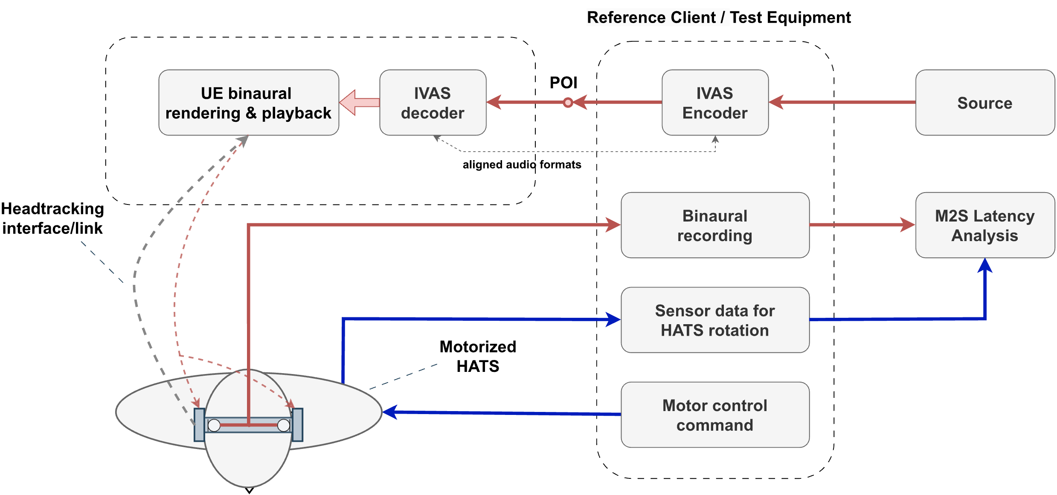
Figure X: Setup for measuring M2S latency using a motorized HATS

The test method evaluates interaural level differences that are calculated from the artificial ear signals with the following algorithm:
1) The left and right ear signals are each filtered with a narrow zero-phase filter that is designed to suppress noise of the measurement apparatus while not impacting the test signal. The filtered signals are denoted as ${\tilde{x}}_{l}\left(l\right)$ and ${\tilde{x}}_{r}\left(l\right)$ with sample index $l$ and shall be made available at a sampling rate of $f_{s}=48 kHz$.
2) The interaural level difference (ILD) is determined on the pre-processed left and right ear signals ${\tilde{x}}_{l}\left(l\right)$ and ${\tilde{x}}_{r}\left(l\right)$, respectively. The ILD is calculated on short frames with index $λ$ and can be stated as
$ILD\left(λ\right)=\max\left(-ILD_{max},\min\left(ILD_{max}, 10\log_{10}{\frac{\sum_{l=0}^{L-1}{{\tilde{x}}_{r}^{2}\left(Rλ+l\right)}}{\sum_{l=0}^{L-1}{{\tilde{x}}_{l}^{2}\left(Rλ+l\right)}}}dB\right)\right)$.
For the calculation, frame length L=[96] and hop size R=[24] are used. The ILD is limited to
$-ILD_{min}≤ILD(λ)≤ILD_{max}$, with $ILD_{min/max}=±12 dB$.
3) The ILD is then smoothed over P=1201 frames using a moving average with
$\overline{ILD}\left(λ\right)=\frac{1}{P}\sum_{r=-\frac{P-1}{2}}^{\frac{P-1}{2}}{ILD\left(λ+r\right)}.$
Time instances per frame index $λ$ are determined by
$t\left(λ\right)=\frac{1}{f_{s}}\left(Rλ+\frac{L-1}{2}\right).$
The motion-to-sound (M2S) latency measurement shall be conducted as follows:
1) The test signal to be used for the measurements shall be the periodic multitone signal with period length 1 ms as used in [X3]. The signal shall be virtually positioned to 0° azimuth and 0° elevation (frontal position for 0° head orientation) as described in clause 5.5.2. The signal shall be calibrated to -20 LFKS as described in clause 5.5.1.
2) The UE and the reference client are setup according to clauses 5.4.2 and 5.3.2, the source signal is encoded by the reference client and inserted at the POI to the UE. In case a volume control is provided in receive direction, it shall be set to nominal setting as identified per clause 5.7.2.
3) The motorized HATS is oriented to 0°. For ILD calibration, the ear signals are captured for a duration of2-5 s without applying any motion to the UE. Then, $\overline{ILD}\left(λ\right)$ is determined for the ILD calibration sequence and an average ILD (denoted as $ILD_{0°}$) is calculated as the mean of $\overline{ILD}\left(λ\right)$.
4) The dynamic part of the measurement (in motion) is conducted as follows:
a) The motorized HATS rotates continuously and repeatedly between +60° (start orientation) and -60°. The 0° orientation shall be passed Nmeas=[142] times, i.e., 7 times for each direction of rotation, so that a total of $N_{meas}$ partial estimates of M2S latency are determined. The duration between two zero-crossings shall be less than 2.0 s.
b) In the angle range between -10° and +10°, the angular velocity shall be constant with a nominal angular velocity of 108°/s.
c) During motion, the left and right ear signals and the time stamps $t_{0}^{(i)}$ (where the motorized HATS passes 0° orientation) are captured for $i=1,…, N_{meas}$.
5) After the last orientation is reached, the motorized HATS is immediately oriented to 0°. Step 3) is repeated to obtain the verification ILD, denoted as $ILD_{0°,\text{v}}$.
6) The M2S latency time is calculated as follows for each zero-crossing $i=1,…, N_{meas}$ of the orientation:
a) The smoothed ILD versus time ${\overline{ILD}}^{(i)}\left(λ\right)$ is determined.
b) The time stamp $t_{1}^{(i)}$ of the sound signal passing 0° orientation is determined by identifying the zero-crossing of ${\overline{ILD}}^{(i)}\left(λ\right)- ILD_{0°}$.
c) The M2S latency for the $i$-th measurement is determined by $T^{(i)}=t_{1}^{(i)}-t_{0}^{(i)}$.
7) The overall M2S latency is determined by calculating the median of $T^{(i)}$.
The principle of motion-to-sound analysis and determination of $t_{1}^{(i)}$ and $t_{0}^{(i)}$ is illustrated in Figure X+1.
NOTE 1: Before starting the measurement, the UE shall be initialized to match its reference (or zero) orientation with the HATS oriented to 0° and the UE shall be in active headtracking mode.
NOTE 2: The measurement method presented requires a constant reference orientation. In some IVAS UE use-cases, a DUT may intentionally adapt its reference orientation over time, for instance, based on the average of past orientations. The measurement method is not suited for such cases.

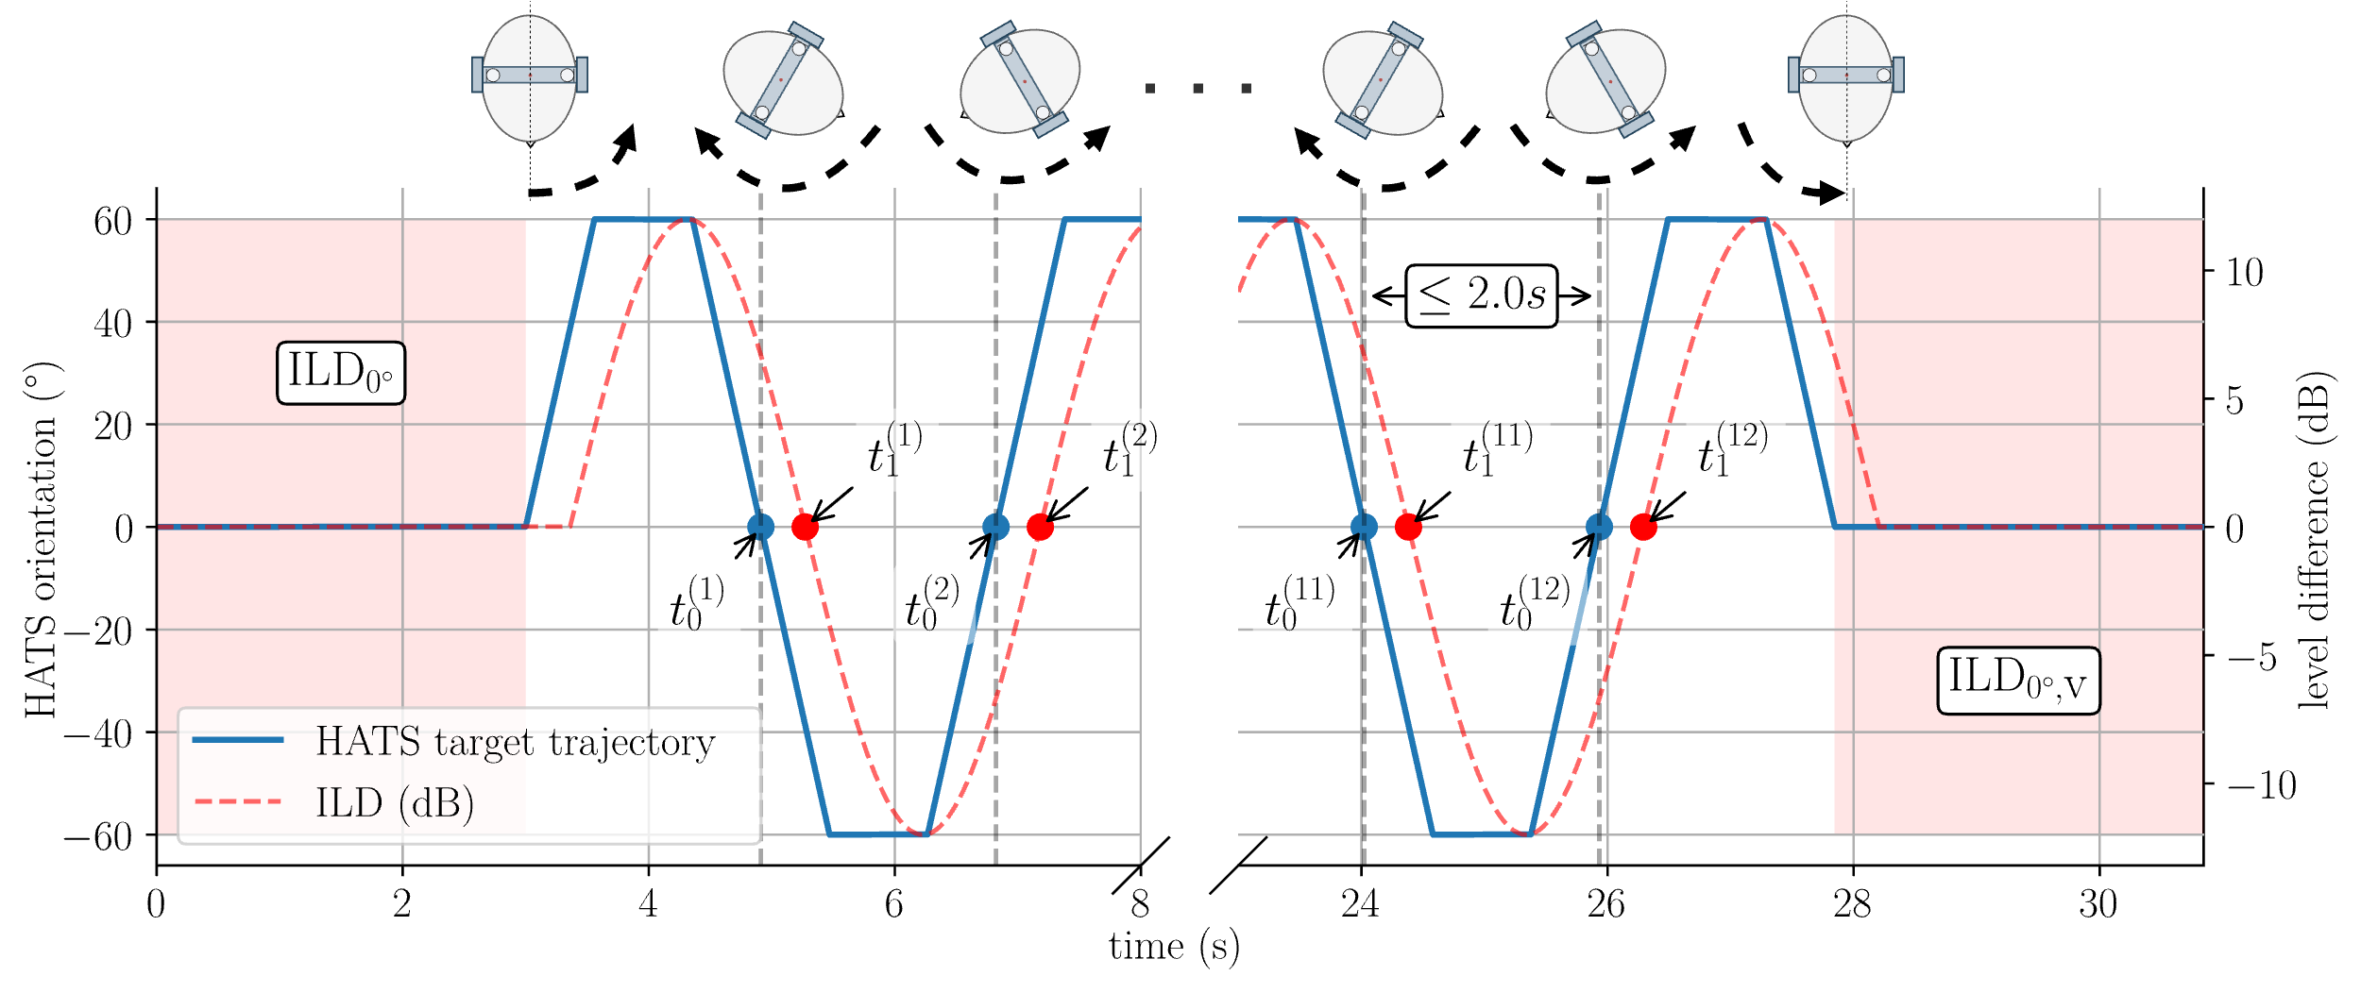
Figure X+1: Example setup for measuring M2S latency using a motorized HATS

The motion-to-sound latency test for ISAR is conducted in a similar way as described above. In this case, the ISAR bitstream is transmitted over headtracking interface/link and the headphone UE performs post-rendering including pose correction. The binaural signal from post-renderer is transmitted to binaural recording block in reference/client for M2S latency computation. The detailed setup is described in Figure X+2.

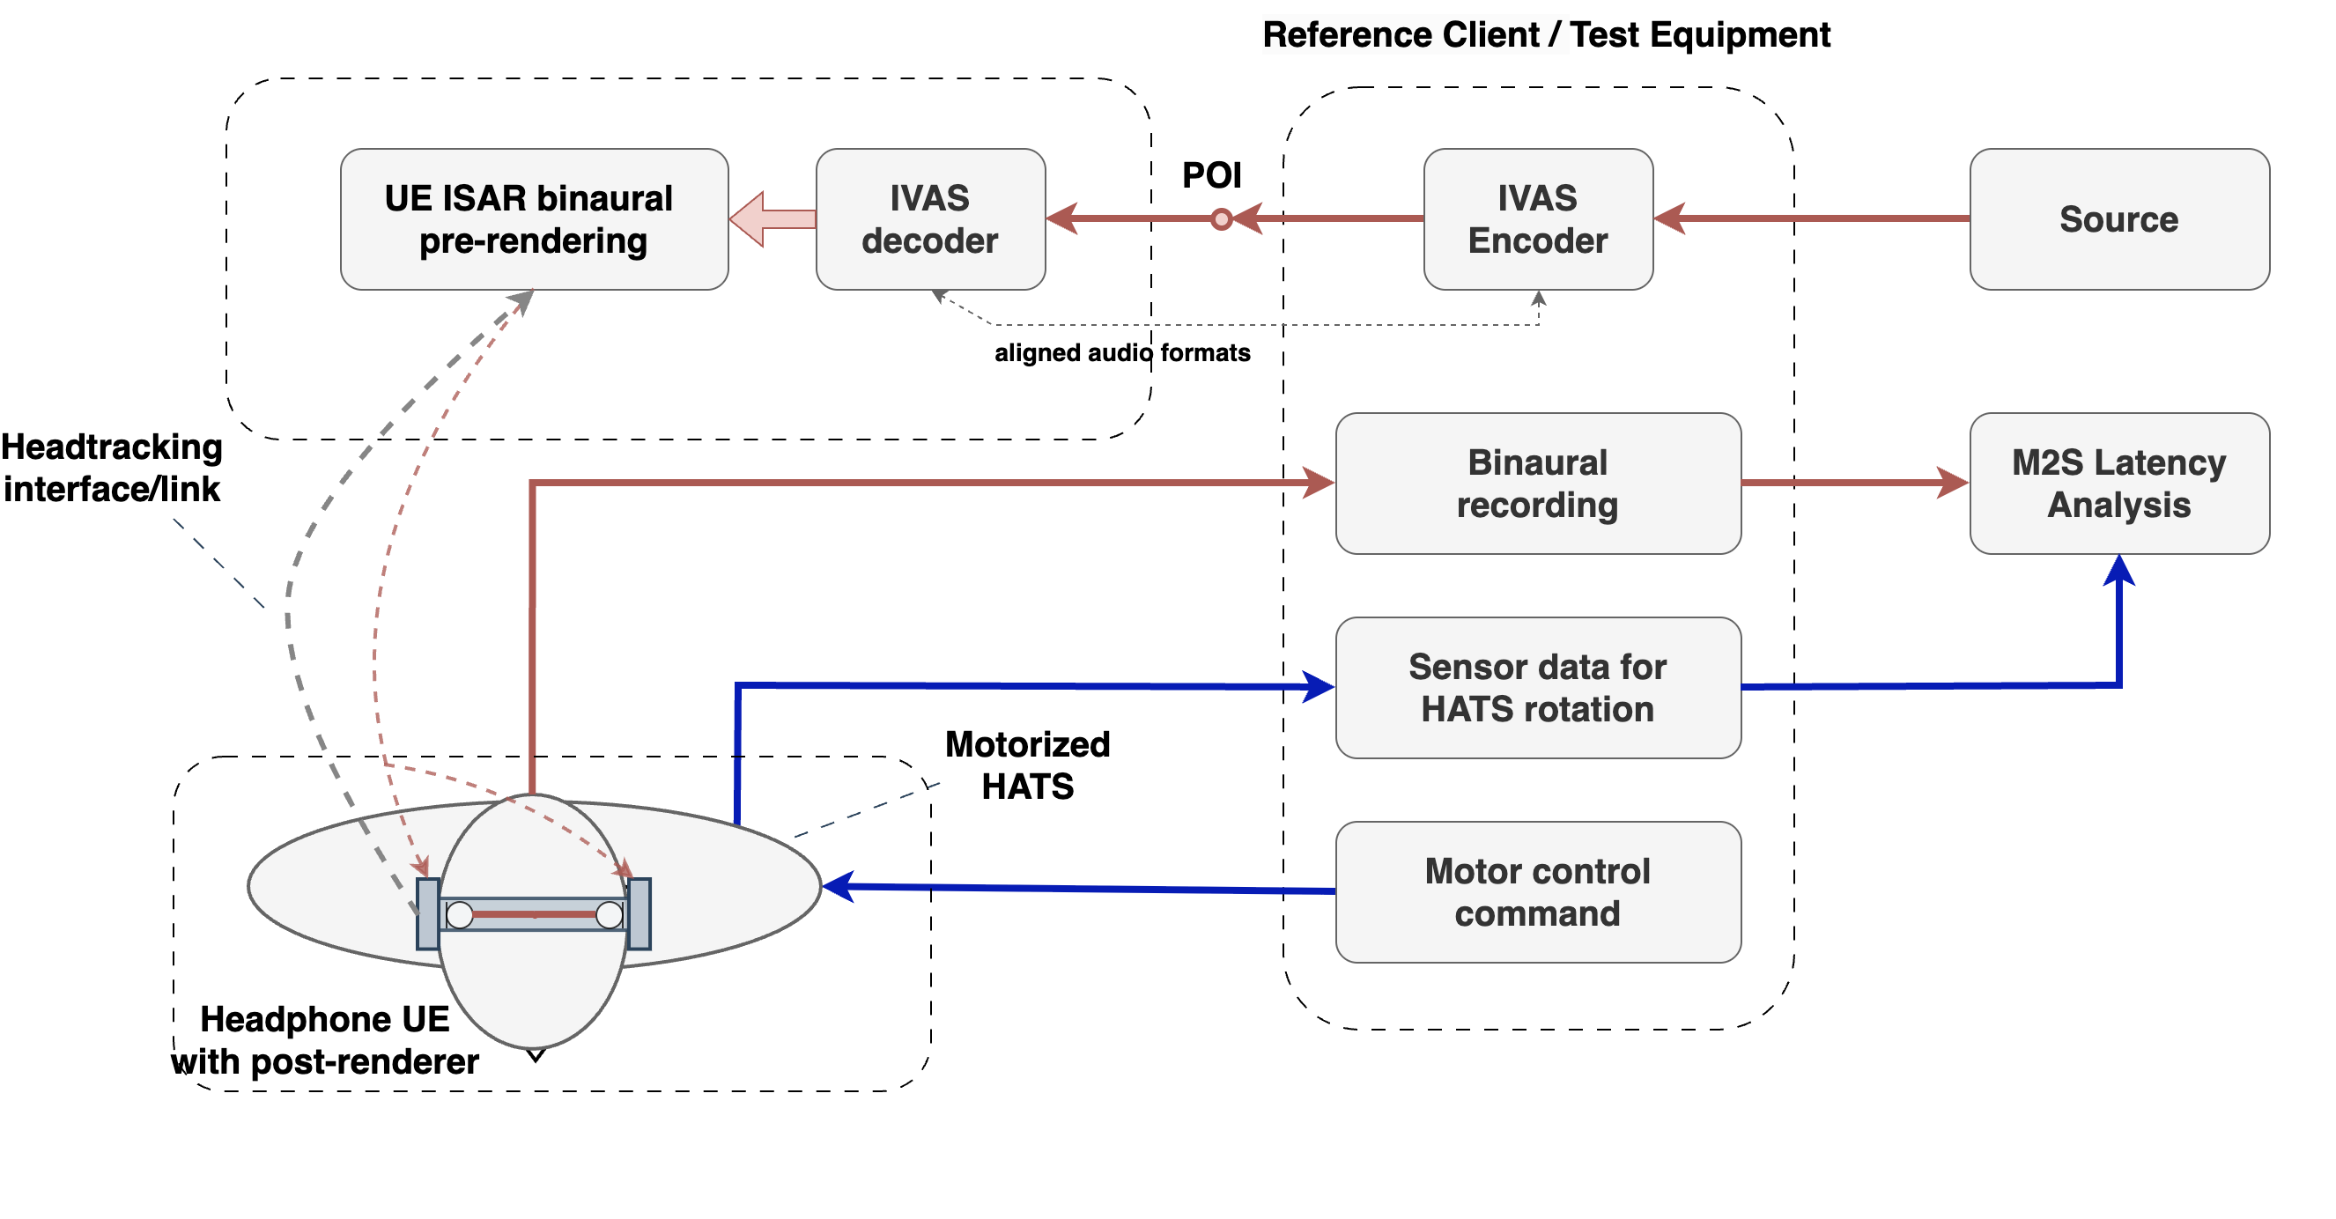
%3CmxGraphModel%3E%3Croot%3E%3CmxCell%20id%3D%220%22%2F%3E%3CmxCell%20id%3D%221%22%20parent%3D%220%22%2F%3E%3CmxCell%20id%3D%222%22%20value%3D%22Headtracking%26lt%3Bdiv%26gt%3Binterface%2Flink%26lt%3B%2Fdiv%26gt%3B%22%20style%3D%22edgeLabel%3Bhtml%3D1%3Balign%3Dcenter%3BverticalAlign%3Dmiddle%3Bresizable%3D0%3Bpoints%3D%5B%5D%3BlabelBackgroundColor%3Dnone%3BfontSize%3D20%3BfontStyle%3D1%22%20vertex%3D%221%22%20connectable%3D%220%22%20parent%3D%221%22%3E%3CmxGeometry%20x%3D%22-185.0101044148405%22%20y%3D%22210.80826111997476%22%20as%3D%22geometry%22%2F%3E%3C%2FmxCell%3E%3C%2Froot%3E%3C%2FmxGraphModel%3E
Figure X+2: Setup for measuring M2S latency with IVAS split rendering (ISAR) using a motorized HATS

T(i)

] End change

5.2.4 Changes for TS 26.261
Start change [
6.5.3 Motion-to-Sound Latency
The M2S latency measured with the test method from clause 5.7.5 from TS°26.260 should not exceed [80 ms] and shall not exceed [100 ms].
The absolute difference between the initial ILD calibration ($ILD_{0°}$) and the verification ILD ($ILD_{0°,\text{v}}$) shall not exceed 0.5 dB.
] End change

5.3 Ambient sound field generation and transmission

5.3.1 Summary
Following points have been identified to further assist on defining tests methods for assessing complex sound field transmission (e.g., ambience). Potential need for defining different capture types (in terms of noise suppression) in send directions:
- The expected performance of each capture type can be defined via sufficient set of test methods and respective requirements.
- Speech quality should be sufficient in every circumstance, including spatial characteristics.
- If the ambience is not targeted to be removed, the transmitted ambience should have similar characteristics as the original sound field.
- Flexible amount of ambience attenuation may be allowed, e.g., based on the user preference, noise conditions, use case, etc.
- If ambience is targeted to be removed, the amount of applied attenuation should be sufficient, while the quality and spatial characteristics of the active speech should be maintained
- Despite the targeted ambience attenuation, simultaneously received far-end signal should not cause interference with the captured and transmitted near-end signal.
- Possible presented capture types for further discussion:
  - Transparent capture (No noise suppression)
  - Nominal capture ("In between" No and Maximum noise suppressions)
  - Suppressed capture (Maximum noise suppression)
- Potential tests for assessing ambience transmission:
  - Loudness
  - Frequency response
  - Temporal characteristics
  - Spatial characteristics
- Common tests and requirements for assessing speech transmission are anticipated despite the applied capture type
- Capture type-specific tests and requirements may be needed to assess transmission of complex sound fields
- A need to robust way to identify applied capture type. Possible approaches:
  - "Transparency test": Based on the 5.6.2 of TS 26.260, SLR with noise(-like) signal to assess whether noise is transmitted or not. [S4aA250014]
  - SDP parameter to indicate and negotiate the applied capture type between UE and system simulator. [S4-250597]
  - Manufacturer-defined capture type(s) supported by the UE
- In addition, a priority for identifying the applied capture types should be considered
Progress: Stable.

5.3.2 Related documents
TDoc | Title / Source | Notes
S4-250205 | "On testing UEs in ambience", Nokia | Initial views on UE ambience transmission testing, indicating need for different capture types
S4aA250014 | "On transparency test", HEAD acoustics GmbH | A first concept for handling (at least two) anticipated UE behaviours in ambient noise conditions
S4-250597 | "On testing different capture types in send direction", Nokia | Further discussion on testing transmission of complex acoustic sound fields. Details on proposed SDP parameter presented.
S4-250612 | "Using a Periphonic Speaker Array for Improved Soundfield Reconstruction", Qualcomm, Incorporated | Equalization of periphonic loudspeaker array for symmetric microphone array according to ETSI TS 103 224.
S4-251004 | "Assessing Diffuseness Reproduction of Loudspeaker Layouts for ATIAS", Qualcomm, Incorporated | Equalization of periphonic loudspeaker array for spherical microphone array, comparing original and reproduced sound field with diffuseness metric.

5.3.3 Changes for TS 26.260
Start change [
3.1 Definitions
[…]

Noise suppression mode: applied noise suppression setting by the UE.
Minimum noise suppression mode: noise suppression setting that applies least noise suppression available to the UE
Default noise suppression mode: noise suppression setting that applies default noise suppression available to the UE. Noise suppression setting that is typically less than the Maximum and greater than the Minimum setting available to the UE.
Maximum noise suppression mode: noise suppression setting that applies most noise suppression available to the UE
Editor's note: Align naming convention ("capture type" and degrees) and definition with possible new SDP parameter for IVAS. done?
] End change

Start change [
5.3.2 System simulator and reference client
The system simulator configuration and radio conditions on the air interface shall be as specified in clause 4.2 of 3GPP TS 26.132 [27]. Unless otherwise specified for the respective test, the system simulator shall provide an error-free radio connection to the UE under test.
The UE shall be connected to a system simulator and test equipment supporting the IVAS codec [28]. Unless specified otherwise, 48 kHz sampling rate and fullband mode shall be used.
Since UEs may provide different capabilities for sending (capture) and receiving (rendering) direction, a bidirectional communication may not be symmetric regarding IVAS Coded Formats, noise suppression modes and corresponding bitrates.
During negotiating and exchange of session parameters via Session Description Protocol (SDP), the UE advertises its supported and preferred Coded Formats in sending and receiving direction, as well as corresponding bitrate ranges. If supported by the UE, the UE advertises its supported and preferred initial noise suppression mode(s) for the session via ns-mode-init or ns-mode-init-send SDP parameter.
- The reference client shall advertise via SDP the envisioned IVAS audio format for testing sending and receiving direction along with corresponding bitrate as specified in Table 1 as the preferred and only capabilities. Reference client shall select the noise suppression mode under test (see clause 5.4.4.1), if applicable. The noise suppression mode shall not be changed during testing.
- For sending direction, the decoder in the reference client shall be configured for the EXT decoder output format, if not specified otherwise by any test method.
- For receiving direction, the encoder in the reference client shall be configured for the Coded Format envisioned for testing.

] End change

Start change [
5.4.4 Noise suppression mode configuration
5.4.4.1 Overview
UEs may support multiple noise suppression modes in sending direction. The noise suppression modes to be tested are selected according to the following priority:
1) Supported noise suppression mode(s) as indicated during negotiation in SDP as described in 5.4.4.1
2) If option 1 is not available, supported noise suppression mode(s) are tested as specified by the manufacturer
3) If options 1 and 2 are not available, all tests are conducted, and the results are evaluated with respect to the requirements for the noise suppression modes.
All send noise suppression modes supported by the UE (up to four) shall be tested and documented in the test report.
5.4.4.2 Noise suppression mode configuration via SDP
The UE may indicate its supported noise suppression mode(s) via SDP using ns-mode-init or ns-mode-init-send parameter. The applied noise suppression mode(s) for testing shall be configured by negotiating the parameter for the session, if applicable. For testing UE with different noise suppression modes, following SDP parameter configurations and noise suppression mode mapping shall be used:
- If ‘none’ value is configured for the session, relevant tests for Minimum noise suppression mode are conducted
- If ‘min’ value is configured for the session, relevant tests for Minimum noise suppression mode are conducted
- If ‘def’ value is configured for the session, relevant tests for Default noise suppression mode are conducted
- If ‘max’ value is configured for the session, relevant tests for Maximum noise suppression mode are conducted

Further information on the IVAS Media Type Registration and Offer-Answer Model Considerations for ns-mode-init and ns-mode-init-send SDP parameters are described in clauses A.4.1 and A.4.3.1 in 3GPP TS 26.253 Annex A, respectively.
EXAMPLE: If the UE indicates that it supports ‘def’ and ‘max’ noise suppression modes via ns-mode-init parameter, both modes are tested. Two individual test calls are established with the reference client, one using ‘def’ value, and other using ‘max’ value. Relevant tests for each supported noise suppression mode are then conducted.
] End change

Start change [
5.4.5 Setup for ambient sound field simulation

The setup for simulating realistic ambient noises in a lab-type environment is described in ETSI TS 103 224 [x], which contains a description of the recording arrangement for realistic ambient noises, a description of the setup for loudspeaker arrangement suitable to simulate an ambient noise field in a lab type environment, and a database of realistic ambient noises. For improved periphony, augmented loudspeaker setup for spatial audio testing comprising 16 loudspeakers defined in Clause 6.0.2 in TS 103 224 should be used for tests.
For headset UE, the [asymmetric microphone array according to clause 5.2 | symmetric microphone array for binaural applications according to clause 5.4] of ETSI TS 103 224 [32] shall be used for the equalization and calibration of the ambient sound field reproduction. The HATS and the headset UE mounted to it are placed to the geometric centre of the loudspeaker array. The ambient sound fields as provided in Table T2 shall be used for testing.
Table T2: Ambient sound fields used for headset UE
Ambient Sound Field | Duration | Averaged Sound Pressure Level  of Microphone Array Elements
[Rock_Concert.wav] | 30s | [95dBSPL(A)]
[Nature_Scene.wav] | 30s | [40dBSPL(A)]
[Kindergarden.wav] | 30s | [60dBSPL(A)]
[Downtown_Scene.wav] | 30s | [70dBSPL(A)]

For handheld hands-free UE, the asymmetric microphone array (handheld setup) according to clause 5.3.2 of ETSI TS 103 224 [32] shall be used for the equalization and calibration of the ambient sound field reproduction. The handheld hands-free UE is placed in the geometric centre of the loudspeaker array. When testing in user capture mode (communication scenarios), HATS shall be [present|absent] during the calibration/equalization routine. The ambient sound fields as provided in Table T3 shall be used for testing.
Table T3: Ambient sound fields used for hands-free UE
Ambient Sound Field | Duration | Averaged Sound Pressure Level  of Microphone Array Elements
[Rock_Concert.wav] | 30s | [95dBSPL(A)]
[Nature_Scene.wav] | 30s | [40dBSPL(A)]
[Kindergarden.wav] | 30s | [60dBSPL(A)]
[Downtown_Scene.wav] | 30s | [70dBSPL(A)]

For table-mounted hands-free UE, the asymmetric microphone array (handheld setup) according to clause 5.3.3 of ETSI TS 103 224 [32] shall be used for the equalization and calibration of the ambient sound field reproduction. In accordance with clause 5.4.2.5, the table-mounted hands-free UE is placed in the geometric centre of the loudspeaker array. The ambient sound fields as provided in Table T4 shall be used for testing.
Table T4: Ambient sound fields used for table-mounted UE
Ambient Sound Field | Duration | Averaged Sound Pressure Level  of Microphone Array Elements
[Rock_Concert.wav] | 30s | [95dBSPL(A)]
[Nature_Scene.wav] | 30s | [40dBSPL(A)]
[Kindergarden.wav] | 30s | [60dBSPL(A)]
[Downtown_Scene.wav] | 30s | [70dBSPL(A)]

For electrical interface UE with binaural input format, ambient sound field recordings according to Table T5 shall be used for electrical insertion, which can be found in clause 8.2 of ETSI ES 202 396-1 [X2]. The binaural input signal shall be calibrated to [-26 LFKS], as described in clause 5.5.1.
Table T5: Ambient sound fields used for electrical interface UE and binaural input format
Ambient Sound Field | Duration | Averaged Sound Pressure Level  of Microphone Array Elements
[Rock_Concert.wav] | 30s | [95dBSPL(A)]
[Nature_Scene.wav] | 30s | [40dBSPL(A)]
[Kindergarden.wav] | 30s | [60dBSPL(A)]
[Downtown_Scene.wav] | 30s | [70dBSPL(A)]

[For electrical interface UE with [other input] format(s), … TBD].
Editor's note: Can we cover all UE types & coded formats here? Or are there "gaps" for which no ambient sound field simulation can be defined? could be, but then such a UE would anyway not "fit" into the current specification?
] End change

Start change [
5.5.3 Loudness calculation for immersive audio formats
The loudness level, K-weighted, relative to full scale (LKFS) for all immersive audio formats supported by the IVAS codec and captured at the POI in send direction is calculated according to ITU-R BS.1770 [23]. The method supports stereo and all multichannel formats as input signals directly.
If the signal to be analysed is not already in one of these formats, the external IVAS reference renderer according to clause 6 of 3GPP TS 26.254 [30] shall be used to render the signal to 7.1+4 output format, which is then used for the loudness level calculation according to ITU-R BS.1770 [23].

] End change

Start change [

5.6.5 Ambient Sound Field Loudness in Send Direction
The following test methods applies to all noise suppression modes.
Test method
1) The UE under test and the reference client are connected and configured as described in clause 5.3.2. The UE is mounted as described in clause 5.4.2.
2) The ambient sound field generation as defined in clause 5.4.5 is set up according to the corresponding UE type.
3) For acoustic measurements, the ambient sound field (test signal) is played back via the loudspeaker array.
For electrical interface, the test signal is played back via insertion into the electrical interface.
4) The captured signal is recorded at the POI and then decoded to the coded audio format of the UE.
5) The UE loudness level, K-weighted (LKFS) in sending direction is calculated according to clause 5.5.3.
6) The test is repeated for each ambient sound field in the corresponding tables of clause 5.4.5.

5.6.6 Ambient Sound Field Frequency Response in Send Direction
The following test method only applies to noise suppression modes Def and Min (see clause 5.4.4.2).
Test method
1) The UE under test and the reference client are connected and configured as described in clause 5.3.2. The renderer in the reference client shall additionally be configured to mono output. The UE is mounted as described in clause 5.4.2.
2) The ambient sound field generation as defined in clause 5.4.5 is set up according to the corresponding UE type.
3) For acoustic measurements, the ambient sound field (test signal) is played back via the loudspeaker array.
For electrical interface, the test signal is played back via insertion into the electrical interface.
4) The captured signal is recorded at the POI and the renderer in the reference client shall be configured to mono output.
5) The frequency response of the decoded and rendered output signal shall be calculated according to the format-specific definitions of the clause 5.6.3.2. For all formats, 1/12th octave intervals as given by the R40 series of preferred numbers in ISO 3 [6], for frequencies from 100 Hz to 12 kHz (inclusive) apply.
6) The reference magnitude spectrum is the 1/12th octave spectrum of a reference microphone positioned in the geometric center of the UE. In the case of headset UE, the reference magnitude spectrum is the 1/12th octave spectrum of a binaural downmix of the ambient sound field captured by the HATS in the absence of the headset UE (corresponds to the HRP).
7) The test is repeated for each ambient sound field in the corresponding tables of clause 5.4.5.

[5.6.7 Ambient Sound Field Temporal Characteristics
The following test method only applies to noise suppression modes Def and Min (see clause 5.4.4.2).
Test method
1) The UE under test and the reference client are connected and configured as described in clause 5.3.2. The renderer in the reference client shall additionally be configured to mono output. The UE is mounted as described in clause 5.4.2.
2) The ambient sound field generation as defined in clause 5.x.x is set up according to the corresponding UE type.
3) For acoustic measurements, the ambient sound field (test signal) is played back via the loudspeaker array.
For electrical interface, the test signal is played back via insertion into the electrical interface.
4) The captured signal is recorded at the POI and the renderer in the reference client shall be configured to mono output.
5) The decoded and rendered signal is referred to the recorder signal with a reference microphone positioned in the geometric center of the UE as level versus time analysis according to IEC 61672 [X3], using an integration time of [250 ms]. The result represents the differences in temporal structure between the transmitted and reference ambient sound field. In the case of headset UE, the reference signal is binaural downmix of the ambient sound field captured by the HATS in the absence of the headset UE (corresponds to the HRP).
6) The test is repeated for each ambient sound field in the corresponding tables of clause 5.x.x.
]
] End change

5.3.4 Changes for TS 26.261
Editor's note: The clauses in the following provide only (draft) requirements for "acoustical interfaces" in general, but not for specific UE types. Do we need separate numbers/tables for that? On the other hand, target values/tolerances for nominal and transparent capture types should indeed be quite similar?

Start change [
5.3 Loudness
5.3.1 Loudness for single source
[…]
5.3.2 Ambient Sound Field Loudness in Send Direction
For all SND-UE-types providing an acoustical interface, the ambient sound field loudness in send direction at the POI shall be according to the ranges in Table T6.
Table T6: Ambient sound fields used for acoustical interface UE
Ambient Sound Field | Duration | Ambient Sound Field Loudness  in Send Direction
[Rock_Concert.wav] | 30s | Minimum noise suppression mode: [TBD to TBD] LKFS  Default noise suppression mode: [TBD to TBD] LKFS  Maximum noise suppression mode: [Lower than TBD] LKFS
[Nature_Scene.wav] | 30s | Minimum noise suppression mode: [TBD to TBD] LKFS  Default noise suppression mode: [TBD to TBD] LKFS  Maximum noise suppression mode: [Lower than TBD] LKFS
[Kindergarden.wav] | 30s | Minimum noise suppression mode: [TBD to TBD] LKFS  Default noise suppression mode: [TBD to TBD] LKFS  Maximum noise suppression mode: [Lower than TBD] LKFS
[Downtown_Scene.wav] | 30s | Minimum noise suppression mode: [TBD to TBD] LKFS  Default noise suppression mode: [TBD to TBD] LKFS  Maximum noise suppression mode: [Lower than TBD] LKFS

For all SND-UE-types providing an electrical interface with binaural input format, the ambient sound field loudness in send direction at the POI shall be according to the ranges Table T7.
Table T7: Ambient sound fields used for electrical interface UE and binaural input format
Ambient Sound Field | Duration | Ambient Sound Field Loudness  in Send Direction
[Rock_Concert.wav] | 30s | Minimum noise suppression mode: [TBD to TBD] LKFS  Default noise suppression mode: [TBD to TBD] LKFS  Maximum noise suppression mode: [Lower than TBD] LKFS
[Nature_Scene.wav] | 30s | Minimum noise suppression mode: [TBD to TBD] LKFS  Default noise suppression mode: [TBD to TBD] LKFS  Maximum noise suppression mode: [Lower than TBD] LKFS
[Kindergarden.wav] | 30s | Minimum noise suppression mode: [TBD to TBD] LKFS  Default noise suppression mode: [TBD to TBD] LKFS  Maximum noise suppression mode: [Lower than TBD] LKFS
[Downtown_Scene.wav] | 30s | Minimum noise suppression mode: [TBD to TBD] LKFS  Default noise suppression mode: [TBD to TBD] LKFS  Maximum noise suppression mode: [Lower than TBD] LKFS

Compliance shall be checked by the relevant tests described in TS 26.260.
5.4 Frequency response
5.4.1 Single Source Send Frequency response
[…]
The requirements for acoustical interface testing with Minimum noise suppression mode are given in Table T8.
Table T8: Sending sensitivity/frequency requirements for acoustical interface & minimum noise suppression mode
Frequency (Hz) | Upper limit (dB) | Lower limit (dB)
100 | TBD
200 | TBD | TBD
300 | TBD | TBD
4000 | TBD | TBD
8000 | TBD | TBD
12000 | TBD

The requirements for acoustical interface testing with Default noise suppression mode are given in Table T9.
Table T9: Sending sensitivity/frequency requirements for acoustical interfaces & default noise suppression mode
Frequency (Hz) | Upper limit (dB) | Lower limit (dB)
100 | TBD
200 | TBD | TBD
300 | TBD | TBD
4000 | TBD | TBD
8000 | TBD | TBD
12000 | TBD

Compliance shall be checked by the relevant tests described in TS 26.260.
5.4.2.2 Electrical interface
The requirements for acoustical interface testing with Minimum noise suppression mode are given in Table T10.
Table T10: Sending sensitivity/frequency requirements for electrical interface UE & minimum noise suppression mode
Frequency (Hz) | Upper limit (dB) | Lower limit (dB)
100 | TBD
200 | TBD | TBD
300 | TBD | TBD
4000 | TBD | TBD
8000 | TBD | TBD
12000 | TBD

The requirements for acoustical interface testing with Default noise suppression mode are given in Table T11.
Table T11: Sending sensitivity/frequency requirements for electrical interface UE & default noise suppression mode
Frequency (Hz) | Upper limit (dB) | Lower limit (dB)
100 | TBD
200 | TBD | TBD
300 | TBD | TBD
4000 | TBD | TBD
8000 | TBD | TBD
12000 | TBD

Compliance shall be checked by the relevant tests described in TS 26.260.
[5.6 Temporal characteristics
Noise suppression modes Minimum and None: The absolute differences in level versus time [shall] be less than [TBD] dB for all evaluated ambient sound fields.
Noise suppression mode Default: The range of absolute differences in level versus time [shall/should] be less than [TBD] dB for all evaluated ambient sound fields.
Compliance shall be checked by the relevant tests described in TS 26.260.
]
] End change

5.4 Additional test methods for scene-based audio in sending direction

5.4.1 Summary
Introducing additional test method for evaluating quality of scene-based audio in sending direction.
Progress: Initial proposal

5.4.2 Related documents
Tdoc | Title / Source | Notes
S4-250282 | "[ATIAS_ph2] Scene-based audio capturing - Additional Test Methods", Bytedance. | Adapted test method for PDoc

5.4.3 Changes for TS 26.260
Editor's note: Some wording/terms/text fragments (highlighted in yellow) seems not very common/suitable for usage in a technical specification, also sometimes the usage of square brackets is inconsistent. This should be improved/rephrased before transferring it to the final CR.
Start change [
4.1.3 Diffuse Field Loudness
4.1.3.1 Test Setup
The recording environment is an anechoic chamber that meets clause 4.0.3. The test equipment should meet clause 4.0.2.
The following test material may be used:
[It’s still TBD on whether using the following material in separate test run or in a single test run.]
- [Uncorrelated pink noise, with length TBD. The loudness of each test signal is calibrated using the method [need clarification, need SPL measurement] in 3GPP TS 26.260.
- the British-English single talk sequence described in clause 7.3.2 of Recommendation ITU-T P.501 [14], which is calibrated as specified in clause 5.4.2 for the corresponding UE type and the tested capture mode (user or spatial).
- Music. Selection of material is TBD]
Sound source(s) are set to the following directions pointing to the device centre of the DUT to record candidate signals respectively. If the DUT is a headset UE, the DUT is mounted on a HATS. For tests with multiple sources, uncorrelated pink noise is used for each sound source.
The source directions are selected as follows.
1. Test 1-7: One single sound source is used, with its direction following all directions in Table TX1.
2. Test 8: Two sources at source directions No.2, and No.5 in Table TX1.
3. Test 9: Two sources at source directions No.3, and No.7 in Table TX1.
4. Test 10: Three sources at source directions No.1, No.4, and No.6 in in Table TX1.

Table TX1: Source directions
i | ϕ_{i} [°] | θ_{i} [°]
1 | -90 | 0
2 | -60 | 0
3 | -30 | 0
4 | 0 | 0
5 | 30 | 0
6 | 60 | 0
7 | 90 | 0

For reference signals, we calculate the test material to Ambisonic, with the same order as recorded SBA, and the a-for-mentioned incident source directions:
anmt=l=1LSltYn,mθl,ϕl,
where L is the number of active sound sources in the test scene, Slt is the test material, and θlφl is the source direction.
Candidate signal is recorded by placing the centre point of DUT at the centre of the test environment, facing the No.4 sound source direction. The test signal is calibrated to a loudness of -26 dB LKFS. SBA time domain signals of the DUT an,mt is recorded as the candidate signal.
4.1.3.2 Test method
The W channel in the FOA recording is an omni-directional channel and hence is selected as the representative of the loudness of the diffuse field in a recording.
For each test, the normalized RMS amplitude of W channel WRMSt=aRMS0,0t=t'=tt+δa0,02tδ is calculated, where δ is a short period of time. Then the loudness error is calculated by:
ϵWRMSt=WRMSt-WRMSt2WRMSt2
4.1.4 Spatial Correlation
4.1.4.1 Test Setup
The recording environment is an anechoic chamber that meets clause 4.0.3. The test equipment should meet clause 4.0.2.
The following test material may be used:
[It’s still TBD on whether using the following material in separate test run or in a single test run.]
- [Uncorrelated pink noise, with length TBD. The loudness of each test signal is calibrated using the method [need clarification, need SPL measurement] in 3GPP TS 26.260.
- the British-English single talk sequence described in clause 7.3.2 of Recommendation ITU-T P.501 [14], which is calibrated as specified in clause 5.4.2 for the corresponding UE type and the tested capture mode (user or spatial).
- Music. Selection of material is TBD]
Sound source(s) are set to the following directions pointing to the device centre of the DUT to record candidate signals respectively. If the DUT is a headset UE, the DUT is mounted on a HATS. For tests with multiple sources, uncorrelated pink noise is used for each sound source.
The source directions are selected as follows.
1. Test 1-7: One single sound source is used, with its direction following all directions in Table TX2.
2. Test 8: Two sources at source directions No.2, and No.5 in Table TX2.
3. Test 9: Two sources at source directions No.3, and No.7 in Table TX2.
4. Test 10: Three sources at source directions No.1, No.4, and No.6 in in Table TX2.
Table TX2: Source directions
i | ϕ_{i} [°] | θ_{i} [°]
1 | -90 | 0
2 | -60 | 0
3 | -30 | 0
4 | 0 | 0
5 | 30 | 0
6 | 60 | 0
7 | 90 | 0

For reference signals, we calculate the test material to Ambisonic, with the same order as recorded SBA, and the a-for-mentioned incident source directions:
anmt=l=1LSltYn,mθl,ϕl,
where L is the number of active sound sources in the test scene, Slt is the test material, and θlφl is the source direction.
Candidate signal is recorded by placing the centre point of DUT at the centre of the test environment, facing the No.4 sound source direction. The test signal is calibrated to a loudness of -26 dB LKFS. SBA time domain signals of the DUT an,mt is recorded as the candidate signal.
4.1.4.2 Test Method
Spatial correlation, as defined as equation 28 in [X4], is used to evaluate the similarity between candidate signals and reference signals per Ambisonic order:
Cnf=m=-nnynmHfWDynmAnfBn
In which:
- m: SH degrees
- n: SH orders
- ynmHf: Conjugate transpose (Hermitian) of the reconstructed SH coefficient vector for order n, degree m, and frequency f. This vector contains the reconstructed SH values across D measurement directions.
- WD: Diagonal weighting matrix of size D×D, containing sampling weights for the measurement grid directions. These weights approximate integration over the sphere to ensure orthonormality of the SH basis.
- ynm: Ideal SH coefficient vector for order n and degree m, containing the theoretical SH values across the same D directions.
- Anf: Energy of the reconstructed SH coefficients of order n, computed as
Anf=m=-nnynmHfWDynmf
- Bnf: Energy of the ideal SH coefficients of order n, computed as
Bnf=m=-nnynmHWDynm

4.1.5 Interaural Differences of Binaural Signals
4.1.5.1 Test Setup
The recording environment is an anechoic chamber that meets clause 4.0.3. The test equipment should meet clause 4.0.2.
The following test material may be used:
[It’s still TBD on whether using the following material in separate test run or in a single test run.]
- [Uncorrelated pink noise, with length TBD. The loudness of each test signal is calibrated using the method [need clarification, need SPL measurement] in 3GPP TS 26.260.
- the British-English single talk sequence described in clause 7.3.2 of Recommendation ITU-T P.501 [14], which is calibrated as specified in clause 5.4.2 for the corresponding UE type and the tested capture mode (user or spatial).
- Music. Selection of material is TBD]
Sound source(s) are set to the following directions pointing to the device centre of the DUT to record candidate signals respectively. If the DUT is a headset UE, the DUT should be worn by a HATS. For tests with multiple sources, uncorrelated pink noise is used for each sound source.
The source directions are selected as follows in Table TX3. Note that only one source is activated each time.
Table TX3: Source directions
i | ϕ_{i} [°] | θ_{i} [°]
1 | -90 | 0
2 | -60 | 0
3 | -30 | 0
4 | 0 | 0
5 | 30 | 0
6 | 60 | 0
7 | 90 | 0

For reference signals, we calculate the test material to Ambisonic, with the same order as recorded SBA, and the a-for-mentioned incident source directions:
anmt=l=1LSltYn,mθl,ϕl,
where L is the number of active sound sources in the test scene, Slt is the test material, and θlφl is the source direction.
Candidate signal is recorded by placing the centre point of DUT at the centre of the test environment, facing the No.4 sound source direction. The test signal is calibrated to a loudness of -26 dB LKFS. SBA time domain signals of the DUT an,mt are recorded as the candidate signal.
4.1.5.2 Test Method
The recorded SBA is rendered into binaural cues for evaluating perceptual error objectively. The same render should be applied to the candidate signal and the reference signal, using the HRTF of HATS.
ITD and ILD of an,mt and an,mt are defined and calculated as follows.
- The ILD is defined as the difference between right and left levels (in dB) and is calculated for octave bands with centre frequencies 500 Hz, 1000 Hz, 2000 Hz, 4000 Hz and 8000 Hz. Octave bandpass filters according to IEC 61260-1 [25] shall be used.
- The ITD is defined as the difference in delay between right and left ear. For the calculation, the signal is prefiltered with a high-pass filter with cut-off frequency 200 Hz and a lowpass filter with cut-off frequency 2000 Hz. Both filters shall use a filter order of four, which corresponds to a roll-off of 24 dB per octave. The ITD is calculated over the whole signal length using the cross-correlation method described in Annex C.
The ITD error is then calculated by:
ϵITD=ITDan,mt-ITDan,mt
and the ILD error of each octave band f is calculated by:
ϵILDf=ILDan,mtf-ILDan,mtf

] End change

